INTRODUCTION

The City of Greater Geelong invited the community to have their say on future park improvements for Rosewall Park, Corio. This community engagement aimed to understand the community's aspirations for the future of Rosewall Park, and the feedback gathered will help inform a concept plan for future upgrade works.
The City would like to thank the participants who generously shared their time and ideas throughout this stage of the engagement process.
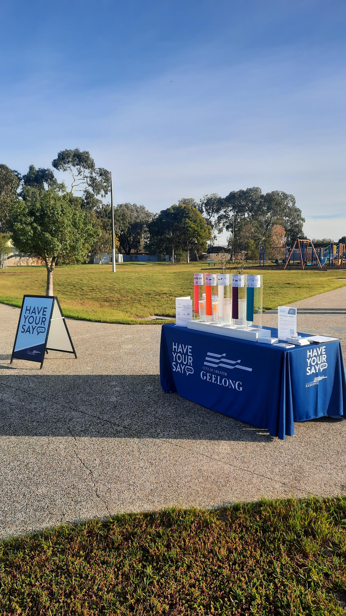
Figure 1 – On-site consultation at Rosewall Park

ENGAGEMENT SNAPSHOT
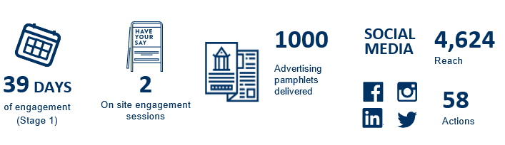

Who we engaged with

PARTICIPATION





918 people visited the 'have your say' page
55 contributions to the 'build your park' tool
49 contributions to the online survey
76% of respondents live within 1km of the park.

HOW WE ENGAGED
Have Your Say Online Portal  Yoursay.geelongaustralia.com.au | The Have Your Say (HYS) platform was the main engagement tool.  https://yoursay.geelongaustralia.com.au/rosewall-park
Online survey | An online survey was published on the Have Your Say project page to help the City better understand who uses the park, how it is currently used, and what the community would like to see in the upgrade works.
You Decide – build your park tool | An online ‘Build Your Park’ tool was utilised on the Have Your Say page to allow the community to choose what elements are most important to them.
On-Site consultations | Two x 2-hour onsite engagements were held on Saturday 14 June at Rosewall Park and Monday 16 June at Rosewall Community Centre.
Posters, Postcards & Letterbox drop | Postcards were distributed in the first 2 weeks of the engagement to inform residents in close proximity to Rosewall Park. Postcards were also made available at the Rosewall Community Centre and the local Milk bar
Written submissions | One written submission ( hard copy of the online survey) was received..
Social media / media releases | Facebook and Instagram campaign advising of Rosewall Park ‘Have Your Say’, as well as a release in City News, and Councillor Aitken’s column in the Geelong Times.
on-site signage | Four (4) signs were installed on-site at all major entrances into the park, directing people to the City’s Have Your Say page to provide feedback.

WHAT WE HEARD
The below information are summaries of the key items and learnings that we heard from the community from both the online survey and on-site consultation sessions.

GENERAL FEEDBACK:
Participating community members expressed a strong desire for the park to feel safe, welcoming, and well maintained. Preservation of green space and a desire to avoid overdevelopment of the reserve was a key theme.
Concerns included poor lighting, lack of security, and visible signs of vandalism and antisocial behaviour.
Many respondents emphasised the need for basic amenities such as toilets, rubbish bins, and seating areas. There was also appreciation for existing features like the barbecue and play areas, though many felt these could be expanded or refreshed.

THINGS TO CONSIDER:
Safety and accessibility emerged as critical considerations. Suggestions included implementing Crime Prevention Through Environmental Design (CPTED) principles and improving lighting. The lack of formalised parking and road access was recurrently mentioned, as was the need to reduce hidden corners that encourage antisocial behaviour.

OVERALL KEY FINDINGS :
The community wants a multi-generational space that caters to toddlers, teens, and adults alike. Popular ideas included fitness equipment, public toilets, BMX or skate facilities, and conversation hammocks for older kids. There was a strong push for environmental enhancements such as more trees, native flora, and biodiversity friendly landscaping. Maintenance issues like mowing, broken glass hazards, and rubbish dumping were frequently cited as barriers to park use.
OVERARCHING THEMES:

Four major themes stood out: safety, accessibility, inclusivity, and environmental care. Residents want a park that feels secure and is easy to navigate, with features that serve all age groups and abilities. There’s a clear preference for preserving and enhancing natural elements while ensuring the space remains clean and functional.

BUILD YOUR PARK TOOL – Top preferences
The City provided 26 different types of park amenities for the community to choose from. Each community member had 100 points to allocate to their most preferred elements. Each element was allocated a point value based on their dollar value.
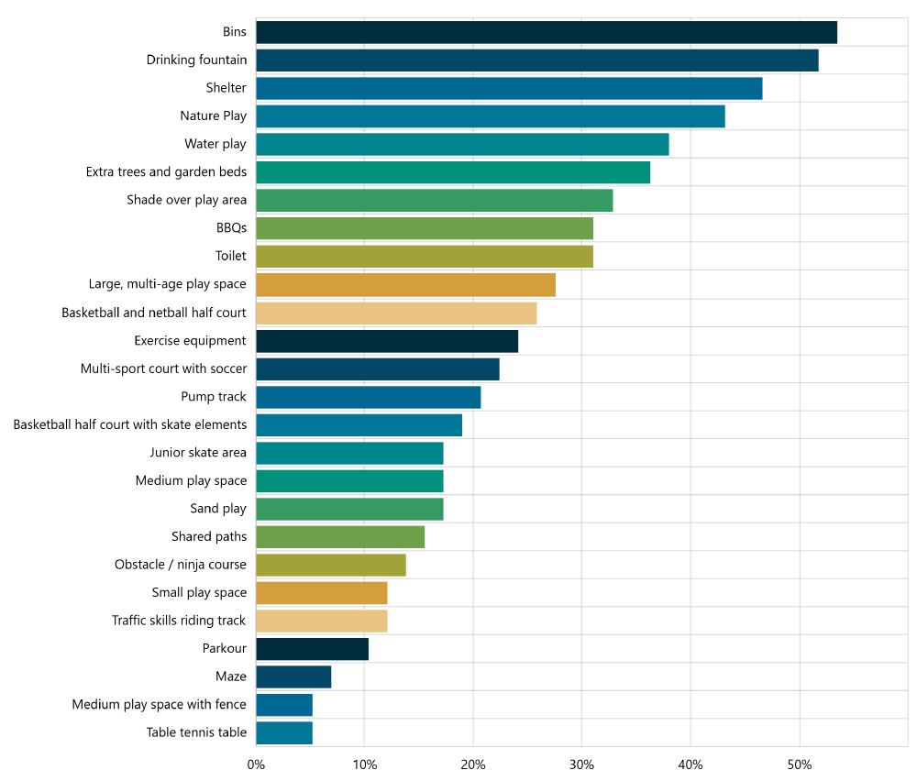

Figure 1 :The above graph shows the results from the ‘build your park’ tool, with the most chosen park amenities to the least.

NEXT STEPS

CONCLUSION/NEXT STEPS
The City will analyse the data captured from the engagement and begin development of an initial concept plan for Rosewall Park.
Once a concept plan is developed, it will be made available for community review via a second round of engagement to ensure it aligns with Community priorities and responds appropriately to the feedback heard through stage 1 engagement.

