THE CITY OF GREATER Geelong’s new Access and Inclusion Action Plan

We want to hear your ideas!

An Easy Read document
How to use this document
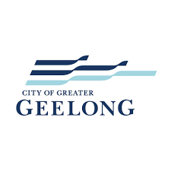 | The City of Greater Geelong wrote this document. When you see the word ‘we’, it means the City of Greater Geelong.
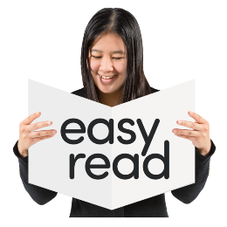 | We wrote this document so that it is easy to read. There are pictures next to the words. This helps to read the words.
B | Some words are written in bold. Bold words are thicker and darker. When you see a bold word, we will tell you what it means.
 | This document is a smaller version of the information on our webpage. This means only the most important things are in it.
 | You can find the full version at:  https://geelong.link/AIAP
 | You can get another person to help you read this document. This person may be:  - a friend  - a support worker  - someone in your family
What is this document about?
 | We are making a new Access and Inclusion Action Plan.
 | We want to make a city that is more accessible, inclusive, supportive and discrimination-free.
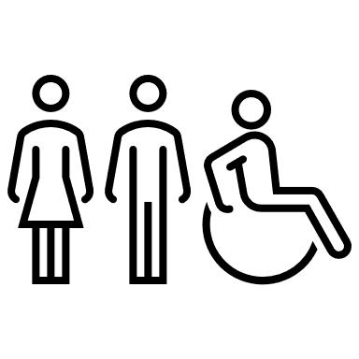 | When something is accessible, everyone can use it.
 | When something is inclusive, everyone can take part.
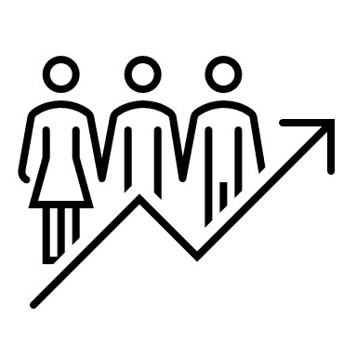 | When something is supportive, it helps everyone to use it.
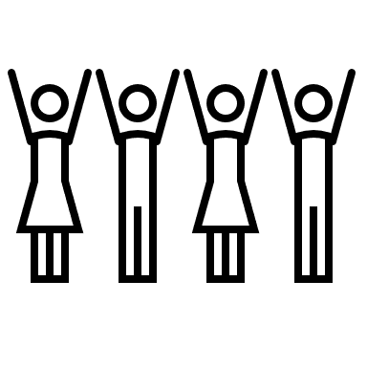 | When something is discrimination-free, it means that nobody is left out.

 | We want to make Geelong more accessible and inclusive for people with disability.
 | We know that environments and attitudes are some of the biggest barriers for people with disability.
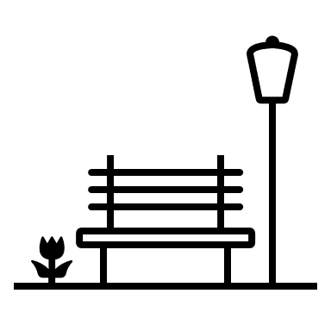 | Environments are places in our city, such as:  - where you live  - where you work  - where you meet friends
 | Attitudes are what people:  - think  - feel  - believe
 | Barriers are things that stop you from doing something you want to do.

 | We want to take away these barriers.
 | We have done some things before to take away barriers.
 | There are more things that are barriers. We don’t know what they are.
 | We want to ask you what the barriers are.
 | We also want you to tell us how we can help take away barriers.

Questions to think about
 | We have three questions that we want you to answer:
 | - What have we done in the last five years that has made Geelong more accessible for people with disability?
 | - What is the most important thing we could do to make Geelong more accessible for people with disability?
 | - What are other things that we could do to make Geelong more accessible for people with disability?
 | Your answers will help us understand what we need to do.
 | On the next page we tell you where you can give us your answers.
How to share what you think
 | There are many ways that you can tell us what you think.
 | You can meet us in person at a meeting. You can sign up for meetings here: https://geelong.link/AIAP
 | You can tell us your ideas in a survey on the “Have Your Say” website https://geelong.link/AIAP
 | You can phone us on 0422 718 686 or  03 5272 5272.

Contact us
 | 0422 718 686 or 03 5272 5272
@ | ccadmin@geelongcity.vic.gov.au
 | Community Inclusion Unit  City of Greater Geelong,  Wadawurrung Country,  PO Box 104,  Geelong VIC 3220
 | This document was made by ARTD Consultants.

