project background
This project was undertaken to refresh and strengthen the City of Greater Geelong’s youth services brand, ensuring it is more visible, accessible and relevant to young people aged 12 to 25. The project responds directly to findings from the 2025 Geelong Youth Survey, which identified that many young people were unaware of available programs and opportunities, or found it difficult to access timely and youth-friendly information.
Advice from the 2025 Youth Council Advisory Committee reinforced these findings, highlighting the need for clearer communication, improved use of digital platforms, and increased opportunities for young people to be involved in shaping how services are designed and promoted. Together, this evidence demonstrated a clear need to improve how the City’s youth services are presented and communicated, and to develop a more cohesive and recognisable identity that better reflects the needs and experiences of young people in Greater Geelong.
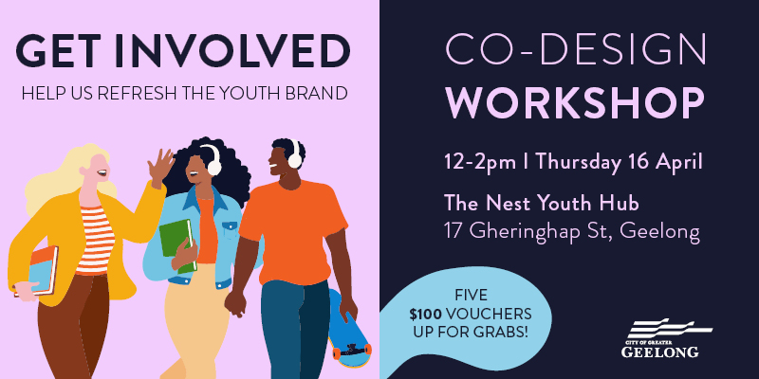
The purpose of the project is to co-design a contemporary youth services brand and identity that makes it easier for young people to understand what is available, connect with services, and participate in programs and events. Key objectives include demonstrating that the City is responsive to and genuinely values youth voice, strengthening relationships with young people, increasing participation in youth services, and improving overall awareness and accessibility for both young people and the wider community.
HOW WE ENGAGED



surveys completed via Have Your Say (HYS)
232
10
42 DAYS
of engagement
Schools visited by the Youth Development Unit
1 youth co-design workshop

19 young people participated in the co-design workshop

DATA METHODOLODY
The engagement adopted a mixed-method approach, combining both quantitative and qualitative data to ensure a robust and evidence-based outcome. Existing data from the 2025 Geelong Youth Survey provided a strong foundation, offering extensive quantitative insights supported by qualitative feedback from young people across the municipality.
New data was collected throughout the engagement period using a combination of online and face-to-face methods. This included structured survey responses, interactive feedback tools, and detailed qualitative insights gathered through workshops and direct engagement activities. The survey component captured both closed and open-ended responses, allowing participants to share preferences and ideas related to visual identity, tone, language, and communication.
Qualitative data was further strengthened through a co-design workshop and in-person engagement via schools and youth hubs, enabling deeper exploration of young people’s perspectives and experiences. This ensured the final dataset reflected not only broad trends but also the nuances of how young people engage with and interpret brand identity. The outputs of this methodology include a strong dataset from surveys and workshops, along with an engagement report summarising key findings and demonstrating how feedback will inform the project outcomes.
ENGAGEMENT TOOLS AND TECHINQUES
A range of engagement tools and techniques were used to ensure broad participation from young people and to capture diverse perspectives across Greater Geelong. Central to the engagement was the City’s Have Your Say (HYS) platform, which acted as the primary online hub for the project. This platform hosted project information, a glossary of terms, Frequently Asked Questions (FAQs), an online survey, interactive engagement tools, and options for participants to register for further involvement, including co-design workshops.
The online survey was a key tool, designed to be accessible and youth-friendly, taking between five and ten minutes to complete. It included a mix of multiple-choice and open-ended questions exploring brand voice, tone, visual identity, and communication preferences. Additional online tools, such as an ideas board, enabled participants to share visual inspiration, stories and creative input in a moderated environment.
Face-to-face engagement complemented the online approach, ensuring inclusivity and improved reach among different cohorts of young people. This included a facilitated youth co-design workshop, which provided an opportunity for in-depth collaboration and creative exploration of brand concepts and ideas. Engagement was also delivered through school visits, youth hubs and mobile outreach activities, enabling informal and accessible conversations with young people in familiar settings.
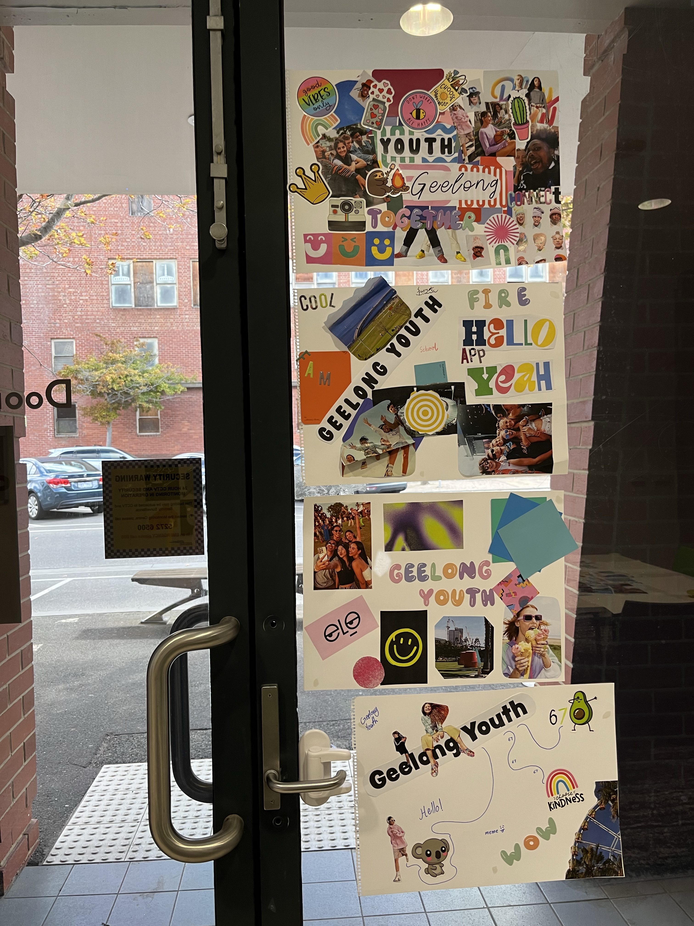
These methods were supported by promotion via digital and social media channels, along with partnerships with schools, local youth services and networks to maximise awareness and participation. Overall, the engagement approach was inclusive, flexible and responsive, meeting young people where they are and providing multiple accessible pathways for participation.
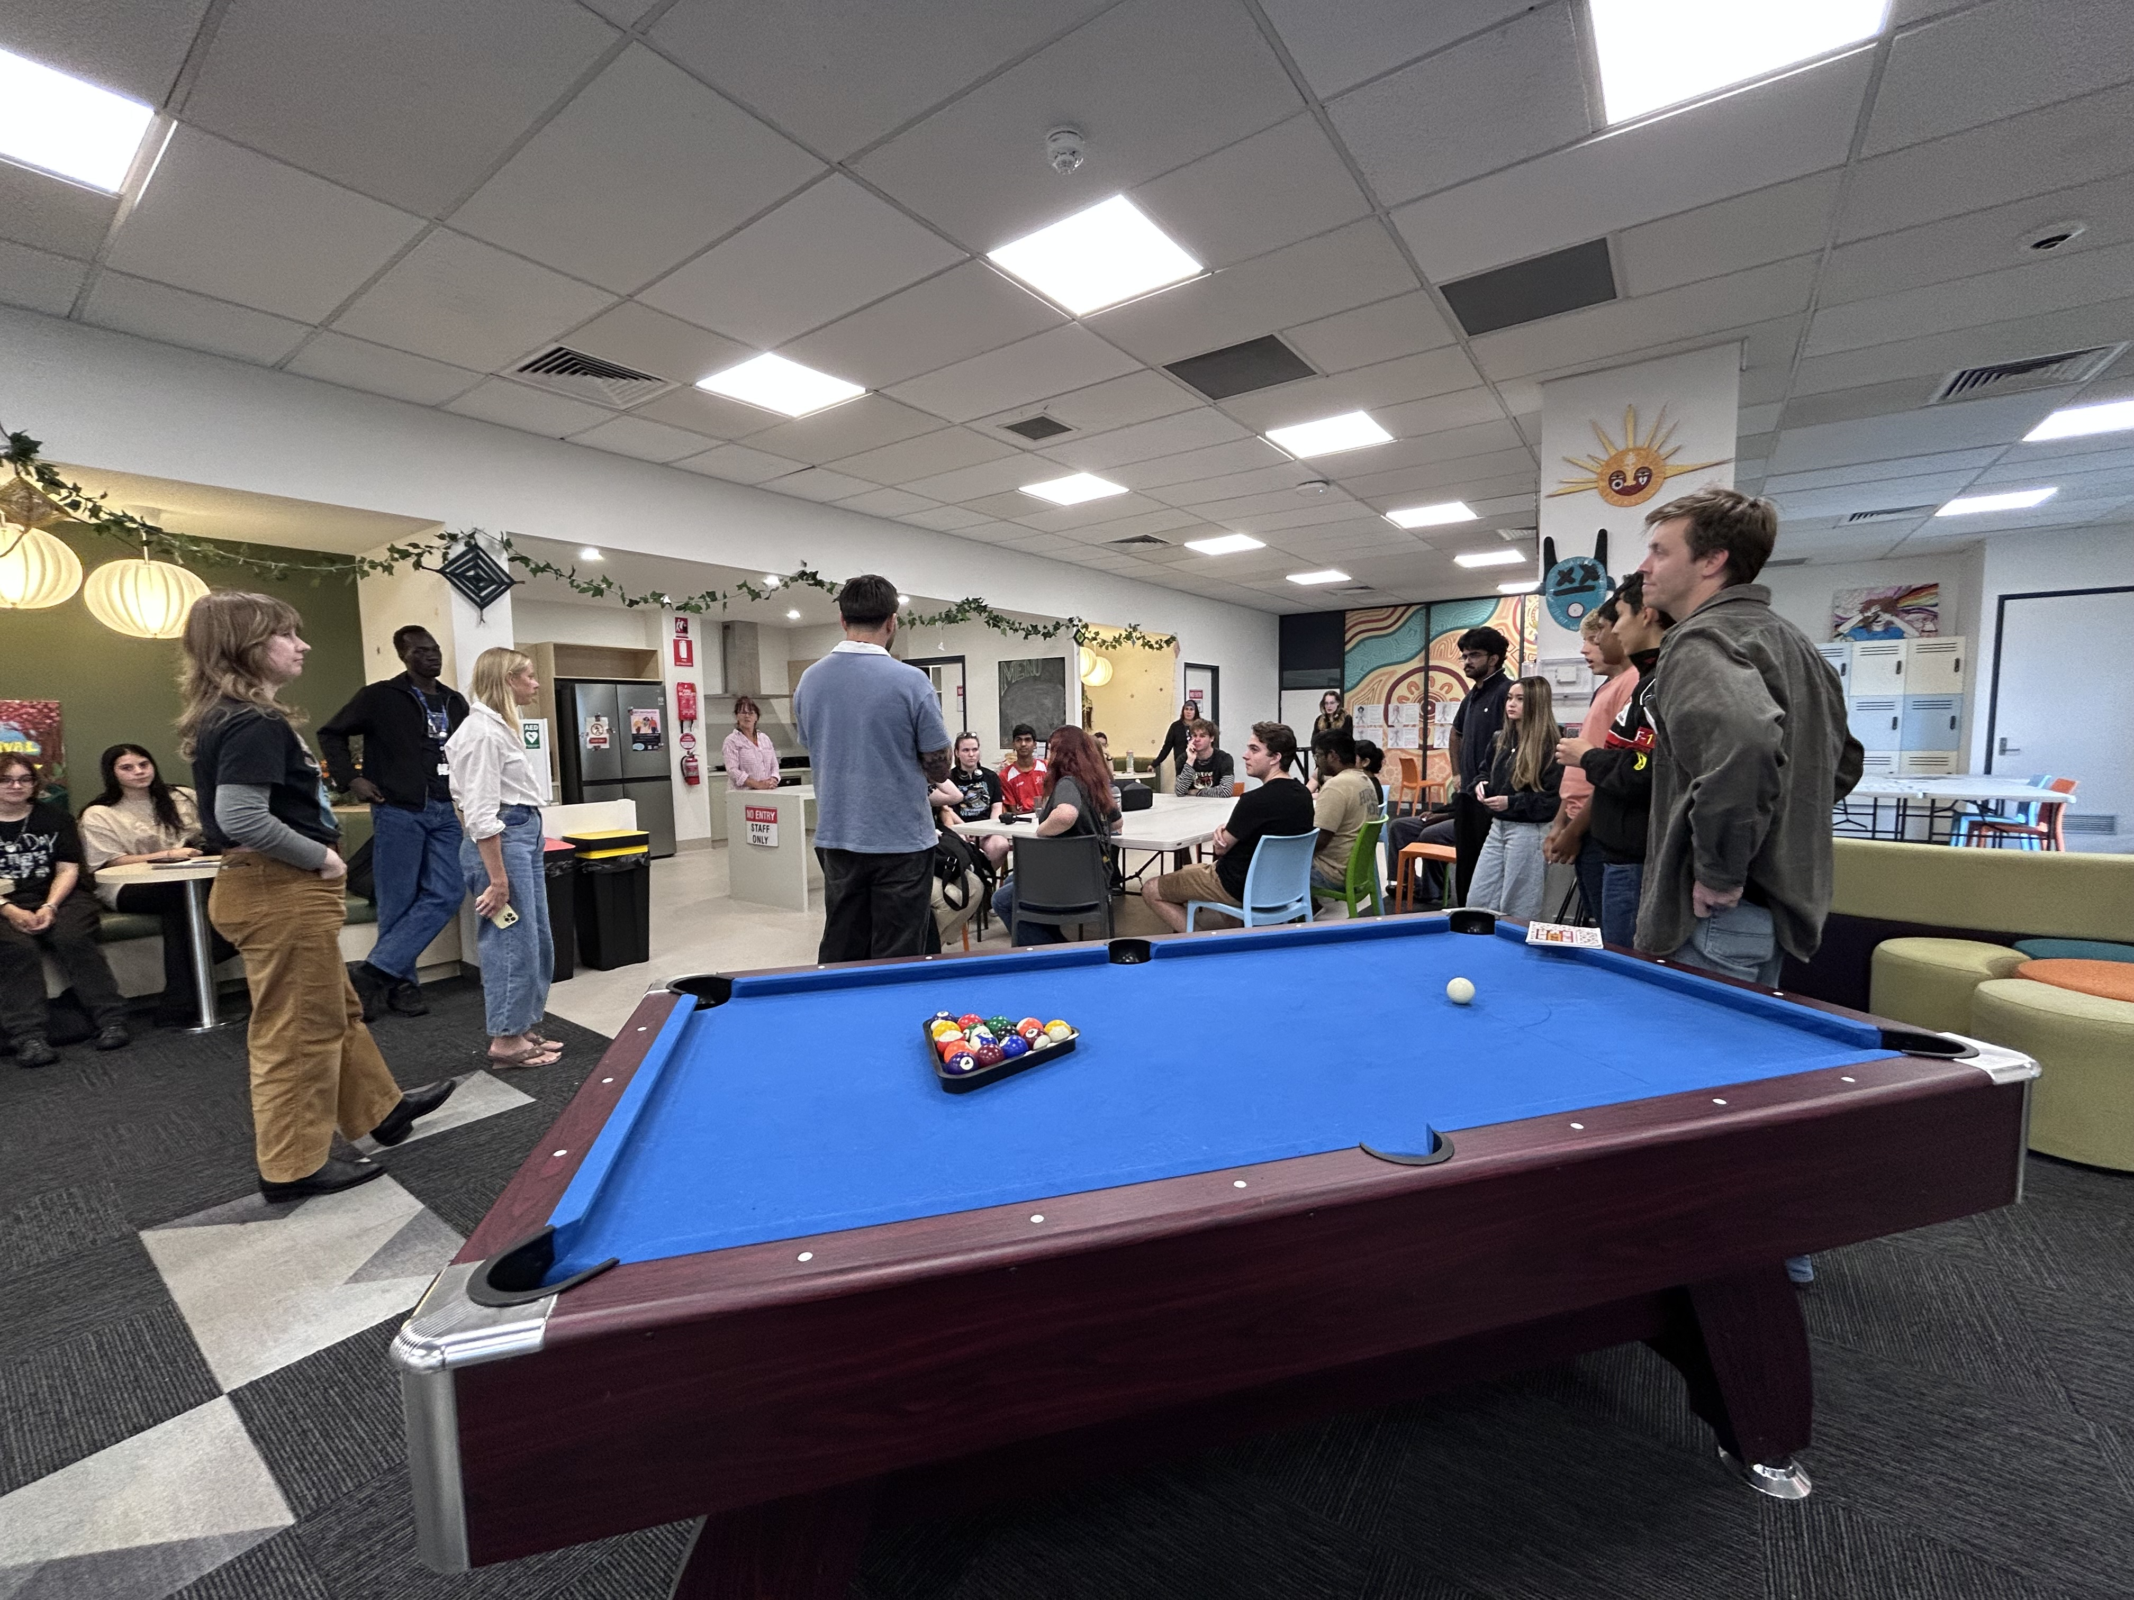

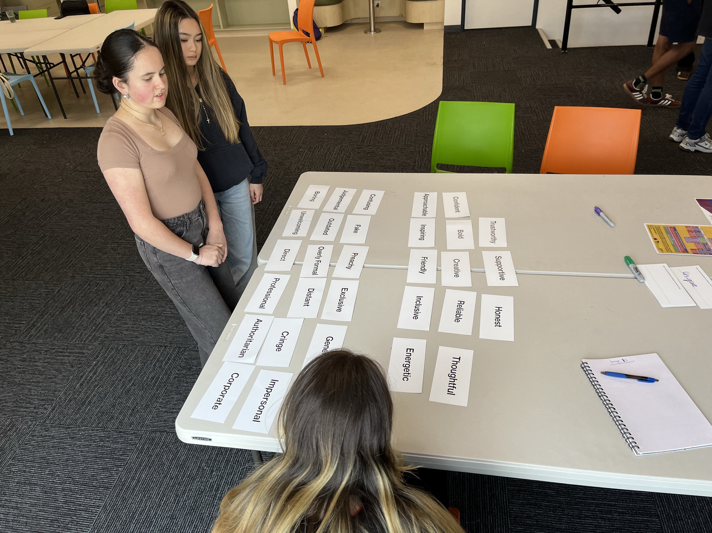
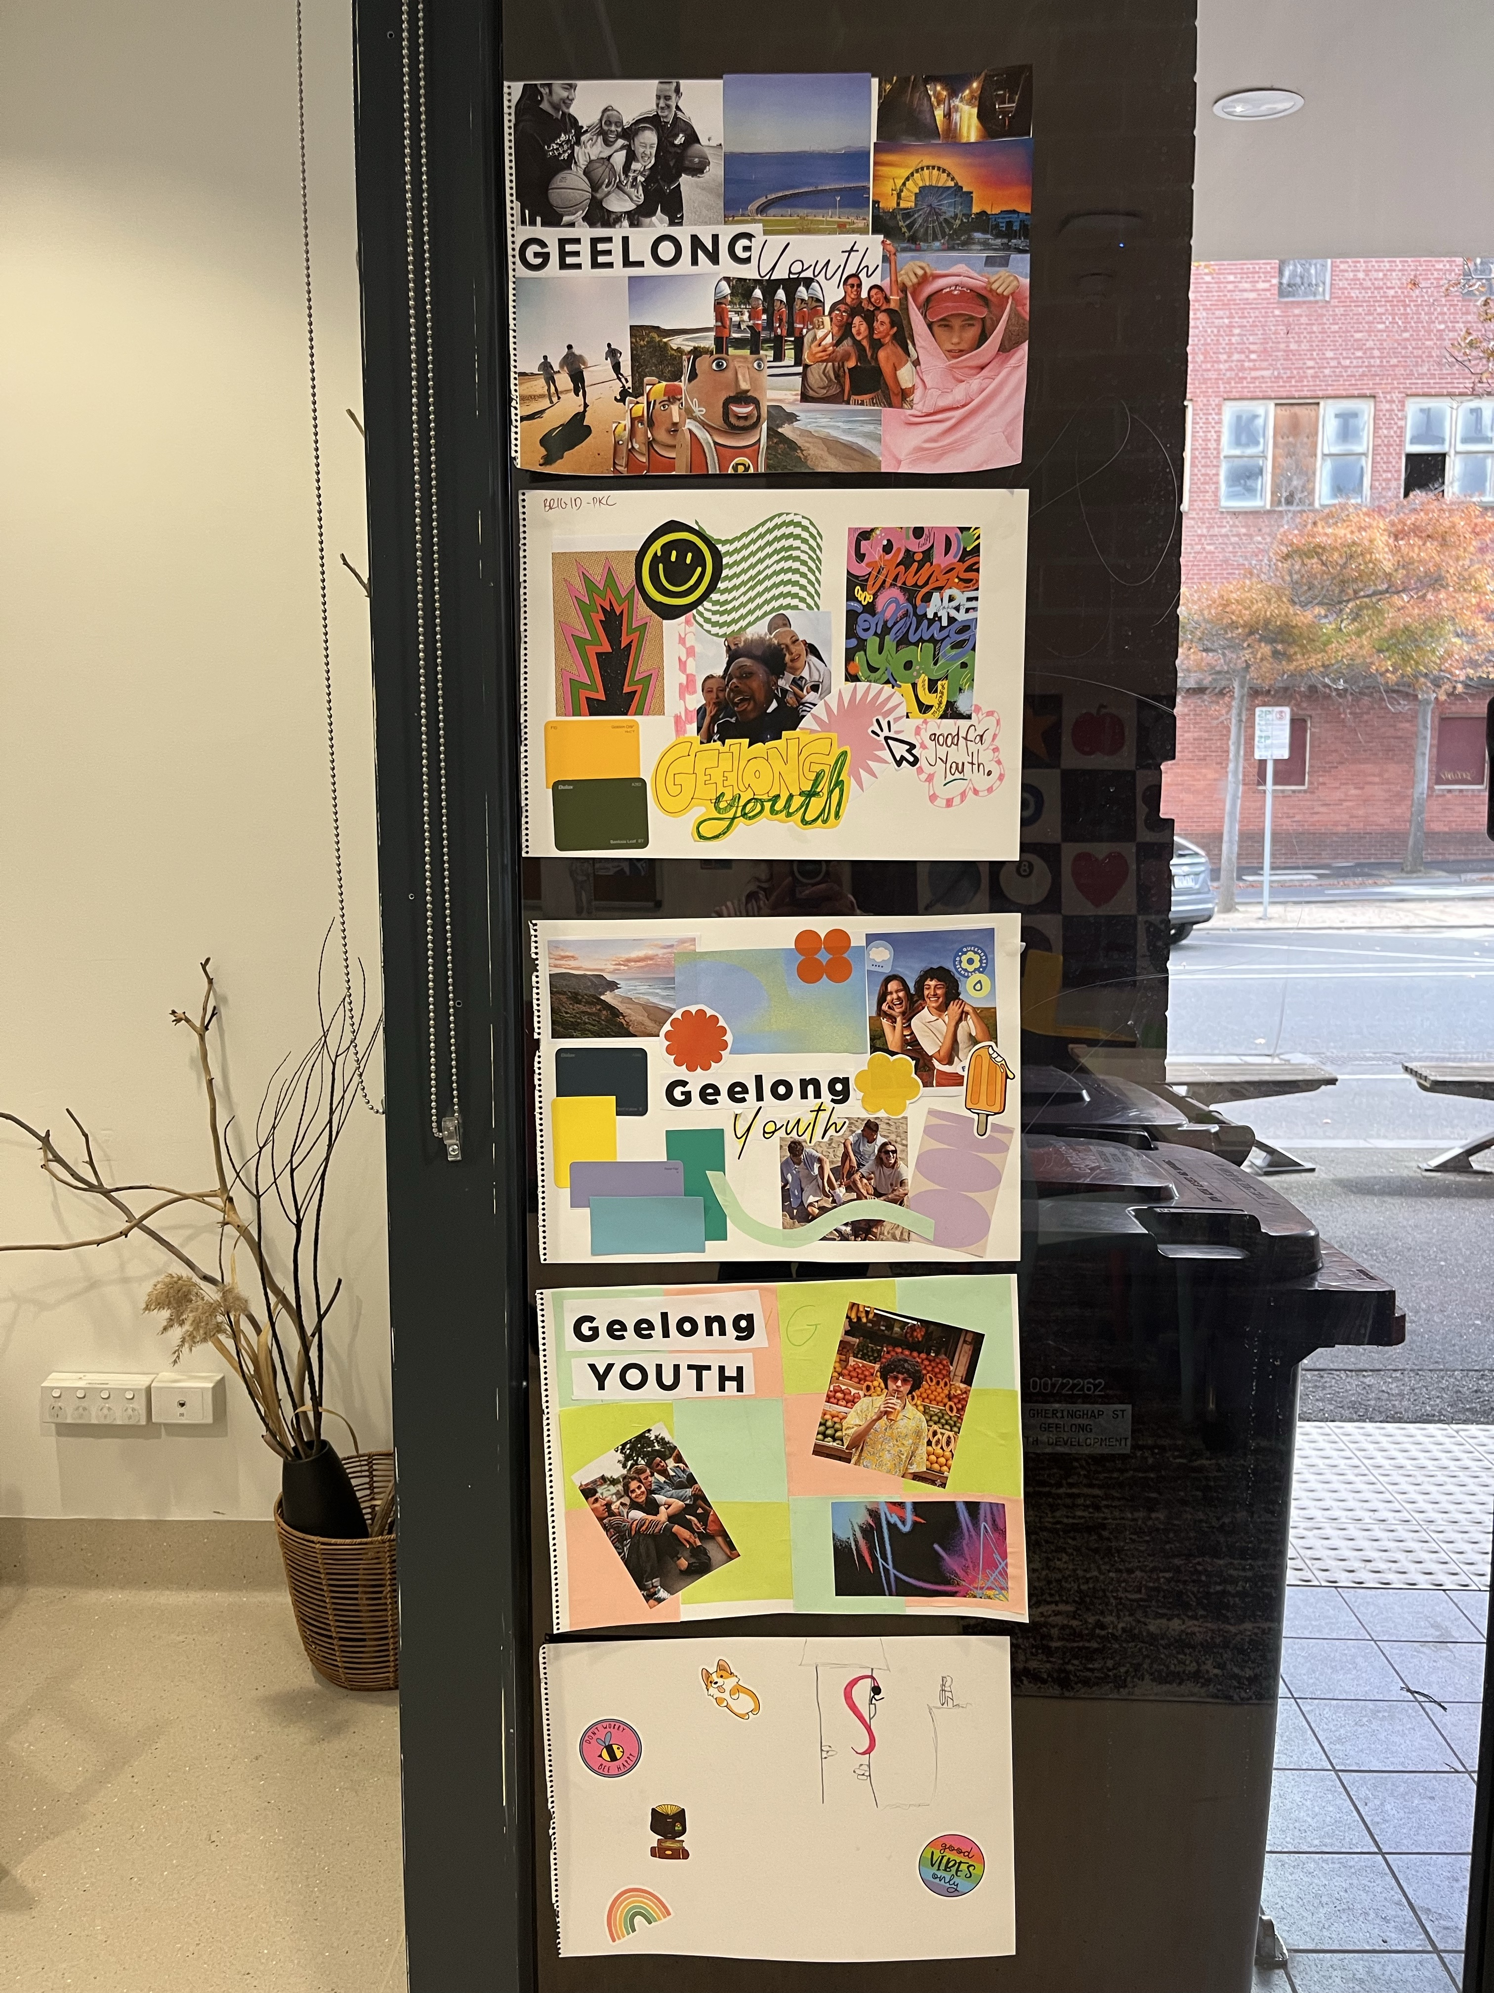

HOW WE ENGAGED
Have Your Say Online Portal  Yoursay.geelongaustralia.com.au | An online Have Your Say (HYS) project page was developed to provide clear, accessible information about the project, outline how young people could get involved, and encourage participation.
Survey (online and hardcopy) | The online survey was open from 16 March to 26 April 2026. Survey questions were developed in consultation with Paul Kelly Creative (PKC) and were designed to be engaging, youth-friendly and easy to understand and complete.
GATHER TOOL | Young people were also invited to interact with the ideas board and upload images of things they had created or seen that inspired them, providing additional visual input to inform the development of the youth brand.
SCHOOL ENGAGEMENT | Lunchtime visits were conducted at Indie School Geelong, Northern Bay College (Year 9), Lara Secondary College, Northern Bay College (VCE/VM), The Gordon TAFE, North Geelong Secondary College, Kardinia International College, St Joseph’s College, Belmont High School and Bellarine Secondary College, providing opportunities to engage directly with young people in familiar settings and promote participation in the project.
CO-DESIGN WORKSHOP | The workshop was held at The Nest Youth Hub on Thursday 16 April 2026 during the school holidays. It was facilitated by the team at PKC and supported by staff from the Youth Development Unit, with a total of 19 young people actively participating in the workshop and activities.
YOUTH COUNCIL PRESENTATION | Presentation to the 2026 Youth Council Advisory Committee was held on Monday 2 March 2026 to provide an overview of the project background and purpose, and to encourage members to promote the opportunity and support peer participation in the engagement process.
SOCIAL MEDIA | Multiple posts were shared across both Youth Development Unit and Corporate social media channels to promote the project, including general awareness posts and targeted content to promote the co-design workshop and encourage young people to register.
LOCAL YOUTH NETWORKS | The engagement was promoted via email to local youth services and organisations, encouraging them to share the opportunity with young people connected to their service and support broader participation.

COMMUNICATIONS
Engagement was promoted through a mix of digital and in-person communications, with the Have Your Say (HYS) page serving as the central hub for participation. All promotional activity directed young people to complete the online survey, share ideas or register for the co-design workshop.

A mixed-methods approach was used to maximise reach and accessibility. While social media was a key channel, access limitations for some younger age groups meant a single platform was not sufficient. Using a combination of online, print and face-to-face methods ensured engagement opportunities were visible and accessible to a diverse youth audience.

Social media platforms including Facebook and Instagram were used to promote the project, share key dates and encourage participation, particularly by directing traffic to the HYS page and promoting the co-design workshop. These channels also helped reach parents, carers, services and community stakeholders who follow @GeelongYouth, extending the reach beyond young people themselves.

This was supported by broader communications including newsletters, stakeholder outreach and promotion through schools and youth services, encouraging partners to share the opportunity within their networks. Printed materials with QR codes were distributed across youth hubs, schools and community locations, and hard copy surveys were made available. In-person promotion through school visits, youth hubs and community settings further strengthened awareness and supported participation through direct engagement with young people.

Geelong Youth social media – Survey post on 19 March 2026
Views: 1,404
Reach: 473
Reactions: 17

Geelong Youth social media – Co-design workshop post on 26 March 2026
Views: 755
Reach: 357
Reactions: 11
Geelong youth social media – Co-design workshop post on 7 April 2026
Views: 673
Reach: 342
Reactions: 7

Corporate social media – Co-design workshop post on 16 March 2026
Reach: 2,447
Engagement: 52

Who we engaged with

A total of 251 young people contributed to the Youth Brand and Identity project, including 232 responses via the Have Your Say survey and 19 participants in the co-design workshop. Participation was primarily online, enabling broad input, while the workshop supported more in-depth discussion. The project was also presented to the 2026 Youth Council Advisory Committee prior to engagement to build awareness and encourage peer participation.

To further support awareness and participation, the Youth Development Unit undertook targeted outreach, including visits to ten secondary schools across Greater Geelong, as well as engagement with young people through site-based and mobile youth hubs including The Nest Youth Hub (central Geelong), The fOrT (Norlane) and Armstrong Creek Youth Hub. These activities promoted the project, built interest and encouraged young people to take part in the survey or workshop. The Youth Development Unit extends its thanks to all participating schools for supporting the project and enabling lunchtime engagement with students.

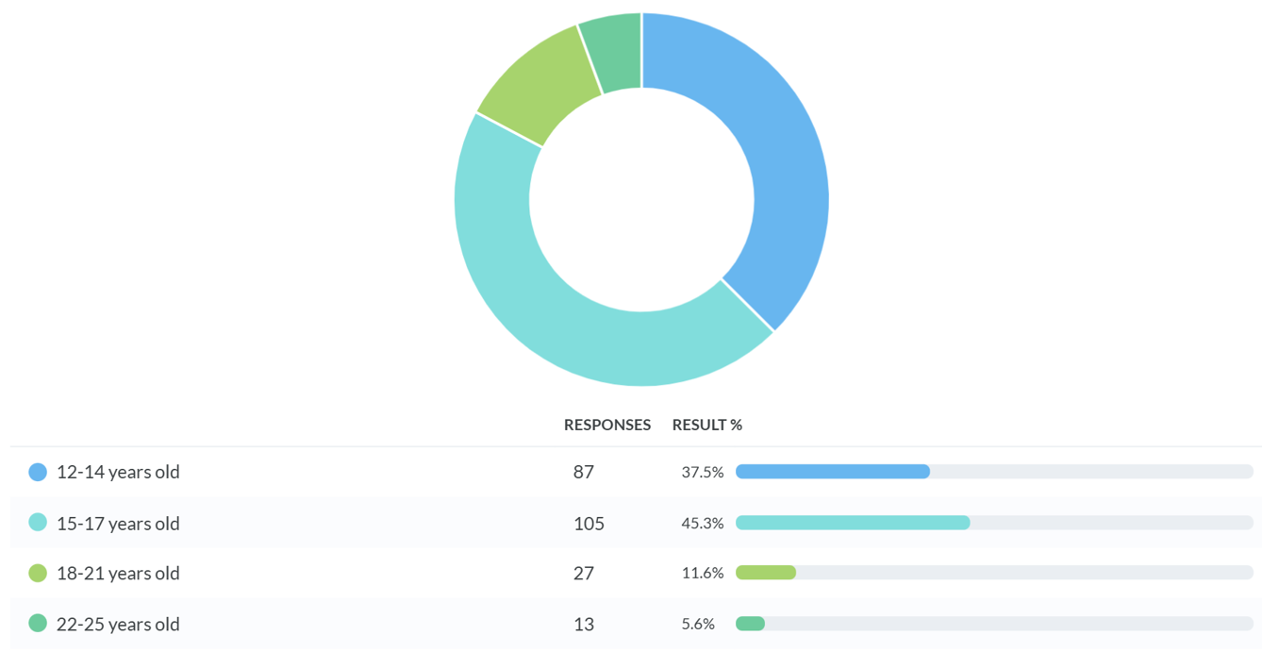
Demographic information collected through the survey was limited to age only, with the below graph providing a snapshot of participation.
WHAT WE HEARD
The HYS survey was designed to guide participants through a series of short, interactive questions that explored different elements of the youth brand and identity. The survey included a mix of multiple choice, sliders and open text responses, covering:
- Where young people currently hear about opportunities and events
- Preferred brand voice and tone
- Desired tone direction using sliding scale questions
- Perceptions of brand personality
- Language that feels authentic, empowering or inauthentic
- Preferences for colour direction
- Preferences for typography and style
- Preferences for imagery and visual style
- Overall brand direction
This structure supported both quantitative insights (through scaled and multiple-choice questions) and qualitative insights (through open responses).
SURVEY RESULTS & KEY THEMES
SECTION 1 – ABOUT YOU
Where do you usually find out about opportunities or events and which platforms do you use? (select all that apply)
Survey responses showed that young people most commonly find out about opportunities and events through friends (63.8%) and school (62.9%), alongside key digital platforms including Instagram (58.6%) and TikTok (50.8%), with family (51.7%) also playing a significant role.
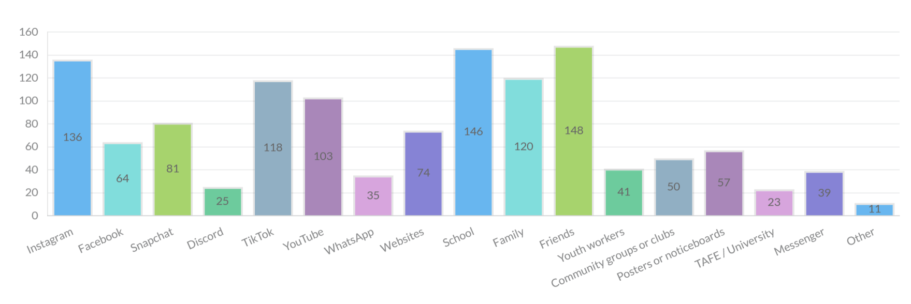
These findings highlight the importance of peer networks, school-based engagement and targeted use of social media platforms. They also reinforce the value of in-person promotion through schools and youth hubs, which aligned with how young people typically receive information and helped strengthen awareness of the project and encourage participation in the survey.
SECTION 2 – BRAND VOICE
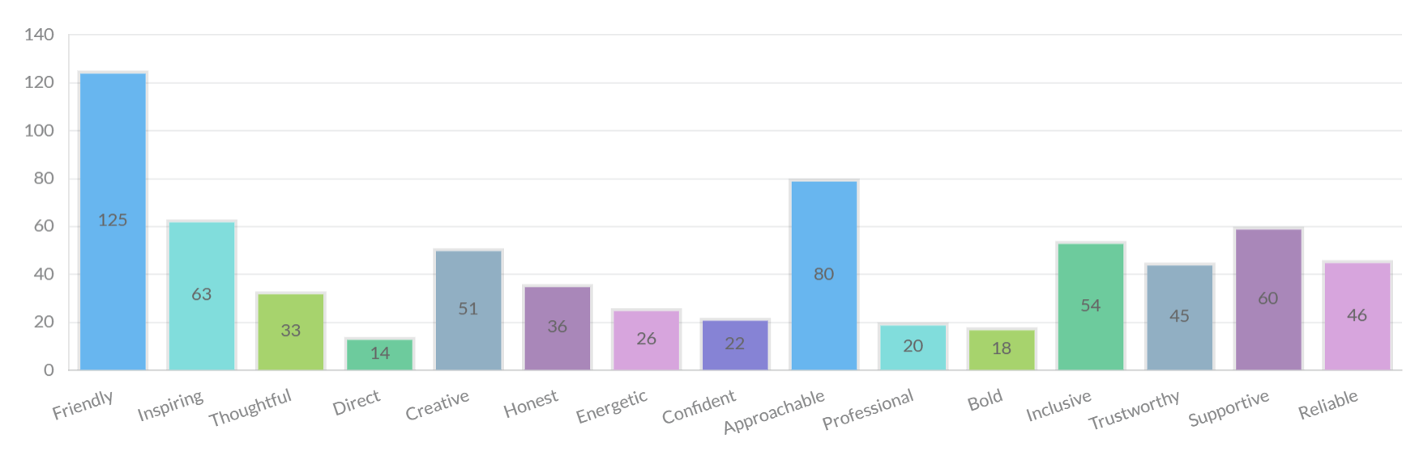
The way Geelong Youth sounds (through socials, our website, posters and how other people talk about it) will shape whether young people feel connected to it. We want to make sure the tone genuinely reflects what resonates with young people in our community. Select up to THREE words that describes how Geelong Youth should sound.
Survey responses showed strong alignment around the desired tone of the Geelong Youth brand. Young people consistently identified preferences for a voice that is friendly, approachable and supportive, reinforcing the importance of connection and relatability in how the brand communicates.
These findings are reflected in the creative interpretation, which emphasises a tone that feels human, conversational and community-led, rather than formal or institutional. Overall, respondents favoured communication that feels genuine and reflects how young people speak, with a clear expectation that the brand should feel built with young people, not for them.
SECTION 3 – TONE DIRECTION
Every brand sits somewhere between two different feelings. We'd like to understand where Geelong Youth should sit on each of the scales below. For each line, mark a point on the line that best reflects where you think Geelong Youth should be. Choose the middle option if you think it should be a balance of both or choose closer to one side if you feel strongly about it
Participants were asked to position the Geelong Youth brand across four key tone sliders to better understand how it should feel and communicate. Across all scales, feedback consistently indicated a preference for a balanced position, rather than leaning strongly to one extreme.
Serious ↔ Playful
Most responses were centred (56.9%), with a strong lean toward playful (38.8%). Very few selected serious (4.3%), indicating a preference for an engaging and expressive tone that still maintains meaning.
Professional ↔ Casual
Responses were evenly distributed, with 46.9% leaning casual and 44.8% selecting a balanced position. This shows a clear preference for communication that feels conversational and easy to connect with, while still maintaining clarity.
Safe and Welcoming ↔ Bold and Empowering
Responses were concentrated in the middle (46.1%), with a notable lean toward safe and welcoming (39.7%). Fewer responses selected bold and empowering (14.2%), reinforcing the importance of a tone that feels inclusive and supportive.
Government-led ↔ Community-led
There was a strong and clear preference for community-led (67.2%), with only 3.0% selecting government-led. This highlights a clear expectation that the brand should feel shaped by and representative of young people.
Overall, the results reinforce the need for a tone that is balanced, approachable and community-led, combining playfulness and creativity with clarity, trust and a strong sense of connection.
SECTION 4 – BRAND PERSONALITY
To help us define the personality of Youth Geelong, imagine it as a person. Who would it be? Choose up to TWO that best represent Geelong Youth.

Responses showed a strong and consistent preference for a personality that feels genuine, supportive and relatable, rather than formal or authority driven. The most selected options were “the youth worker who actually listens and gets it” (40.5%), “the hype friend who backs you 100%” (30.6%) and “the big brother or sister who’s got your back” (25.9%), highlighting the importance of connection, trust and understanding.

These results reflect a clear expectation that Geelong Youth should feel like someone who is easy to talk to, encouraging and present, combining practical support with positivity and energy. Young people are drawn to a personality that feels real and human, where they feel heard and supported, rather than spoken to or directed.

Overall, this reinforces the need for a brand that feels approachable, consistent and community-led, positioning Geelong Youth as a trusted presence in young people’s lives. The brand should ultimately feel like it is part of their world, not separate from it, ensuring it connects in a way that is meaningful and authentic.
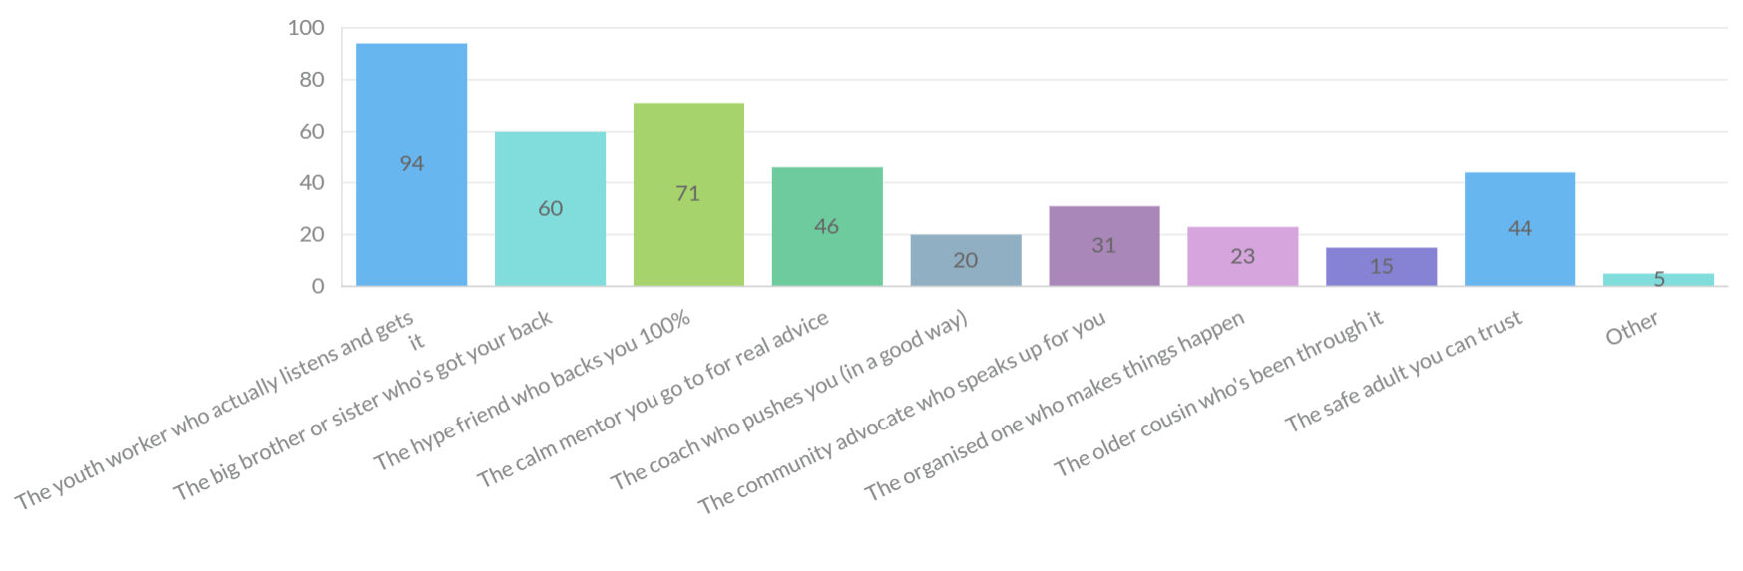
SECTION 5 – LANGUAGE AND EMPOWERMENT
The words a brand uses can make people feel confident or completely disconnected. We want to understand what language feels real and empowering to young people in Geelong. Please list a few words or short phrases for each of the below questions.
- What words feel confident?
- What words feel fake?
- What words feel safe?
- What words feel powerful?

Responses provided clear insight into the types of language that resonate with young people and those that create disconnection. Language that felt confident and empowering centred on encouraging, affirming and supportive phrases such as “you’ve got this”, “strong”, and “be proud”, reinforcing self-belief and resilience.

Language that felt safe focused on themes of inclusion, belonging and support, with common words including “safe”, “inclusive”, “welcome”, “community” and “you’re not alone”. This reflects a strong preference for communication that is non-judgemental, reassuring and builds trust.

In contrast, language that felt fake was often described as forced, overly corporate or reliant on inauthentic slang or trends. Words perceived as trying too hard to be “cool”, overly scripted or using exaggerated tone were widely seen as disengaging.

Overall, the findings highlight a clear preference for language that is genuine, conversational and human, reinforcing the need for the brand to communicate in a way that feels authentic, respectful and connected to young peoples lived experiences.

SECTION 6 – COLOUR DIRECTION
We’re exploring different colour directions for Geelong Youth. Colour plays a big role in how a brand feels. Whether it’s calm and soft, energetic and bold, or modern and dynamic. Which colour style best represents how Geelong Youth should look?
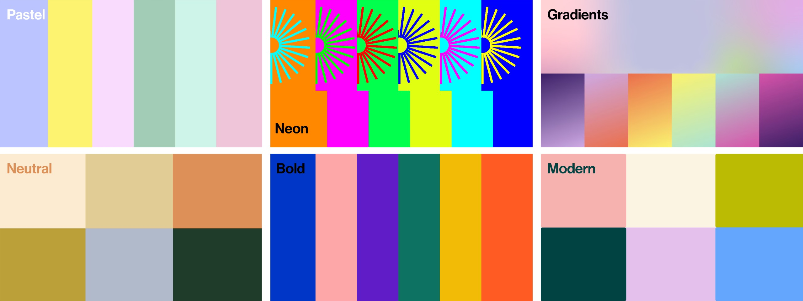

Responses indicated a clear preference for colour palettes that feel modern, fresh and visually engaging, with strong support for styles that balance energy with approachability. Gradient (33.2%) and pastel (23.7%) colour styles were most preferred, with modern tones also contributing to the overall direction.
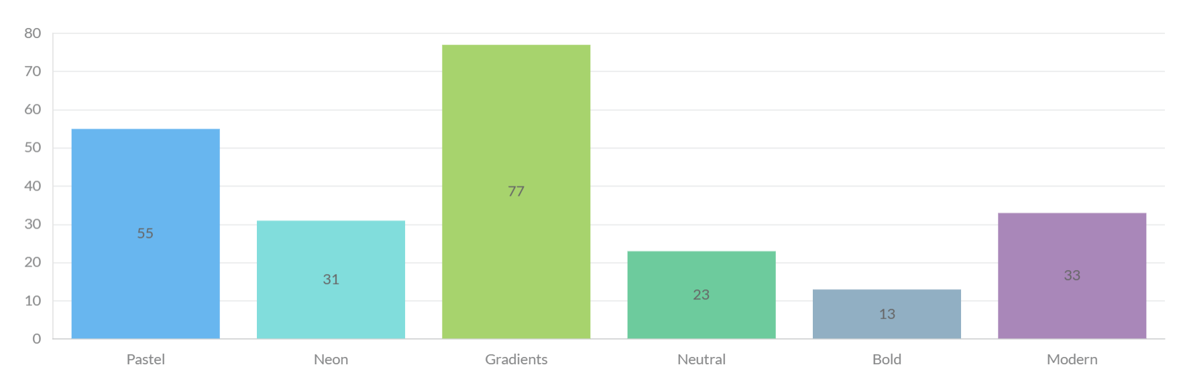
Feedback suggests young people value colour choices that feel youthful, dynamic and adaptable, while still maintaining a sense of calm and inclusivity. Colours that were perceived as too bright, overwhelming or overly intense were less favoured, with many participants indicating a preference for a balanced and cohesive palette that is easy to engage with across different platforms and settings.
SECTION 7 – TYPOGRAPHY & STYLE
The type of lettering (fonts & text styles) used in a brand can make it feel serious, creative, calm or bold. Below are examples of different typography directions. Please select the one that best reflects how you think Geelong Youth should look
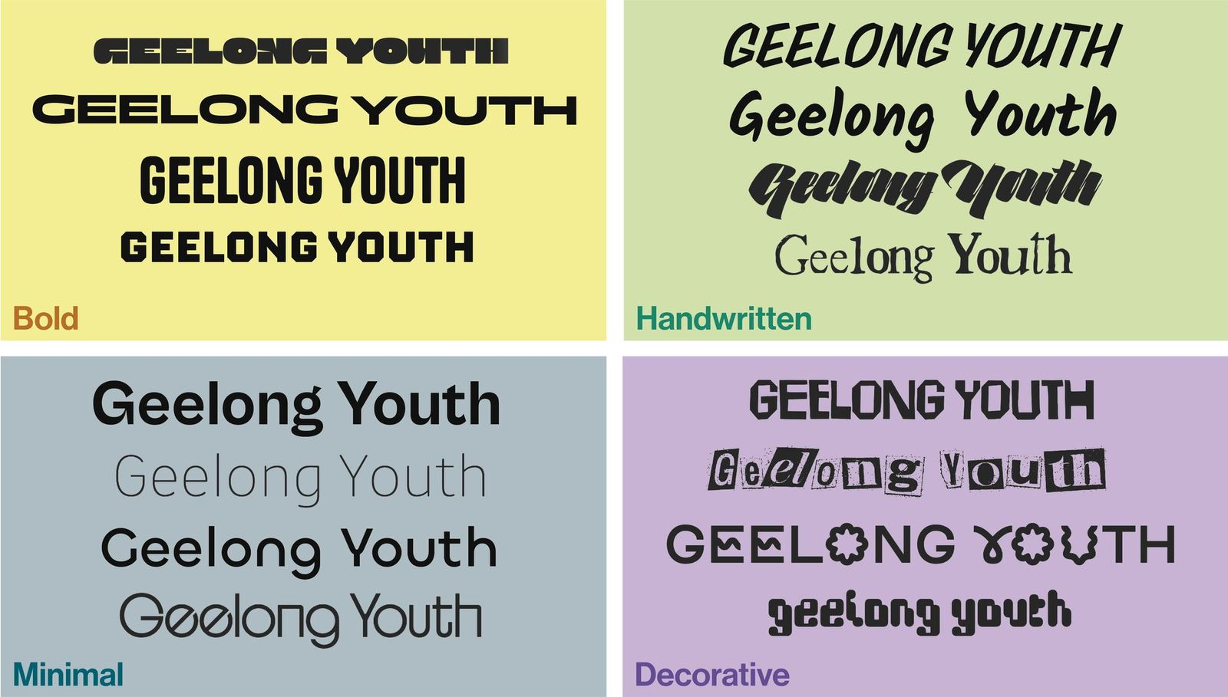

Responses indicated a clear preference for typography that balances personality with clarity, with strongest support for styles that feel handwritten (30.6%) and decorative (28.9%), alongside bold options that remain clear and legible.
Feedback suggests young people value typography that feels creative, expressive and personal, while still being easy to read and accessible. Handwritten and decorative styles were often associated with being more relatable, engaging and reflective of youth creativity, helping the brand feel less formal and more human.
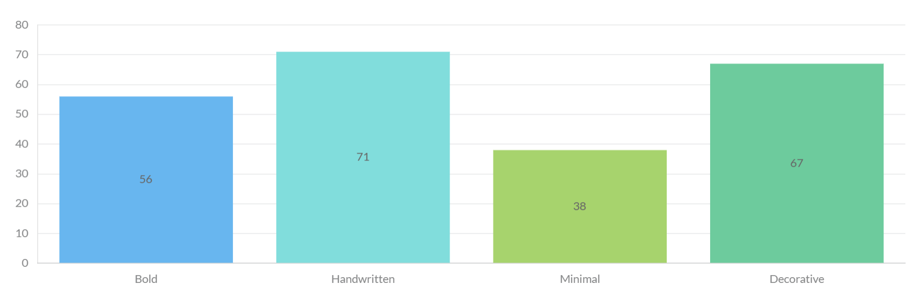
At the same time, clarity and readability remained important. Participants favoured styles that are visually interesting but still clear, simple and functional across different formats, reinforcing the need for a balanced approach that supports both expression and usability across digital, print and community settings
SECTION 8 - IMAGERY & VISUAL STYLE
The images and graphic elements used in a brand shape how real, creative or trustworthy it feels. Below are examples of different visual directions. Colour is not a focus here; it’s about the use of graphics elements (icons, illustrations, patterns, shapes) or imagery. Please select the one that best reflects how you think Geelong Youth should look.
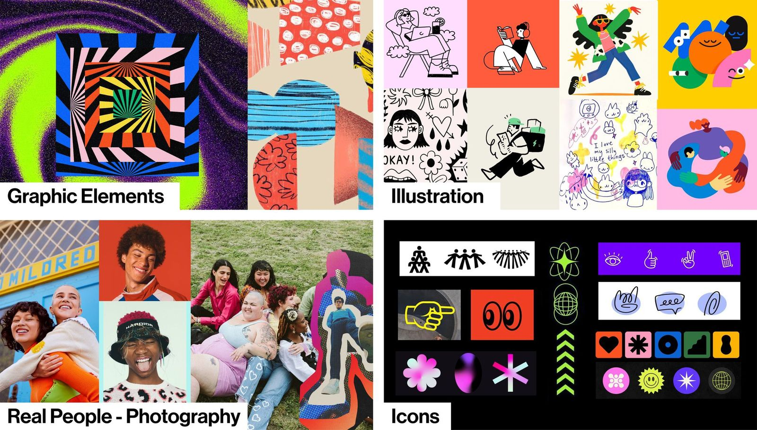

Responses indicated a clear preference for visual styles that are creative, expressive and inclusive, with strongest support for illustrations (38.4%), followed by real people photography (30.6%) and graphic elements.
Feedback suggests young people value imagery that feels relatable, engaging and representative of diverse experiences, with illustrations often seen as more flexible in reflecting a wide range of identities and stories. Illustrative styles were also associated with being more playful, creative and connected to youth culture, helping the brand feel less formal and more approachable.
At the same time, responses highlighted the importance of balance. While creativity is valued, visuals still need to feel authentic and grounded, with some preference for incorporating real imagery to maintain a sense of connection to the local community.
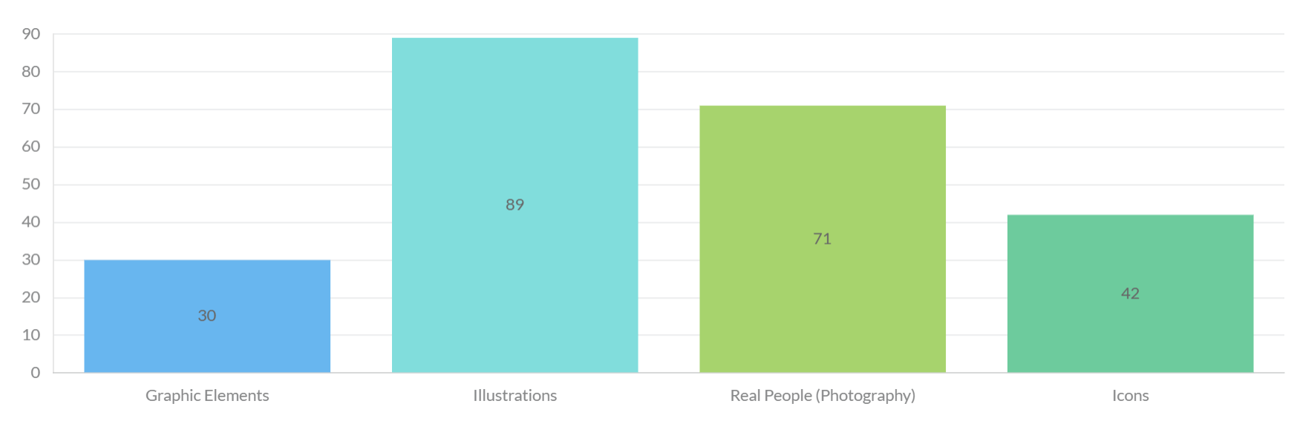
Overall, the findings reinforce the need for a blended visual approach, combining illustration, graphics and real-world imagery to create a brand that is inclusive, engaging and adaptable across different platforms and audiences.
SECTION 9 – BRAND IN ACTION
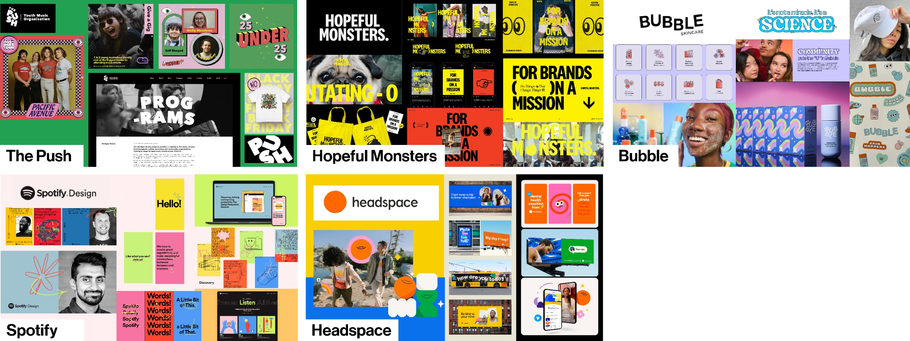
A brand is more than just a logo it is the complete identity, how it looks, feels and expresses its personality. Which brand direction best represents how Geelong Youth should show up?
Responses showed a clear preference for a brand direction that is modern, engaging and familiar, with the Spotify-inspired concept receiving the highest level of support (37.1%), followed by other options with lower levels of preference.
Feedback indicated this direction resonated because it felt easy to navigate, visually appealing and not overly cluttered, with a balance of structure and creativity. Participants described it as engaging without being overwhelming, and reflective of platforms they already use and understand.
Overall, these findings reinforce the importance of a brand that is contemporary, intuitive and user-friendly, supporting a look and feel that connects with young people’s everyday digital experiences while remaining clear, accessible and visually cohesive.
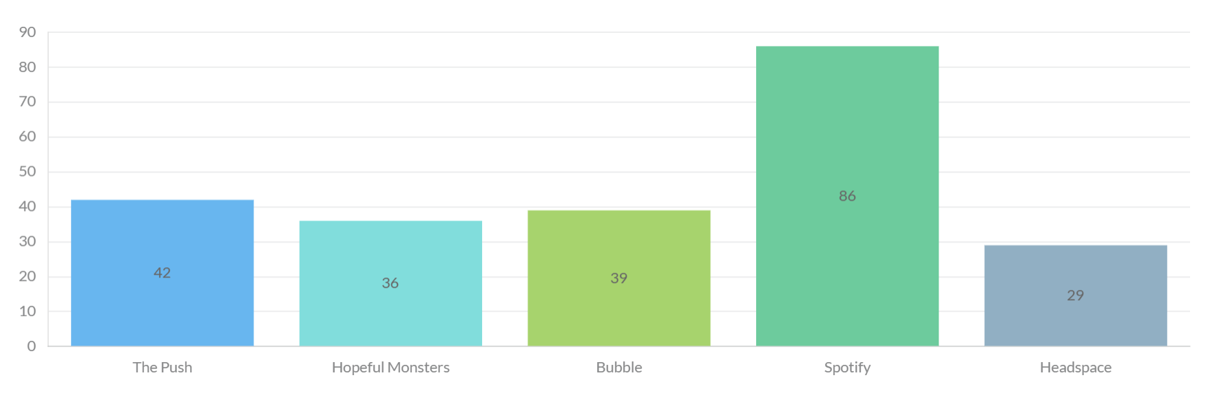
CONCLUSION
Feedback collected during the engagement period has been consolidated, summarised and provided to Paul Kelly Creative (PKC) to inform the development of two draft brand concepts. These concepts will reflect the key themes identified through engagement and will be further tested with young people. The draft concepts will be presented to the Youth Council at their meeting on 13 July 2026 to gather additional feedback and insights.
Following this, the Youth Development Unit will review all feedback received and determine the preferred creative direction. This decision-making process will draw on both community input and project requirements, ensuring that young people’s voices meaningfully inform the outcome. The final youth brand is expected to be launched in the second half of 2026.
The City extends its sincere thanks to all young people who participated in this project and shared their ideas, perspectives and experiences throughout the engagement process. The Youth Development Unit values young people, their voices and opinions, and is committed to providing meaningful opportunities for participation and influence in shaping programs and services that impact them.

