The City Of
Greater Geelong

Northern and western geelong Growth Areas

  - DRAFT Strategic Assessment
  - funding Program

November 2025

Contents
1. Introduction 3
Report Structure 3
2. Conservation commitments and measures 4
Conservation commitments and measures 5
3. Calculation of contributions 8
EPBC approval 8
Biodiversity levy area 8
Project costs 12
Biodiversity Levy 15
4. Administration and Implementation 16
Implementation under the EPBC ACT and coordination with the Victorian planning system 16
Timing for payment of levy liability 20
Works-in-kind, land in kind and offsets 21
Credit for over provision 21
Credit for early provision 21
Funds administration 21
Indexation 22
Review period 22
Monitoring impacts 23
Appendices 25
Appendix 1: Breakdown Of Costs 25
Appendix 2: External Offset Information 31
Appendix 3: Land Budget by PSP 32

List of Figures
Figure 1: Relationship of Strategic Assessment components 4
Figure 2: General plan of biodiversity levy area 9

List of Tables
Table 1: Conservation commitments and measures funded by the Levy 5
Table 2: Share of costs to be applied per PSP 11
Table 3: Northern Growth Area project costs 12
Table 4: Western Growth Area project costs 14
Table 5: Estimated Western Growth Area Levy by precinct (levy subject to change as PSPs approved & costs updated) 15
Table 6: Estimated Northern Growth Area Levy by precinct (levy subject to change as PSPs approved & costs updated) 15

Introduction
The Northern and Western Geelong Growth Areas Strategic Assessment Funding Program (Funding Program) and resulting Biodiversity Levy (Levy) has been prepared by the City of Greater Geelong.
The Funding Program:
- Outlines the conservation land, offsets, resources, documentation and works that are required to give effect to the commitments of the endorsed Environment Protection and Biodiversity Conservation Plan (Plan), associated Commitments and Measures and Biodiversity Conservation Strategy.
- Directly responds to Commitment No. 17 in the Plan, by establishing the arrangements to fund the implementation of the Plan’s commitments and measures over the life of the Plan.
- Sets out a detailed framework within which development proponents will be required to make a financial contribution towards the recovery of costs associated with the implementation of the Plan’s conservation commitments and measures throughout the life of the Plan, or alternatively provide land, works or offsets which the approval holder accepts in lieu of the obligation to make a financial contribution.
- Directly responds to Commitment No. 12 in the Plan, by enabling the approval holder to request that a development proponent provide offsets in lieu of a financial contribution, to ensure that offset delivery occurs ahead of impacts within the Northern Geelong Growth Area.
- Ensures the costs of delivering the Plan’s conservation commitments to protect matters of national environmental significance (MNES) are shared equitably between development proponents.
- Provides certainty about how the Levy will be administered.
The City of Greater Geelong (the City) is the approval holder for the Plan. As approval holder, the City is responsible for:
- Ensuring the Plan’s outcomes are achieved and implementing the commitments and measures
- Ensuring regulated third-parties who undertake an approved action or any part of an approved action under the endorsed Plan take these actions in accordance with the Plan and implementation documents and with the Commonwealth approval conditions
- Taking reasonable steps to ensure regulated third-parties:
  - Are informed of any relevant requirements of the endorsed Plan and Commonwealth approval conditions that regulates or restricts the way in which the action is taken
  - Comply with the endorsed Plan and Commonwealth approval conditions
- Notifying Department of Climate Change Energy Environment and Water of any known non-compliances with conditions by third parties

Report Structure
The Funding Program comprises:
- Conservation commitments
- Calculating the contribution
- Administration and Implementation
- Appendices

Conservation commitments and measures
The strategic basis for the funding framework and this program is outlined in the Northern and Western Geelong Growth Areas (NWGGA) Strategic Assessment. The EPBC Plan outlines objectives, outcomes, commitments and measures to manage impacts to MNES. The relationship of the components and the documents is shown in Figure 1.
The commitments and measures in the Plan to protect MNES that are funded projects over the life of the Plan are outlined in Table 1.
The scope of the projects are detailed in Appendix 1.
The Funding Program uses a project identification system of project category and sequential number in its tables and plans.
The following types of projects are included in the Funding Program:
- Offsets - OF
  - Golden Sun Moth - GSM
  - Striped Legless Lizard – SLL
  - Natural Temperate Grasslands of the Victorian Volcanic Plains – NTG
- Conservation Areas – CA
  - Land – L
  - Conservation works - CW
- Plan implementation and governance - PI
  - Finance costs – F
  - Plan preparation costs – PC
  - Compliance – C
  - MERI Framework – M
The Funding Program does not include infrastructure items associated with a typical growth area that are delivered by a proponent or funded through a Development Contributions Plan (DCP) or Infrastructure Contributions Plan such as roads, community centres or drainage. A separate DCP will apply to each precinct subject to the Funding Program.
The Funding Program does not include amenity upgrades associated with the Cowies Creek and Moorabool River corridors. These amenities such as toilet blocks and shared paths will be funded through the requisite DCP for the Precinct Structure Plan (PSP) area. The riparian corridors for the Moorabool River and Cowies Creek are not included as land items in the Funding Program. These corridors are encumbered land, unsuitable for development and will be vested as part of the subdivision of the adjacent land as part of the progress of development.
Figure 1: Relationship of Strategic Assessment components
Components of the outcomes and funding framework

Description of each component
Commitments and Measures
EPBC Plan
Funding Program
Where each component is presented

The positive impacts or changes which will achieve the overall objectives
Outcomes
Measures
Commitments
The specific actions that will be undertaken to meet the commitments
EPBC Plan, BCS, Commitments and Measures
The direct results of implementing the measures which will achieve the outcomes
The projects to be funded to deliver the measures
EPBC Plan
The broad contribution to be achieved by implementing the EPBC Plan
Objectives
Funded Projects

Conservation commitments and measures
Table 1: Conservation commitments and measures funded by the Levy
Commitment | Description |  | ID |  |  | Projects
Conservation Areas
Northern Conservation Area | The Northern Conservation Area (NCA) will be established to protect and manage native vegetation and 77.7 ha of habitat for Striped Legless Lizard and 119.5 ha of habitat for Golden Sun Moth and and 125.3 ha of habitat potentially important for the recovery of Victorian Grassland Earless Dragon in perpetuity (Commitment 4 and 5) |  | NG_CA_L_1 |  |  | 165 Staceys Road as conservation land
 |  |  | NG_CA_L_2 |  |  | 195 Staceys Road as conservation land
 |  |  | NG_CA_L_3 |  |  | Part of 225 Staceys Road as conservation land
 |  |  | NCA_L_4 |  |  | Part of 135 Staceys Road as conservation land
 |  |  | NG_CA_L_5 |  |  | Part 870 Ballan Road as conservation land
 |  |  | NG_CA_L_6 |  |  | Part 550 Elcho Road as conservation land
 |  |  | NG_CA_CW_1 |  |  | Conservation contractors and works (NCA) 0-10 year period
Eastern Conservation Area | The Eastern Conservation Area (ECA) will be established in perpetuity to avoid and protect 6.7 ha of habitat for Natural Temperate Grassland (Commitment 6, 7) |  | NG_CA_CW_2 |  |  | Conservation contractors and works (ECA) 0-10 year period
Gully Avoidance Area | The gully avoidance area will avoid 3.4 ha of habitat for Striped Legless Lizard, 4.6 ha of habitat for Golden Sun Moth and 3.7 ha of Natural Temperate Grassland (Commitment 8) |  | NG_CA_CW_3
 |  |  | NG_CA_CW_4 |  |  | Conservation maintenance costs 10-30 year period
 |  |  | CA_CW_5 |  |  | Conservation staff (0.89EFT)
Cowies Creek Conservation Area | Managing the Cowies Creek Conservation Area as avoided land (Commitments 9, 10 and 11) |  | WG_CA_CW_3 |  |  | Conservation contractors and works (Cowies Creek) 0-10 year period
 |  |  | WG_CA_CW_2 |  |  | Conservation maintenance costs (Cowies Creek) 10-30 year period
 |  |  | CA_CW_5 |  |  | Conservation staff (0.11 of 1EFT)
External Offsets
Securing offsets | Offset sites will be established to meet specified targets.  (Commitment 16) |  | NG_OF_1_NTG |  |  | 7.3 ha of Natural Temperate Grassland
 |  |  | NG_OF_2_SLL |  |  | 253 ha of habitat for Striped Legless Lizard
 |  |  | NG_OF_3_GSM |  |  | 381.5 ha of habitat for Golden Sun Moth
Waterways
 | Specific mitigation measures will be implemented to minimise the indirect impacts of the development on MNES associated with waterways, riparian areas and wetlands. (Commitment 14,15) |  |  |  |  | To be confirmed at PSP stage
Plan implementation and governance
Monitoring, evaluation, reporting and improvement (MERI) program |  | Implementation of the Plan’s MERI framework over the life of the Plan (Commitment 24) |  | SH_PI_M_1 | MERI framework development and implementation
 |  |  |  | SH_PI_M_2 | Project management and administration costs (1 EFT)
Compliance |  | Implementation of the Plan’s compliance framework over the life of the Plan (Commitment 26) |  | SH_PI_C_1 | Compliance and education costs (1 EFT)
Plan preparation costs |  | Preparation of the Plan, BCS and SAR |  | SH_PI_PP_1
 |  | Technical studies to determine how avoid and mitigate potential downstream impacts as precincts are planned and developed (Commitment 15) |  | NG_PI_PP_2 | Technical study for Hovells Creek
 |  |  |  | WG_PI_PP_2 | Technical study for Moorabool River
 |  | Preparation of the conservation management plans for conservation areas (Commitment 5 and 4) |  | NG_PI_PP_4 | Conservation management plan for Northern Conservation Reserve
 |  |  |  | WG_PI_PP_5 | Conservation management plan for Cowies Creek Conservation Reserve
 |  |  |  | NG_PI_PP_6 | Preparation of Conservation management plan for Eastern Conservation Reserve
Finance costs |  | Costs associated with securing of the offsets package early during Plan implementation to ensure that the biodiversity benefits of protecting and managing MNES are realised as far in advance of impacts as possible (Commitment 13) |  | NG_PI_F_1 | Finance costs
 |  |  |  | NG_PI_F_2 | Compensation Costs (Land Acquisition)

Calculation of contributions

EPBC approval
- The Plan has been prepared to meet the requirements of the Environment Protection and Biodiversity Conservation Act 1999. Following endorsement and associated approvals under the EPBC Act, the Plan enables the development that is described in Chapter 4 of the Plan to proceed.
- The City is the approval holder for the Plan. As approval holder, the City has primary responsibility for implementing the Plan and ensuring the Plan’s outcomes are achieved and its commitments are delivered.
- The City is also responsible for ensuring third-parties who undertake an approved action under the endorsed Plan take these actions in accordance with the requirements of the Plan. The legislative framework also requires that third parties undertake relevant classes of action in accordance with the Plan.
- Development is approved under Part 10 of the EPBC Act through ‘classes of actions’ that represent the scope of development that may be undertaken in accordance with the Plan.
- There are five classes of actions that are included in the Plan:
- Urban and commercial development
- Industrial development
- Rural development
- Supporting infrastructure and services
- Environmental management
- These classes of actions are outlined in Chapter 4 of the Plan.
- Any person can undertake development within the Plan area and access the associated approval under Part 10 of the EPBC Act provided the following requirements are met:
- Development must fall within the classes of actions as defined in the Plan;
- Development must only occur within the development land as defined the Plan;
- Development must proceed in accordance with any Commonwealth conditions of approval;
- Development must proceed generally in accordance with the Plan, including the avoidance and minimisation, mitigation and offset requirements of the Plan;
- Developers must pay the biodiversity Levy outlined in this Funding Program; and
- Development must be registered in accordance with the developer registration system.

Biodiversity levy area
The area covered by the Plan is known as the Strategic Assessment Area. It covers 7,101 ha within the Victorian Volcanic Plains Bioregion. It includes:
- The entire Northern Geelong Growth Area (Northern Growth Area) as described in the Framework Plan which occurs in the Lovely Banks locality and covers 2,103.9ha
- The two northern precinct structure plans within the Western Geelong Growth Area (Western Growth Area) which covers 767.2ha and occurs in the Bell Post Hill and Batesford localities.
The Levy applies generally to the area shown in Figure 2. This is the ‘Levy Area’. Within the Levy Area there are separate levies for the Northern Growth Area and the Western Growth Area . The specific area that the Levy applies to in the Northern Growth Area is shown in Figure 3. Areas nominated for Future Residential Potential and Future Employment Potential in the Northern and Western Geelong Growth Areas Framework Plan August 2020 (NWGGA Framework Plan) have been excluded from the levy area as a land use change in these areas is not confirmed.
When preparing a PSP and calculating the levy per property the City will identify any areas that should be included or excluded from the land use budget and Levy calculation.
If land in the Levy Area is exempt from Part 10 of the EPBC Act and the commitments of the Plan then this land will be excluded from the Levy calculation. The exclusion of that land will occur at PSP approval.

Figure 2: General plan of biodiversity levy area
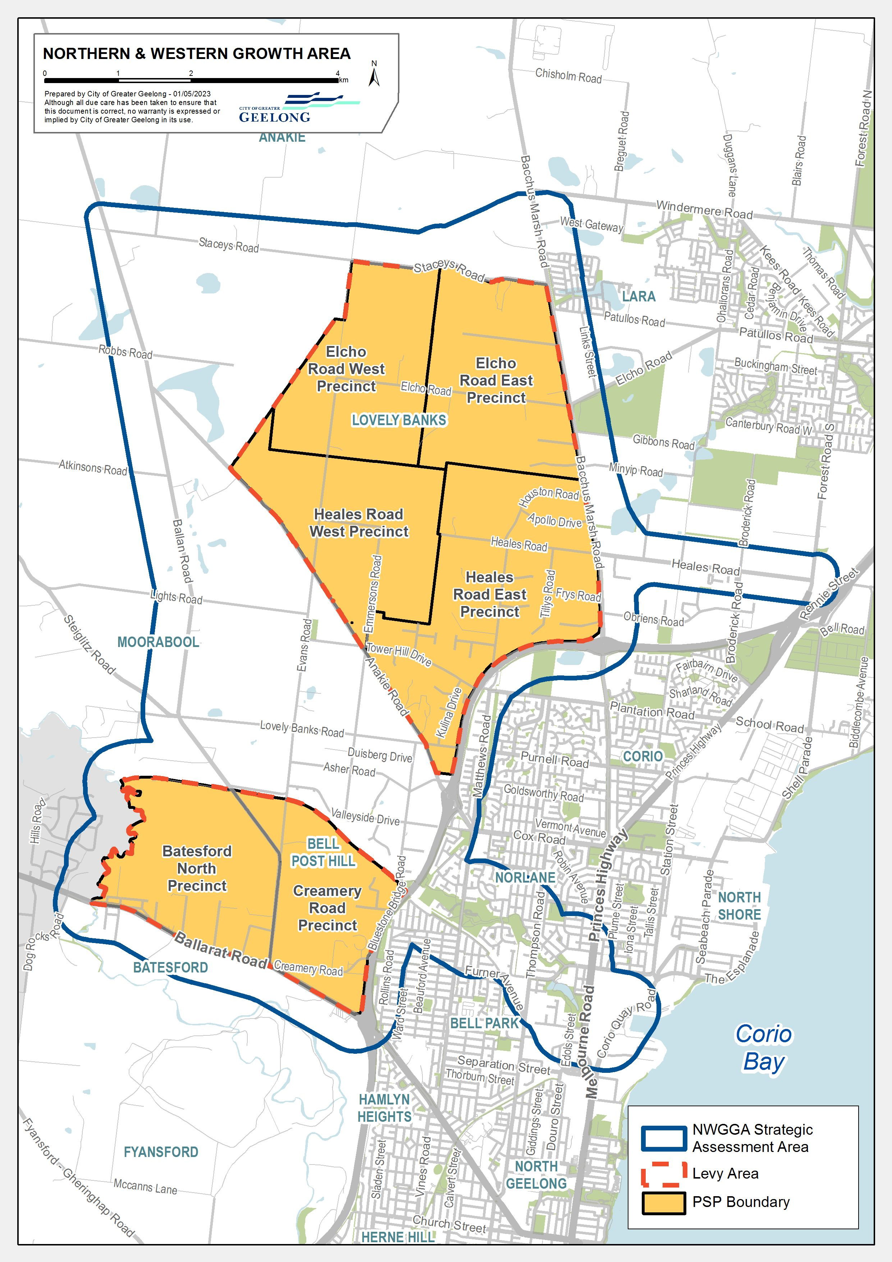

Figure 3 Specific plan of biodiversity levy area Northern Geelong Growth Area
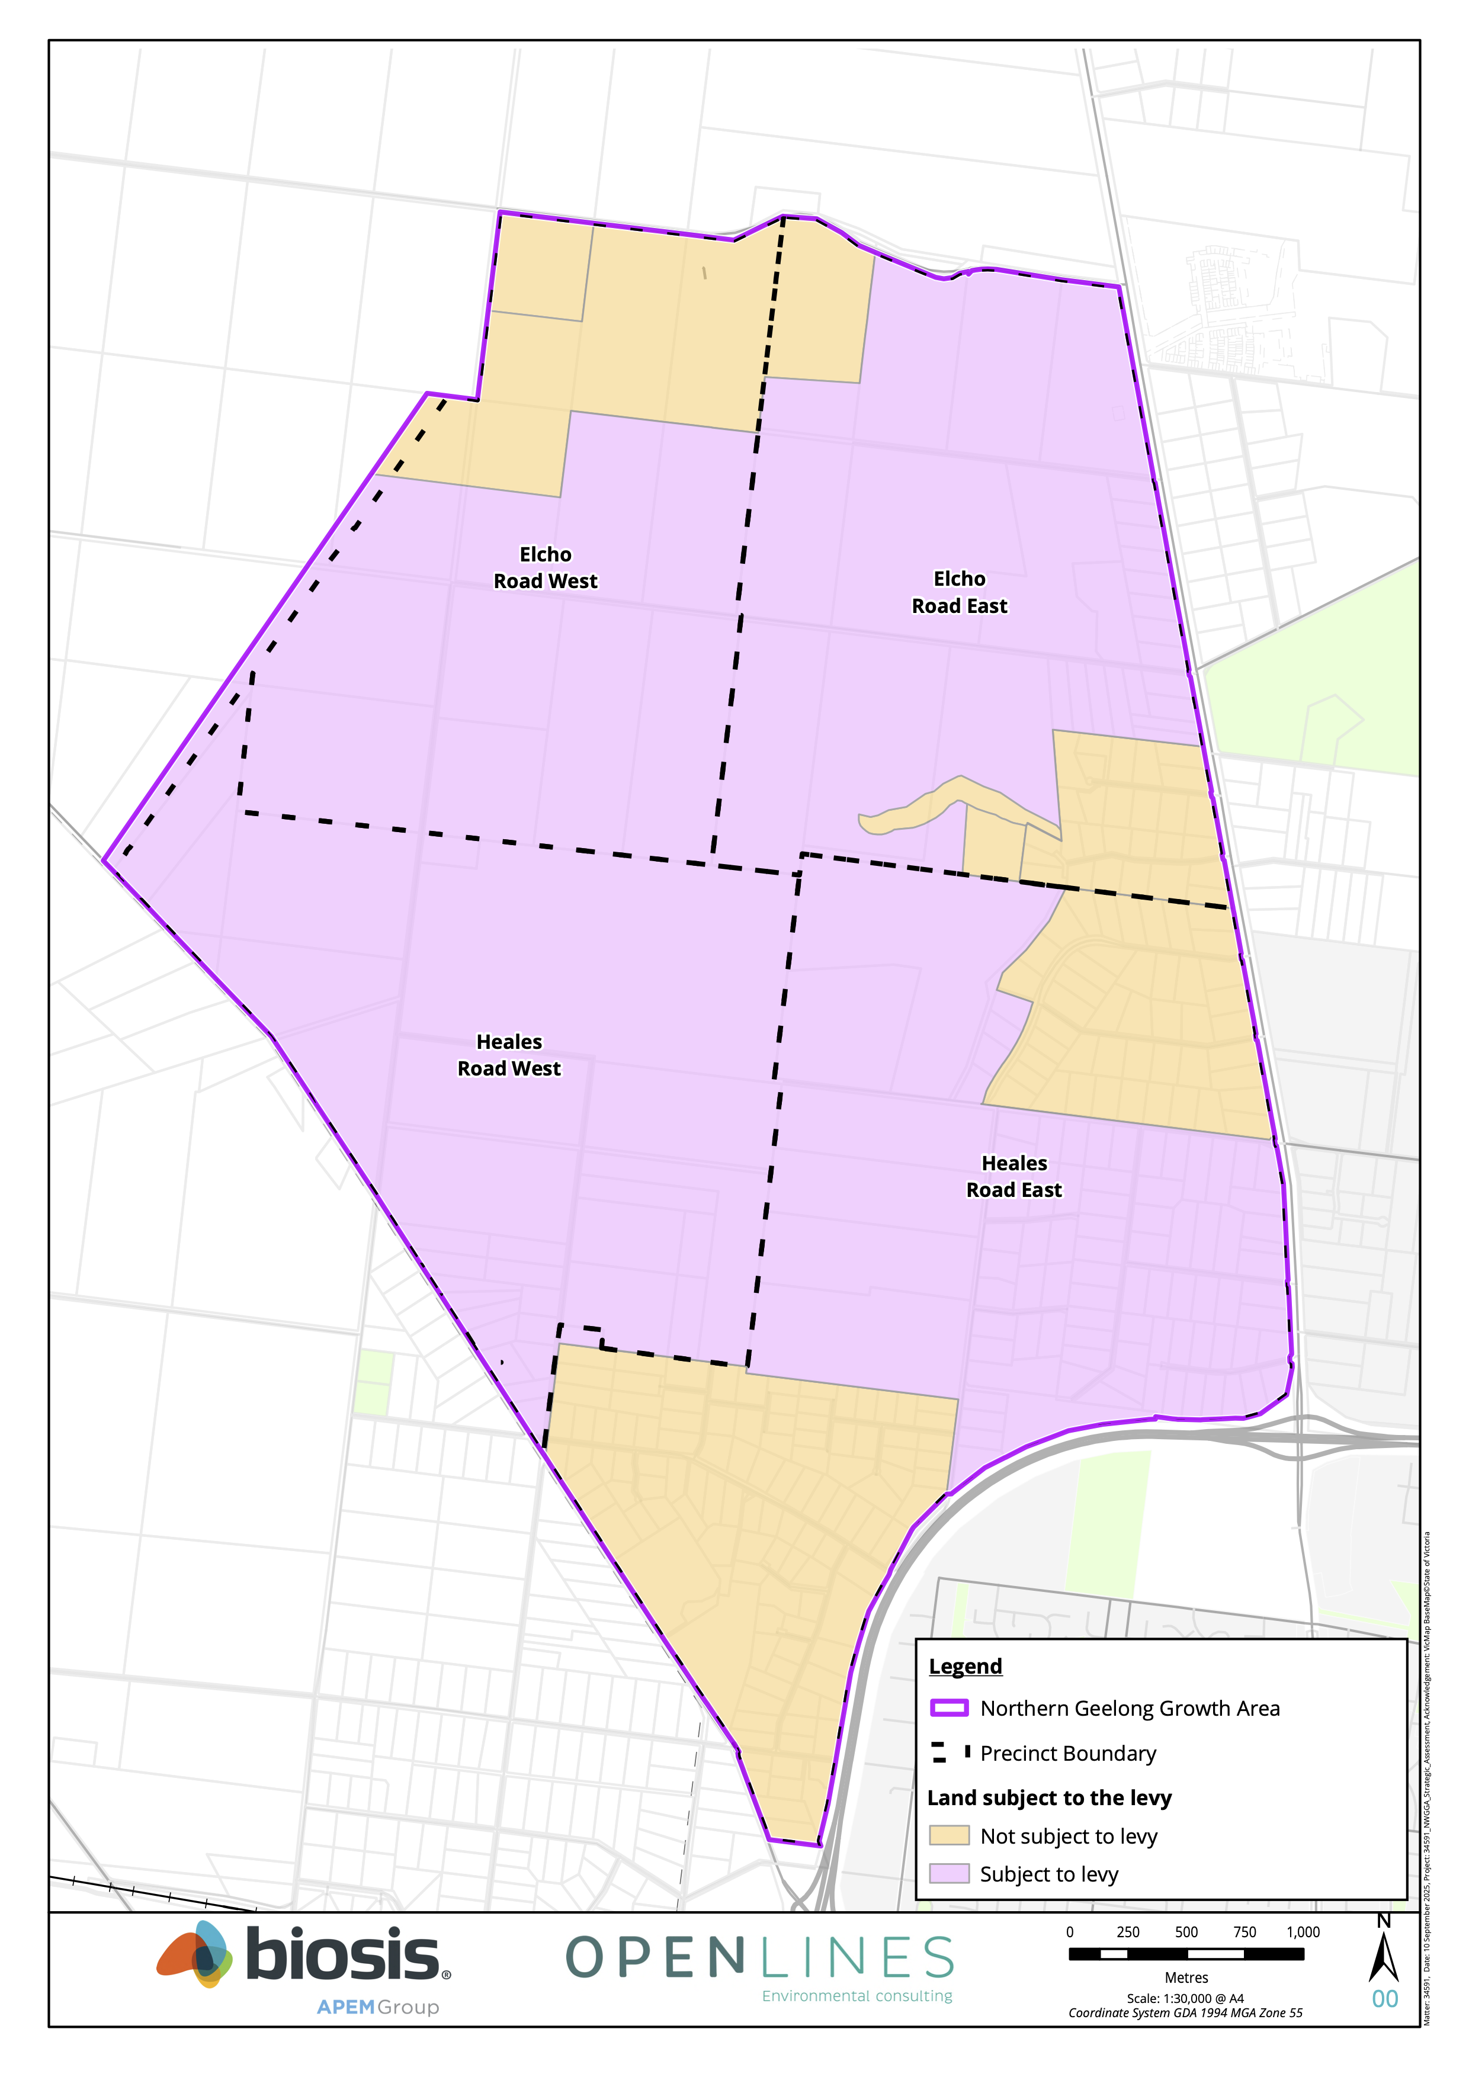

The City will recover the full cost of the delivery and implementation of the commitments set out in the Plan from landholders/developers within the NWGGA during the life of the Plan.
Given the substantial difference in environmental values and impacts of the two growth areas, it is appropriate that separate and distinct levies apply to each of the Northern Growth Area and the Western Growth Area.
The Northern Growth Area Levy will fund:
- Securing and managing the conservation land in the Northern Growth Area including the Northern Conservation Area (NCA), Eastern Conservation Area (ECA) and Gully Avoidance Area;
- Securing external offsets;
- A share of the plan preparation, implementation and governance costs for the strategic assessment proportionate to the overall cost of implementation of the conservation commitments.
The Western Growth Area Levy will fund:
- Capital works and management of the Cowies Creek Conservation Area in the growth area;
- A share of the plan preparation, implementation and governance costs for the strategic assessment proportionate to the overall cost of implementation of the conservation commitments.
The Levy is payable on the net developable area (NDA) of land within a property. For the purposes of the Funding Program the NDA is defined as the total amount of land within the precinct that is made available for development. It is the total precinct area minus community facilities, government educational facilities, open space and encumbered land.
There are six precincts that will benefit from the EPBC Plan and approval. These precincts will share the costs of delivering the projects that make up their respective Levy as outlined in Table 2.
The share of costs attributed to each precinct is based on the nominated land use and gross areas reflected in the Northern and Western Geelong Growth Areas Framework Plan August 2020 (NWGGA Framework Plan). This share of costs is fixed and not subject to change. Areas nominated for Future Residential Potential and Future Employment Potential have been excluded from this calculation as a land use change in these areas is not confirmed.
Table 2: Share of costs to be applied per PSP
Precinct | Residential (HA) | Employment (HA) | Share (%)
Western Growth Area
Creamery Road | 236 |  | 47.01
Batesford North | 266 |  | 52.99
TOTAL |  |  | 100%
Northern Growth Area
Elcho Road East | 346 |  | 24.59
Elcho Road West | 309 |  | 21.96
Heales Road East | 169 | 177 | 24.59
Heales Road West | 406 |  | 28.86
TOTAL |  |  | 100%
The NDA used to calculate the Levy for each precinct will be determined on the approval and gazettal of the respective Precinct Structure Plan (PSP) within the levy area. At this point in time, the Funding Program will be updated with an appendix outlining the NDA of each property and the Levy for the precinct.
Once a PSP is approved the contributions per property will not be amended to respond to changes to the land budget that may result from the subdivision process.
The purpose of determining levies at approval of the PSPs is to ensure that the levy area accurately reflects the land which benefits from the EPBC Plan and to ensure that the Levy provides for the accurate recovery of costs associated with implementation of the Plan’s conservation commitments. The process of adjusting, indexing and reconciling levy costs are outlined in Chapter 4.

Project costs
Each project has been assigned a land, construction or administration cost, as listed in Table 3 and 4. The costs are expressed in 2025 dollars and will be adjusted annually in accordance with the method specified in Chapter 4.
For the conservation land forming part of the Levy, the values have been calculated through a site-specific valuation on a ‘before and after basis.
Refer to Appendix 1 for a more detailed breakdown of costs and Appendix 2 for details of External offset costs.
Table 3: Northern Growth Area project costs

Project number  NG=Northern Grth Area  WG=Western Grth Area  SH=Shared btw Grth Areas | Project name | Land area (HA) | Project cost | Share of cost | Cost to Levy
Conservation Areas – Land
NG_CA_L_1 | 165 Staceys Road as conservation land - Northern Conservation Area (NCA) | 34.10 | $4,100,000 | 100% | $4,100,000
NG_CA_L_2 | 195 Staceys Road as conservation land (NCA) | 32.60 | $4,100,000 | 100% | $4,100,000
NG_CA_L_3 | Part 225 Staceys Road as conservation land (NCA) | 15.00 | $2,270,000 | 100% | $2,270,000
NG_CA_L_4 | Part 135 Staceys Road as conservation land (NCA) | 26.32 | $10,375,000 | 100% | $10,375,000
NG_CA_L_5 | Part 870 Ballan Road as conservation land (NCA) | 10.9 | $4,350,000 | 100% | $4,350,000
NG_CA_L_6 | Part 550 Elcho Road as conservation land (NCA) | 15.1 | $7,550,000 | 100% | $7,550,000
NG_CA_L_7 | Part 295-335 Elcho Road as conservation land – Eastern Conservation Area (ECA) | 6.7 | $4,690,000 | 100% | $4,690,000
Conservation Areas – Management |  |  |  |  | 0
NG_CA_CW_1 | Conservation contractors & works (NCA) 0-10 years |  | $8,093,016 | 100% | $8,093,016
NG_CA_CW_2 | Conservation contractors & works (ECA) 0-10 years |  | $494,078 | 100% | $494,078
NG_CA_CW_3 | Conservation contractors & works (Gully area) |  | $494,078 | 100% | $494,078
NG_CA_CW_4 | Conservation maintenance costs 10-30 years |  | $2,000,000 | 100% | $2,000,000
SH_CA_CW_5 | Conservation staff (1EFT) | - | $4,633,275 | 89% | $4,123,615
External Offsets |  |  |  |  | 0
NG_OF_1_NTG | 7.2 ha of Natural Temperate Grassland |  | $3,316,555 | 100% | $3,316,555
NG_OF_2_SLL | 253 ha of habitat for Striped Legless Lizard |  | $16,763,730 | 100% | $16,763,730
NG_OF_3_GSM | 381.5 ha of habitat for Golden Sun Moth |  | $22,366,304 | 100% | $22,366,304
NG_OF_4_BR | External offsets advice and brokerage cost |  | $300,000 | 100% | $300,000
Plan Preparation, Implementation and Governance |  |  |  |  | 0
SH_PI_M_1 | MERI framework development & implementation |  | $ 375,000 | 89% | $337,750
SH_PI_M_2 | Project management staff(1 EFT) |  | $ 6,160,401 | 89% | $5,482,757
SH_PI_C_1 | Compliance, education,admin staff (1 EFT) |  | $4,633,275 | 89% | $4,123,615
SH_PI_PP_1 | Preparation of EPBC Plan, BCS, SAR and Surveys |  | $2,199,982 | 89% | $1,957,984
NG_PI_PP_2 | Technical study for Hovells Creek |  | $110,154 | 100% | $110,154
SH_PI_PP_3 | Miscellaneous Consultancy costs |  | $200,000 | 89% | $178,000
NG_PI_PP_4 | Conservation management plan for NCA |  | $80,900 | 100% | $80,900
NG_PI_PP_6 | Conservation management plan for ECA |  | $50,000 | 100% | $50,000
NG_PI_F_1 | Finance / interest costs (land acquisition) |  | $3,769,200 | 100% | $3,769,200
NG_PI_F_2 | Compensation (land acquisition) |  | $2,617,500 | 100% | $2,617,500
Total cost (Northern Growth Area) |  |  |  |  | $114,094,236

Table 4: Western Growth Area project costs
Project number | Project name | Land area (HA) | Project cost | Share of cost | Cost to Levy
Conservation Area
WG_CA_CW_1 | Conservation contractors and works (Cowies Creek) 0-10 years | - | $17,596,550 | 100% | $17,596,550
WG_CA_CW_2 | Conservation maintenance costs (Cowies Creek) 10-30 years | - | $1,000,000 | 100% | $1,000,000
SH_CA_CW_5 | Conservation staff (1EFT) | - | $4,633,275 | 11% | $509,660
Plan preparation, Implementation and Governance |  |  |  |  | 0
SH_PI_M_1 | MERI framework development and implementation | - | $375,000 | 11% | $37,500
SH_PI_M_2 | Project management staff (1 EFT) | - | $6,160,401 | 11% | $677,644
SH_PI_C_1 | Compliance, education, admin staff (1 EFT) | - | $4,633,275 | 11% | $509,660
SH_PI_PP_1 | Preparation of EPBC Plan, BCS, SAR and Surveys | - | $2,199,982 | 11% | $241,998
WG_PI_PP_2 | Technical water studies for Moorabool River | - | $150,000 | 100% | $150,000
SH_PI_PP_3 | Miscellaneous Consultancy costs | - | $200,000 | 11% | $22,000
WG_PI_PP_5 | Conservation management plan for Cowies Creek Conservation Reserve | - | $155,129 | 100% | $155,129
Total costs (Western Growth Area) |  |  |  |  | $20,900,141

Biodiversity Levy
The Levy per hectare of Net Developable Area (NDA) by PSP area will be calculated as each PSP is approved and gazetted and Appendix 2 will be updated accordingly over time. The estimated Levy payable for each PSP area is shown in Table 5 and Table 6. The levies shown are estimates only based on the hectares of NDA shown in the NWGGA Framework Plan (as per Table 2 of this Funding Program).
The Levy is imposed to land within the Levy Area:
- For parcels wholly within the levy area, the whole of NDA within that parcel of land will be charged.
- For parcels partly within the levy area, the NDA of that part will be charged
The Levy payment will be coordinated with the development administrative processes outlined in section 4 in the following circumstances:
- The issue of a statement of compliance for a plan of subdivision in relation to a parcel of land wholly or partly within the levy area
- The making of an application for a building permit for the construction of a building on a parcel of land wholly or partly within the levy area
- The approval of a work plan or variation to a work plan under section 77G of the Mineral Resources (Sustainable Development) Act 1990 to carry out an extractive industry
The Levy is only payable once in respect of land. The payment of the levy will be recorded in the ‘developer registration system’ in accordance with the Plan and the administrative process outlined in section 4 below.
The Levy is payable by a development proponent irrespective of any particular impact to MNES caused by the specific subdivision and/or development proposal.
However, the City will monitor the impacts of specific development proposals on MNES, to ensure that the City is achieving the objectives, outcomes, commitments and measures in the Plan and supporting documents.
For the avoidance of doubt, the Levy is not payable in respect of development which occurs on land entirely outside the NDA of a property within a PSP area.
The City in its absolute discretion may waive or defer the requirement to pay the Levy in relation to a development proposal comprised of minor buildings, works and/or other development associated with a pre-existing land use.
The City in its absolute discretion may agree to the staging of the requirement to pay the levy to accord with staged development proposals. For example, subdivision would trigger of a parcel would trigger first administrative process listed above. The Council will consider staging proposals where land is part developed and part balance lots.
Table 5: Estimated Western Growth Area Levy by precinct (levy subject to change as PSPs approved & costs updated)
Precinct | Residential NDA | Employment NDA | Share (%) | Share of total cost (2025) | Levy per HA of NDA
Creamery Rd | 236 | - | 47 | $9,823,443 | $41,635
Batesford Nth | 266 | - | 53 | $11,077,499 | $41,635
Total | 502 |  | 100 | $20,900,942 | $41,635
Table 6: Estimated Northern Growth Area Levy by precinct (levy subject to change as PSPs approved & costs updated)
Precinct | Residential NDA | Employment NDA | Share (%) | Share of total cost (2025) | Levy per HA of NDA
Elcho Rd East | 346 | - | 24.59 | $28,055,773 | $81,090
Elcho Rd West | 309 | - | 21.96 | $25,055,094 | $81,090
Heales Rd East | 169 | 177 | 24.59 | $28,055,773 | $81,090
Heales Rd West | 406 | - | 28.86 | $32,927,597 | $81,090
Total | 1230 | 177 | 100 | $114,094,236 | $81,090

Administration and Implementation
This section:
- Sets out how the Funding Program will be administered and implemented under the EPBC Act alongside development permitted under the Victorian planning system;
- Specifies when the Levy must be paid;
- Describes when and how the City may accept the delivery of works, land or offsets by a development proponent, or request the provision of offsets by a development proponent, in lieu of cash payments towards the Levy liability;
- Sets out how costs will be indexed over time;
- Specifies when the Funding Program will be reviewed and adjusted as necessary over time; and
- Describes how the Funding Program will be used by the City to monitor impacts to MNES over the life of the Plan, to ensure that offset delivery keeps pace with and occurs ahead of impacts within the Northern Growth Area (Commitment No. 12).

Implementation under the EPBC ACT and coordination with the Victorian planning system
Prior to taking an action, landholders/developers are required to seek the City’s authorisation to proceed with that action and rely on the City’s approval under Part 10 of the EPBC Act. Authorisation will be subject to compliance with Commonwealth conditions of approval and the Plan, including the obligation under the Plan to pay the Levy pursuant to this Funding Program.
The Figure 4 depicts how the Funding Program will be implemented under the EPBC Act and the Victorian planning system.
The diagram demonstrates that the City will administer and implement the Funding Program under the EPBC Act and coordinate this implementation with timeframes and milestones under Victorian planning system.
The ability of a development proponent to rely on the City’s approval under Part 10 of the EPBC Act, and the obligation to pay the Levy, arise under the EPBC Act. The provisions of the Greater Geelong Planning Scheme, and the permit application process under the Planning and Environment Act 1987 (Vic), will ensure that relevant development carried out within the NWGGA is consistent and coordinated with the Commonwealth conditions of approval, the Plan and supporting documents (including this Funding Program).
To rely on the City’s approval under Part 10 of the EPBC Act, a development proponent will first need to lodge a ‘developer registration form’ with the City, which initiates the process set out in the ‘EPBC Act Stream’ on the above diagram. The City will administer this developer registration system in its capacity as the approval holder and in accordance with the Plan and supporting documents.
In addition, if a permit is required for the proposed development, a development proponent will need to demonstrate as part of that permit application that it has obtained the City’s consent under the ‘EPBC Act Stream’, and thereafter meet the requirements set out in the ‘Planning Stream’ in the above diagram.
The requirement to submit a ‘developer implementation plan’ under both the 'EPBC Act Stream’ and the ‘Planning Stream’ will ensure consistency and coordination across both processes. For example, it is critical that a person undertaking a class of development has consistency in the staging so that the class of action does not precede satisfaction of the EPBC Act obligations. Likewise changes in a development proposal over time (for example revised staging) will necessitate changes considered under the Plan and changes to be considered under the Planning and Environment Act 1987.
A ‘developer implementation plan’ must:
- Demonstrate that the proposed development satisfies all applicable Commonwealth conditions of approval and complies with the Plan and supporting documents; and
- address various matters including the total area of the plan, the NDA, the proposed development activities, land and/or works and/or offsets proposed to be delivered in lieu of a cash payment towards the Levy, impacts to MNES, and mitigation measures to minimise potential indirect impacts as outlined in the Plan and supporting documents.
A ‘developer implementation plan’ must be approved by the City as the approval holder under the ‘EPBC Act Stream,’ and endorsed by the responsible authority under the ‘Planning Stream’.
Upon the approval and endorsement of a ‘developer implementation plan’:
- The City as approval holder will issue a ‘developer liability statement’ under the ‘EPBC Act Stream’, which confirms the total Levy liability, the timing for the payment of the Levy liability, and any land, works or offsets in kind;
- If required due to the complexity of the land, works or offsets in kind, or any other requirement contained in the ‘developer implementation plan’, the City as approval holder and (if applicable) responsible authority may require that the development proponent enter into an agreement (such as a deed of agreement or an agreement under section 173 of the Planning and Environment Act 1987 ) to secure the developer’s obligations. The agreement must be prepared at the cost of the development proponent/permit holder.

Figure 4: Process outlining implementation of the funding program
Developer registration form:
- Request to rely on Part 10 approval
- Accompanied by:
  - Certificate of title
  - Landowner and developer entities
  - PSP parcel ID and NDA
  - Description of proposed action(s) and area
  - Impacts to MNES
If planning permit required, developer lodges planning permit application:
- UGZ application requirement that permit application is accompanied by a ‘Certificate of Acknowledgement of Consent’
City issues in-principle approval subject to conditions for consent by developer, including:
- An acceptance of obligation to pay levy and/or provide land, works or offsets in-kind
- Requirement to submit a 'Developer Implementation Plan' for approval by the City
Developer submits consent to in-principle approval and conditions:
- Standard form
- Written consent to abide by conditions of Part 10 approval
City issues a ‘Certificate of Acknowledgement of Consent’
EPBC ACT STREAM
PLANNING STREAM
City grants permit with mandatory UGZ condition - ‘Developer Implementation Plan’

‘Developer Implementation Plan includes:
- Demonstrates satisfaction with Commonwealth conditions of approval and complies with the Plan
- The NDA, staging and the development activity
- Land, works and/or offsets in-kind
- Impacts to MNES
- Mitigation measures to minimise indirect impacts
Developer submits ‘Developer Implementation Plan’ to the City as approval holder
City provides a refund of any excess credits at the completion of the delivery of any land, works or offsets in-kind
City approves ‘Developer Implementation Plan’ and issues ‘Developer Liability Statement’ as approval holder which includes:
- Timing for payment of levy
- Land, works or offsets in kind
City issues a ‘Certificate of Satisfaction’ when:
- The levy liability in respect of the land is fully discharged
- Maintains a record on its developer registration system
Developer submits ‘Developer Implementation Plan’ to the City as Responsible Authority
City endorses ‘Developer Implementation Plan’ as Responsible Authority
City issues ‘Interim Statements of Satisfaction’ where there is staged payment and/or delivery
City monitors compliance with endorsed ‘Developer Implementation Plan’ as required
EPBC ACT STREAM
PLANNING STREAM
City and developer enter a deed or s173 agreement if the complexity of land, works or offsets in kind requires it

Review
A development proponent/permit holder can seek a review of conditions attached to any ‘in-principle approval’ issued by the City under the ‘EPBC Act Stream’, or the City’s decision to not approve a ‘developer implementation plan’, from the Northern and Western Geelong Growth Areas EPBC Plan Executive Committee.
Implementation in the Greater Geelong Planning Scheme
This Funding Program will be implemented in the Greater Geelong Planning Scheme as follows:
- It, along with the Plan, will be a policy document; and
- The Schedule to the Urban Growth Zone for each PSP within the NWGGA will include:
  - A permit application requirement regarding evidence of consent under the ‘EPBC Act Stream’; and
  - A permit condition which generally requires: prior to the certification of a plan of subdivision or the commencement of development (whichever comes first), a ‘Commonwealth biodiversity – developer implementation plan’ must be submitted to, and approved by, the responsible authority (see above regarding ‘developer implementation plans’).

Discretion to require offsets in lieu of cash payments towards Levy liability
The City as the approval holder for the Plan may require that a development proponent provide offsets in lieu of a cash payment towards all or part of the Levy liability, in circumstances where the City determines in its discretion that offsets are required to ensure that offset delivery is keeping pace with and occurring ahead of impacts within the NGGA (Commitment No. 12 in the Plan). In those circumstances, a ‘developer implementation plan’ will be approved where it is demonstrated that, where required, offsets have been or will be secured to mitigate the impacts of the proposed development.

Timing for payment of levy liability
For subdivision of land
Provided it has not already been paid in respect of the subject land, the Levy liability must be paid to the City after certification of the relevant plan of subdivision but not more than 21 days prior to the issue of a Statement of Compliance in respect of that plan, or as otherwise agreed by the City. If the City agrees to alternative timing for payment, it must be reflected in the relevant ‘developer implementation plan’ and, if deemed necessary by the City, secured by way of a deed of agreement or section 173 agreement.
Where the subdivision is carried out in stages and the City has approved staged payment, the Levy liability for a stage must be paid to the City after certification of the relevant plan of subdivision for that stage, but not more than 21 days prior to the issue of a Statement of Compliance for that stage, or as otherwise agreed by the City. If the City agrees to alternative timing for payment, it must be reflected in the relevant ‘developer implementation plan’ and, if deemed necessary by the City, secured by way of a deed of agreement or section 173 agreement.
If payment is not received for the Levy, any deficit will be indexed annually.
For development of land where no subdivision is proposed
Provided it has not already been paid in respect of the subject land, the Levy liability must be paid to the City prior to the commencement of any development (development includes buildings, car park, access ways, landscaping and ancillary components).
If payment is not received for the Levy, any deficit will be indexed annually.
Where no planning permit is required
Where no planning permit is required for development of land within the Levy Area, a development proponent is still required to seek approval for the development under the ‘EPBC Act Stream’.
Provided the Levy has not already been paid in respect of the subject land, the Levy liability must be paid to the City prior to the commencement of any development (including subdivisional works), or as otherwise agreed by the City as approval holder. If the City agrees to alternative timing for payment, it must be reflected in the relevant ‘developer implementation plan’ and, if deemed necessary by the City, secured by way of a deed of agreement.

Works-in-kind, land in kind and offsets
The City may choose to accept the delivery of works, land or offsets by a development proponent in lieu of cash payments towards the Levy liability, or request the provision of offsets by a development proponent in lieu of cash payments towards the Levy liability, provided that:
- The works, land or offsets constitute projects that are funded by the Levy;
- The City is satisfied that the timing of the delivery of the land or offsets is consistent with priorities in the Plan;
- The condition of the land is to the satisfaction of the City;
- The works are permanent. Temporary works will not be accepted as works in kind.
- The development proponent complies with all applicable requirements of the City, including tendering, documentation, supervision, and other related requirements.
- Offsets must be provided to the satisfaction of the City and fulfil the following criteria:
  - Secured in perpetuity.
  - Align with the offsets identified in the Plan and not already provided by another party.
  - Include a conservation management plan to outline the values on site and how the values will be improved overtime and conservation advice for the requisite species.
  - Need to meet the strategic landscape outcomes outlined in the Plan and be in accordance with guidelines published by the City.
- There must be no negative financial impact on the Funding Program implementation to the satisfaction of the City.
Where the City agrees to accept the delivery of works, land or offsets in lieu of a cash contribution, or requests the provision of offsets in lieu of a cash contribution, (subject to the above requirements):
- The credit for the works shall equal the final cost of the works as identified in this Funding Program, subject to indexation in accordance with this Funding Program, and the City has approved staged payment.
- The value of works will be applied as a credit against the Levy liability payable by the development proponent;
- No cash contributions towards the Levy liability will be required until the credit has been extinguished; and
- Where works identified in the Funding Program are delivered in part, the City will determine the credit having regard to any wasted costs or costs of mobilisation that are associated with partial delivery.

Credit for over provision
Where the City agrees to accept the delivery of works, land or offsets, or requires the delivery of offsets, in lieu of a cash contribution, the situation may arise where the development proponent makes a contribution with a value that exceeds the applicable Levy liability under this Funding Program (over-provision).
In circumstances where the developer registers an overprovision recognised by the City, the City may agree to pay a cash reimbursement to the development proponent in the amount of the over-provision. The over-provision arrangements will be recorded in a deed of agreement or section 173 agreement.
The value of any credit and reimbursements for the construction of works, land or offsets shall equal the cost of the works identified in this Funding Program, subject to indexation in accordance with this Funding Program.

Credit for early provision
Where a developer is in credit against their Levy liability this credit balance will be indexed annually in accordance with the annual increase in the Levy.
The City may agree to accept early provision of offsets when approving the developer implementation plan.

Funds administration
Levies which are collected under this Funding Program will be held by the City until required to be expended on implementation of the Plan’s commitments and measures.
Details and records of funds received, and expenditures will be held by the City in accordance with the provisions of the Local Government Act 2020 (Vic).
The administration of contributions made under the Funding Program will be transparent and demonstrate the:
- Amount and timing of funds collected
- Source of the funds collected
- Amount and timing of expenditure on specific projects
- Project on which the expenditure was made
- Details of works in kind, land in kind and offset arrangements
The City will provide for regular monitoring, reporting and review of the monies received and expended in accordance with this Funding Program.
The City will establish reserve accounts and all monies allocated to these accounts will be used solely for the provision of projects as itemised in the Funding Program.
Should Council achieve savings on any project or resolve not to proceed with any of the projects listed in this Funding Framework, the funds collected for these items will be used for alternative works necessary to deliver the commitments and measures of the Plan. Changes to the projects and offsets identified in this Funding Program will be agreed to by the Northern and Western Geelong Growth Areas EPBC Plan Executive Committee.

Indexation
The Project Costs outlined in this Funding Program are in 2025 dollars and will be adjusted by the City annually in accordance with the methodologies outlined below.
The adjusted Project Costs must be calculated as at 1 July in each year.
The adjusted Project Costs will inform the Levy and the City will publish the amended Levy on it’s website within 14 days of the adjustments being made.
Infrastructure Projects
Project Costs associated with the construction of infrastructure must be indexed annually in line with the Australian Bureau of Statistics’ Producer Price Indexes, Non-Residential Building Construction Index, Victoria.
Land Projects
Project Costs associated with land value must be adjusted annually to reflect the value of the land as at the date of adjustment, to be determined by a registered valuer based on the same valuation principles that informed the initial valuation. Revisions may occur more frequently if market conditions warrant. Costs incurred by the acquiring authority under the Land Acquisition and Compensation Act 1986 will be included in the Project Cost.
Offsets Projects
Project Costs associated with offsets must be adjusted annually pursuant to the following process:
- The City will seek an opinion of probable cost from a suitably qualified and experienced offset broker to inform the annual offset value per hectare.
- That offset value will be used to adjust the Project Costs associated with offsets.

Review period
This Funding Program be reviewed when each PSP is prepared and approved to give effect to:
- Updates to any aspect of this Funding Program as required
- Review of projects required, as well as their costs and scope and provision trigger
- Preparation of a NDA and land budget for the new PSP for inclusion in this Funding Program.
- The publication of a Levy for the PSP area in question and updates to the Levy for any previous PSP areas as required.
- Review of land values for land to be purchased through the Plan.

Monitoring impacts
The Plan identifies that impacts to MNES will not exceed offset delivery. This commitment and the early delivery of aspects of the offset program are central to the justification for the overall offset requirements.
The City will monitor impacts to MNES outlined in the Plan via the developer registration system under the ‘EPBC Act Stream’, as well as the PSP and planning permit process.
The PSP areas that are contributing impacts to MNES are shown in Table 7.

Table 7: MNES impact area and contribution to offset target
Precincts | Impact area (ha) | Offset target (ha)
Elcho Road East
GSM mod-high | 22.7 | 42.5
GSM low-no | 148 | 111.0
GSM total | 170.7 | 153.6
SLL total | 49.9 | 126.3
NTG total | 2 | 5.2
Elcho Road West
GSM mod-high | 4.8 | 8.9
GSM low-no | 223.9 | 168.0
GSM total | 228.7 | 176.9
SLL total | 40.5 | 102.7
NTG total | 1 | 2.5
Heales Road East
GSM mod-high | 0 | 0.0
GSM low-no | 24.4 | 18.3
GSM total | 24.4 | 18.3
SLL total | 19.4 | 49.2
NTG total | 2 | 5.3
Heales Road West
GSM mod-high | 1.5 | 2.9
GSM low-no | 198.7 | 149.1
GSM total | 200.3 | 152.0
SLL total | 20.9 | 53.0
NTG total | 0.4 | 1.1
Total across the NGGA
GSM mod-high | 29 | 54.3
GSM low-no | 595 | 446.4
GSM total | 624 | 500.7
SLL total | 130.8 | 331.2
NTG total | 5.4 | 13.9

Appendices

Appendix 1: Breakdown Of Costs

Northern Growth Area Project Costings Breakdown

Category | Project ID  NG=Northern Grth Area  WG=Western Grth Area  SH=Shared | Project Name | Assumption Description 1 | Description (Actual number) | Current Day Total Cost (2025) | Notes and details
Conservation areas | NG_CA_L_1 | 165 Staceys Road as conservation land - Northern Conservation Area (NCA) | $120,000 per hectare | 34.2 Ha | $4,100,000 | Land Valuation 14 November 2024
Conservation areas | NG_CA_L_2 | 195 Staceys Road as conservation land (NCA) | $125,000 per hectare | 32.77 Ha | $4,100,000 | Land Valuation 14 November 2024
Conservation areas | NG_CA_L_3 | Part 225 Staceys Road as conservation land (NCA) | $125,000 per hectare | 17.36 Ha | $2,270,000 | Land Valuation 2 December 2024
Conservation areas | NG_CA_L_4 | Part 135 Staceys Road as conservation land (NCA) | $400,000 per hectare | 25.96 Ha | $10,375,000 | Land Valuation 8 July 2025
Conservation areas | NG_CA_L_5 | Part 870 Ballan Road as conservation land (NCA) | $400,000 per hectare | 10.9 Ha | $4,350,000 | Land Valuation 3 Sept 2025
Conservation areas | NG_CA_L_6 | Part 550 Elcho Road as conservation land (NCA) | $500,000 per hectare | 15.1 Ha | $7,550,000 | Land Valuation 3 Sept2025
Conservation areas | NG_CA_L_7 | Part 295-335 Elcho Road as conservation land - Eastern Conservation Area (ECA) | $700,000 per hectare | 6.7 Ha | $4,690,000 | Land Valuation 8 Sept 2025
Conservation areas | NG_CA_CW_1 | Conservation contractors & works (NCA) 0-10 years | 10-year management cost |  | $8,093,016 | Draft Northern Conservation Area CMP costings (Feb 2025)
Conservation areas | NG_CA_CW_2 | Conservation contractors & works (ECA) 0-10 years | 10-year management cost |  | $494,078 | Estimate from consultant
Conservation areas | NG_CA_CW_3 | Conservation contractors & works (Gully area) | 10-year management cost |  | $494,078 | Holding figure based on ECA estimate
Conservation areas | NG_CA_CW_4 | Conservation maintenance costs 10-30 years | 20-year maintenance cost | $100,000 | $2,000,000 | CoGG estimate of $100K per year for 20 years to maintain NCA and ECA (may include pre-acquisition maintenance)
Conservation areas | SH_CA_CW_5 | Conservation staff (1EFT) | 30 years of salary 89% share | $4,633,275.00 | $4,123,615 | Based on Geelong EBA - Band 6
External Offsets | NG_OF_1_NTG | External offsets - 7.3 ha of Natural Temperate Grassland | $350,000 per hectare + site costs | 7.3 Ha | $3,316,555 | See Appendix 2 - Oct 2025 Letter from Biosis for details
External Offsets | NG_OF_2_SLL | External offsets - 253 ha of habitat for Striped Legless Lizard | $45,000 per hectare + site costs | 253.3 Ha | $16,763,730 | See Appendix 2 - Oct 2025 Letter from Biosis for details
External Offsets | NG_OF_3_GSM | External offsets - 381.5 ha of habitat for Golden Sun Moth | $45,000 per hectare + site costs | 381.5 Ha | $22,366,304 | See Appendix 2 - Oct 2025 Letter from Biosis for details
External Offsets | NG_OF_4_BR | External offsets advice and brokerage cost |  |  | $300,000 | CoGG Estimate - includes broker fees and legal advice- annual cost updates and advice
Plan Preparation, Implementation & Governance | SH_PI_M_1 | MERI framework development & implementation | 89% share of cost | $375,000.00 | $337,750 | CoGG Estimate includes: 1. Prepare (independent) end of plan evaluation ($125K), 2. Prepare (independent) five yearly assurance reports ($250K)
Plan Preparation, Implementation & Governance | SH_PI_M_2 | Project management staff(1 EFT) | 30 years of salary - 89% share | $150,040.00 | $5,482,757 | Based on Geelong EBA - Band 8
Plan Preparation, Implementation & Governance | SH_PI_C_1 | Compliance, education,admin staff (1 EFT) | 30 years of salary - 89% share | $114,210.00 | $4,123,615 | Based on Geelong EBA - Band 6
Plan Preparation, Implementation & Governance | SH_PI_PP_1 | Preparation of EPBC Plan, BCS, SAR and Surveys | 89% share of cost | $199,982.00 | $1,957,984 | Consultant fees incurred to date or contracted to occur (figure subject to confirmation)
Plan Preparation, Implementation & Governance | NG_PI_PP_2 | Technical study for Hovells Creek |  |  | $110,154 | Contracted consultant fee to prepare the study
Plan Preparation, Implementation & Governance | SH_PI_PP_3 | Miscellaneous Consultancy costs | 89% share of cost | $200,000 | $178,000 | CoGG estimates to 1. Prepare process based development approval standards ($30K) 2. Prepare Stakeholder Engagement Strategy ($30K) 3. Legal advice on Funding arrangements ($60K) 4.Prepare online development registration system ($60K), 5.Prepare Data management and sharing agreement ($20K)
Plan Preparation, Implementation & Governance | NG_PI_PP_4 | Conservation management plan for NCA |  |  | $80,900 | $30,900 costs incurred on CMP plus $50,000 for updates with additional area added
Plan Preparation, Implementation & Governance | NG_PI_PP_6 | Conservation management plan for ECA |  |  | $50,000 | CoGG Estimate and includes Gully Avoidance Area
Plan Preparation, Implementation & Governance | NG_PI_F_1 | Finance / interest costs (land acquisition) |  |  | $3,769,200 | 3.6% interest over 10 years for Stage 1 NCA FZ properties
Plan Preparation, Implementation & Governance | NG_PI_F_2 | Compensation (land acquisition) |  |  | $2,617,500 | 25% of the total land acquisition cost for Stage 1 NCA FZ properties
TOTAL |  |  |  |  | $114,094,236

Western Growth Area Project Costings Breakdown

Category | Project ID  NG=Northern Grth Area  WG=Western Grth Area  SH=Shared | Project Name | Assumption Description 1 | Description (Actual number) | Current Day Total Cost (2025) | Notes and Details
Conservation Areas | WG_CA_CW_1 | Conservation contractors and works (Cowies Creek) 0-10 years |  |  | $17,596,550 | Made up of $9,760,220 (LMP figure) and $5,836,330 (CMP figure) + $2M additional salvage and wetland construction
Conservation Areas | WG_CA_CW_2 | Conservation maintenance costs (Cowies Creek) 10-30 years | 20-year maintenance cost | $50,000 | $1,000,000 | $50k per year for 20 years
Conservation Areas | SH_CA_CW_5 | Conservation staff (1EFT) | 30 years of salary - 11% share |  | $509,660 | Based on Geelong EBA - Band 6
Plan Preparation, Implementation & Governance | SH_PI_M_1 | MERI framework development and implementation | share of cost 11% | $375,000 | $37,500 | CoGG Estimate includes: 1. Prepare (independent) end of plan evaluation ($125K), 2. Prepare (independent) five yearly assurance reports ($250K)
Plan Preparation, Implementation & Governance | SH_PI_M_2 | Project management staff (1 EFT) | 30 years of salary - 11% share | $150,040 | $677,644 | Based on Geelong EBA - Band 8
Plan Preparation, Implementation & Governance | SH_PI_C_1 | Compliance, education, admin staff (1 EFT) | 30 years of salary - 11% share | $114,210 | $509,660 | Based on Geelong EBA - Band 6
Plan Preparation, Implementation & Governance | SH_PI_PP_1 | Preparation of EPBC Plan, BCS, SAR and Surveys | share of cost 11% |  | $241,998 | Consultant fees incurred to date or contracted to occur (figure subject to confirmation)
Plan Preparation, Implementation & Governance | WG_PI_PP_2 | Technical water studies for Moorabool River |  |  | $150,000 | CoGG estimate - Relates to MNES in downstream Moorabool River and Barwon River/Lake Connewarre
Plan Preparation, Implementation & Governance | SH_PI_PP_3 | Miscellaneous Consultancy costs | share of cost 11% | $200,000 | $22,000 | CoGG estimates to 1. Prepare process based development approval standards ($30K) 2. Prepare Stakeholder Engagement Strategy ($30K) 3. Legal advice on Funding arrangements ($60K) 4.Prepare online development registration system ($60K), 5.Prepare Data management and sharing agreement ($20K)
Plan Preparation, Implementation & Governance | WG_PI_PP_5 | Conservation management plan for Cowies Creek Conservation Reserve |  |  | $155,129 | Cost incurred to prepare draft CMP (55K) + updates ($100k)
TOTAL |  |  |  |  | $20,900,142

Appendix 2: External Offset Information

Appendix 3: Land Budget by PSP
To be inserted when PSPs approved and gazetted.
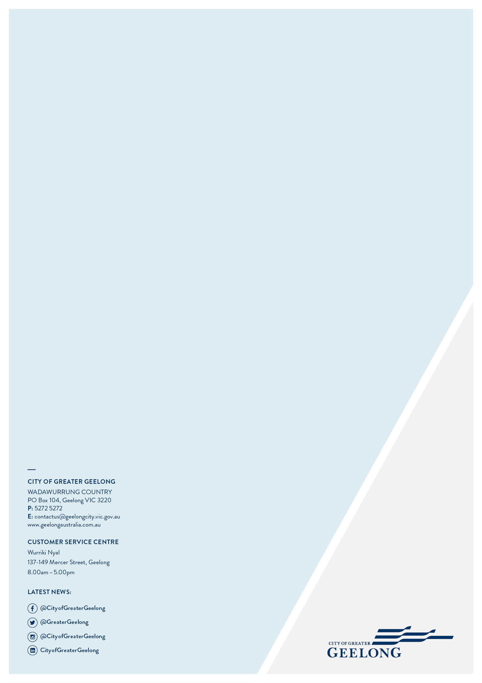

Share of cost to be updated when final costings known. Share based on current cost estimates. Share of cost will be fixed on the approval and gazettal of the first amendment that implements the funding program

