The City Of
Greater Geelong

Integrated transport Strategy

Phase 1 Engagement report

  - September 2024

Contents
Executive Summary 3
Introduction 4
Project Background 4
Engagement Purpose 4
About this Report 4
How we engaged 5
Snapshot 5
Have Your Say online platform 5
Survey 5
Online Interactive map 5
Vision Board 5
Promotion 6
Who we engaged 7
Who we planned to engage 7
Participation 7
Demographics 7
What we asked 9
Why we asked 10
What we heard 11
Key Findings overview 11
Key Theme 1: More frequent, direct, and reliable bus services 11
Key Theme 2: Concerns with growth area staging 11
Key Theme 3: Desire for improved bicycle infrastructure safety and connectivity 11
Key Theme 4: Bus shelter improvements 11
Key Theme 5: More secure bicycle parking 11
Key Theme 6: Improved Bellarine Peninsula bus connectivity 11
Key Theme 8: Improved shared trail connections 11
Key Theme 9: Improved wayfinding 12
Key Theme 10: Desire for safe and connected footpaths that are safe and accessible to all 12
Key Theme 11: Improved signal phasing and traffic congestion 12
Key Theme 12: Improved ferry services 12
Key Theme 13: Effective parking management 12
Key Theme 14: Park and ride options 12
Community values 12
Breakdown of findings 14
Online Interactive Map 14
Bicycle 14
Drive/Vehicles 15
Bus 16
Walk 17
Place/General 18
Train 19
Mobility aid 20
Survey 21
Vision Board 24
Formal Submissions 27
Feedback through informal channels 27
Community engagement successes 27
Community engagement areas for improvement 27
What we have done and/or next steps 28
What we have done 28
Next Steps 28
Appendix A – Survey Questions 29

Executive Summary
The Integrated Transport Strategy is a document that will guide decision making on transport and land use planning for Greater Geelong. The strategy will supersede the Integrated Comprehensive Transport Plan that was previously adopted in 2015.
The City ran engagement for 8 weeks to capture community sentiment on current issues and future vision for transport across Greater Geelong. The engagement will inform a background report, further phases of engagement and the strategy itself.
Engagement overview
The community engagement period for the first phase of engagement on the Integrated Transport Strategy ran from April 24 to June 18, 2024, for a total of 55 days. The aim was to capture community sentiment for the current issues, opportunities, and future vision for the Greater Geelong transport network.
How we engaged
The community engagement was run primarily online using three different tools:
- An online interactive map to capture current issues with and positive aspects of Geelong’s current transport network.
- A survey to capture community sentiment, current travel behaviors and opportunities for use of different modes of transport.
- A vision board to encourage people to think with a long-term, strategic vision and post their big ideas for transport in Geelong.
Who we engaged
It was key that the City obtained feedback from a wide range of transport users of different ages and backgrounds to ensure that the Greater Geelong community was represented throughout the engagement process.
- 947 contributions were made on the interactive map.
- 583 people completed the survey.
- 100 big ideas were shared on the vision board.
What we heard
The key themes identified from contributions across all three engagement tools that were used included:
- More frequent, direct, and reliable bus services.
- Concerns with growth area staging.
- Desire for improved bicycle infrastructure safety and connectivity.
- Bus shelter improvements.
- More secure bicycle parking.
- Improved Bellarine Peninsula bus connectivity.
- Improved shared trail connections.
- Improved wayfinding.
- Desire for safe and connected walking infrastructure that is accessible to all.
- Improved signal phasing and traffic congestion.
- Improved ferry services.
- Effective parking management.
- Park and ride options.
Survey responses also provided a ranking of community values related to transport with the top four values being:
- Public transport that is safe, frequent, reliable, fast, and well connected.
- Liveability and amenity of streets and local neighbourhoods.
- Footpaths that are safe and well connected.
- An equitable and accessible transport system that provides a range of options for all users.
What we will do
After conducting the community engagement for a 55-day period, the next steps for the development of the Integrated Transport Strategy are to:
- Collate and review engagement findings and produce an engagement report (this report).
- Produce a discussion paper/background report to assist with further community engagement.
- Conduct Phase 2 of engagement for the strategy.

Introduction

Project Background
The City is developing an Integrated Transport Strategy (ITS) for Greater Geelong in response to significant population growth that will supersede the Integrated Comprehensive Transport Plan, adopted in 2015.
The strategy will primarily respond to the aspiration of having a fast, reliable, and connected transport network as part of the City’s vision for a “A Clever and Creative Future.”
The strategy will respond to the following pillars of Our Community Plan 2021 – 2025:
Healthy, caring and inclusive community – provision of a safe, reliable and accessible transport network that promotes sustainable transport modes to encourage active living.
Sustainable growth and environment – to meet existing and future transport needs and explore opportunities for Transit Oriented Development to encourage infill development in appropriate locations.
Strong local economy – to create a more vibrant, liveable city and region that attracts investment from the public and private sectors and attracts tourism.
The strategy will be in development while our Council Plan 2025 - 29 is being developed and will respond to the updated plan accordingly.
Greater Geelong is experiencing significant development and population growth in greenfield (new) and infill (redevelopment of land in existing, built-up areas) locations. This growth is currently, and will continue to, place pressure on the existing transport network. In response to this increased network pressure, the ITS will have a focus on how Geelong can achieve a mode shift towards sustainable forms of transport to create a more vibrant and liveable city and region.

Engagement Purpose
The purpose of this engagement was to:
- Understand the community’s current views, values and future vision for the way people travel in and around Greater Geelong.
- Understand community sentiment when it comes to different modes of transport.
- Understand what can enable uptake of different modes of transport.
This information will be used to develop a background report that will inform future phases of engagement as well as the ITS itself.

About this Report
The purpose of this report is to:
- Collate the community feedback regarding transport related issues and summarise common themes.
- Inform the community of engagement findings and maintain transparency in the information that shapes the City’s decision and actions.
- Provide community input in the development of the Integrated Transport Strategy.

How we engaged

Snapshot
The primary method of engagement was via the City of Greater Geelong’s online Have Your Say (HYS) platform and was supported by several face-to-face drop-in sessions and conversations.
The engagement period was between 24 April and 18 June 2024 for a total of 55 days.

Have Your Say online platform
An online HYS project page was designed to provide multiple options for community to submit feedback which included:
- Online Interactive Map
- Survey
- Online Vision Board

Survey
The community was able to complete a survey that asked questions relating to:
- How important particular aspects of transport are to them.
- How they travel around Greater Geelong for different purposes.
- Whether they would use other modes of transport and what would encourage them to.
583 responses to the survey were received.

Online Interactive map
The community was invited to interact with an online mapping tool by:
- Dropping a pin on the map to provide an idea or comment.
- Voting on an existing pin.
Pins were categorised into groups for each mode of transport as well as a general category that could include place-based ideas and comments.
- 947 responses (pins) were provided using this tool from 196 unique contributors.
- 1,818 upvotes were given to the responses (pins).
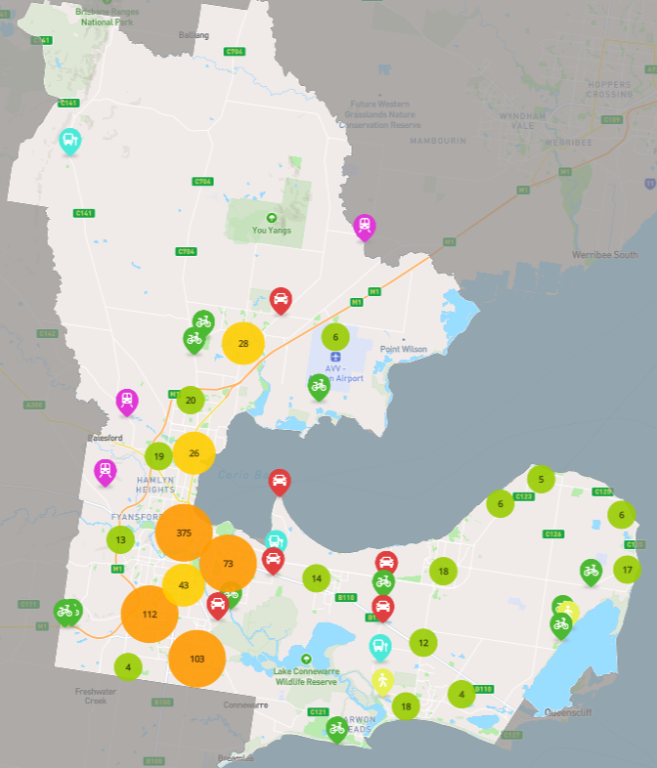
Figure 1 – Interactive map

Vision Board
The community was invited to share “Big Ideas” on an online vision board that allowed community members to upvote and comment on ideas shared by others.
- 100 “Big Ideas” were shared by 68 unique contributors.
- 106 comments were posted.
- 1,543 upvotes were given.

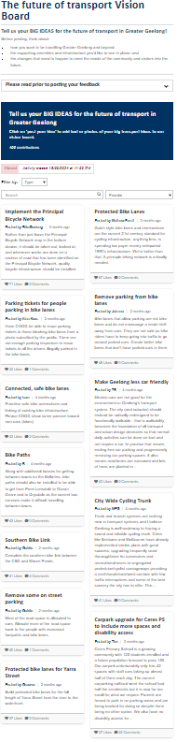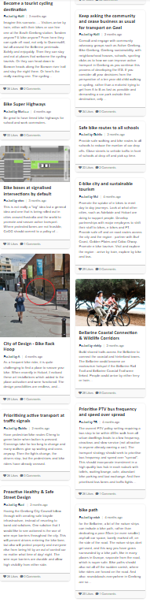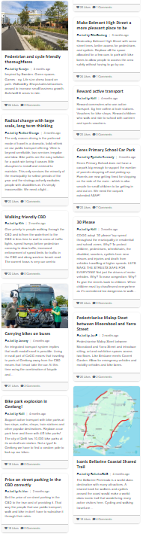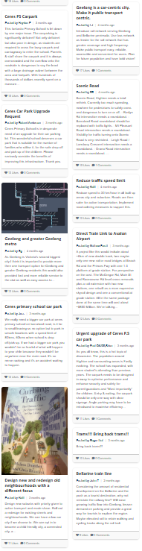
Figure 2 – Vision board

Promotion
The engagement was promoted using the following methods:
- Social media posts.
- Email to HYS members.
- Email to organisations, schools and community groups.
- City staff handing out promotional postcards in areas with high pedestrian activity such as local markets and shopping precincts.
- Promotion on Geelong Regional Library Corporation library screens.
The most effective method for generating traffic on the HYS page was social media posts as each post coincided with a spike in the level of activity. It was also evident that direct emails to schools resulted in many of them sharing with their communities which generated activity that was specific to certain areas of Greater Geelong.

Who we engaged

Who we planned to engage
The intent was to reach a broad cross section of the community as the strategy has a long-term vision and covers the entire municipality. We reached out directly via email to invite participation from the following groups:
- Local schools
- Significant local employers
- Surrounding LGAs (Surf Coast Shire, Wyndham City, Ballarat City, Moorabool Shire, Borough of Queenscliffe, Golden Plains Shire, Colac Otway Shire, City of Ballarat)
- Geelong Regional Alliance (G21)
- Community groups
- Council Advisory Committees
- External stakeholders
- The broader community

Participation
219 (38.5%) heard about the engagement through social media.
124 (22%) heard about the engagement through an email from being subscribed to the City’s HYS platform.
84 (14.8%) heard about the engagement through their local school.
Figure 3 provides a more detailed breakdown of how people heard about the engagement.
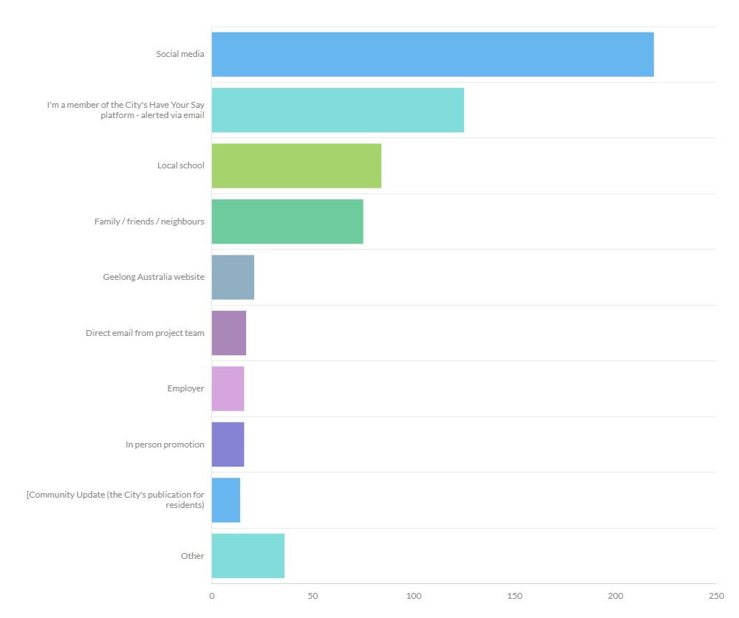
Figure 3 – Breakdown of how survey participants heard about the survey

Demographics
Most survey responses were from those aged between 35-49 which totalled 43% of all responses.
It is often difficult to engage with those aged under 18 and between 18-24 though the levels of engagement at 5% and 3% of responses was considered relatively successful noting that more can be done to engage these age groups in future stages of engagement.
Figure 4 provides a more detailed breakdown of survey participation by age groups.
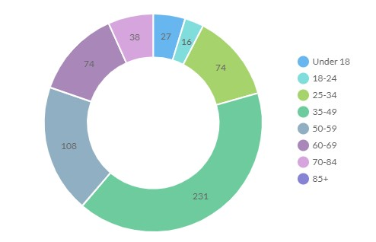Figure 4 - Breakdown of survey participation by age

The most survey responses were from women (60%) and Figure 5 provides a detailed breakdown of survey participation by gender.
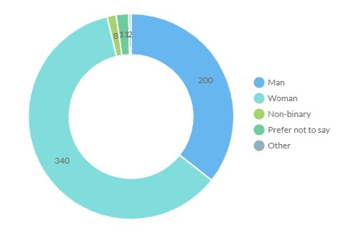Figure 5 - Breakdown of survey participation by gender
Figure 6 provides a detailed breakdown of survey participation by identified groups with reasonable levels of representation from the LGBTIQA+ community (7%) and people with a disability (6.5%).
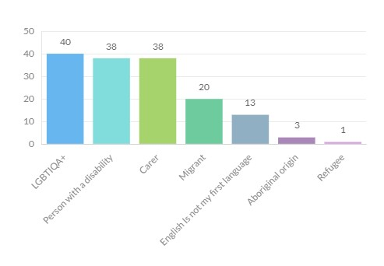Figure 6 – Breakdown of survey participation by identified groups
The highest levels of response were from people who lived in the following suburbs:
- Ocean Grove
- Belmont
- Armstrong Creek
Figure 7 provides a detailed breakdown of participation by suburb of residence.

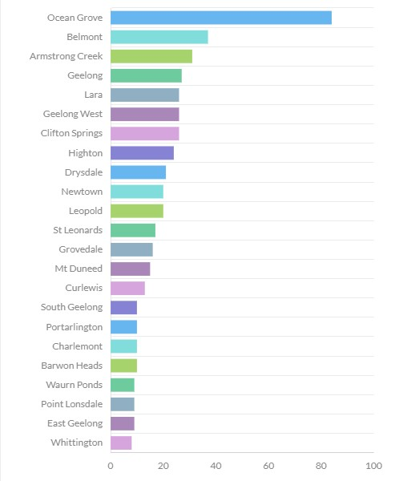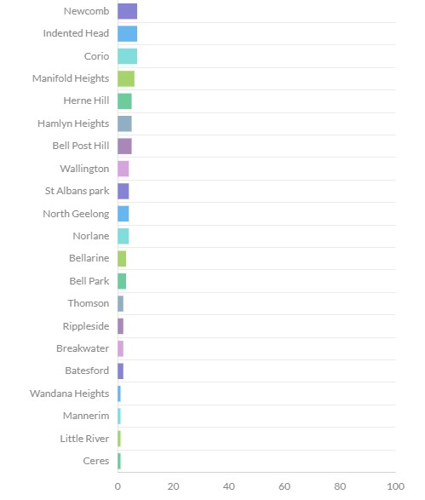
Figure 7 – Breakdown of survey participation by suburb

What we asked
Online Interactive Map
The community was asked to identify issues, opportunities for improvement and things they like about transport across the municipality as they relate to specific modes of transport or creating a sense of place. There was also the opportunity to upvote responses from other community members.
Survey
The community was invited to complete a survey that broadly asked the following questions:
What is your connection to Greater Geelong? (ie. worker, resident, visitor, business owner etc.)
How important are the following aspects of transport to you:
- Public transport that is safe, frequent, reliable, fast and well connected.
- A transport system that promotes Geelong's economic growth and productivity.
- High quality transport connections to other regional centres like Ballarat and Bendigo.
- Liveability and amenity of streets and local neighbourhoods.
- A road network that is safe and well connected.
- An equitable and accessible transport system that provides a range of options for all users.
- Footpaths that are safe and well connected.
- High quality transport connections to Melbourne.
- A bicycle network that is safe and well connected.
- A transport system that is sustainable and generates net zero emissions.
- Innovation and the use of emerging transport technology.
What modes of transport do you use for everyday trips like getting to work, education, the shops, social and recreational activities and getting children to and from daycare, kinder or school?
Are there other modes of transport that you would consider using for these everyday trips?
What would make these modes of transport a more viable option for you to use for everyday trips?
What is your vision for the future of transport across Greater Geelong?
A full copy of the survey questions is available in Appendix B.
Vision Board
The community was invited to share their ‘Big Ideas’ for what transport in Geelong could look like in the future on a vision board. People were able to upvote and comment on the shared ideas.
Surrounding local councils
The team invited nearby local council to discuss common land use and transport planning issues and opportunities. This was used as an opportunity to build closer working relationships with nearby councils and better understand cross border issues and opportunities. The councils included:
- Golden Plains Shire
- Wyndham City
- Surf Coast Shire
- Borough of Queenscliffe
- Colac Otway Shire
- Moorabool Shire
- City of Ballarat

Why we asked
Online Interactive Map
The purpose of the interactive map was to understand where the current issues and opportunities with the transport network were. This information will assist the City to consider what targets and actions may be included in the final ITS and how they’re prioritised.
Survey
The survey was structured in a way that would help us understand five underlying themes.
- What does the community value about transport?
- How does the community currently travel around Greater Geelong?
- What is the community’s appetite to consider different modes of transport?
- What would make these modes of transport more accessible and easier to use?
- What is the community’s long-term vision for transport in Greater Geelong?
Vision Board
The ITS will have a 30-year vision for Greater Geelong’s transport network and this tool was used to prompt the community to think and respond based on that long term, strategic timeframe. This was in contrast with the interactive map which was anticipated to generate more short-term issues and opportunities.

What we heard

Key Findings overview
The three main online tools that were used to capture community feedback were:
- Interactive map (to capture issues and good experiences with the current transport network).
- Survey (to capture current sentiment and enablers for use of different modes of transport.
- Vision board (to encourage and capture long term, strategic thinking).
Feedback has been analysed and several key themes were identified across all three of the tools used. A more detailed breakdown of findings for each tool has been provided in the sections following key themes and community values.

Key Theme 1:
More frequent, direct, and reliable bus services
There was a strong desire for improvements to the bus network across Greater Geelong, suggestions included:
- Improving the frequency, connectivity, directness, and reliability of bus services.
- Improving safety on buses and at bus stops for passengers.
- Providing express services from transport hubs.

Key Theme 2:
Concerns with growth area staging
40 pins that were dropped on the interactive map related to disconnected infrastructure in the Armstrong Creek growth area. It is understandable that the community experiences frustration when walking, riding, driving or catching public transport for everyday activities when infrastructure is disconnected. There is a community expectation that it should be connected already.

Key Theme 3:
Desire for improved bicycle infrastructure safety and connectivity
A significant number of pins dropped on the interactive map related to disconnected bicycle infrastructure and busy roads that are difficult to cross on a bicycle. Survey participants also identified that safer, lower stress and well-connected infrastructure would encourage them to take relatively short trips by bicycle. A small number of responses requested that car parking is not impacted by bicycle infrastructure.

Key Theme 4:
Bus shelter improvements
Several bus stop locations were identified by the Public Transport Users Association indicating that they should have bus shelter, or the existing shelter should be upgraded.

Key Theme 5:
More secure bicycle parking
The ability to park a bicycle securely and close to destinations was identified in survey responses as an enabler to riding a bicycle for transport. Several locations were identified on the interactive map that lack secure bicycle parking.

Key Theme 6:
Improved Bellarine Peninsula bus connectivity
Bus connectivity for townships on the Bellarine Peninsula was identified as a key issue with two primary suggestions being made. These included the suggestion of a “Bellarine Bus Loop” linking townships across the Bellarine via bus. Another suggestion was to link Ocean Grove and Drysdale via bus. There was a strong response from families with children that attend Bellarine High School citing this lack of connectivity as an issue.

Key Theme 8:
Improved shared trail connections
Several suggestions were made regarding shared trails infrastructure and the desire to see more connectivity. It is worth noting that the City has previously developed a Shared Trails Masterplan that identified many gaps and deficiencies in the network.

Key Theme 9:
Improved wayfinding
Inadequate wayfinding signage for people walking and riding bicycles was a common issue identified by pins on the interactive map.

Key Theme 10:
Desire for safe and connected footpaths that are safe and accessible to all
The community identified many locations where they felt unsafe crossing busy roads on foot or using a mobility aid. Many survey respondents also called for improved widths and connectivity of footpaths to cater for all users. There was also a preference for prioritising the movement of people walking or using a mobility aid in high demand areas.

Key Theme 11:
Improved signal phasing and traffic congestion
There were several locations identified where the community felt that traffic signal phasing was inadequate and affected efficient vehicular traffic flow. Several contributions also highlighted that increased car traffic is causing congestion on main roads.

Key Theme 12:
Improved ferry services
Several survey responses suggested that improved timing and frequency of ferry services that connect the Bellarine, Geelong and Melbourne would be desirable for commuting and leisure.

Key Theme 13:
Effective parking management
There is a clear desire for, and expectation of, effective parking management, especially in central Geelong.

Key Theme 14:
Park and ride options
Many contributions noted that they are currently without access to regular and reliable public transport options to travel to central Geelong. Most of these contributions acknowledged that they would like to see improved public transport in the long term with a short-term preference that park and ride options be considered.

Community values
Survey respondents were asked to prioritise 11 statements when considering the future of transport in Greater Geelong by ranking each statement by level of importance, from not at all important to very important. A weighted average ‘score’ out of 5 was calculated for each answer choice. They have been ranked accordingly below:
- Public transport that is safe, frequent, reliable, fast, and well connected (4.61 score, 87% ranked it as fairly or very important)
- Liveability and amenity of streets and local neighbourhoods (4.60 score, 89% ranked it as fairly or very important)
- Footpaths that are safe and well connected (4.55 score, 88% ranked it as fairly or very important)
- An equitable and accessible transport system that provides a range of options for all users (4.53 score, 86% ranked it as fairly or very important))
- A road network that is safe and well connected (4.45 score, 84% ranked it as fairly or very important))
- High quality transport connections to Melbourne (4.40 score, 82% ranked it as fairly or very important))
- A transport system that promotes Geelong's economic growth and productivity (4.08 score, 70% ranked it as fairly or very important))
- A bicycle network that is safe and well connected (3.92 score, 67% ranked it as fairly or very important))
- A transport system that is sustainable and generates net zero emissions (3.73 score, 61% ranked it as fairly or very important))
- Innovation and the use of emerging transport technology (3.68 score, 59% ranked it as fairly or very important))
- High quality transport connections to other regional centres like Ballarat and Bendigo (3.57 score, 53% ranked it as fairly or very important))

Breakdown of findings

Online Interactive Map
The categories available in the interactive map produced the following level of responses:
- Bicycle (34.5%) – 327 pins – 943 upvotes.
- Drive/Vehicles (23.7%) – 224 pins – 376 upvotes.
- Bus (16.6%) – 157 pins – 116 upvotes.
- Walk (15.1%) – 143 pins – 239 upvotes.
- Place/General (6.2%) – 59 pins – 49 upvotes.
- Train (3.2%) – 30 pins – 87 upvotes.
- Mobility aid (0.7%) – 7 pins – 8 upvotes.
All contributions are available to view online at https://yoursay.geelongaustralia.com.au/ITS/ITSmap.

Bicycle
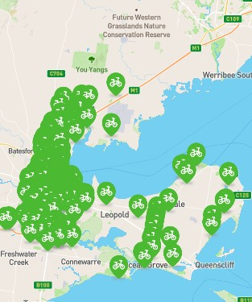
Figure 8 – Map of contributions in the Bicycle category.
Verbatim responses from most upvoted pins:
“Where does this bike lane end? It just kind of drops off mid intersection and leaves you in the traffic while everyone's changing lanes. It would be great to see this continue down Gheringhap St to the Waterfront”. (North of the intersection of Gheringhap Street and Little Malop Street, Geelong)
“Drivers regularly fail to give way to bikes in the bike lane. Drivers regularly stop across the bike lane obstructing both inbound and outbound traffic”. (Gheringhap Street, Geelong)
“Cars park in the bike lane here frequently as the plastic bollards conveniently end a few metres from where the bike lane starts. Very annoying in what is otherwise a decent bike lane. Would be a simple fix to install a few more bollards”. (Gheringhap Street, Geelong)
“Cycle connections lacking from Warralilly along HSB road into Geelong - sections of bike lanes, however other sections where cyclists have to travel on the road - limited space”. (Horseshoe Bend Rd between Warralily Boulevard and Burvilles Road, Armstrong Creek)
Table 1 –Suburbs with the most contributions in the Bicycle category.
Location | Total Contributions | % Contributions
Geelong | 74 | 22.6%
Belmont | 25 | 7.7%
Highton | 18 | 5.5%
South Geelong | 17 | 5.2%
Fyansford | 14 | 4.3%
Corio | 11 | 3.4%
Armstrong Creek | 11 | 3.4%
Waurn Ponds | 10 | 3.1%
Geelong West | 10 | 3.1%
East Geelong | 10 | 3.1%

Drive/Vehicles
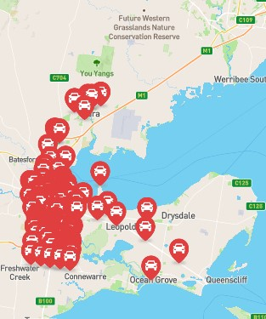
Figure 9 – Map of contributions in the Drive/Vehicle category
Verbatim responses from most upvoted pins:
“Please connect Central Boulevard to Horseshoe Bend Rd to help with cars, pedestrians and bike riders. Would be a big advantage for all the school traffic and take traffic off Warralilly Boulevard & Carter Rd.” (Central Boulevard, Armstrong Creek)
“There should be a dedicated drop off/pick up lane for the primary and secondary school to make drop off/pick ups safer
Cars should be able to approach, pull over and then move off again without stopping the other traffic. There was a child hit while trying to get to school the other day it needs to be made safer and more streamlined”. (Central Boulevard, Armstrong Creek)
“This intersection is getting really dangerous with drivers coming from all 4 directions now. People are getting impatient and rushing out in front of oncoming cars and the cars on opposite sites of entering the main Road (Barwon Heads Road) are trying to figure out who can go first when Barwon Heads Road is free. A roundabout would have been way better here or even lights”. (Intersection of Barwon Heads Road and Boundary Road)
Table 2 – Suburbs with the most contributions in the Drive/Vehicles category.
Location | Total Contributions | % Contributions
Armstrong Creek | 51 | 22.8%
Grovedale | 29 | 13.0%
Geelong | 22 | 9.8%
Highton | 19 | 8.5%
Waurn Ponds | 13 | 5.8%
Belmont | 12 | 5.4%
Charlemont | 12 | 5.4%
Mount Duneed | 9 | 4.0%
Geelong West | 9 | 4.0%
Newtown | 8 | 3.6%

Bus
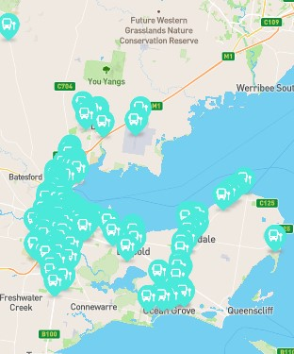
Figure 10 – Map of contributions in the Bus category.
Verbatim responses from most upvoted pins:
“Connectivity between Drysdale and Ocean Grove, will help with locals and tourism (Schools, missing the school bus, beach, shopping, work...)”.
“We need a City Loop bus that’s free or very low cost”.
“No direct bus service around the Bellarine Peninsula for students to move around the area if they miss the designated school bus which can have a huge impact on attendance”.
“The Queens Park Bridge should be upgraded so that route busses can use the bridge allowing for reconfigured Highton and Newtown bus routes that can provide faster and more direct services”.
“The location and amenities at the bus station at Moorabool Street need to be improved and made safer. I will not use them or go near them”.
Table 3 – Suburbs with the most contributions in the Bus category.
Location | Total Contributions | % Contributions
Highton | 16 | 10.2%
Geelong | 13 | 8.3%
Ocean Grove | 12 | 7.6%
Newtown | 9 | 5.7%
Belmont | 8 | 5.1%
Lara | 7 | 4.5%
Norlane | 7 | 4.5%
Grovedale | 7 | 4.5%
Leopold | 6 | 3.8%
Mount Duneed | 5 | 3.2%

Walk
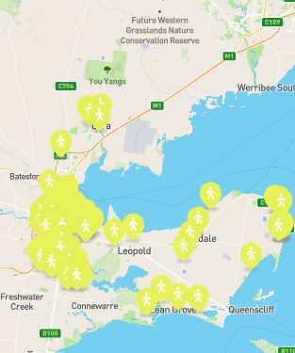
Figure 11 – Map of contributions in the Walk category.
Verbatim responses from most upvoted pins:
“The road is far too wide and has no traffic island, making it extremely dangerous for pedestrians to cross when trying to access parks or shops in this area”. (Fyans Street, South Geelong)
“Add pedestrian priority to crossings around South Geelong Station and lower speed limits to 40 km/h. This area is frequently congested with pedestrians who should have priority given the proximity to public transport”. (Yarra Street, South Geelong)
“This roundabout requires better and safer access for pedestrians, with all the schools/daycares around it and proximity to shops. A good example to follow would be that recently completed near Grovedale Primary School/ Marshalltown Rd”. (Intersection of Central Boulevard and Carter Road, Armstrong Creek)
“This crossing needs to be signalised to allow pedestrians and cyclists using the shared trail to cross Torquay Hwy safely”. (Waurn Ponds Creek Trail crossing at Surf Coast Highway, Grovedale)
Table 4 – Suburbs with the most contributions in the Walk category.
Location | Total Contributions | % Contributions
Geelong | 22 | 15.4%
St Leonards | 14 | 9.8%
Armstrong Creek | 11 | 7.7%
South Geelong | 11 | 7.7%
Grovedale | 10 | 7.0%
Belmont | 9 | 6.3%
Highton | 8 | 5.6%
Newtown | 6 | 4.2%
Waurn Ponds | 5 | 3.5%
Thomson | 5 | 3.5%

Place/General
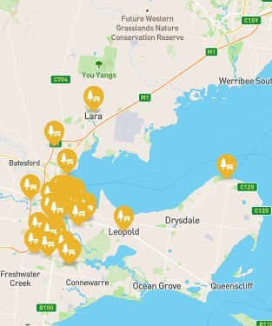
Figure 12 – Map of contributions in the Place/General category.
Verbatim responses from most upvoted pins:
“It would be amazing to have a public playground somewhere on this oval. Younger siblings during sports games could play at it and there are no other playgrounds near this area”. (Creekward Drive, Armstrong Creek)
Advocate to VicRoads to plant up central medians and nature strips along the length of Latrobe Terrace. The street is an eyesore that is a terrible way to welcome visitors to Geelong and makes is less attractive and more pollution-filled to local residents”. (LaTrobe Terrace, Geelong)
“This area is a bit of a concrete jungle. Add street trees and greenery”. (Yarra Street, South Geelong)
Table 5 – Suburbs with the most contributions in the Place/General category.
Location | Total Contributions | % Contributions
Geelong | 13 | 22.0%
Newcomb | 7 | 11.9%
Armstrong Creek | 6 | 10.2%
Belmont | 4 | 6.8%
Grovedale | 4 | 6.8%
South Geelong | 4 | 6.8%
Mount Duneed | 3 | 5.1%
Breakwater | 3 | 5.1%
East Geelong | 3 | 5.1%
Lara | 2 | 3.4%

Train
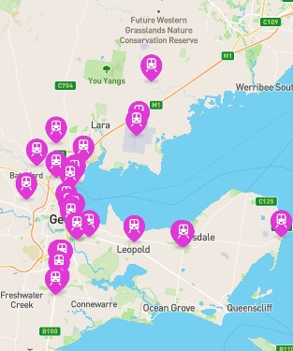
Figure 13 – Map of contributions in the Train category.
Verbatim responses from most upvoted pins:
“Advocate for the return of Breakwater station”.
“Train Station Airport Rail Link
Between Lara and Avalon Airport
A cheaper and affordable method of transit to the airport. Build it and forget Tullamarine”.
“Train Station for Torquay, Armstrong Creek as population grows”.
Table 6 – Suburbs with the most contributions in the Train category.
Location | Total Contributions | % Contributions
Geelong | 5 | 16.7%
Mount Duneed | 3 | 10.0%
North Shore | 2 | 6.7%
South Geelong | 2 | 6.7%
Curlewis | 2 | 6.7%
Victoria | 2 | 6.7%
Little River | 1 | 3.3%
Bell Post Hill | 1 | 3.3%

Mobility aid
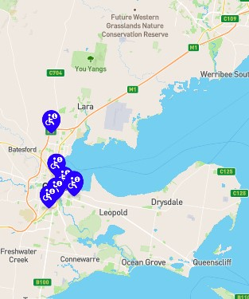
Figure 14 – Map of contributions in the Mobility aid category.
Verbatim responses from most upvoted pins.
“People parking across footpaths, issue right across Geelong”.
“Bad area for elderly to cross the road and get access to the bus to Torquay”. (Barwon Heads Road entrance to Belmont Village, Belmont)
Table 7 – Suburbs with the most contributions in the Mobility aid category.
Location | Total Contributions | % Contributions
Belmont | 2 | 28.6%
Corio | 1 | 14.3%
Drumcondra | 1 | 14.3%
East Geelong | 1 | 14.3%
Newcomb | 1 | 14.3%
Geelong | 1 | 14.3%
Lovely Banks | 1 | 3.3%
Moorabool | 1 | 3.3%

Survey
There were 583 surveys completed during the engagement period. It is worth noting that some questions allowed people to select multiple options and total number of responses is greater than total number of surveys. These questions have been marked with an asterisk (*) below
In the past month what was your most common mode of transport to your place of work or study?*
The most common way of getting to work is by private vehicle with 72% of people indicating they either drive or are a passenger or both.
Figure 15 provides a detailed breakdown of answers to this question.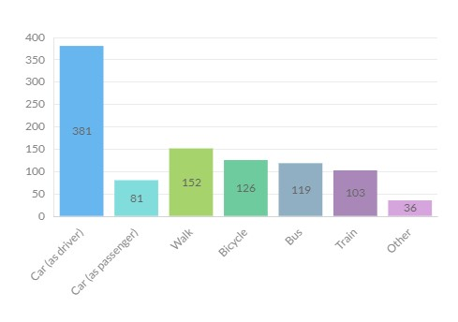
Figure 15 – Responses to “In the past month what was your most common mode of transport to your place of work or study?”
In the past month what was your most common mode of transport to get to the shops?*
The most common way of getting to the shops is by private vehicle as 85% of people indicated they either drive or are a passenger or both.
Figure 16 provides a detailed breakdown of answers to this question.
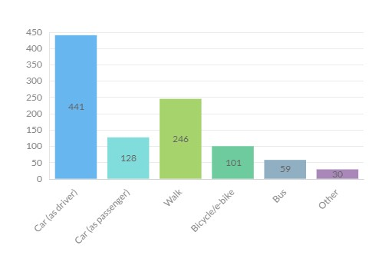
Figure 16 – Responses to “In the past month what was your most common mode of transport to get to the shops?”
In the past month what was your most common mode of transport to get to social and recreational activities?*
The most common way of getting to social/recreational activities is by private vehicle as 87% of people indicated they either drive or are a passenger or both.
Figure 17 provides a detailed breakdown of answers to this question.
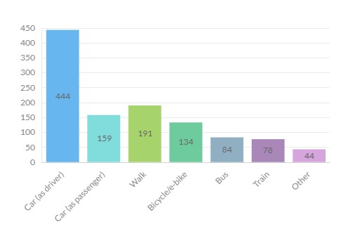
Figure 17 – Responses to “In the past month what was your most common mode of transport to get to social and recreational activities?”
Are there other modes of transport that you would like to use for these everyday trips if they were more accessible and / or easier to use?*

56% of people said that they would catch a bus more frequently for everyday trips if they were more accessible and easier to use.
36% of people said that they would ride a bicycle or e-bike more frequently for everyday trips if they were more accessible and easier to use.
30% of people said that they would catch a train more frequently for everyday trips if they were more accessible and easier to use.
Figure 18 provides a detailed breakdown of answers to this question.
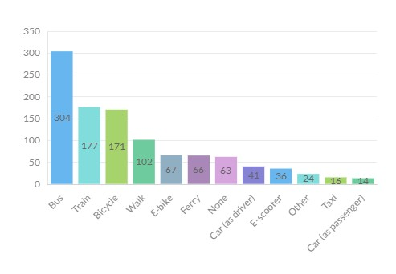Figure 18 – Responses to “Are there other modes of transport that you would like to use for these everyday trips if they were more accessible and / or easier to use?”
What would make accessing these other modes of transport more accessible and / or easier for you to use?
Improving the frequency, connectivity, directness, reliability and safety of buses and bus related infrastructure were the most common aspects that people identified as enablers to more frequent use of this mode for everyday trips.
Improving the safety and connectivity of bicycle infrastructure were the most common aspects that people identified as enablers to more frequent use of this mode for everyday trips.
Improving parking management and traffic congestion were common themes for those preferring to drive.
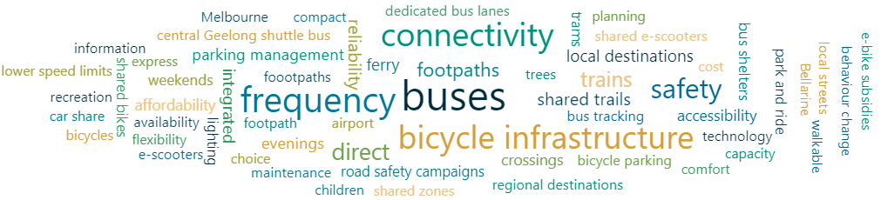
Figure 19 – Common themes that would enable use different modes of transport
Do you have children that attend school, kinder or childcare?
47% of people said that they have children that attend school, kinder or childcare.
Figure 15 provides a detailed breakdown of answers to this question.
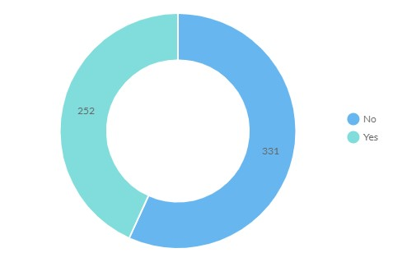Figure 20 – Responses to “Do you have children that attend school, kinder or childcare?”
During a typical week, how do your child/ren travel to and from school, kinder or childcare?*
72% of parents said their child/ren are commonly driven to school, kinder or childcare.
It is worth nothing that “Other” included skateboard and e-scooter. Further, “Public transport” includes privately run school buses for the sake of comparing mode share.
Figure 21 provides a detailed breakdown of answers to this question.
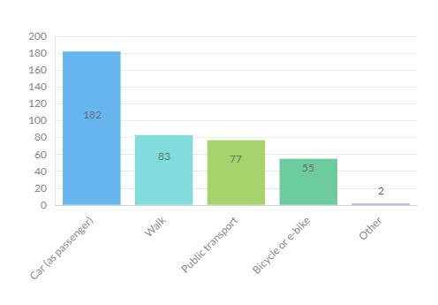Figure 21 – Responses to “During a typical week, how do your child/ren travel to and from school, kinder or childcare?”
Are there other ways you would like your child/ren to travel to and from school, kinder or childcare if it were more accessible and / or easier to do so?*
46% of parents said that they were happy with how their child/ren got to school, childcare or kinder.
33% of parents said that they would like their child to get to school, childcare or kinder on a bicycle or e-bike. It is unclear what age the child/ren are and what proportion of these parents would opt for their child/ren to ride independently or with an adult.
19% of parents said that they would like their child/ren to catch public transport to school. It has been assumed that most of these responses relate to school aged children catching public independently.
Figure 22 provides a detailed breakdown of answers to this question.

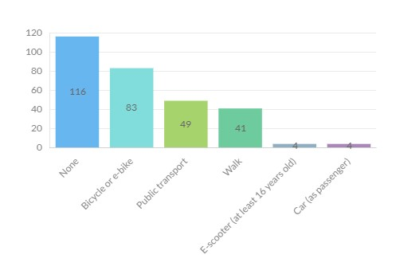Figure 22 – Responses to “Are there other ways you would like your child/ren to travel to and from school, kinder or childcare if it were more accessible and / or easier to do so?”
What would make these modes of transport more accessible and / or easier for your child/ren to travel to school, kinder or childcare?
There were four main themes that parents identified regarding access to school, kinder and/or childcare by different modes of transport which were:
- Safety and connectivity or footpaths and road crossings to improve walkability to these destinations.
- Safety and connectivity of bicycle infrastructure on the way to and directly adjacent to these destinations.
- Reliability, timing, availability and avoiding overcrowding of public transport options to these destinations.
- Effective parking management directly adjacent to these destinations.
Is there anything else you'd like to tell us about your vision for the future of transport in Geelong?
The responses to this question helped inform and are generally aligned with the key themes presented on pages 12-14 of this report.

Vision Board
All vision board posts are available to see online at https://yoursay.geelongaustralia.com.au/ITS/ITSvision.
The most popular vision board posts that aligned with the objective of being transformational for Greater Geelong were:

A comprehensive network of safe and connected bicycle infrastructure
There was a desire for bicycle infrastructure that attracts people of any age and ability.

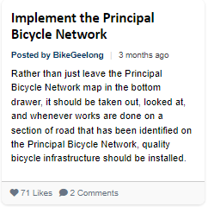

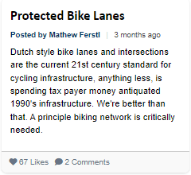
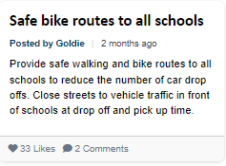

To make Greater Geelong safer for people walking
There were calls to adopt an approach that prioritises people walking in central Geelong and local neighbourhoods.
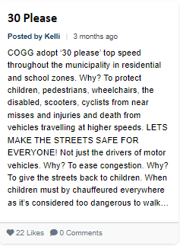

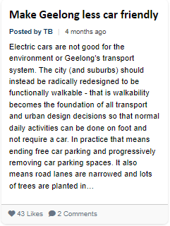

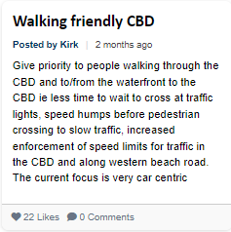

Drastic improvement in public transport offerings and integration with other modes
There were calls for a more modern bus system that prioritises frequency and direct travel for commuter trips and radial connectivity between suburbs for other trips.
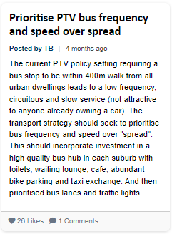

Idea to promote the uptake of e-bikes and create safe active travel links to transport hubs to promote active travel and tourism.
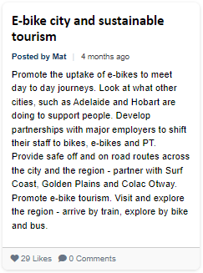
Idea for a metro-style train service for Geelong that encourages urban renewal projects with fast and reliable rail connections to central Geelong, other suburbs, and Melbourne.
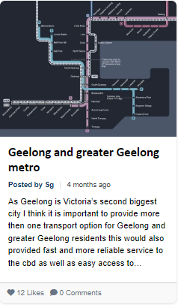

Formal Submissions
We received written submissions from organisations and individuals and the content of these submissions generally aligns with the broader community’s response.

Feedback through informal channels
The engagement also attracted 21 comments on social media across two posts. These comments broadly reflected the sentiment and themes gathered through the formal engagement process.

Community engagement successes
Reaching out directly to local schools via email to request that they share the engagement with their communities generated good levels of engagement from parents and those under 18 years of age.

Community engagement areas for improvement
Attending local markets and area of high pedestrian activity yielded lower rates of engagement than expected. This is likely because the engagement phase covered such a broad concept and the entire municipality. Higher rates of engagement from pop up and promotional activities are more likely to be achieved when the project is more specific to a location. Hosting in person sessions and promotional activities are still considered an important component of engagement on strategy development and opportunities for improvement will be identified for future phases.

What we have done and/or next steps

What we have done
The findings from this engagement will help inform a background report/discussion paper that will assist with further phases of engagement and the development of the ITS itself.
The project team will consider the most appropriate strategic responses to each of the key themes identified and work with internal departments to ensure that responses that relate to operational issues are captured, documented, and responded to accordingly.

Next Steps
The background report/discussion paper will be drafted and made publicly available at the beginning of the next phase of engagement for the ITS that will focus on active travel.
The review of the Principal Bicycle Network will be conducted in partnership with the Department of Transport and Planning, TAC and community groups. Feedback on outcomes of the review will be sought from the broader community as part of the next phase of engagement.

Appendix A – Survey Questions
Q1. Which of the following best describes your connection to Greater Geelong?
Q.2 Please tell us how important the following are to you when thinking about the future of transport in Greater Geelong. (Each of the below was rated on a 5-point scale from “Very important” to “Not at all important”)
- Public transport that is safe, frequent, reliable, fast and well connected
- A transport system that promotes Geelong's economic growth and productivity
- High quality transport connections to other regional centres like Ballarat and Bendigo
- Liveability and amenity of streets and local neighbourhoods
- A road network that is safe and well connected
- An equitable and accessible transport system that provides a range of options for all users
- Footpaths that are safe and well connected
- High quality transport connections to Melbourne
- A bicycle network that is safe and well connected
- A transport system that is sustainable and generates net zero emissions
- Innovation and the use of emerging transport technology
Q3. In the past month what was your most common mode of transport to your place of work or study?
Q4. In the past month what was your most common mode of transport to get to the shops?
Q5. In the past month what was your most common mode of transport to get to social and recreational activities?
Q6. Are there other modes of transport that you would like to use for these everyday trips if they were more accessible and / or easier to use?
Q7. What would make accessing these other modes of transport more accessible and / or easier for you to use?
Q8. Do you have children that attend school, kinder or childcare?
If response was “Yes” to Q8, survey included Q9, Q10 & Q11.
Q9. During a typical week, how do your child/ren travel to and from school, kinder or childcare?
Q10. Are there other ways you would like your child/ren to travel to and from school, kinder or childcare if it were more accessible and / or easier to do so?
Q11. What would make these modes of transport more accessible and / or easier for your child/ren to travel to school, kinder or childcare?
Q12. Is there anything else you'd like to tell us about your vision for the future of transport in Geelong?

