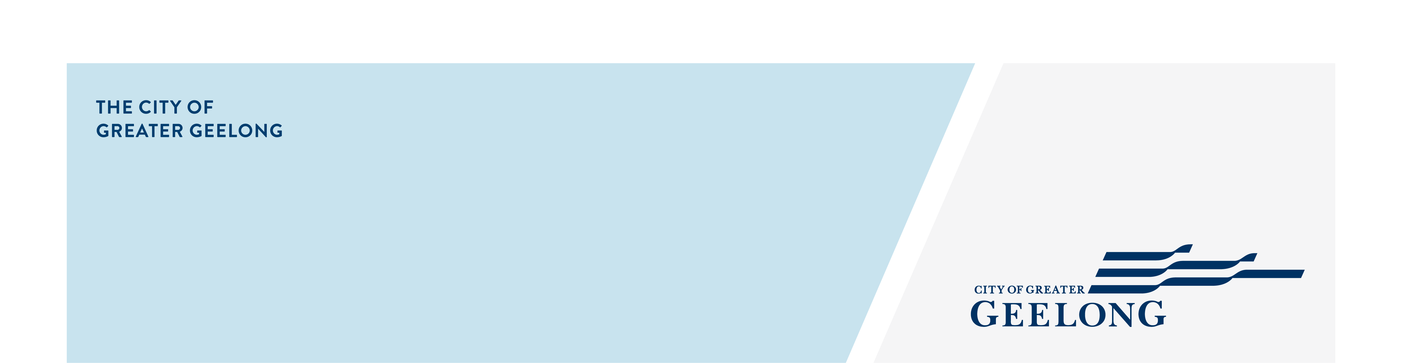
Social Inclusion Action Group

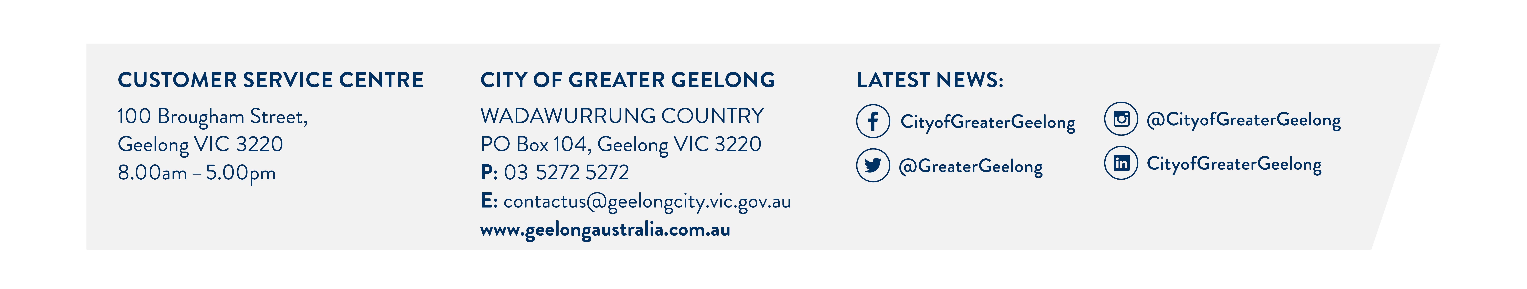
Expression of Interest

The City of Greater Geelong is forming a Social Inclusion Action Group (SIAG) — a group of local people who will, together, investigate the drivers of loneliness isolation in the Greater Geelong Community and decide on the best course of action to overcome them.

We are looking for people of all backgrounds to join our group and the questions below reflect this. We are committed to providing a safe and respectful space where your experiences can be shared. We can offer support to participate, including support with child-care and transport.

Please complete this form and send it to: Social Inclusion Action Group Officer, Community Strengthening, Wadawurrung Country, PO Box 104, Geelong, Vic 3220
Applications Close July 2025.

Check this box to indicate that you have read and agree to the privacy statement provided Required

Do you agree to work respectfully with people from all walks of life? Required

First name:

Last name:

Best contact number:

Email address:

Why do you want to be a part of the Social Inclusion Action Group?: ______________________________________________________________________________________________________________________________________________________________________________________________________________________________________________________________________________________________________________________________________________________________________________________________________________________________________________________________________________________________________________________________________________________________________________________________________________________________________________________________________________________________________________________________________________________________________________________________________________________________________________________________________________________________________________________________________________________________________________________________________

8. Have you experienced any of the following situations? Please select all that you're comfortable sharing?
- Experience of unemployment
- Experience of mental-illness or mental ill-health
- Felt lonely or social isolation
- Lived in unstable housing
- Caring for someone
- None of the above
- Other experience- please tell us more:
______________________________________________________________________________________________________________________________________________________________________________________________________

9. Are you connected to any community groups? Please tell us about any social or sporting clubs, lived experience networks, or consumer groups (formal or informal) you are a part of.
______________________________________________________________________________________________________________________________________________________________________________________________________

Do you identify as any of the following? Please select any that apply. We are hoping to ensure the group reflects the diversity of our community and would like to find out if any of the aspects of your identity may empower you to lend valuable perspectives to group discussions.
- First Nations
- Person with a disability
- LGBTQIA+
- Culturally and Linguistically Diverse
- Single Parent
- None of the above

What Town or Suburb are you from:

What is your gender?
- Man
- Woman
- Non-binary
- Prefer not to say
- Self-described (please specify)

What is you age group?
- Under 18
- 18-24
- 25-34
- 35-49
- 50-59
- 60-69
- 70-84
- 85+

14. Would access to any of these supports assist you to take part in the group. Please select all that apply. We will work with you to organise supports if you are selected to be a part of the group.

- Childcare or child friendly meeting space
- Transport
- Wheelchair/pram access
- Digital access
- Sign language
- Assisted listening
- Visual aids
- Something else (please let us know)

