community engagement summary
The City of Greater Geelong is currently undertaking a Stormwater Study in our Highton Catchment. This study will assist the City and relevant authorities to better understand and manage flood risk, stormwater quality impacts on local waterways, and alternate water supply options for the region. The study area encompasses parts of the suburbs of Highton, Belmont, Wandana Heights and Ceres. More information on this study can be found at Have Your Say- Highton-SWMS.

We conducted the first round of community engagement between 14th May 2025 to 13th June 2025. We are grateful for all the members of the community who came forward to provide their feedback and share their experiences.

The feedback shared by the community is being used to validate the catchment model to ensure it reflects their experiences.

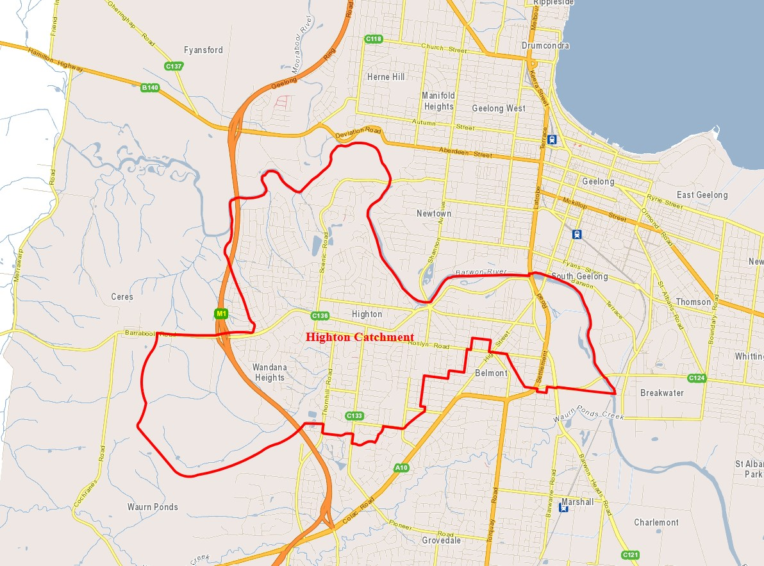

HOW WE ENGAGED
WHAT DID WE DO?
A dedicated Have Your Say project page was designed to enable the community to share relevant information and provide their feedback. All community members were welcome to respond to the survey.

An interactive map was also made available to gather further local insights from the community. This will help us better inform our work and assist with the accuracy of the catchment modelling. We received a total of 48 responses using this social map.

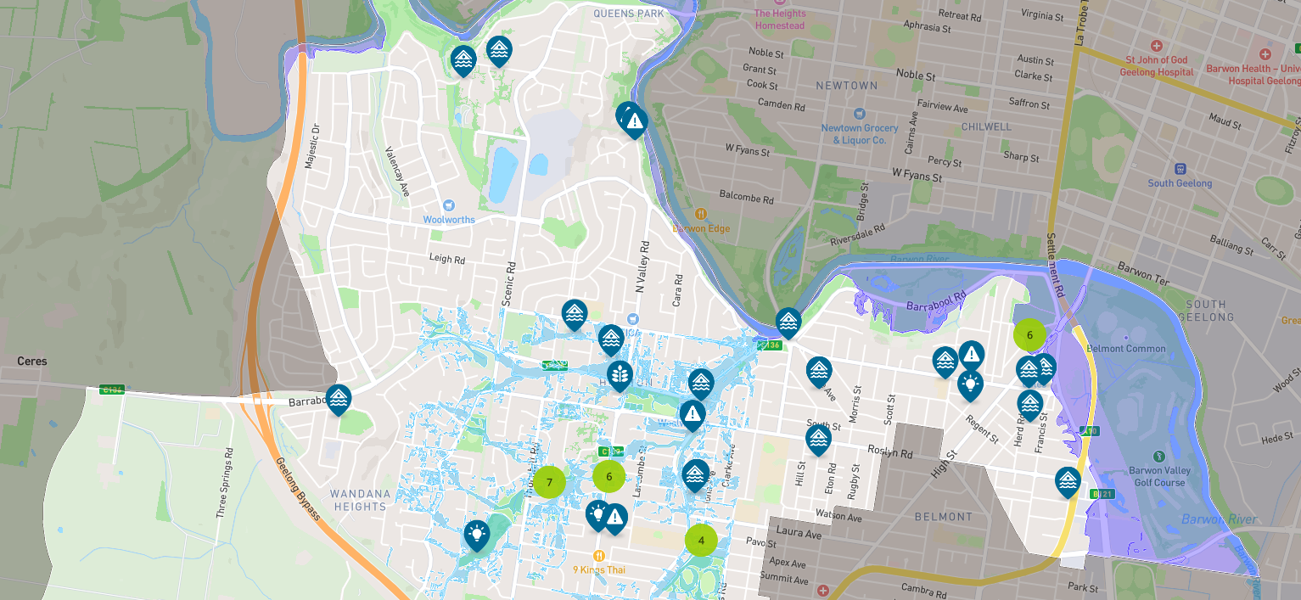

The Have Your Say page had an online survey which was designed as a tool to gather some core feedback from the community. This will also help us in getting better understanding of the local area. We received a total of 151 responses from this survey.


702
People visited the Have Your Say (HYS) page.

151
Number of completed online surveys.
Suggestions (comments) from the public left online via social map
48

68
31 DAYS
of engagement (Stage 1)

People following the project.

Communications
The engagement survey was widely promoted using social media posts using platforms such as Facebook, Instagram, and LinkedIn.


SOCIAL MEDIA
2,401
Reach/Impressions
34
Actions (Clicks, reactions,
shares, comments etc.)

Who we engaged with

PARTICIPATION
Most responses were from residents and community members within the study area. We saw a wide variety in the demographics of the residents who responded to the survey. We received feedback from interested community members, property owners, current and past residents, community groups, and business owners.

The vast majority of residents to respond were long term residents who have been living in the area for more than 10 years.

WHAT WE HEARD

THE FEEDBACK
Of the residents who responded, 78% of have experienced flooding on or around their property and 69% are concerned about future flooding.
Most respondents believe flooding has been caused by excess overland water (68%) and blockage of underground drains (58%).

OVERALL KEY FINDINGS
- Most respondents come from the suburbs of Highton, Belmont, and Wandana Heights.
- Most respondents are highly impacted and invested, in that they:
- Almost exclusively represent residents and property/business owners.
- Predominantly are long-term residents living in the area for more than 10 years (56%).
- Majority of residents have first-hand experience of flooding (78%).
- 46% of residents have recent (1-2 years) flood experience.
- More than two-thirds (69%) of residents are concerned about future floods.

- Among the residents who have experienced flooding, more than half (60%) reported flooding on driveways, streets, footpaths, or gardens, while 50% reported flooding inside their homes/dwellings.
- Most respondents said they believe flooding occurred because of both excess natural water and blocked drains.

Next Steps

We are currently using the provided feedback, experiences, and digital resources (photos/videos) to validate our catchment model. We will undertake a floor-level survey of selected properties in the study area to assist with the accuracy of our results.
There will be two further rounds of community engagement during the life of the study.
- Stage 2 – This stage presents draft flood mapping and mitigation options to reduce the impact of flooding on impacted community members. Feedback and suggestions are welcome. This round of engagement is expected to be run in early 2026.
- Stage 3 – This stage informs the community by presenting the draft final Highton Stormwater Management Strategy. This is expected to occur in the second half of 2026.

