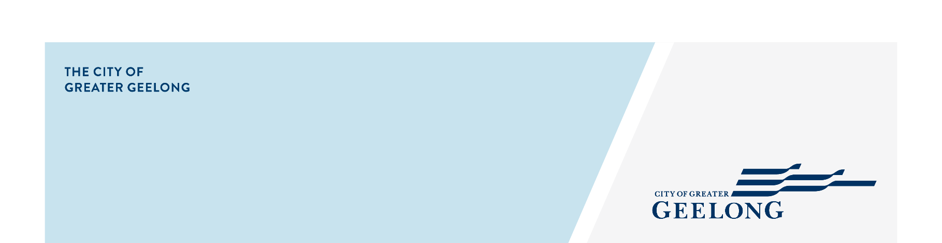

PUBLIC ART STRATEGY
ENGAGEMENT SUMMARY

COMMUNITY ENGAGEMENT RESULTS
The Public Art Strategy Engagement Report provides an overview of the findings from online and face-to-face community/stakeholder engagement activities conducted from March-August 2025, to inform development of the new Public Art Strategy. Research, benchmarking, and the development of a background paper were drafted to inform key issues and opportunities. A peer review external reference panel was established for the duration of the engagement, providing expert advice.

KEY OBJECTIVES HOW WE ENGAGED

The key objectives for the consultation and engagement were to:
- Gain an understanding of community values and priorities for art in the public realm.
- Gather diverse perspectives - voices from different demographic, cultural, and stakeholder groups, including artists/creatives.
- Identify opportunities and challenges.
- Inform strategic decision-making - guide goals, policies, and implementation plans.
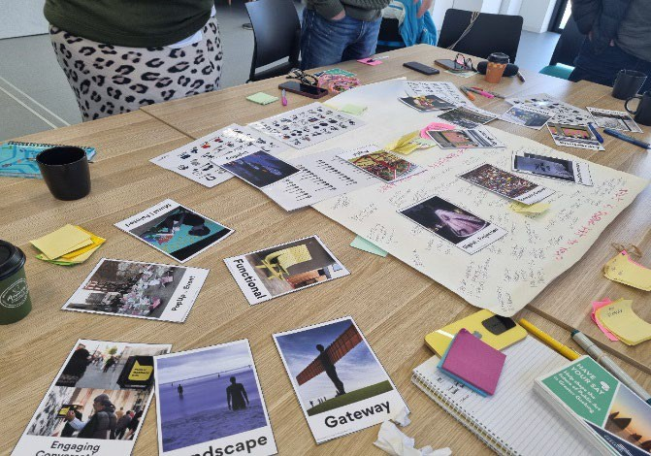
- Build public awareness and support for the public art program - developframeworks and relationships for ongoing public art initiatives.
Engagement consisted of:
- 6 workshops – community, artists and creatives, peer review panel, developer interviews
- Online surveys (general and youth specific)
- Face-to-face drop-in sessions at our libraries across the municipality
- Youth Council workshop, drop-ins at the NEST, and targeted survey
- Council briefing and workshop
More than 590 individual engagements, including 167 survey responses, 71 participants across the organisation, 164 participants across 6 workshops, 254 participants through library drop-ins, youth-focused engagement, ongoing First Nations targeted engagement, and a Councillor briefing and workshop.
Approximately (30%) engaged online, and (70%) engaged in person through workshops and our face-to-face events.
Information regarding key visitation and utilisation on the Have Your Say page resulted in the following:
- 1,549 views of pages on the Have Your Say site.
- 1,141 vsits - user sessions on the Have Your Say site.
- 174 responses or feedback collected through the participation tools.

HTTPS://YOURSAY.GEELONGAUSTRALIA.COM.AU/PUBLICARTSTRATEGY

WHAT WE HEARD
Overall, the Public Art Strategy consultation received widespread feedback from community members and stakeholders, reflecting strong local support and engagement. This is consistent with recent community feedback for the Council Plan 2025-29, which highlighted Arts and Culture as one key priority area - noting the community’s desire for more support for arts and cultural activities, especially for youth. Community and stakeholders feedback highlighted several reflections, issues, and opportunities, and embraced a broad vision for public art into the future.
VALUE OF PUBLIC ART
The community and stakeholders placed a strong value on public art, noting that public art adds a ‘defining image to our city identity’, ‘enhances our cultural destination offer’, ‘builds connection and expresses our people and place’, and highlighted how public art enriches public life in meaningful ways.
DEFINITION OF PUBLIC ART
Participants acknowledged the ever-changing definitions of contemporary public art and practice - that contemporary public art is constantly evolving, shaped by cultural, social, political, and technological changes. It has become more temporary, participatory, engaging and often challenges boundaries of art, space (public realm) & audience.
CURRENT OBSERVATIONS
When asked about public art in Geelong now – observations noted that whilst the current program is varied, participants considered public art to be lacking broad visibility and being somewhat ‘timid’ ‘minimal and sparse’, ‘conservative’. When asked about a future vision for public art across the city, responses were extremely positive – ‘be ambitious’, ‘inspiring’, ‘challenging’, ‘authentic’.
HAVE A PURPOSE
The key phrase that resonated with most participants was ‘to make art public’. They wanted to ensure that public art remains democratic – a visual voice that can speak truth, raise awareness, celebrate identity, and inspire change.
Contributors expressed the desire to see public art ‘say something’ and how public art can spark conversation amongst the community and be a powerful voice.
THE IDENTITY OF PLACE
Community and stakeholders also conveyed their aspirations for ‘public art to help to enhance/ develop/investigate the identity of place across Geelong’. This is particularly applicable given the City’s current and rapid urban transformation, driven by strategic planning, significant infrastructure projects, and a surge in population growth. Participants also acknowledged that being ‘inventive’ with public art and the public realm’ would ‘support the municipality’s designation of UNESCO City of Design’.
‘CARE FOR COUNTRY’
Community shared their interests for public art to be strongly place driven and be investigative and responsive to environmentally sustainable practice/issues, ecology and adopting First Nations ‘Care for Country’ principles (cultural, spiritual, and physical connection).
This could also be expressed through community generated projects to contributing to sustainable design.
TEMPORARY PUBLIC ART AND ART INVENTIONS/ACTIVATIONS
Respondents expressed comments on revitalising Central Geelong and how temporary public art and ‘art inventions/activations’ could help transform neglected areas into vibrant places of meaning, shifting how people use and relate to those spaces. Likewise how more engagement with the development sector on public art.
Stronger value also was expressed by participants on public art sustaining local events, festivals and traditions supporting the City’s wealth of shared history/heritage. An opportunity exists in creating shared, vibrant, and often temporary experiences in public space for cultural celebration.
HTTPS://YOURSAY.GEELONGAUSTRALIA.COM.AU/PUBLICARTSTRATEGY

