Acknowledgement of country
Greater Geelong is located on the traditional lands of the Wadawurrung people. The land was created by the great ancestor spirit, Bunjil, the wedge-tailed eagle. Wadawurrung territory extends from the great dividing range in the north to the coast around Port Phillip Bay.
The city acknowledges the Wadawurrung people as the traditional owners of this land who to this day practice their culture and uphold the dignity of their ancestors.

DOCUMENT TRACKING
This document was prepared on behalf of the City of Greater Geelong by Biosis and Open Lines.
DOCUMENT TRACKING
PREPARED BY:
Heather Tolley, Peter Hemphill, Heidi Birkby (Open Lines)
REVIEWED BY:
Heather Tolley, Peter Hemphill (Open Lines)
Mitchell Deaves (Biosis)
VERSION CONTROL:
VERSION: | Public exhibition version
DATE: | May 2023

Contents
List of Figures ii
1 What is the Strategic Assessment and why is it being undertaken? 1
1.1 Background to the Strategic Assessment 1
1.2 Key social and environmental values of the Growth Areas 1
1.3 The current status of the project 3
2 What are the key documents? 3
2.1 Overview 3
2.2 The NWGGA EPBC Plan 3
2.3 The Strategic Assessment Report 4
2.4 The Northern and Western Geelong Growth Areas Commitments and Measures 4
2.5 The Northern and Western Geelong Growth Areas Biodiversity Conservation Strategy 4
2.6 The Northern and Western Geelong Growth Areas Funding Program 4
3 What development is allowed for under the Plan? 4
3.1 Types of development under the Plan 4
3.2 Location of development 5
4 What is the conservation program? 5
5 What assurance is there that the Plan will be delivered successfully? 7
6 What are the key findings of the Strategic Assessment Report? 8
6.1 Purpose of the Strategic Assessment Report 8
6.2 Biodiversity values at risk of direct impacts under the Plan 8
6.3 Biodiversity values at risk of potential indirect impacts under the Plan 8
6.4 Evaluation of the adequacy of the Plan 9
References 10

List of Figures
Figure 1: Location of the strategic assessment 2
Figure 2: Strategic assessment documents 3
Figure 3: Location of development under the Plan 6

The purpose of this document is to provide the community and other stakeholders with a summary of the Northern and Western Geelong Growth Areas (NWGGA) Strategic Assessment. It provides a brief overview of the background and context, the key documents, and the main components of the strategic assessment.

What is the Strategic Assessment and why is it being undertaken?

Background to the Strategic Assessment
The City of Greater Geelong (the City) has identified two areas for urban growth near the centre of Geelong. These areas are known as the Northern and Western Geelong Growth Areas (the Growth Areas) (see Figure 1). The Growth Areas were identified to support the long-term growth of Geelong over the coming decades (Geelong Region Alliance, 2007; The City of Greater Geelong, 2021). The City prepared the Northern and Western Geelong Growth Areas Framework Plan which identifies these areas for urban development until 2047.
The development of the Growth Areas will lead to impacts to various biodiversity values which are protected under the Commonwealth Environment Protection and Biodiversity Conservation Act (EPBC Act) and Victorian state biodiversity regulations.
The City is undertaking a strategic assessment under Part 10 of the EPBC Act to support the development of the Growth Areas while protecting matters of national environmental significance (MNES). The strategic assessment provides landscape scale assessment and approval of development under the EPBC Act, and the opportunity to deliver improved environmental and developmental outcomes.

Key social and environmental values of the Growth Areas
The traditional owners of the country now known as Geelong are the Wadawurrung Aboriginal people, meaning “the people who belong to the water”. The Wadawurrung people are a recognised tribe comprising 25 clans (family groups) which form part of the larger Kulin Nation of Aboriginal people (Rowe, 2021).
Today, the land relevant to the strategic assessment (the ‘Strategic Assessment Area’, see Figure 1) has mostly been developed for agricultural purposes. As a result, the condition of the environment of the Growth Areas varies. Most of the area has been impacted by agricultural land use, is highly modified, and dominated by weeds. Areas of native vegetation do occur, though are limited to riparian corridors and areas which have not been subject to cropping (EHP, 2021).
Despite this, the Growth Areas continue to support a number of biodiversity values which have not been impacted by historical disturbance. Biodiversity values which have been identified by on-ground surveys of the Growth Areas include (EHP, 2021):
- Areas of native vegetation - including Plains Grassland (EVC 132), Creekline Grassy Woodland (EVC 68), and Floodline riparian woodland (EVC 56)
- Threatened ecological communities - including the Commonwealth listed Natural Temperate Grassland of the Victorian Volcanic Plain and the state significant Western (Basalt) Plains Grassland in the Northern Geelong Growth Area
- Threatened flora - including the Commonwealth listed Adamson’s Blown Grass (Lachnagrostis adamsonii) (historical records) and the state significant Leafless Bluebush (Maireana aphylla)
- Threatened fauna - including three Commonwealth listed species – the Golden Sun Moth (Synemon plana), Striped Legless Lizard (Delma Impar), and Growling Grass Frog (Litoria raniformis), the state significant species Hardhead (Aythya australis), and an active Platypus burrow within the Moorabool River
- Waterways - including the Moorabool River, the Barwon River, and Cowies Creek which provide known and potential habitat for a range of fauna species
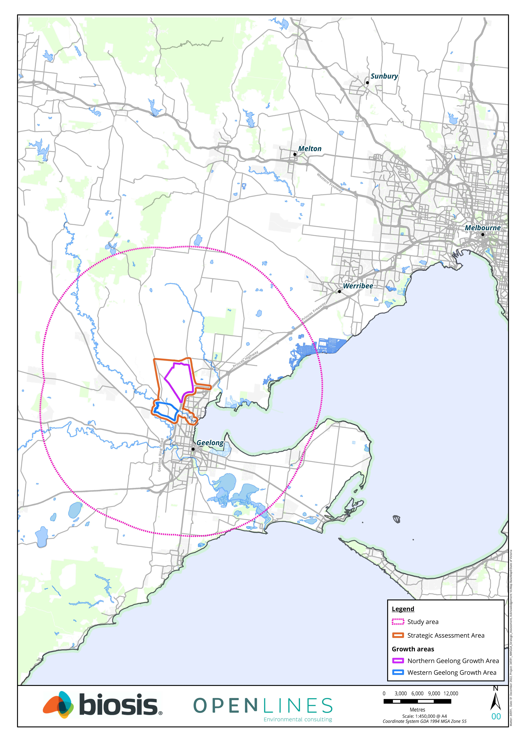

Figure 1: Location of the strategic assessment

The current status of the project
Detailed work on the strategic assessment commenced in early 2022 leading up to public exhibition of the draft documents in 2023. Following the formal public exhibition process, the document package will be finalised for submission to the Commonwealth Environment Minister for endorsement in early to mid 2024.

What are the key documents?

Overview
The Northern and Western Growth Areas EPBC Plan (the Plan) is the key document which will manage impacts to protected biodiversity values and facilitate development of the Growth Areas through approval under Part 10 of the EPBC Act. The Plan is supported by the following documents:
- The Strategic Assessment Report (SAR)
- Three implementation documents:
  - The Northern and Western Geelong Growth Areas Commitments and Measures
  - The Northern and Western Geelong Growth Areas Biodiversity Conservation Strategy (BCS)
  - The Northern and Western Geelong Growth Areas Funding Program
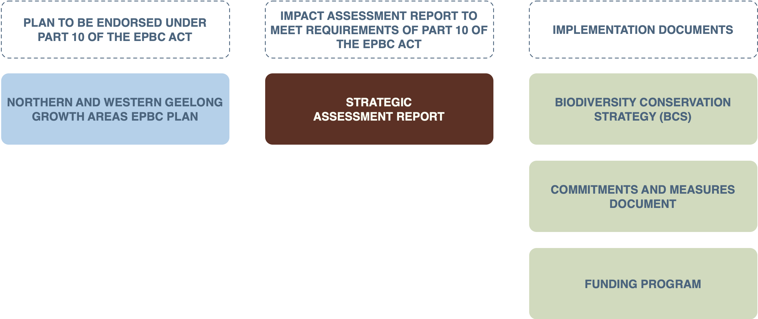
Figure 2 shows the relationship between the documents and the strategic assessment. A brief description of these documents is provided below.

Figure 2: Strategic assessment documents

The NWGGA EPBC Plan
The purpose of the Plan is to ensure development protects MNES and proceeds in accordance with the requirements of the EPBC Act. The Plan will facilitate the growth of Geelong by streamlining approvals under the EPBC Act and ensuring that implementation is cost efficient for both development and conservation.
The Plan was prepared in accordance with the Endorsement Criteria in the Strategic Assessment Agreement between the Commonwealth Minister for the Environment and the City. Its overarching objective is to:
“Provide for the protection of matters of national environmental significance while supporting the delivery of the Northern and Western Geelong Growth Areas Framework Plan and its objectives”
The Plan includes six environmental and socio-economic outcomes that need to be fulfilled in order to achieve the overall objective. It also includes a range of commitments for the City to undertake actions to address impacts on MNES. Following endorsement under Part 10 of the EPBC Act, the City will be responsible for implementing these commitments over the life of the Plan.

The Strategic Assessment Report
The Strategic Assessment Report (SAR) has been prepared to assess the impacts of development under the Plan on biodiversity values listed under the EPBC Act (MNES). The SAR evaluates the adequacy of the Plan’s outcomes and commitments in protecting MNES.
The SAR was prepared in accordance with the Terms of Reference for the strategic assessment provided under the Strategic Assessment Agreement.

The Northern and Western Geelong Growth Areas Commitments and Measures
The commitments and measures provide the mechanism through which the Plan’s objective and outcomes will be achieved. The outcomes and commitments set out in the Plan will not be changed once the Plan is endorsed. However, the measures used to implement these commitments may be updated over the life of the Plan through an adaptive management process. The measures provide key details for the responsibility, support partners, and timing for implementation of the commitments.

The Northern and Western Geelong Growth Areas Biodiversity Conservation Strategy
The BCS is an implementation document which responds to the requirements of the EPBC Act, and State biodiversity policy. The purpose of the BCS is to:
- Identify the biodiversity values in the Growth Areas (Commonwealth, state, and local) and provide a conservation program for providing long-term benefits to biodiversity
- Set out the process for implementing the conservation elements of the EPBC Plan
- Guide the preparation of Precinct Structure Plans to ensure development suitably addresses biodiversity and is consistent with state policy

The Northern and Western Geelong Growth Areas Funding Program
The funding program sets out how the Plan will be funded. Key components which require funding include:
- The delivery of offsets
- Securing and managing conservation areas
- Implementing conservation measures, the adaptive management process, and compliance program

What development is allowed for under the Plan?

Types of development under the Plan
The types of development to be approved under the Plan are defined through a set of ‘classes of actions’. There are five classes of actions which will be allowed for under the Plan:
- Urban and commercial development
- Industrial development
- Rural development
- Supporting infrastructure and services
- Environmental management
Each class of actions includes a number of broad ‘development types’ which relate to a set of ‘impact activities’ (defined in the Victoria planning provisions) that may be undertaken. The impact activities provide an understanding of the specific actions within the scope of the classes of actions.

Location of development
Development under the Plan can occur within the following areas:
- ‘Land Subject to development’ within the Growth Areas (see Figure 3)
- External infrastructure development areas outside of the Growth Areas within the Strategic Assessment Area (see Figure 3)
- The avoided areas in the Growth Areas (only certain types of actions (e.g. environmental management) where the activities are complementary to the biodiversity values of the area)

What is the conservation program?

Purpose of the conservation program
The key purpose of the conservation program is to:
- Ensure that development adequately avoids and minimises impacts to state and Commonwealth biodiversity values in accordance with the EPBC Act and State biodiversity policy and that any impacts which cannot be avoided are appropriately mitigated and offset
- Ensure biodiversity outcomes of the BCS, and the objective and outcomes of the Plan are achieved
The conservation program was developed in accordance with the offset mitigation hierarchy. An overview of the offset mitigation hierarchy, and how it applies to the conservation program is provided below.

Offset mitigation hierarchy
The offset mitigation hierarchy requires impacts to biodiversity to first be avoided and minimised, then mitigated. Any unavoidable residual impacts require offsets. An overview of the conservation program in relation to these three steps is provided below.

Avoidance and minimisation of impacts
The conservation program provides for a strategic planning process to balance the environmental and socio-economic values of land within the Growth Areas. This process led to the identification of three categories of biodiversity areas which provide opportunities to avoid and minimise impacts to biodiversity values. These areas include:
- Strategic conservation areas which represent the most important locations for protecting biodiversity
- Biodiversity opportunity areas which represent locations that are primarily used for another purpose (e.g., to manage stormwater) but that may provide opportunities for providing co-benefits for biodiversity
- Investigation areas which are locations that require further work or studies to determine their suitability as either a strategic conservation area or biodiversity opportunity area
The strategic planning process resulted in the identification of four strategic conservation areas which are to be avoided, protected, and managed in-perpetuity, in addition to a range of biodiversity opportunity areas and investigation areas which will be resolved at the precinct planning stage.

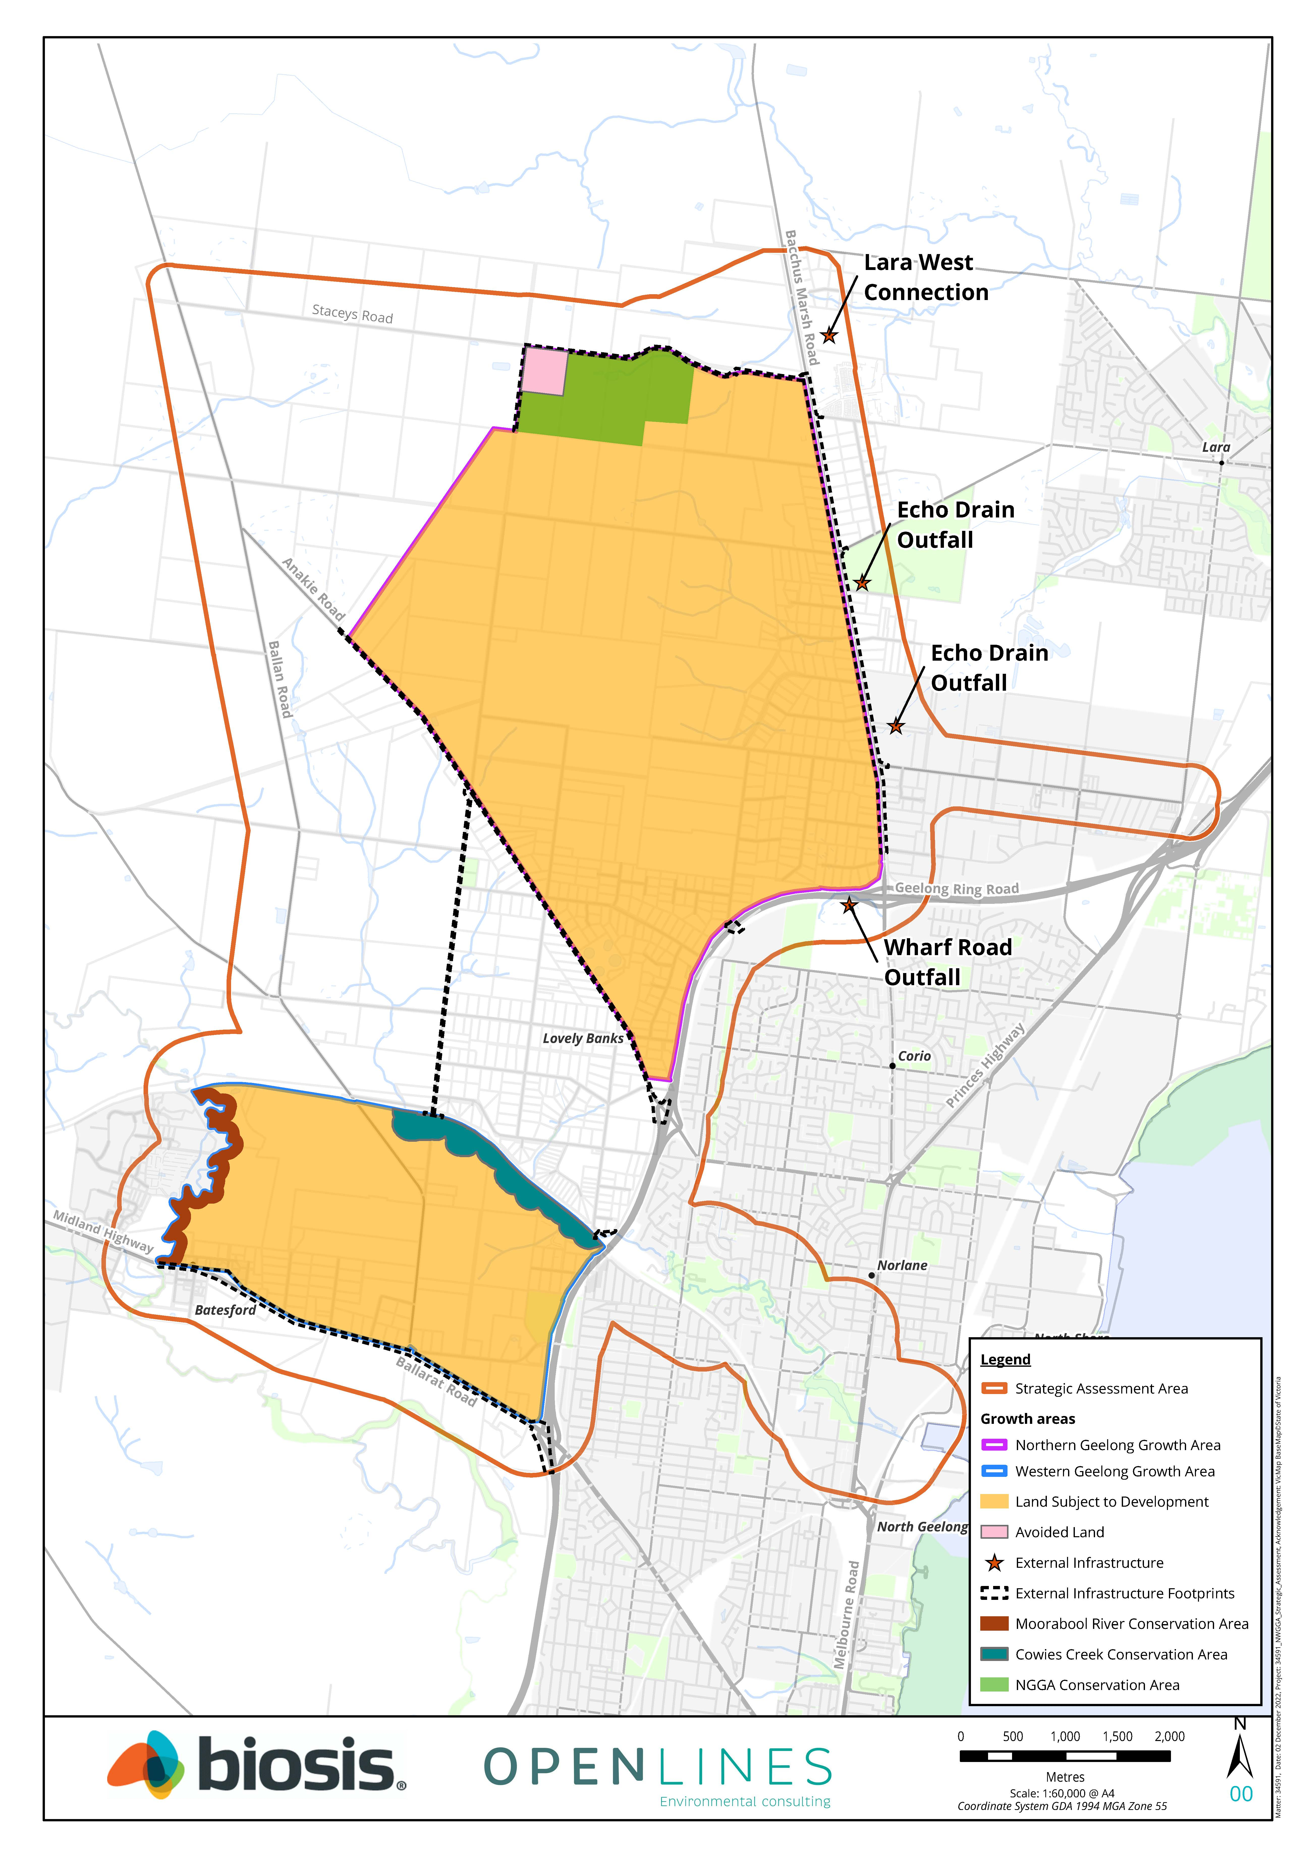

Figure 3: Location of development under the Plan

Mitigation of indirect impacts
The Conservation Program provides a range of state and Commonwealth level commitments to mitigate potential indirect impacts associated with the Plan. These indirect impacts relate to:
- Altered fire regimes
- Changes to water flows and water quality
- Disturbance due to noise, dust, or light
- Disturbance from increased public access to natural areas
- Fauna mortality and barriers to movement
- Inadvertent impacts on adjacent habitat or vegetation
- Predation or competition by pest or domestic fauna
- Spread of infection or disease
- Spread of weeds
Mitigation measures under the Plan fall under two broad categories:
- Standard mitigation measures and processes which will be implemented through the existing Victorian planning system and the Geelong Planning Scheme to mitigate the indirect impacts
- Additional specific mitigation measures provided for under the Plan to address particular vulnerabilities or risks to MNES from indirect impacts
Any potential indirect impacts to state significant biodiversity values will be assessed under the planning permit process when development is proposed.

Offsets
The final component of the conservation program is offsets for residual impacts to biodiversity values. The conservation program addresses both Commonwealth and state offsets. Noting that the state and Commonwealth offsets will be delivered separately due to restrictions in offset site locations and availability.
The Commonwealth offset package provides offsets for three MNES (Golden Sun Moth, Striped Legless Lizard, and Natural Temperate Grassland) which occur within the Northern Geelong Growth Area. These offsets will be delivered through a strategic offsets package which intends to provide substantially better results than what would be achieved through standard project-by-project approvals.
The state offset package involves offsets for impacts to areas of native vegetation as required by the Guidelines for the removal, destruction or lopping of native vegetation.

What assurance is there that the Plan will be delivered successfully?
A key component of the Plan are the processes to ensure successful delivery. The Plan includes an ‘assurance and implementation framework’ which will ensure that the Plan complies with Commonwealth approval conditions, the conservation program is efficiently and effectively delivered, and the implementation processes are transparent and accountable.
The key elements of the assurance and implementation framework include:
- A strong set of governance arrangements to support the delivery of commitments and measures
- A funding program established by the EPBC Plan to implement the Commonwealth level commitments and measures, and funding through PSP and development processes to implement state level commitments and measures
- Implementation of a monitoring, evaluation, reporting and improvement (MERI) program to understand if outcomes and commitments are being achieved, outline communication points with stakeholders, and the process to adapt measures as necessary
- A compliance program to ensure that commitments and measures relating to third parties are implemented appropriately

What are the key findings of the Strategic Assessment Report?

Purpose of the Strategic Assessment Report
The SAR provides an assessment of the potential impacts of development under the Plan and evaluates the adequacy of the commitments and measures in protecting MNES. The SAR considered potential impacts to 29 MNES. These include:
- Two threatened flora species
- 18 threatened fauna species
- One threatened ecological community
- One Ramsar wetland
- Seven migratory species
The SAR also provides a cumulative impact assessment to consider development under the Plan in the context of other projects, and a socio-economic impact assessment.
A brief overview of the key biodiversity values at risk of direct impacts and potential indirect impacts under the Plan, and a summary of the evaluation of the adequacy of the Plan is provided below.

Biodiversity values at risk of direct impacts under the Plan
The SAR has identified three MNES subject to potential direct impacts under the Plan including:
- Golden Sun Moth (Synemon plana)
- Striped Legless Lizard (Delma impar)
- Natural Temperate Grassland of the Victorian Volcanic Plain
The Plan provides a strategic conservation area within the NGGA which retains and protects a large, contiguous area of grassland which provides habitat for Golden Sun Moth and Striped Legless Lizard. There will be residual direct impacts on these three MNES which are accounted for in the EPBC offsets package.

Biodiversity values at risk of potential indirect impacts under the Plan
Development under the Plan has the potential to result in a range of indirect impacts on biodiversity values and other protected matters. Indirect impacts may occur to the following:
- Parts of the Port Phillip Bay (Western Shoreline) and Bellarine Peninsula Ramsar site which occur downstream from the Growth Areas, and the threatened and migratory birds which use these areas
- Three fish species which may in future use habitat in the Moorabool River
- Areas of native and non-native grassland in the NGGA and the associated MNES (Striped Legless Lizard, Golden Sun Moth, Natural Temperate Grassland)
The commitments and measures included in the Plan provide for a range of both specific and standard mitigation measures for MNES which are considered appropriate to address potential indirect impacts on biodiversity values.

Evaluation of the adequacy of the Plan
Part 5 of the SAR provides an evaluation of the Plan against the principles of ecologically sustainable development, and the evaluation requirements of the Terms of Reference. The key findings of the evaluation are that the Plan:
- Is consistent with the principles of ESD
- Includes commitments that:
  - Achieve substantial avoidance of impacts to MNES
  - Adequately mitigate the potential indirect impacts of development
  - Will lead to the protection and management of significant areas of land as part of a strategic approach to both avoidance and offsets
- Incorporates a robust assurance and implementation framework to ensure that the outcomes and commitments are delivered successfully

References
EHP (2021) ‘Existing Ecological Conditions: Northern and Western Geelong Growth Areas’. Prepared for the City of Greater Geelong.
Geelong Region Alliance (2007) ‘The Geelong Region Plan’. G21 Geelong Region Alliance.
Rowe, D. (2021) ‘About Corayo: A Thematic History of Greater Geelong’. The City of Greater Geelong.
The City of Greater Geelong (2021) ‘The Northern and Western Geelong Growth Areas Framework Plan.’

