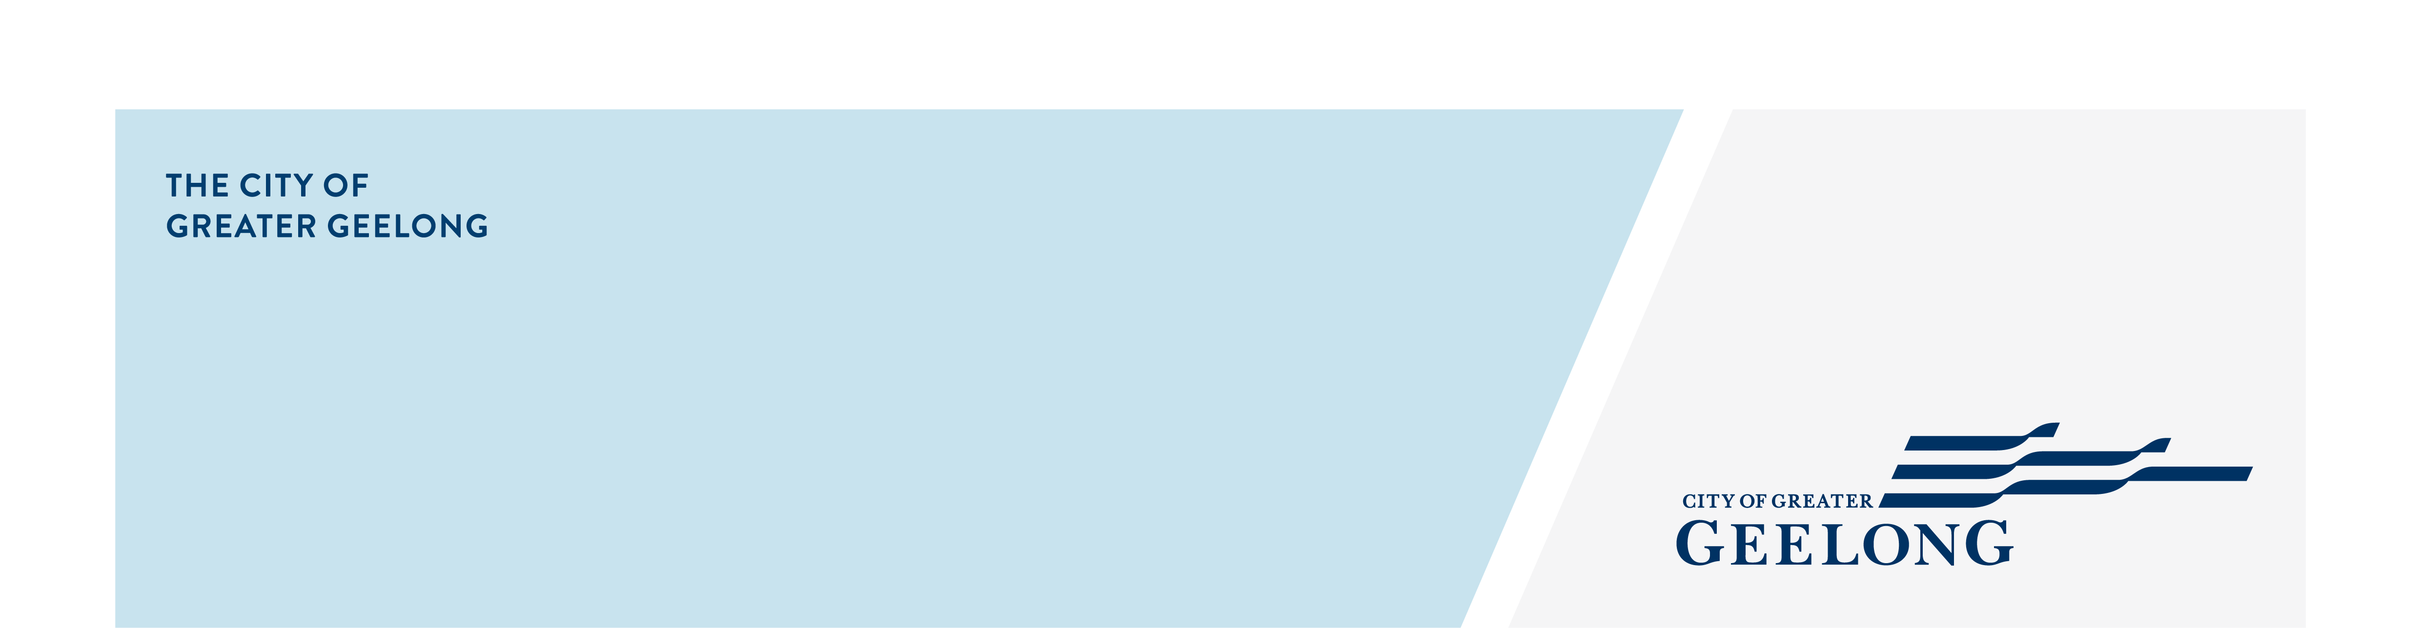
positive ageing strategy

2021-47

community engagement summary
The draft Positive Ageing Strategy 2021-47 was made available for community feedback from 26 May until 23 June 2021.
Over 94 per cent of respondents agreed that the strategic objective of the strategy aligned with their vision of positive ageing. The Strategy’s three themes were supported, which focus on improving outcomes for people as they age including:
- living in safe, welcoming and strongly connected local communities;
- being respected, supported and encouraged to participate as active citizens; and
- having equitable access to places, spaces and services.
Over 70 per cent agreed that the themes covered all aspects of an age friendly community. However, some felt that there needed to be a stronger emphasis on safety, transport and implementation timelines.
Resulting changes to the strategy include a stronger reference to human rights and social equity, the importance of safety, transport, lifelong learning and arts and culture, as well as clarifying the active involvement of older people in shaping their communities.
The final strategy is due for Council adoption on 28 September 2021.The next step is to co-design an action plan with stakeholders and the community which will include relevant timelines.

SOCIAL MEDIA
6,700
Reach/Impressions
405
Actions (Clicks, reactions,
shares, comments etc.)
29 DAYS
of engagement

112
Surveys returned including 3 written submissions

NEWS

4
print adverts in local newspapers

People following the project
25

community comments:
- “A statement of the Rights of the Older Person should be included”
- “Something around safety would be nice”
- “The arts and cultural dimension were missing”
- “Transport covering all areas and easily accessible is important once a person is unable to drive”

