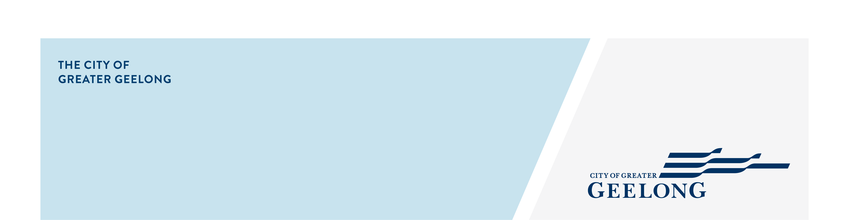
labuan square

public space improvements
community engagement summary
The City of Greater Geelong have prioritised landscape improvements for Labuan Square in Norlane in 2021/2022. To inform the design development, the City have partnered with Norlane Community Initiatives to undertake community engagement to understand what you value about Labuan Square and what improvements you would like to see in the public space.
A Have Your Say page was established to facilitate a community survey to ask for feedback on Labuan Square and opportunities for improvement. The survey was available from 3 to 31 May and was augmented by one on one surveying of community members and a Listening Post was conducted at Labuan Square on 27th May 2021. The survey was promoted via direct mail, print and social media.
The community have responded and told the City what you treasure about Labuan Square and what you would like improved. We heard from a range of people including residents, workers and traders who said they value the shops, natural environments and seating and would prioritise investment in a sustainable landscape, access to nature, public art and play experiences.
This feedback will be used to develop a concept plan for improvement to Labuan Square.

NEWS

8
print adverts in local newspapers
 179
Surveys completed
Suggestions (comments) from the public left online via Visioning
11
138
Number of people to leave feedback
28 DAYS
of engagement (Survey)


People following the project
49
SOCIAL MEDIA
9,280 (+ 27,734)
Labuan Square HYS (& Mayors FB Page
290 (+ 6,730)
Labuan Square HYS (& Mayors FB Page)
Actions (Clicks, reactions,
shares, comments etc.)


Radio announcement on K-rock
1


Next steps

181 online surveys & 6
Hard copies of surveys received
Advertising postcards delivered
850
Next Steps or any Verbatim comments and officers can remove which is not applicable.
The Community Survey component of the engagement has closed for evaluation. We will be reviewing the results and developing a preliminary concept design for improvements to the Labuan Square public open space based on your feedback.
The concept plans will be available for community feedback in August/September 2021.

