City of Greater Geelong | 
12.09.24

Greater Geelong Community Panel
Deliberative Engagement Report


Giving every person a voice.
Capire Consulting Group  The Commons,  Wurundjeri Country  36-38 Gipps Street,  Collingwood VIC 3066  (03) 9285 9000  info@capire.com.au  capire.com.au  Capire acknowledges  and deeply respects the Wurundjeri people and  the Traditional Owners  of the Victorian land. | 


Privacy  Capire Consulting Group and any person(s) acting on our behalf is committed to protecting privacy and personally identifiable information by meeting our responsibilities under the Victorian Privacy Act 1988 and the Australian Privacy Principles 2014 as well as relevant industry codes of ethics and conduct.  For the purpose of program delivery, and on behalf of our clients, we collect personal information from individuals, such as e-mail addresses, contact details, demographic data and program feedback to enable us to facilitate participation in consultation activities. We follow a strict procedure for the collection, use, disclosure, storage and destruction of personal information. Any information we collect is stored securely on our server for the duration of the program and only disclosed to our client or the program team. Written notes from consultation activities are manually transferred to our server and disposed of securely.  Comments recorded during any consultation activities are faithfully transcribed however not attributed to individuals. Diligence is taken to ensure that any comments or sensitive information does not become personally identifiable in our reporting, or at any stage of the program.  Capire operates an in-office server with security measures that include, but are not limited to, password protected access, restrictions to sensitive data and the encrypted transfer of data.  For more information about the way we collect information, how we use, store and disclose information as well as our complaints procedure, please see www.capire.com.au or telephone (03) 9285 9000. |  | Consultation  Unless otherwise stated, all feedback documented by Capire Consulting Group and any person(s) acting on our behalf is written and/or recorded during our program/consultation activities.  Capire staff and associates take great care while transcribing participant feedback but unfortunately cannot guarantee the accuracy of all notes. We are however confident that we capture the full range of ideas, concerns and views expressed during our consultation activities.  Unless otherwise noted, the views expressed in our work represent those of the participants and not necessarily those of our consultants or our clients.  Definitions  The City: The City of Greater Geelong organisation led by the Chief Executive Officer.  Committee: A delegated committee, joint delegated committee or community asset committee under sections 63, 64 and 65 of the Act, respectively.  Council: The Greater Geelong City Council comprising Councillors and its Delegated Committees.  Deliberative engagement: Deliberative engagement is a process of engagement that brings participants closer to the decision makers than other forms of engagement; where participants are provided with a clear task or question, have access to appropriate resources and information, and are given the time and space required to deliberate and reach their consensus.  Engagement: A process for improved decision-making that invites the feedback from, and incorporates the insights, wisdom and concerns of, affected stakeholders and also meets the needs of the decision-making body.

VERSION | AUTHOR | AUTHORISED | DATE
1 | Abbey Mag, Spencer Nash,  Emily Mellon | Denise Francisco | 12/09/2024
2 | Emily Mellon | Denise Francisco | 21/10/2024

Contents
1. Introduction 4
1.1. Purpose of the report 4
1.2. Project background 4
2. Program overview 6
2.1. Purpose and objectives of the Panel 6
2.2. Scope of the Panel 6
2.3. Panel process 7
2.4. Limitations 12
3. Panel selection and participation 13
3.1. Panel recruitment 13
3.2. Panel selection and representation 13
3.3. Panel participation 14
4. Panel outputs 17
4.1. Panel’s principles 17
4.2. Developing the Panel’s key areas 18
4.3. Developing priorities and outcomes 21
4.4. Panel’s key areas, priorities and outcomes 21
4.5. The Parking Lot 35
5. Panel evaluation 37
5.1. Participant journey 37
5.2. Process evaluation 42
6. Appendices 44

Introduction

Purpose of the report
This report details the deliberative engagement process undertaken to inform the development of the City of Greater Geelong’s integrated Council Plan and Public Health & Wellbeing Plan 2025-2029 (the integrated Council Plan). The findings will also support the development of Council’s major long-term plans for 2025-29, including:
- 2025-35 Financial Plan (including Revenue and Rating Plan)
- 2025-35 Asset Management Plan
- 2025-26 Annual Budget.
The contents of this report capture the process and outputs of the deliberative engagement Community Panel (Panel). The views presented are those of the Panel members that participated in the process, and do not necessarily represent views held by The City of Greater Geelong Council (the City). While consensus building was part of the deliberative process, the report notes where individual Panel members provided feedback and comments.
The report has been prepared by Capire Consulting Group (Capire) who were engaged by the City to independently design, deliver and report on the deliberative engagement process.

Project background
Under the Local Government Act 2020, local government areas must adopt or review a Vision with a minimum lifespan of 10 years and develop a four-year Council Plan based on its deliberative engagement practices.
The City has undertaken both a broad engagement program (not included in this report) and a deliberative engagement process to understand current community aspirations, to inform a refresh of its 30-year Community Vision (see Figure 1) and the development of its integrated Council Plan. Currently named ‘Our Community Plan’, this strategy is set by Council to outline how it will work towards the Community Vision. The integrated Council Plan represents the commitment of the Council of the day and guides which activities to focus its resources to ensure the social, economic and environmental sustainability of the region during the period of the plan.
The Panel’s guidance and recommendations will help Council focus on what is important to community, including health and wellbeing priorities, for the next four-years.

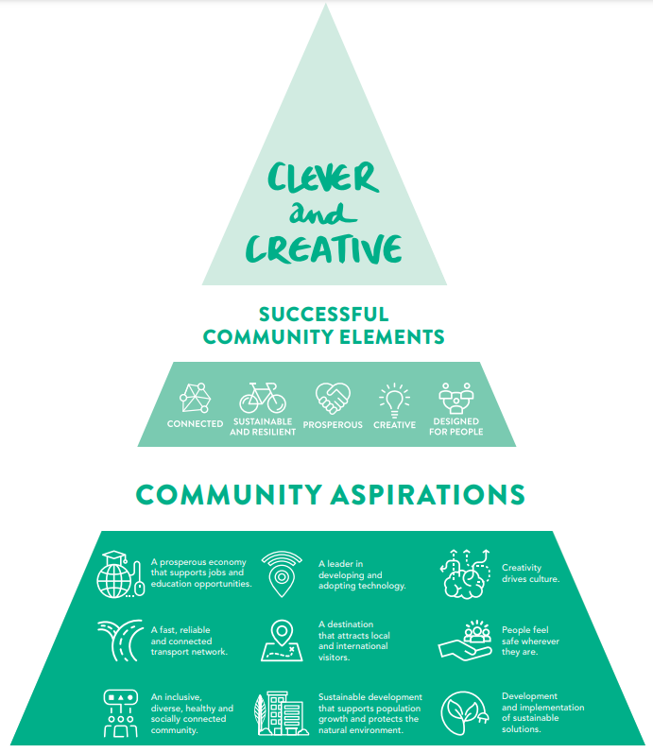
Figure 1. Geelong Community Vision diagram

Program overview

Purpose and objectives of the Panel
The overarching purpose of the deliberative engagement was to recruit a group of community members who live, work or study in the Greater Geelong region to form the Greater Geelong Panel (the Panel). The goal of the Panel membership was to create a diverse group of participants that represented the diversity of the Greater Geelong municipality. The Panel’s role was to identify key priorities to help shape Council’s strategic plans for the next four years.
The objectives of the deliberative engagement were to:
- Conduct an engagement process that fosters trust and involvement from the community, Panel members, council staff, leaders, and Councillors.
- Review the Community Vision to make sure it matches community goals and needs.
- Identify community priorities agreed upon through consensus to help shape key strategic directions and inform the development of subsequent strategies and plans.
The deliberative approach aims to provide policy and decision-makers with a deep level of understanding of the community’s perspectives on Council’s role and what the key priorities should be for the next four years through engaging with a diverse and representative sample of the community.

Scope of the Panel

Engagement level
The Greater Geelong Panel sits at the ‘Involve’ level of the International Association of Public Participation (IAP2) spectrum where the promise is that ‘the City will work with you to ensure that your concerns and aspirations are directly reflected in the alternatives developed and provide feedback on how the input influenced the decision’ (see Figure 2).

Figure 2. IAP engagement spectrum
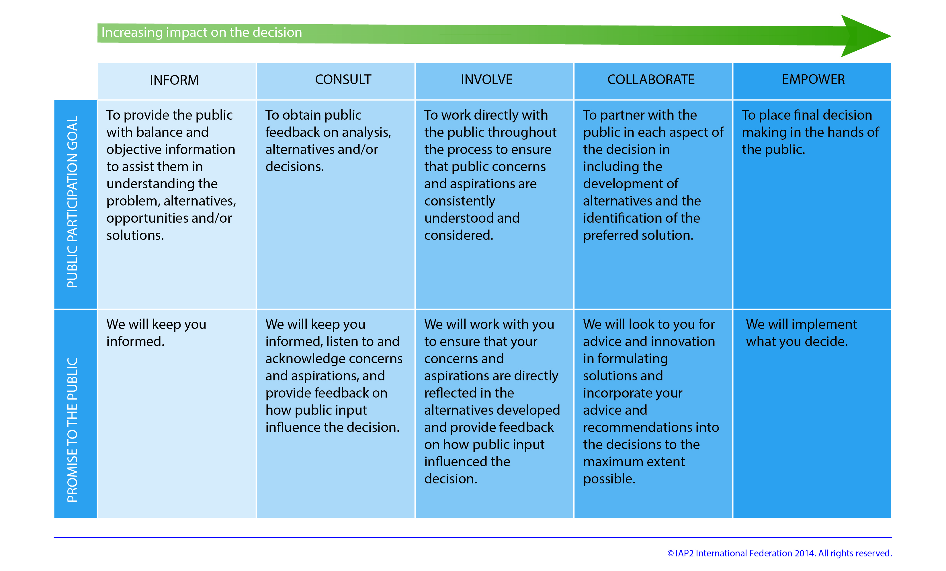

The remit
Community panels address a challenge or a ‘remit’ which frames the conversations, determines what information is relevant and clarifies what is negotiable and what the Panel can influence.
The remit for the Panel was:
In 2047 Greater Geelong will be known for its vibrant community life, sustainability, innovation, inclusive culture and economic prosperity. To move closer to that vision, what should the priorities of Council be over the next four years and what outcomes would those priorities bring?
This remit was shared with the community during recruitment for the Panel and with the Panel, throughout the deliberative process.

Panel process
The Panel came together across four sessions, 15 hours in total, to deliver the following outcomes:
- Building informed participation – scene setting, introductions and exploring the challenges and opportunities facing Council
- Identifying key values, challenges and opportunities for the City of Greater Geelong
- Identifying high-level focus areas and guiding principles
- Identifying the key priorities and associated outcomes under the high-level focus areas
- Identifying health and wellbeing priorities and outcomes.
A private page was set up on the City’s Have Your Say website for Panel members to share questions, comments, and to interact with each other between sessions.
Table 1 provides an overview of the deliberative Panel sessions, including each session's objectives. Section 2.4 summarises the information shared with the Panel before and during sessions, including presentations, to support knowledge building and deliberations.
Table 1. Greater Geelong Panel session overview
Session | Session 1: Introductions and Scene Setting | Session 2: ideation of Key AREAS and priorities | Session 3: Developing priorities and outcomes | Session 4: Refine priorities and final recommendations
Date and time | Date: Wednesday 14 August  Time: 5.30pm to 8pm  Location: National Wool Museum, Geelong | Date: Saturday, 17 August 2024  Time: 10am to 3pm  Location: Geelong Library | Date: Saturday, 24 August 2024  Time: 10am to 3pm  Location: Wurriki Nyal Civic Precinct | Date: Wednesday 28 August  Time: 5.30pm to 8pm  Location: Wurriki Nyal Civic Precinct
Objectives | - Panel members learn about Council, the Panel remit and the expected session journey  - Group forming with ‘getting to know each other’ activity  - Develop principles for working together  - Introduce the interconnection between Council’s key strategic documents  - Introduce community and health and wellbeing (HWB) data and the HWB priorities set by the state government  - Introduce the Fact File (evidence gathering and analysis)  - Share reflections from the bus tour  - Facilitate Panel questions and seeking additional information. | - Group forming and learning about the roles and responsibilities of the various levels of government (game)  - Panel learns about the Community Vision, current performance and broad community feedback on how the Vision aligns with current aspirations  - Present current challenges, opportunities and aspirations across key Council areas  - Reflect on information shared and evaluate through their Fact File and discussions  - Facilitate Panel questions and seeking additional information  - Identifying Key Areas of importance: Panel to identify key values, challenges and opportunities for the municipality over the next 4 years. | - Welcome from the CEO, Ali Wastie  - Group forming and reminder of the diversity across the Panel energiser  - Council to provide organisational context and sense-making of the key areas to assist in developing priorities and outcomes under the key areas, examples to be provided  - Reflect on information shared and refine the Key Areas  - Develop priorities and outcomes for each Key Area  - Facilitate Panel questions and seeking additional information. | - Refine priorities and outcomes based on feedback from Session 3 and check in on the Vision  - Panel to individually indicate level of comfort with drafted priorities and outcomes and share reasons why if neutral, uncomfortable or very uncomfortable  - Finalise recommendations around priorities and outcomes and describe principles.

Building informed participation
 | Background reading  Before the first session, Council shared background reading with Panel members. The Community Panel Information Pack included:  - An introduction to the project  - Information on the role of government  - Information on Greater Geelong City Council  - Information on the Greater Geelong community  - Information on the Our Community Plan 2021-25 strategic directions and achievements  - The Health and Wellbeing Plan  - Challenges and opportunities across six key areas for Council  - Council commitments to consider – long term strategies.
 | Bus tour  Before the first session Panel members were invited to participate in a Bus tour of the Greater Geelong municipality to visit council assets, such as [Council to send itinerary]. The bus tour was not a mandatory activity however the majority of the Panel elected to participate.
 | Presentations, Panel and videos  - Verbal presentations by City officers were delivered throughout the deliberative process to inform, build knowledge and to assist to make sense of ideas.  - Two short videos were shared, as an additional knowledge building tool.  - Panel members heard from a wide range of City officers during a Panel presentation session.  - The Panel was able to ask questions as a table after presentations.
 | Learning from each other  Panel members shared their personal insights, experiences, and ideas with one another as well as considering the evidence shared by the City through a range of facilitated and non-facilitated activities.
 | Individual reflections and small group activities  Panel members had the opportunity to reflect on information and share ideas through individual reflections and brainstorming and through small group (table-based) activities.
 | Fact File Reflection  Panel members were encouraged to document their individual reflections (what stood out, what was important) during presentations. Then at their tables they compiled their learnings and reflections into a ‘Fact File’. As part of the Fact File, members were able to document questions they would like the City to answer, which were gathered between sessions and then shared at the following session.
 | Tactile learning  Panel members worked together at their tables to explore the different levels of government, and which level is responsible for various public services and infrastructure. This activity helped to build the group’s knowledge about the role of local government.
Building informed participation is a key element of a deliberative process. The following methods were used to build informed participation throughout the process. The information shared with the Panel is outlined in more detail in the following section of the report.

Information provided to the Panel
The information in Table 2 outlines the presentation and/or handouts provided to the Panel during the sessions. Note, Panel members had the opportunity to ask questions of the City and Capire (regarding the process) throughout the deliberative engagement. If not answered during the sessions, the questions were collected and responded to via the Panel’s private Have Your Say page. A summary of the page contents can be accessed from the City project team.
Table 2. Information shared with the Panel during sessions
Session | Presentations/Handouts | Information covered
Session One:  Introductions and Setting the scene | Presentation 1: Council 101 & Strategic Planning  Daniel Ross – Chief Transformation Officer | - Council 101  - How the Community Vision and Plans work together and interrelate  - How the Vision and Plans influence the work that Council does: budgets, rates, service levels  - Changes to Council plans over the last 4 years  - Panel influence on plans.
Session One:  Introductions and Setting the scene | Bus tour reflections  Neil Allen – Strategy Lead | - City staff and attending Panel members shared reflections of the bus tour and sites visited, answering:  - what stood out?  - what surprised you?
Session One:  Introductions and Setting the scene | Presentation 2: The City of Greater Geelong community and the health and wellbeing needs and opportunities  Cass Fleming – Research and Insights Analyst  Marnie Jewell – Coordinator Health Equity & Planning  Kylie Riley – Senior Health Planner | - An overview of the About Our Community- Data for the Council Plan Community Panel booklet and how to use it  - Introducing the Municipal Public Health and Wellbeing Plan and legislative requirements  - The City’s approach to health and wellbeing  - 10 Victorian Health and Wellbeing priorities  - Key health and wellbeing stats for the municipality.
Session One:  Introductions and Setting the scene | Handouts | - About Our Community- Data for the Council Plan Community Panel  - Community Panel Information Pack  - The City’s Community Vision document  - Economic Development Plan  - Major Events Strategy
Session Two: Ideation of Key Areas and priorities | Presentation 1: The Community Vision  Neil Allen – Strategy Lead | - What is the Community Vision?  - Community Engagement findings related to the Community Vision.  - What the City would like the Panel to consider as they deliberate.
Session Two: Ideation of Key Areas and priorities | Council Panel: What is important for the community Panel to know about when their developing recommendations?  Brendan Saunders – Manager, Economic & Cultural Development  Shaun Owens – Manager, Financial Planning & Analysis  Kate Shearer, Manager, Planning and Growth (Acting)  Joe Murphy – Manager, Asset Management  Marnie Jewell – Coordinator, Health Equity & Planning  Jeanette Spittle – Coordinator, Environment & Natural Resources | - City officers shared challenges, opportunities, trade-offs and aspirations related to their respective areas of responsibility
Session Three:  Developing priorities and outcomes | Presentation 1: Things to consider for priorities under key areas  Neil Allen – Strategy Lead | - Making sense of key areas reflecting organisational context  - Examples of related priorities from previous Council Plan/ examples of new priorities and outcomes
Session Four:  Refine priorities and final recommendations | Handouts | - What influences health and wellbeing (demonstrating the links between health, education, social justice and other systems.

Limitations
All engagement processes have limitations. The following points highlight the limitations that should be considered when reading this report.
- It was assumed in good faith that the information provided by participants in their Expression of Interest (EOI) forms about their demographics was accurate, along with any declared perceived conflicts of interest.
- Capire independently selected participants to represent the demographic profile of the municipality from the EOIs received, however, the final Panel membership can't be deemed a statistically accurate sample of the region.
- Although Panel members offered a range of perspectives, it is not guaranteed that all community viewpoints were fully represented.
- The Panel membership lacked representation from younger participants (under 34 years old), the Indigenous community, one-parent households and community members new to the region (under 5 years).
- Notably, the EOIs received predominantly were from older age demographics, with similar socio-economic backgrounds and residence tenure within the municipality.
- Some participants withdrew from their roles during the process, which is common between selection and delivery of sessions. Consequently, the number of participants varies across sessions. The reasons for withdrawal were due to unexpected personal commitments and illness.
- Despite agreeing on principles for respectful collaboration, some participants frequently interrupted and dominated discussions in some sessions. This behaviour sometimes marginalised others and hindered their ability to participate fully.

Panel selection and participation

Panel recruitment
The recruitment process was independently managed by Capire with promotional support from the City. Recruitment took place through an Expression of Interest (EOI) process, which was promoted through the City’s dedicated Your Say webpage: https://yoursay.geelongaustralia.com.au/.
The EOI was open for 4.5 weeks, from Monday 8 July to Thursday 8 August 2024.
Other promotional activities undertaken by the City, included:
- media releases
- advertisements in the CityNews and City e-newsletters
- email campaigns to subscribers of the City’s Have Your Say platform (3,096 recipients), previous submitters and Advisory Committee members
- paid and organic social media
- presentations and communication to the City’s Advisory Committees
- promotion on screens at Geelong Regional Library Corporations libraries
- promotion at ten pop-up face-to-face community engagements.
The EOI form included questions designed to help Capire assess the applicants and determine their suitability for the Panel. The form aimed to identify:
- demographics to enable selection against targets
- availability to attend all four sessions.

Panel selection and representation
A medium-sized deliberative panel, comprising 30 to 50 participants, is required to form a representative sample. This size ensures a range of perspectives while aligning with the ‘Involve’ level of engagement on the IAP2 spectrum (see Figure 2).
Given the size of the Greater Geelong region, the target Panel size of 50 people was accounted for by recruiting 62 participants, allowing for an expected drop-off of 10 participants. A total of 77 community members expressed their interest in participating, 62 were invited as Panel members, and 48 attended a minimum of two of the four sessions. A breakdown of Panel attendance throughout the four sessions is outlined below (see Table 3), with a detailed breakdown of the Panel member composition targets in Appendix 2.
Panel members were selected based on their eligibility to reflect the diversity of the Greater Geelong community. The selection process sought to ensure a diverse range of backgrounds, experiences and opinions were included on the Panel. Capire received demographic information from the Australian Bureau of Statistics (ABS Census, 2021) and provided demographic and segmentation targets to establish selection criteria.
Criteria for Panel selection included:
- an equal mix of members from the current respective Wards (Windermere, Bellarine, Kardinia and Brownbill)
- age group
- gender
- housing tenure and type
- family composition
- educational attainment
- years lived in Greater Geelong
- concession card status
- previous participation in Council’s community engagements.
Note, certain groups were not present in the EOI process and were therefore not represented on the Panel, most notably those who identify as non-binary and those who live in social housing.

Panel participation
The number of participants who attended the Panel session is outlined in Table 3.
Table 3. Panel attendance at each session
Session | Number of participants present
Session One  Introductions and setting the scene | 46
Session Two  Refresh the vision and ideation of priorities | 41
Session Three  Developing priorities | 36
Session Four  Refine priorities and final recommendations | 37

Overall, there was a relatively consistent group of participants across the four sessions, in terms of:
- area
- gender
- age
- housing tenure
- education.
However, although present in the initial Panel, there were no participants who identified as Aboriginal or Torres Strait Islander present for more than two sessions, or whose highest educational attainment was Year 9 or below. The composition of the overall Panel, determined by those that attended two sessions or more, is depicted in Figure 3 below.

Figure 3. Overview of Panel composition
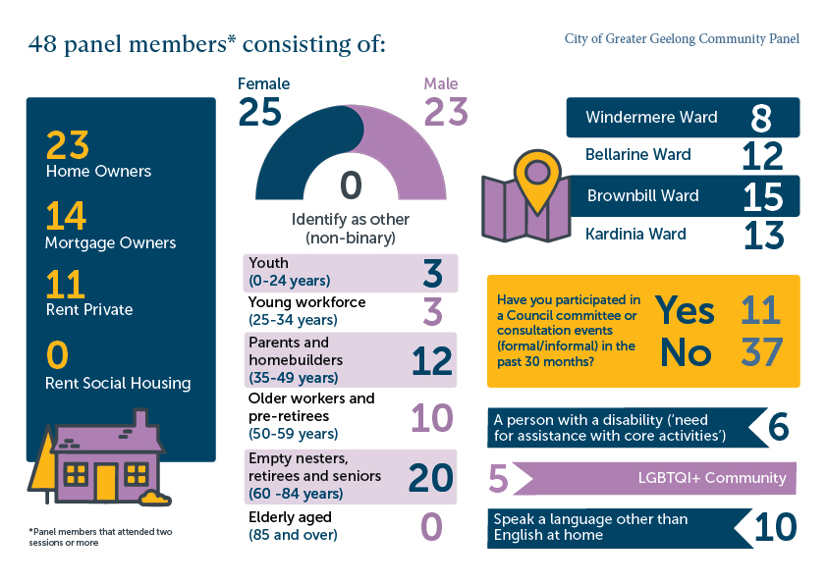

Panel outputs
This section of the report shares the key outputs of the Panel. Figure 3 shows the journey and expected outputs of the Panel. The primary objective of the Panel was to develop strategic directions (mostly described as Key Areas), priorities and related outcomes to inform Council’s strategic documents. The Panel members were also given the opportunity to share any additional ideas outside of this scope via a Parking Lot and on the Panel’s HYS page.
In addition, the Panel developed two sets of principles; 1) as rules of engagement to guide and frame their deliberation and 2) a set of overarching key values to frame the recommended key areas, priorities and outcomes.
Figure 44. The community Panel journey and expected outputs
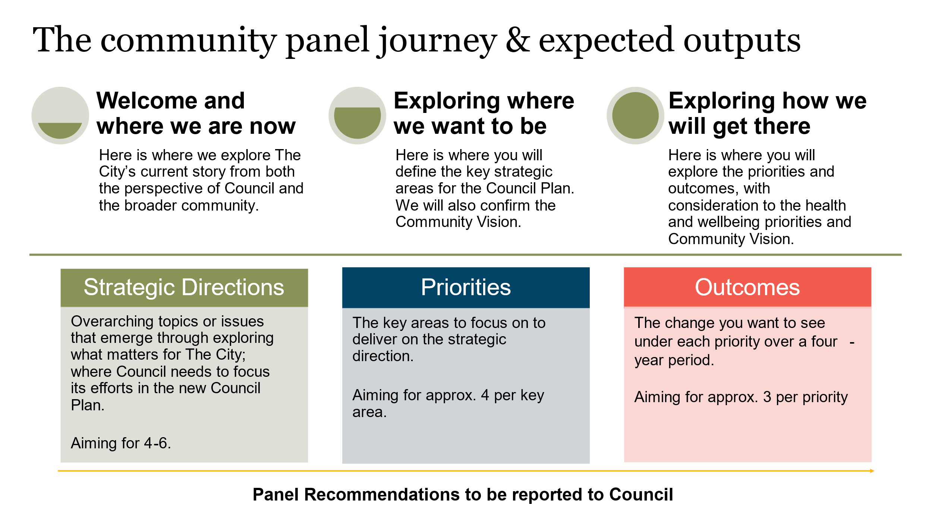

Panel’s principles
Below are the principles established by the Panel during session one.
- Listen to each other, be open to learning something new.
- Ensure everyone can finish their point, so that we can have a rich conversation.
- Respect - make sure we respect each other’s opinions and values.
- Disagreement is to be expected but do this with respect and agree to disagree – may not be a convergent outcome every time.
- Be curious.
- Maintain a sense of humour in the way we work together.
- Equity and inclusivity – ensure everyone gets a chance to voice their opinions, and they can do this in the way that works for them.
- Make sure that it’s not only the big voices that are heard, notice the quiet voices.
- Focus on the positive as much as possible, speak positively to each other, be constructive.
- Actively engage while allowing the right to pass if you don’t want to speak about something.
- Stay focused, stick to the task.
- Be confident in speaking up.

Developing the Panel’s key areas
Brainstorming and clustering their top three values, opportunities and challenges
The Panel members used a consensus building process to identify the values that describe the City of Greater Geelong, and the opportunities and challenges facing the City (see Figure 4, below).
Figure 55. Description of values, opportunities and challenges to guide the Panel
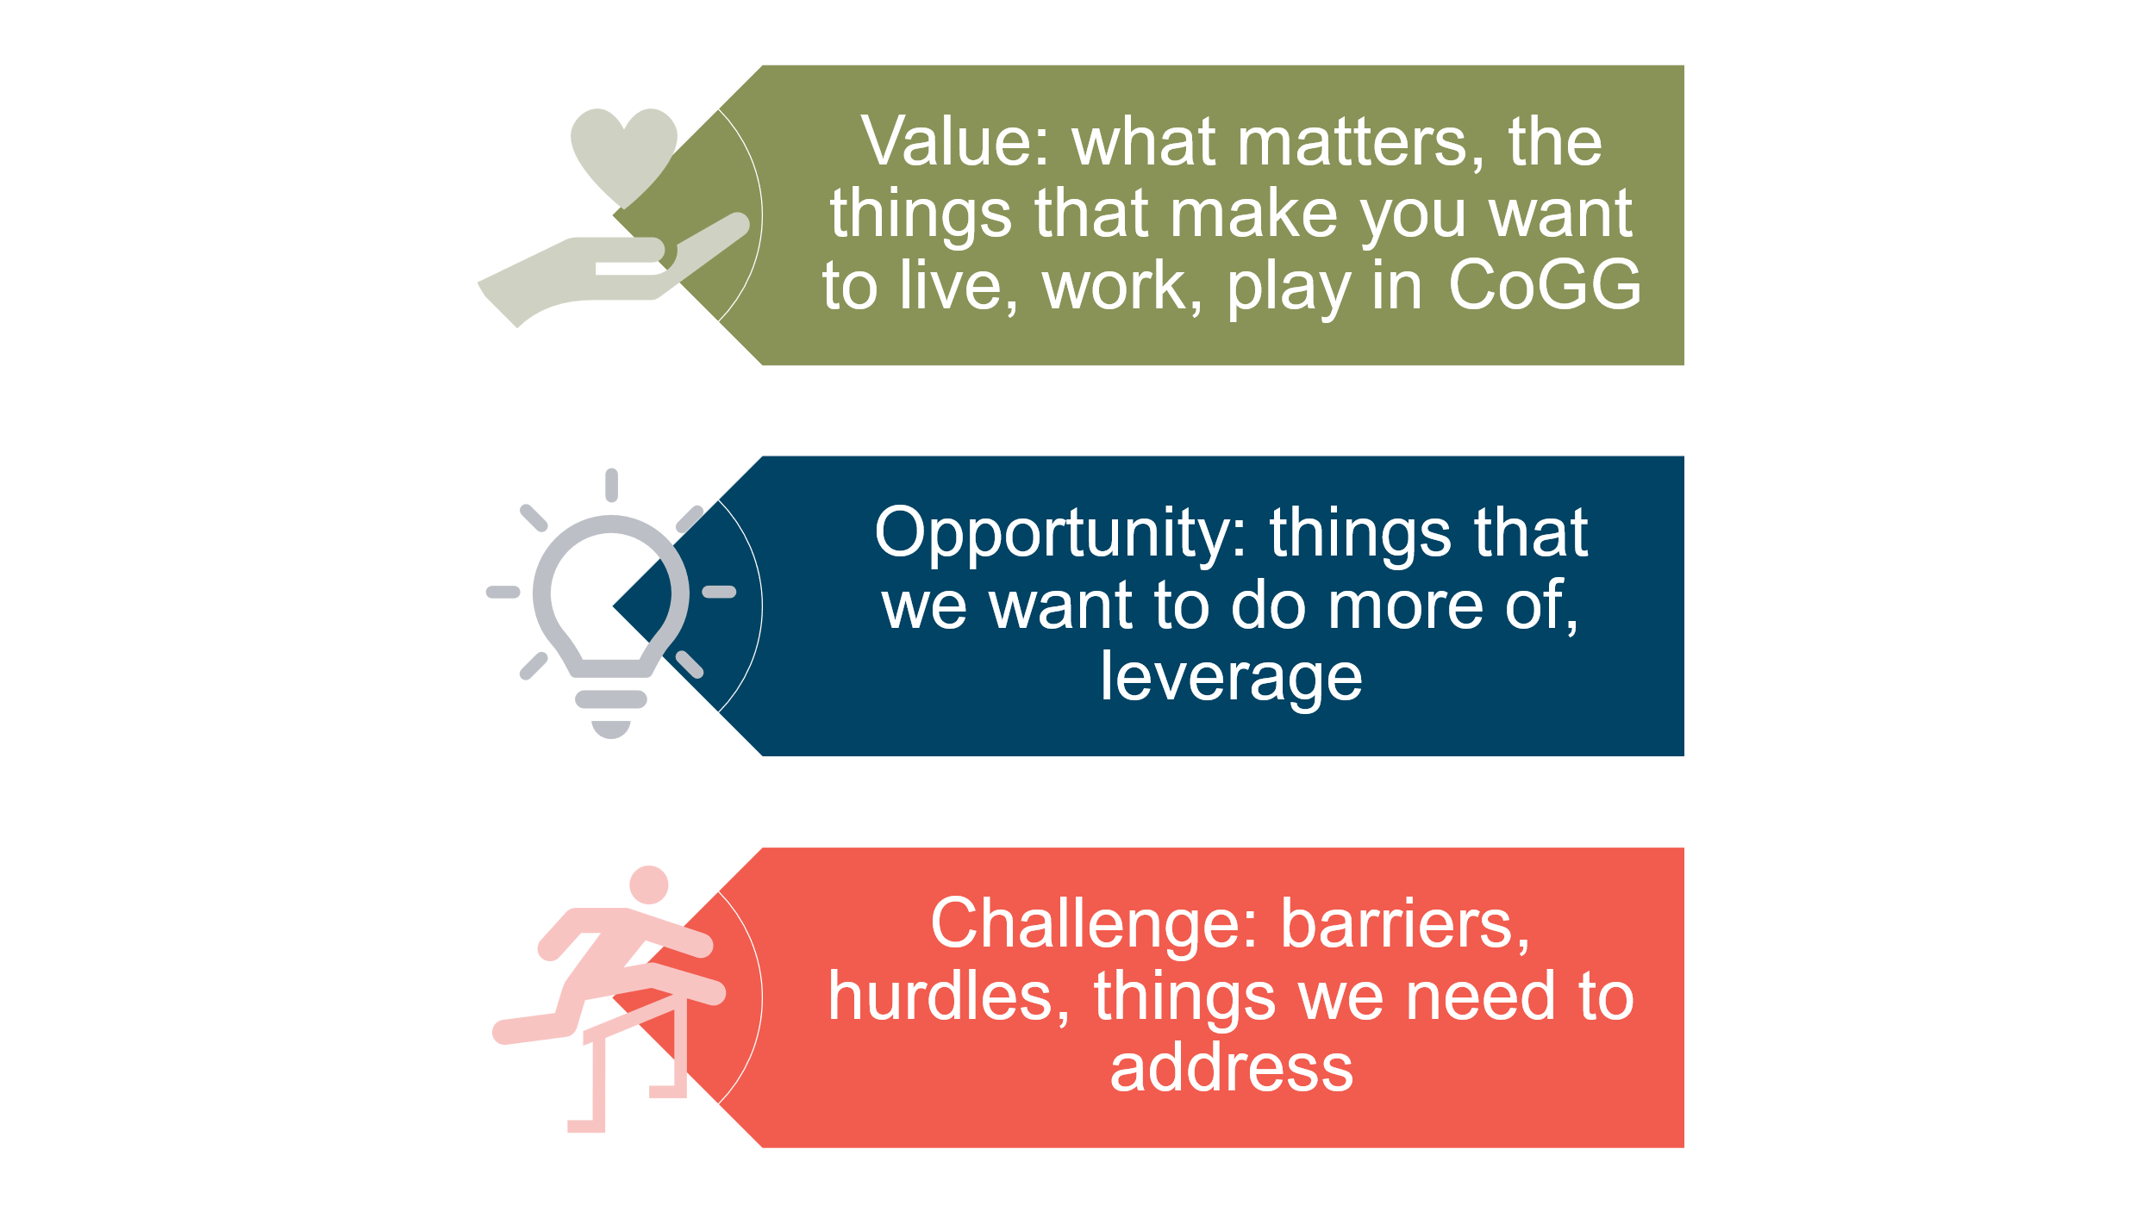

Participants individually identified as many values, opportunities and challenges as they could, before sharing their individual results with their table. Each table then collectively compiled their top three values, challenges and opportunities, recording one statement per card. Each group pinned their cards on the wall.
The Panel then worked to combine the cards on the wall into clusters, reflecting common intent or issues, irrespective of whether the card represented a value, challenge or opportunity. The end of this process saw the Panel identify 13 high-level themes. The initial high-level themes and the Panel’s associated cards are presented verbatim in Table 4.
Table 4. Panel's initial themes and associated values, challenges and opportunities (verbatim)
Theme | Associated values, challenges and opportunities
managing resources and finances | - The city of Greater Geelong is a financially sound and well governed council meeting all its regulatory requirements and sanctions  - Invest wisely for future opportunities inc. recycling, the environment, business, jobs  - Accountability and transparency: integrity of processes and decision making, what council owns, do what we say  - How council structures impact prioritisation and competing priorities (challenge)  - Values versus economics e.g. departmental focus economics and cultural dev (challenge)  - Financial and other limitations: lack of staffing, reduced expenditure on health and wellbeing and low spending on environment (challenge)  - Time to achieve outcomes (challenge)  - Working with state and federal government priorities (challenge)  - How do we leverage the highest Gross regional product (GRP) in Australia to find opportunities for community services
community connectedness | - Community is connected  - Belonging and inclusion: diverse and intergenerational  - Diversity, inclusivity, accessibility (value)  - Develop connected communities; empower locals, work with churches and community groups  - Community connection: people, nature and animals  - Support for mental health and youth services.
equity | - [Enable] our wealth and community strength to trickle down to support our wider community  - Provide for marginalised individuals and groups (refugees and migrants), LGBTIQA+, older divorced women, DV victims  - Improve the life outcomes of people living in less well-off areas through housing, employment, transport, community services  - [Ensure] services are accessible for all  - Availability of religious and faith provisions
environment AND liveability | - Maintain and preserve, make the most of our natural assets including beautiful north facing bay  - Geelong has an incredible natural world that we need to continue and grow our engagement and protection of. Best way we can do that is through socially and environmentally responsible development. Our diverse landscape; regional centre, coast, mountains, bays (value)  - Leverage our natural environment  - Tourism (opportunity)
good Council: communication AND community engagement | - Develop the appetite for community to work and engage with Council  - Educate and communicate to help locals know why/ what / how  - Communicate Council’s great strategies  - Connectedness with Council  - Improve community consultation in planning areas and new Council wards: collaborate and partner with sporting clubs, small business, community groups  - Council has an opportunity to link community groups to deliver benefits with multiple outcomes  - Consult regarding natural resources
sustainability | - Sustainably develop housing  - Sustainability [in all areas]: financial, organisational, environmental, social  - Adapt to climate change: housing retrofitting, aging population, health and wellbeing
managing growth | - Planning for a changing environment; population growth and climate change  - Clever planning laws to define and address future growth, including high density, congestion, traffic  - Appropriate infrastructure, facilities and services to support the changing population and support those most in need, including transport, housing and employment
clever & creative | - Clever & creative (value)  - Embrace creative and innovative design through all facets of our city  - [discussion noted that this also included supporting the arts]  - Support clubs, organisations, and individuals (e.g. artists) to find funding
MAXIMISING And VALUING ASSETS | - Geelong is a well-planned city and taking care of its built environment ensuring assets are fit for purpose  - Council assets [support] vibrant and creative community spaces  - Utilisation of existing assets (opportunity)  - Share use of spaces  - Improve knowledge and access to assets
safety | - Safe, thriving, connected community  - Safe city  - Crime: youth, drugs, robbery (challenges)
Responsibly embrace technology | - Responsibly embrace new and emerging technologies to assist in meeting CoGG strategic targets.  - Transparency needs to be enshrined into the process to ensure the community benefits and understands these benefits.
advocacy | - State and federal out of control of Council. Advocacy through peak bodies e.g. GAI [unknown], Municipal Association of Victoria (MAV)
promote & nurture small business | - Support diverse businesses  - Support small business for youth employment

Refining the key areas
During session two, the City provided feedback on the initial themes as well as the values, challenges and opportunities that relate to each theme which informed the next stage of the Panel's consolidation of their ideas (see Appendix 3 for the City’s feedback). The Panel reflected on the City’s feedback and refined the key areas and principles to frame their recommendations.
The Panel recommended the following overarching principles:
- Equitable
- Safe
- Clever and creative
- Sustainable
- Wellbeing.
The Panel’s refined key areas were:
- Inclusion, diversity and community connectedness
- Arts, culture and heritage, First Nations
- Health and wellbeing
- Environment
- Governance and integrity
- Sustainable growth/development and infrastructure
- Economic development.

Developing priorities and outcomes
Defining the priorities and outcomes for each key area
The Panel was asked to consider the information they had been provided under the topic for the key area allocated to their table, including:
- data information packs
- The City’s answers to Panel questions
- The Panel’s Fact Files.
The Panel was provided with a definition and an example of both a priority and an outcome, as shown below.
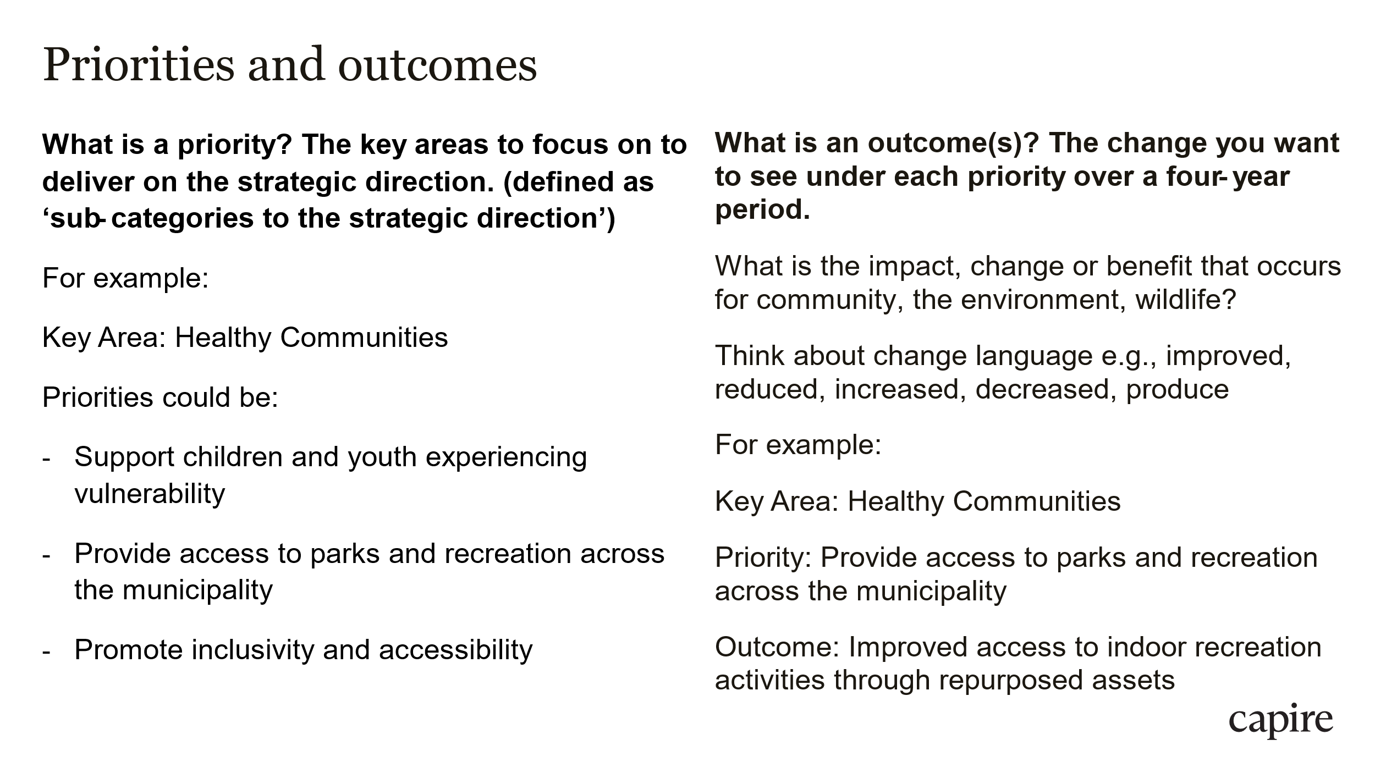
Participants individually identified as many priorities and outcomes they could for each key area, before sharing with their table. Each table then identified approximately four priorities and three associated outcomes per priority.
Providing feedback on the key areas, priorities and outcomes
Every Panel member then had the opportunity to provide and document feedback on each of the key areas, priorities and outcomes through a World Café activity (World Cafe is an engagement method that allows for simultaneous rounds of deliberation in small groups, and in this case, allowing for the whole Panel to provide feedback on every key area and associated priorities and outcomes.) City officers acted as table hosts to capture the six rounds of feedback.

Panel’s key areas, priorities and outcomes
In the final session, Panel members were invited to focus on a key area that most interested them to further refine the priorities and outcomes based on the feedback provided from all Panelists in the previous session. Table 5 presents the Panel’s refined priorities and outcomes for each strategic direction. The final feedback provided by all Panelists is presented in section 4.4.1.
Table 5. The Panel's key areas, priorties and outcomes (final Panel feedback not included)
KEY AREA (STRATEGIC DIRECTION): ARTS, CULTURE AND HERITAGE
Priority focus area: Arts: Encourage access to and production of the arts (e.g. visual, theatre, film, music, etc.). | Outcomes:  - Training and empowerment are made available to develop local talent through access to funding and partnerships (e.g. commercial, philanthropic and government).  - More people are aware of opportunities to attend arts and cultural activities in the region.  - That the arts are equitable, accessible and affordable to hold and attend in the region.
Priority focus area: Culture: Invest in and promote cultural events and initiatives. | Outcomes:  - Geelong is known as a food destination featuring regional specialties through support of local food and produce suppliers (including wineries, etc.).  - Improved visibility and engagement with First Nations values, connection to Country and community.  - Improved visibility of multiculturalism within the community, including through art, events and other celebrations.
Priority focus area: Heritage: Promote, celebrate and protect heritage in our buildings and natural environment. | Outcomes:  - Improved utilisation of our assets for multi-purpose uses.  - Technology supports the improved and increased use of heritage buildings and natural assets (e.g. develop public access information, trails).  - The architectural and artistic identity of the region is developed and retained within a cohesive plan which respects our history and community values.
KEY AREA (STRATEGIC DIRECTION): COMMUNITY CONNECTEDNESS
Priority focus area: Consider Council assets and if revenue generating, how to ensure equitable access for all people. | Outcomes:  - Equitable pay system to utilise council assets.  - Partnerships and consultation with community groups and council to support and promote effective service delivery.
Priority focus area: Consider needs across the lifespan / life stages. | Outcomes:  - Improvements to services, infrastructure and support reflecting the needs of the community based on evidence  - Greater Geelong is a network of well-connected communities who feel their health and wellbeing and other needs are being met at all life stages.
Priority focus area:  Promote connection through the support of community groups and empowerment of volunteers. | Outcomes:  - Collaborate with existing community groups to understand needs and find synergies and potential efficiencies.  - Grassroots, community groups, not for profits feel connected and supported by Council and each other.
KEY AREA (STRATEGIC DIRECTION): ECONOMIC DEVELOPMENT
Priority focus area: Business growth and diversity is encouraged:  - International  - Increase new jobs  - Support small- and medium-sized businesses  - Support businesses that solve our problems. | Outcomes:  - Brings prosperity at all levels across the community.  - Businesses survive and thrive.  - Attract more employers.
Priority focus area Diverse employment opportunities for:  - all ages and stages  - paid and volunteer  - local jobs for local people  - skills development and transition into employment. | Outcomes:  - Brings prosperity at all levels across the community and provides social, environmental, and economic benefits.  - Employment outcomes to match priority areas - equity, safety, clever, creative and sustainable.  - Reduced unemployment and increased volunteering.
Priority focus area: Investment in infrastructure and services:  - public transport  - education (tertiary)  - Information technology (IT)  - roads. | Outcomes:  - Infrastructure is keeping up with population growth.  - Economic development is responsible - socially, environmentally, economically and culturally.
KEY AREA (STRATEGIC DIRECTION): GOVERNANCE, INTEGRITY AND ACCOUNTABILITY
Priority focus area: Council demonstrates open and transparent decision making. | Outcomes:  - Councillor voting associated with decisions is provided to the community.  - It is clear where decisions are made between Council and councillors.  - Residents can opt-in to receive info on Council decision making in a simple form.
Priority focus area: Councillors are accountable to the Community Plan. | Outcomes:  - Councillors regularly engage with the community.  - Councillors operate with integrity, declare conflicts of interest and are citizen-focused.  - Councillors are open to performance reviews.
Priority focus area: Demonstrate Council's performance to the community. | Outcomes:  - Majority of residents are satisfied with the Council performance.  - Council provides relevant data to meet community needs to understand what is happening on a regular basis.  - The community is able to understand how well the Council services the Councillors.
KEY AREA (STRATEGIC DIRECTION): HEALTH AND WELLBEING
Priority focus area: Community connectedness and social interaction | Outcomes:  - Reduced disparities in health outcomes.  - Increased awareness of services and access to services.
Priority focus area: Health and wellbeing are part of planning across all key areas. | Outcomes:  - Health and wellbeing are built into planning processes.  - Council reports on population health outcomes.  - There is a discrete budget for health and wellbeing.
Priority focus area: Preventative approaches. | Outcomes:  - Councillors consider long-term health and wellbeing benefits in decision making.
KEY AREA (STRATEGIC DIRECTION): NATURAL ENVIRONMENT AND WILDLIFE
Priority focus area: Inspire the community to connect and engage responsibly with the environment and wildlife. | Outcomes:  - Improved and equitable access to natural spaces and amenities for community and wildlife, for example coast, forest, rivers, oceans, grasslands  - Explain plan for respectfully connecting with nature and wildlife through research, education and promotion (marketing).  - All Council plans must consult community for impact on natural environment and wildlife.
Priority focus area: Proactive planning, innovation and advocacy for liveability, natural environment and wildlife. | Outcomes:  - All plans and work respond to climate change and climate emergencies.  - Better food security by incorporating innovative agricultural practices while improving liveability and balancing natural and urban environments.
Priority focus area: Protect, maintain, preserve, enhance and regenerate the natural environment and wildlife on land and seas. | Outcomes:  - There is net gain to existing value and quality of our natural environment and wildlife.  - Optimised urban environment for liveability to highest blue/green space per person ratio in Victoria.
KEY AREA (STRATEGIC DIRECTION): SUSTAINABLE GROWTH AND DEVELOPMENT
Priority focus area: Deliver sustainable infrastructure. | Outcomes:  - Adaptive/innovative reuse initiatives.  - Well (long term) planned and integrated transport infrastructure.  - Infrastructure development enhances existing Geelong city character (character needs to be defined).
Priority focus area: Innovative and environmentally responsive planning (that meets community needs) | Outcomes:  - Council is known for diverse housing (for diverse needs).  - Planning scheme reflects sustainable practices.  - Council 'leads the way' by building its buildings innovatively and environmentally.  - Council facilitates processes to help businesses be innovative and environmentally responsible.
Priority focus area: Provision and protection of natural environment and open spaces in all areas of Geelong. | Outcomes:  - Create and maintain open spaces that support liveability and wellbeing.  - Coordination and provision of services matched with forecast demands and growth.  - Ensure equitable access to open spaces.

Panel feedback on priorities and outcomes
Every Panel member had the opportunity to move around the room reviewing the priorities and outcomes for each key area for the last time during the deliberative process. Panelists were asked to indicate their level of comfort on the ‘love it to loathe it scale’ using sticky dots and to provide suggested edits or reasons if they ‘loathed, lamented, or could live with it’. Figure 6 shows the scale used by participants.
Figure 66. The Loathe it to Love it scale
Loathe it  I am 0 – 20% comfortable with the option, it needs an overhaul, I can’t see it working at all | Lament it  I am 20 - 40% comfortable with the option, it needs significant re-work, there are lots of changes required | Live with it  I am 40 – 60% comfortable with the option, some significant changes are required but I can accept it as it is | Like it  I am 60 – 100% comfortable with the option, some small changes required, but mostly very happy | Love it  I am 80 – 100% comfortable with the option, only very minor tweaks if any required, very happy
 |  |  |  | 
What would make you like it or love it? Provide suggested edits or reasons if you loathed, lamented or could just live with it:

The total number of sticky dots received across the scale for each priority area and the associated outcomes are presented below, as well as individual Panel member comments.

Key Area (Strategic Direction): Arts, culture and heritage
Priority focus area:
Arts: Encourage access to and production of the arts (e.g. visual, theatre, film, music, etc.).
Outcomes:
- Training and empowerment are made available to develop local talent through access to funding and partnerships (e.g. commercial, philanthropic and government).
- More people are aware of opportunities to attend arts and cultural activities in the region.
- That the arts are equitable, accessible and affordable to hold and attend in the region.
Panel level of comfort and feedback:
0 | 0 | 5 | 10 | 20
What would make you like it or love it? Provide suggested edits or reasons
- Include provision of facilities and support

Priority focus area:
Culture: Invest in and promote cultural events and initiatives.
Outcomes:
- Geelong is known as a food destination featuring regional specialties through support of local food and produce suppliers (including wineries, etc.).
- Improved visibility and engagement with First Nations values, connection to Country and community.
- Improved visibility of multiculturalism within the community, including through art, events and other celebrations.
Panel level of comfort and feedback:
0 | 1 | 3 | 9 | 23
What would make you like it or love it? Provide suggested edits or reasons
- Known nationally and internationally [for our cultural events and initiatives]

Priority focus area:
Heritage: Promote, celebrate and protect heritage in our buildings and natural environment.
Outcomes:
- Improved utilisation of our assets for multi-purpose uses.
- Technology supports the improved and increased use of heritage buildings and natural assets (e.g. develop public access information, trails).
- The architectural and artistic identity of the region is developed and retained within a cohesive plan which respects our history and community values.
Panel level of comfort and feedback:
0 | 0 | 2 | 9 | 25
What would make you like it or love it? Provide suggested edits or reasons
- 'Heritage' suggests backward looking versus forward. What is our 'future' heritage - like technology. More please.
- Include respecting our heritage - buildings and significant places.
- Another possible outcome - Geelong celebrates our history, promotes our community culture and innovative and urban future.

Key Area (Strategic Direction): Community connectedness
Priority focus area:
Consider Council assets and if revenue generating, how to ensure equitable access for all people.
Outcomes:
- Equitable pay system to utilise council assets.
- Partnerships and consultation with community groups and council to support and promote effective service delivery.
Panel level of comfort and feedback:
1 | 2 | 15 | 4 | 10
What would make you like it or love it? Provide suggested edits or reasons
- Provide office support in each ward
- Needs more work / detail
- Could be enhanced / more powerful, could have a stronger message.

Priority focus area:
Consider needs across the lifespan / life stages.
Outcomes:
- Improvements to services, infrastructure and support reflecting the needs of the community based on evidence
- Greater Geelong is a network of well-connected communities who feel their health and wellbeing and other needs are being met at all life stages.
Panel level of comfort and feedback:
1 | 1 | 8 | 11 | 14
What would make you like it or love it? Provide suggested edits or reasons
- Bit more specific please.
- Outcome 2 has to be dug more in depth.

Priority focus area:
Promote connection through the support of community groups and empowerment of volunteers.
Outcomes:
- Collaborate with existing community groups to understand needs and find synergies and potential efficiencies.
- Grassroots, community groups, not for profits feel connected and supported by Council and each other.
Panel level of comfort and feedback:
0 | 3 | 3 | 12 | 15
What would make you like it or love it? Provide suggested edits or reasons
- Develop programs and processes to improve Councillor connectedness.
- Not loving loss of diversity.
- How would marginalised and non-represented groups be engaged [unclear]?

Key Area (Strategic Direction): Economic development
Priority focus area:
Business growth and diversity is encouraged:
- International
- Increase new jobs
- Support small- and medium-sized businesses
- Support businesses that solve our problems.
Outcomes:
- Brings prosperity at all levels across the community.
- Businesses survive and thrive.
- Attract more employers.
Panel level of comfort and feedback:
0 | 2 | 8 | 17 | 7
What would make you like it or love it? Provide suggested edits or reasons
- Enabling pathways to new jobs.
- Leadership group to engage with key drivers regularly.
- Status quo nothing new not adventurous (x2).

Priority focus area:
Diverse employment opportunities for:
- all ages and stages
- paid and volunteer
- local jobs for local people
- skills development and transition into employment.
Outcomes:
- Brings prosperity at all levels across the community and provides social, environmental, and economic benefits.
- Employment outcomes to match priority areas - equity, safety, clever, creative and sustainable.
- Reduced unemployment and increased volunteering.
Panel level of comfort and feedback:
0 | 4 | 9 | 15 | 8
What would make you like it or love it? Provide suggested edits or reasons
- Statutory planning = too much control over outcome (e.g. Economic Development to manage key applications).
- Facilitate or enable businesses to deliver employment opportunities.
- How about jobs for immigrants too!
- Diversity' has many meanings but in this context, Geelong may not be able to attract and select 'diverse' range of businesses. The businesses choose!
- How does 'local jobs for local people' fit with 140,000 new houses by 2051? State Housing target
- How realistic are they like local jobs for local people?
- Clearly define prosperity in positive terms.

Priority focus area:
Investment in infrastructure and services:
- public transport
- education (tertiary)
- Information technology (IT)
- roads.
Outcomes:
- Infrastructure is keeping up with population growth.
- Economic development is responsible - socially, environmentally, economically and culturally.
Panel level of comfort and feedback:
0 | 2 | 1 | 16 | 17
What would make you like it or love it? Provide suggested edits or reasons
- Local government - limited budget. Public transport = State, tertiary education = Federal.
- Infrastructure and services are keeping up with population growth.

Key Area (Strategic Direction): Governance, integrity and accountability
Priority focus area:
Council demonstrates open and transparent decision making.
Outcomes:
- Councillor voting associated with decisions is provided to the community.
- It is clear where decisions are made between Council and councillors.
- Residents can opt-in to receive info on Council decision making in a simple form.
0 | 0 | 2 | 14 | 18

Priority focus area:
Councillors are accountable to the Community Plan.
Outcomes:
- Councillors regularly engage with the community.
- Councillors operate with integrity, declare conflicts of interest and are citizen-focused.
- Councillors are open to performance reviews.
Panel level of comfort and feedback:
0 | 0 | 6 | 11 | 15
What would make you like it or love it? Provide suggested edits or reasons
- Difficult to fully tell if the Councillors would truly act with integrity.
- These points are also relevant for the Council.
- A lot of information re. Councillor voting etc. is currently available - understand idea of proactive communications.

Priority focus area:
Demonstrate Council's performance to the community.
Outcomes:
- Majority of residents are satisfied with the Council performance.
- Council provides relevant data to meet community needs to understand what is happening on a regular basis.
- The community is able to understand how well the Council services the Councillors.
Panel level of comfort and feedback:
0 | 0 | 9 | 15 | 10
What would make you like it or love it? Provide suggested edits or reasons
- Not sure this is achievable/realistic especially outcome 3 (and 1)
- Collaboration between Council and Councillors transparent
- Difficult to achieve outcome 3 (and 1)
- Community consultation groups must accurately reflect the actual demographic composition of the population which makes up the Geelong area
- How to measure 'able to understand'?
- How many resources/much should be used/spent to achieve this?

Priority focus area:
Effective community engagement.
Outcomes:
- Communities are represented on working groups (not just through Councillors).
- Consultation is with a demographic cross-section of the Geelong population.
- Residents are communicated with and educated to build trust with the Council.
- Residents have easy access to info and data to provide greater accountability.
Panel level of comfort and feedback:
0 | 0 | 1 | 16 | 17

Key Area (Strategic Direction): Health and wellbeing
Priority focus area:
Community connectedness and social interaction
Outcomes:
- Reduced disparities in health outcomes.
- Increased awareness of services and access to services.
Panel level of comfort and feedback:
Loathe it  I am 0 – 20% comfortable with the option, it needs an overhaul, I can’t see it working at all | Lament it  I am 20 - 40% comfortable with the option, it needs significant re-work, there are lots of changes required | Live with it  I am 40 – 60% comfortable with the option, some significant changes are required but I can accept it as it is | Like it  I am 60 – 100% comfortable with the option, some small changes required, but mostly very happy | Love it  I am 80 – 100% comfortable with the option, only very minor tweaks if any required, very happy
3 | 7 | 7 | 13 | 1
What would make you like it or love it? Provide suggested edits or reasons
- This is tough. Needs more time.
- How can we reduce majority of these disparities?
- Bit thin on the ground (x2) - needs more!
- Agree - there are many poorly reflecting trends regarding health outcomes and social cohesion - needs more finite outcomes as a priority.
- Not sure if outcome 1 is reasonably measurable.
- Very nebulous concept. Leaning health [illegible]. Engagement with health care providers?

Priority focus area:
Health and wellbeing are part of planning across all key areas.
Outcomes:
- Health and wellbeing are built into planning processes.
- Council reports on population health outcomes.
- There is a discrete budget for health and wellbeing.
Panel level of comfort and feedback:
0 | 4 | 6 | 16 | 6
What would make you like it or love it? Provide suggested edits or reasons
- I am not convinced about the discrete budget. Perhaps there is accountability across other budget or broader council measures
- How are priorities determined? Which health outcomes are priorities?
- Is discrete the right word for budget? Should it be explicit? Detailed?

Priority focus area:
Preventative approaches.
Outcomes:
- Councillors consider long-term health and wellbeing benefits in decision making.
Panel level of comfort and feedback:
0 | 2 | 14 | 7 | 4
What would make you like it or love it? Provide suggested edits or reasons
- How would Councillors be able to fully consider long-term decisions in issues regarding health and wellbeing? Especially to a lot of demographics here?
- Bit bland / more specific
- A bit thin! Needs some more time to develop
- Need more!
- Service delivery is complex and expensive. How can this be achieved?

Key Area (Strategic Direction): Natural environment and wildlife
Priority focus area:
Inspire the community to connect and engage responsibly with the environment and wildlife.
Outcomes:
- Improved and equitable access to natural spaces and amenities for community and wildlife, for example coast, forest, rivers, oceans, grasslands
- Explain plan for respectfully connecting with nature and wildlife through research, education and promotion (marketing).
- All Council plans must consult community for impact on natural environment and wildlife.
Panel level of comfort and feedback:
0 | 1 | 5 | 17 | 8

Priority focus area:
Proactive planning, innovation and advocacy for liveability, natural environment and wildlife.
Outcomes:
- All plans and work respond to climate change and climate emergencies.
- Better food security by incorporating innovative agricultural practices while improving liveability and balancing natural and urban environments.
Panel level of comfort and feedback:
1 | 4 | 8 | 15 | 5

Priority focus area:
Protect, maintain, preserve, enhance and regenerate the natural environment and wildlife on land and seas.
Outcomes:
- There is net gain to existing value and quality of our natural environment and wildlife.
- Optimised urban environment for liveability to highest blue/green space per person ratio in Victoria.
Panel level of comfort and feedback:
0 | 3 | 5 | 15 | 7
What would make you like it or love it? Provide suggested edits or reasons
- Clarification of nature/natural environment and non-built environment to be clearly called out. Inclusive of oceans/seas/waterways.
- Stormwater indicator, add to recycled, increase harvesting, reuse of stormwater.
- Environment' is broad topic, 'natural environment' is too narrow - solar, greenhouse gas, recyclability
- Give it back.
- Protection of natural environment seems in direct conflict with food security. Will farmland take over more forests for food production?

Key Area (Strategic Direction): Sustainable growth and development
Priority focus area:
Deliver sustainable infrastructure.
Outcomes:
- Adaptive/innovative reuse initiatives.
- Well (long term) planned and integrated transport infrastructure.
- Infrastructure development enhances existing Geelong city character (character needs to be defined).
Panel level of comfort and feedback:
0 | 3 | 2 | 14 | 15
What would make you like it or love it? Provide suggested edits or reasons
- An outcome should be providing increased public transport services - buses that run more frequently than 30-60 mins and go where people need in a timely manner
- "Integrative ACTIVE transport infrastructure" - bike lanes, walking, youth, kids, access for all abilities.

Priority focus area:
Innovative and environmentally responsive planning (that meets community needs)
Outcomes:
- Council is known for diverse housing (for diverse needs).
- Planning scheme reflects sustainable practices.
- Council 'leads the way' by building its buildings innovatively and environmentally.
- Council facilitates processes to help businesses be innovative and environmentally responsible.
Panel level of comfort and feedback:
0 | 1 | 3 | 15 | 15

Priority focus area:
Provision and protection of natural environment and open spaces in all areas of Geelong.
Outcomes:
- Create and maintain open spaces that support liveability and wellbeing.
- Coordination and provision of services matched with forecasted demands and growth.
- Ensure equitable access to open spaces.
Panel level of comfort and feedback:
0 | 1 | 1 | 13 | 19
What would make you like it or love it? Provide suggested edits or reasons
- An outcome should be maintaining and growing green spaces (/parks) as part of infrastructure with urban growth.
- Climate change must be explicitly mentioned.
- Link to environment group.

Community Vision check-in
Once the Panel’s key outputs were finalised, Capire provided the Panel with a summary report and a brief online survey to provide members with the opportunity to review the Community Vision to make sure it matches community goals and needs. The survey questions was:
Given the Panel's recommended priorities and outcomes for Greater Geelong, does the current Community Vision still reflect the Greater Geelong community and the direction we want to head? Please tell us on a rating from 1 to 10. With 1 star being not at all and 10 stars being completely.
The survey received 15 responses; the results are shown in Figure 7 below. A rating of 10 (‘completely’) was the most common response, with the average rating being 7.8 stars, regarding the alignment of the Community Vision with the Panel’s recommendations.
Overall, most respondents shared that the Community Vision is reflective of the Panel’s discussions and recommendations. A couple of participants disagreed questioning the relevance of creativity for 2025, stating that there should've been a greater emphasis on liveability, health and wellbeing. There was an acknowledgement among respondents that the Vision is broad, thus all encompassing, with some concerns focused more on implementation. There were a couple suggestions to improve the Community Vision including greater connection to the nine aspirations.
Figure 7. Participants rating of the Community Vision against the Panel’s recommendations (n = 15)

The Parking Lot
Where Panel members had additional ideas or difficulty including ideas or comments under a specific area, they were encouraged to place them in the ‘Parking Lot’. Individual Panel member’s comments from the Parking Lot are documented below.
- Responsible embrace tech is more than operational – Council is counting success as surveillance in low socio-economic areas is not responsible.
- Governance and integrity; why is the Council in administration and when does that end?
- How does one contact the CEO, via email?
- In environment and liveability, we thought tourism was important to keep in this category to acknowledge that maintaining the environment presents an opportunity to encourage tourists to the region.
- It would be excellent to have a statue or some other acknowledgment of the role if Indigenous people played in the world wars so everyone can learn this history.
- There is no statue of First Nations people from World War 2 in the City of Greater Geelong
- Accountability, clarity of purpose.
- Meals on wheels.
- More signage around aged care facilities for people crossing roads when no footpaths.
- Advocate for Avalon Airport to be renamed Geelong Airport.
- Diversity is political should not overrule by priority groups
- Mental health unknown ethnic groups
- Inclusive/diversity are divisive.

Panel evaluation

Participant journey
This section provides data from the survey conducted before (baseline) and after the deliberative engagement process. The survey asked participants to indicate their level of agreement with statements about their trust and confidence in Council, how they feel about civic participation, and their knowledge of the Council planning environment.
Collecting this data at the beginning and end of the process helps Council assess the effects of the deliberative engagement and how members’ responses may have changed based on their participation.
Before the commencement of the first session, participants were encouraged to complete the online baseline survey, with the post-survey completed at the end of session four. The completion rate was as follows:
- Baseline survey (collected prior to and on August 14, 2024), n = 29
- Post-surveys (collected at the end of session 4, August 28, 2024), n = 35.
The graphs below illustrate the quantitative data collected. Quotes are presented verbatim.

Trust and confidence in council
As shown in Figure 8 and Figure 9, there was an increase in the number of people who agreed that they have a positive perception of Council, and a decrease in the number of people who disagreed and none that strongly disagreed following the deliberative engagement.
There was also an increase in the number of people who strongly agreed and agreed that Council actively supports community involvement in decision-making, including a decrease in the number of people who were unsure. Lastly, there was an increase in the number of people who agreed that Council will honour the outcome of this process, although a greater number of people were unsure after the engagement.

Figure 8. Baseline survey question on trust and confidence in Council

Figure 9. Post-evaluation survey question on trust and confidence in Council

Civic participation
As shown in Figure 10 and Figure 11, there was a slight increase in the number of people who indicated they strongly agreed that they felt they had the skills and knowledge to contribute to decision-making processes, although there was also an increase in the number of people who were unsure following their participation in the engagement process. The Panel’s confidence in engaging with decision-making processes increased, where 91% of respondents indicated that they strongly agreed or agreed that they felt confident engaging in civic decision-making processes, and no participants indicated that they disagreed or strongly disagreed.

Figure 10. Baseline survey question on civic participation

Figure 11. Post-evaluation survey question on civic participation

Knowledge of Council planning environment
As shown in Figure 12 and Figure 13, the proportion of Panel members indicating that they strongly agreed or agreed that they understood the broader challenges/issues impacting strategic planning increased significantly, with no respondents indicating that they disagreed after participating. A greater proportion of respondents also indicated that they strongly agreed that they understood the economic environment Council operates within. Finally, there was an increase in the proportion of respondents indicating that they understood what decisions are within Council’s control and influence.

Figure 12. Baseline question on knowledge of Council planning and environment

Figure 13. Post-evaluation survey question on knowledge of Council planning and environment

Additional comments and feedback
The baseline survey also included open-ended questions aimed at understanding participants’ expectations, past barriers to engaging, and whether they understood and felt connected to the City of Greater Geelong Council brand. The broad themes that emerged from these responses are as follows:
What are your expectations of the Greater Geelong Community Panel?
- Sharing / discussion. Members anticipated that the Panel would provide a valuable chance for engaging in constructive dialogue and collaborative processes with other members.
“I expect that there will be respectful and honest discussion around the future needs of our community. I am hoping there is lots of big picture, innovative thinking without too much focus on the past.”
“I hope that we can develop and agree upon sensible recommendations for the Council to consider.”
- Learning. Members sought to learn about Council procedures, structures, and the process of planning and development.
“To see what the procedure is that the Council goes through.”
“To learn and gain knowledge and experience about the process of planning, and development, to see accountability for our actions to become effective in this future planning.”
- Providing input. Members anticipated that the Panel would provide an opportunity to offer their input and advocate on behalf of their community.
“To contribute an important voice to the planning of the future strategy and plan for the Council”
“A voice that is heard, respected, acknowledged and incorporated wherever possible”
What are the factors that stop you from getting involved in Council decision-making processes?
- None. Many felt as though they did not have any barriers to engaging in Council decision-making processes.
“None, I have been involved in a range of ways”
- Time. Members frequently cited time as a major barrier to their involvement in Council decision-making processes.
“Time/work commitments irregular hours may impact this. However, this is my first Panel application since recently returning to live in Geelong.”
“Time, work and family are my two main commitments. Work is five days per week and family includes kids sports and after school activities.”
“My personal time and also I trust Councillors as elected by the community to make decisions.”
- Lack of understanding. Multiple participants indicated that they don’t know how to get involved in Council decision-making processes. Additionally, decision making processes can be complex and difficult for some members to grasp.
“I don't know where the door is to the decision makers.”
"Fear that I do not know enough”
“Unfamiliar with the process”
Do you feel that you understand and connect with the City of Greater Geelong Council brand?
- One-third of respondents understood and felt connected to the City of Greater Geelong Council brand.

Process evaluation
The post-survey included a series of questions to assess the overall delivery of the deliberative process from the perspective of Panel members. The survey collected feedback on their enjoyment of the process, whether they would recommend a process like this to friends or family, the quality of facilitation, their belief in Council to act on the outcomes of the engagement, and if they felt that they had the opportunity to express opinions and views throughout the sessions. The responses to each statement were positive, with most respondents either “Strongly agreeing” and “Agreeing.”
Process evaluation survey results

Figure 14. Panel’s evaluation of the deliberative process

Additional comments and feedback
The post-survey included questions about what improvements would participants recommend for any future Greater Geelong Community Panels, as well as if they understand and connect with The City’s brand. The broad themes that emerged from these responses are as follows:
What improvements would you recommend for any future Greater Geelong Community Panels?
  - Location. Multiple respondents cited parking issues at the locations where the Panel sessions were held. One respondent suggested neighbourhood houses for future Community Panels.
“Meetings should be held on other assets owned by Council such as Neighbourhood houses. Parking was a nightmare and having it elsewhere like neighbourhood centres would have been better for everyone. Also, the food got boring as we had the same every time."
"Free parking. Don't refer to Greater City of Geelong brand. It is community-oriented. Avoid corporate-speak."
  - Diversity and representation. Many respondents recommended a greater level of Panel member diversity for future Community Panels. Frequently mentioned examples include age (including more young people), as well as members from culturally and ethnically diverse communities. One respondent suggested that greater publicity could help achieve this.
“More diversity in participants - ages, ethnicities”
“Better diversity of panel members, age, cultural and income status specifically.”
"I would like to see many more young people involved in the panel and process. I would have liked to hear from a representative of the Youth Council in the same way we heard from Councillors about their concerns, needs and aspirations."
  - Session structure and Panel conduct. Alongside overall approval of the process, some respondents cited that they would recommend a clearer outline, more breaks, and more time to dive deeper into topics. One respondent felt as though they did not get the time to finalise their recommendations. Critically, respondents also suggested that behaviours of certain participants required regulation.
“This opportunity is invaluable and hope this engagement will continue in future as well and look forward to see better outcomes in future.”
“Additional session to finalise the group comments (dots on A3 sheets)”
“Regulate the negative behaviour of some panel members who have their own agendas!!!”
“I feel that we can try to have a better avenue in providing a safe environment to voice out our opinions rather than pushing for an agenda.”
Do you feel that you understand and connect with the City of Greater Geelong Council brand?
  - Half of the respondents understood and felt connected to the City of Greater Geelong Council brand.
  - Multiple respondents indicated distaste for calling the City of Greater Geelong Council a ‘brand.’

Appendices

  - Panel membership composition targets versus Panel in attendance.

Category | Criteria and Representation target (%) | Selection target #  (based on 60 participants) | Selected Panel | Panel in attendance  (to a minimum of 2 sessions)
Area | Windermere Ward (25%) | 15 | 10 | 8
Area | Bellarine Ward (25%) | 15 | 13 | 12
Area | Kardinia Ward (25%) | 15 | 18 | 13
Area | Brownbill Ward (25%) | 15 | 19 | 15
Gender | Male (47%) | 28 | 30 | 23
Gender | Female (48%) | 29 | 30 | 25
Gender | Non-binary / identify as other (5%) | 3 | 0 | 0
Age | Youth (0 - 24 years) (31%) | 19 | 4 | 3
Age | Young workforce (25 – 34 years) (13%) | 8 | 4 | 3
Age | Parents and homebuilders (35 - 49 years) (19%) | 11 | 16 | 12
Age | Older workers and pre-retirees (50 - 59) (13%) | 8 | 11 | 10
Age | Empty nesters, retirees and seniors (60 - 84) (22%) | 17 | 25 | 20
Age | Elderly aged (85 and over) (3%) | 2 | 0 | 0
Traditionally under-represented groups | Aboriginal or Torres Strait Islander (1%) | 2 | 1 | 0
Traditionally under-represented groups | A person with disability ('need for assistance with core activities') (7%) | 4 | 12 | 10
Traditionally under-represented groups | LGBTQI+ community (5%) | 3 | 5 | 5
Traditionally under-represented groups | Speak a language other than English at home (17%) | 10 | 8 | 6
Household types | Couples with children (27.7%) | 17 | 21 | 17
Household types | Couples without children (25.3%) | 15 | 15 | 14
Household types | One parent families (11.1%) | 7 | 2 | 1
Household types | Lone person households (26.3%) | 16 | 19 | 13
Household types | Group households (3.4%) | 2 | 3 | 3
Household types | Other (6.1%) | 4 | N/A | N/A
Housing tenure | Home owners (33.2%) | 20 | 29 | 23
Housing tenure | Mortgage owners (32.5%) | 20 | 17 | 14
Housing tenure | Rent private (22.1%) | 13 | 13 | 11
Housing tenure | Rent social housing (3.6%) | 2 | 0 | 0
Housing tenure | Other tenure/not stated (8.6%) | 5 | 1 | 0
Years in Geelong | Less than 2 years (25%) | 15 | 9 | 6
Years in Geelong | 2-5 years (25%) | 15 | 9 | 8
Years in Geelong | 6-10 years (25%) | 15 | 11 | 8
Years in Geelong | 11 years or more (25%) | 15 | 31 | 26
Education | Bachelor’s degree level and above (24%) | 14 | 31 | 24
Education | Advanced Diploma and Diploma level (10%) | 6 | 14 | 13
Education | Cert level IV (5%) | 3 | 6 | 6
Education | Cert level III (14%) | 8 | 1 | 1
Education | Year 12 (13%) | 8 | 5 | 2
Education | Year 11 (7%) | 4 | 1 | 1
Education | Year 10 (9%) | 5 | 1 | 1
Education | Cert level II (0%) | 0 | 0 | 0
Education | Cert level I (0%) | 0 | 0 | 0
Education | Year 9 or below (8%) | 5 | 1 | 0
Education | Inadequately described (2%) | 1 | 0 | 0
Education | No educational attainment (1%) | 0 | 0 | 0
Education | Not stated (8%) | 4.5 | 0 | 0
Custom targets | Concession card (50%) | 30 | 15 | 12
Custom targets | No Concession (50%) | 30 | 45 | 36
Have you have participated in a Council committee or consultation events (formal/informal) in the past 30 months? | Yes (30%) | 18 | 15 | 11
 | No (70%) | 42 | 45 | 37

  - Council feedback on Panel’s initial key themes
Council feedback on the Panel’s initial key themes was provided in the form of a presentation in session 3, the slides presented to the Panel are below.

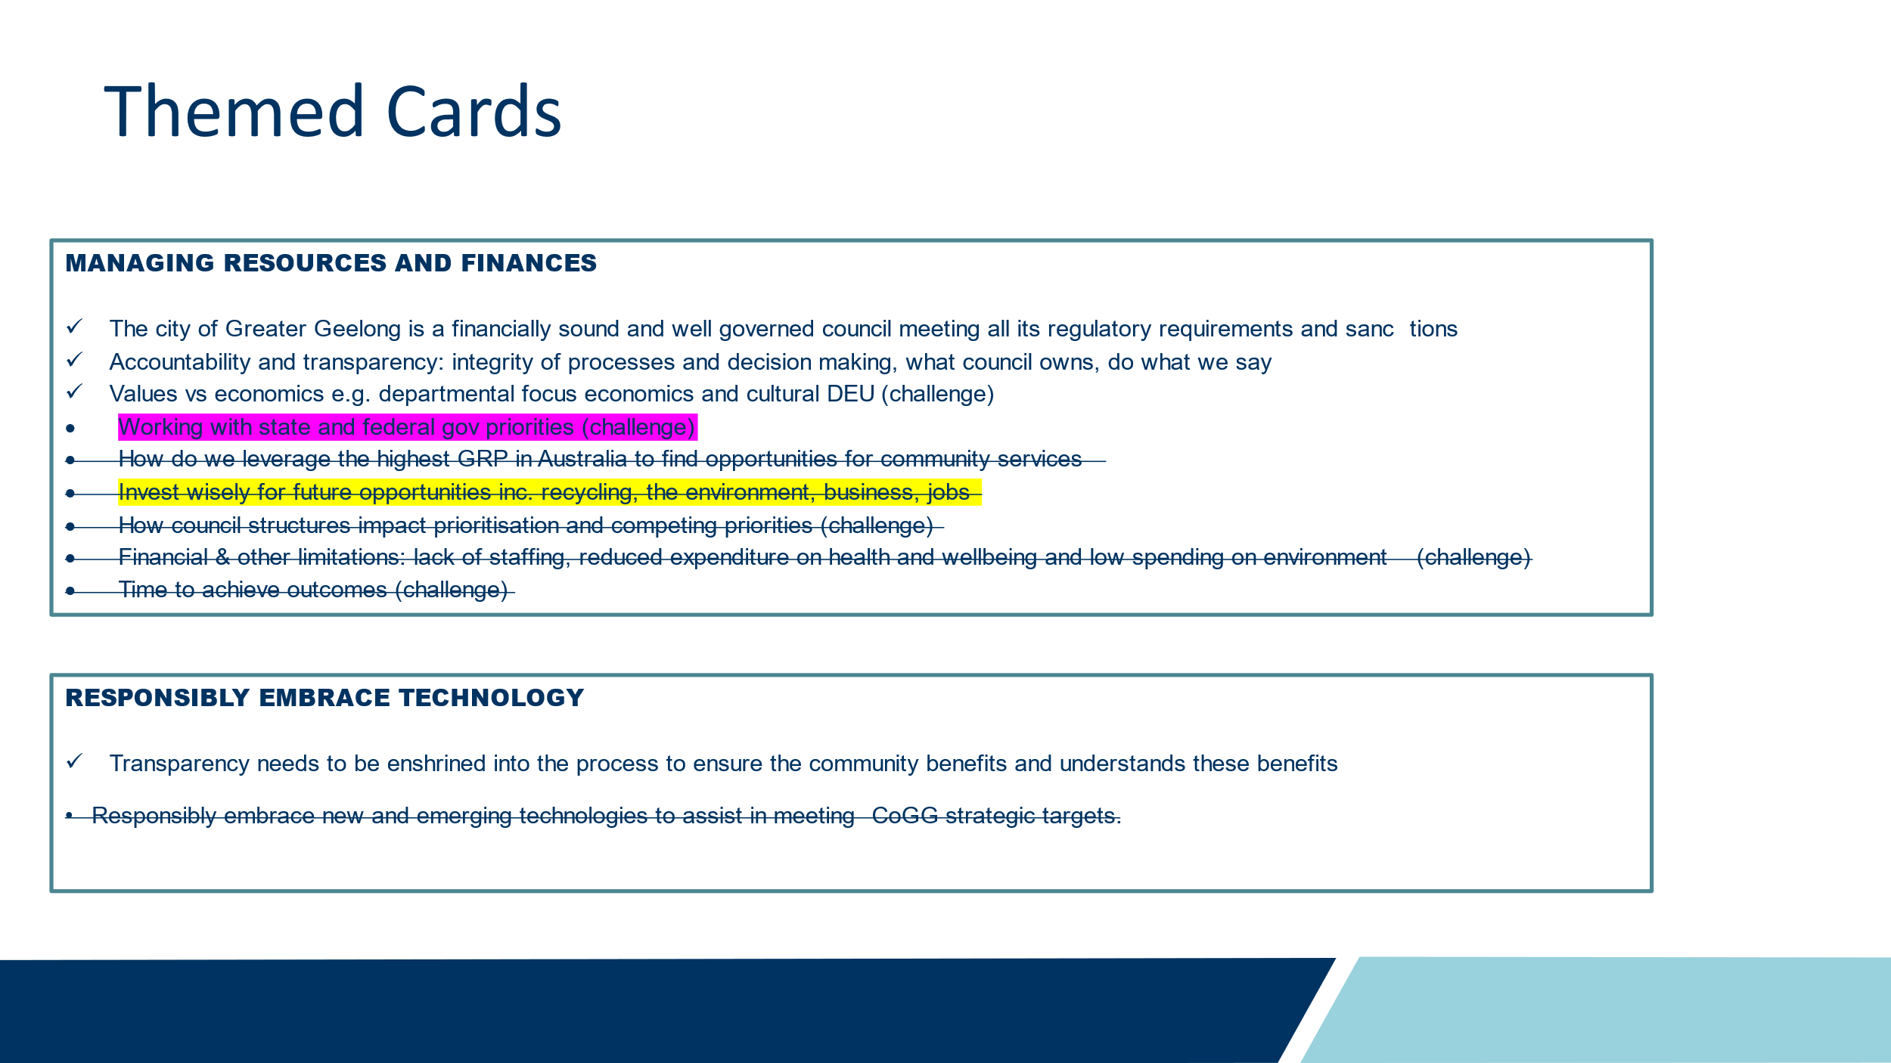

Council noted the following;
- The crossed out cards are discussing City operational responsibilities. The role of Council is to set the strategic direction, it is then the responsibility of the Organisation to allocate resources to achieve the objectives as outlined in the Council Plan.
- The magenta highlighted card is a consideration against a number of strategic directions, be that around our environment or growth planning or economic direction
- The yellow highlighted card would be part of delivering the Council Plan. Based on the strategic direction of council, investment would be made into those areas.

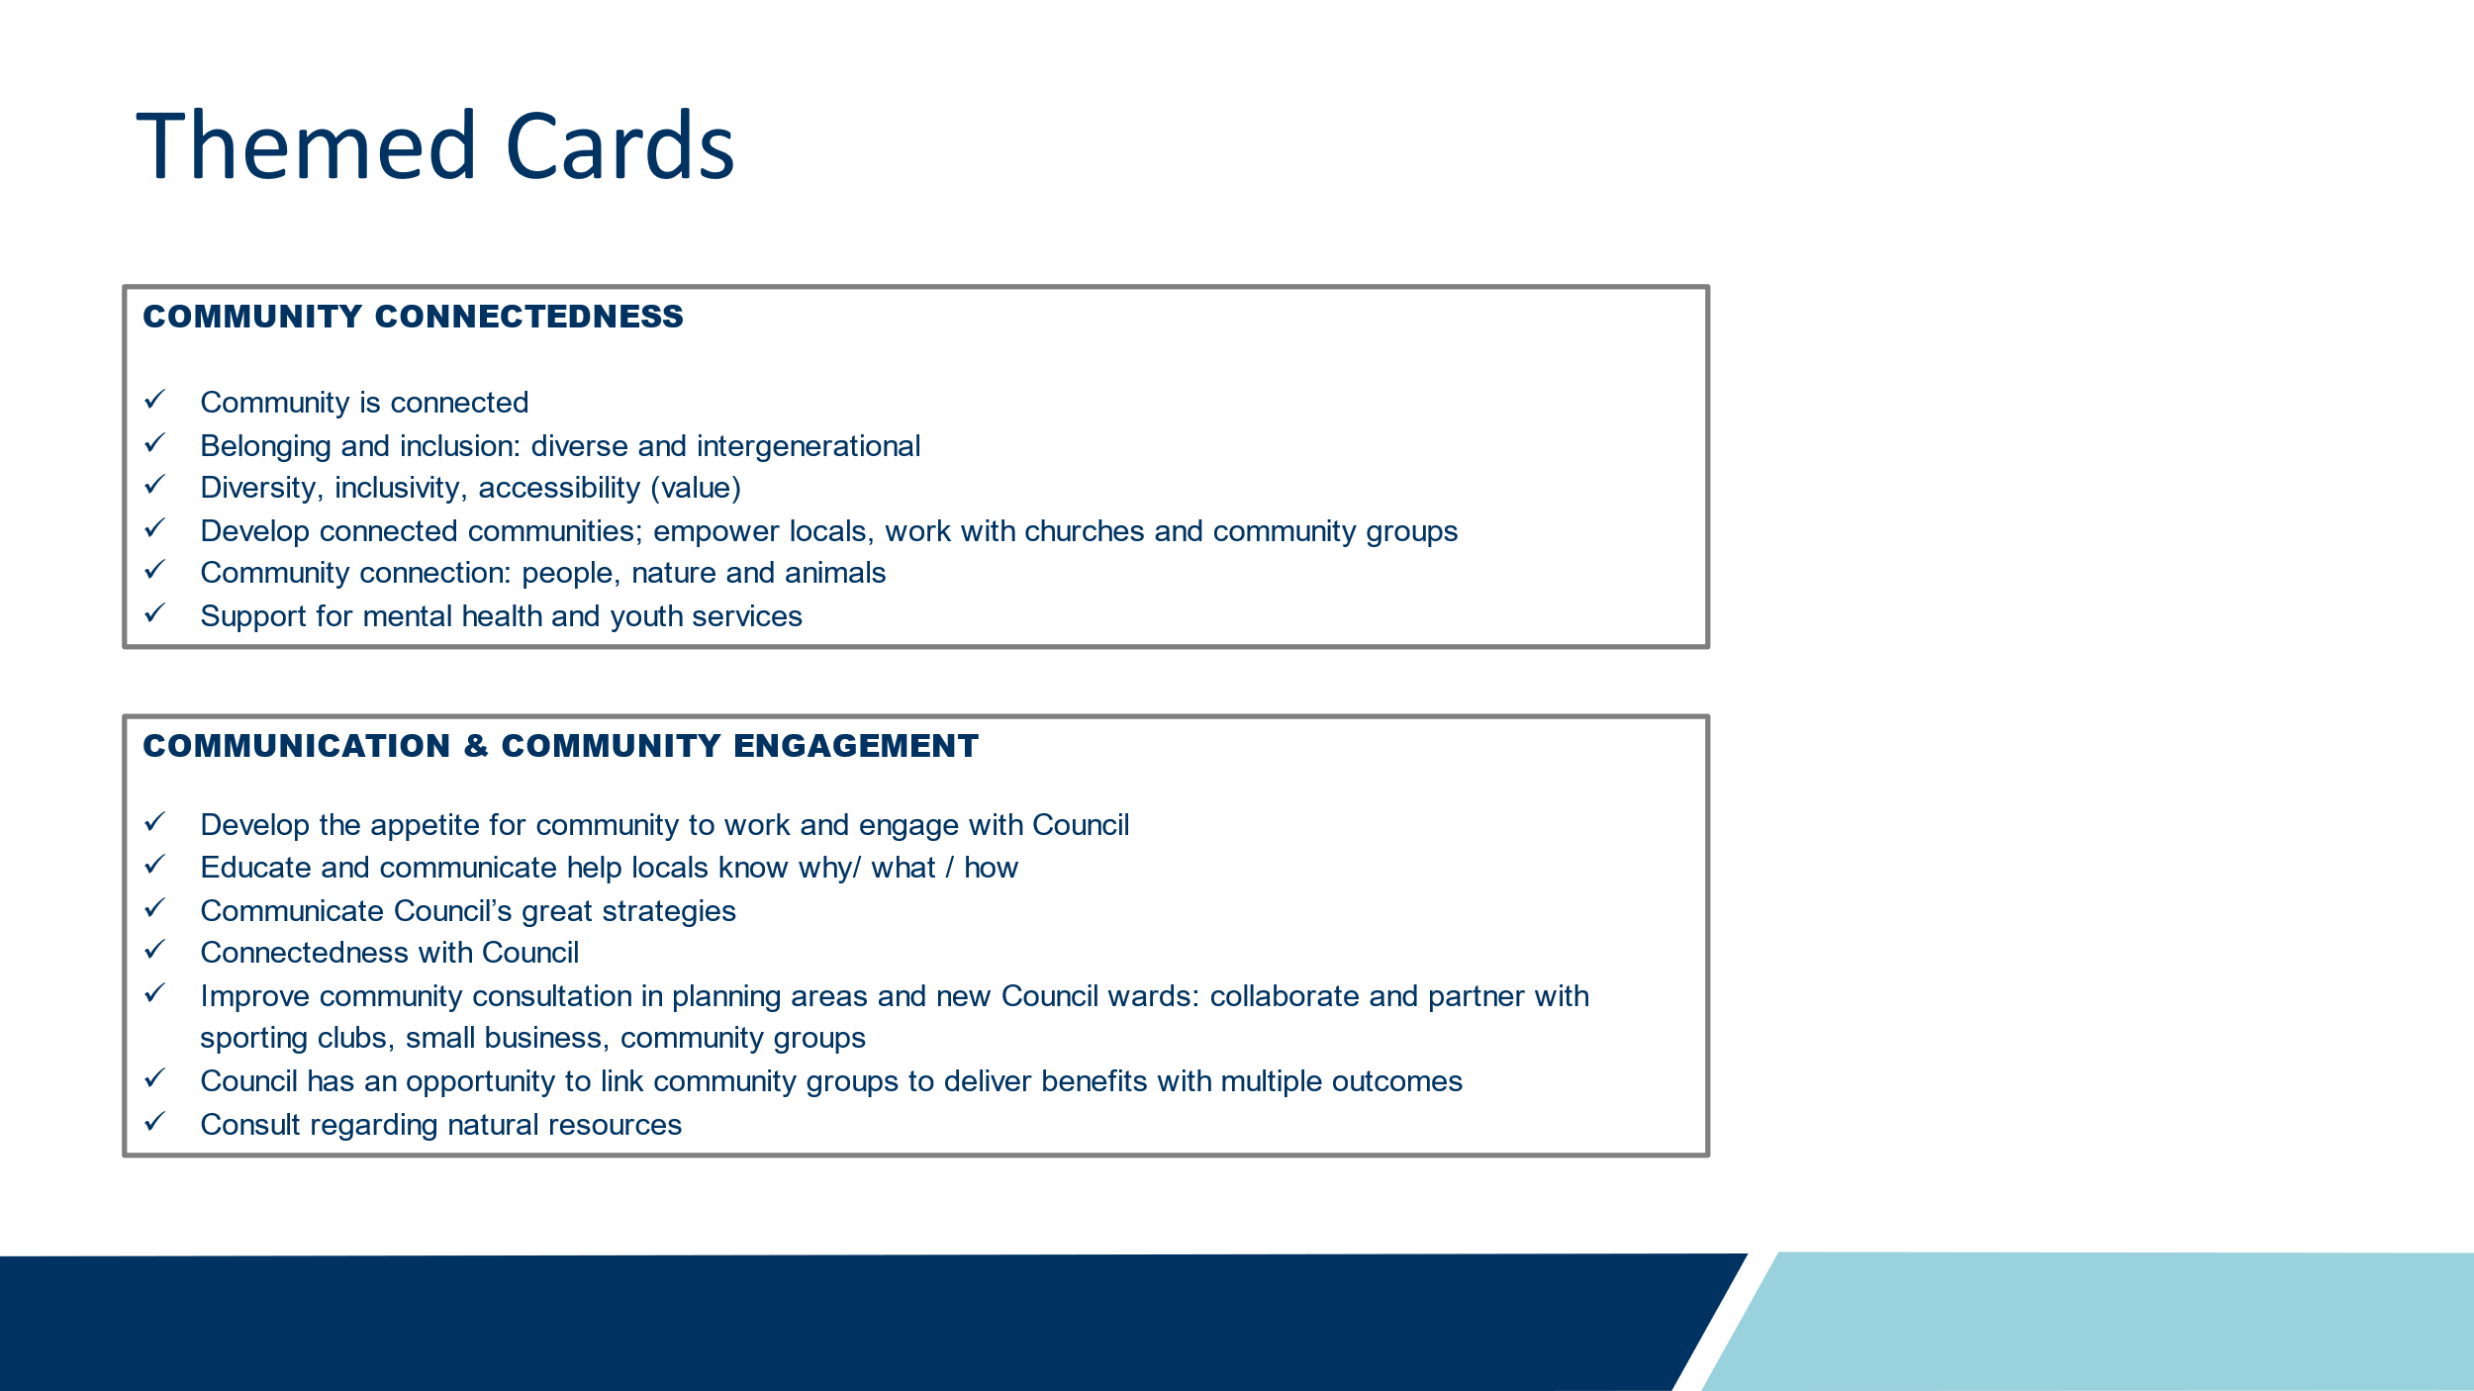
Council noted;
- Community Connectedness and communication are strong themes that you might consider bringing together, based on what was on the cards
- You might also think about lifting it up into a health and wellbeing Strategic Direction.
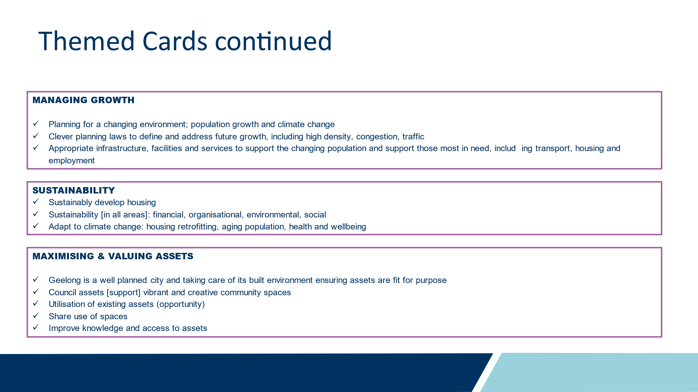
Council noted;
- These are very strong themes
- If you review the cards within them, you notice that there close relationships between these three themes
- You might consider bringing these together into a single theme and use priorities to look deeper into these areas

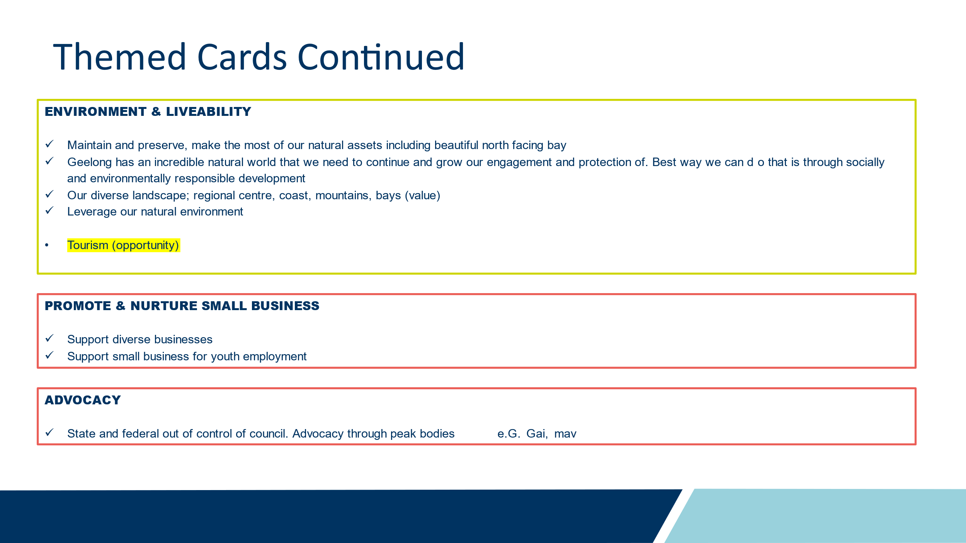
Council noted the following;
- The cards here very strongly align.
- Tourism reads as an ‘odd one out’ in the context of the other cards. You could think about where this fits best, perhaps reframing the small business and advocacy themes to include broader economic opportunities – bearing in mind our recently endorsed economic development plan that covers these topics

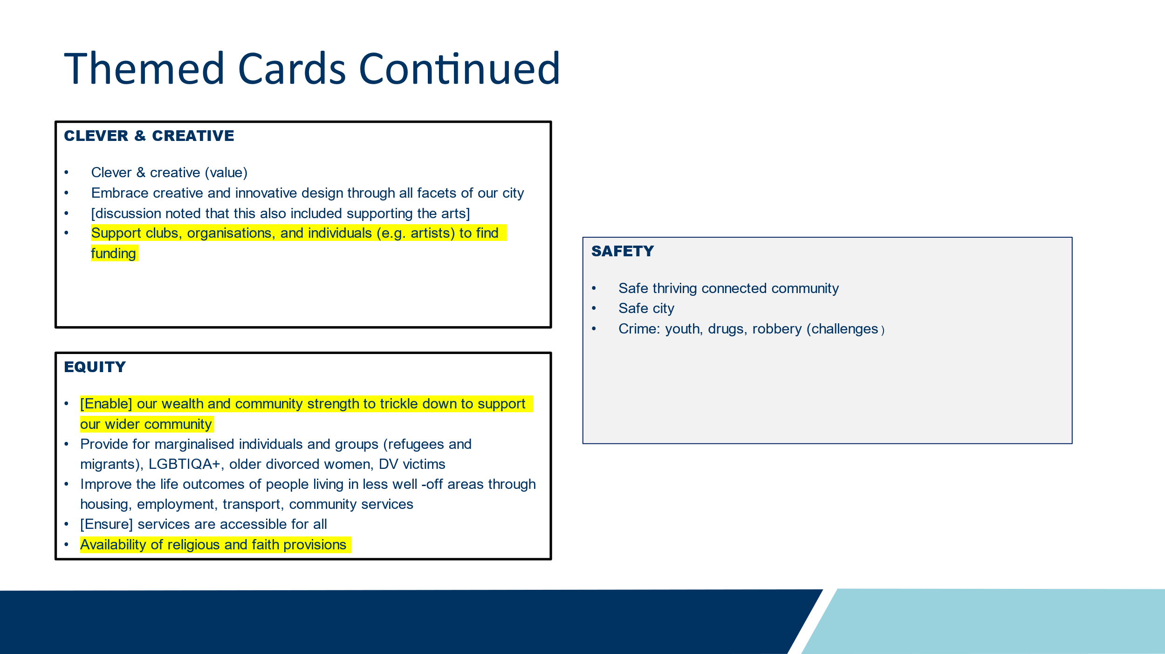
Council noted the following;
- The yellow highlighted theme might belong somewhere else, perhaps with the community connectedness themes as a benefit of thriving sporting/social clubs.
- Perhaps an opportunity for the Panel to consider reframing to capture wholistic health and wellbeing themes.
- Equity & clever and creative talk to how we design the actions to achieve the strategic directions, design led thinking and how those solutions impact different sections of our community differently
- Safety: The Panel may reflect on this theme and consider if these are outcomes of other priorities, e.g. if there is appropriately designed infrastructure, that would lead to safe, thriving, and connected communities
- Clever Creative: Design led thinking is a principle that can be applied across all areas of council, extending beyond built environment and arts, as reflected by the UNESCO City of Design designation.

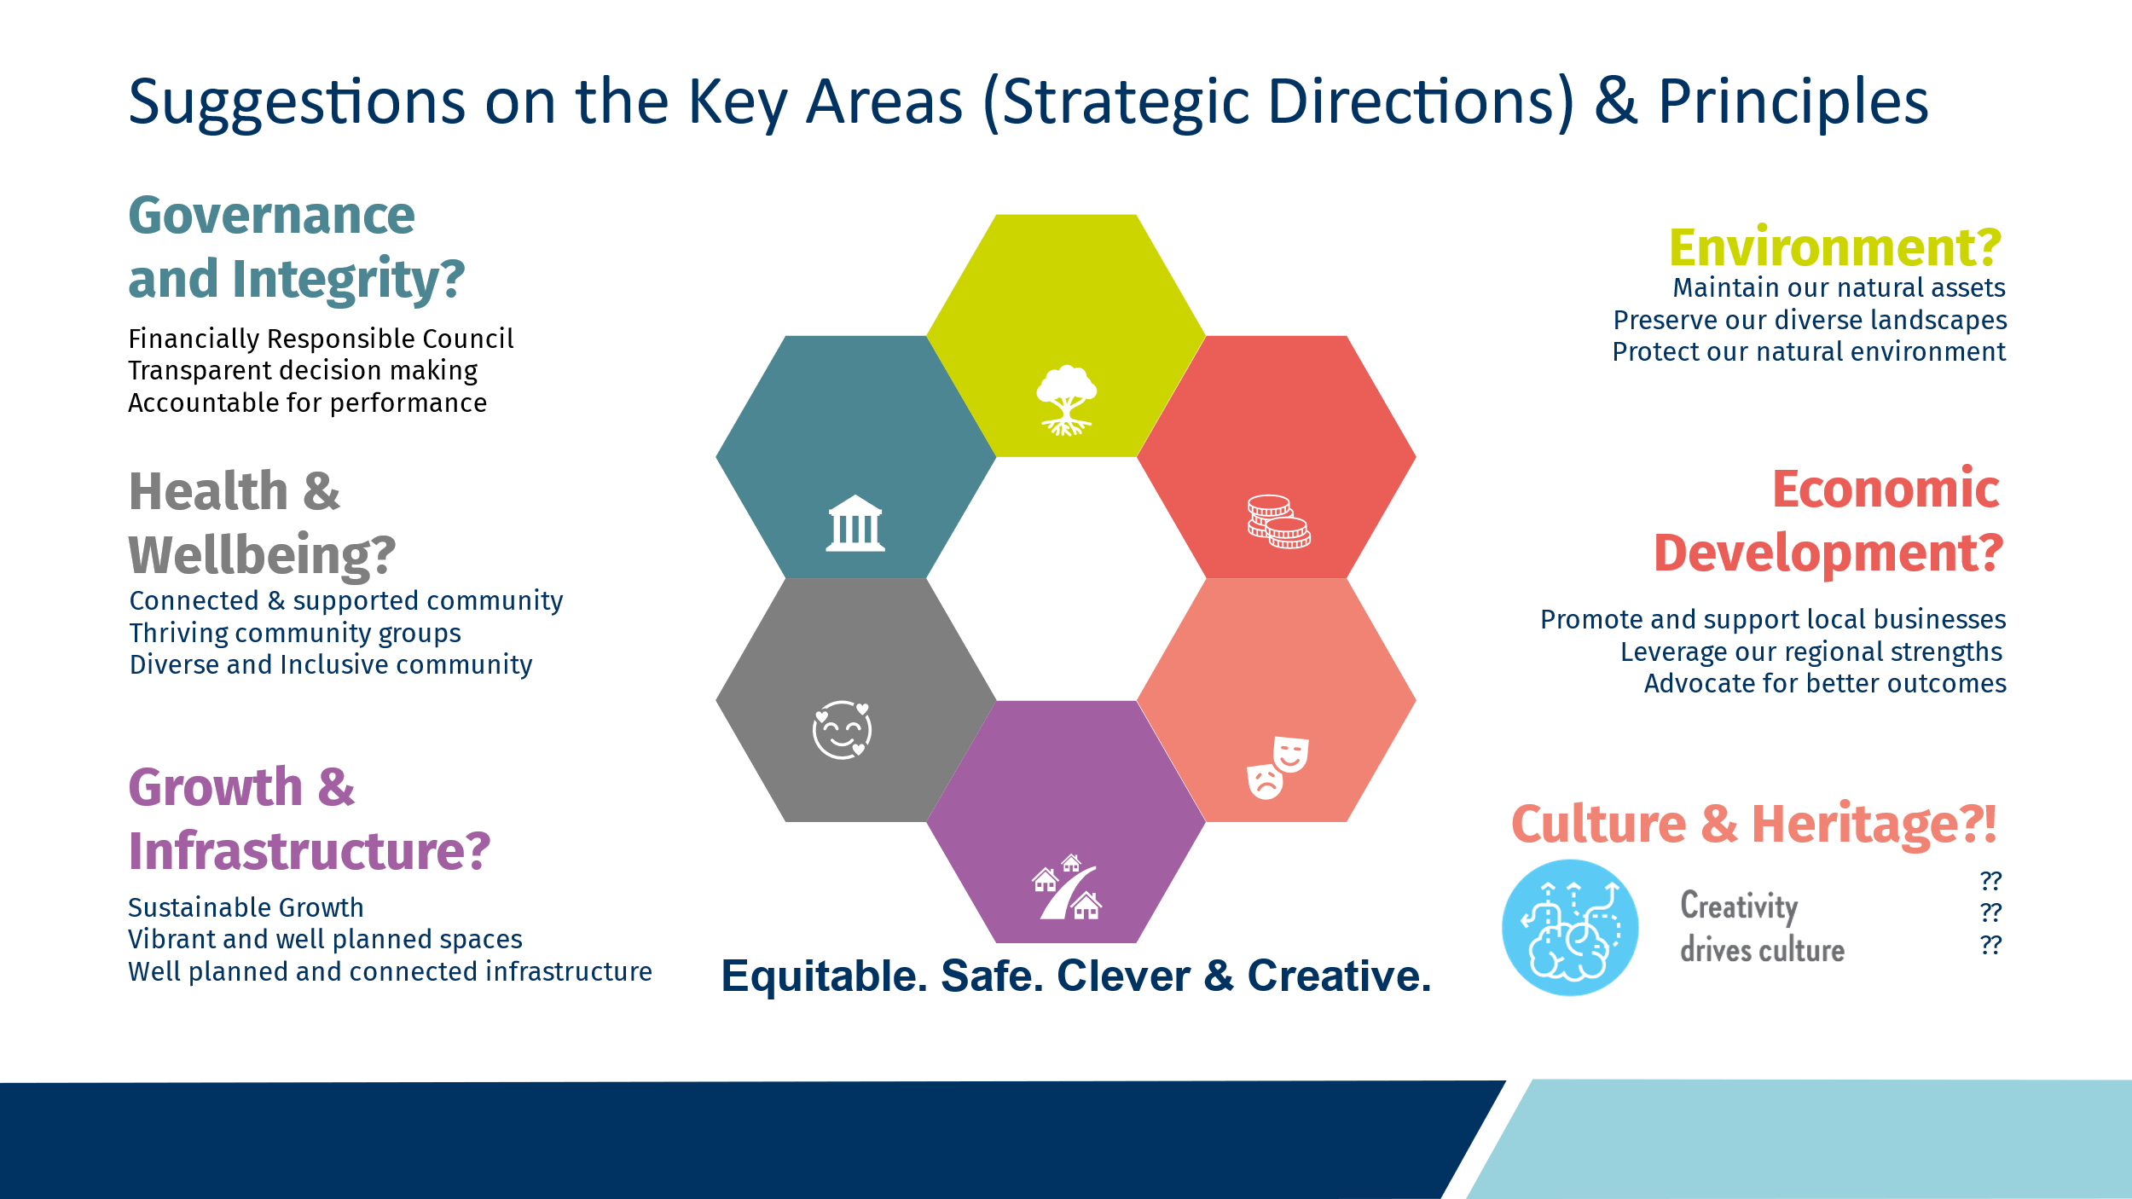

Council noted the following;
- This is a diagram of how that feedback comes together, with some really high level descriptions, based on the cards in each theme
- One area that noticed was absent in the cards was a major area in Arts, Culture, Heritage – including First Nations.
- Obviously, this is just something the Panel can reflect on and consider
xx
Capire Consulting Group
The Commons,
Wurundjeri Country
36-38 Gipps Street,
Collingwood VIC 3066
(03) 9285 9000
info@capire.com.au
capire.com.au

Capire acknowledges
and deeply respects the Wurundjeri people and
the Traditional Owners
of the Victorian land.

