The City Of
Greater Geelong

sale of land (buildings) – four commercial properties

Contents
Background 3
Land Proposed For Sale 4
21 Gheringhap Street, Geelong 4
Locality Plans – 21 Gheringhap Street, Geelong 4
30-54 Brougham Street, Geelong 6
Locality Plans – 30-54 Brougham Street, Geelong 6
17 Reynolds Road, Belmont 9
Locality Plans – 17 Reynolds Road, Belmont 9
200 Princes Highway, Corio 11
Locality Plans – 200 Princes Highway, Corio 11

Background
- Four commercial properties have been identified as land potentially surplus to the City’s needs.
- Each of these properties are developed with commercial activities which are or could be provided by commercial entities.
- The properties are listed here and additional details on each property are provided in the attachments to this report.
  - 21 Gheringhap Street, Geelong, known as the Civic Carpark
  - 30-54 Brougham St, Geelong, known as the Busport Carpark
  - 17 Reynolds Road, Belmont, including a tenpin bowling centre and associated carparks
  - 200 Princes Hwy, Corio – containing a KFC fast food outlet
- Income from land sales is included in the Proposed 2022-23 to 2025-26 Budget and the Long-term Financial Plan 2021-2031.
- The sale of these assets aligns with Our Community Plan, Strategic Direction 4 High-Performing Council and Organisation to support financial sustainability by divesting surplus assets to invest in the development and renewal of community infrastructure.
- Before selling land, the Council must comply with section 114 of the Local Government Act 2020, which includes publishing notice of intention to do so on the Council’s internet site and undertaking a community engagement process in accordance with its community engagement policy.
- To set the projected land sales budget, the process required by section 114 of the Local Government Act 2020 will be conducted on identified land as part of the budget preparation process
- For more information and to provide feedback about the proposed sale, please visit Have Your Say at https://yoursay.geelongaustralia.com.au/

Land Proposed For Sale

21 Gheringhap Street, Geelong

- The land at 21 Gheringhap Street, Geelong contains the Civic Carpark, with 503 commercial car parks and 4 retail shops.
- The land measures approximately 4062.7m² and is zoned Activity Centre 1 Zone (ACZ1).
- The retail shops front Little Malop Street and are leased commercially. This retail activity contributes to the vibrancy of Little Malop Street and compliments the civic and cultural precinct.
- The building was constructed in the mid-1970s, with land acquisition and development works of $2,602,977 including an estimated contribution of $944,530 from a Special Rate which was levied on surrounding traders over 20 years.
- The structural integrity of the building has been examined in the GHD Report ‘Civic Centre Car Park – Condition Assessment Materials Investigation’ dated November 2018. This suggests that the current building improvements have approximately 10-15 years remaining life before significant investment would be required to renew it.
- It is intended that a condition of any potential sale would ensure that the current use for commercial car parking and car park numbers to be retained for a minimum of 10 years, which would align with the practical remaining life of the building.
- While the sale of the building would reduce the commercial income from parking fees and retail leases, the City will receive the capital income from the land sale and not have the burden of renewing the building in 10 years.

Locality Plans – 21 Gheringhap Street, Geelong
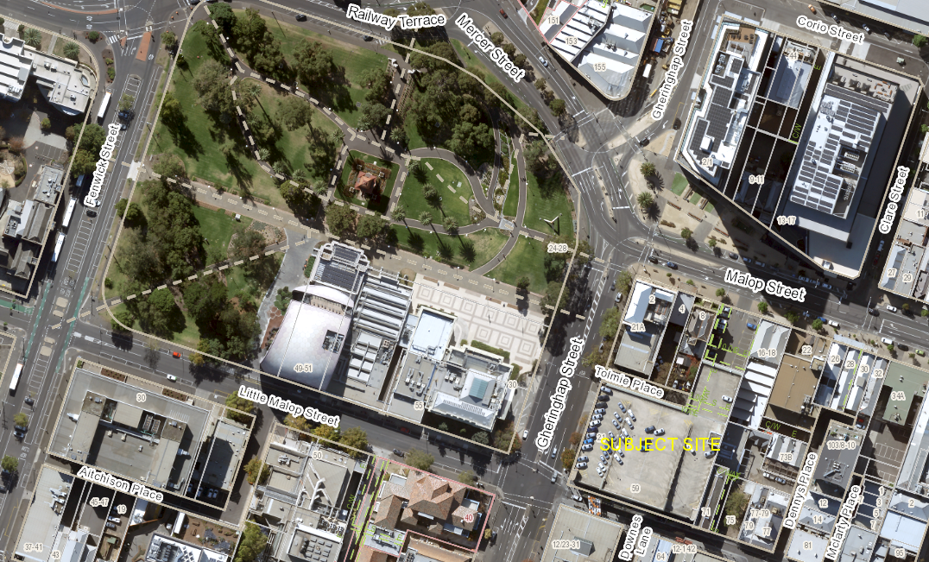

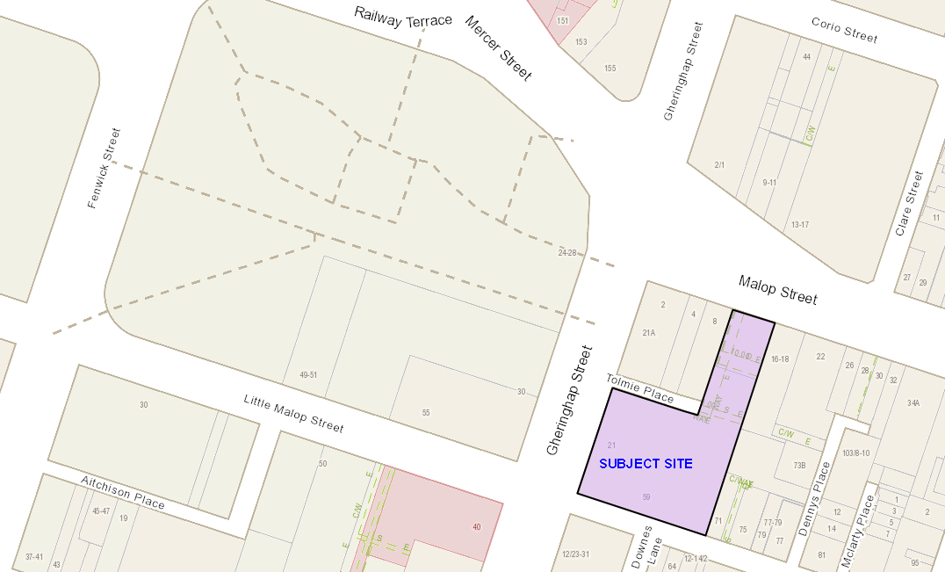

Street View – 21 Gheringhap Street Geelong
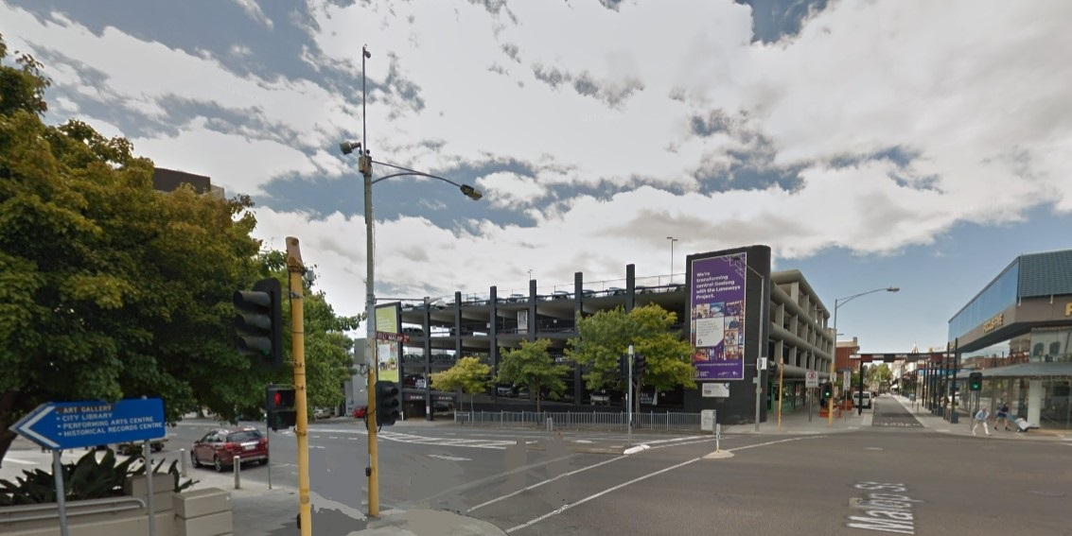

30-54 Brougham Street, Geelong
- The land at 30-54 Brougham Street, Geelong contains the Busport Carpark with 196 commercial car parks and office space
- The land measures approximately 3,218m² and is zoned Activity Centre 1 Zone (ACZ1).
- The office space is predominately occupied by the City, however will not be required once the new Wurriki Nyal building is completed in 2022.
- The building structure is capable of supporting another two levels of car parking.
- While the sale of the building would reduce the commercial income from parking fees and potential office leases, the City will receive the capital income from the land sale and not have the burden of maintaining or operating the building.

Locality Plans – 30-54 Brougham Street, Geelong
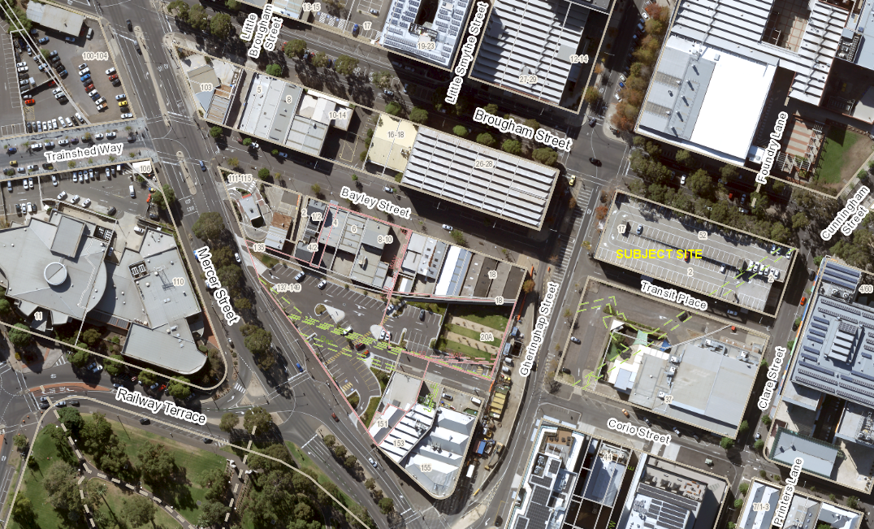
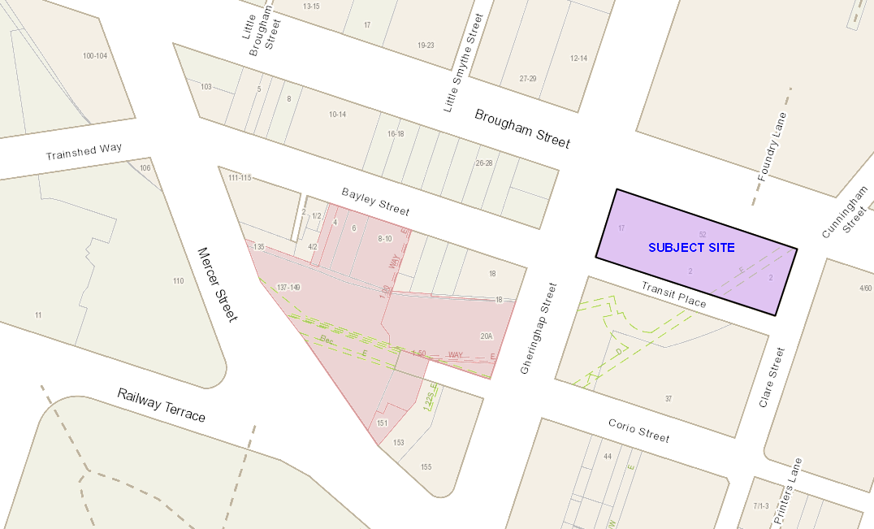

Street View – 30-54 Brougham Street, Geelong
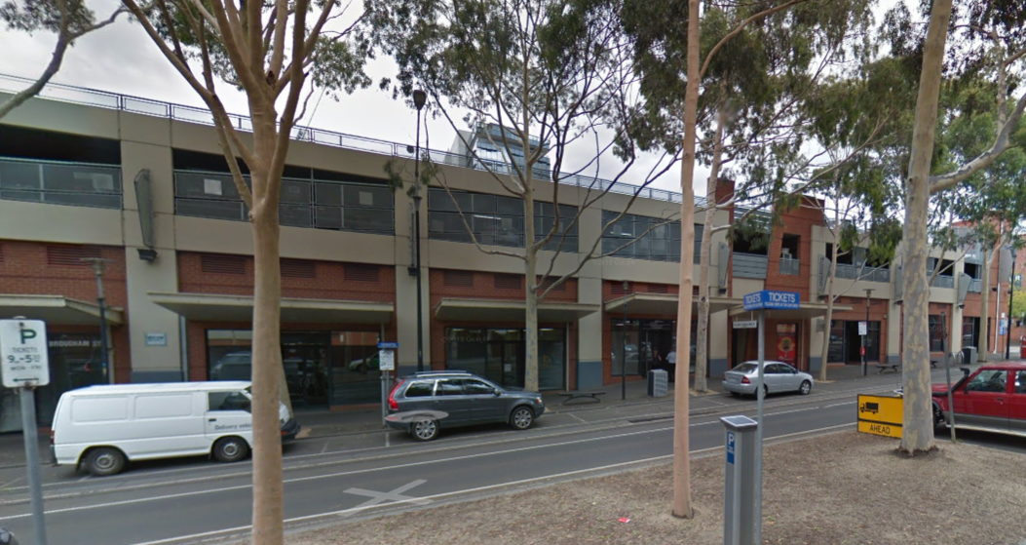

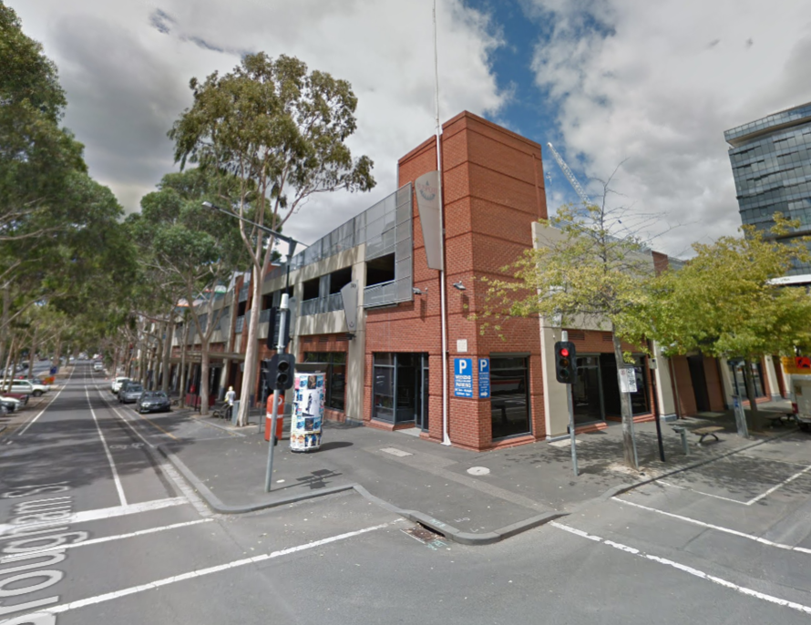

17 Reynolds Road, Belmont
- The land at 17 Reynolds Road, Belmont measures 1.561Ha and is zoned Mixed Use Zone (MUZ)
- The land has a tenpin bowling centre with a commercial lease, a maternal health centre run by the City and car parking.
- There are several easements on the title for underground services including drainage, water and gas.
- If the land is sold, the City will include a condition on the sale to secure a 20 year lease for the Maternal Health Centre so the service would not be impacted.
- The sale will enable the commercial use to continue without the City being responsible for maintaining the land and buildings.
- The sale may open the opportunity for additional development.

Locality Plans – 17 Reynolds Road, Belmont

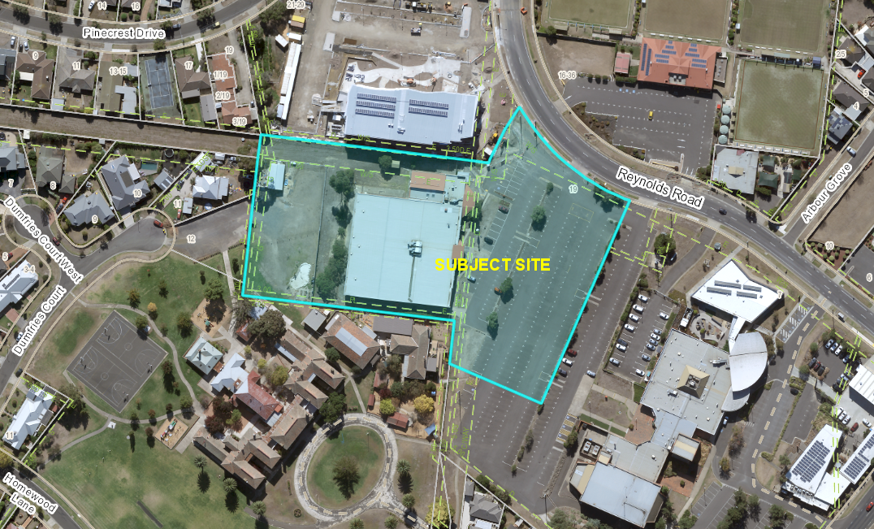

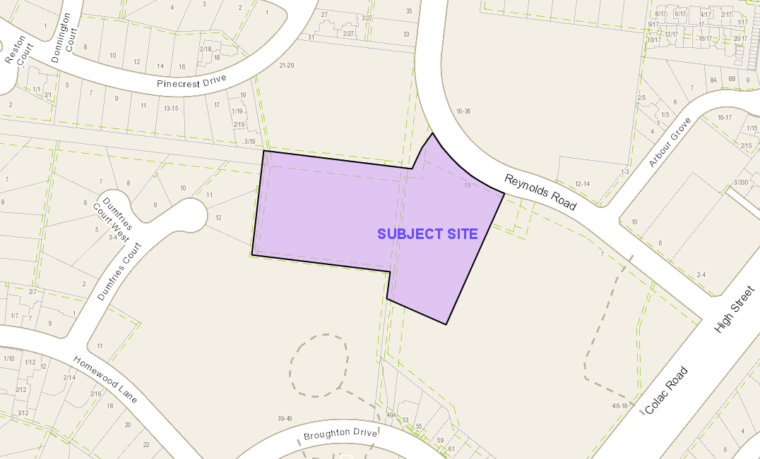

Street View – 17 Reynolds Road, Belmont
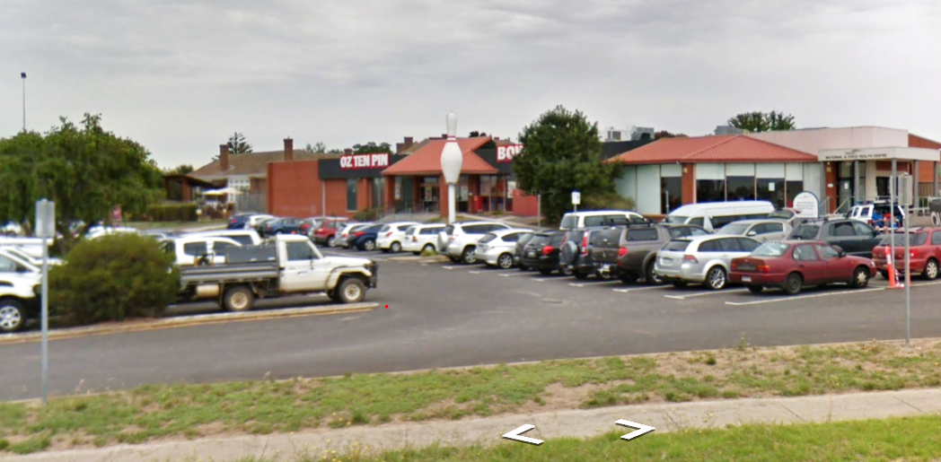

200 Princes Highway, Corio
- The land at 200 Princes Hwy, Corio contains a KFC store and associated car parks which have been there for over 40 years.
- The property is commercially leased until 2029 with a further 2 x 5 years options to extend the lease.
- The leased area is within Stead Park, which is a well utilised, regionally significant, reserve.
- The commercial activity is inconsistent with the reserve land use, however the fast-food restaurant is a well-located and a popular amenity for the area.
- The City intends to subdivide approximately 1,570m² from the reserve and rezone it to a Commercial 2 Zone (C2Z) to conform with the developed use. This is shown in the images as Lot 2 on the proposed plan of subdivision.
- If the land is rezoned, the City proposes to sell the C2Z land which will enable the commercial use to continue without the City being responsible for maintaining the land and buildings.
- This proposed land sale will not negatively impact the reserve as the income will support ongoing maintenance and investment in improving Stead Park and other reserves for the enjoyment of the wider community.
- The subdivision will create road reserves to align with the constructed roads, create easements over the existing drainage and discontinue an unmade road reserve.

Locality Plans – 200 Princes Highway, Corio

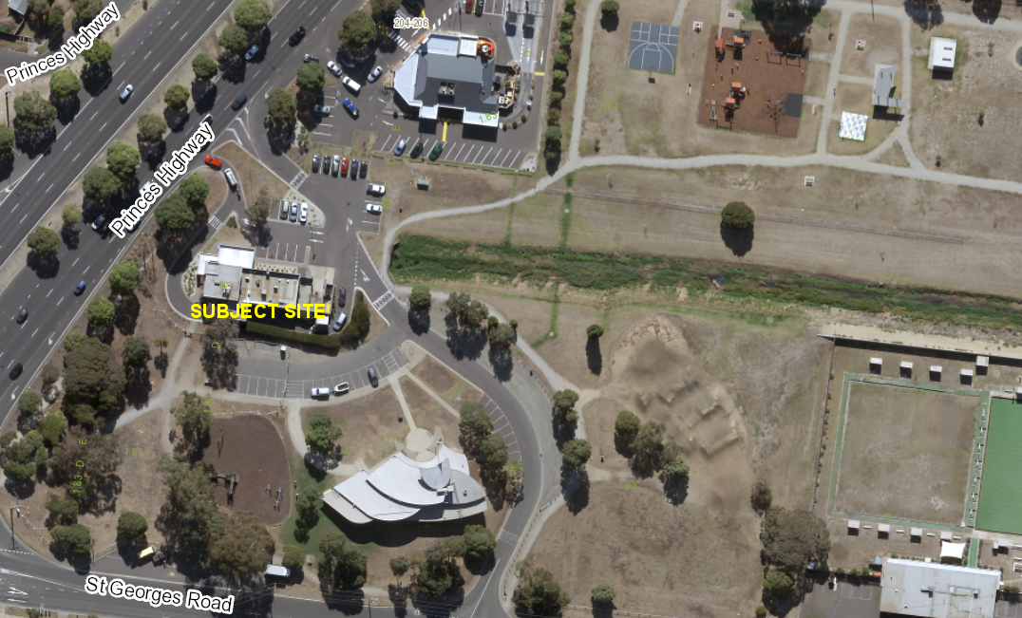

Site Plan – Proposed plan of subdivision – Lot 2
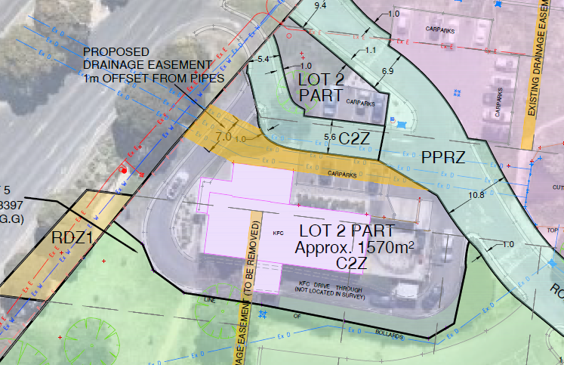

Site Plan – Proposed plan of subdivision- Stead Park
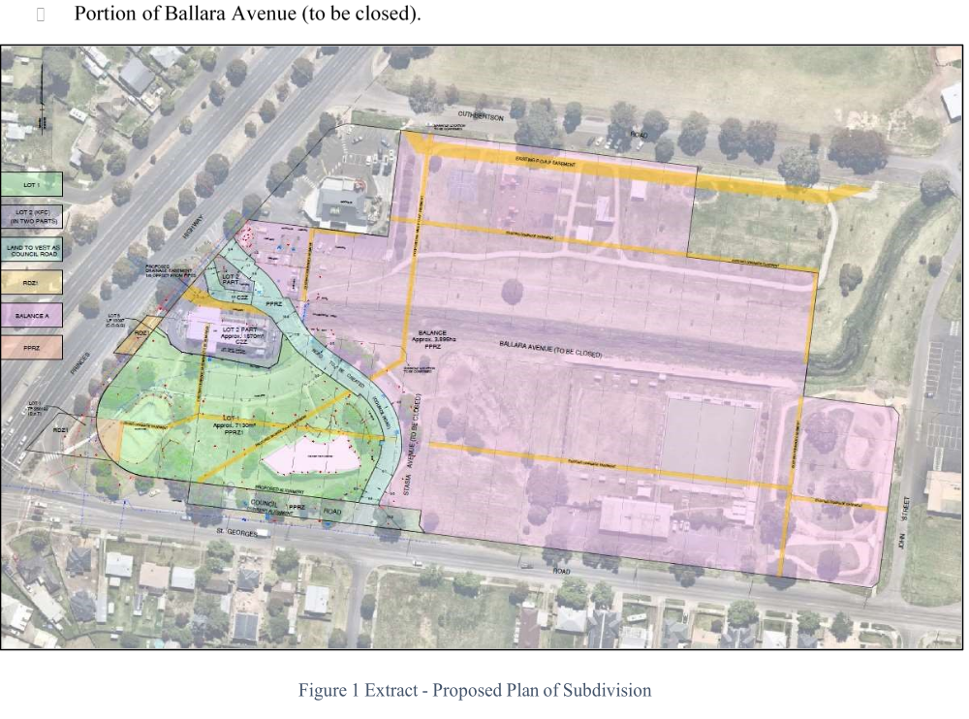


—
CITY OF GREATER GEELONG
PO Box 104
Geelong VIC 3220
P: 03 5272 5272
E: contactus@geelongcity.vic.gov.au
www.geelongaustralia.com.au
CUSTOMER SERVICE CENTRE
Geelong
100 Brougham Street
Geelong VIC 3220
8:00am – 5:00pm
LATEST NEWS:
geelongaustralia
@GreaterGeelong
@CityofGreaterGeelong
@CityofGreaterGeelong
CityofGreatGeelong

