community engagement summary

HOW WE ENGAGED
WHAT DID WE DO?
To promote applications for the expression of interest (EOI) application for our Social Inclusion Action Process we used both a broad and targeted approach. It was important to us that we received applications from across the Greater Geelong region and from a mix of ages and genders however we were also aware that certain groups in our community experience loneliness and social isolation at higher rates. Our key target groups were established from data provided from the Wellbeing’s Promotions Office and also from the Geelong Preventative Health Survey.
Once the priority groups had been established, face-to-face engagements and targeted emails were prepared to ensure members from these groups were aware of the Social Inclusion Action Group. Posters, a media release, councillor columns, and social media posts were disseminated across the broader community to ensure the Expressions of Interests reach a wide audience also.

50
“Such important work! It is wonderful to hear diverse voices and experiences will be heard in plans to increase inclusion in our region”

122
Expressions of Interest

42 DAYS
of engagement

People following the project

HOW WE ENGAGED
Have Your Say Online Portal  Yoursay.geelongaustralia.com.au | An online HYS project page was designed to share relevant information to encourage community to submit Expressions of Interest to be part of the Social Inclusion Action Group
Survey (online and hardcopy) | Survey distributed online via HYS page and hardcopy through Neighbourhood houses and specific community groups
FACE-TO-FACE PROMOTION OF eoi | - Cultura Refugee Week Expo  - The Nest Youth Hub  - Vines Road Community Centre  - Norlane Neighbourhood House  - Cloverdale Neighbourhood House  - Gateways Parents Group  - The Lounge International Students Group  - Armstrong Creek English Conversation Club
PROFESSIONAL NETWORKS | In person promotion at:  - CAOS – The City of Greater Geelong  - HOMELESSNESS NEWORK – The City of Greater Geelong  - Community Strengthening Department Meeting  Shared Via email to:  - Geelong Health and Wellbeing Network  - Barwon Youth Services Connect network  - Health and Wellbeing Partners network  - Barwon Elder Abuse Primary Prevention network  - LGBTIQA+ Networks-
Posters, Postcards & Hard copy surveys dropped | - All Libraries in the City of Greater Geelong  - Select Neighbourhood Houses in target suburbs  - The Fort and The Nest Youth Hubs
Written applications | Open at any time during the public engagement period. Submissions could be provided by email or mail.
Communications
We promoted the EOI on the The City’s social platforms found here which was then shared by other local health and wellbeing organisations. Posters promoting the EOI were placed in Libraries, Neighbourhood Houses, youth drop in spaces and other community spaces encouraging people to apply. As well as promoting the EOIs by speaking in person to groups of community members and also relevant professional groups.
We released the following media release: Join the local movement to support mental health - City of Greater Geelong which was picked up by the following news articles Mental health group launched for region - K ROCK 95.5 and Mental health group launched for region - bay 93.9. We also ran a radio announcement on K ROCK.
The Expression of interest was also been featured in the following Councillor Columns: Call for mental health group | Ocean Grove Voice and https://timesnewsgroup.com.au/bellarinetimes/news/seeking-feedback-and-feedback-on-feedback/

who expressed their interest in becoming a siag member

PARTICIPATION
From June 19 to July 31 122 people submitted an EOI to become a member of The City of Greater Geelong’s SIAG group.
It is crucial to the SIAG project that the group is made up of a broad representation of the residents of the City of Greater Geelong, ensuring there is strong representation from demographics of people in our community who are at greater risk of experiencing Loneliness and Social Isolation. We were thrilled to receive EOIs from 34 suburbs representing excellent reach across the Greater Geelong region. With at two or more submissions from each of the surburbs in the graph below.

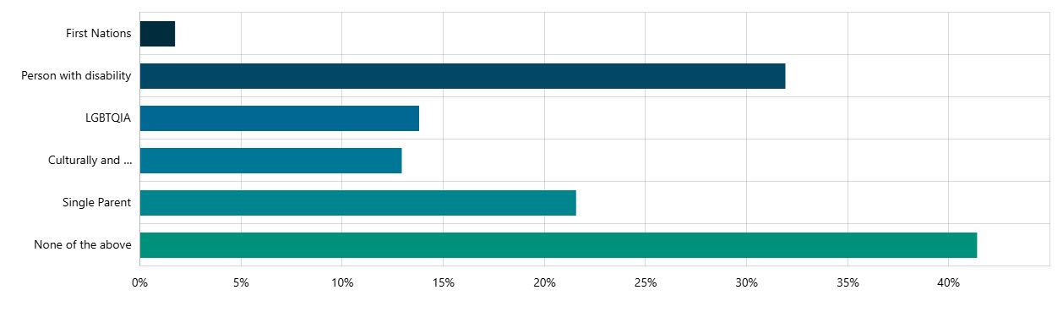
Of equal importance was representation from groups who are at a greater likelihood of experiencing social isolation, over 55% of our applicants selected they identified as a member of at least one of the following groups:

It is crucial to the success of SIAG that the group is formed by community members who have life experiences that can inform their decision making on loneliness and isolation. We asked participants to select from a list of experiences known to impact on an indivuals feeling of connection. The results of the applicants show our applicants have a rich background of experiences that will inform their decision making.

WHAT WE HEARD

Key reasons why people wanted to be a part of SIAG

1. Lived Experience of Isolation and Loneliness
Many applicants share personal experiences of social isolation, loneliness, mental health challenges, unemployment, housing instability, and caring responsibilities. They want to use their lived experience to help others facing similar challenges and ensure no one feels as isolated as they once did.
2. Desire to Give Back and Create Meaningful Change
Applicants express a strong motivation to contribute to their community and make a difference in people's lives. They want to be part of collective action that breaks down barriers to inclusion and creates lasting positive change for vulnerable community members.
3. Professional Expertise and Community Connection
Many bring relevant professional backgrounds in mental health, community services, healthcare, social work, and community development. They want to apply their skills and knowledge while building stronger connections within the Geelong community.
4. Representation of Diverse Voices
Applicants from various backgrounds want to ensure diverse perspectives are heard, including:
- LGBTQIA+ community members
- People with disabilities
- Culturally and linguistically diverse residents
- First Nations people
- Parents and carers
- Different age groups and life stages
5. Personal Growth and Social Connection
Several applicants see SIAG as an opportunity for their own social connection and personal development. They want to build networks, gain new skills, feel valued, and develop a stronger sense of belonging within the community while helping others do the same.

NEXT STEPS for The Social inclusion Action group

Due to the unprecedented volume of high-quality applications, a SIAG Loneliness forum will be held on 30 August 2025 with 60 community members invited to explore drivers of loneliness and social isolation in the Greater Geelong Region. Final SIAG member selection will follow, with a formal welcoming event planned for early November 2025 announcing both the members and the key priorities of the SIAG to the community and relevant organisations.
A “Friends of SIAG” mailing list has also been created open to all applicants who did not make the final SIAG group as well as community members and community organisations who are interested in staying up to date with SIAG activities and outcomes.
How we chose forum participants

The selection process was deeply considered and challenging. We were committed to forming a group that reflects the rich diversity of our region, from geographic location, age, gender, and life experience to differing levels of community involvement and social connection.
Each application was thoroughly considered, particularly the response to the question “why do you want to be a part of the Social Inclusion Action Group” with those applicants who could communicate their lived experience of loneliness and social isolation as well as identifying an idea or desire to change things for others were scored the highest.

