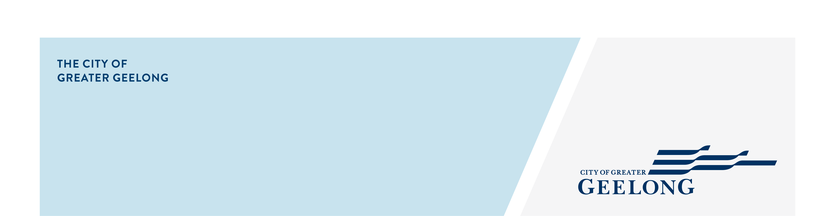
DRAFT FAIR PLAY POLICY

CommuNity Enagement

Snapshot report

community engagement summary
Feedback on the draft Fair Play Policy has closed, thank you to everyone who provided feedback, your contribution is valued and appreciated.
On 23 July, 2025 the City commenced community engagement on the draft Fair Play Policy 2026-2029, inviting the community to have their say. The Policy aims to ensure equitable access to facilities, fair application of fees and charges, and decision-making guided by clear principles. It also seeks to support growth in community sport and recreation while balancing the City’s responsibility to maintain and invest in its facility network.
A summary of the engagement period is provided below.


3
Fair Play Policy sporting club information sessions
2,679
Visits to the Have Your Say page
30 DAYS
of engagement

70
Sporting club information session attendees
2
Community Drop-In Sessions



NEWS

2
Print adverts in local newspapers

15
One-to-one meetings with sporting clubs
36,312
Social Media reach

25
Community Feedback Submissions

Next Steps
Community engagement is closed for evaluation and review. The insights and feedback received during this period will be used to shape the final Policy, which will be presented to Council at its November 2025 meeting. The community engagement report will be uploaded to the Have Your Say page for viewing following the meeting.
All stakeholders that provided a submission and requested to be contacted by the project team, will be contacted via their preferred method.

