The City Of
Greater Geelong

Domestic animal management plan 2026-2029

HAve your say

Engagement report

  - June 2025

Contents
executive Summary: 4
Project Overview 4
Engagement Overview 4
How We Engaged 4
Who We Engaged 4
What We Heard 4
What We Will Do 4
Introduction 5
Project Background 5
Engagement Purpose 5
About This Report 5
How We Engaged 6
Snapshot 6
Promotion 6
F2f Consultation Schedule 6
Who We Engaged 9
Who We Planned To Engage 9
Face To Face Demographics 9
Suburb 9
Animal Ownership 10
Survey Demographics 10
Animal Ownership 10
Gender 10
Suburb 11
Who Actively Engaged 11
Geelong Animal Welfare Society 11
Internal City Departments 12
What We Asked 13
What We Asked - Survey 13
Participant Information 13
Responsible Pet Ownership 13
Animal Management Officers 13
Suggestions 13
About You 13
Why We Asked 13
Participant Information 13
Responsible Pet Ownership 13
Animal Management Officers 14
Suggestions 14
About You 14
What We Asked – Internal & External Stakeholders 14
Invested City Departments 14
Geelong Animal Welfare Society 14
What We Heard 15
Key Findings Overview 15
F2F Consultation Summary 15
Survey Response Summary 15
Previous Reading And Awareness Of The Domestic Animal Management Plan 18
Main Benefits Of Being A Pet Owner 18
Safety In The Presence Of Domestic Animals When Using The City’s Open Spaces 18
Awareness Of Bi-Laws Applying To Pets 20
What Has Been Noticed In Your Area In The Last Year 21
Barriers To Being A Responsible Pet Owner 22
Favorite Things About Domestic Animals Living In The Community 23
Animal Management Officers (Amo’s) 24
Animal Management Topics Requiring Further Promotion 26
Cat Findings 27
Dog Feedback 28
Clever And Creative Ideas 29
Gaws Suggestions 31
Internal City Departments 31
Animal Management Services 32
Discussion 33
Uptake 33
Key Themes 33
Structure And Location Of F2F Events 33
Survey Uptake 33
Survey Structure And Theming 34
Promotion 34
Survey Fatigue 34
Distrust In Council 34
Informal Feedback 34
What We Have Done And Next Steps 37
What We Have Done 37
Next Steps 37
Appendix A - Survey Hardcopy 38
Appendix B – Promotional Materials 43
Postcard 43
Appendix B - Promotional Materials 44
Appendix C – Social Media Posts 45
Appendix D – Safety Commentary 46
Appendix E – Best Things About Pets 49
Appendix F – Amos 52
Appendix G – Cats 54
Appendix H – Dogs 59
Appendix I – Clever And Creative Ideas 62
Appendix K – Gaws Written Submission 67
Appendix L – Community Group Written Submissions 82
Appendix M - Submission From Parks And Natural Assets 98

Executive Summary:

Project overview
In accordance with the Domestic Animals Act 1994, every four years all Victorian local councils must prepare a plan outlining how it will manage dogs and cats within its municipal boundaries.
As part of this obligation and process, the City was required to consult with our community regarding domestic animal matters, and consider the feedback received when developing the new version of the DAMP.
All feedback received has been collated and analysed in this report, to depict themes and trends, as well as where there is community support, the need for change or further education and promotion of domestic animal bi-laws.

Engagement overview
The City went out for community consultation for 6-weeks and heard from interested community members regarding cat and dog observations in our public spaces, how the City can support responsible pet ownership, and what the community would like to see change going forward.

How we engaged
The consultation was designed to allow feedback from the community in a variety of ways, including an online survey, hardcopy survey, speaking to staff at scheduled face-to-face (F2F) consultations and at pop-up engagements scattered around the City’s reserves and trails over the 6-week period.

Who we engaged
The City wanted to hear from residents who owned cats and/or dogs, as well as residents who didn’t but utilize public spaces or are impacted by the presence of pets and want to share their feedback.
By the end of the 6-week period, we had received 754 completed online surveys, 2 hardcopy surveys submitted to customer service, and spoke with over 400 people through our combined F2F engagement events.
Internal City departments who manage elements of public spaces or who plan their design and location, including Parks and Natural Assets, Waste Services, Urban Design and Place and Community Participation, were also consulted with, providing the opportunity to voice what is currently working with animal management from their perspectives, and what’s not.
Geelong Animal Welfare Society (GAWS) were also engaged with to understand where Animal Management Services could better support their welfare work and minimise demand on the shelter.

What we heard
Residents highlighted the request for:
- More education regarding dog-on-leash orders, animal bi-laws, doggy etiquette in public spaces, and what “effective control” means
- Greater patrolling and enforcing orders that are not being abided by in the community, most commonly: not picking up dog poo, dogs off leash in on leash areas and cats not contained during cat curfew hours.
- Improved protection of wildlife
- Greater Animal Management instigation of fun animal-friendly community events, along with Council run dog behaviour training and etiquette classes, and online education courses as part of registration fees
- Subsidised desexing, cat enclosure materials and reduced or entirely voided registration renewal fees if pet owners met certain criteria.

What we will do
This report will be available for public consumption via the Have Your Say (HYS) page, as well as presented to various internal and external stakeholders who were engaged with regarding domestic animal issues, and to the Councillors as a supporting document accompanying the DAMP Council report.
Additionally, the themes from the community’s feedback will be used to shape the future actions outlined in the upcoming DAMP draft.

Introduction

Project Background
Every four years, under the Domestic Animals Act 1994, Victorian local councils must prepare a plan outlining how it will manage dogs and cats within its municipal boundaries.
The Domestic Animal Management Plan (DAMP) identifies how the City will:
- help pets, pet owners and the general community to live harmoniously together
- protect the environment and local wildlife from the negative impacts of dogs and cats
- balance the needs of those who own pets with those who do not
- promote responsible pet ownership
- address legal and animal welfare issues
- improve the experience of animal ownership.

Engagement Purpose
As part of the review process, the City was required to consult with our community regarding domestic animal matters and consider this feedback when developing the new version of the DAMP.
Therefore, the City went out for community consultation for 6-weeks asking the community what is currently working well regarding our Animal Management Services, what’s not, what they would like to see going forward and if there are areas where our community are lacking knowledge of animal bi-laws or are having difficulty abiding by them.

About this Report
This report will provide a synopsis of what was involved in our community engagement process, what the community were asked and what themes became prevalent when analysing their responses.
This report will be available for public consideration via the Have Your Say (HYS) page, as well as presented to various internal and external stakeholders who were engaged with regarding domestic animal issues, and to the Councillors as a supporting document for the DAMP Council report and also the draft DAMP 2026 – 2029 document.

How we engaged

SNAPSHOT
A 6-week community engagement was run from 10 March to 20 April 2025 and was designed to be highly accessible and allow the community to leave feedback in a variety of formats.
To achieve this, an online survey was available 24/7 for the 6 weeks, along with a hardcopy version at Customer Service Centres (Appendix A), as well as 6 face-to-face (F2F) consultations that were both scheduled and advertised, and another 12 ad-hoc pop-ups in busy local reserves and trails, to further promote the DAMP redevelopment and capture more moderate feedback.
Additionally, feedback was sought from internal City stakeholder groups who are affected by the presence of cats and dogs, including Parks and Natural Assets, Waste Services, Urban Design and Place and Community Participation, as well as from Geelong Animal Welfare Society (GAWS) who run the City’s pound services.

Promotion
The community consultation was advertised on 4 of the 6 consultation weeks through print (Appendix B) via CityNews, which is featured in the Geelong Times, Bellarine Times and Armstrong creek Times; and also weekly on social media (Appendix C) via Facebook and Instagram.
Additionally, large A-Frame sandwich boards with consultation advertising and a direct link to the survey via QR code were placed out in public reserves on most days of the engagement period to help raise the DAMP consultation’s profile and uptake.

According to the HYS page software, Social Pinpoint, there were 2517 visits to our “Domestic Animal Management Plan 2026- 2029” page, and the breakdown of traffic driven to the page was as follows:
- Direct (URL input) 32.7%
- Social media 32.5%
- Campaigns 23.4%
- Websites 7.5%
- Search engine 3.9%

Moreover, of the 2517 visits to the HYS webpage, 1425 of those also opened the survey page, and 53.1% of those visits resulted in survey completion (756).

F2F consultation schedule
The following table outlines the date, location and type of each of the F2F consultations throughout the 6-week period. All were 2 hours long, except the Norlane ARC consultation which was part of the “Festival of Night” event that ran for 4 hours, and the final 2 pop-ups at Richmond Oval and Sovereign Park, which were reduced to 1-hour each due to staff shortages.

Date | Location | Type of consultation event
12/3/25 | St Albans Dog Park – St Albans | Pop-up
13/3/25 | Barwon River Trail – Newtown | Pop-up
15/3/25 | Ocean Grove Main Beach (promenade) – Ocean Grove | Advertised
18/3/25 | Geelong Waterfront – Geelong | Pop-up
19/3/25 | Belmont Dog Park – Belmont | Advertised
21/3/25 | Norlane ARC – Norlane | Advertised
25/3/25 | Lara Dog Park – Lara | Advertised
26/3/25 | Rippleside Park - Rippleside | Pop-up
27/3/25 | Stead Park = Corio | Pop-up
2/4/25 | Beau Vista Trail - Curlewis | Pop-up
4/4/25 | Lake Lorne - Drysdale | Advertised
9/4/25 | Belchers Oval - Drysdale | Pop-up
10/4/25 | Bakers Oval – Geelong West | Pop-up
12/4/25 | Mirambeena Park – Armstrong Creek | Advertised
15/4/25 | Belmont Dog Park – Belmont | Pop-up
16/4/25 | The Dell – Clifton Springs | Pop-up
17/4/25 | Richmond Oval – South Geelong | Pop-up
17/4/25 | Sovereign Park – Mount Duneed | Pop-up

Scheduled, advertised F2F sessions were created so that passionate community members who wanted to speak directly with Animal Management staff or who preferred this method of leaving feedback rather than the online portal, had ample opportunity to plan their time and do so.
Moreover, the locations of each of these schedule engagement sessions (shown on map below) were selected to maximise accessibility for residents across the municipality, enabling attendance without a long commute.

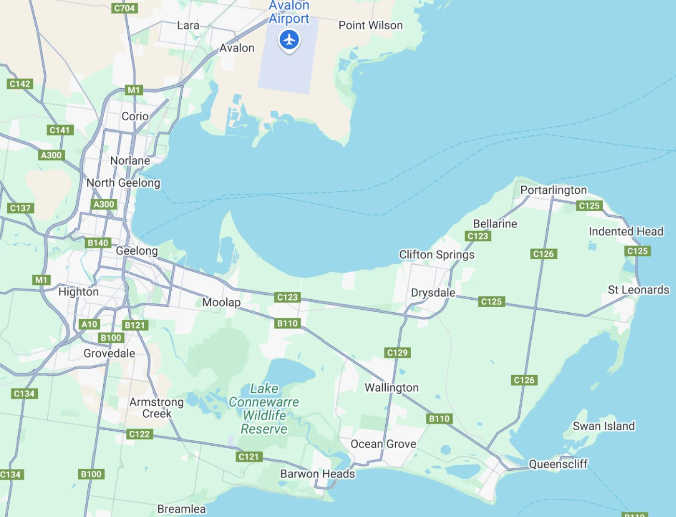

The “pop up” style engagement locations were decided in-house based on predicted high-level foot traffic, and rostered when park or trail attendance was close to peak, balanced with when staffing could be best facilitated.
This consultation style was included to capture more moderate opinions of everyday folk using public spaces, rather than just those who were strongly pro or against domestic animals in our outdoor spaces – as consultations commonly attract opposite opinions from persons who feel most invested at either end of the spectrum.

By providing online surveys, hardcopy surveys, advertised F2F locations and pop-up engagements, it was expected that any community members who wanted to leave feedback, could.
If internet access, timing of in-person F2F sessions, mobility impairment, literacy, or lack of transport were a barrier, alternatives were provided.
If community members weren’t aware of the consultation through the various channels of advertising used, there was a chance they would come across staff at a local reserve or trail, due to the frequent and widespread nature of pop-up engagements at these busy public spaces.

Who we engaged

Who we planned to engage
The City hoped to engage with any of our residents who use shared public spaces or who wanted to express their opinions and experiences regarding the presence and behaviour of domestic animals in our community.
We also wanted to be sure we spoke to key stakeholders who had valuable feedback and experience with matters that are impacted by cats and dogs, including the Council’s internal departments of Parks and Natural Assets, Waste Services, Urban Design and Place and Community Participation, as well as GAWS who are commissioned to run the City’s animal impoundment services.

Face to face Demographics
We noted the attendance of over 210 people at our scheduled community engagements, and an estimated further 200 interactions at the pop-up consultations.
At the 6 promoted events, staff attempted to capture key information about respondents; their animal ownership status and which suburb they resided in, however due to the nature of these events and staffing levels, not every attendee’s details could be captured.

Suburb
Our 6 advertised face-to-face drop-in sessions were held in Armstrong Creek, Belmont, Drysdale, Lara, Norlane and Ocean Grove – and at each of these, most people we spoke with confirmed they lived in the suburb of the consultation, or a neighbouring suburb.
The following chart highlights the attendance figures by suburb, for each of the promoted F2F engagements.

Animal ownership
Overall, 44% owned one dog, 21% owned 2 or more dogs, 21% owned a combination of cats and dogs, 8% owned 1 cat, 3% owned no animals, and 3% owned 2 or more cats.

SURVEY DEMOGRAPHICS
Over the course of the 6 -week engagement, we received 754 completed online surveys, 2 hardcopy surveys that was submitted through our customer service centre and 5 written submissions from animal welfare and environment groups.
Within the survey, there were 3 questions we asked to better understand our respondents, and to allow us to further refine data to identify trends. These questions were regarding whether they were a pet owner, which suburb they resided in, and what gender they identified as.

Animal ownership
Many survey respondents had a vested interest in the development of the domestic Animal Management Plan 2026 – 2029, as they were cat or dog owners (81.4%).
Additionally, they could note any other reasons for their interest which included “Local park user” (64.55%), “Recreational bird/wildlife watcher” (19.44%), “Sports club player/volunteer/member” (8.2%), “Member of wildlife/conservation group” (7.14%), “Animal fosterer” (6.08%), “Member of animal advocacy or rescue group” (5.03%), “Animal business operator” (2.12%), “Vet/Vet nurse” (2.12%), “Register cat/dog breeder” (1.98%), and “Registered domestic animal business” (1.06%).

Gender
We asked respondents to confirm their gender, as this helped us understand whether safety related issues are gendered or experienced across the board and aligns with the City’s commitment to the Gender Equity Framework.

Suburb
A breakdown of the residential location of each survey respondent was requested and has been included in the next chart.
The top 5 residential suburbs for survey submissions (in order) were:
- Ocean Grove
- Lara
- Armstrong Creek
- Highton
- Newtown

Who actively engaged
This DAMP community engagement was successful when analysing various markers:
- On average, over 125 survey responses each week, which is higher than the Council average for HYS pages
- 130+ captured attendees at our 6 x F2F advertised consultations, plus ~80 more that weren’t noted - especially at the Norlane ARC event)
- Over 200 interactions with community members at our pop-up engagements
- Social media reach on Facebook was 43315, and clicks, reactions, comments and shares totalled 1224 across Facebook and Instagram
- 5 written submissions received (Appendices K, L and M)

On the back of our highly successful Cat Curfew consultation which had the highest level of feedback ever received by Community Safety and Regulation department and more impressively, than the City had received on any consultation prior, the numbers received for this DAMP look lacking in comparison (2352 vs. 756). However, when comparing to previous DAMP engagement levels, we pleasingly had a higher response rate than both the 2022-2025 (717) and 2018-2021 versions (197).

Geelong Animal Welfare Society
A Meeting was held with GAWS to discuss which areas of animal management and more so, animal welfare, they felt Council could improve on.

Internal City Departments
As aforementioned, some members from the City’s Animal Management Services team held a meeting with representatives from Parks and Natural Assets, Waste Services, Urban Design and Place and Community Participation – to hear what the main animal-related issues were that they were dealing with in shared public spaces, as well as any suggestions they had on how to negate the impact.

Furthermore, the Animal Management Officers were consulted with regarding key observations, issues and changes they would like to see going forward that would improve public safety concerns and job constraints.

What we asked

What we asked - SURVEY
The following is a full list of all available questions within the online “Domestic Animal Management Plan 2026 – 2029 Survey”. Within this survey, we had questions divided into the following sections:

Participant information
- I have read the privacy statement
- Have you read the previous Domestic Animal Management Plan (DAMP) 2022 – 2025 document?
- What is your interest in the City’s DAMP?
- Name of group/organisation/business (if applicable)
- What are the main benefits you feel from being a pet owner?
- Do you feel safe in the presence of domestic animals when using the City’s open spaces?
- Why do you feel this way?

Responsible pet ownership
- Are you aware of the following laws applying to pets?
- In the last year, have you noticed the following things when our in your local area?
- What do you think are the main barriers to being a responsible pet owner?
- What is your favourite thing about domestic animals living in our community?

Animal management officers
- Do you feel this is enough Animal Management Officer (AMO) presence?
- If no, what type of public areas would you like to see them more?
- Is there a specific public place you’d like Animal Management Officers to patrol? (max 3 pin drops)
- Where would you like to see AMO’s focus their energy?
- Have you had an interaction with an AMO?
- How would you rate the interaction?
- Further comment on Animal Management Officer interaction?

Suggestions
- Which of the following topics do feel the City needs to further promote?
- Do you have any cat-related feedback?
- Please share your cat-related feedback
- Do you have any dog-related feedback?
- Do you have any clever and creative ideas, as to how to improve the animal management services provided by the City?

About you
- Town or suburb?
- Gender?

Why we asked

Participant information
Questions within this section of the survey were asked so we could better understand the survey participant’s circumstances, their understanding of the DAMP and perceived safety when in public spaces with domestic animals.

Responsible pet ownership
Throughout this section, questions were asked of the participants knowledge of orders, as well as what they witness in public spaces, so that we could identify gaps in community knowledge and where to focus our education and promotion efforts.
This information also helps us target our surveillance efforts regarding which local laws are frequently being breeched, should education not provide the change in behaviour we would hope for.

Animal management officers
Questions relating to our Animal Management Services team’s presence and performance were asked throughput this section, with the hope to gauge how the community values the service, where/how it can improve, and if there are particular problem sites that need addressing, signage etc.

Suggestions
This section allowed respondents to elaborate on any issues they were experiencing, as well providing an avenue to put forward any clever and creative ideas that may improve the way the City supports our pet owners, balances the needs of all public space users and manages Domestic Animals in our region.

About you
This section allowed us to filter down responses between genders, in case there was a difference in perceived safety for this reason, as well suburbs, to see if trends emerged according to location.

What we asked – INTERNAL & EXTERNAL STAKEHOLDERS

Invested City departments
The following questions were asked of our Parks and Natural Assets, Waste Services, Urban Design and Place and Community Participation teams:
- What are the most common issues you face regarding the presence of cats in our public spaces?
- What are the most common issues you face regarding the presence of dogs in our public spaces?
- How do you currently manage these issues?
- How would you like to see these issues managed or negated going forward?

Geelong Animal Welfare Society
- What are the biggest challenges you face regarding domestic animal welfare currently?
- What would you like to see going forward?
- How can Council support your vision for improving domestic animal outcomes, both proactively and reactively?

What we heard

Key Findings overview
The F2F consultations, whist providing the opportunity to discuss animal related experiences with the public and record some suggestions, resulted in most people preferring to submit their feedback online through the survey, and opting to take a promotional postcard containing a QR code that would direct them to the Have Your Say page (Appendix B).
Only 1 person completed the survey via a City-supplied iPad during the F2F session.

F2F consultation summary
Combined conversational suggestions from all scheduled F2F consultations are listed below:
- Signage around courtesy at dog poo bag dispensers (some people take the whole reel)
- BCCM signs are confusing and need to be redone; Improve BCCM signs
- Emergency marker system hard to see as green signs blend into foliage. Look to highlight.
- Small dog area at Belmont needs more shade and seats
- Put timers on cat traps to indicate time of capture to allow fining of owners who don't follow curfew
- More dog parks in Armstrong Creek/Mount Duneed growth corridor
- More dog parks, particularly one on the Bellarine which has been promised and not yet delivered.
- Clear cigarette cylinder bin to show butts and act as smoking deterrent and clear disposal point.

Survey response summary
The following table collates the response rate to all questions throughout the survey.
“Required” questions had to be answered before being able to progress, and therefore have a 100% response rate, whereas those with lower response rates had the opportunity to be skipped at the respondent’s discretion if it was not applicable or a detail, they wanted to keep private.
Throughout this report, a “sentiment” was provided to all open text questions, to categorise if answers were deemed positive, negative, mixed or neutral.
To apply sentiment, rules needed to be established and utilised against individual comments. For example, basic suggestions were deemed “neutral”, notes of danger, damage, harm or attacks were “negative”; praise, responsible behaviour, joy and health benefits were considered “positive”, and comments that had positive and negative notes included were labelled as “mixed”.
If it was a multiple-choice question, the most frequently selected response option was noted as the sentiment.

Survey question | Response rate | Majority sentiment
I have read and agree with the privacy statement for this consultation. | 100% | Yes (100%)
Have you read the previous DAMP 2022 – 2025 document? | 100% | Yes (100%)
What is your interest in the City’s DAMP? | 100% | Neutral (100%)
Name of group/organisation/business | 7.94% | Neutral (100%)
What are the main benefits you feel from being a pet owner? | 81.08% | Positive (100%)
Do you feel safe in the presence of domestic animals when using the City’s open spaces? | 100% | Most of the time/Often (53.6%)
Why do you feel this way? (safety) | 23.68% | Negative (92.74%)
Are you aware of the following laws applying to pets | 100% | -
Cats and dogs are required to be registered with Council annually (April 10 is start of registration period) | 100% | Yes (98.1%)
Cats must be contained to their property from sunset to sunrise | 100% | Yes (93.1%)
Cats must be desexed at 3 months of age, and prior to registration | 100% | Yes (77.6%)
Cats must not be deemed a 'nuisance' regarding trespassing on neighbouring properties | 100% | Yes (78.3%)
Dogs are to be kept on lead in all public spaces, unless otherwise signed/designated | 100% | Yes (95.6%)
Dogs are not permitted within 10m of playgrounds or BBQ's | 100% | Yes (63.2%)
Dogs are not permitted on artificial sports surfaces or turf wickets | 100% | Yes (61.4%)
Dogs are allowed off-leash in sporting reserves when no organised sport is taking place | 100% | Yes (76.6%)
Dogs must not bark to 'nuisance' levels | 100% | Yes (93.5%)
If you have more than 2 domestic pets on a residential property, you are required to obtain a Multiple Animal Permit | 100% | Yes (69.3%)
You must always carry a receptacle to collect and correctly dispose of dog poo | 100% | Yes (95.4%)
In the last year, have you noticed the following things when out and about in your local area? | 100% | -
Dog poo left on the ground | 100% | Most of the time/Often (36.0%)
Dogs off-leash in on-leash areas | 100% | Most of the time/Often (33.1%)
Dogs annoying or menacing people | 100% | Rarely (36.8%)
Dogs annoying or menacing other dogs | 100% | Sometimes (35.6%)
Dogs chasing or attacking wildlife | 100% | Never (37.8%)
Dogs returning to their owners when called (effective control) | 100% | Most of the time/Often (40.3%)
Dogs barking excessively | 100% | Sometimes (34.3%)
Cats roaming at night | 100% | Sometimes (24.3%)
Cats preying on wildlife | 100% | Rarely (28.8%)
Cats appearing to be unowned | 100% | Rarely (27.8%)
Cats fighting other cats | 100% | Rarely (33.2%)
Cats confined to their property | 100% | Sometimes (30.0%)
Cats damaging property | 100% | Never (48.9%)
Do you feel there is enough AMO presence?
If no, what type of public area would you like to see them more? | 59.92% | Parks (65.3%)
Is there a specific public place you’d like AMO’s to patrol? | 30.16% | Various
Where would you like to see AMO’s focus their energy? | 100% | Patrolling, preventing/ addressing dog attacks (46.8%)
Have you had an interaction with an AMO? | 100% | No (70.6%)
How would you rate the interaction? | 29.37% | 5 stars (49.1%)
Further comment on AMO interaction? | 31.35% | Neutral (45.57%)
Which of the following topics do you feel the City needs to further promote? | 100% | -
Why registration is important | 100% | Yes (54.8%)
How to register or renew registration online | 100% | No (59.4%)
Why desexing is important | 100% | Yes (76.5
Responsibilities of dog owners when exercising their dogs | 100% | Yes (87.4%)
What "Effective Control" of your dog is | 100% | Yes (88.1%)
Dog barking nuisance | 100% | Yes (67.5%)
Dogs displaying menacing behaviour | 100% | Yes (76.1%)
What to do if you witness or suffer a dog attack | 100% | Yes (83.2%)
What is the cat curfew | 100% | Yes (78.8%)
Cat trespass and cat trapping requests | 100% | Yes (66.1%)
What to do with unowned cats in your neighbourhood | 100% | Yes (71.0%)
What to do if you find a lost pet | 100% | Yes (67.1%)
What to do if your pet goes missing | 100% | Yes (65.1%)
What to do if you can no longer care for your pet | 100% | Yes (75.5%)
Do you have any cat-related feedback? | 100% | No (69.2%)
Please share your cat-related feedback | 30.69% | Negative (52.16%)
Do you have particular dog-related feedback? | 100% | No (61.1%)
Please share your dog-related feedback | 38.62% | Negative (43.49%)
Do you have any clever and creative ideas, as to how to improve the animal management services provided by the City? | 47.22% | Neutral (37. 54%)
Town or suburb | 99.34% | Various
Gender | 97.88% | Various

Breakdown of SURVEY findings

Previous reading and awareness of the Domestic Animal Management Plan
Respondents were asked to confirm whether they had read the previous DAMP, with only a yes or no option. Pleasingly, more than half of our 756 respondents confirmed they had (52%).

Main benefits of being a pet owner
“Companionship” (97.4%), “cuddles and comfort” (68.4%) and “physical exercise” (67.1%) were the top 3 answers as to what respondents felt were the biggest benefits of being pet owners.

19 people or 3.1% of survey respondents noted “other’, with cited additional benefits being:
- Increased personal wellbeing (8)
- Assistance dog (3)
- Rodent control (3)
- Family enrichment (3)
- Providing a home for a rescue animal (2)

Safety in the presence of domestic animals when using the City’s open spaces
When asked about safety due to the presence of domestic animals in public spaces, “Most of the time” was the most common answer (53.6%), followed by “All the time” (22.8%), “Sometimes” (16.3%), “Rarely” (4.9%) and “No, never” (2.5%).

If respondents indicated an answer other than “yes, all the time”, they were prompted to answer why they sometimes felt unsafe.

179 people went on to answer this question, with a majority 92.7% negative sentiment. (166 submissions)

The top “safety” themes that were identified through this open comment section of the survey, are listed next.
- Dogs Off-Leash in On-Leash Areas
This is by far the most dominant theme. Many people express frustration and fear over dogs being off-lead in areas clearly marked as on-lead zones. This is seen as a violation of rules and a direct threat to safety.
- Lack of Owner Control and Responsibility
Numerous comments highlight that many dog owners do not have effective control over their pets. This includes poor recall, inattentiveness (e.g. using phones), and ignoring signs or laws.
- Aggressive or Unpredictable Dog Behaviour
There are many accounts of dogs attacking or rushing at people, children, or other dogs. Even when owners claim their dogs are friendly, the lack of control leads to fear and sometimes injury.
- Impact on Children and Elderly
Several respondents mention children being frightened or rushed by dogs, and elderly individuals feeling at risk of being knocked over. This highlights a broader concern for vulnerable community members.
- Dog Attacks and Injuries
There are multiple first-hand accounts of dog attacks resulting in injuries to people or pets. These incidents often leave lasting trauma and reinforce the need for stricter enforcement.
- Dog Waste and Hygiene Issues
Dog excrement—both bagged and unbagged—is a recurring complaint, especially in parks, beaches, and sports fields. This contributes to a sense of unsanitary and unsafe public spaces.

- Inadequate Enforcement by Authorities
Many people feel that local councils or animal management officers are not visible or proactive enough in enforcing leash laws or penalising irresponsible behaviour.
- Fear and Anxiety Around Dogs
Even among dog owners, there is a strong sense of anxiety about encountering off-leash dogs. This is especially true for those with reactive or anxious pets.
- Roaming Cats and Wildlife Impact
While less frequent than dog-related issues, roaming cats are mentioned as a threat to wildlife and a nuisance in residential areas, particularly for those trying to protect native birds.
- Calls for More Fenced or Designated Dog Areas
There is a clear demand for more enclosed, off-leash dog parks to provide safe spaces for dogs to run without endangering others. This is often paired with calls for better signage and infrastructure.

To read some comment excerpts regarding perceived safety or lack thereof, see Appendix D.

Females out-responded males at a rate of almost 4:1, and therefore when reviewing safety data by gender, the response ratio needed to sit outside 4:1 in any category to be significant.
Less women felt safe “all the time” compared to men when applying the 4:1 ratio (114 vs 49 = 2.3:1), and additionally, women felt safe “most of the time” more frequently than men (328 vs 64 = 5.1:1).
All other safety categories were not significantly different from the predicted ratio.

Awareness of bi-laws applying to pets
All 756 respondents were quizzed on their awareness of 11 important bi-laws applying to domestic pets in our municipality.

The 3 pet orders that were least known were:
- “Dogs are not permitted on artificial sports surfaces or turf wickets” (38.6% no vs 61.4% yes)
- “Dogs are not permitted within 10m of playgrounds or BBQs” (36.8% no vs 63.2% yes)
- “If you have more than 2 domestic pets on a residential property, you are required to obtain a multiple animal permit” (30.7% no vs 69.3% yes)

And the 3 orders that the community were most known were:
- “Cats and dogs are required to be registered with Council annually (98.2% yes vs 1.8% no)
- “Dogs are to be kept on lead in all public spaces unless otherwise signed/designated” (95.6% yes vs 4.3% no)
- “You must always carry a receptacle to collect and dispose of dog poo” (95.4% yes vs 4.6% no)

What has been noticed in your area in the last year
A mixture of positive and negative exposures relating to the presence and habits of domestic animals and their owners were listed, with respondents asked how often they had seen these things, with the options of “always”, “often”, “sometimes”, “rarely”, and “never”.
All 756 respondents were requested to answer each of these questions, and the statements that received the highest response rate of “always” were:
- Dog poo left on the ground (30%)
- Cats roaming at night (21.6%)
- Dogs off leash in on-leash areas (21.3%)

The exposures that respondents most frequently answered to “never” seeing were:
- Cats damaging property (48.9%)
- Dogs chasing or attacking wildlife (37.8%)
- Cats fighting other cats (32.9%)

A full breakdown of questions and answers is in the chart overleaf.

When reviewing the incidence of positive and negative exposures and removing the ambiguous answer of “sometimes”, the data skew was more evident and the following trends could be seen as listed below.
Please note all 756 respondents were required to answer each of these questions.

More frequently seen pet behaviours | Less frequently seen pet behaviours
Dog poo left on the ground (499) | Cats damaging property (586)
Dogs off leash in on-leash areas (423) | Dogs annoying or menacing other dogs (317)
Cats roaming at night (337) | Dogs annoying or menacing people (414)
Dogs returning to their owner when called (329) | Dogs chasing or attacking wildlife (529)
 | Dogs in playgrounds (422)
 | Cats preying on wildlife (421)
 | Cats appearing to be unowned (417)
 | Dogs barking excessively (306)
“Cats confined to their property” was very even when comparing positive and negative sentiment, with 268 (35.4%) stating always or often, and 263 (34.8%) stating never or rarely.

Barriers to being a responsible pet owner
All respondents were required to nominate the key barrier/s as to why they feel some pet owners are not responsible. The answers, ranking from most to least frequently cited were as follows:
- Lack of care for others wellbeing/sense of safety (539 = 71.3%)
- Sense of self-entitlement (525 = 69.4%)
- Lack of consequences when breaking laws (489 = 64.7%)
- Deliberate defiance (319 = 42.2%)
- Lack of knowledge of the City’s local laws (313 = 41.4%)
- Inability to provide all wellbeing resources for their pet (205 = 27.1%)
- Other (67 = 8.9%)

Most common “other” reasons provided were:
- Cost (9)
- Lack of understanding of issues caused/why there are laws in place (7)
- personal arrogance/ignorance (6)
- Rules aren’t enforced enough by animal management (6)
- The fenced off leash areas for dogs significantly less than facilities provided in the community for other sports and activities yet the largest group in the community are dog owners (6)
- There are no barriers/excuses (4)
- Lack of education! (4)
- Think their cat needs to roam and not hunters (4)
- Too many rules/hard to enforce (4)
- Lack of understanding and ability effectively responding to their own dogs’ behaviour/cues (3)
- Treat their pets as if they have the same rights as people (3)
- Most pet owners are responsible people who keep their pets well under control (3)
- Don’t care about others/wildlife (2)
- Not enough compassion for pets (2)
- Deliberate pest control (1)
- Time poor (1)
- Lazy (1)
- Council lack of taking in all breeds of dogs when doing dog parks. (1)
- Having an aggressive dog for the wrong reasons (1)

Favorite things about domestic animals living in the community
This open text question allowed respondents to write any reasons why they enjoyed domestic pets living in the community.

524 people went on to respond to this question, with a majority 87.2% positive sentiment. (457 submissions)

The top themes that were identified through this open comment section of the survey, are listed next:

1. Companionship
Many people deeply value the emotional support and friendship pets provide. This was the most frequently mentioned benefit, especially for those living alone or experiencing mental health challenges.
2. Social Connection
Pets—especially dogs—act as social bridges. They help people meet neighbours, start conversations, and build community bonds during walks or at parks.
3. Mental Health and Wellbeing
Pets are widely seen as beneficial for reducing stress, anxiety, and loneliness. Their presence brings joy, calm, and a sense of purpose to their owners.
4. Physical Activity and Routine
Owning a pet, particularly a dog, encourages regular exercise and outdoor activity, which contributes to healthier lifestyles.
5. Community Atmosphere
Seeing pets out and about contributes to a friendlier, more vibrant neighbourhood. People enjoy watching animals play, interact, and bring joy to others.
6. Teaching Responsibility
Pets are seen as valuable for teaching children (and sometimes adults) about responsibility, empathy, and care.
7. Sense of Safety
Some respondents noted that pets—especially dogs—can provide a sense of security at home or while walking.
8. Shared Spaces and Inclusivity
There’s appreciation for dog-friendly spaces like parks and beaches, where pets and people can enjoy time together. These spaces foster inclusivity and shared enjoyment.
9. Emotional Support and Therapy
Pets are described as emotional anchors, helping people through grief, trauma, or isolation. Some even referred to them as “lifelines.”
10. Joy and Entertainment
Simply watching pets play, interact, or be affectionate brings happiness to both owners and bystanders. Their presence is uplifting and often humorous.

To read some commentary regarding the best things about pets, see Appendix E.

Animal Management Officers (AMO’s)
62.4% of respondents felt that there is not enough AMO presence in the community.

When the survey respondents answered “no”, they were prompted to state what type of public space environments AMO’s should visit more, and the “Parks” (65.3%), “Beaches” (64.8%) and “Trails” (38.63%) were the top 3 answers, followed by “Playgrounds” (33.6%), “Sporting reserves” (30.5%) and “Other” (17.9%).
228 respondents opted to leave up to 3 pins on the Question Map in Q14, highlighting locations they found problematic with lack of compliance regarding pet ownership.
As the locations were very specific, the data has been dialled back to suburb level for this report, and the top suburbs pinned as problematic (and the number of pins within their boundary) were as follows:
- Ocean Grove (100)
- Belmont & Lara (20)
- Geelong (17)
- Highton (16)
- Newtown (13)
- Mount Duneed & Rippleside (12)
- Clifton Springs, Drysdale & Portarlington (11)
- St Leonards (9)
- Leopold (8)
- Armstrong Creek, Corio, Curlewis & East Geelong (7)

Respondents noted quite evenly where they would like to see AMO’s focus their energy. See chart below for statistical breakdown.

Interaction with an AMO was confirmed by 29.4% (222) of respondents, and the average rating received for the interaction was 4.02 out of 5.
49.1% of the 222 respondents scored the AMO 5 stars.
21 people, or 9.5% of respondents scored the AMO interaction 1 star.
A breakdown of the AMO interaction ratings is displayed below.

Respondents were asked if they would like to leave further comment on their AMO interaction.

237 people went on to answer this question, with a majority 45.6% neutral sentiment. (108 submissions)

The top themes that were identified within this open AMO comment section of the survey, are listed here:
1. Visibility and Presence
Many people noted they have never seen an AMO in their area, even after years of pet ownership or walking in public spaces. There’s a strong desire for more visible patrols, especially in high-traffic areas, during weekends, and in response to seasonal issues like beach use or wildlife protection.
2. Professionalism and Courtesy
When interactions did occur, most respondents described AMOs as polite, professional, and helpful. However, a few noted negative experiences, including poor communication, lack of empathy, or feeling dismissed.
3. Under-Resourcing
A recurring theme was that AMOs are understaffed and overextended, limiting their ability to respond quickly or follow up on complaints. This was especially noted in relation to barking dog complaints, cat trapping, and off-leash dog enforcement.
4. Enforcement and Follow-Up
Some respondents expressed frustration that complaints were not followed up, or that offenders faced no consequences. There were calls for stronger enforcement, more fines, and better communication about complaint outcomes.
5. Education and Outreach
Several people suggested that AMOs could be more effective if they were seen as educators and community allies, not just enforcers. Ideas included:
- Handing out treats or poo bags
- Hosting info sessions at dog parks
- Participating in school or community events

6. Response to Incidents
In cases of dog attacks or serious incidents, many respondents praised AMOs for being compassionate, thorough, and supportive. However, others felt the process was too slow or lacked transparency.
To read some commentary regarding AMO experiences and suggestions, see Appendix F.

Animal Management topics requiring further promotion
Survey respondents were asked which of the following topics they felt the community needed more education about, and they could supply an answer of “yes” or “no” to each.

Cat findings
An open text question was asked regarding respondent’s experiences with cats in public spaces.
232 people went on to answer this question, with a majority 52.2% negative sentiment. (121 submissions)

The top cat-related themes that were identified through this open comment section of the survey, are listed below:

- Strong Support for a 24-Hour Cat Curfew
Many respondents expressed frustration that the previously proposed 24/7 cat curfew was rescinded. There is widespread support for reinstating it to protect wildlife and reduce nuisance behaviour.
- Wildlife Protection
A dominant concern is the impact of roaming cats on native wildlife, especially birds and small mammals. Many people cited personal experiences of cats killing or disturbing wildlife in their gardens or local reserves.
- Trespassing and Property Damage
Numerous complaints were made about cats entering private properties, using gardens as toilets, spraying, and causing disturbances such as fighting or upsetting indoor pets.

- Calls for Equal Responsibility
Many respondents feel that cat owners should be held to the same standards as dog owners—keeping pets confined to their property and being accountable for their behaviour.
- Enforcement and Fines
There is a strong call for stricter enforcement of existing curfews, including issuing fines, conducting patrols, and following up on complaints. Some suggested spot checks or mandatory containment assessments.
- Need for Education and Communication
Several people suggested better education for cat owners through letterbox drops, community workshops, and clearer council communication about responsibilities and containment options.
- Support for Cat Containment Infrastructure
Many respondents supported the idea of subsidising or assisting with the cost of cat enclosures, especially for low-income or elderly residents, to help them comply with containment rules.
- Frustration with Council Inaction
There is a recurring sentiment that the council is not doing enough to address the issue, with some feeling ignored or unsupported when reporting roaming cats.
- Mixed Views on Fairness
While most support stricter rules, a minority expressed concern about the fairness of enforcing curfews on older cats or the emotional and financial burden on owners.
- Desire for Humane Management of Stray and Feral Cats
Some respondents advocated for trap-neuter-return (TNR) programs and better support for rescue groups to manage the stray cat population humanely.

To read some comment excerpts regarding cat presence in the community, see Appendix G

Dog Feedback
This open text question allowed respondents to write about their experiences with cats in public spaces.
232 people went on to answer this question, with a majority 43.5% negative sentiment. (101 submissions)

The top dog-related themes that were identified through this open comment section of the survey, are listed below:

1. Dogs Off-Leash in On-Leash Areas
Many respondents expressed frustration with dogs being walked or allowed to roam off-lead in areas where leashes are required. This was often linked to safety concerns, especially for children, reactive dogs, and wildlife.
2. Dog Waste and Hygiene
Dog poo left on footpaths, parks, and beaches was one of the most frequently mentioned issues. Some owners bag it but leave the bags behind. There were also calls for more bins and bag dispensers.
3. Barking and Noise Complaints
Excessive barking—especially when dogs are left alone—was a major concern. Many felt that council responses were slow or ineffective, and that the complaint process was too burdensome.
4. Lack of Enforcement
There is a strong call for more visible and proactive enforcement of leash laws, barking complaints, and dog park behaviour. Respondents want more patrols, fines, and accountability.
5. Need for More Off-Leash and Fenced Dog Areas
Many people want more safe, fenced spaces for dogs to run freely, especially in growing suburbs. Some suggested separate areas for reactive or small dogs.
6. Education for Dog Owners
There were repeated calls for better education on responsible dog ownership, including understanding “effective control,” dog behaviour, and the impact of dogs on others and the environment.
7. Wildlife Protection
Concerns were raised about dogs disturbing or attacking wildlife, particularly in sensitive areas like beaches and reserves. Some suggested seasonal or stricter leash rules in these areas.
8. Infrastructure Improvements
Suggestions included more bins, bag dispensers, drinking fountains, lighting in dog parks, and clearer signage about leash rules and dog zones.
9. Aggressive or Poorly Socialised Dogs
There were multiple reports of dog fights or aggressive behaviour in parks, often due to lack of supervision or poor training. Some called for better training facilities and stricter rules.
10. Community and Social Benefits
Despite the issues, many people highlighted the positive social impact of dog ownership—meeting neighbours, building community, and improving mental health.
To read some comment excerpts regarding dog presence in the community, see Appendix H.

Clever and Creative ideas
This open text question allowed respondents to put forward any suggestions they think the City may be able to implement to improve the management of domestic animals in our community and balance the needs of all public space users.
357 people answered this question, with a majority 37.5% neutral sentiment. (134 submissions)

The top clever and creative idea themes that were identified through this open comment section of the survey, are listed here:
- Education and Awareness
There is strong support for more education on responsible pet ownership, including:
- School programs
- Pre-ownership training
- Public campaigns
- Signage and community events
- Enforcement and Patrols
Many respondents want:
- More visible animal management officers
- Weekend and after-hours patrols
- Plain-clothed officers
- Fines for non-compliance

- Dog Parks and Off-Leash Areas
Suggestions included:
- More fenced and shaded dog parks
- Designated off-leash zones
- Booking systems for reactive dogs
- Greyhound-specific spaces
- Cat Containment and Curfews
There is widespread support for:
- A 24-hour cat curfew
- Subsidised cat enclosures
- Stricter enforcement and fines
- Humane management of stray cats

- Dog Waste Management
Dog poo was a major concern. Ideas included:
- More bins and bag dispensers
- Compostable bag programs
- “Pooch pouch” giveaways
- Public awareness campaigns

- Desexing and Registration Support
Many called for:
- Free or subsidised desexing
- Lifetime registration options
- Discounts for responsible owners
- Support for low-income pet owners

- Community Engagement and Events
Creative ideas included:
- Pet parades and festivals
- “Paws in the Park” pop-ups
- Meet-the-ranger days
- Volunteer ambassador programs

- Training and Behaviour Support
There is a clear need for:
- More accessible dog training
- Council-supported obedience programs
- Incentives for completing training
- Support for reactive or anxious dogs

- Infrastructure Improvements
Suggestions included:
- More lighting in dog parks
- Water fountains for pets
- Clearer signage
- Enclosed areas for safe exercise

- Technology and Innovation
Innovative ideas included:
- GPS tracking for pets
- Smart reporting apps
- QR-coded pet tags
- AI-monitored dog parks

To read some “clever and creative” suggestions from respondents regarding in the community on how to improve responsible pet ownership and improve public shared space use, see Appendix I.

GAWS Suggestions
From GAWS’ perspective, they exclaimed that they wanted to see more proactive management of dogs and cats, to prevent them from coming into the shelter.
They noted that providing more subsidised or free desexing programs and further community education were key steps in achieving this.
A Community Cat program was also a key idea they put forward, and details of this are provided in their written submission found in Appendix K.

Internal City departments
Some key discussion points raised by the various City departments who are impacted by the presence of cat and dogs in the community, included:
- Dog litter being uncollected, which poses significant health, waste and nuisance implications, particularly for those who belong to community sport clubs who are burdened with cleaning up sports grounds prior to organised cricket, football and soccer competitions taking place
- Dog litter collected and bagged, but then thrown into vegetation or left it bagged on the side of the path
- Council supplied dog bags and bins are expensive to service (2-3x more expensive than standard bins), and routinely abused by some owners who grab 10’s of bags at a time, rather than supplying their own, which is the City’s requirement. Better to redistribute the funding into other areas of Animal Management and education re: pet waste
- The hunting instincts of cats and the negative impact on many species of birds, lizards and small mammals, including those who are native and of vulnerable status, as well as posing a nuisance to neighbouring properties
- New developments in growth corridors comprised of high-density housing, which in turn means little to no backyard. This leads to:
  - A heavy reliance on public spaces for exercising animals. Additional dog parks are required to ease the burden placed on shared sporting reserves, particularly in the municipality’s southern suburbs of Mount Duneed, Armstrong Creek and Charlemont.
  - Barking dog complaints are more common in these environments as there is little space for the dog to exercise and self-entertain, and the proximity to neighbours, means barking is very easily heard. These complaints are usually very emotional, stressful, tedious to work through for the complainant, and slow to resolve
- Dogs off leash in on leash areas, pose large problem to turf wickets and the additional labour to remove paw prints, particularly at Kardinia Park and Queens Park. More signage needed in these areas.
- Kardinia Park has many areas within owned by Kardinia Park trust, and they would like these areas to be made “dog on leash”, but would need to enter an agreement with Council to have any orders enforced
- Shared use of sporting reserves by dog owners – not always working well and questioned whether some need dog access to be revoked. Despite ovals not being constructed for the purpose of dog exercise, we need to find solutions to a growing population and therefore demand on shared spaces
- Free education courses and other animal “bonuses” supplied at time of registration to reward responsible animal ownership and promote better outcomes
- Focus funding into education, promotion etc, rather than in services that are not necessary and feeding into unrealistic and entitled expectations
- Visibility of AMO’s in public spaces does have clear and immediate impact on improving dog owner behaviours and compliance
- The DAMP could commit to reviewing dog orders across the municipality, repeatedly at a set interval – perhaps 2-yearly?
- Is there the ability to change dog orders temporarily?

Animal Management Services
Some feedback from the AMO’s who respond to animal nuisance complaints, conduct patrols, assist with lost pets, and investigate dog attacks, were as follows:
- Community education on:
    - Dogs on lead, unless otherwise signed. Aim to have signage on all major arterials entering Geelong, so visitors are also aware of orders
    - Appropriate pet selection
    - Benefits of animal desexing
- Challenges:
    - Old dog order signs needing to be removed which contradict current orders
    - Proving the time at which cats are trapped, and therefore inability to fine for not abiding by curfew
- Preferred changes:
    - Legislation to allow adopted animals from GAWS to be registered at time of adoption, and supplied with free registration
    - Vet education packs to go out with clients regarding ongoing responsibilities with Council
    - Targeted discount dog desexing program
    - More dog parks in Mount Duneed/Armstrong Creek
- Staff requirements
    - Employ more team members to meet demand, including a designated patrolling officer and an “out-of-hours” officer for nuisance complaints
    - Provide training for first aid, animal first aid and self-defence
    - Improved equipment including shields, poles, battens, microchip scanners, van fit-outs, and slings for safely manoeuvring heavy animals
- Clever and creative ideas:
    - Art displays in public spaces for conveying dog orders
    - Make first year of registration free
    - Problem behaviour dogs offered discount dog training voucher, or results in a fine if not used
    - Partner with hardware providers like Bunnings to reduce cost of cat enclosure materials
    - Eftpos for staff to register unregistered animals on the spot- and avoid issuing unregistered fine
    - Cat curfew in “high wildlife risk” areas
    - Street shoutouts and rewards for excellent compliance rates
    - Social media channel for Animal Management Services

Discussion

Uptake
The community consultation which ran for 6-weeks included an array of mediums in which interested community members could leave their feedback.
Between March 10 – April 20, almost 400 members of the public were spoken with by our AMO staff at 18 different event locations, 756 surveys were submitted, and 5 written submissions (Appendix K) were forwarded for consideration by various organisations.
The engagement aimed to be highly accessible, unbiased through careful language choices, and used to not only hear what our community would like going forward regarding domestic animals and how to encourage responsible ownership practices, but to also understand gaps in knowledge and where education and promotional efforts need to be targeted.

Key Themes
There were several strong themes that came through from the community’s feedback, and these included:
- Too many dogs are off leash in “on leash” areas
- Many dog owners are not collecting their dog’s poo, and this is a large point of frustration and disgust for the wider community who use public spaces, particularly those who play on, volunteer at or use sporting reserves for organised sport
- Cats and dogs should have similar rights regarding roaming – therefore cats should be contained to their own property at all times for the benefit of wildlife, neighbours, and the cats themselves
- There is a need for more fully fenced dog off-leash areas
- Not enough AMO staff available to meet the demands of their jobs – increase the AMO workforce and the number of infringements they issue, as well as focus on closing the loop on complaints so residents know outcomes of investigations etc
- Council should support cat owners who create enclosures by:
    - Subsiding material costs
    - Utilising volunteer services for construction (men’s sheds etc)
    - Reducing or removing ongoing registration fees once an enclosure is inspected and approved
- More City-led education (for broader public and specifically in schools) and community events to build better rapport with the community and foster increased knowledge and cooperation in responsible pet ownership
- The community feel nuisance complaints to Council regarding cats (trespass) and dogs (barking) are not acted upon promptly enough and burdensome for the victim
- A need for City-led initiatives regarding mandatory dog training and/or animal behaviour courses

Community engagement successes

Structure and location of F2F events
This DAMP engagement was the first run by the Community Safety and Regulation department which followed a new model for consultation regarding the locations of scheduled and pop-up consultations.
Instead of booking halls and other public buildings and then asking the community to come out of their way somewhat to see us, we instead ensured that we placed ourselves in widely used public locations, most of which were in open space and required the setup of a gazebo.
By being in heavy foot traffic locations, we were bound to interact with more members of the community, whether they were specifically interested in pets or not. This meant that we heard more moderate feedback, but also raised the profile of the engagement by being so visible and creating interest.
The 2022 - 2025 DAMP engagement had 3 scheduled F2F sessions with only 6 total attendees. This DAMP engagement resulted in over 210* noted attendees (not all attendees of Norlane ARC event could be captured) in total at our 6 F2F events by comparison.

Survey uptake
Uptake of the online survey was the highest it has ever been historically for DAMP-related consultation.
Whilst we would have liked to have heard from more of the community, 756 responses provide ample data to extract themes and identify trends, which is key to moving forward with strategic focus points and tasks.

Survey structure and theming
The survey structure seemed to have worked well regarding the mix of multiple choice and open-ended questions, to allow efficient data filtering whilst also providing respondents with ample opportunity to leave more detailed and specific feedback.
The way that the logic was applied to generate additional probing questions based on previous answers was effective at fleshing out answers.
And the use of grading tools to understand both which bi-laws aren’t well known and need further promotion, as well as what orders the community are regularly seeing breeched, allows our Animal Management Services team to target education and enforcement more adeptly.
The use of AI to filter and theme open-ended responses for themes is an invaluable tool – saving an enormous amount of time.

Community engagement areas for improvement

Promotion
Despite advertising through print media in 3 different newspapers on 4 separate occasions, posting weekly on social media, distributing A-Frame advertising boards on busy trails and reserves throughout the municipality, placing posters in Veterinary practices and on-screen ads across various City buildings – awareness of the DAMP 2026 - 2029 and its ensuing consultation appeared limited.
Social media statistics alone show that whilst over 43000 people were reached through our Facebook and Instagram posts, only 1221 people clicked, shared or liked the posts – and clearly, even less actually used the link to complete the survey.

Survey fatigue
This community engagement is the first for the Animal Management Services team in 2025 but follows on from 3 regarding Dog Orders on Barwon Coast land (2019, 2020, 2021), 2 for Dogs in Public Places (2018, 2023), Barwon Head Village Park rezoning (2020), Cat Curfew (2023), and the previous DAMP (2021).
9 consultations within the last 7 years may be contributing to the feeling of survey fatigue around animal ownership and be impairing survey completion rates.

Distrust in Council
A key barrier noted prior to commencing this community engagement was regarding a perceived lack of trust between Council and the community, due to the 2023 Cat Curfew consultation. Despite 2/3 community support (including majority support from cat owners) to change cat curfew to a 24/7 model, Council did not heed this message and uphold the broader community’s wishes.
This sentiment was noted verbally many times at the F2F sessions held throughout the 6-week period and has become very apparent when theming responses left in the survey.
The community’s feeling of distrust in the Council’s process and decision making may have hindered people completing the survey as they may have felt their voices are not heard or appropriately actioned upon.

Informal feedback
Comments left on our Facebook posts regarding the DAMP 2026 – 2029 consultation have been deidentified and compiled in the table below.
Date | Comment
11/3/25 | Cats should be kept on their owner’s property at all times in a properly constructed cat enclosure, and registered, same as a dog must be. All dogs should be kept ON a leash when outside their owner’s property, and that means actually connected to the leash, not running free with the owner holding the leash in their hand as so many do. Uncontrolled dog barking should attract a fine which goes higher the more the dog barks without the owner doing something to stop or investigate why the dog is barking. As a pet owner for over 50 yrs, I've seen it all and seen the tricks by people to side-step common sense rules
11/3/25 | My two cats are permanently inside and registered
11/3/25 | Same role they have played for decades Move on. save $ on consultants who happen to be ex council employees is many cases
11/3/25 | Lisa Kearns
11/3/25 | Taasha Quirk
11/3/25 | Would you stop wasting valuable resources and money on this shit for the love of god!! Nothing changes after all your consulting! You wouldn't send out calendars this year but you will still waste money on this shit!
11/3/25 | Heaps more cat traps need to be available for the public to hire.
11/3/25 | How about reinstalling all the bins along our beach that you removed?? What a dumb decision that was, astonishing!! For the number of rates, we pay there’s very little service. Justify your wages! 🤬
11/3/25 | Done. Dogs seem to be everywhere and so many owners assume that everyone loves dogs and wants them running around, which isn’t true. Many people are allergic or afraid of them & even those that aren’t don’t want dogs coming up to them when they are trying to relax on the beach. I see dogs off leash all the time in on-leash areas, but there seem to be no consequences or anyone enforcing the rules. Dog poo is a real problem too. There should be more dog parks where they can run free in an enclosed area & not bother other people. There also needs to be some safe dog-free areas, especially for little kids to play without the fear of a dog towering over them.
11/3/25 | Laura Ivens well said! I absolutely agree this is exactly our experience. We’ve had a large dog off lease rush us and the owner couldn’t care less, on the waterfront which is an on-leash area.
11/3/25 | Our cat is permanently inside and registration paid annually
11/3/25 | After all these years and surveys and you still do not know?
11/3/25 | Everyone needs to desex their cats, even indoor ones. Don't dump your cats if you can't care for them.
11/3/25 | Here's my "take" on it! Stay out of people's lives and their pets! Deliver, what you are supposed too! Balance your budget! When will the COGG, ever get it right??? 😫
12/3/25 | Get rid of all the signs around Ocean Grove and BH. They are never enforced, no one follows them, so why bang them up everywhere? Enforce them or get rid of them.
12/3/25 | Darren Connell. Genaya Rowbottom
3/4/25 | Why should I have to pay $213 for an undesexed but microchipped dog that is the same amount as a dangerous dog?  Your pricing is absolutely ludicrous!  It should be double of what you pay for a desexed dog, not a dangerous dog. Like $96. My dog will be desexed once the vet allows it. 🙄
10/4/25 | Narelle Crowe
10/4/26 | https://www.theguardian.com/lifeandstyle/2025/apr/10/pet-dogs-have-extensive-and-multifarious-impact-on-environment-new-research-finds
16/4/25
  Maddison Brodee this would be why they were at the park the other day I'd say
16/4/25
  Rebecca Kate ahh yes it would be!
16/4/25 | 😂💯👎
16/4/25 | City of Greater Geelong I sent a message via email a few weeks ago and dropped a couple of messages regarding this branch and nothing has been done about it yet! Hopefully something gets done before someone gets killed.  Location: Moorak Park, Nobel St Newtown.  Geelong TV Geelong Advertiser
18/4/25 | F@off
22/4/25 | What's the situation on foxes and owls?
23/4/25 | City of Greater Geelong I see the branch is still hanging there. Pretty useless in my opinion.

What we have done and next steps

What we have done
After running the community consultation for 6-weeks and hearing from 756 people through our survey, and an additional ~300 people at the combined scheduled face-to-face and pop-up sessions, all findings, themes and suggestions have been collated in this report.
Discussions have been and will continue to be held regarding the themes identified through this report, and how the City proposes to move forward with animal management strategies, key focus areas and actions to achieve all identified desired outcomes.

Next Steps
This report will be shared with all internal stakeholders, the community through the Have Your Say page, and also ELT and Councillors at the briefing meeting and then October Council Meeting.
The information contained within this report will inform the Council report regarding the DAMP 2026 – 2029, as well as the development of the Domestic Animal Management Plan itself.
It may be deemed necessary to run additional community consultation on domestic animal experiences, and if so, this will be conducted briefly in Q3 of 2025.
Drafting and formalisation of the DAMP 2026 – 2029 will continue throughout the latter half of 2025, as the final Domestic Animal Management Plan 2026 – 2029 document is required to be written and submitted to the Victorian State government by Dec 3, 2025.

Appendix A - Survey Hardcopy

DAMP 2026 -2029 Survey
Participant information
Have you read the previous DAMP 2022 - 2025 document? (Required)
□ Yes
□ No

What is your interest in the City's DAMP? (Required)
□ Cat/Dog owner
□ Local park user
□ Sports club player/volunteer/member
□ Registered cat/dog breeder
□ Registered domestic animal business
□ Vet/vet nurse
□ Member of wildlife/conservation group
□ Animal fosterer
□ Member of animal advocacy or rescue group
□ Animal business operator (trainer/walker/groomer etc)
□ Recreational bird/wildlife watcher

Name of club, business, practice, conservation group or rescue group? (Skip if doesn’t apply)
___________________________________________________________________________________________________

If you are a cat/dog owner, what do you feel are the main benefits of having your pet/s? (Skip if doesn’t apply)
_________________________________________________________________________________________________________________________________________________________________________________________________________________________________________________________________________________________________________

Does the presence of domestic animals leave you feeling safe when using the City's open spaces? (Required)
□ Yes, all the time
□ Most of the time
□ Sometimes
□ Rarely
□ No, never

Why?
_________________________________________________________________________________________________________________________________________________________________________________________________________________________________________________________________________________________________________

Responsible Pet Ownership
Are you aware of the following laws applying to pets? (Required)
Understanding where our community are lacking knowledge of local laws, helps us direct educational efforts to bridge these gaps.
Yes No
Cats and dogs are required to be registered with Council annually (April 10 is start of registration period)
Cats must be contained to their property from sunset to sunrise?
Cats must be desexed at 3 months of age, and prior to registration
Cats must not be deemed a “nuisance” regarding trespassing on neighbouring properties
Dogs are to be kept on lead in all public spaces, unless otherwise signed/designated
Dogs are not permitted within 10m of playgrounds or BBQ's
Dogs are not permitted on artificial sports surfaces or turf wickets
Dogs are allowed off-leash in sporting reserves when no organised sport is taking place
Dogs must not bark to 'nuisance' levels
If you have more than 2 domestic pets on a residential priority, you are required to obtain a Multiple Animal Permit
Your cat or dog is required to wear a registration tag at all times
You must always carry a receptacle to collect and correctly dispose of dog poo
In the last year, have you noticed the following things when out in your local area? Required

In the last year, have you noticed the following things when out in your local area? (Required)
Always Often Sometimes Rarely Never
Dog poo left on the ground
Dogs off-leash in on leash areas
Dogs annoying or menacing people
Dogs annoying or menacing other dogs
Dogs chasing or attacking wildlife
Dogs returning to their owners when called (effective control)
Dogs in playgrounds
Dogs barking excessively
Cats roaming at night
Cats preying on wildlife
Cats appearing to be unowned
Cats fighting other cats
Cats confined to their property
Cats damaging property

What do you think are the main barriers to being a responsible pet owner? (Select all appropriate answers)
□ Lack of knowledge of the City's local laws
□ Lack of consequences when breaking laws
□ Lack of care for others wellbeing/sense of safety
□ Deliberate defiance
□ Inability to provide all wellbeing resources for their own pet
□ Sense of self-entitlement
□ Other (please specify)

What is your favourite thing about domestic animals living in our community?
_________________________________________________________________________________________________________________________________________________________________________________________________________________________________________________________________________________________________________

Animal Management Officers
Do you feel there is enough Animal Management Officer (AMO) presence? (Required)
□ Yes
□ No

If no, what type of public area would you like to see them more? (Skip if doesn’t apply)
□ Beaches
□ Parks
□ Playgrounds
□ Sporting reserves
□ Trails
□ Other (please specify)

If no, you can list 3 specific locations you’d like AMO’s to patrol? (Skip if doesn’t apply)
- ________________________________________________________________________________________
- ________________________________________________________________________________________
- ________________________________________________________________________________________

Where would you like to see AMO’s focus their energy? (Required)
□ Patrolling
□ Addressing nuisance complaints (barking dogs & cat trespass)
□ Education
□ Cat trapping
□ Feral cat management
□ Preventing and investigating dog attacks
□ Impounding stray cats
□ Other (please specify) ________________________________________________________________________

Have you had an interaction with an AMO? (Required)
□ Yes
□ No

If yes, how would you rate the interaction? (Skip if doesn’t apply)

Further comment on AMO interaction? (Skip if doesn’t apply)
______________________________________________________________________________________________________________________________________________________________________________________________________

Which of the following topics do you feel the City needs to further promote? (Required)
Yes No
Why registration is important
How to register or renew registration online
Why desexing is important
Responsibilities of dog owners when exercising their dogs
What "Effective Control" of your dog is
Dog barking nuisance
Dogs displaying menacing behaviour
What to do if you witness or suffer a dog attack
What is the cat curfew
Cat trespass and cat trapping requests
What to do with unowned cats in your neighbourhood
What to do if you find a lost pet
What to do if your pet goes missing
What to do if you can no longer care for your pet

Do you have any cat-related feedback? (Required)
□ No
□ Yes (please specify) _________________________________________________________________________________________________________________________________________________________________________________________________________________________________________________________________________________________________________

Do you have particular dog-related feedback? (Required)
□ No
□ Yes (please specify)
_________________________________________________________________________________________________________________________________________________________________________________________________________________________________________________________________________________________________________

Do you have any clever and creative ideas, as to how to improve the animal management services provided by the City? (Skip if doesn’t apply)
____________________________________________________________________________________________________________________________________________________________________________________________________________________________________________________________________________________________________________________________________________________________________________________________________________

About You
Before you go, can you tell us a little bit about you? In this section we are asking for information about you to help us understand who we are hearing from in the community. Any information you provide will be de-identified (i.e. anonymous) from your survey responses and managed in line with the City of Greater Geelong Privacy Policy

Town or Suburb: ______________________________________________________________________________

Gender

□ Male □ Female □ Other identity

Thank you for your time and feedback. Both are highly valued.

Appendix B – Promotional materials

POSTCARD
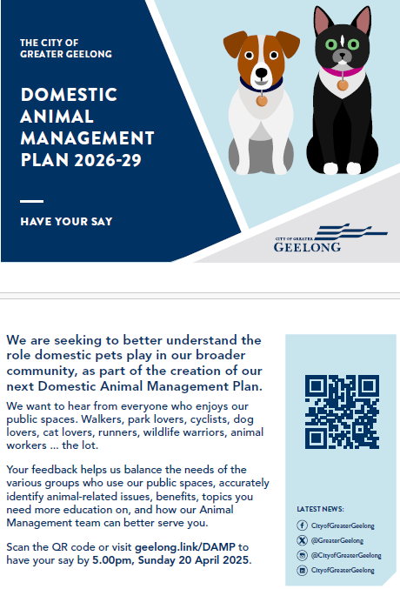

Appendix B - Promotional materials

CORFLUTE SIGN (600 x 900mm) and A3 Poster
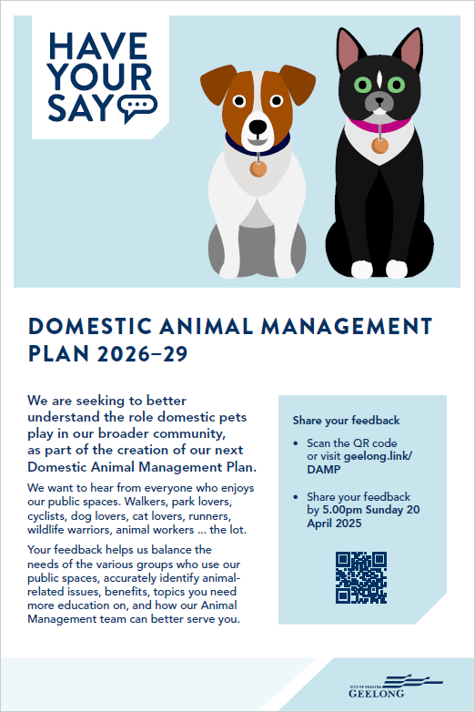

Appendix C – Social media posts
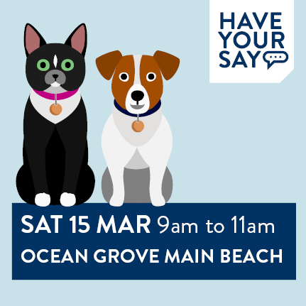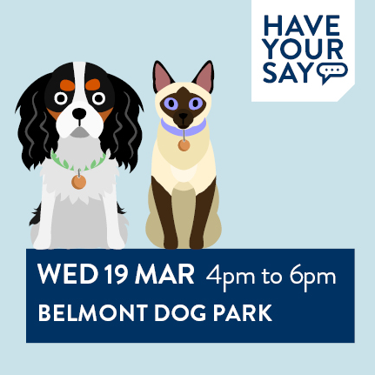
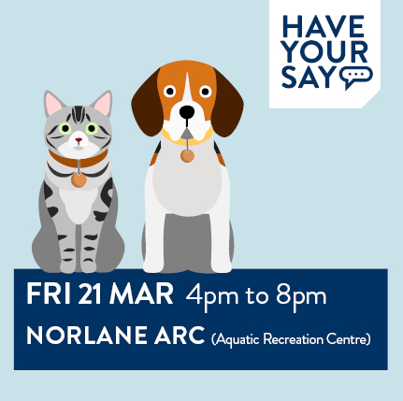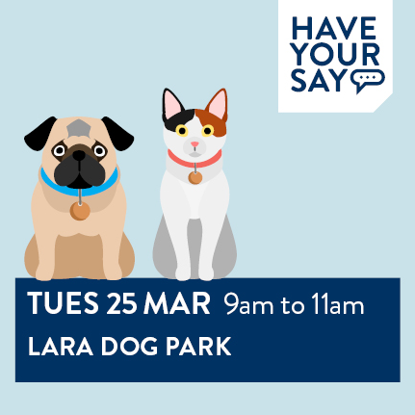
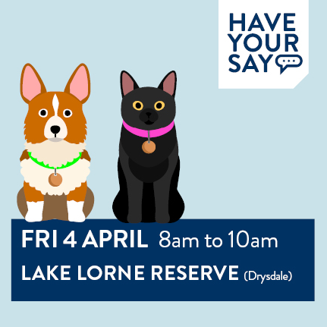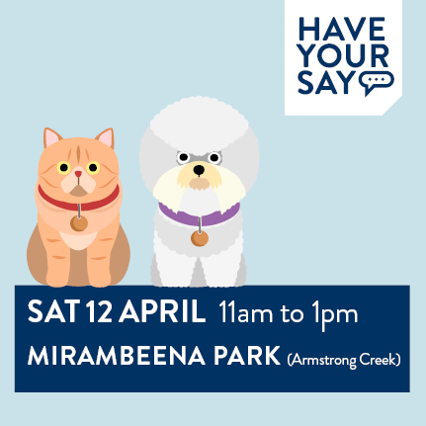

Appendix D – Safety commentary

Walk the river and irresponsible owners let their dogs charge, bark and scare the crap out of you. Dogs should not be off lead on that path ever.
Owners rarely pick up dog poo. If they do there are no bins supplied by CCMA or Council on the river so they throw it in the bushes.
Dogs off leash, owners have little if no respect for others

People don't always obey the law. They don’t use leads in areas requiring a lead.
My dogs are nervous and people just leave their dogs to run up in their face. Others are too busy looking at their phone than what their dog is doing.

Over 80% of dog owners don't know how to manage their animals effectively. their animals aren't under control and they don't correct them for bad / aggressive behaviour towards other people or animals.
Many dog owners ignore the rules and allow their dogs to roam freely on the waterfront when they're jogging.

I am old and not good on my feet, I often feel that I will be knocked over by the larger dogs whose owners have little control of.

When walking my dog on lead in local parks and areas, there are always some dogs off lead.
I have a dog that does not like unknown dogs approaching her, so the off lead dogs are always a problem as I have no idea whether they're going to approach my dog or not. I find it amazing that even in a place such as Lake Lorne in Drysdale, which is a designated and signed wildlife area, there are multiple dog owners that think it is ok to have their dog off lead! Even in other areas, such as Griggs Creek area in Curlewis, The Reserve in Drysdale and The Rail trail, there never fails to be dogs off lead when walking my dog.

There are people that let their dogs off in on lead areas and say “don’t worry my dog is friendly” I foster a blind rescue dog who scares easily and is known to bite when scared.

Was attacked by a dog when age 4 so strange dogs scare me.

Far too many irresponsible dog owners who think it’s okay to have their dog’s off-leash. It is not okay

Many dog owners allow their dog to roam off lead with no control. This occurs in off leash areas and on footpaths in my local area, often more than 100m away from their dog or distracted by taking calls/texting. In addition, some owners allow their dog (on or off leash) to approach children/elderly or other animals without consent.

Often off leash dogs get too close to my young children
I have a very anxious dog and people always try and pat her even when I am telling them no and she has her tail between her legs and barking because they are still trying to pat her when it's unwanted
I've had my dog attacked by another dog because the owner had no control

Numerous people with dogs have zero control over their pet and continue to let them off lead. My own dog has excellent recall and doesn't leave my side owing to the time, effort and financial effort I have put in, but other dogs constantly run up to mine, which she is not interested in engaging with them and has been attacked in the past so she is on edge. Often the owners are not even within earshot of their pet, and are oblivious to me trying to keep their pet away from mine. I have had to separate more fights than I care to remember, simply because other dogs have no manners and constantly run up into my dogs' space and cant read her uninterested vibes. This also causes avoidable arguments between me and the other owners. *At dog beaches*
Using the dog park in Belmont, my dog has been sick after attending this area leading me to believe owners are not only not training their dogs appropriately, but also not having their dogs seen by the vet and vaccinated regularly either.

Particularly on sports ovals when my kids are practicing dog owners still gather and don’t see the potential danger for the children. Also the ovals are always covered in dog poo which becomes the responsibility of the club to remove.
I have also had my late dog attacked whilst on lead which resulted in my dog requiring surgery this was an on lead area I was in.
Lots of dog owners don’t have effective control and even though their dog might be friendly, their dogs run up to my children.

My on-leash dog was attacked by an off-leash dog. My dog was mauled and required 2 surgeries that week. I am traumatised by the experience years later.

Unwanted interactions with other people’s dogs i.e. dogs not on leash in public areas with the owner saying “they’re fine, they’re friendly” but I’m not actually wishing interaction for myself, my family member or people I support.

I have had a serious injury as a result of being chased by a dog off lead causing me to fall off my bike while on a bike path. I have also been rushed at by large dogs in areas where they should be on lead. When requested their owners have refused to put the animals on lead
Neighbours 3-4 cats allowed to roam and almost caused another injury when one of them got into my house, causing me to fall off the back step as it rushed out. They also stalk birds.

Too often dogs are off lead on soccer pitches in Lara, I take my children there to play and they have dogs running up to them, there’s dog poo all over the pitches.

Too many people with their did off lead and under no effective control. I stick to on lead areas to feel safe but am constantly harassed by off lead dogs

Too many irresponsible pet owners with lack of consequences for disobeying regulations/lack of pet command in public spaces

Too many irresponsible owners with their heads in their phone rather than managing their dogs, particularly when off leash. Even when on leash owners seem to have a disregard for others and allow their dogs to pull them over to another dog.

Too many dog owners ignore rules and have their dogs off lead, my dog has been attacked in the past and can now be reactive towards certain dogs, I feel like there is no where that I can confidently take her for a walk without coming across an off lead dog.
Too many dogs off lead around the streets with entitled owners.

Still feel there are too many areas where dogs are permitted off lead. We need more safe spaces for Wildlife and the community and better enforcement of the on lead areas.

Due to unpredictability of dogs on the loose. I have had 37 years as an intensive Care Paramedic and I have had to deal first hand with the injuries and harm caused by so called friendly dogs who would do no harm. Even those dogs in their owners homes have caused severe and life threatening injuries. Have a park that is fully fenced where the dogs can not escape and let them loose in there but not in public places.
As for cats, I am so annoyed at having to clean cat faces out of my garden. Sadly there are owners who do not keep them in at night and during the day, they are out and free to roam. We have worked hard to develop a garden to attract birds back into the area however we have had native birds taken in our back yard by cats. Cats don’t discriminate between sparrows and other native birds.
I am uncomfortable with dogs I don't know.

Too many dogs are off-lead in designated on-leash areas and never under control by their owners. This particularly occurs with large dogs, often with one person walking multiple animals that they cannot possibly control. Sometimes there are children walking a dog twice their size that they have no hope of controlling even if on a lead. I have never seen a ranger along the Geelong waterfront issuing infringements for dogs off lead, but have been told that if they do attend, they give warnings that owners then ignore. I no longer feel safe walking on tracks and in parks near my home because of this flouting of on-leash rules by dog owners and lack of action by council officers. Young children are also at risk of a serious dog attack, particularly on Rippleside and St Helen’s beaches, where dogs often rush at them on the sand.

There are too many irresponsible dog owners who think it is their right to have dogs off lead in on dog lead areas. Yesterday we watched at least 3 people do that by Lake Lorne in Drysdale, where there is native birds/animals. They just don’t care. Dogs on leads feel threatened when rushed at by off lead dogs, so no, I don’t feel safe.

Increasing number of irresponsible dog owners and what appears to be insufficient council patrols to manage/reduce/educate owners on leash requirements and cleaning up after their dogs.
Also insufficient poop bags and bins placed in common areas to promote clean up

Dogs are often out of control, they run at you, they bark at you, they chase you, they bite you, they bite your children, they are off lead when it specifies they should be on lead.

Appendix E – Best things about pets

One of the best things about Geelong is how dog-friendly it is. It is great to see so many people out walking and playing with their dogs, whether it is in parks, along the waterfront, or just around the neighbourhood. Dogs bring so much energy and connection to the community, getting people outside, socialising, and enjoying the area. It really adds to the friendly and welcoming vibe of the area.

If people need animals, fine. Just make sure they:
* Don't attack wildlife
* Cats to stay in their yard
Honestly these two items are the biggest issue

The human animal bond is critical given the state of society at the moment

I love domestic animals, but are exasperated at the feeling of entitlement many pet owners have when their pets are in public areas, and think their pets can go wherever they humans go.

They provide social connection for people - they always pat dogs at shops and chat. Often isolated and lonely elder folk as well

Companionship, exercise, social interactions and friendships that otherwise wouldn't exist. A sense of community and getting to know neighbours.’

Important for some people for social//physical/psychological needs, e.g. people living on their own and assistance dogs.
Important for children to grow up learning about animals and their care.
I enjoy seeing people walking their dogs even though I don't want to own one myself.
(I have nothing much positive to say about cats, though I'm sure they help some lonely people.)

The way they encourage a sense of community with casual low level interaction between strangers.

Little at the moment. People following the rules are outnumbered by those who don't - it's not a small minority of irresponsible owners.

The love, joy and companionship they bring to our lives. The are part of our family, and a well adjusted member of the community. Our dog loves the space, air and beach that living in the City of Greater Geelong brings.
There is a great sense of community that being a dog owner and walking on the beach brings.

Honestly, I live across the road from a conservation reserve in Armstrong Creek. There is constantly dog poop on the ground. The signs at the entrance say ON LEASH. Most dogs are off leash. People stop right out the front while their dog poops and then they walk off. Just yesterday I asked a lady if she was going to pick it up. She pretended to ignore me, and I asked her again, she said, "Oh sorry I didn’t realise." Then she continued on her way, then I asked again, and she said, "Sorry I don’t have any bags." I gave her a bag.

Dogs are great for our community, encouraging people to get outdoors, exercise, and socialise. Walking or playing with a dog benefits both owner and pet while fostering a stronger sense of community.
In contrast, many cat owners ignore regulations and allow their cats to roam freely. This leads to cats trespassing on private property and, more importantly, endangering native wildlife. Unlike responsible dog owners who keep their pets under control, free-roaming cats hunt birds, reptiles, and small mammals, contributing to wildlife decline.
The rare people who follow and know the law, and help trap outdoor cats, and report unruly dogs due to owner negligence and ignorance.

Pets provide companionship, loyalty, and can teach children responsibility.
Responsible pet ownership is essential. Just as dog owners manage their pets, cat owners should also keep their animals contained. Enforcing these rules would protect wildlife, reduce disturbances, and create a more respectful community for all.

Health benefits - mental & physical.

I love pet animals, they need to be kept safe and happy.
Cats should be kept confined 24 hours a day, dogs should be well trained from birth, they should be confined within property and not able to rush people passing the property. Kept on leash when off property.
Both cat and dogs fully vaccinated and registered.
Both provide company and enjoyment of the owner.
At present, I cannot afford to keep any domestic animals so they remain healthy, happy and registered, therefore I choose to not own an animal

Having animals around enriches our lives in so many ways, even those of us who don't own them

Cats roaming free. Locking cats in houses, especially overnight is disgusting. Grow a set and tell the 5% of our community to shut up. If I have to live with 25 dogs around my house that bark ruthlessly all the time and the council forces me to make a log book, then people can get over cats having any basic liberties

Domestic animals bring people together, start conversations and can be a good comfort. I have seen a number of dogs, aggressive breeds included off leash at playgrounds and parks with no way to resolve it without confrontation with the owner who clearly wouldn't care anyway.

Facilitate interactions; impetus for making new friends; add richness to suburban living; provide interest & stimulation

Companionship. Keeping fit. Interacting with other dog owners, building community ties. People's kindness to each other and willingness to assist e.g. walking another dog when owner isn't well. Animals give a lot of love.
Domestic animals bring boundless benefits. Irresponsible owners are the problem. Dog parks are fun but dogs should all wear muzzles. My dogs don't need one but many do. So make it a rule for all. We walk our dogs daily on leads, don't let them roam or approach others without consultation in case they're scared of dogs, register them, regular vet visits, pick up after them when walking, etc. But we have stopped going to the dog park in Lara. Too many aggressive dogs and also greyhounds. Our Westie was attacked by a greyhound and the owner just said "Sorry, she does that sometimes." ???

That the council takes dog ownership seriously, the rangers are responsive & helpful & there are many dog friendly spaces to walk in

Companionship

Seeing responsible dog owners walking their dogs on leash and picking up after them. It's a nice way to interact with others if they have a well behaved dog.

Lovely thing that people can own a pet for company and other reasons, however, this comes with responsibilities. Owners should consider it a privilege to own their pets and respect others at all times. These responsibilities include, controlling their pets at all times in public spaces, picking up their droppings at all times and obeying all Council rules.
We are daily walkers on the river circuit around the Barwon river, from Buckley Falls, over Red Gum Island to Fyansford, back to the one lane bridge, back around Queens Park golf course side to Buckley Falls. We see blatant disregard for Council rules and respect for other people on a daily basis. Only some people pick up after their dogs. Some leave droppings in the middle of the path, which then gets run over by bikes, prams and walked on by other users. This really is disgusting, disappointing and disrespectful towards everyone else.

They are very good for mental health.

Appendix F – AMOs

The Officer themselves were quite helpful but waiting almost 2 weeks for a cat trap was unacceptable.

Not enough officers to effectively patrol areas.

Never seen one patrolling my areas

The AMO has come to my house and the interaction was positive and professional the AMO was polite and knowledgeable. This reinstated my confidence in dealing with the council and their AMO as I have had bad experiences in NSW.

Initially response was great to concerns however no outcome and continuation of dog and owner behaviour occurs without consequence.. and now approved dog park where entitled owners will continue poor behaviour with their dogs and home. Owners don’t feel safe to aggressive dogs off lead and poo on nature strips and property.

I've never encountered one so they should probably be more visible

I worked at GAWS for several years and met many officers. Some were completely clueless, others seemed well educated but there was often a lack of empathy for the animals being managed.

I sometimes see the animal vans driving (great visuals on their vans) but I think the council might be under resourced in this area for such a big council area. It would be great if council could approve more officers so the community could view these officers out in the community regularly.

I live on a corner in Norlane & have multiple interactions with the rangers as a few dogs roam around pretty freely & then some seem to become absconders & are frequently out. The problem of inter generational trauma & mistrust of authority is huge in this area & rangers do a great job in trying circumstances. Not sure increased fines is the key to compliance but it needs to be addressed as the minority off dog owners cause concern for many

I have called regarding dogs off lead many times and running at our dog. They always follow up and come out however most people are gone. AMO have always been great.
I think people should be fined if their dog isn’t recalled or intruding on peoples space. Education doesn’t work in my opinion.

I expect the AMO's are doing their best, they can only charge/prosecute if they catch the perpetrator. Not easy - if an AMO is see I would imagine those not following the rules quickly shift direction and put their dog back on leash. It's difficult for the AMO's to be in 'all places at once'. More AMO's are probably needed to randomly patrol parklands, streets and beaches but that's not easy when funds are always limited.

I am a Hooded Plover volunteer, have been for over 10 years. This last summer was by far the worst year for policing the beach, I got abused multiple times, did not see a COGG Officer once. It was disgraceful. You just get volunteers to help wildlife and provide no support. There is no interest in the COGG to protect anything.

Had a noise complaint against my dog. Officer was polite, informative and fantastic to deal with

For their job to become effective there needs to be more appointed

Fantastic. Very kind, understanding fair and understanding. They have a very hard job.

Excellent. My dog, a whippet, was on a lead and was violently attacked by another dog, totally unprovoked, at Memorial Park in Ocean Grove in 2023. Owner left without giving me their details. My vet bill was $2000. Officer was understanding and said she would keep my report on file for one year. I felt she listened and I had done what I could to prevent other dog attacks.

As a volunteer at GAWS I meet with AMO on regular basis and know how hard it is for them to carry out their duties with little, or no public involvement. It seems they can’t ever get on top of the cat population.

A change of attitude would help - move away from "enforcement" and regulation, and accept that pet ownership is a significant contribution to community well-being. Less action like quasi-police officers and more about support for pet owners - after all their title includes "management", so manage, not "enforce"

Appendix G – Cats

It is incredibly disappointing that despite large volumes of feedback from the community regarding the 24/7 cat curfew, and the fact that it had 2/3 MAJORITY SUPPORT, Council did not uphold the wishes of the community!!
If Council is so committed to being transparent and representative of their community, it is a blatant slap in the face to not uphold the wants and needs of the majority who left feedback. The Cat Curfew consultation was to reflect the whole community's experience, not just cat owners - and when I read the report, over half the cat owners agreed with the 24/7 curfew!!!
Shameful and has created a lot of distrust that Council will actually listen to anything we have to say.

Please make cats stay within their property 24/7. I love cats but I love my guinea pigs more. We have cats coming into our yard at night and harassing our guinea pigs.

Cats should be confined to owners property 24 hours a day, at all times. It is ludicrous the Geelong council backed down on this ruling last November. Everyone knows cats are a menace to our wildlife. No matter how much we love our cats they should not be able to kill our wildlife. Australia has a disgraceful record of animal extinction and it is time to get tougher on cat owners.

What is the benefits for cat registration? Especially if kept inside at all times. Should be much cheaper than dogs rego as they have dog parks, bins with consumable bags, etc. seems unfair and a disincentive to register a cat.

Disagree with logic and implementation of cat curfew. Very hard to change ways of a 15 year old cat. Would be better for the cat if it was put down than make it a prisoner
Enforce curfew so people bring their cats inside over night.

Cats aren't being contained within their properties and cat owners have no obligation to clean up the mess they leave in other peoples gardens. Cat poo can cause toxoplasmosis and yet it's fine for feral and unrestrained cats to use wherever they want as their toilet with no consequences for the owner. I hate the stink of someone else's cat using my garden as a toilet and shouldn't have to clean that up. Cats also kill so much wildlife. There shouldn't have been a back-track on making people keep cats confined to their properties. If people can't /won't comply they shouldn't have a cat.

The extent to which pet cats roam for hunting and killing of wildlife by pet cats is not understood or accepted (or perhaps cared about) by those owners (70%) who allow their cats to roam. Tracking research shows that an individual roaming pet cat kills 186 reptiles, birds and mammals per year, 59% of these being native species - per km2 this is 30-50 times more than feral cats do in the bush.
The proximity of our town to the beach means that cats (whether feral or roaming pets) have good access to the dunes and therefore the Hooded Plover breeding areas. We see cat prints on the sand each breeding season.
From tracking research in Tasmania: One domestic cat that was tracked over 24 hours travelled almost four kilometres, visited 16 different backyards, crossed three roads and explored a nearby bushland reserve at night.
It is quite unclear on the CoGG website what constitutes a 'nuisance cat'. A link takes you to AgVic where it states that legally you can't let your cat trespass on someone else's property. If this is the case in our municipality, it is not explained. And if it is not the case, it should be. For my own issue of a neighbour’s roaming cat, I was asked to provide evidence of multiple occasions of its visits before CoGG would take action like fining the neighbour.
Cat are made out to be the villain of wildlife killing, where Vic parks kill more native birds with 1080 poisons than any amount of cats.
Cats should be contained within the owners property at all times not just sunset to sunrise. All responsible cats owners would agree with this. Cat owners should have a fully fenced area for their cat.
Cat registration should not be charged to owners who have their property inspected for a fully enclosed cat area, have their animal desexed, and microchipped their should be a one of fee for registration for the council records in case this animal so how escaped the confines of their home. Why should responsible owners pay for irresponsible owners. Animal management officers can inspect the owners premises and then allow cancellation of all further animal registration charges if criteria is met. If you have a car that is never used on the road you don't have to pay registration fees so why should council charge for a cat confined on owners property 24/7, like our cat is.
I was bitterly disappointed when, after adopting a 24-hour cat containment policy a year or so ago, the council rescinded this on the basis of cat owner hardship (financial and mental health). While understanding and appreciating these concerns, the initial policy could have been supported by a greater lead-in time and one/two year program to help owners work out how best to contain their cats, with subsidies for those who needed it and engagement with the Men’s Sheds, Bunnings etc for practical assistance. Engagement too with owners who already have cat runs, as examples, and especially any renters who have managed containment. This could have been supplemented by educational materials (see my response to your last question) and perhaps even some local cat tracking data to show how far roaming cats travel, and what they do when out and about.
Please consider the re-introduction of this policy, alongside a thorough engagement and roll-out program. It is not acceptable to preference pets over wildlife.

Can we PLEASE finalise the 24 hour cat curfew? Greater Geelong has a whole range of native wildlife including birds, reptiles, amphibians and small mammals. The science is clear on domestic cats - they kill wildlife, even when their owners think they don't hunt or roam. Cats are a fantastic pet but they are a natural hunting disaster.

A neighbour’s grey cat has decided that she loves my garden. She comes here to leave her poos, and hunts the birds that I have carefully planted my garden to attract. I do not want her.
I have spoken in a friendly fashion to my neighbour many times. She says the cat runs out between their legs when they open the door. They cannot control her. For some weeks she was absent altogether from their home. I think she was spending much of her time under my house.
I was delighted to see that last year COGG Council had voted that cats must remain under control at all times, and most disappointed that this had been subsequently rescinded.
I cannot understand why.
Dogs are not permitted to range freely. Cats ought not to either.
Why should I be imposed upon by this cat, and indeed, her owners?
Cats can live perfectly healthy lives indoors. Their lifespan is greater if they do so.
Please reinstate this law, for healthier and happier cats, and a more peaceful Geelong.
Cats (the four-legged kind!) must be confined.

I own no pets but have at least 4 different cats roaming through my property on a daily basis. One consistently tries to get in my house. I have a cat allergy and just a bit over it.

Wild life experts strongly suggest that a 24 hour cat curfew Is required to protect our wildlife.

People cannot stop their roaming cats being a nuisance - once the cat is off their property there's no way to prevent it entering my property. It's nonsense to say cats can roam but aren't allowed to trespass - there's no way to stop them.

We installed full cat netting on our property because we were told by an officer it was coming into law in November 24 but from this survey I’ve discovered it’s not required so I’m not appreciating having wasted $8k.

If a cat is restricted 24/7 I don’t believe registration should be required

We constantly have neighbouring cats roaming our yard at night. Occasionally we smell cat piss. It also bothers out dogs to find or smell them in the yard. I don’t really believe our neighbours care to follow any rules about cat curfew. Other than paying to collect a trapped cat, a fine or an in person visit from the council as a warning could deter them?

I am sick of digging up cat poo in my garden beds! It’s disgusting and health issue.

many people don't adhere to the curfew and allow there cats to roam and harass and spoil other people's homes - there is not enough deterrent for cat owners to stop this.
Being that I work in rescue and regularly am called to help trap stray cats or get cats and kittens dumped on the rescue I think stricter rules need to come into place with cats. And higher fines and actions if they aren't followed. People aren't listening and it's only getting worse and at the end of the day it's the animals suffering.

Commendable that Geelong did not go ahead with a 24/7 cat curfew, this was great to see.

Cats should have to wear a bell on it's collar to keep wildlife safe
We have a Cat curfew in place but it is not enforced. I have always had my Cats in for the curfew but none of my neighbours ever have. This is my 4th home & at every house I have had a problem with neighbours cats on my property after the curfew fighting with my cats through windows or doors! Council wanted to introduce a 24hr curfew but can't police the dusk til dawn curfew they have at the moment. Get the curfew we have now patrolled & make owners responsible.. If they take the cat to GAWS a lot of owners will just leave them there & get a new one & repeat the pattern. Take the cat back to the owners & fine them. If they do it again a bigger fine & a 3rd time even larger, 4th time compulsory acquisition & banned from owning a cat for 12mths. Repeat it after 12mths 2 strokes & no owning for 2yrs. 3rd time offending life time ban. We need to be tough, too many cats are out & about & breeding or getting injured. I support a 24hr curfew as long as we get discount on registration & building a cat run or 6mth notice to save & get a run built. I have a 14yo farm Cat who will not take to 24hr indoor life so I will need to build a run.

For environmental reasons, cats should be confined to their own properties and be kept indoors overnight. There should be no signs of cats in the community. This is common practice in some municipalities and is not cruel. It keeps both the pet safe (think misadventures with cars and cat fights) as well as our fast dwindling wildlife, especially birds, reptiles and even insects and butterflies. Both my daughters have cats that are very happy to live indoors, with day time excursions to an enclosed area in the garden. This keeps everyone happy and the owner is being responsible and caring towards their pet.

We need access to cat traps to get rid of animals that are allowed to roam freely at all hours, and to punish owners for being so lazy.

have fostered for GAR for 10 years, and the numbers of kittens and cats needing care and adoption are not decreasing, despite desexing all animals coming into rescue groups.
The desexing message is not getting through.
Council need to provide a free or largely subsidised ( MEANS TESTED) like Project Meow, desexing program. In fact council could do with adopting Project Meows values. A blanket desexing program for 2 years would reduce the number of unwanted kittens substantially.
Also council need to man up and enforce the containment of all cats 24 /7. No wandering, no unwanted litters. Birds and wildlife so much safer, cats safer and healthier.

I'm disappointed the 24 hr cat curfew was not implemented, our wildlife is being decimated by cats. Maybe council could offer some incentive or subsidy or reduction in their rates for installing a cat cage to keep cats contained to owners properties.

Yes, there is a clear lack of awareness among cat owners about the rules regarding cat containment. However, an even bigger issue is those who know the rules but choose to ignore them. Too many cats are roaming the streets at all hours, trespassing on private property, and posing a serious risk to native wildlife. Unlike dog owners, who face strict penalties for allowing their pets to wander, cat owners often get away with breaking the rules. Harsher fines and stricter enforcement are needed to ensure responsible pet ownership and protect our community and environment.

I am a cat owner and I love cats. We need a 100% ban on cats going outdoors, not a curfew.

we have already done a survey not long ago on cat curfews and COGG back flipped last minute. Why are they allowed out of the property during daylight hours. Change that as a starting point. Empower community to take matters into their own hands if you’re not going to do anything about cats.

A previous review of cat curfew showed overwhelming support for 24-hour curfew. However, this step was never taken by council. It should be revisited as the danger to wildlife is ever-present within the City of Greater Geelong and much research indicates that cats are efficient killers no matter whether they are feral or domesticated.

Cats as you know have a huge impact across cities and country areas, killing a huge amount of birds and small mammals
Cats in my view should be contained within a house or secure area at all times to reduce this unacceptable situation
Why should cats come before our native birdlife and animals??
My cat is very well behaved
He loves his outside time lying in my garden and visiting my neighbours
I cannot afford to build an enclosure and don’t believe this is necessary

I own a cat that is contained at all times. I firmly believe cats should be contained at all times. They are a menace to wildlife during the day as well as at night.

I want cats to be eventually banned from the country. In 20 years, we would have no cats and therefore more wildlife. No cat should be allowed to leave its owners property, day or night. If it does, increasing fines, then confiscation are needed.
Cats such as my neighbour’s cat should not be allowed to roam freely up and down the street, including into my garden and surrounding gardens, into the children's park and playground 100metres away.
I no longer have Honey Eaters, Eastern Spinebills and other small birds in my bird friendly garden.
My cats are inside 24/7, but the amount of hate and vitriol cats and cat owners experience is disgraceful. The sort of people that don't like cats, are the sort of people that are emboldened to hurt cats intentionally if councils put too much emphasis on certain aspects of cat ownership. I see problem dogs every single day, but rarely any cats causing any problems.

We have an adult daughter on the spectrum that we are trying to get more engaged in the community including just walking outdoors. Her fear of dogs is constantly reinforced by regularly seeing dogs off lead just looking out the window of the home or car. It impacts her level of physical activity and quality of life in being too scared to go out of the house to walk or even catch a bus in case of encountering an off lead dog. Responsible dog owners who not only keep their dog/s on lead but control them around people or other dogs are so rare and stand out so much because of how rare they are. There are many days I wish there were dog free communities that we could live in but in lieu of that, getting to a point where my daughter feels safe to walk down our street would be a great start. Meantime we continue to work with support workers for year after year trying to get her more engaged despite this particular challenge.

Cat registration should not be charged to owners who have their property inspected for a fully enclosed cat area, have their animal desexed, and microchipped their should be a one of fee for registration for the council records in case this animal so how escaped the confines of their home. Why should responsible owners pay for irresponsible owners. Animal management officers can inspect the owners premises and then allow cancellation of all further animal registration charges if criteria is met. If you have a car that is never used on the road you don't have to pay registration fees so why should council charge for a cat confined on owners property 24/7, like our cat is.

Appendix H – Dogs
More dog owners should keep their animal under control and spend less time being distracted by their mobile phone

Most dog owners do the right thing but there's a small percent giving others a bad name by not having control of their dog/following leash rules in crowded areas.
Some kids also need education on not approaching and patting dogs without owner permission - the parents of those kids probably need the education too.

Council seems to take too long in newer suburbs and more recently acquired reserves to put up dog-on-lead signage, so that down the track (time I mean) people can't say things like 'but we have always had our dogs off lead here', 'always had our dog enter the river for a swim or drink in summer', etc. There are reserves with indigenous vegetation, river access, wildlife still present (despite the loose dogs) which have not been gazetted through the state government. In particular, Fyansford and Highton sides of the Barwon River, Red Gum Island (Fyansford) downstream of the Ring Road and upstream of Queen’s park (bridge). Council reserves, not managed by Corangamite CMA.

Geelong and the community would greatly benefit from a Greyhound specific dog park. There is a strong Greyhound community in Geelong, demonstrated in the high attendance to the weekly Greyhound walking group, and interactions on the Facebook page. It would be great for these pets and pet owners to have a safe place to bring their Greyhounds to socialise and exercise, as this breed is excluded from local dog parks.
Please keep open safe spaces free for our dogs. In my local area I have met so many wonderful people. It brings a sense of community. These interactions are important for human wellbeing.

Further education is a massive issue in the community. Every owner should undergo compulsory education to in turn try and ensure all owners are aware of the relevant laws and try to mitigate preventable dog attacks.

Just education of owners and using leads. Number of times we are walking and I put my dog on a very short leash, and random let their dog come and say hello because ‘theirs is fine’, and then mine reacts and it’s my fault???

Most people don’t mean to do the wrong thing they just don’t know what do. They are also reactive not proactive. I would be MORE a than happy to collaborate with council.

Dog owners on beaches are a major issue. Many people are terrific and respond positively to information about beach nesting birds for example and how to protect them and also understand that their dogs could be a nuisance to other beach goers if not controlled. However, a small minority are arrogant, aggressive, self-entitled and very unpleasant to volunteers -- this leads to volunteer drop off.

Dogs are often poorly socialised (as are some owners) & this leads to issues down the track. Upon first registering a dog owners should be required to provide a certificate of completion for puppy classes or dog obedience level 1
A significant number of people clearly do not understand what effective control means and also that dogs can behave quite differently on beaches (with all those lovely birds to chase!) to the way (even if properly trained) they do in domestic settings.

I live in Portarlington and own 2 dogs who get 2 walks per day. Between 2021-2025 I have never seen AMO presence in Portarlington and the Bellarine Bayside precincts. I appreciate officers have a big city to patrol and respond to complaints however unless there is regular visibility of AMO officers in locations like Bellarine Bayside, some dog owners will continue to ignore dog restrictions to the detriment of responsible dog owners and people enjoying open spaces and beaches particularly during peak holiday seasons.

More enclosed areas for off-lead use - this could include a booking system and would be highly beneficial for non sociable dogs to ensure they too can run and explore.

I would like to make a recommendation about Dogs off Leash on beaches and walking tracks in St Leonards / Indented Head /Portarlington. I know that dogs must be on leash from late December until the end of February - but this rule is almost never observed by dog owners, and is never enforced by the Council.
I have lived in multiple states and multiple countries and I can’t remember ever seeing dog poo so prevalent in public spaces as I do in Geelong. Every walk or run even multiple dog poo bags simply discarded on the side of the path.
I would like to recommend that the Council change its policy and dogs should by on-leash from 1 November until 30 April the following year. There are more and more people/tourists coming to the beaches with their dogs and taking them off-leash in November & December as well as in March & April. I have observed many dogs chasing wildlife including swans which travel along the water. I have had conversations with some dog owners who have basically either ignore, get aggressive towards me or inform me that their dogs are allowed off-leash. When I inform them that they need to be in control of their dogs and they must prevent them from chasing the swans, all I get is they are allowed to be off leash and they are dogs - they are going to chase birds.
For this reason, I believe that the dates should be changed as mentioned above to have dogs on-leash from 1 November until 30 April. I hope this makes sense and the Council will give it serious consideration.

People who take their toddlers to play parks, should not bring their dogs too. They feel rules only apply to others.

Off lead dogs that run up and jump up with owners who have zero control and / or make zero effort to ensure the safety and wellbeing of others and their dogs are the main irritation of my life, and ruin many a walk or outing, especially if I have grandchildren or my dog with me. So over it.

Many dog owners are very entitled, dogs dominate the local beach experience around Ocean Grove to the detriment of enjoying nature, and cause disturbance to local species. Should be excluded from known hooded plover nesting beaches

There are very few places that accommodate off lead dog walking sufficiently. On ovals when no one else is on there is not accommodating and welcoming. It is more like tolerating when no-one else wants to use it. Fyansford common is good. Belmont dog park is fine, but we need a bunch more around Geelong. As a previous resident in multiple suburbs of Melbourne and a 30 year dog owner, I can say that Geelong is the most unfriendly place I've ever lived when it comes to dogs. Even this survey is about regulating and controlling rather than encouraging and accommodating and acknowledging the great communities that come from dog ownership, social connectedness and mental health.

As a dog owner I see too many unsupervised dogs in public areas but in particular owners who think they are above the law and can do what they want.
In off leash areas I have witnessed many dogs not under effective control and have had dogs rushing at and bowling over my very small dog and again owners who don’t care that they do.

You want people to apply for multiple animals permits but the cost its prohibitive. You pay your registration plus the permit each year. It's easier to register them under someone else's name.

In the City of Greater Geelong Domestic Animal Management Plan 2022 - 2025 report, the number 1 issue of that report deals with Dogs in Public Places and it states very clearly - Dogs must be kept on leash in all public areas, unless signs indicate otherwise. The response to that point in the report was Recommendation 2. Organise a community education information campaign to promote that dogs must be kept on-leash in Greater Geelong unless otherwise signed. I have seen no evidence of a community education information campaign. If there has been, I would like to know the details of that campaign and how the success of that recommendation has been measured.
I believe that there is a public misconception that dogs are permitted to be off-leash in all public areas, unless signs indicate otherwise. Perhaps, instead of having signs that have 'Keep your dog on a lead', have every single existing sign changed to read:
DOGS MUST BE KEPT ON A LEASH IN ALL PUBLIC AREAS, UNLESS SIGNS INDICATE OTHERWISE

There is an ever increasing number of people choosing to walk their dogs off-leash in on-leash areas. I walk my dog daily and find it very difficult when training my dog to walk on lead and ignore other dogs when there are constantly other dogs running up to us often barking and growling as well.
When walking around local streets there are often dogs roaming outside their homes (unattended) - often barking/growling, running up to or choosing to follow a dog walker.
Also, when sitting at an outdoor café no-one wants an off-leash dog running up to their table regardless of whether they have a well behaved dog sitting there with them or no dog at all.
If and when you're brave enough to ask someone to put their dog on lead the response is often "oh, but my dog doesn't like the lead" or you are simply met with a barrage of abuse.

Bellarine Dog Activities Group has been providing training classes and activities for dog handlers of the Geelong Region since 1996. We provide foundation training at beginner to advanced levels, and we offer specialist classes including, agility, scent detection, rally, and occasionally, accredited training for assistance dogs and their handlers. We employ positive, motivational training methods which are force-free and fear-free. We are a not-for-profit club of some 140 members with some 15 volunteer instructors and assistants. Anyone can join the club.
We operate from the cattle pavilion at Geelong Showgrounds, which severely limits our capacity to provide services to the Geelong community. We always have a wait list of people wanting to train, and often this extends out to 12 months. Our training venue is too small, and training classes often have to be cancelled at the whim of the showgrounds management to accommodate agricultural and other endeavours. Dog training is not a priority for the showgrounds administration

Encouraging dog owners to stop letting off-leash dogs run up to people and think it’s enough to say “It’s okay, he’s friendly” - it can be less about the dog being friendly and more about the person having an aversion/fear of dogs

There needs to be more fenced off lead areas. Not all dogs can be under effective control at all times, sometimes people and dogs make mistakes. it's like putting a playground next to a highway without a fence and being like oh to bad your kid got run over you should have watched them better - it only takes a moment of inattentiveness or 1 time for a dog to not recall for tragedies to happen. The stupid thing is most ovals are 98% fenced it's like the council purposely leaves gaps for no reason. (For example the Mt Duneed pony club oval mowing gates were replaced with a swing gate that does nothing, all the oval needs is a pedestrian gate and the old gates back to be 100% enclosed). Often a switch of gate types or a few extra metres of fencing could fully enclose and oval giving puppies and friendly foster dogs in training a safe play to play and work on recall during quite times of the day

Appendix I – Clever and creative ideas

More signs posted around, perhaps comedic type posters about cleaning up after dogs and not letting cats out at night. Perhaps ones that belittle those who knowingly do the wrong thing.

Offer volunteer positions i.e.: "Animal Management Assistant" for people with relevant experience/education in animals, use free labour to assist the cities management and get extra support, I guarantee you'll have a BUNCH of people happy to assist

Get schools involved in developing posters, AI social media posts. Get kids involved they will train their parents.

- Change every single sign pertaining to dogs changed to DOGS MUST BE KEPT ON A LEASH IN ALL PUBLIC AREAS, UNLESS SIGNS INDICATE OTHERWISE.
- Contact every Geelong Dog Walking group on Facebook and inform them of the number one issue of the 2022-2025 DAMP document.
- Submit an article to The Geelong Advertiser revealing issue number one of the 2022-2025 DAMP document
- Have advertisements placed in the Geelong cinemas prior to feature films revealing issue 1.
- Have it printed underneath Rates Notices. e.g.
2024-25 RATES, VALUATIONAND CHARGES NOTICE
DOGS MUST BE KEPT ON A LEASH IN ALL PUBLIC AREAS, UNLESS SIGNS INDICATE OTHERWISE.
- Bring to the attention of the mayor, all councillors and Geelong staff that Dogs must be kept on a leash in all public areas, unless signs indicate otherwise.

It will be great to have lighting at dog parks (especially Lara) so I can feel safer exercising my dogs after work.
The solar sensor lights for example which are not running all the time, just when motion is detected.

More visible patrolling by AM officers late in the afternoons when people are walking their dogs after work/school. Also weekend mornings around 11am onwards.

If funding to cover all weekends with animal management officers is not feasible, find sufficient budget to move weekday shifts to cover one weekend a month, on a random basis, so that surprise patrols can occur in high traffic public spaces, particularly where non-compliance has been reported. Weekends is the most likely time for recreation and 'out of routine' activities.

Yes BIG signs that say NO DOGS WHICH MAY NEED TO BE CHANGED SEASONALLY. Allow wildlife volunteers to issue fines to dog owners for non compliance. We're on the beach in tourist season protecting hoodies anyway we have working with children checks and done various courses about interacting with the public etc.. Makes sense and would save you a lot of money. Just need to volunteers to be wearing body cams and maybe a short training course.

Some sort of campaign that makes it clear to dog owners that being the guardian of an animal is a privilege, as they don’t have the right to take their animal everywhere or have it interfere with other people.

Institute City run dog training classes where numerous dogs congregate. To cover obedience training, agility, top and tricks.
How to exercise a dog's mind to prevent boredom

Maybe do plain clothed walks with a dog , in certain areas. See it through a dog walkers eyes.

As said above, bring a roaming cat straight back to the owner & fine them on the spot. I lot will not go to GAWS & get there animal back, it's too easy to get a new one. Enforce the curfew make people abide by it.

Have pet education/interaction days where people and pet owners can get together with experts and council animal management officers to listen to talks on the issues raised in the survey, watch obedience training dogs, talk to dog trainers etc. These days could be fun, informative and social events for the whole family. You could include things like best animal costume, smallest dog etc with prizes that relate to pet care.
Having more signage, doggy poo bags and bins at entrances and exits of walking tracks and sporting ovals.

- Smart Dog Parks with Monitoring & Education
Install AI-powered cameras in off-leash parks to monitor dog behaviour and alert council officers to conflicts.
Provide interactive education screens with videos on dog body language and socialisation.
Use QR codes linking to responsible pet ownership resources.
2. Community Pet Education & Social Integration
Run free education sessions at parks and events on leash training and dog etiquette.
Launch a campaign on safe dog introductions and recognising stress signals.
3. City of Geelong Pet Census & Data Dashboard
Conduct an annual pet census to track registrations, compliance, breed trends, and adoption rates.
Publish real-time data on a public dashboard comparing Geelong’s pet statistics with other councils.
4. Geelong Pet-Friendly Accreditation Program
Certify businesses and public spaces that offer safe and responsible pet-friendly environments.
Develop a rating system to highlight pet-friendly businesses and encourage best practices.
5. Public Pet Policy & Advocacy Hub
Centralise pet-related laws, off-leash area maps, and emergency contact information on a council website.
Host a quarterly forum for residents to provide feedback on pet policies.
Pet Ownership Data
Geelong has ~80,000 registered pets, one of the highest rates in Victoria.
Casey (~60,000 pets) and Wyndham (~50,000 pets) face similar challenges.
Nationally, 69% of households own a pet, highlighting the need for better urban planning.
Conclusion:
By prioritising education, data-driven policies, and structured pet-friendly initiatives, Geelong can enhance public safety, community engagement, and responsible pet ownership.

Signs. Not focus groups. No consultants. Not fact finding missions to Spain. Signs. Put up some signs, double the ranger staffing levels and make the fines meaningful.
Employ more officers for afternoon and weekend work to fine people as no signage or education is working anymore. People just simply ignore the laws.

Maybe the city could put together a 'puppy pack' for people who register a new pet with a lead, poop bags and information on council laws.
Most of the time when a post is posted on Facebook it is reposted to community groups which is great

Employ more officers! And have them work after hours more often. Its not rocket science.
Maybe provide training for individuals who are checked and responsible to assist after hours if you're too broke to pay for proper services. We can become champions..

Who is filling the void for ‘pocket pets’ now that GAWS are no longer taking them in? The lack of duty of care for these animals from COGG is unacceptable

The City of greater Geelong, in conjunction with Barwon Coast, should revisit its Hooded Plover Action Plan to establish a Shorebird Protection Zone at Thompsons Creek estuary (Breamlea beach), which would integrate both sides of the estuary. Thompsons Creek has been nationally listed as 'endangered' under the 'Environment Protection and Biodiversity Conservation Act (EPBC) and is described in the Surf Coast Distinctive Area and Landscape Statement of Planning Policy (DAL) as of "Outstanding environmental significance". The Great Ocean Road Coast and Parks Authority (GORCAPA) already has a Shorebird Protection Zone on their side of the estuary, with a 'dogs on leash all year round' regulation. However, this does not match the current Barwon Coast/City of Greater Geelong dog regulations which is seasonal 'dogs on leash' during the Hooded Plover breeding season and then reverts to 'Under effective control' (dogs off leash) from April to August. These regulations do not provide the appropriate protection for migratory and local shorebirds and waders. Continuity of signage for land managers on both sides of the estuary would provide clarity to dog walkers and assist by-laws officers with enforcing compliance.

Some pop up community interaction days at council dog parks. Animal management officers with a marquee for shelter spending a day of interaction & advice We are noticing a lot of inexperienced dog owners now who don't understand dog behaviour, what is acceptable & what needs correcting, don't recognise anxiety, some people who know their dog has some issues but don't know where to turn for help (e.g. suggesting dog behaviour classes, help from trainer etc ) A lot of positive things could come from this interaction. This day would be advertised at the entrance in advance and could be supported by pet businesses in the region. The animal management might even reward well behaved dogs, diligent owners or anything they deem relevant with discount vouchers or promotional donations from the supporting businesses (e.g. my own vet would possibly donate free dog wash vouchers for their hydro bath). I could see this really helping to promote responsible dog ownership and give COG a great image in this area.

Pretend to be a dog walker on the beach and take a camera.
Check dogs at owner's vehicles in car parks for registration tags on collars.
The Dog Park on Woodlands Drive, for example, does not need a private contractor to empty a dog poo bin. Use Council garbage trucks, and ask the driver to save us money.

Stop putting in by-laws that cannot be policed effectively and quickly.

Patrol neighbourhoods at night to check for compliance

As above - I think dog training by an "accredited" trainer is important. One suggestion would be that there would be less need for AMO interaction if dogs were trained properly (by a registered trainer). An incentive to do this would be to reduce dog rates and possibly increase for others (other than those on benefits).

Nothing clever or creative! Just a desperate plea for more resources and a proper implementation of all the items in the 2022-2025 plan and a tightening for the next plan, e.g. 'Explore the possibility/feasibility of providing more resources, needs to be 'Provide more resources'.

Feedback is related to more safe enclosed spaces.
These spaces could have a booking system and or small fees that go towards upkeep and maintenance.
I intend to look into Greyhound adoption in the near future and I am keen to explore permitted spaces where they can be potentially off-lead, given the rules and regulations associated with their breed. It would be great to have a space in Geelong where dog owners, whether of restricted or reactive dogs, who have a safe space to bring their pet. This may help reduce dog attacks or people doing the wrong thing if there was more options available to take their dog.

Off leash pens with identifier showing if owner is comfortable with a doggy play date. Reactive dogs need to have a run too and honestly some people are just unbelievably stupid, oblivious and inconsiderate of this.
Dog poo drop off points in (bus stops maybe) in addition to public bins, in the neighbourhood. People may be more inclined to pick it up if they know a “dump” point is nearby.
Incentivising foster carers to save (primarily) dog and cats lives. There is a crisis in our country with people surrendering their beloved/unwanted pets. Too many animals are being euthanised for space.

So much of the problem is related to education of owners, especially those who seem to have more concern for their pet than for members of the public. If they can't be educated they should be penalised.

A key solution to many of the dog issues expressed in the DAMP is the training and education of dogs and dog handlers. Bellarine Dog Activities Group (BDAG) provides this type of training, however we cannot meet the level of demand in Geelong. We are currently fully booked, and we have no capacity to expand our services. We are a volunteer organisation with limited financial capacity, and we could do a lot more with additional support.

RE dogs . First and foremost, COGG needs to allocate more funds for Animal Management Services . It has so many roles and so many areas/locations to cover . There needs to be dedicated patrol officers for beaches . These patrols need to take place on weekends too . And when I do my Maths , more AMOs could be employed if so many more infringement notices were handed out . Collected fines would add heaps to COGG coffers.
Add some more creative signs in busy dog areas , with happy little dog images with speech bubbles. ( E.g. I cant read I want to do the right thing" )Many councils have adopted this sort of approach . E.g. lots of great signs on Largs bay beaches in Adelaide. And some good ones re poo at Cronulla Syd .
Put out sandwich boards on beaches at times to reinforce "dog banned Beach " and to keep dogs near you etc on dogs allowed beaches .
Most areas have a local Facebook page . COGG , councillors AMO s should be regularly reminding dog owners of their responsibilities and that not everyone loves their dog . And honestly , regular non compliant owners should have their dog photographed and posted with .."IS this YOUR DOG " . Time for calling out poor behaviour .
Owners need to be reminded the beaches are for all for recreation and relaxing. Beaches should not be seen as "dog walking parks " Get rid of the saying .. "dog Beach " . There are only " shared" beaches . Or of course dogs banned beaches .
AMOs or Councillors need to walk the OG bike/ walk track regularly and put a paint marker or stick with "was this your dog ." on all seen dog poo . Or chalk around poo on hard surfaces .
AND COGG needs to build some fenced dog parks .. lots . Ocean grove and Barwon heads both need one . Don’t wait for dog owners to ask . Just do it
In summary COGG must dedicate more funds to AMS. Its a no brainer . Helps this precious coastal environment if dog owners doing the right thing and makes a safer environment /town for ALL.
The development of a purpose-built dog training and event facility for Geelong would improve our ability to deliver dog training classes. Such a facility could be shared by a number of dog clubs. The facility could also be used for dog events - for which there is a huge and growing demand. This could make a major contribution towards attracting dog-event tourism to Geelong. There is a very substantial gap to be filled in the region and in Victoria more broadly.
We recommend that CoGG explore the potential for providing a purpose-built dog training facility for Geelong to enable clubs to meet the demand for dog training, and for dog events. We would be pleased to further discuss this with CoGG, and we would be happy to renew our conversation with Council in this regard.
We can be contacted at bdag.training@gmail.com

- provide free or heavily subsidised cat & dog desexing service (some Australian councils have already done so with substantial cost savings to them & reduction in euthanasia & suffering by animals e.g. Banyule & Gold Coast Councils)
- Educate public that kittens can become pregnant at 4 months, puppies at 6 months or earlier
- Fun signs on trails, sports ovals advising responsibilities of dog owners
-Pop up (annual?) info sessions at supermarkets or sports ovals with giveaways, onsite dog registration
-Fridge magnet sent to cat & dog owners after they register with fun info on their pet responsibilities
-Radio advert for animal registration dates & advising pet ownership responsibilities
-Info pack for real estate agents to give to newcomers to area (rental or property owners) about pet ownership with dog poo bag holder &/or poo bags or cat or dog-shaped keyring or children's colouring sheet with dog or cat image & small packet of coloured pencils

Don’t think people listen. Money better spent on animal control officers.

Not necessarily creative but animal breeding control in known areas of stray cats. i.e.. cemeteries, school grounds, parks and beach resorts as well as bush blocks where animals get dumped.
More half price desexing, Cheap registration periods, and consider reducing costs to reclaim their animal from GAWS. Too easy to get another and the dumping cycle continues.

Dedicated greyhound slip track in Geelong

Lifetime one off registration would be fair, not yearly fees.

More ethical consultation with pet owners shouldn’t need to be said but after last year’s debacle, sadly it’s needed.

Registered dog owners should get a "pooch pouch" that attaches to their lead to put their recycled plastic bags or poo bags in to reduce poo on footpaths, nature strips, parks, etc. The COGG used to issue each owner that registered or renewed their dog registration with these bags, even if this was done every 2nd year this would help. On the bags could be printed the 2 rules / laws the city is working on the most each year, thereby educating owners.

An idea in UK is the local ‘guardian’ if a park or reserve.
They may be a resident, living close to the park, who often walks through the park & can readily assess a need and alert the City officers to a problem.

Not sure if this is already done as I haven't had a pet for about 6 years, it would be helpful to send with the registration renewal notice a list of the top 4 or 5 rules to keeping a cat or dog (depending on the type of registration) as a reminder, in decent size print - maybe with a clear simple image depicting the rule. Too much text means people just don't bother reading the rule.
Having fun education sessions in primary schools - young children love pets and knowing how to care for them and keeping pets safe. Could also provide fun quizzes to schools which depict the main rules for keeping dogs and/or cats - such as Word Search, Crossword, Spot the Difference pictures, colouring in pages etc.
Do the groups that 'sell' pets, whether rescue centres or pet stores, when selling a cat/dog, hand out a simple one-page (clear concise) list of the council rules that apply to that pet?

Provide a service at a reasonable rate (not for profit making) to help owners assess their property and set up cat-proofing in their backyard. Most people have no idea how to do it or even afford it. If the council can set up a team to assist people who want to contain their animals, I believe it would generate a big interest. Forget making a profit and do it for genuinely wanting to bring change and control to the domestic pets in society.

It makes no sense that you can have 2 dogs, 2 cats, 2 rabbits etc but more than only 2 dogs needs a permit. It should be an accumulative total rather than based on species.

Unfortunately not because all the problems are caused by self entitled and/or idiot owners and I’m not sure there’s a clever or creative idea to solve human stupidity.

Could possibly offering owners free or discounted basic training with their dogs. As many dog owners may not have the finances to do so.

More patrols, higher fines, promote indoor pets. Offer more desexing at reasonable cost, enforce cat curfew, men’s sheds making cat enclosure

I think this is a hard one. I work for council in a different department and totally understand how hard managing funds is. So its all well and good to say all these things need to be done but that isn't necessarily going to happen due to costs.
I think education is very important. I think it should be compulsory for an education program for people to attend that own an animal.
And school based education. Often kids learn how to deal with animals from their parents so we need to change that

Appendix K – GAWS Written Submission
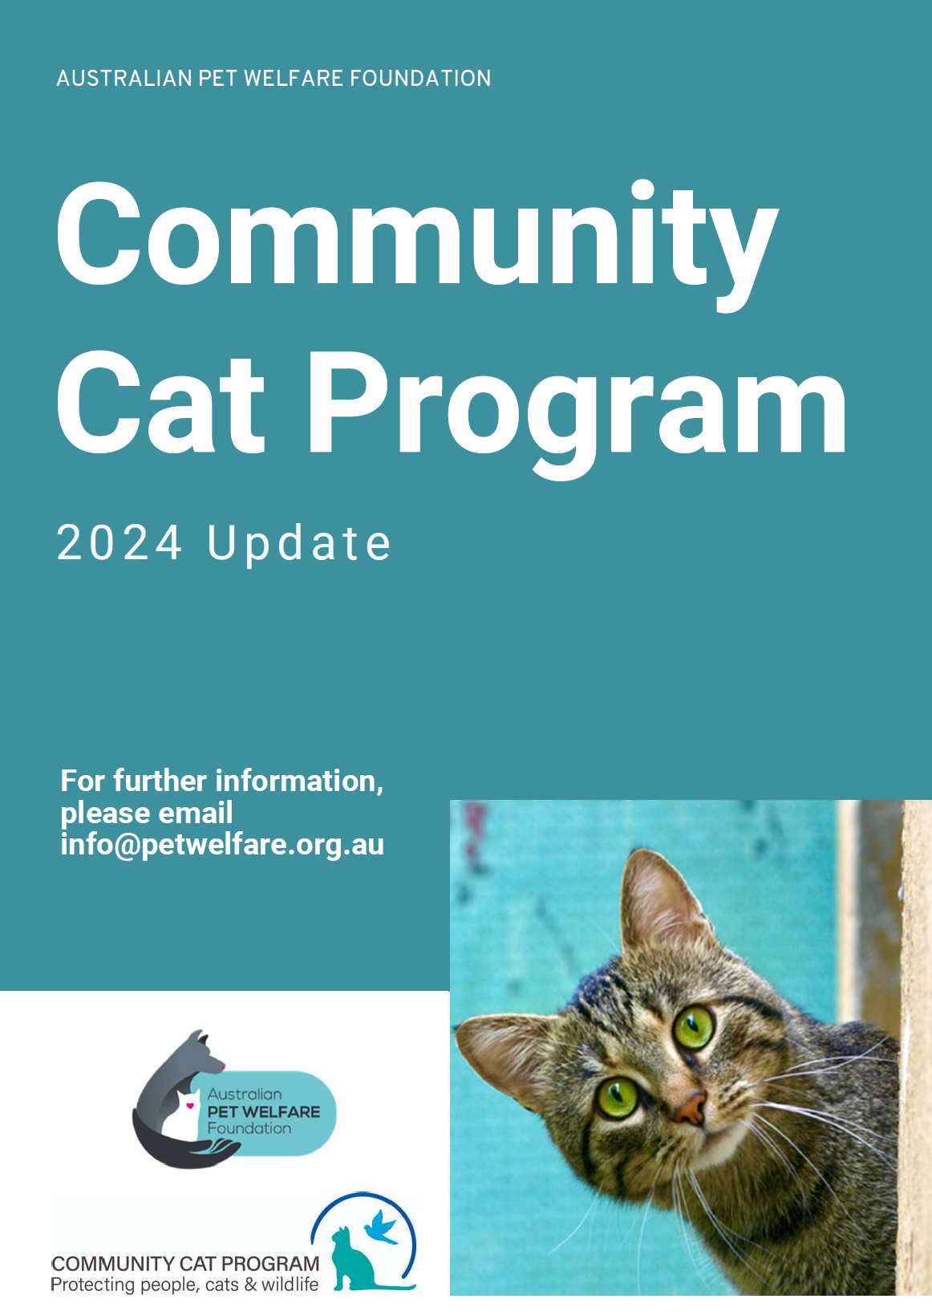

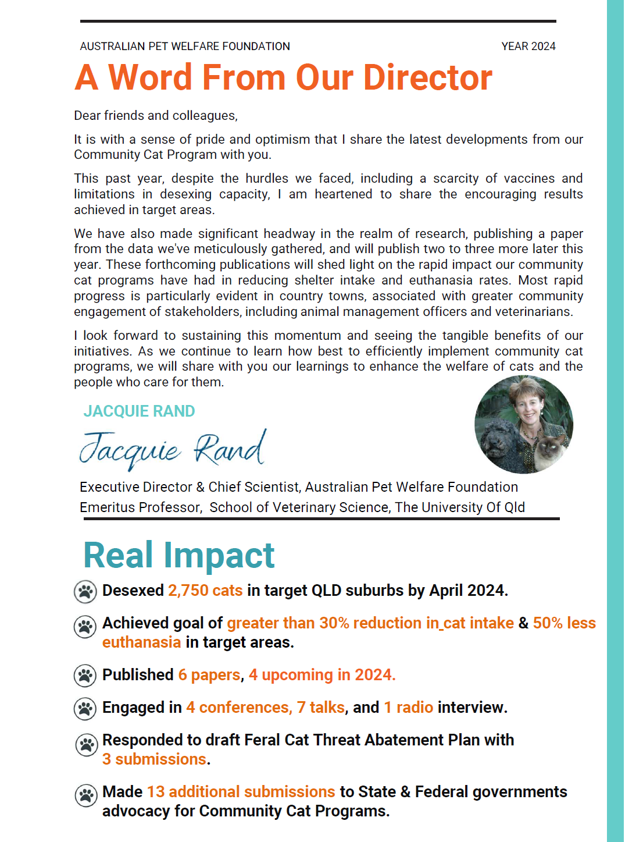

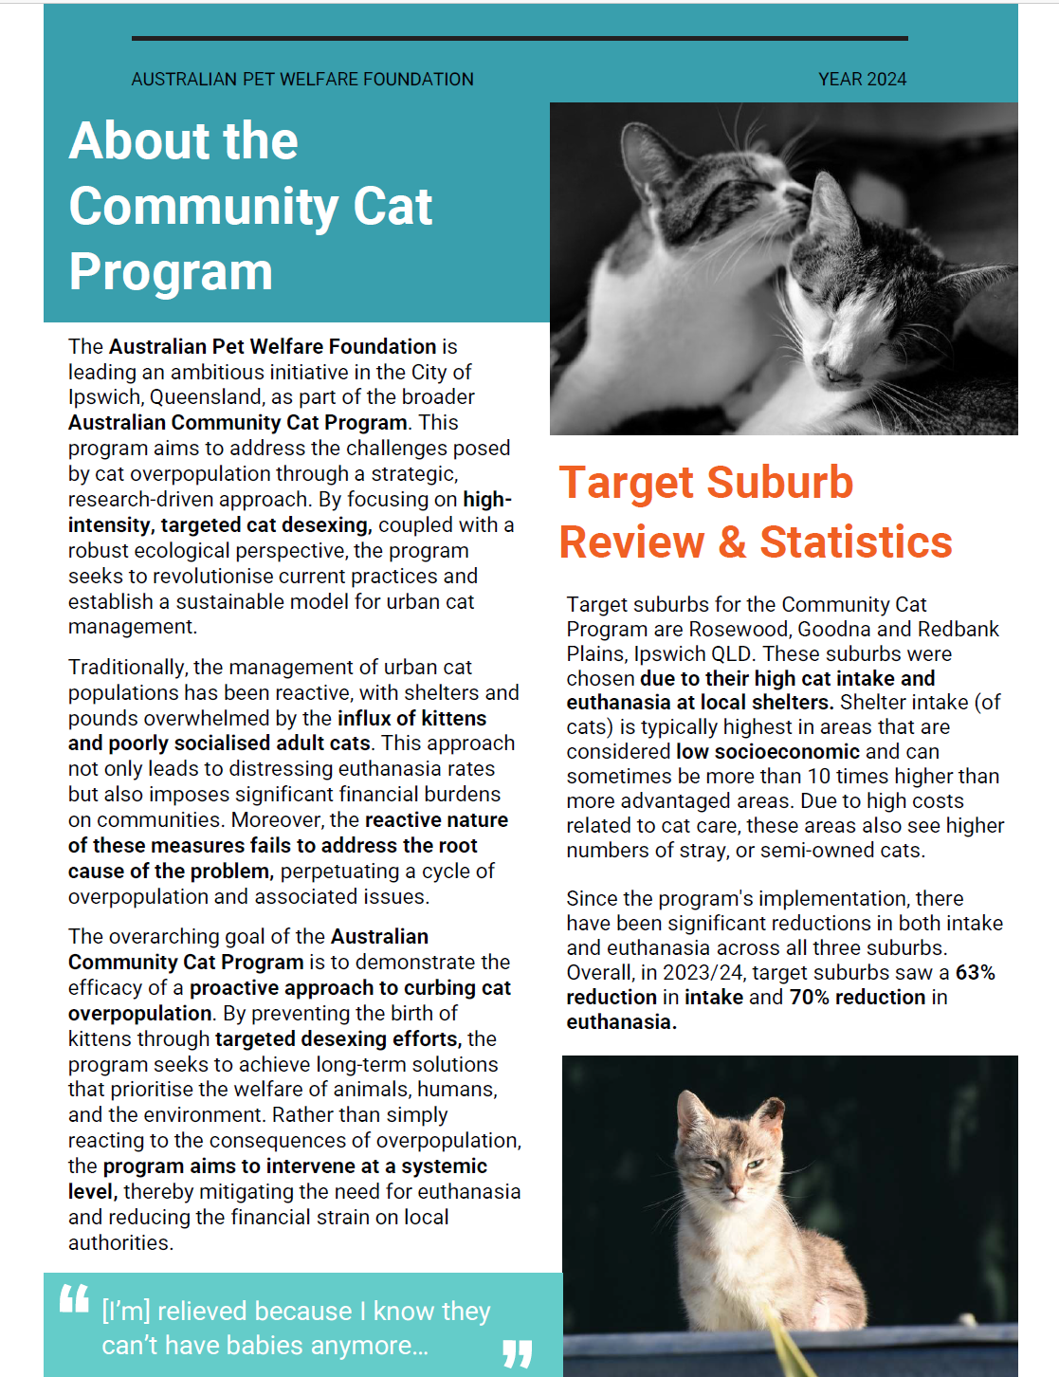

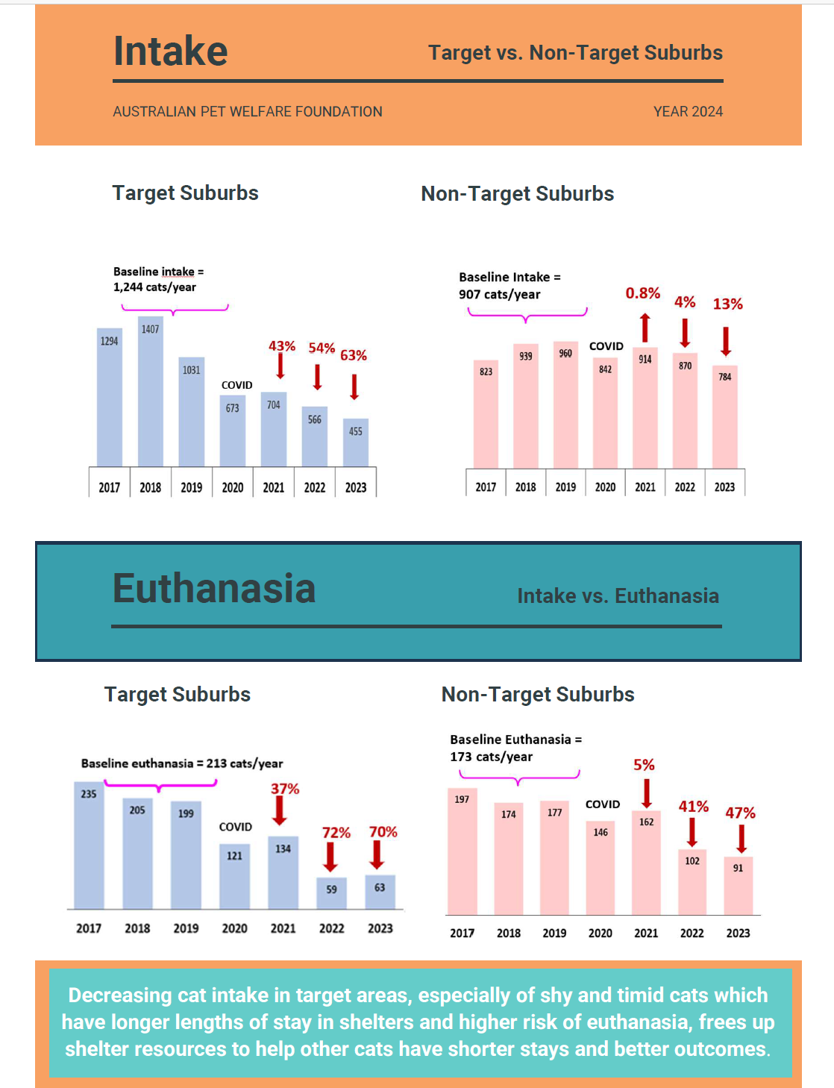

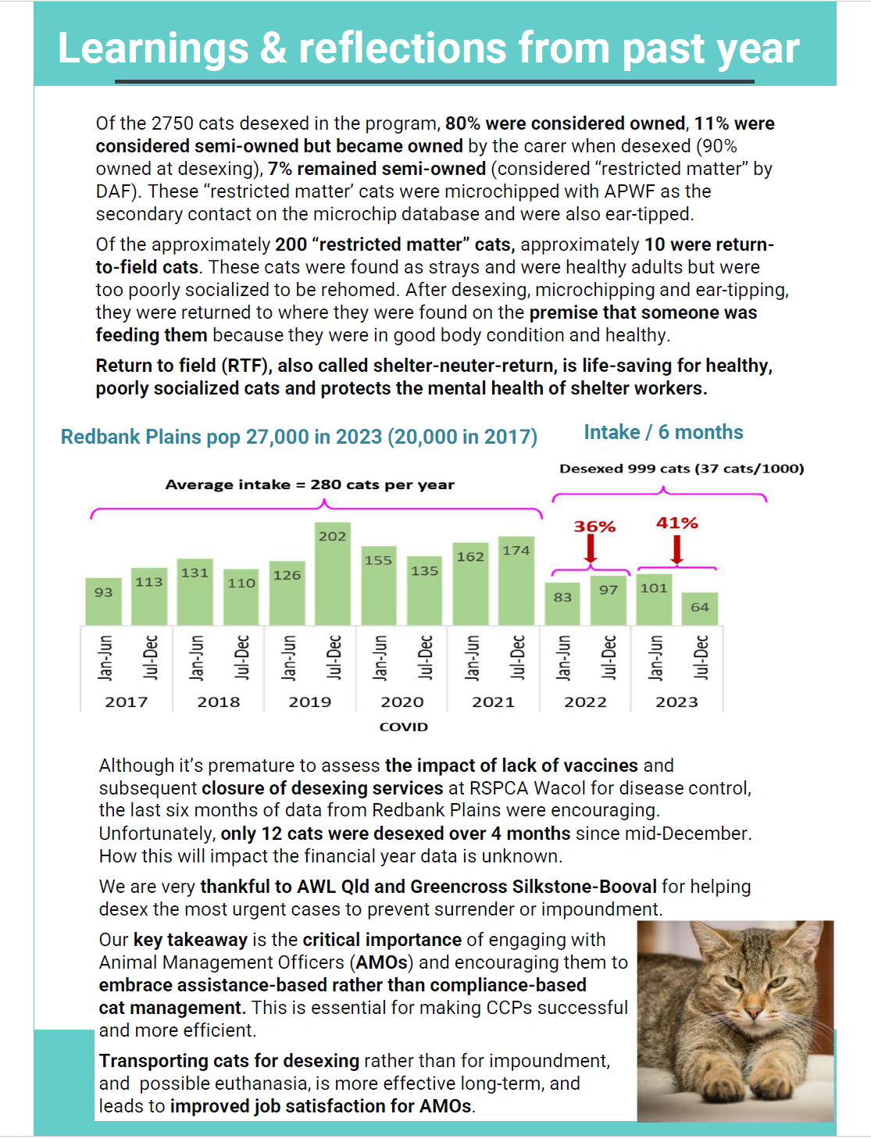

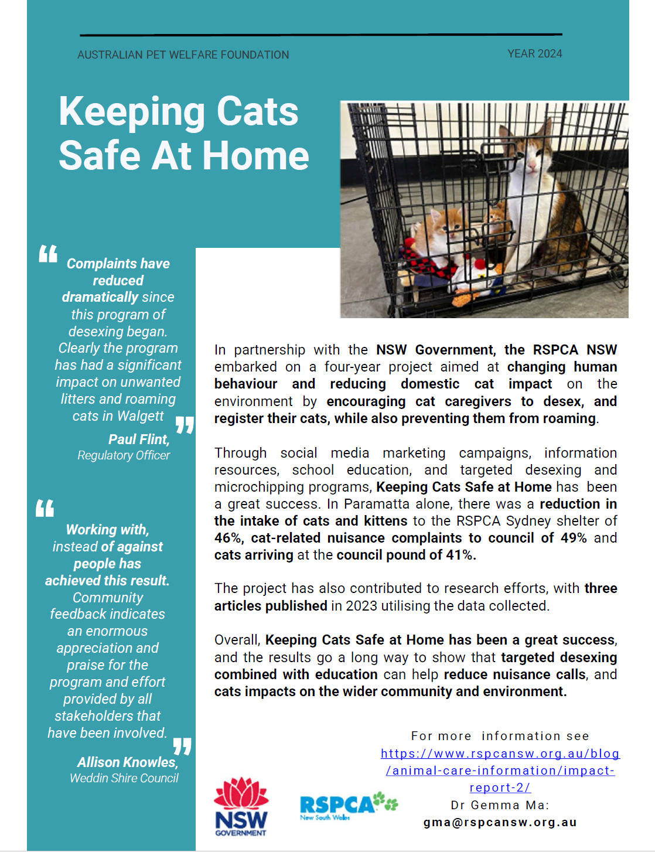

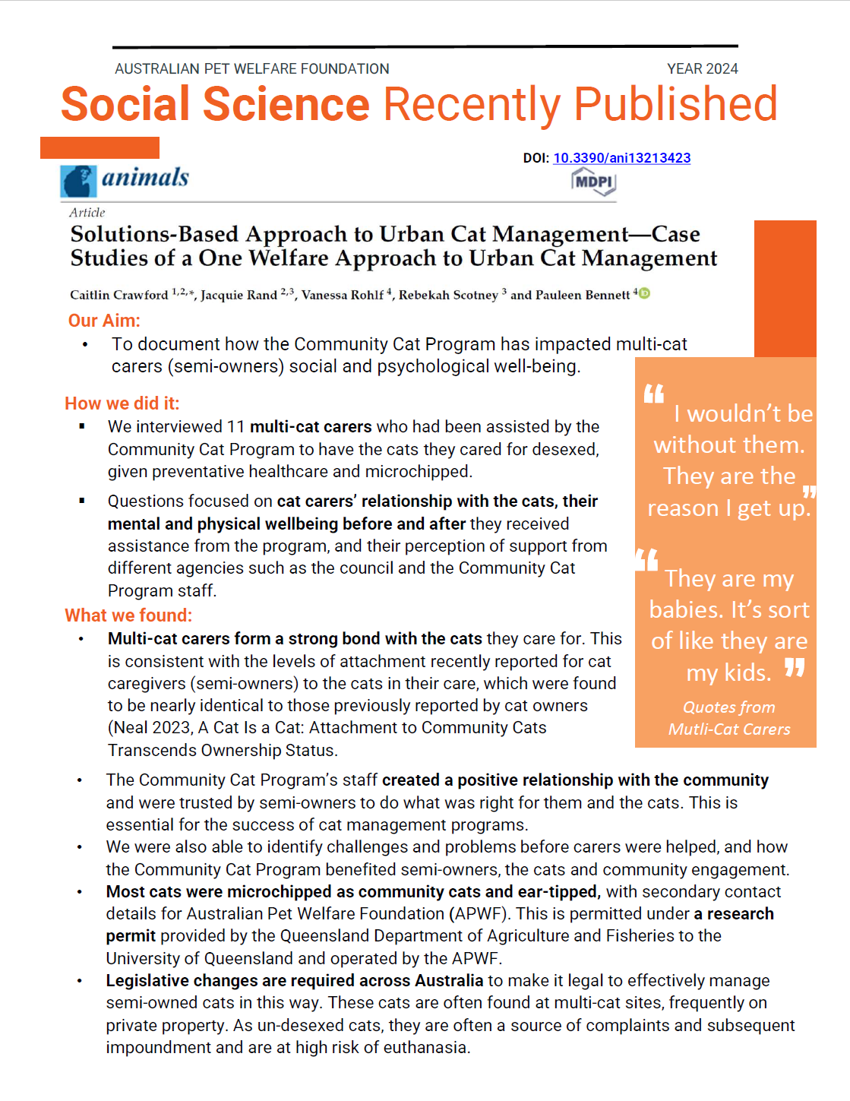
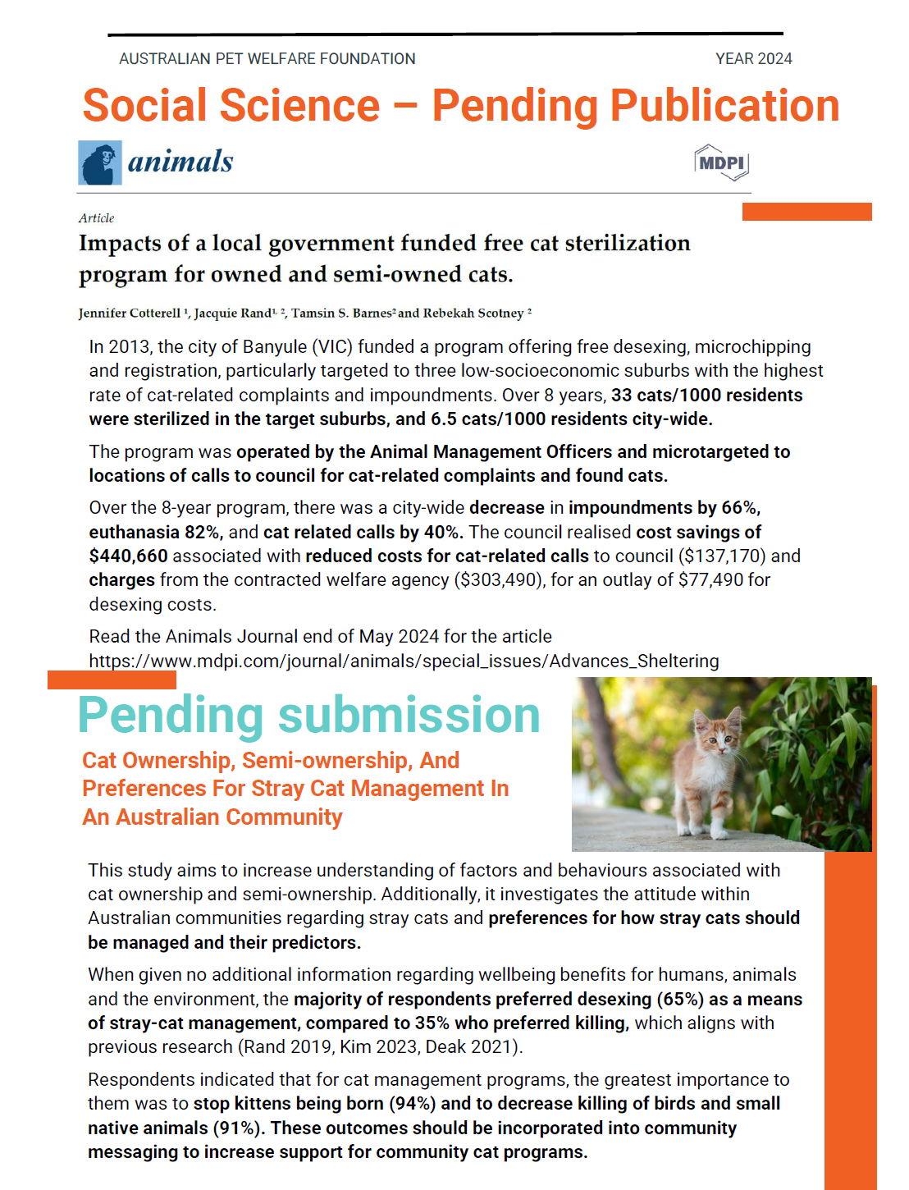

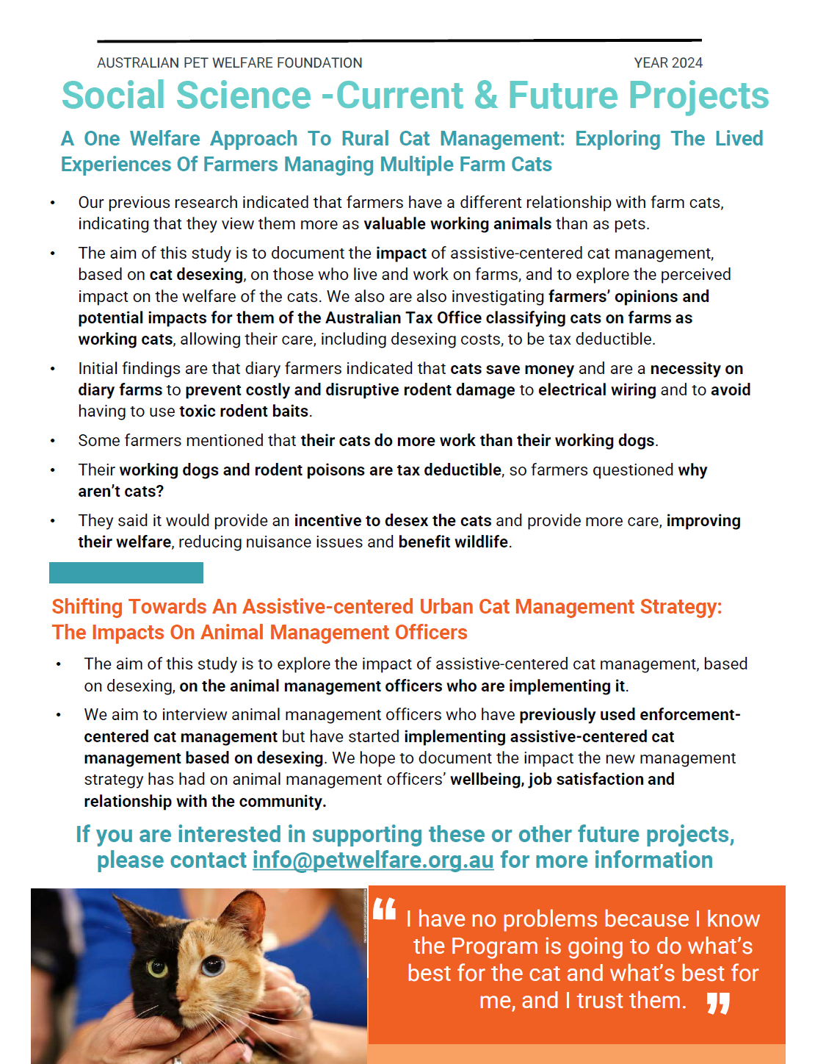

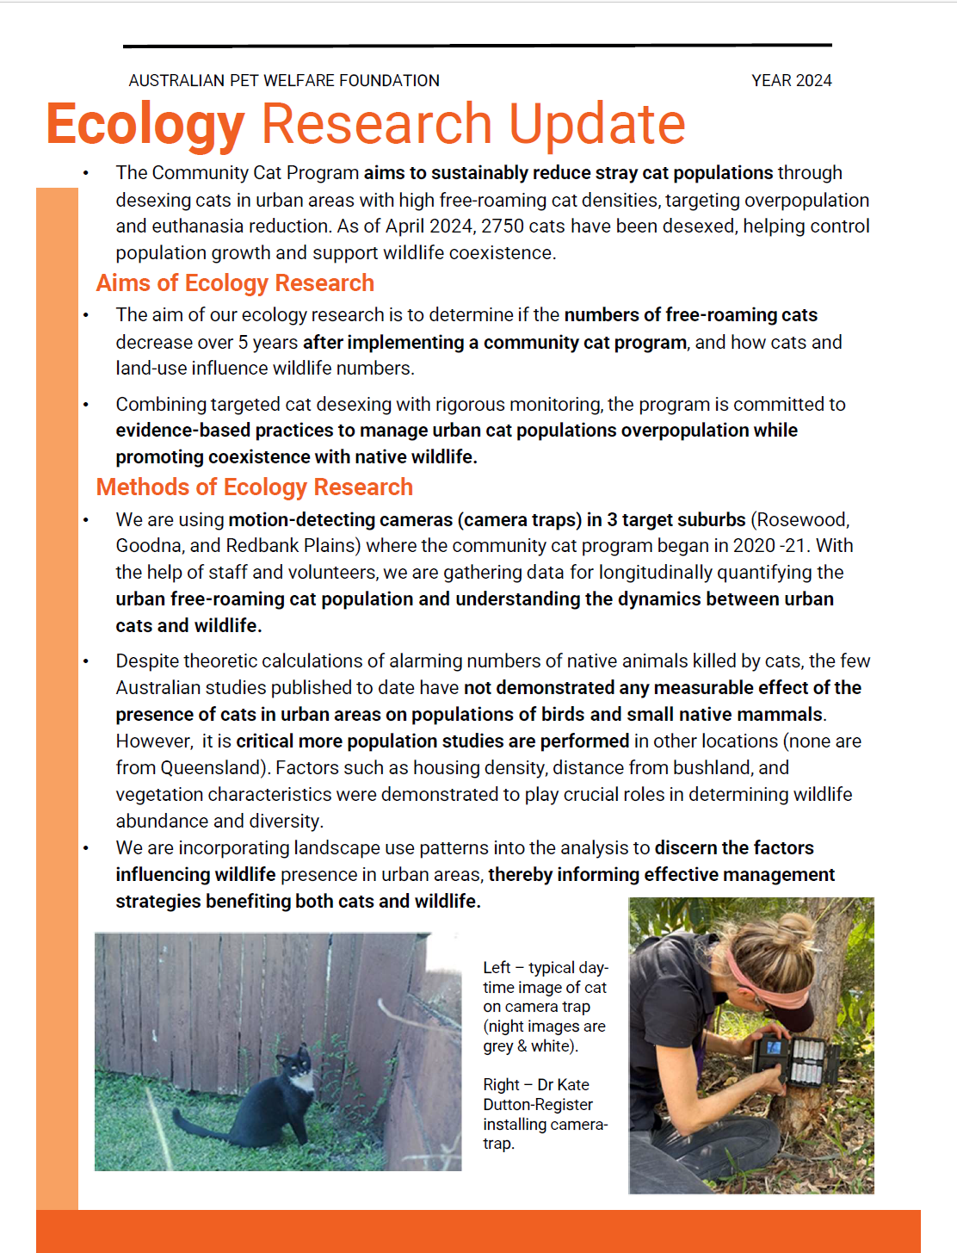

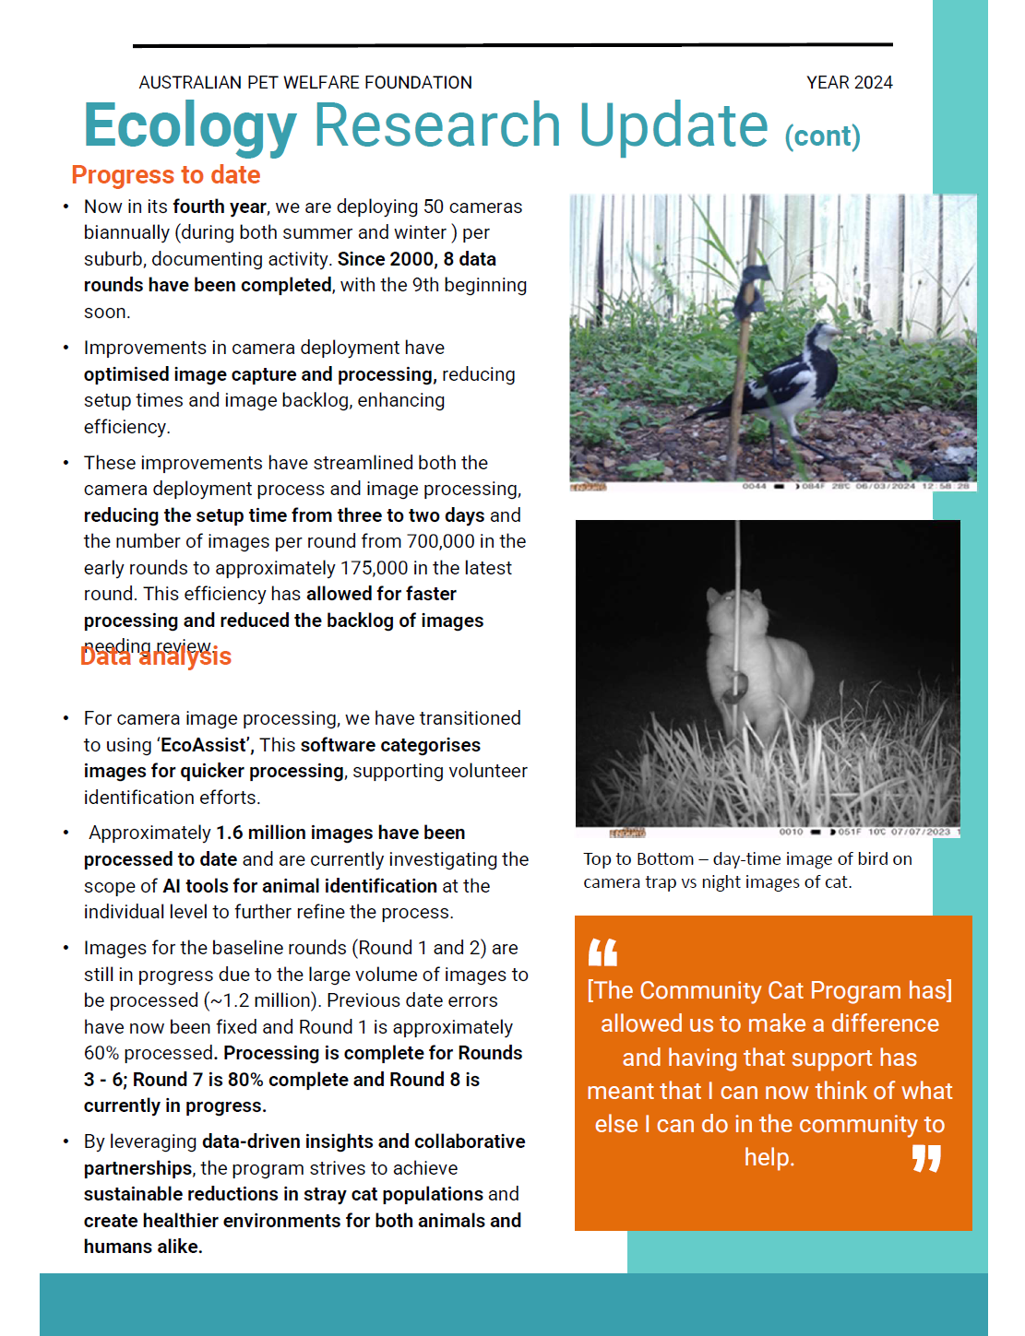

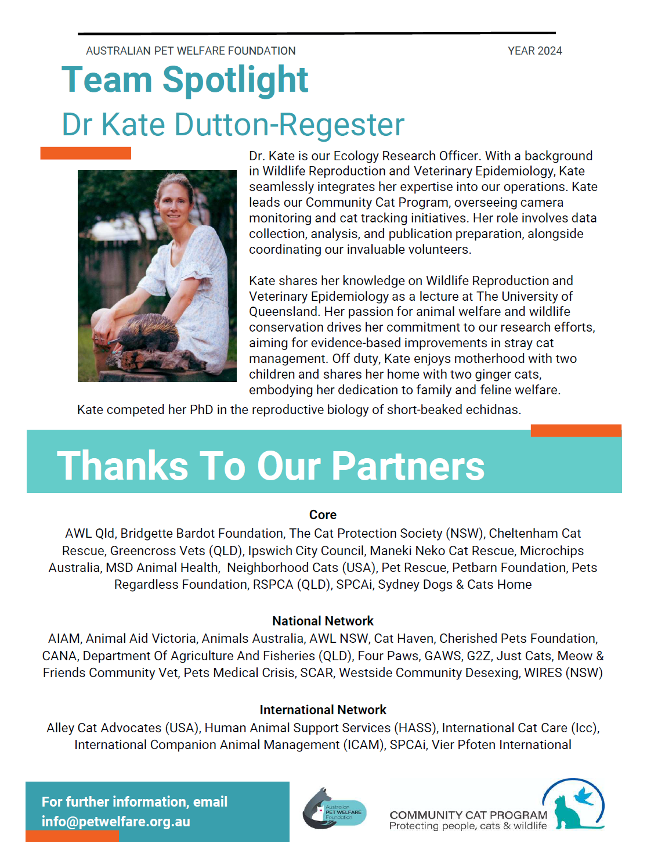
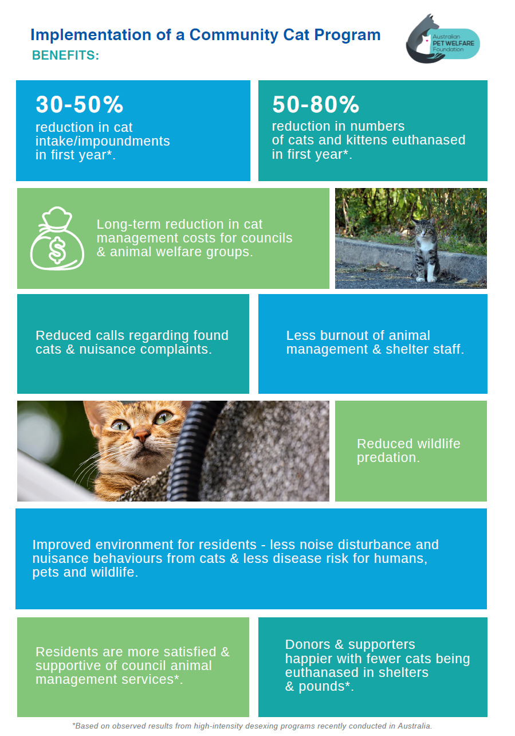
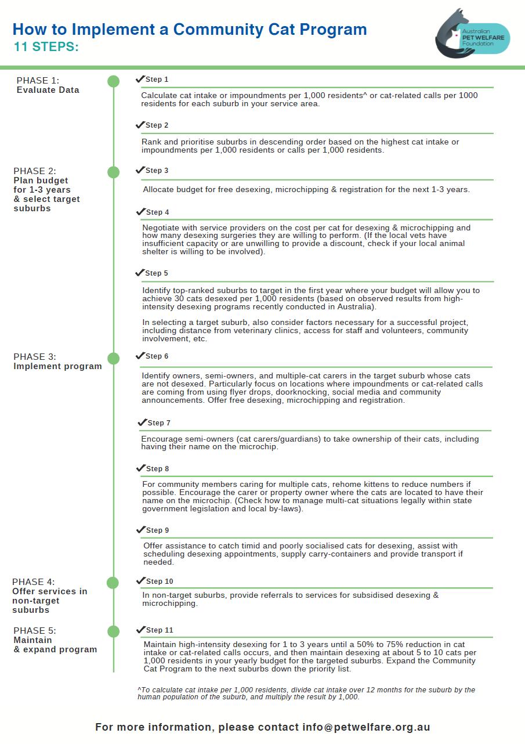
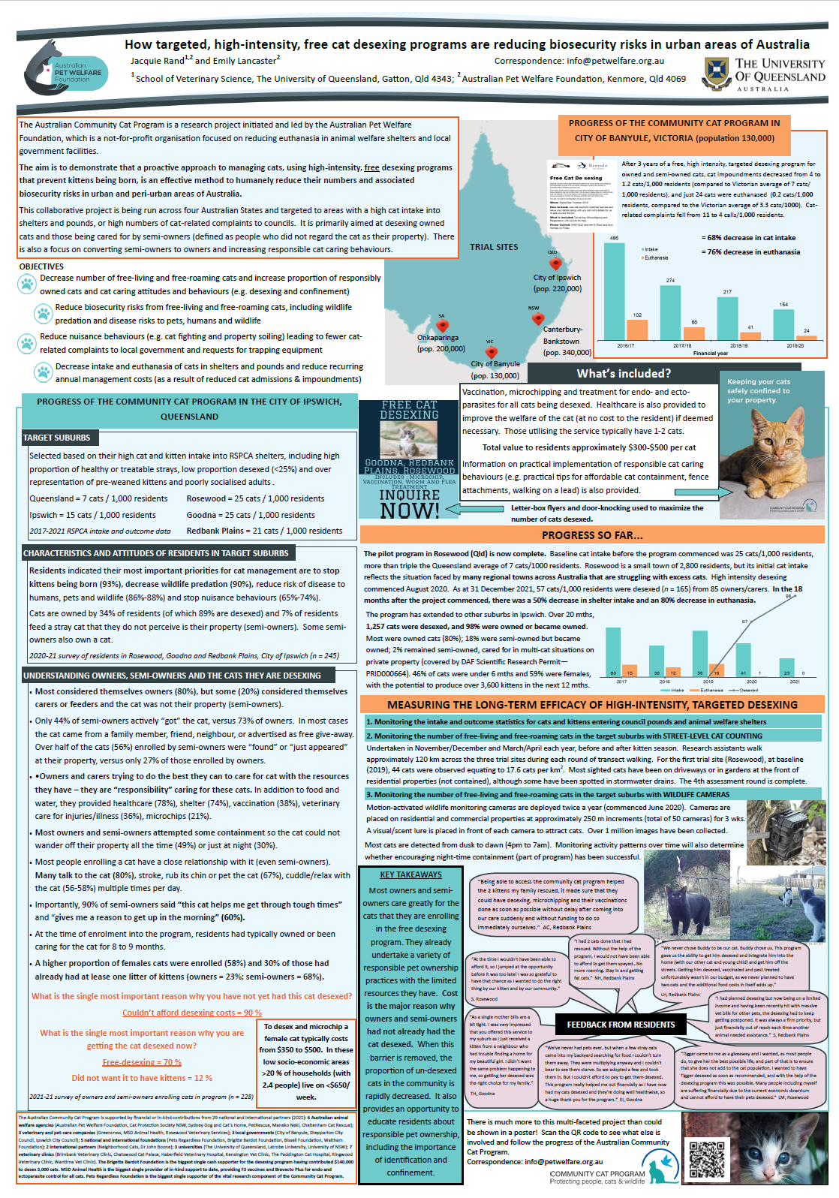

Appendix L – Community group written submissions
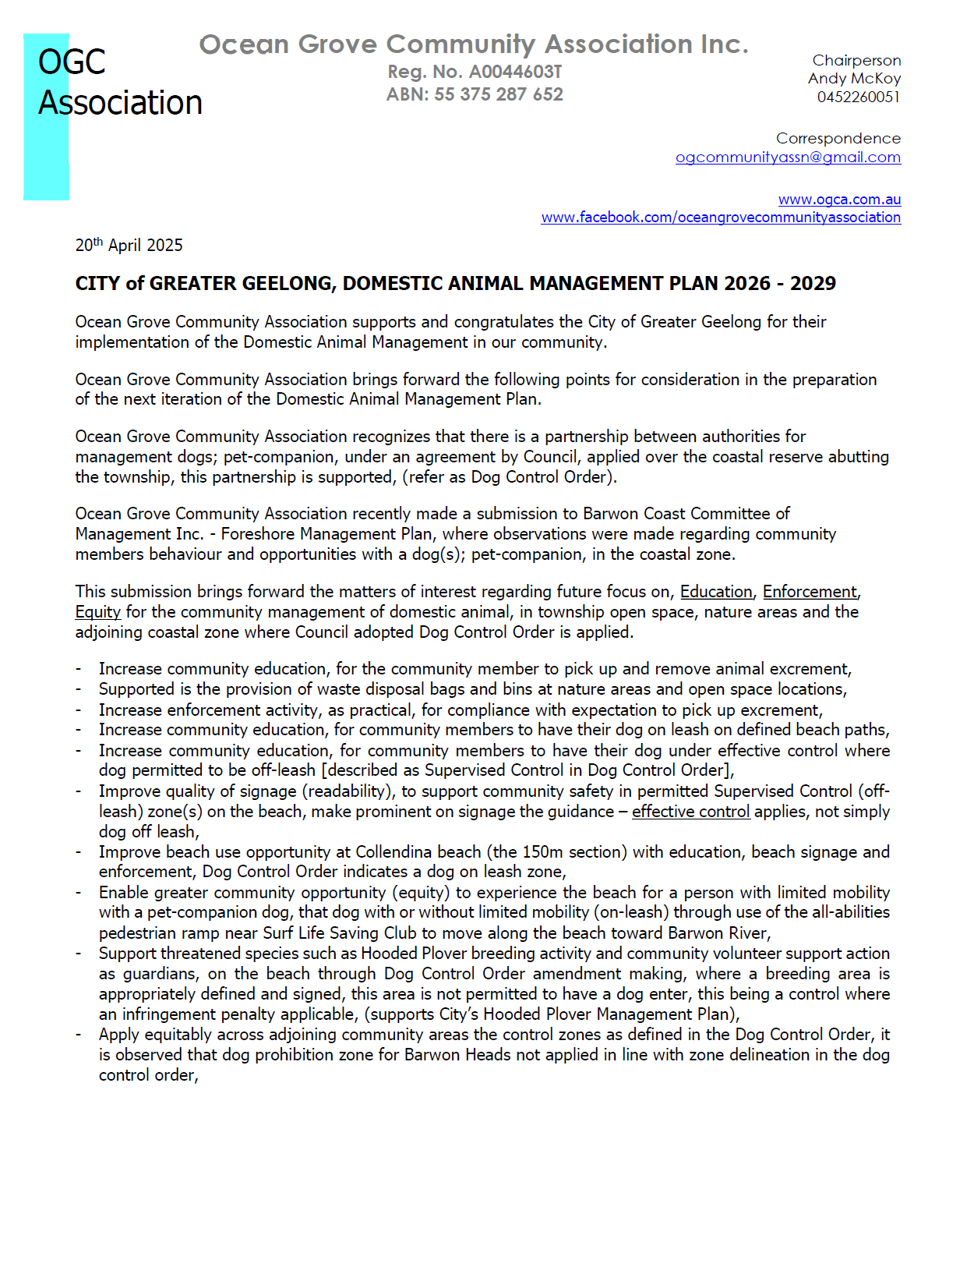
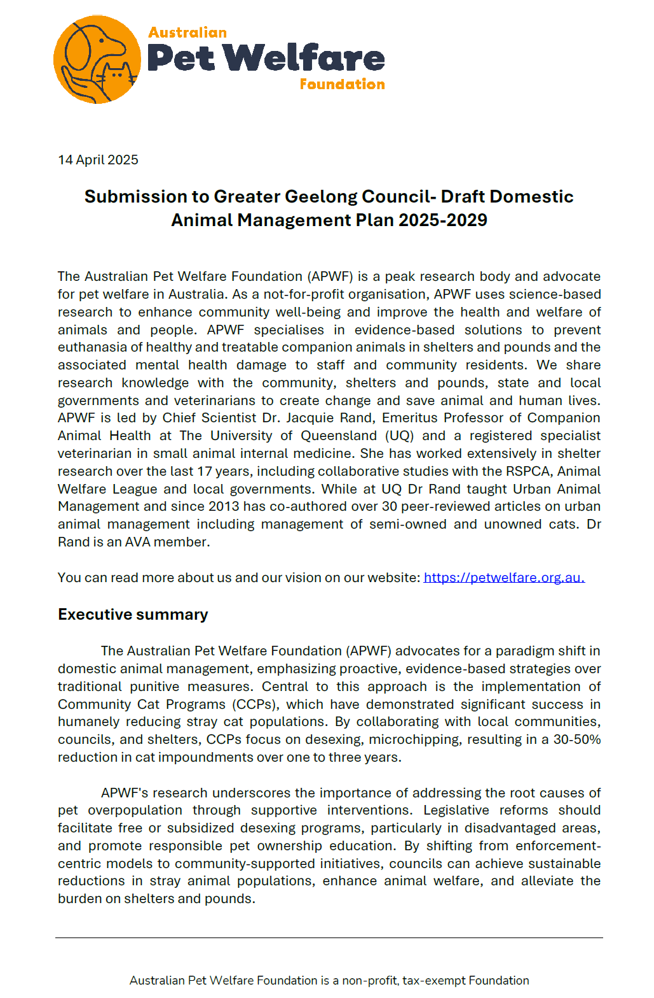

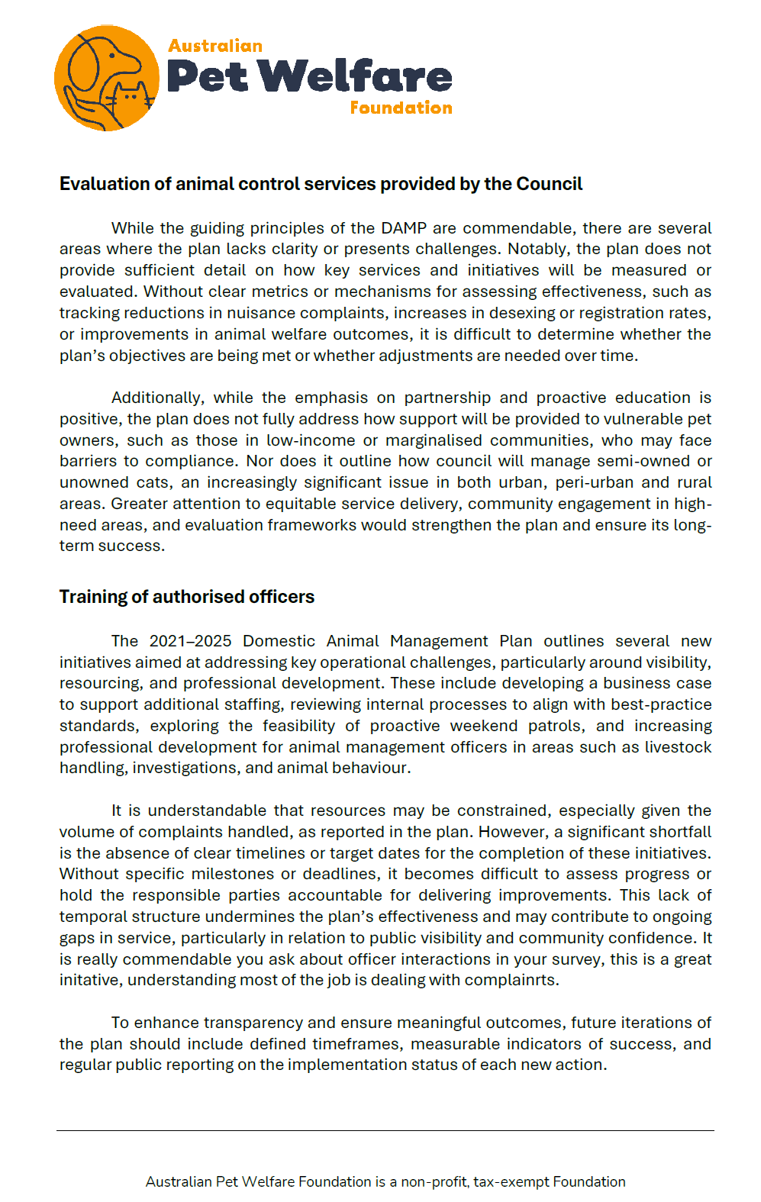
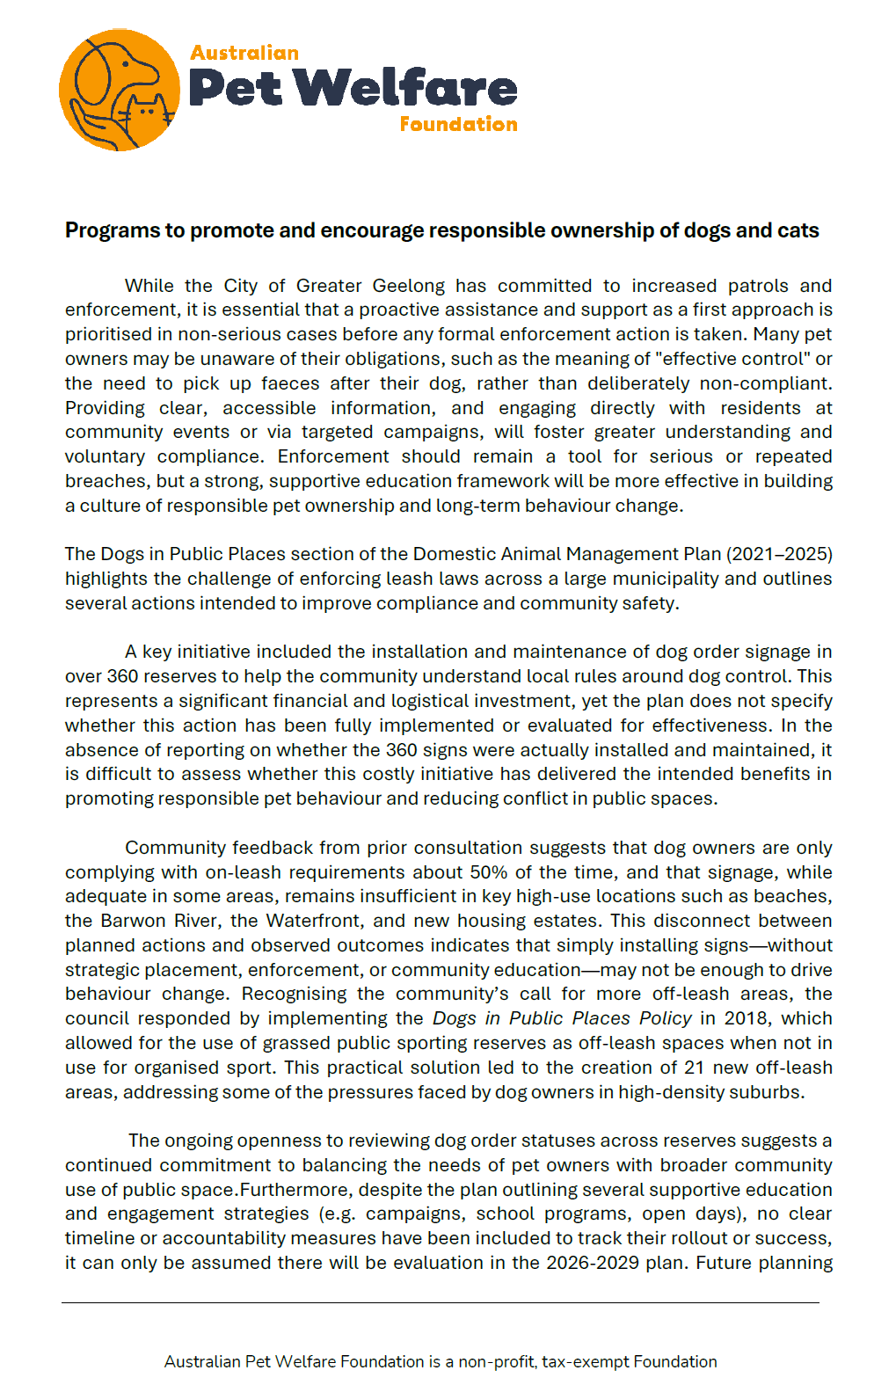
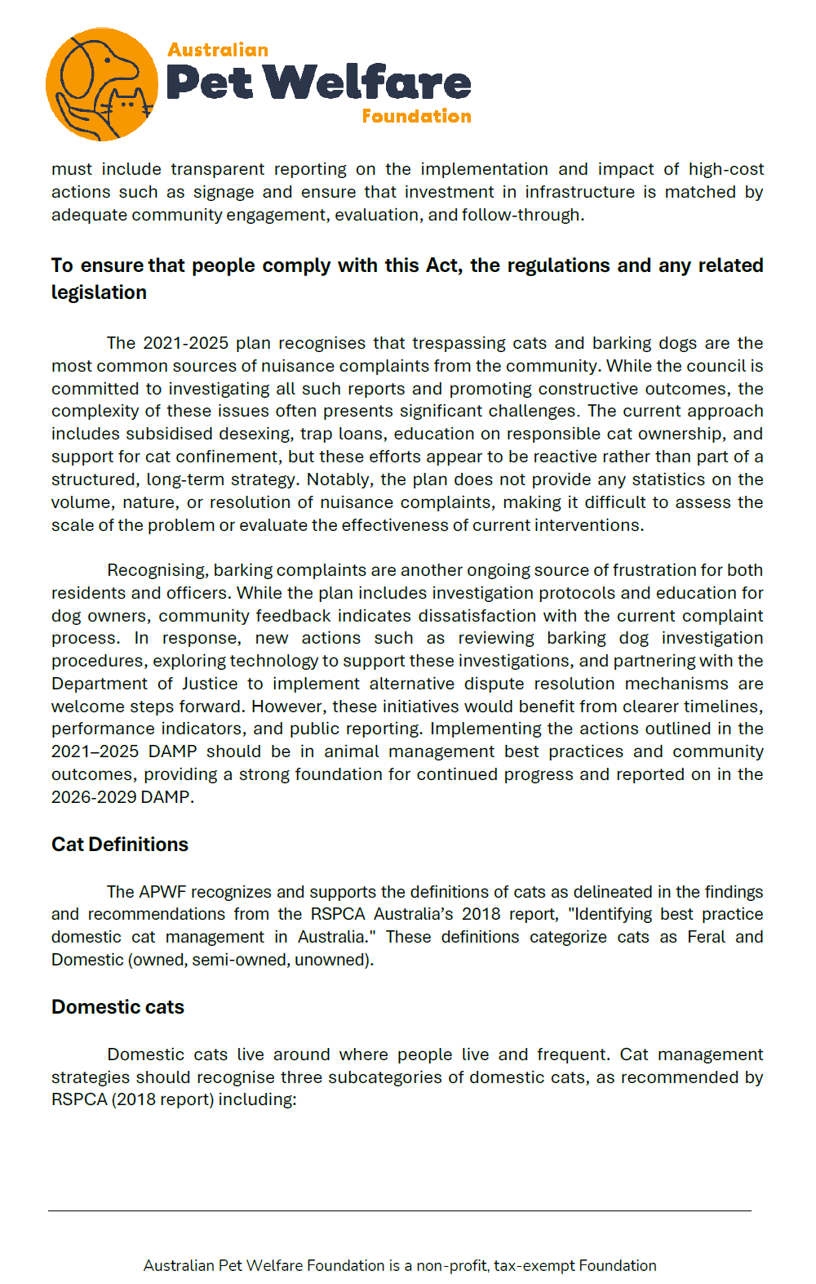
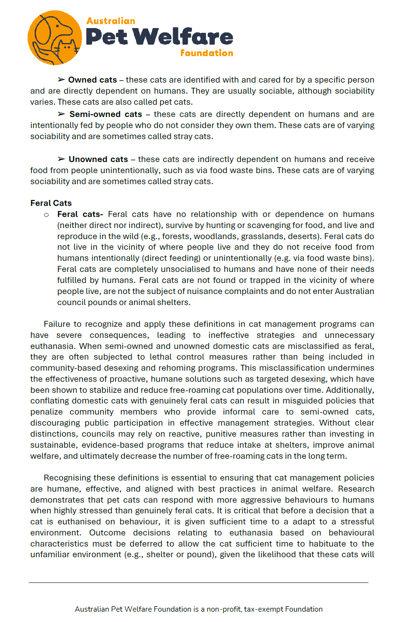
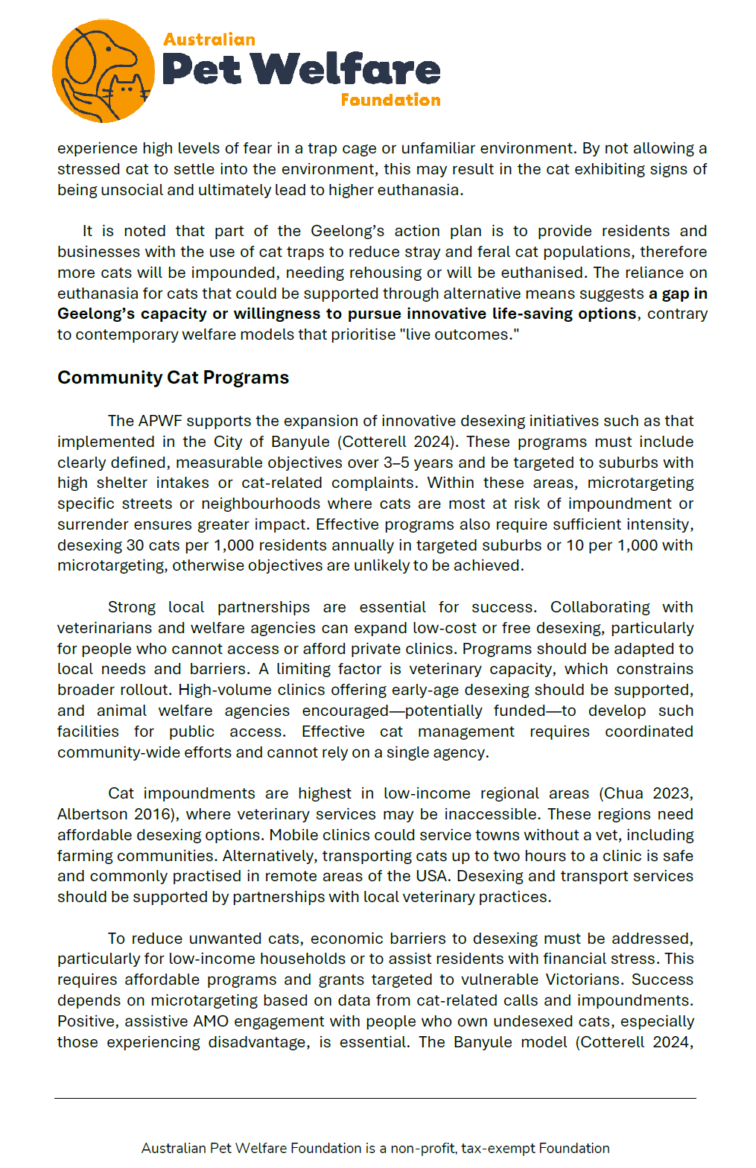
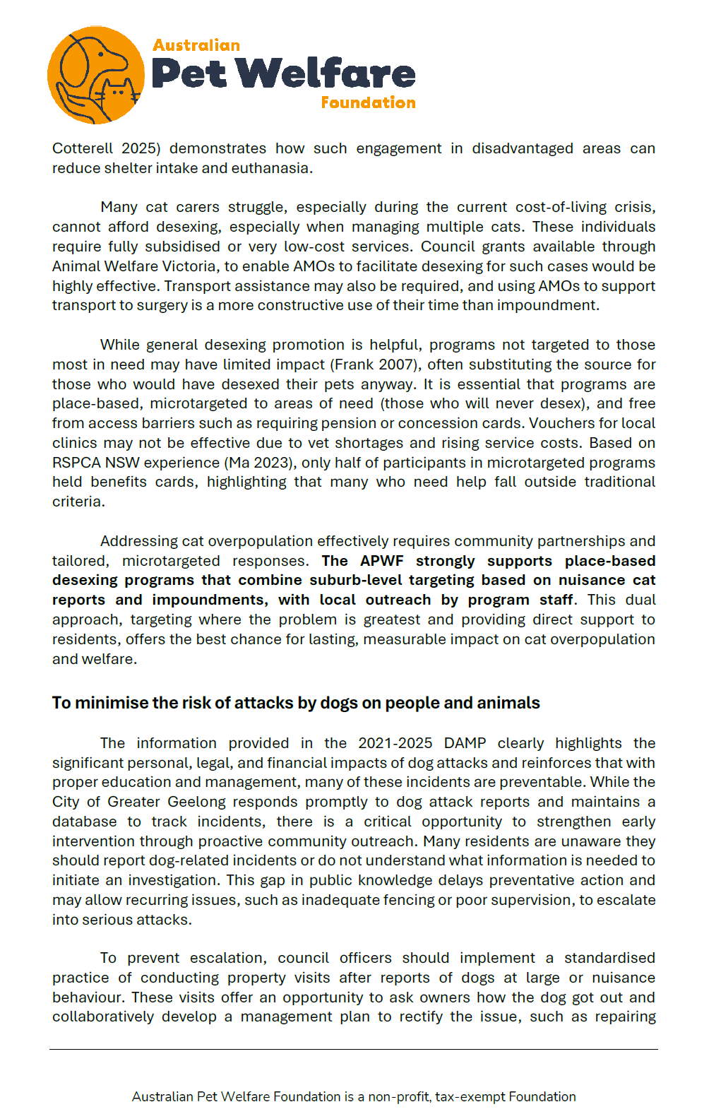
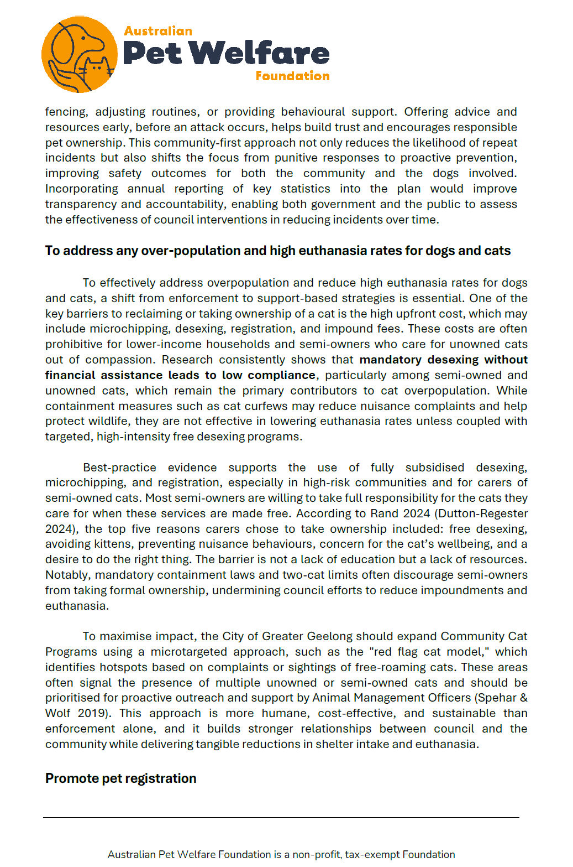
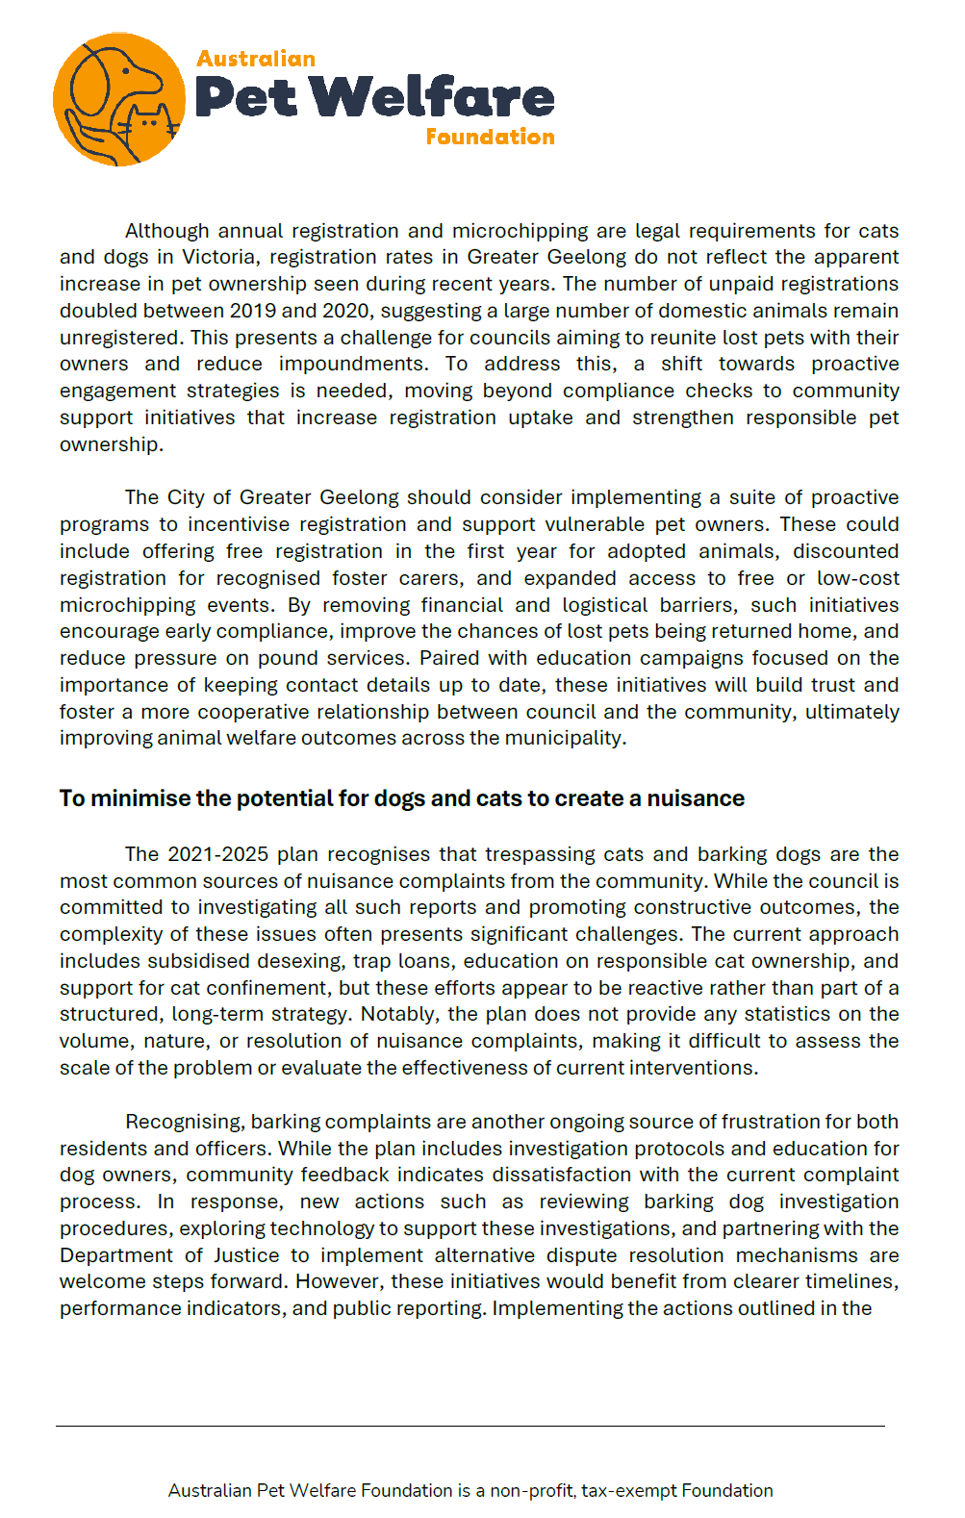
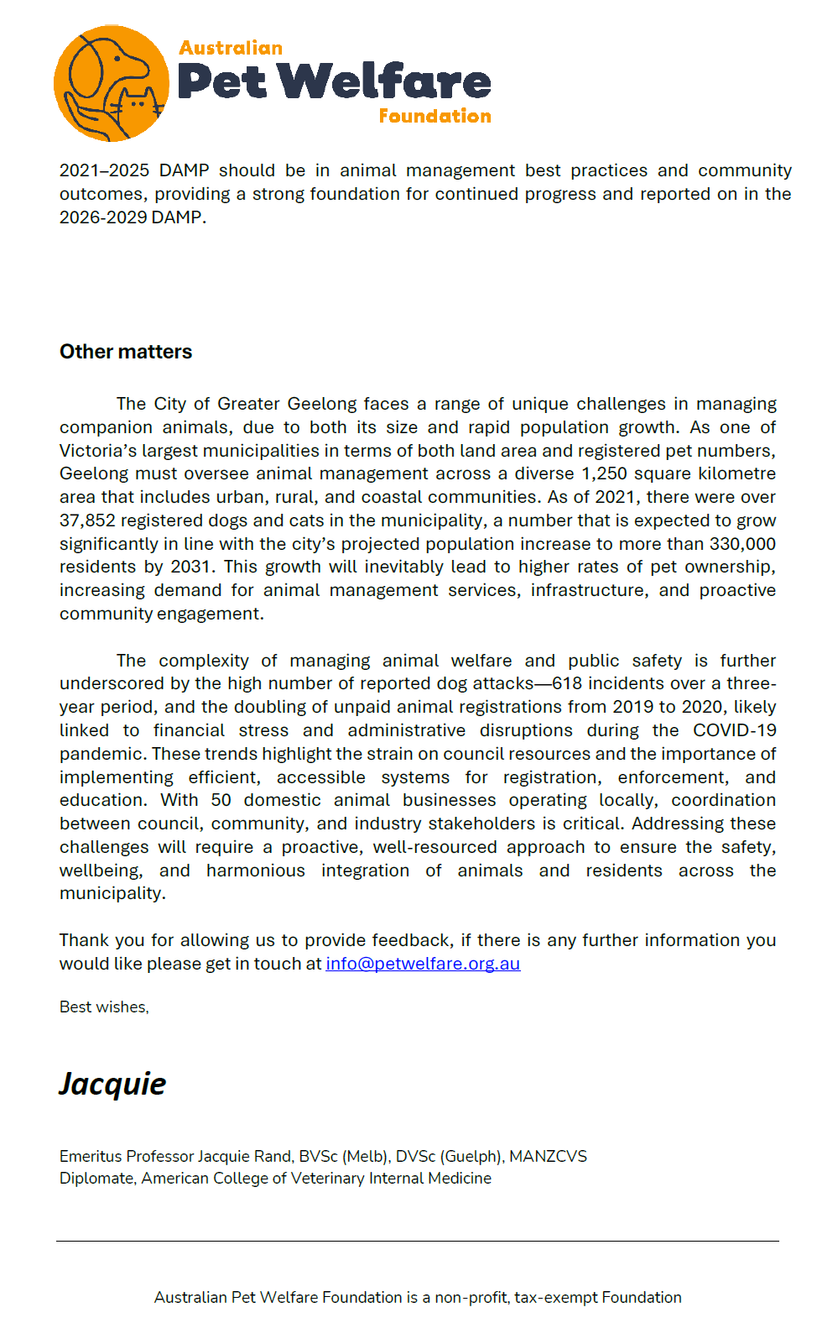

March 2025

Attention: Katie Young - Project Support Engagement Officer

Domestic Animal Management Plan 2026 – 2029 Have your Say

Woofers and Walkers Responsible Dog Owners’ Group Portarlington wish to provide the following feedback as part of the development of the DAMP 2026 – 2029. Briefly, Woofers and Walkers has been in place since 2009 and aim to advocate, encourage and support responsible dog ownership within the Northern Bellarine. (Please refer to our brochure about our group).

The following feedback is some key points specifically in relation to the existing Dog Control Orders on the Northern Bellarine:
- Over all these are working well with the majority of dog owners responding positively to the existing orders, zones and conditions.
- The benefits are various, most importantly these provide clarity and certainty for everyone to respectfully share and enjoy the Northern Bellarine.
- Seasonal conditions and zones ensure fair and equitable access to foreshore reserves for all users.
- They provide consistency across the Northern Bellarine.
- Signage is clear and highly visible.
- There is a small number of dog owners that totally ignore the dog control orders and consistently allow their dogs to run off-lead in on-lead zones throughout the Summer.
- Summer requires greater presence of animal management and fines imposed to change the behaviour of those ignoring the seasonal control orders. This Summer I saw the animal management van only once along the Portarlington foreshore area.

Actions by Geelong Animal Management Officers that will provide greater support for these orders are:
- Education is an ongoing necessity for dog owners in relation to what is required of them to be a responsible dog owner.
- As responsible dog owners we support dogs being well socialised, trained and most importantly dog owners understanding and having the skills and confidence to have effective control of their dog at all times.
- A definition of effective control is well explained in ‘Taking the Lead on the Northern Bellarine’. What is required is greater patrolling of officers to educate and apply fines for non-compliance of dog orders.
- Visibility is an essential part of education as it continually reinforces good behaviour and applies consequences for dog owners who do not comply. This requires much greater presence of the animal management patrolling the coastline.
- Summer holiday period would be an excellent time to set up a marquee with Bellarine Bayside perhaps near the Portarlington pier to provide education around the importance of the orders being complied with throughout the year.
- Shared open spaces need to be safe for all users and irresponsible behaviour demonstrated by dog owners needs to be responded to appropriately.

The previous Domestic Animal Management Plan has been a good one and served the community well. The main priority is the need for greater education and emphasis on execution of the plans to make behavioural changes in dog owners who act irresponsibly.

Julie Elterman
Secretary of Woofers and Walkers Responsible Dog Owners’ Group Portarlington

Animal Management Policy – review for 2025 and coming years!
Brian and Jill Golland – submission to this review – 20 April 2025
Let’s start by reviewing what our Mayor said in release of this current policy in 2021!!
- a. Owning a pet can be a source of great pleasure in life.

Having a constant companion who gives you unconditional love is invaluable, as is the responsibility and lessons that children learn in looking after a furry friend. In fact, scientific studies have found owning a pet can increase a person’s physical and mental wellbeing through lower stress levels, increased fitness levels and more opportunities to socialise. As the owner of many cats and a few dogs in my life, currently one of each, I can attest to these benefits and more.
This was a great opening statement and basically mirrors what all pet owners have in mind when obtaining a pet and certainly having a sense of companionship which comes with responsibility! All well and good for a greater majority of owners.
- b. With around 37,000 registered animals in Greater Geelong already living across 1,250 square kilometres, and forecast population growth likely to lead to higher density living, the importance of helping pets, owners and the general community live together harmoniously will only grow.

Again, we see the massively expanding animal ownership within CoGG environment and this has and will continue. This would therefore provide a greater initiative for the CoGG Animal Management team to make a more determined effort to provide a higher support structure in maintaining an increased presence in management on the ground!
- c. The community’s feedback has helped to shape the City of Greater Geelong’s Domestic Animal Management Plan 2022–25.

If this is true then the community needs to have confidence in providing feedback, advice and reports to the team knowing and receiving sound advice from the team with appropriate actions.
- d. This plan not only outlines our organisation’s role in animal management, but is also intended to have an

educational focus, encouraging and teaching community members that it’s every owner’s responsibility to take care of their pets. By doing the right thing, we can all continue to enjoy safe shared spaces, have healthy pets and protect our unique native habitat.
Whilst this plan, as depicted in the mayor’s comments, has some short comings in action and community understanding on the ground, and in the places where we find animals either exercising with owners, running free without supervision or in a manner which does not provide safety and confidence for the general community.
- e. Over the last four years, we have accomplished a lot in animal management, including the construction of new dog parks, branding of animal management fleet for greater visibility and increasing the availability of open space areas for dogs.

Some work was completed in some of these areas mentioned but one can count or point to a number of areas where this did not happen and examples of restrictive management has
been displayed and issues not addressed appropriately to residents’ satisfaction, with almost none or very little tangible understanding, feedback or concrete timely positive actions.
- f. In the coming few years, we are committed to doing more, including: constructing two additional dog parks for supervised off-leash dog socialisation; investigating and advocating for the purchase of sustainable dog poo bags; increasing proactive patrols across trails, reserves, parks and beaches; and exploring the viability of an extra cat desexing month each year.

This was admirable in the context of the future, but, can it be truly said that as with pet numbers exploding, has enough been done in achieving such aims? Much more seem to be legitimately required in this arena when there is very little, if any, reported evidence of how the KPI’s of Animal Management is ever seen by the residents and community in general.
- g. By working with the community, we can continue to ensure that pet owners, their animals and the broader community can continue to enjoy a high quality of life.

Evidence would indicate by survey of the general populous around CoGG environs that there is a very high degree of negative comment on Animal Management, particularly with animal owners and even those residents who interact with owners of animals. We have the policy but not the policing!
Summary and comments:
It appears from a community perspective about how this policy works in reality and how much has changed since 2022!
Seriously, the clear evidence from the community when asked shows that nothing has changed and there is no evidence to be seen by the community on what CoGG Animal Management team have achieved in nearly three (3) years!
Even the data used on numbers of dogs and cats in the municipality are as of 2021…really 4 years ago!
Yes, we do see registrations up, as well as population and housing in Greater Geelong, and one can expect that registrations rise accordingly.
But, where have we seen evidence in respect of numbers, incidents, fines, permits, education, inspections etc through CoGG reports including annual reports to Council?
The only aspects of animal management seen in reports are 100% of prosecutions have been achieved! We would be interested to know!
We have bylaws, legislation, vehicles with glossy advertising, land management controls and of course Victorian State Laws which, when all that lands on the community, we see an ad hoc approach to management in terms of “on the ground” activity toward meaningful outcomes!
Making complaints to Animal Management are always 99.99% voice based with an email to tell the complainant how to follow through with at least 14 days of logs and then a voice call in most cases to indicate that the evidence is not enough to proceed!
In our experience all communications, if you can call it that, is voice based without any correspondence as either follow up, or conclusion to any complaint. We may be wrong but we have canvassed numbers of the community and find this is a pretty clear outcome!
In fact, any written communication comes from a clerical base and not the officers themselves, with information out of a “biblical like phrase” book! Even some of this correspondence is incorrect in information!
Where is the community education, and when and how, as there also appears that this does not happen!
Evidence is that the officers do not, and cannot achieve any significant outcome, due simply to possibly inadequate training, and the apparent avoidance, simply on the basis of “non conflict” with individuals or even complainants!
Officers in the field are not resilient or understanding, and offer very little in discussion with those whom they come in contact with, and when questioned on any operational activity, tend to shut the community member down, even to the extent of refusing to entertain substance on a matter!
When CoGG talk about risk management in respect of dog attacks and unwieldly behaviour, there does not appear to be procedures for this risk management in the community, as all the community see or hear, is the poor outcomes of such behaviour by dogs and their owners. Additionally, the only outcome most media reports indicate is “under investigation” which provides little confidence in the community! There is certainly no feedback in the media to enlighten the community on any positive outcomes.
Attendance at advertised meet and greet for discussion, usually when a decision is about to be made on a change of operation, almost always appears to be a talk fest with officers and some management, but we have almost never seen notes being taken on initiatives or actions suggested by attendees and in many cases the suggestion is immediately overridden with “we could not do that because…”!
When CoGG talk about minimising cat or dog nuisance situations, it seems to be the absolute responsibility of the receivers of that nuisance to go to great lengths to “prove” that the nuisance is significant enough to be investigated, and generally CoGG will rule out the nuisance on a basis of “we consider” it not to be a nuisance.
The CoGG policy clearly states that “ANY” noise or disturbance is sufficient for action to be taken by the Animal Management Team….BUT when asked about this fact….the policy is overruled by Victorian State law which requires verified proof of the nuisance and degree of nuisance. What a farce! Why not change the policy in favour of the State Law??
Could the team please inform the community when and if there are justifiable overpopulation of animals, and high rates of euthanasia in areas of the CoGG region, with education to prevent this as a risk in the earliest instances?
One can only imagine how the team could or would address the “potential” for dogs and cats creating a nuisance in any neighbourhood or precinct … an interesting concept to say the least!
For CoGG Animal Management to work with Land Managers and GAWS in their contractual plan is pretty basic stuff which is welcomed as an ongoing concept, but it does not provide any community understanding of “how and what” this means to the community in everyday actions and behaviours!
A clear and ridiculous situation was regarding a cat curfew proposal by the team to council last year. This saw one councillor completely ruin the issue with comments of one instance of such a burden on the community to restrict cats overnight and all the work went down the drain…..cats are running rampant with wildlife eradication, noise, excrement in neighbours yards, doorsteps and smell abounds! What exactly do the Animal Management team do about this….A Policy…Not likely!
Who exactly is running this carnival??
We have caught such a cat in roving overnight circumstances, taken it in to GAWS and within 36 hours the cat is back roaming as before, which appears to be pay a fine and return the cat to do more damage!
Listed hereunder is the extract from the 2022 document in summary! Our comments above are attributable to these statements!
CoGG …… HOW DO WE CURRENTLY MANAGE ANIMALS?
As well as registration and identification of dogs and cats, our central functions are to:
• promote and encourage the responsible ownership of dogs and cats
• make sure people manage their animals in accordance with the law
• minimise the risk of attacks by dogs on people and animals
• encourage registration and identification of dogs and cats
• address overpopulation and high euthanasia rates for dogs and cats, where they exist
• minimise the potential for dogs and cats to create a nuisance
• effectively identify all dangerous, menacing and restricted breed dogs, and make sure they are kept appropriately
• contract the Geelong Animal Welfare Society (GAWS) to deliver our pound service
• work with land management authorities to develop local dog control orders.
According to the previous Domestic Animal Management Plan the following should have been the priorities:
GUIDING PRINCIPLES
The following principles underpin this plan:
• Pets contribute to our quality of life.
• The needs of pet owners must be balanced with the needs of others.
• Responsible pet ownership is highly valued.
• Animal management and education should be proactive.
• The environment and local wildlife must be protected from the negative impacts of dogs and cats.
• The best outcomes result from working in partnership.
• The City has a leadership role in animal management.

Some critical and observant understanding of what these principles really mean or even say!
- • If and only if management was as proactive as they appear in the above statement we would be in a much better space with regard to operations and community support!

- • We have already said above that there appears a decisive lack of animal management and certainly education under the previous plan and probably from many years past!

- • There appears no partnership agreement or indeed supportive actions to achieve any outcomes under the plans as they appear in the document.

- • Where are the actions and positive management that the plan talks about?

- • We need verbs and action statement not the sort of words that we see in this document…. were are the “we will achieve by the end of 2025…” or “A monthly education seminar or workshop will be held in the following centres in the third Saturday each month!”

- • Or even in reports to council showing how many instances of dog attacks in parks, on beaches etc with numbers of fines issued along with revenue generated to council?

- • What happened to the number of non-paid dog or cat registrations in the past year or years, and what revenue was generated or even did the registrations just disappear off the register?

- • Land Managers have no authorisation in any shape – CoGG are the jurisdiction actors!

- • The “Park your Pet” App does not work currently!

- • CoGG appear to be handing developers the job to provide fenced off leash areas for dogs!

- • Why does public signage not list the applicable fine associated with the displayed sign…a deterrent would be a good starting point!

- • Where are the euthanasia stats if we are to highlight an discourage the numbers particularly in a post Covid era?

Finally:
Our thanks to CoGG for allowing us the opportunity to critically review this Domestic Animal Management Plan and to add comments and provide our view on what happens on the ground in our part of suburbia of Ocean Grove. We value our space and our surrounds but it does seem that with numbers growing by the day generally the majority of pet owners are doing the right thing in the community BUT we need a tidy up a lot “going forward”, to use a council phrase!
Brian and Jill Golland
4 Somerdale Avenue
Ocean Grove 3226
0417 772 220 and 0409 562 976

Appendix M - Submission from Parks and Natural Assets

- Regulations
  - Frequent changes to dog regulations at a location can be confusing for people.
  - People want to finish their walking route so often disregard dog regulations when moving from a dog off leash area to a dog on leash area or a no dog area.
  - Consistent rules for where dogs can’t go is important for setting community norms.
  - We need to reestablish the ‘no dogs’ within 10 metres of waterways and wetlands regulation
  - Is there a regulation that dogs must be on leash on shared paths as off-leash dogs are a hazard for bikes?
  - Can we ban cats from neighbourhoods adjacent to nature reserves?

- Education
  - More Animal Management presence in reserves to encourage correct behaviours
  - Increase temporary signs (i.e. A frames) communicating patrols are regularly occurring at hotspots for non-compliance.
  - Promote messages of why dogs need to be on leash – could do social media posts or similar
  - Promote off leash reserves and messaging around benefits of taking dogs to these locations.
  - Clear signage at the interface where dog regulations change from dogs off leash to dogs on leash / no dogs.
  - More education of where dogs can go off-leash and where they are not permitted.
  - Some people are scared of dogs so can use this in the messaging as to why dogs must be on leash.
  - Review dog reg signage – especially time share signs as these are often confusing for dog owners
  - More Dogs Breakfasts to promote positive pet ownership.
  - Partner with Zoos Vic to promote Safe cat, Safe wildlife program

- Enforcement
  - We could always do with more enforcement of dog regulations on our reserves.
- 24-hour cat curfew – Cats must be confined at all hours.
- Incentives / program ideas
  - ‘Dobb in a d***head dog owner’
  - Reward people who are doing the right thing.
  - Offer Discounts for desexed cats which are kept indoors
  - ‘Catch a cat’ program

- Disincentives
  - Increase the cost of registering animals and the cost of repatriation of captured cats.

