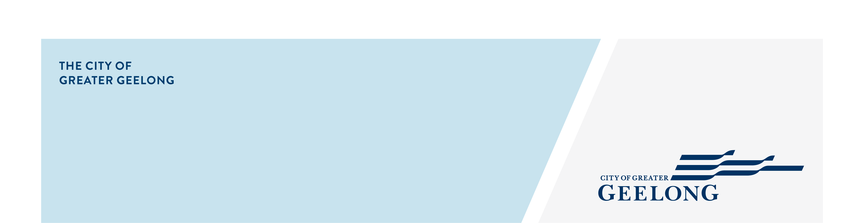
Frequently asked questions

What is a Special Rate?
Special Rates or Special Charges are different from general rates and charges because they are levied for particular works or services and they are levied on a limited number of ratepayers.
Councils can levy a special rate, a special charge, or a combination of these to help pay for any council service or activity that will be of special benefit to a group of property owners.
Common examples of special rates or charges include schemes for constructing footpaths, roads, kerbs and channels or drains.
Special rates and charges must be levied in proportion to the special benefits to which they relate. Before a council proposes a special rate or charge, it must estimate the proportion of the benefits of the proposed works or services that will be of benefit to the people who are liable to pay.

How do you work out who pays what amount?
Calculations on cost apportionment is carefully worked out following strict guidelines as set out under Section 163 of the Local Government Act 2020.

We already pay rates, why should we have to pay an additional cost for this Special Rate and Charge Scheme?
Many of the sealed roads, upgraded drains and footpaths that have been built in the City, have been funded through the Special Rates and Charge scheme. Once the roads, drains and footpath are constructed, the City will maintain and replace the proposed footpaths as part of the rates collected. Annual rates do not fund projects where the local community benefit more than the wider City of Greater Geelong.

The annual rates collected help the City to deliver a diverse range of community and business services such as:

- Waste Management
- Recreation and Sports facilities
- Family Services
- Maintaining Parks and Reserves
- Community Care
- Arts Culture and Libraries
- Transport and related infrastructure maintenance
- Plus many more.

Although rates help to fund the maintenance and repair of existing City infrastructure such as roads and footpaths, it does not cover the costs of delivering extensive works.

I can’t afford to pay the Special Rate/Charge?
Once a scheme is declared by Council, affected property owners will be notified in writing and will be invoiced at the completion of works.

There are 4 payments options to select:

- Pay in full within 28 days interest free
- Pay in 2 quarterly instalments over 6 months interest free
- Pay in 8 quarterly instalments over 2 years
- Pay in 20 quarterly instalments over 5 years

If, when this time comes, you are experiencing financial hardship, you can approach our financial department to arrange a payment schedule that suits your individual needs.

I don’t want the scheme to go ahead. How do I oppose the scheme?
There will be a submissions period open for 28 days after the City’s Intention to Declare the scheme has been advertised. All submissions will be invited to a panel meeting. The scheme may be abandoned at this stage.
Should Council decide to declare the scheme, there will be a further submission period where objections can be sent to VCAT. Further details on VCAT objections will be made available should Council declare the scheme.

For any further questions, please e-mail engineeringplans@geelongcity.vic.gov.au

