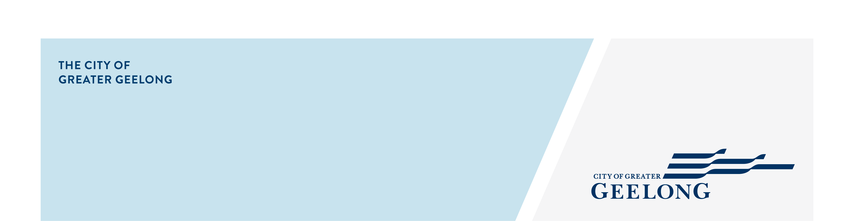
Pakington Street (Geelong West)

Public Parking Plan

Engagement Summary Report

COMMUNITY ENGAGEMENT SUMMARY REPORT
Final Pakington Street and Gordon Avenue Urban Design Framework (UDF) includes an action to prepare a Public Parking Plan for Pakington Street North and Heritage Core Precincts. A parking plan analyses the parking conditions and needs of an area and can provide the basis for a Public Parking Overlay or other appropriate implementation mechanisms. A Parking Overlay implements a parking plan in a statutory form.
This report provides a summary of the feedback received on parking related issues and challenges on Pakington Street (Geelong West) in the first phase of community engagement and the outcomes will inform the preparation of the Draft Public Parking Plan as well as the workshops with businesses and traders on Pakington Street to be held in May 2022.
HOW WE ENGAGED

WHAT DID WE DO?
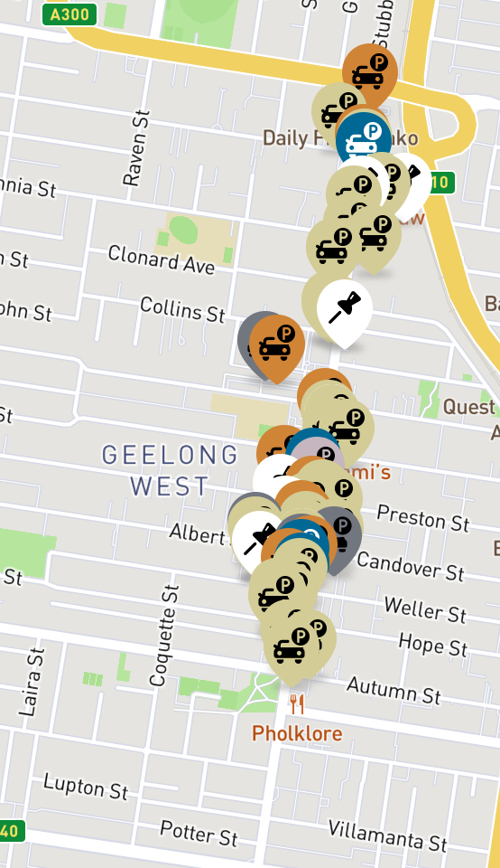
The local community had an opportunity to provide feedback on parking related issues and challenges via the Social Map Tool on the Have Your Say Webpage.
Suggestions (comments) from the public left online via social map
68
28 DAYS
of engagement


53
Number of people left feedback

26

People following the project

The engagement was open to public. Letters were sent to residents and businesses in the study area to invite them to visit the Have Your Say Webpage and provide feedback. Social media and print adverts were also used to raise awareness about the project and encourage participation.
Figure 1 a snapshot of markers provided via the social map tool

WHAT WE HEARD

Next Steps or any Verbatim comments and officers can remove which is not applicable.

THE FEEDBACK
Overall, 68 comments from 53 individuals were submitted via the map. Participants had the opportunity to choose from one of these categories:
- Parking availability
- Time restrictions
- Disabled parking
- Safety concerns
- Loading bay concerns
- Other comments
Figure 2 categories of submissions
For majority of submissions (58%), ‘parking availability’ was the chosen category. ‘Safety concerns’ (16%) and ‘other comments’ (13%), were the next two most discussed categories (Figure 2).
Nearly half of the submitted comments were referring to parking related issues and concerns in general or the whole neighbourhood rather than a specific place. Comments which had a spatial reference (54%) were imported to QGIS for spatial analysis (Figure 3).
Most of these comments focused on parking availability and safety concerns concentrated on the southern part of the study area. There were also some comments highlighting the need for revised time restrictions and disabled parking (Figure 3).
All comments were qualitatively analysed to identify key themes and areas of concern and opportunity. There were 30 comments on parking availability and challenges of finding a car park in the study area. Some participants indicated that Geelong West area would benefit from a multi-storey car park (12 comments), while others believed that discouraging vehicle movement, providing more opportunities for pedestrian activity and public transport as well as removing some of the parking spaces can provide further opportunities for greening and outdoor dining (eight comments).
Other comments include safety concerns regarding parking spaces and some of the crossings (six comments), parking replaced by bike lanes (six comments), the need for more disabled parking (five comments), the need for improved time restriction (five comments) and the need for improved public transport in the study area (five comments).
NExt Steps
Two facilitated workshops will be held with businesses in the study area in May 2022.
The outcomes of this engagement and workshops will inform the preparation of the Draft Public Parking Plan.
The draft Public Parking Plan will go out for public feedback mid-2022.
A Final Public Parking Plan will be prepared for Council’s consideration in late 2022.
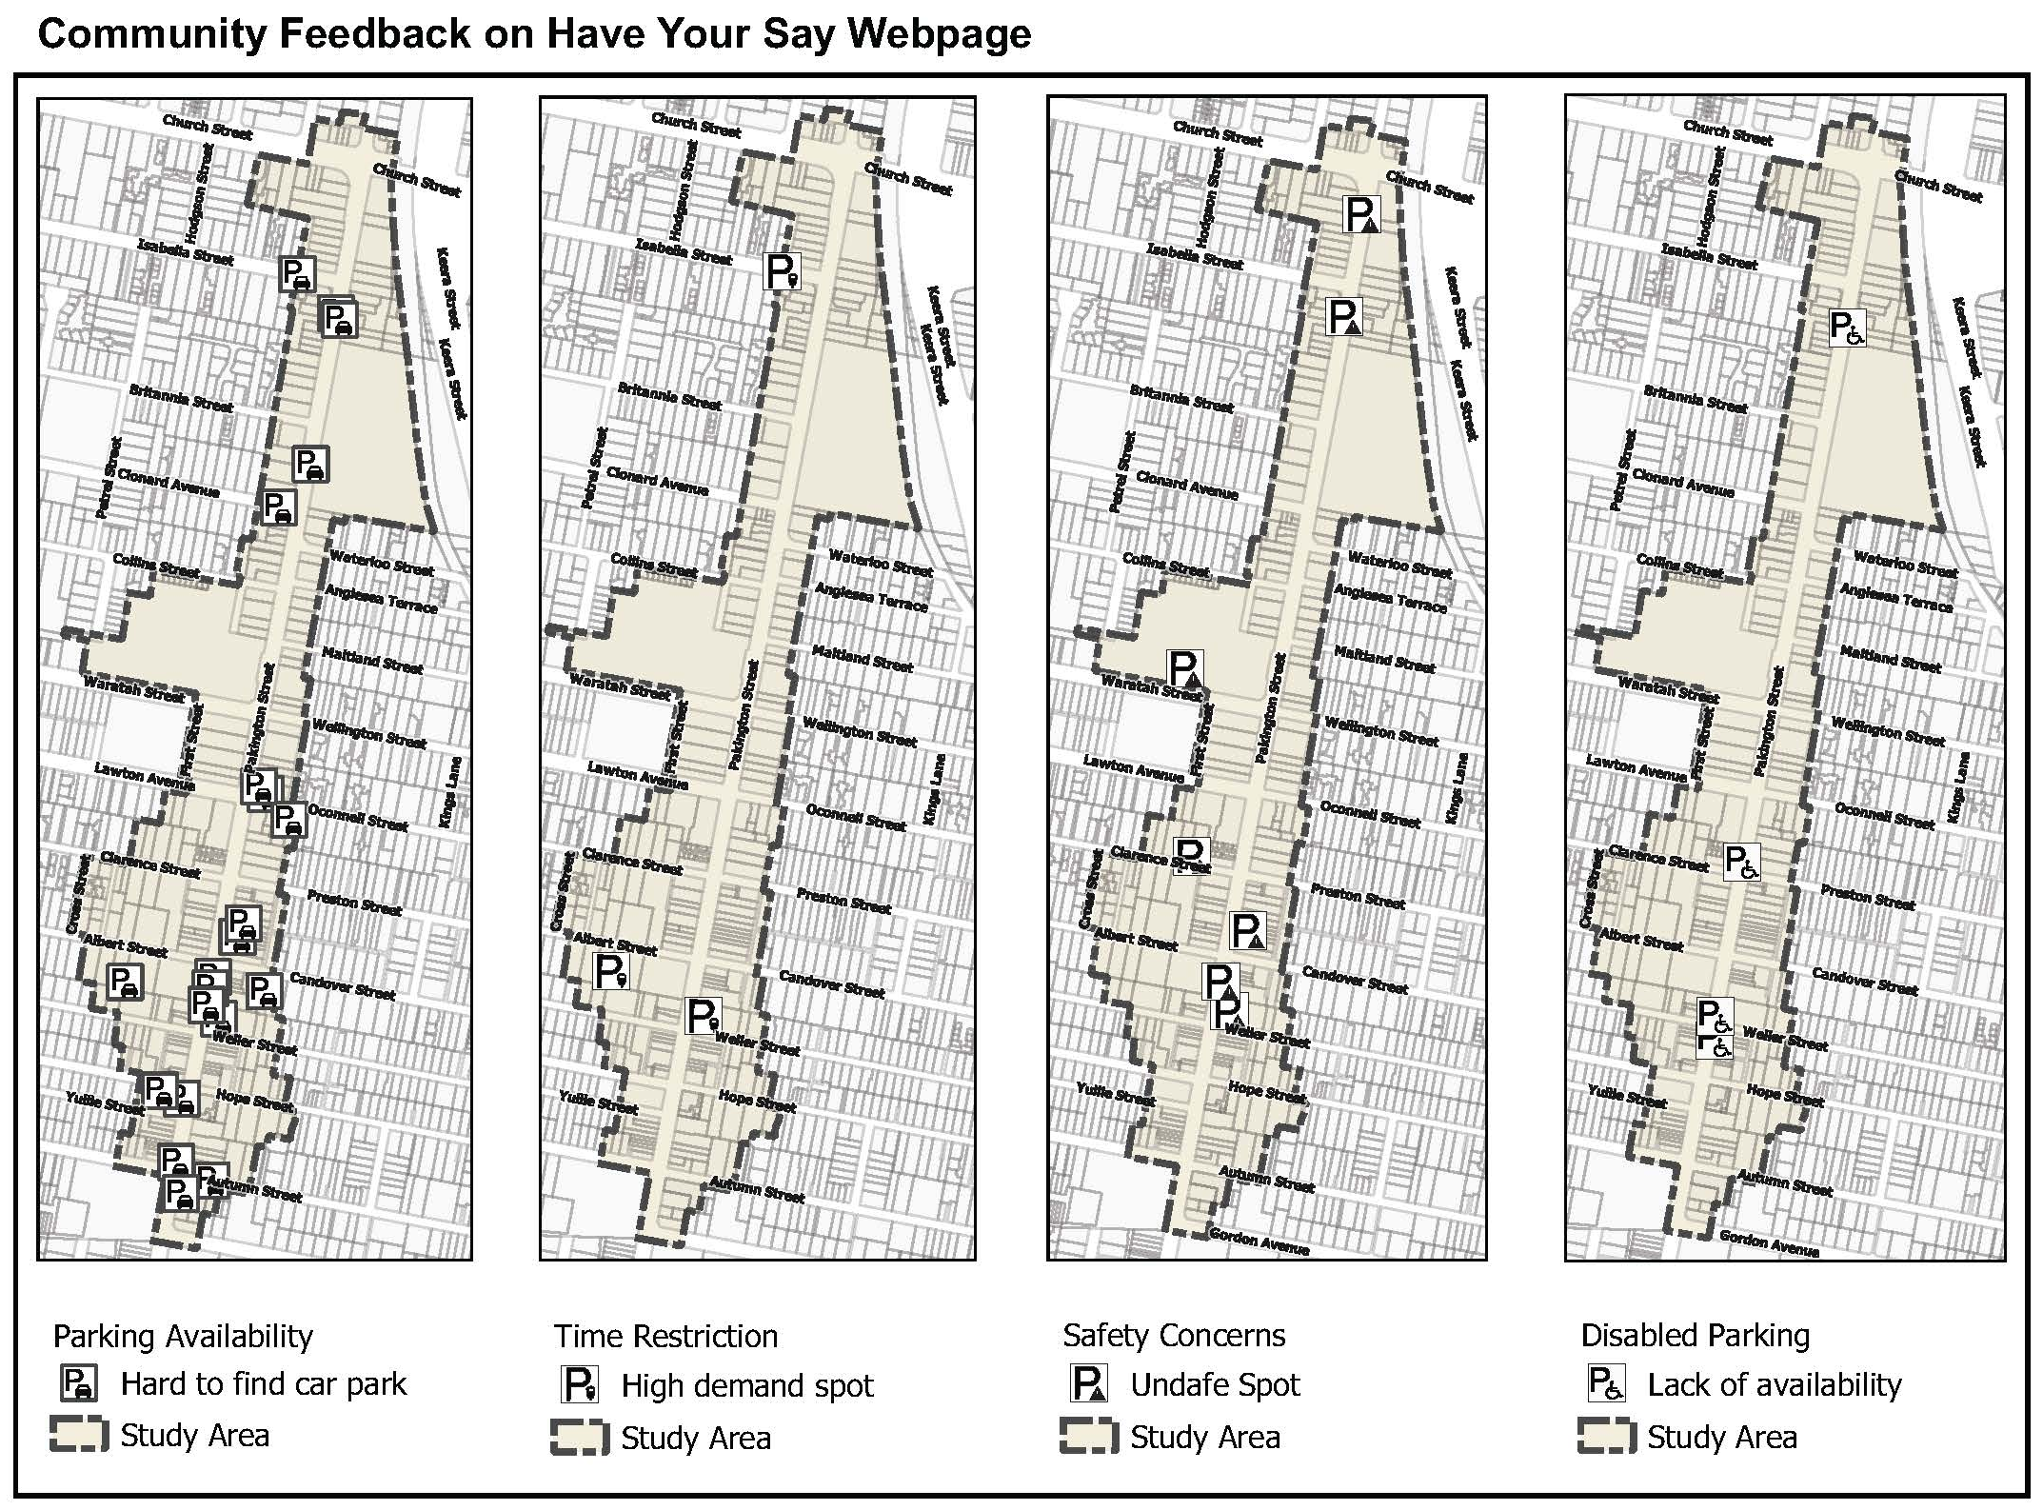
Figure 3 Analysis of comments on parking related concerns in specific areas

