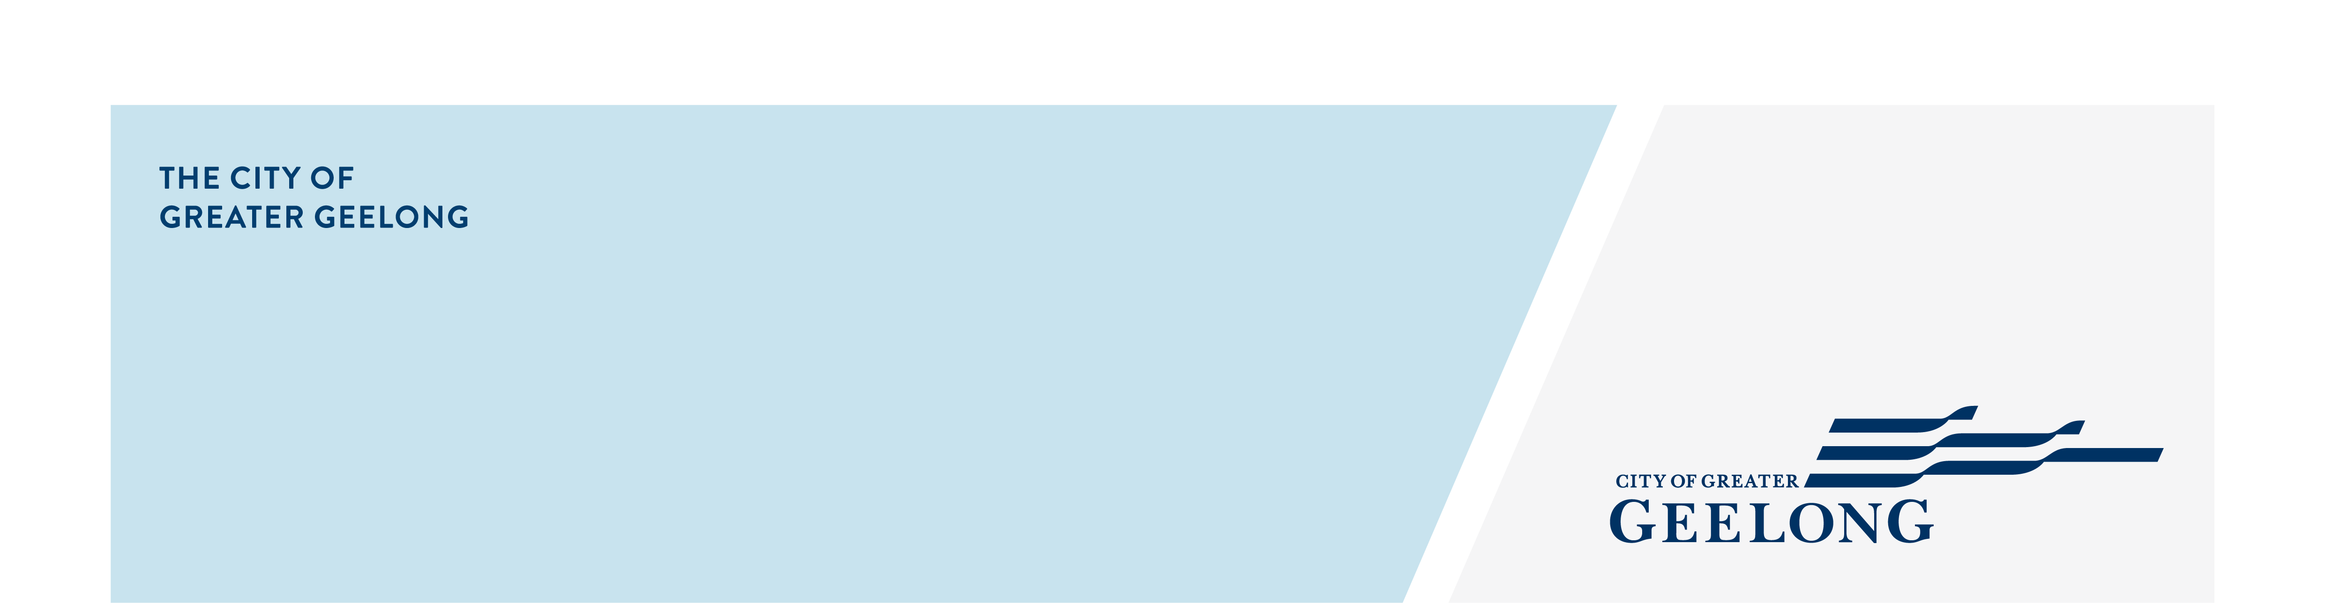
Expressions of interest
LGBTQIA+ Advisory Committee

November 2025

Thank you for your interest in joining the LGBTQIA+ Advisory Committee
Thank you for your interest in joining the LGBTQIA+ Advisory Committee for a term that commences in early 2026 and finishes in June 2028. The purpose of this committee is to provide advice and recommendations to Council on issues that affect people in the City of Greater Geelong who identify as LGBTQIA+, and their families.
You will receive confirmation of your application once your Expression of Interest has been received. Shortlisted applicants may be invited to attend an interview. Interviews are 10 minutes in length and conducted online.
Everyone who applies will be contacted once the selection process is complete and advised of the outcome.
If you need support in applying, please contact Ruth Cuttler on 5272 5537 or email RCuttler@geelongcity.vic.gov.au
Thank you again for your time and interest in helping make Greater Geelong a more equitable community.

Privacy Collection Statement
The personal information and feedback (collectively the Data) requested on this page is being collected by City of Greater Geelong (City) for the purpose of Expressions of Interest for the City's LGBTQIA+ Advisory Committee, and any other directly related purpose (Project).
A de-identified engagement summary report may be published on our website.
If your personal information is not collected, the Project may not be able to be adequately conducted, and the City may not be able to contact you for further questions or to find solutions.
In order to collect and conduct in depth and detailed analysis of the Data for the purposes of the Project, the City will disclose the Data (including your personal information if provided) to its third-party service providers, including Social Pinpoint Pty Ltd, Converlens Pty Ltd and Amazon Web Services.
Other than as stated above, your personal information will not be disclosed to any external party without your consent, except as required or authorised by law
Our privacy policy is available on our website. If you wish to alter any of the personal information you have supplied to the City, please contact us by sending an email to privacy@geelongcity.vic.gov.au.

Survey
- Check this box to indicate that you have read, and agree to the privacy statement provided for this consultation.

Yes
- Why would you like to be a member of the LGBTQIA+ Advisory Committee?
(Tip - Background, interests, skills and experience):
- What else would you like to tell us about yourself in support of your Expression of Interest?
- Do you identify as being part of the LGBTQIA+ community?

Yes
No

- Have you been involved in strategic work for your local community (e.g. committee of management, board or advisory group)?
Select one answer only
Yes.
Please provide details:

No

- Are you applying as an independent community member or a representative of a non-profit organisation, network or group?
Select one answer only
Independent community member
Representative of a non-profit organisation, network or group

Referees
We may contact a referee as part of the selection process. Please provide the name and contact detail of one referee below.
- Referee Name:
- Referee Telephone:
- Referee Mobile:
- How do you know this person?

- Please attach any additional information in support of your application.
Disclaimer - Preferred applicants will be required to undergo a National Police Check and a Working with Children's Check as part of the recruitment process (funded by the City).
Child Safety Responsibilities - We are committed to being a child-safe organisation and have zero-tolerance for child abuse. We have specific policies, procedures, and mandatory training in place to support employees, volunteers, and contractors to achieve and adhere to these commitments. Please read our Child Safe Standards Management Policy

About you

- First Name
- Last Name
- Preferred contact number
- Email address
- Town or Suburb
- What is your gender?
Select one answer only
Woman
Man
Non-Binary
Prefer not to say
Self described:

- Do you identify as being of Aboriginal or Torres Strait Islander origin?
Select one answer only
Not Aboriginal or Torres Strait Islander
Aboriginal origin
Torres Strait Islander origin
Both Aboriginal and Torres Strait Islander
Prefer not to say
- Age Group
Select one answer only
Under 18
18-24
25-34
35-49
50-59
60-69
70-84
85+

