The City Of
Greater Geelong

Fair Access Policy – Draft Background Report

  - Version: 5

Approval Date: June 2024
Approved by: Council
Review Date: June 2028
Responsible Officer: CEO
Authorising Officer: Executive Director, City Life

Contents
Acknowledgement of Country 4
Introduction 5
Process 5
Why do we need a Fair Access Policy? 5
Strategic Review 8
Corporate Framework 8
International Treaty to Gender Equality in Sport 9
Legal Framework 9
Charter of Human Rights and Responsibilities Act 2006 (Victorian Charter) 10
The Equal Opportunity Act 2010 (Victoria) 10
Gender Equality Act 2020 (Victoria) 10
Sex Discrimination Act 1984 (Commonwealth) 10
Commission for Gender Equality in the Public Sector 10
State Government Strategies and Policies 11
Victorian Government Inquiry into Women and Girls in Sport (2015) 12
Fair Access Policy Roadmap (2022) 12
Regional Health Strategies and Policies 13
VicHealth Strategy 2023- 2032 13
Local Government Strategies and Policies 13
Case Study: City of Greater Geelong GIA+ Tool – Assessing the Gendered Nature of the Mountain Bike Track at Armstrong Park Playground 14
Peak Sporting Bodies Strategies and Policies 15
Cricket Victoria – Women and Girls Strategy 2023 -2028 15
AFL – Women’s Football Victoria and Women and Girls Game Development Action Plan 15
Tennis Australia – Women and Girls Strategy 2022-2027 16
Football Australia – Legacy ‘23 16
Football Victoria – Football Her Way 17
Planning Frameworks and Guidelines 17
UN Human Rights Council Resolution 40/5 – International Human Rights Framework on the Elimination of Discrimination against Women and Girls in Sport 17
Guidelines for the Inclusion of Transgender and Gender Diverse People in Sport, 2019 17
Guidelines for Trans and Gender Diverse Inclusion in Sport – Complying with the Equal Opportunity Act 2010, 2017 18
Sport Australia Women and Girls Strategic Advice 19
Making Space for Girls 19
Female-Friendly Sport Infrastructure Design Guidelines 21
Monash XYX Lab 21
Key Findings of Strategic Review 23
Current State of Play 26
Demographic Factors 26
Target Groups 27
Participation 28
Local Sports Club Participation Use of Greater Geelong Sports Facilities 28
AusPlay Participation Rates in Sport 30
Barriers to Girls and Women's Participation in Sport and Recreation 31
Local Governments Response to Gender Equity in Sport and Recreation 31
Infrastructure Allocation 31
Sporting Bodies Governance 32
Infrastructure 32
Resource Allocation 32
Examples of Local Initiatives 33
AFL Inclusive Clubs and Gender Equity Education Program 33
Women in Community Life Awards 33
Her Story 34
The Girl Can Free ‘Come and Try’ Exercise Sessions 34
Women in Sport Breakfast 34
Greater Geelong Sports Pavilion Development Program 34
Go Soccer Mums – Drysdale Soccer Club 34
Key Findings of Current State of Play 34
Stakeholder Engagement 37
Project Advisory Group Feedback 37
Sport and Recreation Advisory Group Workshop 37
Health and Wellbeing Advisory Group Workshop 38
Women in Community Life Advisory Group Workshop 39
LGBTQIA+ Advisory Group and Access and Inclusion Advisory Group Advice 40
Key Findings of Stakeholder Engagement 40
Next Steps 42

Acknowledgement of Country

We Acknowledge the Wadawurrung People as the Traditional Owners of the Land, Waterways and Skies. We pay our respects to their Elders, past and present. We Acknowledge all Aboriginal and Torres Strait Islander people who are part of our Greater Geelong community today.

Otium Planning Group would like to acknowledge the staff and community from Greater Geelong City Council that have provided their expertise and input to the Greater Geelong Fair Access Policy.
Their valuable insights and feedback have been instrumental in shaping the principles and approaches.

Introduction

The Fair Access Policy will include principles and approaches to address known barriers experienced by women and girls in accessing and using community sports and active recreation facilities, services and programs.
The Greater Geelong Fair Access Policy will include:
- Fair Access Background Report
- Fair Access Policy
- Fair Access Policy Evaluation Framework.
An intersectional approach will underpin the delivery of the Fair Access Policy. The Policy and Evaluation Framework will include principles, approaches and an evaluation tool to facilitate equitable access and allocation of sport infrastructure.

Process
The following planning process will inform the Fair Access Policy.

This Background Report reviews the current state of play in terms of providing equitable access and allocation in Greater Geelong.
The Policy has been informed by engagement with the following Project Advisory Groups:
- Sport and Recreation
- Health and Wellbeing
- Women Community in Life
- LGBTQIA+
- Access and Inclusion.

Why do we need a Fair Access Policy?
There is a substantial gap in the participation of women and girls in sport and recreation and an identified gender imbalance in leadership positions across all levels of the Victorian sporting and recreation industry.
As a defined outcome of the Gender Equality Act 2020, all councils will be required from 31 March 2021 to conduct Gender Impact Assessments (GIA) on all new policies, programs, communications, and services, including those up for review, which directly and significantly impact the public (Gender Equality Act 2020). The access and use of community sports infrastructure is an example of a policy that has a direct and significant impact on the public.
The following graphic details some of the inequity’s women and girls are facing in accessing and using community sports and active recreation facilities, services and programs.

17%  Men and Boys  9%  Women and Girls  Sports participation rates across all ages are higher for men and boys than women and girls.    Only 21% of girls aged 0-14 years participate in organised sport and active recreation outside of school hours 3 times a week.  AusPlay 2021 | There has been a decline of 22,000 women and girls’ participation after COVID-19 where men and boys’ participation rose by over 20,500 participants in 2021 compared to 2019.  VicHealth Sports Participation in Victoria 2015 -2021  In 2020, women’s physical activity levels were more impacted than men’s during and after the global coronavirus pandemic.  Latrobe University 2021, At Home Exercise Campaign Explorer Report | 28% of women have considered leaving their club due to inequitable treatment.  Women are 2.5 x more likely to report feeling unwelcome at their sporting club compared to men.  Of people who played community sport, women were less likely than men to agree that club facilities were shared equally.  Women working or volunteering in sport were 13% less likely than men to feel comfortable voicing their opinion, and 8% less likely to feel that their opinions were valued.  State of Play Survey 2022-23, Change Our Game
81.7% of trans and gender diverse young people would like to exercise more, but don’t feel like they can because of financial barriers, discomfort while exercising (e.g. due to wearing binders) and fear or unwillingness to exercise in public.  89% of trans and gender diverse young people experience peer rejection which impacts their ability to engage in activities such as sports.  Trans Pathways 2017 |   29% Executive Officers  33% Board positions  Twenty-nine percent of executive positions and 33% of board positions are held by women in State Sporting Organisations.  Inquiry into Women and Girls in Sport and Active Recreation - 2015 | Many Victorian women and girls don’t have access to the best courts or grounds, have facilities of lesser standard, or are relegated to less convenient competition and training times.  Change Our Game – Victorian Government

The Fair Access Policy is a mechanism for change.
Key reasons for the Policy:
- Greater Geelong City Council through their Fair Play Strategy identified a need to improve participation for all genders and abilities. A Fair Access Policy is now required focusing on infrastructure, programs and governance.
- Engagement and partnership with sporting bodies, leagues and associations to define their role in improving equality.
- Overall participation trends show an increase in women and girls participating across sport and recreation activities, including improved development pathways and competition structures. However, some sport specific trends still indicate low levels of women and girls participation, and support is needed to reverse this trend.
- Women and girls people continue to face barriers to accessing or participating in sport and active recreation.
- State Government policy mandate for all Local Government Authorities requiring a Fair Access Policy to access State Government funding opportunities effective from 1 July 2024.
- A partnership approach with State Sporting Associations, local sports associations and leagues and local sport and active recreation clubs is important to improve gender equality in sport and active recreation. The policy defines the roles and responsibilities of each stakeholder.
- Recognition of the impact of initiatives within Greater Geelong and associated campaigns like “This Girl Can” has increased the visibility of participation opportunities and encouraged women and girls to be active in various sports and active recreation activities.

Strategic Review
What are the strategic and legislative drivers that influence gender equity and access policies?
This section summarises the legal framework and strategic context and relationships for the Greater Geelong Fair Access Policy.

Corporate Framework
The following graphic shows the relationships between the Greater Geelong Fair Access Policy with the Federal Government and State Government gender equality legislation and policy and Local Government strategies.

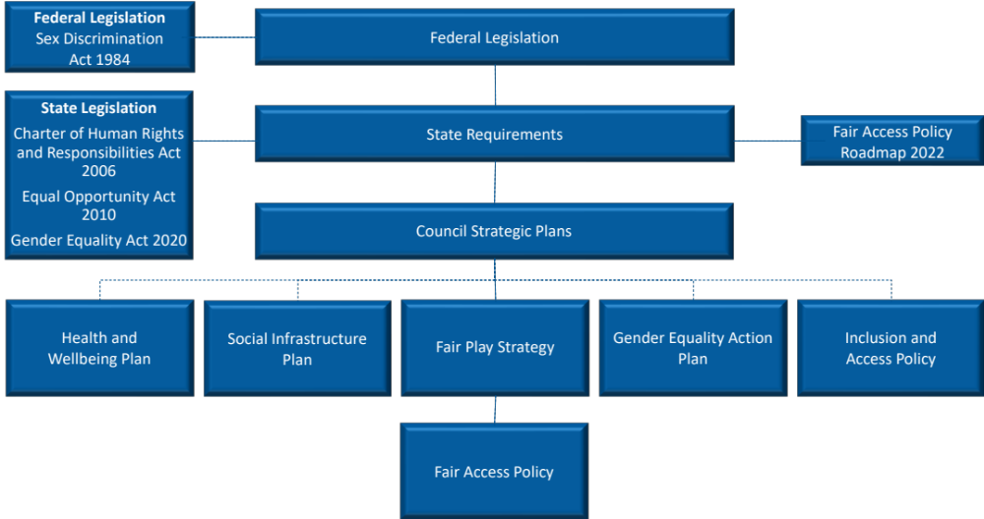
Figure 1: Relationships between legislation, policies and strategies

International Treaty to Gender Equality in Sport
The Brighton plus Helsinki 2014 Declaration on Women in Sport was adopted during the sixth IWG World Conference on Women and Sport. The declaration is an international treaty that has become a road map to support the ongoing development of a more fair and equitable system of sport and physical activity, fully inclusive of women and girls.
The declaration has 10 principles outlined below. The IWG is committed to proactively adding value to the work of the signatories to the declaration.
Principles:
- Principle 1: Equity and Equality in Society and Sport
- Principle 2: Facilities
- Principle 3: School and Youth Sport
- Principle 4: Developing Participation
- Principle 5: High Performance Sport
- Principle 6: Leadership in Sport
- Principle 7: Education, Training and Development
- Principle 8: Sport Information and Research
- Principle 9: Resources
- Principle 10: Domestic and International Cooperation
Today, nearly 600 organisations are signatories to this treaty. They include the following Australian organisations:
- Australia Sport and Recreation Ministers Council
- State and Territory Governments in Australia
- Sport Australia
- Australian Olympic Committee
- Standing Committee on Recreation and Sport - Australia
- Australian University Sport
- Australian Baseball and Softball Federation
- Netball Australia
- Australian Table Tennis Federation
- Australian Women Sport and Recreation Association
- Women’s Sports Foundation of Western Australia.

Legal Framework
The following State and Federal Government legislation provides the legal framework for the Fair Access Policy.
Local Government have an obligation to gender equality, not only under State Government legislation but also under Commonwealth legislation. The State and Commonwealth Government legislation includes:
- Charter of Human Rights and Responsibilities Act 2006 (Vic).
- Equal Opportunity Act 2010 (Vic).
- Gender Equity Act 2020 (Vic).
- Sex Discrimination Act 1984 (Cwth).

Charter of Human Rights and Responsibilities Act 2006 (Victorian Charter)
The Charter is Victorian legislation that sets out the basic rights, freedoms, and responsibilities of all people in Victoria. The Charter requires public authorities, including local government, to act consistently with the human rights in the Charter.
Specifically, Section 8 of the Charter protects the right to enjoy other human rights free from discrimination. It states that laws, policies and programs should not be discriminatory.

The Equal Opportunity Act 2010 (Victoria)
The Equal Opportunity Act 2010 provides protection from discrimination in public life in Victoria.
Specifically, under the Act, sports clubs and organisations have a positive duty to eliminate discrimination and victimisation as far as possible. When participating in sports, it is against the law for someone to treat you unfairly or bully you because of a personal characteristic (disability, race, religion, sex, sexual orientation) that is protected by law.

Gender Equality Act 2020 (Victoria)
Following the 2016 Royal Commission into Family Violence and extensive public and stakeholder consultation, The Gender Equity Act 2020 (The Act) was passed in parliament. The Act is a landmark piece of legislation that will drive gender equity in the public sector workforce and the broader Victorian community.
The Commissioner has a range of enforcement options available under the Act, including:
- Working directly with an organisation to achieve an informal resolution (section 22(3)).
- Issuing a compliance notice (section 22(1)).
- Recommending that the Minister takes action against the organisation (section 26(b)).
- Naming the organisation and their failure to comply on the Commission’s website (section 26(c)).
- As a last resort, making an application to the Victorian Civil and Administrative Tribunal (VCAT) for an order directing the organisation to comply (section 26(d)).
The Act applies to certain organisations that have 50 or more employees, including the public sector, universities and local councils (‘defined entities’). Defined entities will have obligations under the Act to promote gender equity in their policies, programs and services, and complete Gender Impact Assessments.

Sex Discrimination Act 1984 (Commonwealth)
Section 42 of the Sex Discrimination Act outlines the obligations of sport:
Nothing in Division 1 or 2 renders it unlawful to discriminate on the ground of sex, gender identity or intersex status by excluding persons from participation in any competitive sporting activity in which the strength, stamina or physique of competitors is relevant.
Subsection (1) does not apply in relation to the exclusion of persons from participation in:
- The coaching of persons engaged in any sporting activity.
- The umpiring or refereeing of any sporting activity.
- The administration of any sporting activity.
- Any prescribed sporting activity.
- Sporting activities by children who have not yet attained the age of 12 years.

Commission for Gender Equality in the Public Sector
The Commission for Gender Equality in the Public Sector was established after the Gender Equity Bill 2019 (Vic) passed in February 2020. The Commission supports the Public Sector Gender Equality Commissioner to oversee the implementation of the Gender Equality Act 2020 and promote gender equity in the public sector workforce and the broader Victorian community.
Local Government Authorities are required to complete Gender Impact Assessments and submit these to the Commission for Gender Equality. The Commission reports on progress made towards delivering on the Gender Equality Act 2020.
The Act requires defined entities to:
- Develop, publish and implement a Gender Equality Action Plan (GEAP) every 4 years based on the results of a workplace gender audit.
- Make reasonable and material progress in relation to the Act’s workplace gender equality indicators, and publicly report on this progress every 2 years.
- Undertake gender impact assessments on all new policies, programs and services that impact the public and publicly report this activity every 2 years.
- Take into account that gender inequality may be compounded by other forms of disadvantage or discrimination and have regard to this when developing strategies for improvement.
The Act is the first formal integration of the concept of compounded discrimination (intersectionality) into Australian equality law. This means that defined entities must consider the disadvantage or discrimination that a person may experience on the basis of Aboriginality, age, disability, ethnicity, gender identity, race, religion and/or sexual orientation in addition to gender inequality across the majority of their obligations. This includes as part of their duty to conduct workplace gender audits, promote gender equality, develop their GEAPs, and undertake gender impact assessments.

State Government Strategies and Policies
The following figure details the strategic relationship of State Government’s strategies and policies on gender equity in sport and recreation with relevant legislation described below. This framework underpins the Fair Access Policy.

Gender inequity continues to be a major barrier to the realisation of rights and access to sporting facilities and opportunities for girls and women in the state. In the past two decades there has been significant government policy and legislative reform that seeks to address systemic and long-term issues of violence against women and gender diverse people.

The figure is an overview of the laws, legislation and policy that have evolved and applies to local government and the broader sporting community.

Figure 2: Strategic Relationships

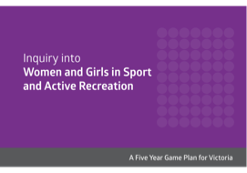
Victorian Government Inquiry into Women and Girls in Sport (2015)
The Victorian Government initiated an Inquiry into Woman and Girls in Sport and Active Recreation which resulted in key monumental changes in the sector. The changes included the establishment of a Victorian Office of Women in Sport, followed by the Female Friendly Sport Infrastructure Guidelines (2017) and funding program and then the Change Our Game Initiative. These resources were developed to support LGAs to better engage and provide for women and girls in sport. In response to the Inquiry, The Office for Women in Sport and Recreation was created by the Victorian Government – the first Office of its kind in Australia.

Fair Access Policy Roadmap (2022)
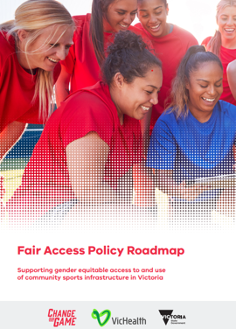
Following the Inquiry and Change Our Game funding program the Victorian Government in 2022 released the Fair Access Policy Roadmap. The Fair Access Policy ‘RoadMap’ includes the following six principles.
- Community sports infrastructure and environments are genuinely welcoming, safe, and inclusive.
- Women and girls can fully participate in all aspects of community sport and active recreation, including, as a player, coach, administrator, official, volunteer and spectator.
- Women and girls will have equitable access to and use of community sport infrastructure.
- Women and girls should be equitably represented in leadership and governance roles.
- Encourage and support all user groups who access and use community sport infrastructure to understand, adopt and implement gender-equitable access and use practices.
- Prioritise access, use and support all user groups who demonstrate and ongoing commitment to gender equitable access and use of allocated community sport infrastructure.
The following graphic details the implementation roadmap.
Figure 3: Fair Access Policy Implementation Roadmap
“From 1 July 2024, all LGAs must have endorsed a Fair Access Policy to be eligible for State Government funding of sport and recreation facilities.”

Regional Health Strategies and Policies

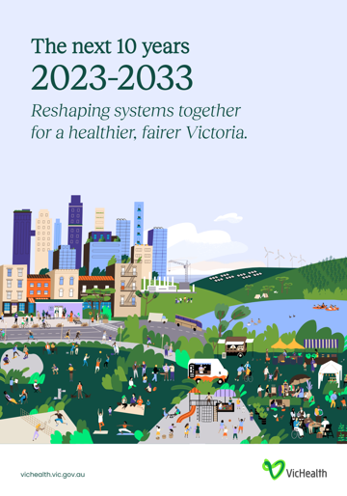
VicHealth Strategy 2023- 2032
VicHealth has developed a 10-year strategy, with the vision to transform Victoria’s health outcomes and reshape systems for a healthier, fairer Victoria. VicHealth was Established as an independent statutory authority by the Victorian Parliament in 1987 and as an agency they partner and invest with many organisations, including LGAs.
The Strategy focuses on three key areas including:
- Health - Deliver healthier, longer lives for all Victorians.
- Economy - Deliver value to the Victorian healthcare system and economy.
- Equity – Drive fairer health outcomes with and for Victorian communities.
Directly relating to LGAS, within the VicHealth Strategic plan it states:
“VicHealth looks forward to continuing its deep, place-based partnerships as it invests long-term for those communities facing the greatest barriers to good health. This will involve building on existing partnerships and creating new ones. VicHealth can complement the work of local government through its power to convene, provide technical capability, contribute to funding, and evaluate impact.”
The VicHealth Strategic Plan strongly supports the need for a Fair Access Policy. Its third strategic priority is directly focused on fairer and more equitable health outcomes and is identified as an opportunity to possibly explore future partnerships and potential funding programs from VicHealth should they arise.

Local Government Strategies and Policies
The table below identifies Greater Geelong City Council strategies and policies relevance to the Fair Access Policy.

Table 4: Greater Geelong City Council Strategies and Policies Review
Policy Name | Expiry Date | Relevant Sports | Relevance to the Fair Access Policy
Ba-gurrk Gender Equity Action Plan and Respect 2040 Regional Plan | 2024 and 2040 | All | Specifically addresses topics of access for women and considers prevention of family violence.
Gender Equality Action Plan and Gender Impact Assessments | Ongoing | All | GIAs are required for new policies or reviews, programs and services. This is a function of the Diversity and Inclusion team. Mandated under the Gender Equality Act 2020
Fair Play Strategy (2017) | Ongoing | All | The existing Fair Play Strategy (2017) has now been in place for six years and needs to be refreshed to better reflect contemporary standards and expectations.  The Fair Play Strategy was recommended and adopted as a means of trying to equalise the levels of support being provided to sporting clubs across the municipality and to have a more strategic approach to ensure clubs were treated with equity and fairness.
Social Infrastructure Plan - Generation One (2020-2023) | 2023 | All | The Social Infrastructure Plan outlines the needs of our community, investment priorities relating to social infrastructure, and the way forward to ensure that people know what is planned in the place that they live. The Plan consists of 13 different networks including Outdoor Sport and Recreation.
Social Equity Framework | 2025 | All | Provides the principles for achieving social equity across all Council decisions relating to our services, facilities, budget and planning approvals. The framework provides a set of six common enablers to inform the way we develop process, policies and action plans and make decisions supporting an equitable community.
Municipal Public Health and Wellbeing Plan | 2025 | All | The MPH&WB Plan is a legislative requirement. The plan is integrated with the Our Community Plan. Demonstrating and promoting gender equity practices is one of the 5 health and wellbeing priorities.
Community Safety Framework | 2026 | All | Feeling confident and safe is a key determinant of participation. The framework identifies the range of opportunities and strategies available to the City to influence and support safe community participation and access to places, services and opportunities.
Gambling Harm Minimisation Policy | Dec-24 | Venues with electronic gaming machines and promoting gambling | Harm from gambling impacts not only the problem gambler but family and broader community. The policy has two statements relevant to fair access:  Encouraging policies and strategies that consider funding, support services, infrastructure and program initiatives that provide alternative social and recreation choices to gambling; Support local community-based organisations that generate some of their income from gambling activities, to reduce their reliance on gambling income streams.
Multicultural Action Plan | Jul-05 | All | Recognising the differencing cultural and intersectional needs / requirements for women from CALD and CARM (culturally and racially marginalised) backgrounds
Vital Communities and the Geelong Financial Inclusion Action Plan |  | All | Specifically consider impacts of complex social challenges including income, employment, social connection and resilience.
GIA+ Tool |  | All | The Council has developed a GIA+ tool, these templates have been developed based on the Commission for Gender Equality in the public sector to meet legislated requirements, to achieve gender equality across our community.

Case Study: City of Greater Geelong GIA+ Tool – Assessing the Gendered Nature of the Mountain Bike Track at Armstrong Park Playground
The City of Greater Geelong Social Planning and Infrastructure Department, Sport and Recreation Planning Unit applied a gender lens to the mountain bike track, amphitheatre, natural play area and half basketball court. The focus was initially on the bike track as the initial assumption was girls would be less interested in using it, so the facility would benefit boys more than girls.
The approach was to engage internal staff in a process that would start thought and conversation leading to information that would advise the development of the mountain bike track.
A workshop was held and included:
- Introduction to the gender equity pilot
- Gender analysis video (GBA+)
- Overview of open space referrals business and playground submission
- GIA+ Tool assumption questions
- Group work – suggestions for playground improvements/considerations for improved gender equity.
The questions outlined in the GIA+ Tool were followed and used to guide the discussions with participants.
What was learnt and changed?
- The Council should have collected data on who uses open spaces, such as parks and mountain bike tracks, and rely on consulting participation data captured by Ausplay.
- There was an awareness for all staff participating to be alert for their own unconscious bias.
- Increased awareness of how to ensure future planning work has a gender lens.
- Using the GIA+ Tool and collecting and storing gender-disaggregated suse data across services and facilities will enhance organisational capacity.
Ongoing discussions regarding embedding gender and intersectional factors and considerations into designing future open spaces.

Peak Sporting Bodies Strategies and Policies
Some peak sporting bodies have been developing girls and women strategies to improve representation and participation of girls and women in their respective sports. The following sport strategies from Cricket Victoria, Football Victoria, AFL and Tennis Australia give an idea to what sport initiatives local governments will need to support in partnership with peak sporting bodies.

Cricket Victoria – Women and Girls Strategy 2023 -2028
The strategy vision is to be the favourite sport of all Victorians and it sets strong targets for the game by 2028 including a 100% increase in girls’ participation across Club and Woolworths Cricket Blast Cricket to 30,000 participants.
The strategy also sets out a roadmap to 1,000 active female coaches in Victoria and earmarks the Premier Cricket competition to become a net exporter of contracted state players.
The strategy is built on three key pillars:
- Strengthening the existing footprint in community cricket.
- Creating a truly integrated competition in Premier Cricket.
- Building the leading female High-Performance system in Australian cricket.

AFL – Women’s Football Victoria and Women and Girls Game Development Action Plan
The Women’s Football Vision for participation is striving for equal participation and representation by 2030. This translates into:
- Equal opportunity for women and girls to play, coach, umpire, officiate and govern.
- A participation pathway that best supports the continued development of participants and enables lifelong participation in the game.
The Women and Girls Game Development Action Plan supports the delivery of the 2030 Women’s Football Vision participation objectives and is currently in Phase One. Phase One action goals include:
- Dedicated women and girls’ participation options in every region at every level, from Auskick to Senior Community Football.
- Consistent implementation of a Participation Framework that supports the needs of girls.
- Access to curriculum-linked football programs and school competitions for all school-aged girls.
- Gender-balanced leadership in all community football leagues and clubs.
- Women role models in community coaching positions, with women making up at least 40% of all accredited coaches.
- Inclusive and safe pathways for women in umpiring, with women making up at least 40% of accredited umpires.
- Sufficient capacity of gender-neutral community football facilities to support the growth of women’s football.
- Equity in investment and allocation of resources.
- Education, tools and resources available for community clubs to build inclusive environments for women of all backgrounds.

Tennis Australia – Women and Girls Strategy 2022-2027
The Women and Girls Strategy vision is for “no limited for women and girls on and off the court”. To achieve this vision, Tennis Australia have developed four focus areas:
Lead – Drive accountability through:
- Ensuring equitable investment across tennis.
- Applying a gender lens to funding strategies, policies and agreements in tennis and with partners.
- Publicly reporting progress in Australian tennis annually.
- Engaging and inspiring the tennis community to embrace change.
- Providing leadership to achieve equality in sport globally.
Influence – Create an equal voice through:
- Strengthening career and volunteer pathways and opportunities on and off the court.
- Creating sustainable networks to influence and advance women.
- Inspiring and developing women to be a public voice for tennis from grass roots to the world stage.
- Ensuring equal and appropriate representation of women in the media.
- Advancing governance structures to ensure equal representation of women at all levels and roles.
Play – Enrich playing experiences through:
- Ensuring safe, inclusive and welcoming environments that value and empower women and girls.
- Applying a gender lens to enrich the playing experience across life stages.
- Empowering women and girls to excel and thrive in tennis.
Underpinning everything we do are the principles that:
- Women and girls are central to shaping and influencing Australian tennis.
- Courageous and relentless improvement and innovation drive sustainable change for women and girls.
- Safe environments enable women and girls to feel empowered and valued on and off the court.
- Systems, policies, practices and resources are available to progress equality for women and girls.
- Unconscious bias and current practices that constrain women and girls must be exposed and changed.
- Equality is embedded into the performance expectations of leaders and team members across Australian tennis.

Football Australia – Legacy ‘23
Legacy ‘23 is Football Australia’ strategic plan to grow women’s football and deliver enduring benefits for football beyond 2023, including becoming the first community sport to reach gender parity in participation.
There are five key pillars with supporting programs and initiatives that will deliver on this vision:
- Participation: Growing football through expanded community programs to ultimately achieve gender parity, with 400,000+ new female participants.
- Facilities: Building football through improved grassroots infrastructure to ensure equitable female facilities to meet surging demand.
- Leadership and development: Leading football through capacity in women’s leadership to shape the future of Australian sport and foster a culture that welcomes more women and girls to the game.
- Tourism and international engagement: Expanding football to boost tourism, trade and international relations when co-hosting 30 nations and their leaders at the FIFA Women’s World Cup 2023.
- High performance: Elevating football with world-class preparation to support the Matildas, whilst also developing the next generation of talent.

Football Victoria – Football Her Way
The Football Her Way’s vision is a whole of Football Family objective that must impact culture, values, policies, practice, planning and programs with each and every one committed to achieving true gender equity in Football.
This plan goes beyond participation. Football Victoria has set the ambitious target to reach 50/50 gender balance by 2027. FV is striving to drive change among the football industry and ultimately develop women leaders at all levels in our game – players, coaches, referees and administrators.
The Plan follows a strategic framework with five key priority areas, these include:
- Clubs – Change the dynamic of our clubs to be more inclusive within the spirit of diversity.
- Facilities and Infrastructure – Our Football Homes will cater for families, women and girls, elevating our standing in the community that football is the sport of choice for women and girls.
- Enjoy our game – ensure women and girls can participate in football whenever and wherever they choose.
- Promoting our game – Create a movement that encourages women and girls to engage with football.
- Our People - Invest in advancing gender equity.

Planning Frameworks and Guidelines

UN Human Rights Council Resolution 40/5 – International Human Rights Framework on the Elimination of Discrimination against Women and Girls in Sport
The UN Human Rights Council passed resolution 40/5 on the elimination of discrimination against women and girls in sport. Australia is a signatory to the resolution.
The resolution includes the following statements relevant to the Fair Access Policy that supports reducing inequality in sport based on race and gender:
- Recognise the potential value of sport as a universal language that contributes to educating people on the values of respect, dignity, diversity, equality, tolerance and fairness and as a means to combat all forms of discrimination and to promote social inclusion for all.
- Recognise further the imperative need to engage women and girls in the practice of sport and to enhance their participation.
- Noting with concern that many women and girls face multiple and intersecting forms of stigma and discrimination in sport.
- Recognise that sports regulations and practices that discriminate against women and girls from competing on the basis of race, gender or any other ground of discrimination can lead to the exclusion of women and girls from competing.
A report was prepared by the UN High Commissioner for Human Rights titled “Intersection of race and gender discrimination in sport”. In her report, the High Commissioner discusses relevant international human rights norms and standards and the obligations of States and the responsibilities of sporting bodies towards women and girl athletes, identifies possible gaps in the protection of the human rights of women and girls in sports and provides recommendations aimed at enhancing protections.
https://www.ohchr.org/en/documents/thematic-reports/ahrc4426-intersection-race-and-gender-discrimination-sport-report-united
The resolution and supporting report call for States to ensure sporting bodies implement policies and practices in accordance with human rights norms and practices.

Guidelines for the Inclusion of Transgender and Gender Diverse People in Sport, 2019
The Australian Human Rights Commission, together with Sports Australia and the Coalition of Major Professional and Participation Sports (the coalition includes AFL, Cricket Australia, Football Australia, National Rugby League, Netball Australia, Rugby Australia and Tennis Australia), released the Guidelines for the Inclusion of Transgender and Gender Diverse People in Sport to provide guidance to sporting organisations on promoting the inclusion and participation of transgender and gender diverse people in sport.
The guidelines provide information about the operations of the Commonwealth Sex Discrimination Act 1984, and practical guidance for promoting inclusion in line with fundamental human-rights-based principles of:
- Equality
- Participation in sport
- Freedom from discrimination and harassment
- Privacy.
- Guidance is provided across the following focus areas:
- Leadership
- Inclusion policies
- Codes of conduct
- Uniforms
- Facilities
- Information collection processes.
These Guidelines should be used to help inform local governments and sporting organisations of their obligations under the Commonwealth Sex Discrimination Act 1984.
Of specific relevance to the Fair Access Policy, the Guidelines recommend developing an inclusion policy for the following reasons:
- Help a transgender or gender diverse person identify a sporting organisation that will welcome them.
- Encourage a transgender or gender-diverse player to remain engaged in sport throughout their transition or affirmation.
- Provide guidance to staff and volunteers at a sporting organisation on how to include transgender and gender-diverse participants and respond appropriately to any issues that may arise.

Guidelines for Trans and Gender Diverse Inclusion in Sport – Complying with the Equal Opportunity Act 2010, 2017
The Victorian Human Rights Commission issued the Guidelines for Trans and Gender Diverse Inclusion in Sport – Complying with the Equal Opportunity Act 2010, an update to the Commission’s 2015 Guidelines for Transgender People in Sport. It provides guidance for sporting organisations about promoting an inclusive environment, being active in preventing discrimination and responding appropriately if it occurs.
The guidelines provide information about the operations of the State Equal Opportunity Act 2010 (now 2020 following a review) and practical guidance for sporting organisations on how to comply with the Act.
The following minimum steps to comply with a sporting organisation's positive duty include:
- Develop a policy that deals with equal opportunity in sport, employment, club membership and service delivery.
- Ensure the policy is communicated to all players and staff at induction and through refresher training, and that players and staff understand their obligations and what they mean in practice.
- Review the policy at regular intervals to ensure it is up to date.
- Ensure players and staff know their rights and responsibilities, as well as your policies on inclusion and member protection.
- Develop a fair, effective and confidential complaints procedure for players and staff, and make sure people know about it.
- Regularly monitor your club or organisation’s activities, employee knowledge of legal obligations and any complaints received, in order to promptly deal with any issues that arise and improve compliance.

Sport Australia Women and Girls Strategic Advice
Sport Australia support the UN Human Rights Council Resolution 40/5, “From grassroots to the elite level, it’s imperative that the sport sector increases the representation of women and girls in sport to better reflect Australian society and create a fairer and more inclusive environment”.
Sport Australia identifies the following strategies:
- Advocate for equal representation at all levels including coaching and on club committees.
- Create a safe and welcoming place.
- Promote initiatives for females to the public i.e., profile female role models, and ensure equal representation in imagery and social content.
- Provide accessible activities and facilities such as equal access to courts/pitches, female-only activities, appropriate changing rooms and toilets.
- Allow participation in flexible uniforms such as hijabs for Muslim females.
- Instigate a zero-tolerance policy towards any type of prejudice or behaviour that puts the wellbeing of women and girls at risk.
- Provide a pathway and opportunities for progression and career development.
- Emphasises and supports the social aspects of sport.
- Offer alternative/modified formats.
- Ask women and girls for input and feedback.
- Deliver group activities.
- Providing activities at the right time of the day/week.
- Reduce financial barriers.
- Promote women into decision-making roles in your club.
- Create a pipeline for women contenders for committee roles and promote gender balance in selection processes.
- Provide training opportunities to increase women’s capabilities for advancement.
- Develop policies that are gender inclusive, and that club culture promotes gender equality.
- Ensure the requirements for committee membership are free from discrimination and bias.
- Create opportunities to educate boys and men about the benefits if gender equality through sport.

Making Space for Girls
In the past, design for sport and active recreation facilities and services has been more suited to male participation. The following design guidelines and resources respond to extensive research and engagement with girls and women that focus on barriers faced when participating.
The ‘Make Space for Girls’ is a resource that includes research, design principles and case studies for making space for girls and women in a public space.
Specifically, the website refers to research and guidelines developed by the University Leads titled Safer Parks – Improving Access for Women and Girls”. The guidelines included extensive research and reports the concern about safety as the “biggest single barrier to women and girls’ enjoyment of parks and green spaces”. The guidelines include the following design principles:
Eyes on the park:
- Busyness and activation – Provide alternative seating options, locate spaces popular with women and girls in busier areas of the park, encourage businesses to use the park increases activity, a broad range of activities to activate the park and encourage new users and circular running or walking routes.
- Staffing and authority figures – Arrange working patterns to maximise staff presence.

Awareness:
- Visibility and openness – Provide canopies above head height to enable a clear view, maintain buses and shrubs alongside paths to ensure visibility, locate facilities close to main routes and busy areas of the park, mounds and high points give good prospects.
- Escape – Provide wide and clearly visible park entrances and park edges as open and accessible as possible with regular breaks and regular exits with clear signposts.
- Lighting – Provide human-scaled lighting rather than floodlights - low and even light can be safer than bright lights that create strong contrast and glare. Using lighting helps activate key routes and spaces, and lighting should enable good colour rendering.
- Wayfinding and layout – Provide a clear hierarchy of paths that connect with routes beyond the park, a circular path around the perimeter with regular exit points, paths should connect key facilities with each destination and clear signage with directions to key destinations.
Inclusion:
- Belonging and familiarity – The naming of facilities to signal multiple uses broadens their appeal, statues and artworks can indicate belonging, and specific facilities aimed at women and girls signal that they are welcome.
- Image – A tidy park signals care, remove graffiti and repair any vandalism, well-maintained vegetation around paths and well-maintained signage and information boards.
- Access and location – Access should be via safe and well-used routes. Prioritise entrances close to public transport connections and signpost nearby places as safe zones.
- Co-production and engagement – Engagement with existing women’s and youth groups can be a good starting point for co-production, co-designing parks might change what is included and how spaces feel, engagement must be intersectional and involve existing and potential park users, and safety walks help to articulate perceptions of safety in the park.
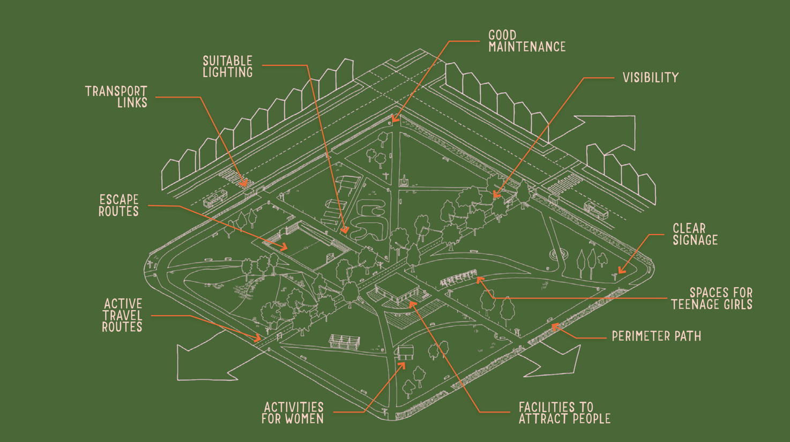
Figure 5: Design Advice for Improving Access to Parks for Women and Girls (Source: Safer Parks, 2023)

Female-Friendly Sport Infrastructure Design Guidelines
Female sports participation at the elite and peak of athlete pathways is increasing rapidly in line with an increase in grassroots participation in sport and physical activity. This represents an exciting time for Australia but also presents challenges for sports administrators and facilities.
Sport and Recreation Victoria has developed the Female Friendly Guidelines that include the following design principles to create female-friendly facilities:
- Fit for purpose: While promoting a flexible and multi-use approach, ensure female-friendly design elements and specific requirements meet the level and type of activities being delivered, as well as occupant, club or tenant needs.
- Multi and shared use: Infrastructure should be efficiently designed to promote equitable and flexible use by a mixture of users capable of sharing facilities and usage times. The facility space planning and design of public spaces should adopt a multi-purpose approach.
- Compatibility: Identification of compatible sports, teams, activities, clubs or organisations with similar objectives and requirements for facility design, use and management should be promoted.
- Universal Design: The principles of Universal Design should be applied to community sport and recreation facilities so that they accommodate users of all ages, genders, abilities and cultural backgrounds.
- Public Safety: Crime Prevention through Environmental Design (CPTED) takes into consideration the relationship between users and the physical environment in the design of public spaces in crime prevention and assists with public safety.
- Health and safety: The security and safety of users should be paramount. Sport and active recreation facilities and their surroundings should be designed, built and maintained in accordance with relevant occupational health and safety standards. They should also incorporate child-safe and safer design principles into facility design.
- Functionality: Facility design and layout should promote safe and optimal functionality to accommodate formal, competitive, social and recreational forms of usage and participation.

Monash XYX Lab
The Monash University XYX Lab is a team of design researchers exploring gender-sensitive design practices and theory. Their work looks at gender, identity, urban space and advocacy. They bring together planners, policy makers, local government and stakeholders in their research and have developed urban space and planning resources.
The XYX Lab has developed an interactive online tool called YourGround that has mapped safety in public spaces for women, girls and gender-diverse people. The tool enabled women and gender-diverse people to anonymously add a spot directly into a custom survey on the map. The survey asks participants questions about their safety relating to recreational experience in public space (type of activity and stress level). Users can also vote and comment on any spots already added to the map by other participants. Local Government can use this spatial dataset to inform location-based insights for improving safe participation in recreation experiences within our public space.

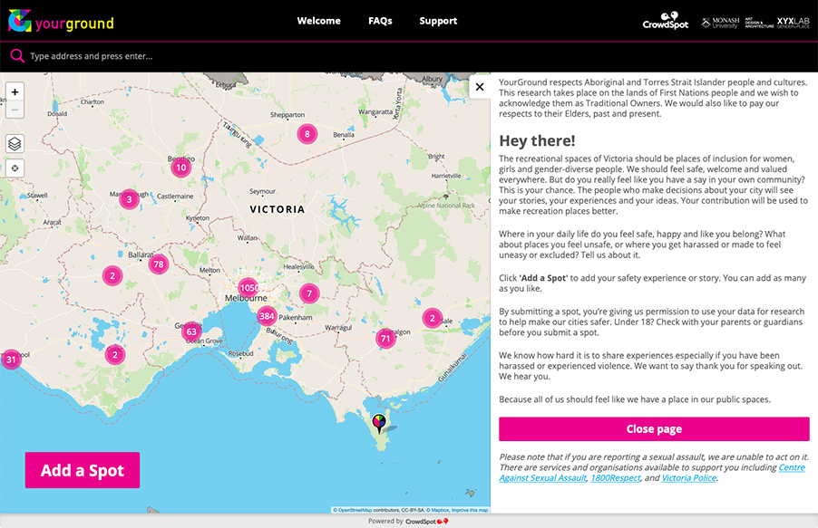
The City of Greater Geelong is participating in the YourGround project. The research shows in general people participating in the research report feeling:
- Some parks, civic spaces and boulevards, particularly in the Geelong CBD and Corio/North Shore were rated unsafe. The reasons provided include due to antisocial behaviour, traffic conditions, poor lighting and large gatherings of men.
- Large parks that have been embellished and include park lighting were rated safe.
- Natural areas like along the Barwon River and Ocean Grove beaches were rated safe.
The image below shows the YourGround data for the City of Greater Geelong.
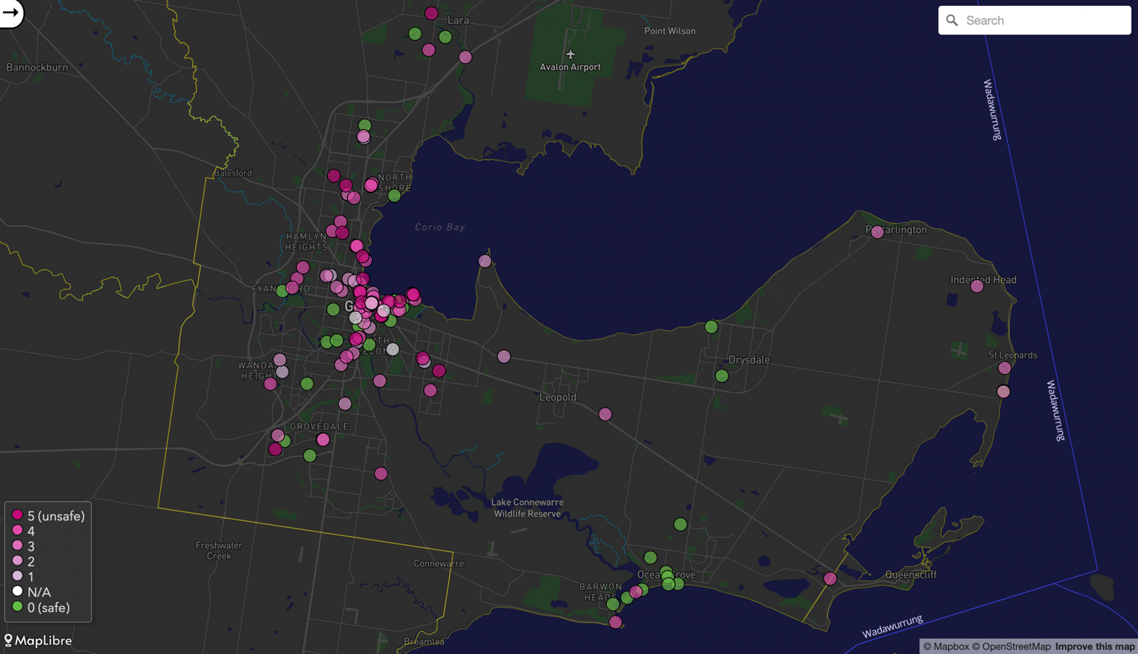
Figure 6: YourGround Map – City of Greater Geelong

Key Findings of Strategic Review
Local Government strategic and policy alignment with State Government legislation and policy on gender equity in sport and recreation is critical to a regional response to the issue
The following graphic shows the indicative relationship between the Greater Geelong Fair Access Policy with State Government’s gender equity legislation and policy and Local Government strategies.

Figure 7: Relationships between legislation, policies and strategies
The review of council’s current policies and strategies that influence gender equality in sport and recreation outcomes found the following key findings:
- Greater Geelong City Council strategies and policy statements support improved gender equality in sport and active recreation, particularly its Fair Play Strategy 2017. These strategies are now supported by a Council Gender Equality Action Plan (usually a four-year cyclic plan). The State Government mandates these plans through the relevant legislation.
- Greater Geelong City Council’s Social Infrastructure Strategy identifies the long-term strategic priorities, objectives and actions the council would take to support female participation in sport and active recreation.
- Greater Geelong City Council use financial incentives or discounts to encourage girls and women participation in sport and active recreation, identified in the council’s fees and charges policy.
- Greater Geelong City Council provides sporting clubs, associations and leagues with tool kits, campaigns and resources to support women and girls’ participation in sport.
- Greater Geelong City Council use a GIA+ Tool to review and assess the gender equality impact of the Council services.
The strategic objectives relating to the Fair Access Policy were:
- Equitable use and access to sports facilities for women and girls.
- Partnering and collaborating with local sporting clubs and associations and peak sporting bodies
- The council has a responsibility to provide safe and inclusive infrastructure.
New sports facilities should adopt industry planning frameworks and design principles that deliver inclusive, safe and welcoming sport and recreation facilities and programs.
The planning frameworks provide the following principles that will guide the design of future sport and recreation facilities, programs and services:
- Accessible and Inclusive: Sport and active recreation facilities and programming will be universally designed and inclusive, fostering participation in sport and active recreation by all our community, across all life stages, genders and cultures.
- Diverse and Equitable: Sport and active recreation facilities will offer a diverse mix of facilities, programs and experiences. The council will provide an equitable distribution of sport and active recreation precincts across the municipality and to girls' and women's sport and recreation.
- Safe and Welcoming: Sport and active recreation facilities and programs are designed to be visible, open and welcoming to the community, creating a safe place for girls and women to participate.
- Multi-Use: Sport and active recreation facilities will be multi-use, offering several activities, programs and experiences for users and enabling access to girls and women's sport and recreation.
- Connected: Sport and active recreation participation opportunities are connected to our communities, including our unique natural environments.
- Sustainable: Sport and active recreation facilities will be designed and operate efficiently, whilst being well managed and maintained.

The following reference documents and links are provided for guiding design principles:
- Creating Places for People
- Making Places for Girls
- Healthy Active by Design
- Crime Prevention through Environmental Design
- Universal Design Principles
- Female Friendly Sports Infrastructure Design Guidelines
- Monash XYX Lab.
Councils and State Sports Associations should partner with local clubs, associations and leagues in delivering Sport Australia strategies for increasing women and girls’ representation and participation.
The Fair Access Policy should include a partnership approach with State Sporting Associations where policies, practices and resources that support, encourage, and incentivise the delivery of Sport Australia strategies for increasing women and girls’ representation and participation are developed collaboratively (See Section 2.8).
These strategies, together with the Victorian Government’s Fair Access Policy Road Map, are examples of how governments and peak sporting bodies are responding to Australia’s obligations to the international human rights framework, specifically as a signatory to the UN Human Rights Council passed resolution 40/5 on the elimination of discrimination against women and girls in sport and the Brighton Declaration 2014.
Case Study: Creating a Place for Women in Sport
(Yarra Ranges, Knox and Maroondah Councils, EACH and Inspiro Health)
- Creating a Place for Women in Sport – Self Assessment Tool.  - For community recreation and sporting clubs to promote equality.  - Enabling councils to work in collaboration with clubs to develop a gender equity action plan.  - The initiative has been well received and successfully run since 2018 with three to four clubs from each Council participating each year. | 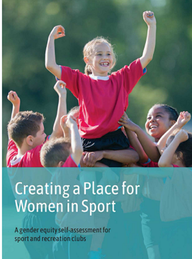

Current State of Play
What is the current state of play for improving gender equality and access?
This section summarises the current state of play for sport participation in Greater Geelong and a review of industry trends.

Demographic Factors
In Greater Geelong, there are some groups of women and girls that encounter higher levels of disadvantage and discrimination, as well as additional obstacles to achieving good health and well-being. These groups include Aboriginal women, immigrant and refugee women, trans and gender diverse people, women and girls facing socio-economic challenges, and women and girls with disability.
We acknowledge that intersectionality can impact participation in sport and active recreation. Intersectionality refers to the ways in which different aspects of a person’s identity can expose them to overlapping forms of discrimination and marginalisation. For example, an immigrant woman who also identifies as a person with a disability may be more likely to experience discrimination.

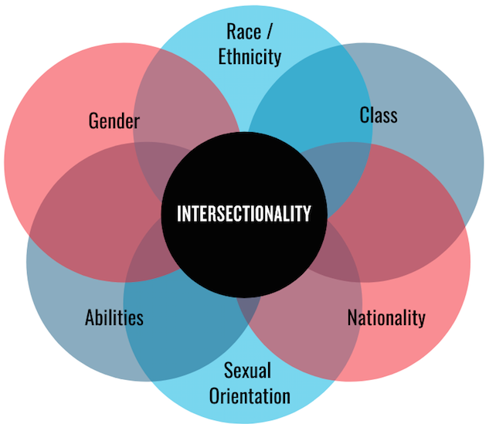

Figure 10: Intersectionality described as, the ways in which different aspects of a persons identity can expose them to overlapping marginalisation or discrimination.
The table below shows the latest Australian Bureau of Statistics (ABS) Census 2021 data, sourced from id.community:
- Greater Geelong has pockets of disadvantage, specifically in Norlane – North Shore (SEIFA 764.3), Whittington (SEIFA 817.0) and Corio (SEIFA 822.7) communities.
- A growing population is fuelling female participation in sport and recreation. The current female population will grow from 139,203 in 2021 to 203,743 in 2041.
- There are an estimated 79,192 females within the most active years age groups (5 and 49 years) that will demand access to sport and recreation facilities, programs and services.
- There are an estimated 1,809 Aboriginal females in Greater Geelong. Providing culturally sensitive programs and services that connect Aboriginal girls and women to Country, community and culture will be important to encouraging sport and recreation participation.
- There are an estimated 25,053 females from a CALD background (born overseas). Encouraging inclusive sport and recreation clubs and programs that recognise the needs of these diverse cultural communities are important to encouraging sport and recreation participation.
The following tables details the Greater Geelong current and future (2041) estimated female population.
Table 8: Greater Geelong Female Population Breakdown
Total 2021 Pop. | Total 2041 Pop. | Total Pop. Change % | Female Pop.2021 | Female Pop. 2021 % | Female Pop. 2041^ | Female Pop. Diff. | Female Aboriginal Pop. 2021 > | Female CALD Pop. 2021 (Born OS) > | Female Active Years (5-49) Pop. >
270,786 | 396,388 | 46.38% | 139,203 | 51.4% | 203,743 | 64,540 | 1,809 | 25,053 | 79,192
^ If current proportion of females is maintained.
> If current proportion of target group; and current proportion of females is maintained.

Target Groups
Aboriginal women
There is small percentage of the Greater Geelong population identifying as Aboriginal. Aboriginal women face systemic disadvantages. Compared to non-Aboriginal women, Aboriginal women are 32 times more likely to be hospitalised as a result of family violence and are almost 10 times more likely to die from assault. Aboriginal women are also at far greater risk of homelessness and incarceration.
Women with disability
The latest Ausplay Survey 2021 found 70.2% of women (over 18 years) with a disability participate at least once per week (compared to 84.1% of other Australian women) and 53.7% three times per week (compared to 67.9%). There were 21.3% that do not participate in any sport or physical activity (compared to 9.1%).
People with a disability receive the same physical, mental, and social benefits from participating in sport and physical activity as those not having a disability. However, they are not participating at the same levels as all Australian women. Addressing barriers to participation for people with disabilities is essential to reversing this trend.
CALD women
There is a small percentage the Greater Geelong population identifying as being born overseas. Women from CALD backgrounds face additional barriers to education and employment and may need additional information about their rights. CALD women are over-represented in low-paid and insecure work and coupled with family commitments, find it a challenge to participate in sport and recreation.
For example, migrant women are 7% less likely to be employed than those born in Australia. Thirty seven and a half percent of women accessing domestic violence support services are of non-English speaking backgrounds but represent only 17.3% of the total population in Victoria.
Age
The impacts of gender vary over a lifetime. For example, during adolescence, expectations of girls are increasingly shaped by gender norms that impact girls’ social, educational and leisure choices. Women retire with half the superannuation savings of men, and older women are at greater risk of homelessness than older men.
People in their active years tend to be the biggest participants in sports.
Women from low SES backgrounds
There are pockets of disadvantage in Greater Geelong. Women from low SES backgrounds face barriers in accessing services and supports which can compound other gendered disadvantages. For example, socio-economic inequity heightens the risk of violence against women. Women from low SES are less likely to participation in sport and recreation.

LGBTIQA+
LGBTIQA+ communities face significant barriers to accessing essential inclusive services and support in the community including the sport and recreation environment. The LGBTIQ community experience discrimination when attempts are made to access services, or when attempting to support friends, partners or other individuals who identify as LGBTIQA+ within the service system. This experience often leads to a fear that this will also occur in other life settings such as a sports club or fitness program. This community experiences family violence, and significant discrimination, which have negative implications for individual and collective mental health, general health and wellbeing.

Participation

Local Sports Club Participation Use of Greater Geelong Sports Facilities
The infographic on the next page summarises the participation profile of sports using Greater Geelong City Council’s sports facilities.
Key findings from the Greater Geelong Sports and Recreation Census 2023:
- Junior girl participants – 6,252 (21.85%).
- Senior women participants – 4,714 (16,48%).
- 95% of all sports facilities are used for training, events or games for all genders.
- 91% of clubs have women coaches, managers and administrators.
- 84% of clubs report women and girls’ results and achievements.
- 30% of change rooms are gender neutral.
- 38% of clubs report members identifying as a person within the LGBTIQA+ community. There are 27% of clubs that report 1-10 members, 8% of clubs that report 11-20 members and 3% of clubs that report 20+ members.
- 53% of clubs comply with the Discrimination Act by providing accessibility facilities. There are 16% that report their venues did not comply and 31% report they were unsure.
- 58% of clubs report members living with a disability. There are 43% of clubs that report 1-10 members, 5% of clubs report 11-20 members and 9% of clubs report 20+ members.
- Only 2% of clubs identifying equity and inclusion as the biggest challenges facing clubs and community groups compared to 51% of clubs identifying infrastructure and 31% volunteers.

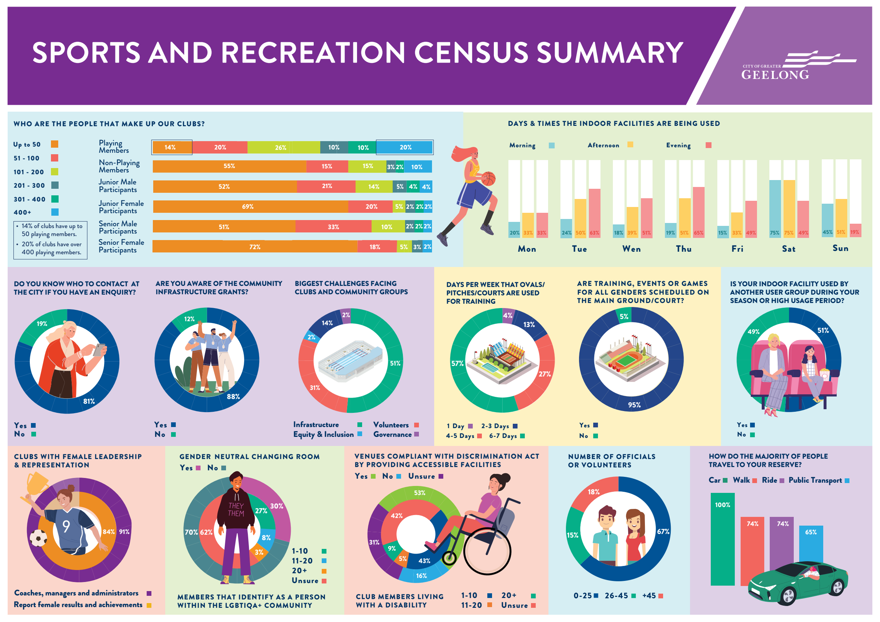
Figure 10: City fo Greater Geelong Sports and Recreation Census 2023

AusPlay Participation Rates in Sport
To gain an insight into the local women and girls' participation level of major participation sports in the Greater Geelong City Council area, the AusPlay participation rates were applied to the current (2021) and 2041 population forecasts. State participation rates were used for sports where data was reported. National participation rates were used for sports where State participation rates were not available.
The table below summarises the outcomes of applying the adult and children AusPlay participation rates to the current (2021) and 2041 population forecasts for major participation sports.
Table 9: Women and Girls Population Projections 2021-2041
City of Greater Geelong Population | Adult (15yr+) | Children (0-14yrs) | Total
2021 | 114,767 (82%) | 24,555 (18%) | 139,322
2041 | 167,835 | 35,909 | 203,743
The table below shows significant growth in women and girls between 2021 and 2041 if the current participation rates are maintained for major participation sports modelled. The estimated 2021 women and girls’ participation of 38,702 across these sports will grow to 56,597, an additional 17,895 participants in 20 years.
Additional participants will be encouraged to play through new playing formats and competitions being introduced and maturing. Providing new and improving existing sport and active recreation facilities will be important to meeting future demand for women and girls, trans and gender-diverse people participation.
Table 10: Participation Projections 2021-2041
Sports | 2021 Total Participation – Model Participation Rate | 2041 Total Participation – Model Participation Rate
Outdoor Field Sports | 19,303 | 28,229
Australian Football | 7341 | 10735
Cricket | 4163 | 6087
Hockey | 1270 | 1857
Football | 6530 | 9549
Outdoor Court and Green Sports | 19,399 | 28,368
Netball | 5318 | 7777
Tennis | 6834 | 9994
Bowls | 1381 | 2019
Golf | 5866 | 8578
Indoor Sports | 14,835 | 21,695
Basketball | 8184 | 11969
Badminton | 2369 | 3464
Table Tennis | 393 | 575
Gymnastics | 3889 | 5687
Total | 38,702 | 56,597

Barriers to Girls and Women's Participation in Sport and Recreation
In 2015 the then Moreland City Council (now Merri -bek City Council) developed the Moreland Active Women and Girls Strategy (2015). The Strategy reported on survey findings exploring the participation barriers faced by women and girls in sport and recreation and in leading an active lifestyle.
Whilst barriers vary for different people, some common barriers reported are:
- Fragmented time constraints – family commitments and household responsibilities.
- Availability of options at convenient times.
- Cultural norms.
- Inadequate infrastructure i.e., lack of suitable change rooms or women-only spaces.
- Family commitments and responsibilities.
- Existing injury or disability (for older women).
- Racism and discrimination towards women from a CALD background i.e., different cultural values and dress.
- Limited social network.
- Negative body image.
- Perceived lack of skills to undertake the activity i.e., swimming etc.
- Perceived safety issues i.e., accessing recreation facilities after dark, dogs, uneven pavements, etc.
- Lack of fitness and associated concerns about keeping up or doing the right thing.
- Tiredness due to family/childcare responsibilities.
- Cultural and religious barriers – inappropriate dress codes and lack of safe, comfortable, and accessible facilities.
- Lack of childcare and lack of awareness of childcare options.
The World Health Organisation recently conducted a study into the Barriers and Facilitators of Physical Activity Participation in Adolescent Girls. The report was released in March 2022 and found:
Teenage girls quit sports because school and academic activities are too demanding. They tend to get involved in other activities that are less demanding than a competitive sport that requires training and competing two to three times each week.
Participation of girls between 10 and 19 is in decline, and there is urgent action needed to reverse this trend to safeguard their long-term health. “Globally, around 85% of girls do not meet the WHO recommendations of at least 60 minutes per day of moderate to vigorous physical activity. Also, the participation of girls in exercise and sports declines throughout adolescence.
WHO identifies providing for physical exercise (PE) in the school curriculum but also before, during and after school day. A whole-of-school approach that links the school curriculum with the broader school environment and local community programs can increase the participation of adolescent girls.

Local Governments Response to Gender Equity in Sport and Recreation
This section summarises Greater Geelong City Council’s response to gender equality in sport and recreation. The evidence cited in this section was sourced by surveying and seeking evidence from the Community and Recreation Services.

Infrastructure Allocation
Greater Geelong City Council capture and monitor participation data for most of its sporting facilities through the Sport and Recreation Census as well as obtaining State Sporting Association registered participation data and Ausplay Participation Survey data.
Greater Geelong clubs report 95% of sports facilities are used by all genders. However, there is an inequity in the use of sports facilities between boys and men’s teams and girls and women’s teams with boys and men allocated greater use of fields.

As girls and women’s participation grows and more teams and programs are introduced, councils in partnership with state and local clubs, associations and leagues will need to consider how to provide equitable allocations to sporting clubs to meet this demand/need. This may require re-prioritising or thinking differently about how sports facilities and competitions are distributed across a network, as opposed to allocating to a specific club for a summer or winter season. Improving usage data collection is a key consideration for the Fair Access Policy.
Greater Geelong City Council meet with 12 different local sports associations as part of a Sport and Recreation Network to review match schedules annually.

Sporting Bodies Governance
To gain future funding, State Sports Associations (SSAs) are now required to have 40% women on their boards, and this is a priority for many SSAs. Whilst this mandate is not currently directed for local sporting clubs, associations and leagues, it is shows that the leadership gender split in the sports industry is increasingly a priority.
Greater Geelong City Council collects information on the gender distribution of local sports clubs, associations and leagues committees. Ninety one percent of clubs in 2023 had women coaches, managers and administrators. However, the gender split of committees is unknown. Improving governance data collection is a key consideration for the Fair Access Policy.
Research shows that increased gender diversity on boards leads to improved organisational performance.

Infrastructure
The Council has conducted several female-friendly capital works projects. Female-friendly specific developments include gender-neutral change rooms, car parks and pathway security lighting.
The Council has supported infrastructure audits organised by State Sporting Associations and used these audits and strategies to inform upgrades.

Resource Allocation
Greater Geelong City Council prioritises funding under its Community Infrastructure Grants to specific outcomes and objectives to access and universal design principles that help support women and girls’ participation.
The Council tracks total budget spend for:
- New builds (i.e., new pavilion)
- Redevelopments and renewals (i.e., renewal of sports courts)
- Maintenance and operations (i.e., turf maintenance, cleaning, utilities)
- Total annual council grant funding for sporting clubs.

Case Study: Gender Budget Analysis
(Monash City Council)
In recent years, Monash City Council has reviewed the capital spend, per sport and gender. The budget reporting table is shown below. Monash City Council report that collecting data and reporting on funding to projects and programs based on gender has helped inform decision-making that is more equitable.
Table 11: Monash City Council budget breakdown by sport and gender 2023
(Source: Monash City Council, 2023)
 | Overall Spend Per Sport |  |  | Gender Analysis Of 2022/23 Capital Spend
Sport | 2022/23 Capital Works Spend on Sporting Facilities | Capital Spend Per Participant | Male Participants | Female Participants | Male Spend | Female Spend
Cricket | $3,627,000 | $1,278 | 2629 (93%) | 209 (7%) | $3,373,110 | $253,890
AFL | $1,238,000 | $626 | 1606 (81%) | 374 (19%) | $1,002,780 | $235,220
Soccer | $600,000 | $310 | 1722 (89%) | 210 (11%) | $534,000 | $66,000
Rugby | $357,000 | $506 | 575 (82%) | 130 (18%) | $292,740 | $64,260
Tennis | $10,645,250 | $2,650 | 2209 (55%) | 1808 (45%) | $5,854,887 | $4,790,362
Golf | $3,910,750 | - | 65% | 35% | $2,541,987 | $1,368,762
Total | $20,378,000 |  |  |  | $13,599,504 | $6,778,494

These steps have led to sports facilities being designed to welcome and accommodate girls and women participants. Improving Council expenditure data collection is a key consideration for the Fair Access Policy.

Examples of Local Initiatives
What are we currently doing to make the change?

AFL Inclusive Clubs and Gender Equity Education Program
Leisure Networks are partnering with the AFL and local clubs to build greater awareness around gender equity and inclusion.
The program helps clubs to:
- Create safe, equal, and respectful environments for all, especially women and girls, to increase involvement on and off the field.
- Review and update club policies, governance, website and social media.
- Create community-based initiatives.

Women in Community Life Awards
The annual awards acknowledge the contribution women have made to the Greater Geelong community, particularly the impact they have made to promote and advocate for advancing gender equality.
The awards are presented during the City's International Women's Day celebrations.

Her Story
Her Story shares the untold stories of Geelong women. This storytelling helps to increase gender balance awareness and further guide and influence policy design.
The project team undertook a process to identify women with inspiring stories. The stories told have been collated and uploaded to a Her Story digital application, which utilises the existing City of Greater Geelong walking trails technology.
The stories highlight key themes of adversity and although society has come a long way in terms of gender equality. Women featured include
Corrina Eccles, Nancy Donkers, Tracey Gaudry and Nina Morrison. The following provides a link to some of these stories.
https://www.committeeforgeelong.com.au/wp-content/uploads/2019/09/HerStory-web.pdf

The Girl Can Free ‘Come and Try’ Exercise Sessions
As part of the This Girl Can Week Councils four indoor aquatic and leisure centres offer a range of free sessions, including beginners strength, pilates, circuit and yoga classes as part of the This Girl Can Week.

Women in Sport Breakfast
Councils annual Women in Sport Breakfast attracts 200 people in Greater Geelong to hear from women in the sport industry. The breakfast is a great way to share knowledge, insights and network.

Greater Geelong Sports Pavilion Development Program
Greater Geelong City Council has focused on providing a sufficient number of gender-neutral change rooms for participants to ensure women and girls, trans and gender diverse people have access to appropriate facilities to participate. Recent examples include:
- Anakie Recreation Reserve Pavilion
- Estuary Reserve Pavilion, Leopold
- Hume Recreation Reserve, Bell Park
- Lara Recreation Reserve Pavilion
- Shell Reserve Pavilion, Corio.

Go Soccer Mums – Drysdale Soccer Club
Go Soccer Mums is an introductory soccer program for women. Each week up to 50 women participate in the Drysdale Soccer Club Go Soccer Mums program. The program is run in conjunction with Leisure Networks, the Geelong-based disability service. facilitated improved access to soccer within the Muslim community.

Key Findings of Current State of Play
Women and girl’s participation in sport and recreation is being fuelled by population growth and improved access to new competitions and programs.
The proportion of women and girls in Greater Geelong is 51.4% or 139,203 people in 2021. If the current proportion of women and girls is maintained, there will be an estimated increase of 64,540 women and girls by 2041, reaching 203,743 women and girls. Population growth will translate into more women and girl’s participants in sport and recreation that will demand access to sport and recreation facilities, programs, and services.
The most active years age groups in our community are between 5 and 49 years of age. There are an estimated 79,192 women and girls within this age group that will demand access to sport and recreation facilities, programs and services.
Women and girls’ participation for major participation sports modelled will increase from 38,702 participants in 2021 to 56,597 participants in 2041 (an additional 17,895 participants). This will mean access to more facilities, competitions, and programs, which will be needed to service this future demand.
Delivering culturally sensitive, accessible, and inclusive sports facilities, programs and services is important for parts of the Greater Geelong
There are an estimated 1,809 women and girls that identify as Aboriginal or Torres Strait Islander. Providing culturally sensitive programs and services for Aboriginal girls and women that welcome and connect people to Country, community and culture will be important to encouraging sport and recreation participation.
There are an estimated 25,053 women and girls that are from a CALD background (born overseas). Encouraging inclusive sport and recreation clubs and programs that recognise diverse cultural backgrounds and particularly customs that impact female participation will be important to encouraging sport and recreation participation.
Females with a disability participate less than all female Australians. Limited opportunities to participate in a supported and modified way are restricted participation by people with a disability. Providing adaptive programs and services and accessible sport and recreation facilities are key ingredients to improving participation by females with a disability.
Delivering affordable sports facilities, programs and services is important for parts of the Greater Geelong.
There are pockets of disadvantage in Greater Geelong, specifically in Norlane – North Shore (SEIFA 764.3), Whittington (SEIFA 817.0) and Corio (SEIFA 822.7) communities. Providing affordable programs and services and accessible sport and recreation facilities are key ingredients to improving participation by women and girls from low socio-economic communities.
Greater Geelong City Council have improved access to facilities for women and girls; however, the lack of data on the use and representation of girls and women in sport and recreation is limiting progress.
There is a lack of detailed data available. It will continue to be challenging to make meaningful change across the Greater Geelong without an evidence base to inform decision-making. Key survey data has identified how many girls and women have access and use sport and recreation facilities, programs and services, the proportion of representation of women on boards and committees, and the council’s funding of initiatives designed to improve access to sport and recreation facilities, programs and services.
The survey found:
- Ninety five percent of sports facilities are used by all genders. However, there is an inequity in the use of sports facilities between boys and men’s teams and girls and women’s teams with boys and men allocated greater use of fields.
- As girl's and women’s participation grows and more teams and programs are introduced, council will need to consider how to provide equitable allocations to meet this demand/need. This may require re-prioritising or thinking differently about how sports facilities are distributed across a network, as opposed to allocating to a specific team for a summer or winter season.
- Council has a proactive approach to managing allocations through partnering with local sports associations. The Council meets with 12 different local sports associations as part of a Sport and Recreation Network to review match schedules annually.

- Female governance leadership of sporting bodies has been identified as a key priority for the Government through the adopted Gender Equity Strategies and State Sporting Associations. The Greater Geelong Sport and Recreation Census shows 91% of clubs in 2023 had women coaches, managers and administrators. However, the gender split of committees is unknown.
- Council allocates funding towards capital works and asset renewal of sporting facilities and the delivery of sport and active recreation programs and services. There has been a prioritisation of female friendly design improvements to sports facilities over the last 10 years where the Council has partnered with State Government in funding targeted improvements to provide improved access to women and girls, trans and gender diverse people.
- Council has not conducted a Gender Impact Assessment on their budget allocations, per sport and gender. Other councils have adopted this approach and found it beneficial when discussing funding priorities, and when adopting their fair access policies.
- Council has a GIA+ Tool that assesses the gender equality impact of the Council services/ However, Council does not currently use a Gender Equality Self-Assessment Tool to collaborate with clubs on creating welcoming and inclusive environments for women and girls. Other councils have developed these tools and found it beneficial in improving the culture and environment in local sport and active recreation clubs, so they are inclusive to all.

Stakeholder Engagement
How do our project partners feel about gender equality and access to sport and active recreation in Greater Geelong?
This section summarises the feedback received from Project Advisory Groups to the City of Greater Geelong.

Project Advisory Group Feedback

Sport and Recreation Advisory Group Workshop
The following provides a summary of the key issues identified through discussion with the Sport and Recreation Advisory Group.
Table 12: Sport and Recreation Network Feedback
Organisation | Key Issues and Opportunities
Geelong Cricket Association | Largest of 3 cricket associations in Geelong with 50 affiliated clubs  Association has experienced a large growth in women and girls’ participation – lagging other regions  Conversations commenced about diversity and inclusion and a brand framework has been established, however there is a long way to go.  Some clubs have embraced diversity and inclusion better than others.  Barwon Women’s Cricket Association has experience significant growth from 12 teams in 2018/2019 to 52 teams in 2023/2024. Junior girl’s teams are not growing at the same rate  There would be approximately 10% female representation at the executive level. Female representation improves as the competition level
Softball Victoria | Softball in Geelong played as a summer sport between October and March.  Membership consists of 60% female and 40% male.  High representation of women on Executive Committee  Junior participation/development program – Home Run Hero is supported by all female volunteers.  Currently no junior competition structure. School programs being run to encourage junior participation
Football Victoria | The success of the Matildas has had a significant impact on participation.  Club Changer Program commenced approximately 18 months ago. The program included “our Game” Women and girls, module which are required to achieve a 1-star status with FA. The programs included women and girls Strategy and Equity Strategy of the back of Change makers.  The Change Makers Project, an innovative collaboration between FV, Victoria University and Clubs. The project assists Clubs to make tangible improvements and opportunities for women & girls, with the aim of achieving 50/50 representation.  Of the 22 clubs in the region approximately 70% are 1 star accredited  FV have also undertaken a large number of facility audits with a State of the Nations report due to be released in March 2024.  There are a number of 12-month soccer programs of different formats that support women and girls such as Go Soccer Mums. MiniTillies is Football Australia's national introductory football program for girls aged between 4 to 11 years.  There are 3 local women who have recently been appointed as coaches. There are a number of teenage females taking on coaching roles.  Within the region there is a 33% female participation. Growth in women and girls has been between 10-15% over the last few years.  Clubs are becoming more aware and are supporting mentoring programs and leadership positions.  A number of clubs have closed off registration due to the high participation numbers.  The women’s game participation was slower to rebound after Covid.
AFL Barwon | There are approximately 22,300 football/netball participants (539 teams). There has been an 8.9% increase each year.  Lack of infrastructure (courts and grounds) is the biggest issue.  There is a need for a purpose-built netball facility.  There is ongoing discussion to schedule female football on a Friday evening.  The AFL have developed a range of resources and seminars to support female participation.  The St Joseph Football Club provides a locally based club that support women and girls. The club has a female president.
Aus Cycling | Recent merger with BMX, cycling and mountain biking.  Horizon One is the building block to bring the three sports into one organisation.  Current barriers is the lack of volunteers, coaching to support increased female participation and the ability to implement programs (focus for 2024/2025)  She Rides Program aim at encouraging women and girls to participate. The clubs with female presidents are more likely to take up the program.  Lack of statistics to understand split between male and female participants. However womenand girls competitive participants represent approximately 20% and there are 40% of coaches that are women.

Health and Wellbeing Advisory Group Workshop
The Health and Wellbeing Advisory Group agreed with key findings of the background research.
The group also identified the following local issues and programs:
- The increase in cost of living is impacting participation for girls and women, transgender and gender diverse people, particularly from First Nation and CALD communities and people from low incomes or have a disability. An intersectional approach is needed.
- Some CALD women and girls are not confident to play in competitions. The social norm is a barrier to participation. These are built up over time and are not just focused on sport and active recreation. The stigma impacts participation and may be unsolvable. But it means we need to find other ways to present participation for CALD women and girls, transgender and gender diverse people.
- There is a need to breakdown the idea that this sport is a boys sport and this sport is a girls sport. We need to encourage all genders to participate in sport and active recreation.
- The declining volunteer base and lack of time is a key barrier to participation. This is a particular issue for women that are generally the primary family care giver, that also are working. Time pressures are impacting women taking on leadership position and participating in sport and active recreation.
- Leisure Networks partner with other providers in Greater Geelong as well as peak sporting bodies and local councils in the region on a range of initiatives to address gender equality in sport and active recreation. These includes:
  - Informing the design of sport facilities and programs. There has been a focus on improving gender access and inclusive design in sports facilities across Colac Otway Shire Council, City of Greater Geelong, Surf Coast Shire Council and Golden Plains Shire Council. The particular concern was a lack of appropriate gender neutral facilities to support girls and women, transgender and gender diverse people participating in sport. There is an optimism from local government to address gender equality in partnership with sports and clubs.
  - Changing cultural change with young girls in schools program. Interestingly, we are facing the same barriers we have battled for last 25 years. The program works with girls that are not participating in sport and active recreation with view of pathway into exercise and sports (Active Our Way – This is a co-design project).
  - Leisure Networks have been hosting gender equality sessions with local councils, clubs and community. Encouraging policy development and putting in place actions to create inclusive places and cultures in sport and active recreation.
  - AFL / Leisure Network pilot project - Women and Girls Charter and quick wins on why, where and how. Cluster of clubs come together to develop gender equality action plans.
- Resourcing is an issue to delivering policy ideas.
- Respect 2040 focussed on addressing domestic violence issue. Engaging with clubs means we can get into homes of violence and create safe places in clubs may translate to homes and visibility of violence.
- Safety is an important factor when participating. Some places are unwelcoming and don’t invite. There are 210 sports clubs in the City of Greater Geelong. This is a large community base where we can influence behaviours.
- Key partners to delivery are Regional Sports Organisations - Leisure Networks and South West Sport
- We need to see cultural change, a shift in attitude and behaviours.
The group identified the following ideas:
- We need long-term, sustainable actions to change.
- Listening sessions with interest groups like the CALD community will help inform participation opportunities. Conversations are important and are considered low hanging fruit. Prioritise what is important to their community, as opposed to the sports interest. Club to connect with community and understand diversity - conversations.
- We have a Safety Audit that could be a good tool to use to assess places, cultures and environments.
- Develop training tools that help clubs answer “What do we do when things go wrong?”
- Reward creating visibility for women and girls, transgender and gender diverse people in sport and active recreation. Celebrate their participation and success.
- Host Bystander training. This will build capacity in sports clubs and associations.
- Mandate or incentives for clubs to undertake cultural change. We want to see a commitment from sports clubs and association to a process for change (i.e. participate in a safety audit, gender equity self-assessment and action plan, bystander training, etc).
- Define partners roles and responsibilities. Use the local expertise and tools available in Greater Geelong.
- Diversify our sport and active recreation participation opportunities so they support different women and girls, transgender and gender diverse people from different cultural backgrounds.

Women in Community Life Advisory Group Workshop
The Women in Community Life Advisory Group agreed with key findings of the background research.
The group also identified the following local issues and programs:
- Women are busy and find it hard to find the time to exercise or participate in sport and recreation, let alone take on volunteering positions like being on a committee or being a coach or official. There are competing work and life pressures.
- Cost of living is also a pressure now impacting participation.
- There is an over-dependence on volunteers.
- The culture and environment of some sport and recreation places is considered unsafe. It can be scary joining a club; if it is unwelcoming, women and girls will not join.
- Particular focus should be on the one in three women and girls that are disadvantaged. They face the greatest barriers to participate in Greater Geelong.
- There are powerful links between clubs.
The group identified the following ideas:
- Develop facilities so they welcome families.
- Solutions need to be local and place-based.
- There is a need to prioritise women and girls participation. This means allocating priority times in sport and recreation.
- Improve data collection so we can measure performance. The data should be used to set targets, measure performance and report on progress. This process should be transparent.
- Support gender impact assessments and safety auditing sport and recreation facilities and Council funding improvements.
- Listen and involve women and girls in developing initiatives.
- Consider outreach programs to target groups like women and girls who live in disadvantaged communities in Greater Geelong.

LGBTQIA+ Advisory Group and Access and Inclusion Advisory Group Advice
The Fair Access Policy needs to be inclusive of all genders. We want sport and recreation to be available and welcoming to everyone in our community, with equitable access and use of facilities for gender-diverse, nonbinary and trans people.
The Advisory Groups query how peak body guidance around inclusion of transgender athletes will be considered in the development of the policy and what plans there are to ensure those State Sports Association policies are being supported in local competitions.

The Advisory Groups are willing to offer feedback on a wide range of key focus areas, including infrastructure, team selection, uniforms, reward and recognition, the gendered nature of coaching, etc.
The LGBTQIA+ Advisory Committee strongly supports the inclusion of people of all genders across all sports.

Key Findings of Stakeholder Engagement
Project partners and key stakeholders agree that progress is being made but there is still a way to go. Creating space for women and girls, transgender and gender diverse people to lead and participate in a safe, inclusive and empowering environment is a key focus area.
Discussions with the Sport and Recreation Advisory Group indicate varying levels of programs and support to encourage women and girls’ participation. The organisations and state bodies to differing levels have a range of resources including strategic documents, training programs, targeted activities and facility audits focused providing the necessary tools to support women and girls.
The City of Greater Geelong and project partners like Leisure Networks have partnered with peak sporting bodies. They are delivering initiatives aimed at creating inclusive places and cultures in sport and active recreation. These initiatives include the Active Our Way School Program, safety audits and the AFL / Leisure Network pilot project – Developing a Women and Girls Charter and club-based Gender Equality Action Plans.
Project partners identifying particular interest groups like women and girls, transgender and gender diverse people from First Nations, CALD, disability and disadvantaged communities that find it more difficult to participate. Engaging with these groups will help inform the design of initiatives that support their involvement in sport and active recreation.
It was recognised that engaging in sport and active recreation will improve the community's health and wellbeing and a person’s engagement with the community and reduce violence in our communities.
Ideas for improving gender equality in sport and active recreation include:
- Listening sessions with interest groups (intersectional approach).
- Develop a set of tools to improve places and cultures in sport and active recreation. These include gender equity self-assessment tools and actions plans, safety audits, bystander training, etc. This will build capacity in sports clubs and associations.
- Reward creating visibility for women and girls, transgender and gender diverse people in sport and active recreation. Celebrate their participation and success. This can be through annual awards or incentives for clubs that demonstrate cultural change, a shift in attitude and behaviours that is inclusive of women and girls, transgender and gender diverse people.
- Consider mandating or offering incentives for sports clubs to participate in gender equity training and demonstrate cultural change. We want to see a commitment from sports clubs and associations to a process for change (i.e. participate in a safety audit, gender equity self-assessment and action plan, bystander training, etc).

Next Steps
The next steps for the project are:
- Greater Geelong City Council Project Working Group to consider the findings of the Background Report, discuss what this means and what are important themes for the Fair Access Policy.
- Prepare the Fair Access Policy that contains why we need a policy, what we found, what is the policy for, what we want to achieve, and what steps we will take to achieve this?
- An Evaluation Framework will follow this step. The Evaluation Framework will include an action plan with measurable targets. The evaluation framework will determine a baseline to track gender equity data.
- Following Council endorsement, the Fair Access Policy will be provided for public community consultation. The Council will consider feedback and finalise the Fair Access Policy for adoption.

