

DRYSDALE LANDFILL LANDSCAPE PLAN
COMMUNITY CONSULTATION REPORT

DECEMBER 2021

TABLE OF CONTENTS

PAGE #
- Consultation Process 3
  - Summary of community engagement 3
  - What we asked 3
  - Summary of what was said 4
  - Summary of common themes 5
  - List of detailed comments 5
- Response to feedback on the Draft Landscape Plan 6
Attachment 1 – Community Display Plan Options 1, 2 and 3
as used in consultation 16

REV | DATE | AMENDMENT
B | 21/12/2021 | Amend draft with response to community feedback
A | 18/11/2021 | Draft for comment

Consultation Process

Summary of community engagement

Engagement with key stakeholder groups has been undertaken over the past three years culminating with a six week community consultation period in September and October 2021. The project has been promoted through several different activities, including:

    - Presentation to the Drysdale Landfill Project Reference Group

    - Hardcopy Have Your Say leaflets distributed on site to users at the Drysdale Waste and Recycling Centre.

    - Online via the City of Greater Geelong Have your Say page

    - A total of 51 surveys were completed along with three detailed written responses from community organisations including:

      - Geelong Environment Council
      - Bellarine Landcare Group

What we asked

Community members were invited to provide feedback the draft landfill rehabilitation options via Council “Have Your Say” website.

The Community feedback is intended to identify the highest priority actions for the new Drysdale Rehabilitation Master Plan and to identify if there are any other issues and opportunities that need to be considered in the development of the plan.

Questions as published on Council’s “Have Your Say” webpage

    - Do you live in the City of Greater Geelong?

    - Do you live on the Bellarine Peninsula?

    - Do you use the Drysdale Landfill Resource Recovery Centre?

    - Which of the three landscape plan options do you prefer?
- Option 1 – Community Use and Access
- Option 2 – Environmental Restoration
- Option 3 Restoring the landfill and quarry

    - Do you have any further comments or suggestions?

Summary of what was said
    - Do you live in the City of Greater Geelong?
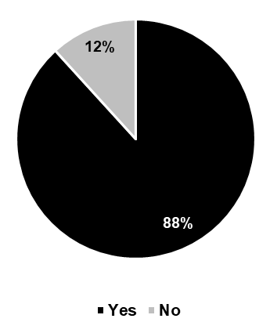

    - Do you live on the Bellarine Peninsula?

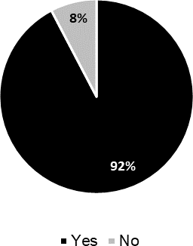

    - Do you use the Drysdale Landfill Resource Recovery Centre?
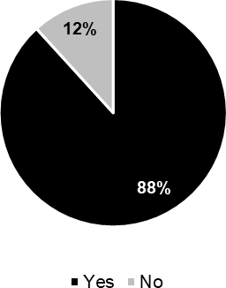

    - Which of the three landscape plan options* do you prefer?

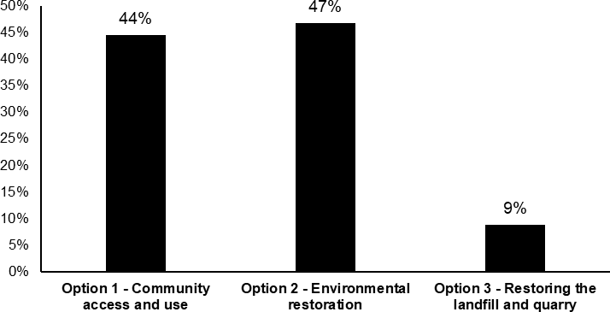

*Refer to Appendix 1 for each of the three landscape plan options.

Summary of common themes
    - 92% of liver on the Bellarine Peninsula and 88% use the Drysdale Landfill Resource Recovery Centre indicating strong local community engagement and interest in the future of the site.

    - Option 1 (44%) and Option 2 (47%) were evenly supported indicating local preference is for both community access and environmental restoration at the site.

    - There were concerns raised about the threats from ongoing landfill operations including:
- windblown litter
- potential contamination of the creek and Swan Bay
- vehicle traffic impacts
    - Several respondents suggested a hybrid model combining the proposed environmental restoration objectives with improved community access for walking, dog walking and a potential equestrian trail link.

    - Local residents requested new public road access between Becks Road and Founds Road.

    - Respondents queries why an earlier proposal for establishment of mountain bike tracks has been removed from Options displayed for consultation.

List of detailed comments

Option 1
    - Important to provide areas of open space for community access and use as density increases (1)
    - Inclusion of dog off lead walking area. (1)
    - Why have mountain bike tracks been removed? (3)

Option 2
    - Public access for walking and cycling along the maintenance track could be included in this option (1)
    - Phytocap provides best basis for future revegetation (2)
    - Best option to improve biodiversity (5)
    - Good way offset increased development elsewhere in the region (1)
    - Extended timeline is disappointing, increasing depth of Phytocap could address this to a degree (1)
    - Support continued creek restoration (4)
    - Water quality testing should be maintained, and water only released once tested safe for release? (1)
    - Support fencing to keep feral animals out (1)
    - Could existing chain mesh fence be used to keep animals out?
    - No dogs should be allowed in the area (1)
    - Add an information centre to the site (1)

Option 3
    - Waste of landscape and wildlife asset if quarry is filled in (2)
    - Volume of truck traffic crossing the Bellarine will adversely impact the amenity if quarry is filled in (2)
    - Concern regarding litter and quality of clean fill and risk of contaminating the water table that leads to Swan Bay if the quarry is filled in (2)

General
    - Re-visit previous idea put forward for a horse trail to be put through the area (1)
    - Wheelchair/disability access to be designed to be independently accessible, not just with aid of carer (1)
    - Consider wheelchair/disability path grades to be 1:16 rather than 1:14 to allow for easier independent access (1)
    - Options are essentially all the same even factoring in landfill cost (2)
    - Combination of Options 1 and 3 is possible (3)
    - Connectivity is the issue – none of the options provide access from Becks Road to Founds Round (1)
    - 24/7 access needs to be provided from Becks Road to Founds Road preferably car access, but foot, bicycle and horse riding access as a minimum (5)
    - Heavy traffic flow on Murradoc Road reduces areas where children can play safely
    - Room for access to north of this site near the West Stormwater Pond and Green Waste Recovery area (1).
    - Any works at the site to be undertaken inline with the principles of Distinctive Areas and Landscape documents. (1)
    - Maintain current water quality testing regime for dams associated with Drysdale Tip to ensure contaminants do not negatively affect farmland and animals, regeneration areas, vegetation, local fauna or flow into Swan Bay further downstream (1)
    - Concerned about removal of stormwater dam in Options 2 and 3 because impossible to guarantee quality of liners degrading over time or integrity of leachate capture system especially in extreme rainfall event (1)

Extended Responses

    - Geelong Environmental Council (GEC)
Geelong Environment Council (GEC) strongly supports a decision for the COGG to proceed with Option number 2, Environmental Restoration.

It is a once-only chance to increase biodiversity, make an identifiable tourist destination on the Bellarine and create a very significant indigenous parkland in the heart of the Bellarine.

A unique opportunity would be provided for ‘nature’ experiences and wildlife viewing, environmental education, and community involvement in what will be a momentous restoration project with lasting values appreciated for many years in the future.

GEC recognises the following values of the site and the potential for increasing indigenous vegetation and maximizing bird and habitat values. Opportunities for nature tourism at the Tip redevelopment site would establish the region as a significant environmental destination.

The site is situated within the Bellarine Peninsular hinterland and is within the Swan Bay catchment, a part of the Port Phillip Bay Ramsar site. Swan Bay is a vital site for protection of migratory birdlife and as a fish breeding nursery. Drainage via streams to Swan Bay would be protected from pollution by environmental restoration of the Tip .

Increase of biodiversity in a wider area of the Bellarine and a significant increase in biodiversity in the Geelong region.

The Drysdale Tip is situated within a rural farming region. It can be claimed as being the heart of the Bellarine, and a place from where vegetation links throughout the region can be established. Roadsides and streamside restoration would provide an opportunity to increase biodiversity within the rural and attractive landscape. Geelong’s approximately 5% of remnant vegetation is a sad reminder of the huge loss of biodiversity, wildlife areas and lack of indigenous parklands on the Bellarine.

GEC notes that there is very little indigenous vegetation remaining on the Bellarine Peninsular with early settlers removing most of the woodland EVCs and large areas of coastline have been cleared and developed. The Ocean Grove Nature Reserve is the only remaining intact large area, with remnant strips along unused roads or occasional small areas on private land being the remaining indigenous vegetation.

The Ramsar and associated lakes and wetlands together with an indigenous large Tip nature restoration project, and popular coastal beach and town areas, would create and increase the Distinctive Areas and Landscape values found here. These have been recognised in the Victorian Government DAL Planning Statement.

A great opportunity to restore Bellarine biodiversity and provide habitat for wildlife and a tourism destination on the Bellarine. The closure of the Tip site has provided a fantastic opportunity to restore a significant area of the Bellarine with indigenous vegetation and increase biodiversity in the Geelong region.

An opportunity for a whole new biodiverse tourism attraction in the Bellarine area will be created

Coastal beaches, townships and the wine industry will become a part of a more diverse, environmentally significant area and will provide visitation opportunities to another level of environmental and natural assets. The tip is situated in an attractive rural landscape with magnificent views from the top of the landfill. This will add to the attractions of the restored site.

Option 1 and 3 are not supported.

    - Bellarine Landcare Group (BLG)
We agree that, to re-establish ecological integrity, it is best to restore the waterway to its original course. However there continues to be some concern about potential contamination downstream. The current practice of releasing water into the creek from the landfill site only after it has been monitored and cleaned, has been working well. So, both from an environmental and farming perspective we believe it is a good option to temporarily retain the stormwater pond as outlined in Option 1 and release clean water from it into the creek. This gives the council some control in heavy rainfall periods in the unlikely event that contaminants are leached in to the waterway. A number of farmers downstream have expressed that removing the dam has the potential to contaminate the water downstream and affect their stock. From an environmental perspective potentially unmonitored water flowing into Swan Bay, although unlikely, could have significant effects on the biodiversity of Swan Bay. The stormwater pond could be returned to a waterway and replaced with reed beds once there is confidence that the risk of contamination has declined.

The Quarry site should be made safe and opinions vary on whether the site should be filled in or remain as is. From an environmental perspective care should be taken as to what fill is used, if the quarry is filled. If so, would it be monitored in the same way as the landfill site? Contaminating the creek and Swan Bay via the quarry’s water table is a major concern, as “clean fill” is difficult to monitor. Another concern with filling in the quarry is the huge amount of truck traffic that would be generated across the Bellarine, with its implications for noise and air pollution, detriment to amenity and inconsistency with a Distinctive Area and Landscape. If the quarry is to remain unfilled BLG supports the return of grassy woodlands to appropriate sites and the quarry’s use for habitat and landscape values.

Walk/ bike access from Founds to Becks or Murrodoc Rd. should be established once the site is established and safe, whichever Option is chosen.

The locals of Becks Rd would like restricted vehicle/ emergency vehicle access to Founds Rd. A second exit point is critical for those living opposite this site.

Maintaining the existing chain mesh fences as the basis for a vermin proof fence in the future, could potentially save money and time in securing this area for indigenous fauna.

BLG supports the development of the current landfill site using new technology (phytocap) to facilitate planting. The deeper the phytocap, the better. The establishment of grassy woodland vegetation plots will enhance the amenity of the site as well as its benefits to indigenous flora and fauna.

BLG supports maximising habitat values by restricting dogs to the former landfill site along Founds Road and by restricting public access to certain areas (e.g., the quarry and part of the current landfill site).

Response to community feedback on the Draft Landscape Plan Options
The following provides a direct response to issues and suggestions raised in community consultation on the Draft Landscape Plan Options as displayed for comment. The number of respondents for each topic, including those received via the website, via e- mail are noted in brackets where more than one person commented. The response column outlines the proposed recommendation for changes to the plan for consideration in finalisation of the Landscape Plan.

No. | COMMENT | RESPONSE
1. ENVIRONMENTAL
1.1 | - Waste of a wonderful asset of great landscape and wildlife value, if the quarry is filled in.  - Litter control over quality of clean fill so  risk of contaminating water table and there Swan Bay, if Quarry is filled in.  - Revegetation will at least partially offset  the amount of land clearing that has occurred on the Bellarine associated with past agricultural development and present residential development.  - Important to keep it natural | The existing quarry has no indigenous vegetation and the steep embankments and deep water present an ongoing safety risk and limited habitat value.  Filling the quarry with clean fill will provide a source of funding for landfill environmental rehabilitation works and will reduce operational costs for Council major projects requiring a clean fill disposal site.  Ultimate rehabilitation of the natural undulating landform at completion of clean fill operations and restoration of indigenous Grassy Woodland vegetation originally found on the site will provide the highest long term biodiversity improvement and is consistent with Bellarine Distinctive Area Landscape values.  Recommendation:  Adopt Option 3 – filling the former quarry with clean fill to match the natural undulating landform and undertake indigenous revegetation as  Grassy Woodland.
1.2 | - Maintain the existing chain mesh fences as the basis for vermin proof fence in the future, could potentially save money and time in securing this area for indigenous fauna. (2) | Chain mesh fencing will be retained short term for site security and could assist in rabbit control during revegetation establishment at completion of landfill operations.  Recommendation:  Show existing fencing retained.
1.3 | - The Quarry site should be made safe  and opinions vary on whether the site should be filled in or remain as is. From | Refer Item 1.1

No. | COMMENT | RESPONSE
an environmental perspective care should be taken as to what fill is used, if the quarry is filled. If so, would it be monitored in the same way as the landfill site?
- Contaminating the creek and Swan Bay via the quarry’s water table is a major concern, as “clean fill” is difficult to monitor.
- If it is unfilled it will become an
unnecessary risk as more residents use this as a recreation area.
- There are no plans revealed for the
disused quarry if it is left unfilled.
1.4 | - Actively encourage restoration and breeding heritage programs.  - Maximum effort to revegetate to entice birds and native animals back to the area and then protection of these from humans.  - Provides a unique opportunity for  ‘nature’ experiences and wildlife viewing, environmental education and community involvement in what will be a momentous restoration project with lasting values to be appreciated well into the future.  - It is disappointing that the timeline for  rehabilitation has been pushed out by so many years. | Active environmental restoration works have commenced along the central waterway section and at the Phytocap trial site using indigenous planting which will begin to attract local bird species as it becomes more established.  Recommendation:  Support ongoing revegetation at the landfill site where possible to reduce time required to achieve environmental restoration.
1.5 | - To re-establish ecological integrity, it is best to restore the waterway to its original course. However there continues to be some concern about potential contamination downstream.  - The current practice of releasing water  into the creek from the landfill site only after it has been monitored and cleaned, has been working well.  - Both from an environmental and farming  perspective we believe it is a good option to temporarily retain the stormwater pond as outlined in Option 1 and release clean water from it into the creek. This gives the council some control in heavy rainfall periods in the unlikely event that contaminants are leached in to the waterway.  - A number of farmers downstream have expressed that removing the dam has the potential to contaminate the water  downstream and affect their stock. | The landfill operates with two types of dams: A leachate dam which holds contaminated water collected at the base of filled landfill cells, and stormwater dams which catch surface water running off the non-landfilled areas of the site. There is no connectivity between the surface water dams and the landfill cells so contamination of these water bodies from waste material is not possible.  Leachate is pumped from the leachate dam via an underground piping system and is discharged into a nearby sewer connection.  Water from stormwater dams onsite has a high sediment content, which is very common for farm dams in the area. To ensure compliance with EPA  regulations, the stormwater is treated

No. | COMMENT | RESPONSE
 | - From an environmental perspective potentially unmonitored water flowing into Swan Bay, although unlikely, could have significant effects on the biodiversity of Swan Bay.  - The stormwater pond could be returned  to a waterway and replaced with reed beds once there is confidence that the risk of contamination has declined.  - Frederick Mason Creek flows through  our property to Swan Bay. We use the water from this creek to water our cattle. The creek enters the property through a fenced off area, where there has been trees planted along the bank of the creek to allow regeneration. After leaving our property the creek runs into Swan Bay. It is important to us that the water flowing down the creek does not contain any contaminates. The dams which are associated with the Drysdale tip must remain and the current testing regime of water from these dams be maintained. Without the storm water dams there is a risk, during an extreme weather event, that the landfill site would flood and fail allowing contaminates to go into the creek.  - Option 1 maintains the leachate dam, which is important, but it is not clear if the testing regime for the storm water dams will to be maintained before water release. It is important that the testing regime of water from the storm water dams is maintained to ensure there isn’t any contamination of the water going into the creek. Any contamination of the creek would have a catastrophic effect not only on the vegetation and animal life along the creek but also on stock and farming businesses and of course Swan Bay.  - While the landfill cells are currently  sealed, it is impossible to guarantee the long term integrity on any of the liners which are at risk of breaking down over time, or the integrity of the leachate capture system especially in an extreme rainfall event which is why I am concerned about the removal of the stormwater dam being put up in Options  2 & 3. | using a clarifier unit which removes the sediment from the water. The treated water is then released into the downstream waterway.  Regular testing of this water is undertaken by a third-party environmental consultant to ensure there are no detrimental impacts to the receiving waterway.  Option 2 and 3 included the reset of the eastern stormwater pond as a wetland at completion of landfill operations to maximise bird habitat values. Option 1 retained the existing form with the dam wall allowing for the detention of more water on the site.  Under all options leachate will continue to be captured and discharged via the sewer connection. All water discharged from the site will continue to be monitored in accordance with EPA requirements and to protect the Swan Bay catchment.  Recommendation:  Retain the existing dam in its current form maximising retention if water on the site while extending the ephemeral planting zone around the perimeter to improve bird habitat.  The above rehabilitation works will commence at completion of landfill operations with existing detention and discharge arrangements to continue in accordance with existing environmental management requirements.

No. | COMMENT | RESPONSE
 | - While the environmental works proposed in the rehabilitation plans are positive, the closed landfill should still be viewed as a contaminated site and steps need to be put in place to protect the downstream environment and properties in the event of several components failing at some point in the future.
 | - Filling in the quarry would also introduce an extra risk of contaminating the creek and Swan Bay through the quarry’s water table . “Clean” fill would have to be carefully monitored which would be difficult and expensive. | Clean fill to the site will be closely monitored as part of the existing Drysdale Waste and Recycling Centre Operation. Strict testing/analysis will be undertaken to ensure all material used to fill the quarry is clean fill.  Recommendation:  Adopt Option 3 – filling the former quarry with clean fill to match the natural undulating landform and undertake indigenous revegetation as Grassy Woodland. Monitoring of operations will continue to be controlled at the waste and recycling  centre.
2. TRAFFIC

 | - Too many trucks traversing the Bellarine impacting adversely on the amenity, if the Quarry is filled in traffic impacts will continue.  - Filling in the quarry would generate  considerable traffic across the Bellarine, increasing noise and air pollution, reducing the amenity and introducing inconsistency with the Distinctive Area  and Landscape. | There is currently only access to the site is from Becks Road.  Recommendation:  Investigate opening a second entrance to the site off Founds Road to primarily service the clean filling works associated with the former quarry. This will reduce the truck traffic along Becks  Road.
3..ACCESS
3.1 | - Walk/bike access from Founds Road to Becks Road or Murrodoc Road once the site is established and safe irrespective of which option is chosen. (3)  - Locals of Becks Road would like  restricted vehicle/emergency vehicle access to Founds Road. A second access point is critical for those living opposite this site.  - Speed limit on Murradoc Road makes it  dangerous for horse riding, walking or cycling, access to Founds Road for these activities would provide locals | Options 1, 2 and 3 provide walking/cycling access between Becks Road and Founds Road. However there is no strategic basis for upgrade of this as a regional link in the Cycling Plan at this stage.  At this stage the aim will be to have the site publicly accessible at all times with fenced security to the waste recycling centre only.  Recommendation:

No. | COMMENT | RESPONSE
 | better and safer access to their own community.  - The previously put forward idea of a  horse trail through the area is a good one. (3)  - Public access for walking and cycling  could be included in this option, along the maintained vehicle access tracks.  - Options only provide walk/ride access from Becks Road that cuts back through the Resource Recovery Area and therefore it will most likely need to have restricted access for security reasons. | At completion of landfill operations establish local community walking/cycling access between Becks Road and Founds Road via existing tracks.  Investigate future bridal trail access along the boundary to provide a route away from potential dog off lead zones and areas of higher future environmental values.
3.2 | - Include dog off lead area.  - No dogs should be allowed in the area  - Support maximising habitat values by restricting dogs to former landfill site along Founds Road and restricting public access to certain areas (eg quarry and part of the current landfill).  - There is ample area for dog walking  around and open grassy ovals on the Bellarine for open-space recreation but extremely little of this habitat for protection of native species and indigenous flora and fauna/ | There is currently a shortage of fenced dog off lead areas across the Greater Geelong area. The large open grass area (11ha) in the north east corner of the site has been capped and has separate access from Founds Road. This site has magnificent elevated views and must remain as mown grass as part of the EPA capping requirements. It would make a suitable dog off lead area as fencing could be installed to the western and southern boundary to separate the area from current landfill operations and the quarry however amenity at the site due to the smell will be poor until operations cease.  Recommendation:  Establish an 11ha fenced dog off lead area in the north western corner of the site, subject to review of need for this facility at completion of the landfill  operations.
3.3 | - Connectivity is the issue. None of them provide public road access from Becks Road to Founds Road. This cuts off the advantages that can be gained from the site being a community and tourism asset. Access needs to be provided 24/7 from Becks Road to Founds Road preferably car access but foot and ride access as a minimum. This will allow for a pathway to be created from Ocean Grove to Portarlington on the highest parts of the Bellarine Peninsula. What a fantastic asset for tourism and community members!! There is room  for this access to the north of this site | Local residents requested new public road access between Becks Road and Founds Road in previous correspondence. Internal Traffic Assessment concluded that there is no current requirement for public road access in this area.  Clean fill operations at the former quarry site will require use of the existing weigh station and a new haul road. The haul road could then be used as an exit only out onto Founds Road to reduce truck traffic in Becks  Road. At completion of clean fill

No. | COMMENT | RESPONSE
 | near the West Stormwater Pond and Green Waste Recovery Area. Please do not cut this option off. | operations the unsealed haul road could potentially be used as a public road subject to re assessment of traffic access requirements at the time.  Recommendation:  Re investigate the need for public road access between Becks Road and Founds Road at completion of clean fill operations and prior to decommissioning of the proposed  unsealed haul road.
3.4 | - Inclusion of the green waste area on the neighbouring property is an uncertain and unnecessary addition as other locations and options exist for this activity. Its inclusion prevents direct vehicle access from Becks Road to Founds Road which is a desirable outcome for the residents of Becks and Founds Road. | The green waste recovery area is part of the existing Waste Transfer and Recycling Operations at the site and will be still needed at completion of landfill operations at the site. There is no alterative site for this area which required direct access from the waste transfer facility.  Recommendation:  Retain existing green waste recovery area.
3.5 | - Needs more mountain bike tracks. Why have they been removed? (2)  - Potential mountain bike track in key but not on plan? (2) | The use of the former quarry site was discussed as a potential mountain bike area in early discussion of options for the site however there are currently other sites servicing this use and the risk associated with the steep cliffs and the limitation imposed by this use on future environmental rehabilitation at the site meant it was not included in options displayed.  Recommendation:  Provision of a dedicated mountain bike track network in the former quarry is not supported.
4. GENERAL
4.1 | - All these options are basically the same even the cost if you factor in refilling the quarry site. (2)\  - Combination of all 3 options is possible  - Combination of Option 1 and 3. Option 1 to make the area a community recreation area with potential for other activities such as mountain biking and Option 3 to fill the quarry.  Merge Options 1 and 3 to create a 4th option | Various options for the site were proposed to seek community input on future development and environmental restoration at the site. Option 1 (44%) and Option 2 (47%) were evenly supported indicating local preference is for both community access and environmental restoration at the site.  Recommendation:  Adopt a hybrid model combining the  proposed environmental restoration objectives with improved community

No. | COMMENT | RESPONSE
access for walking, dog walking and a potential equestrian trail link while noting that income generated from clean fill operations at the quarry
remain and important source of funding for implementation of works.
4.2 | - Any works done to this site should be consistent with the Bellarine Distinctive Areas and Landscape values. | Works will be consistent with the Bellarine Distinctive Areas and Landscape values.  Recommendation:  Include reference to the Bellarine Distinctive Areas and Landscape  values on the final plan.
4.3 | - Addition of an information/education centre explaining gas produced used to provide power/waste to energy benefits. | Noted  Recommendation:  Include additional information regarding sustainable power at the  Waste Transfer Station.
4.4 | - Work with local community organisations, i.e. Landcare Bellarine, and other volunteer based groups, to rehabilitate the site. It is imperative, especially after the imposed Drysdale bypass we've had to endure the past few years. | Ongoing landfill operations including high volumes of vehicle and truck movements within the site make community involvement in initial rehabilitation works difficult to safely manage.  Recommendation:  Local community groups will be an important part of future site rehabilitation at completion of landfill  operations.
4.5 | - Some form of availability for people to enjoy the area would be good but not picnic facilities unless specific measures are taken to manage rubbish.  - Opportunities for nature tourism at the  Tip redevelopment would establish the region as a significant environmental destination.  - The tip is situated in an attractive rural  landscape with magnificent views from the top of the landfill. This will add to the attractions of the restored site.  - An opportunity for a whole new  biodiverse tourism attraction in the Bellarine area will be created.  - All options will boost to Bellarine assets  for tourists.  - Serious practical consideration must be given to the entire site regarding  disability access, from toilet facilities, | Picnic areas were not well supported in consultation and are unlikely to be needed until after the landfill and quarry have closed and the site revegetation has become well established – likely 10+ years.  Recommendation:  Review need for additional facilities only when site revegetation has become established.  All paths in the ultimate layout will be established at accessible grades.

No. | COMMENT | RESPONSE
path gradients, allow for independent use of the site by wheelchair users.
- Important to have community access to
a natural environment for recreation as
the surrounding district becomes more populated and built up.

Attachment 1 –
Community Display Plan Options 1, 2 and 3 as used in consultation

City of Greater Geelong is seeking community feedback on the future rehabilitation and use of the site after the end of the landfill operations to identify what are the highest priority actions for the new Drysdale rehabilitation Master Plan and to identify if there are any other issues and opportunities that need to be considered in the development of the plan.
Residents are invited to provide feedback on the draft landfill rehabilitation options via the Council webpage yoursay.geelongaustralia.com.au/DLPCLP or by contacting Council by phone 5272 4961 or via email to Jack Taylor, Project Engineer JTaylor2@geelongcity.vie.gov.au
All feedback must be submitted by close of consultation at 5pm on Wednesday 13 October 2021.
If you would like to be kept informed about the project, please fill out your name and address at the website link and you will be emailed a copy of the Draft Rehabilitation Master Plan when ready for comment and updated on progress of the works at the Drysdale Landfill Resource and Recovery Centre.

DRAWING KEY

- Mw14 GROUNDWATER MONITORING WELL

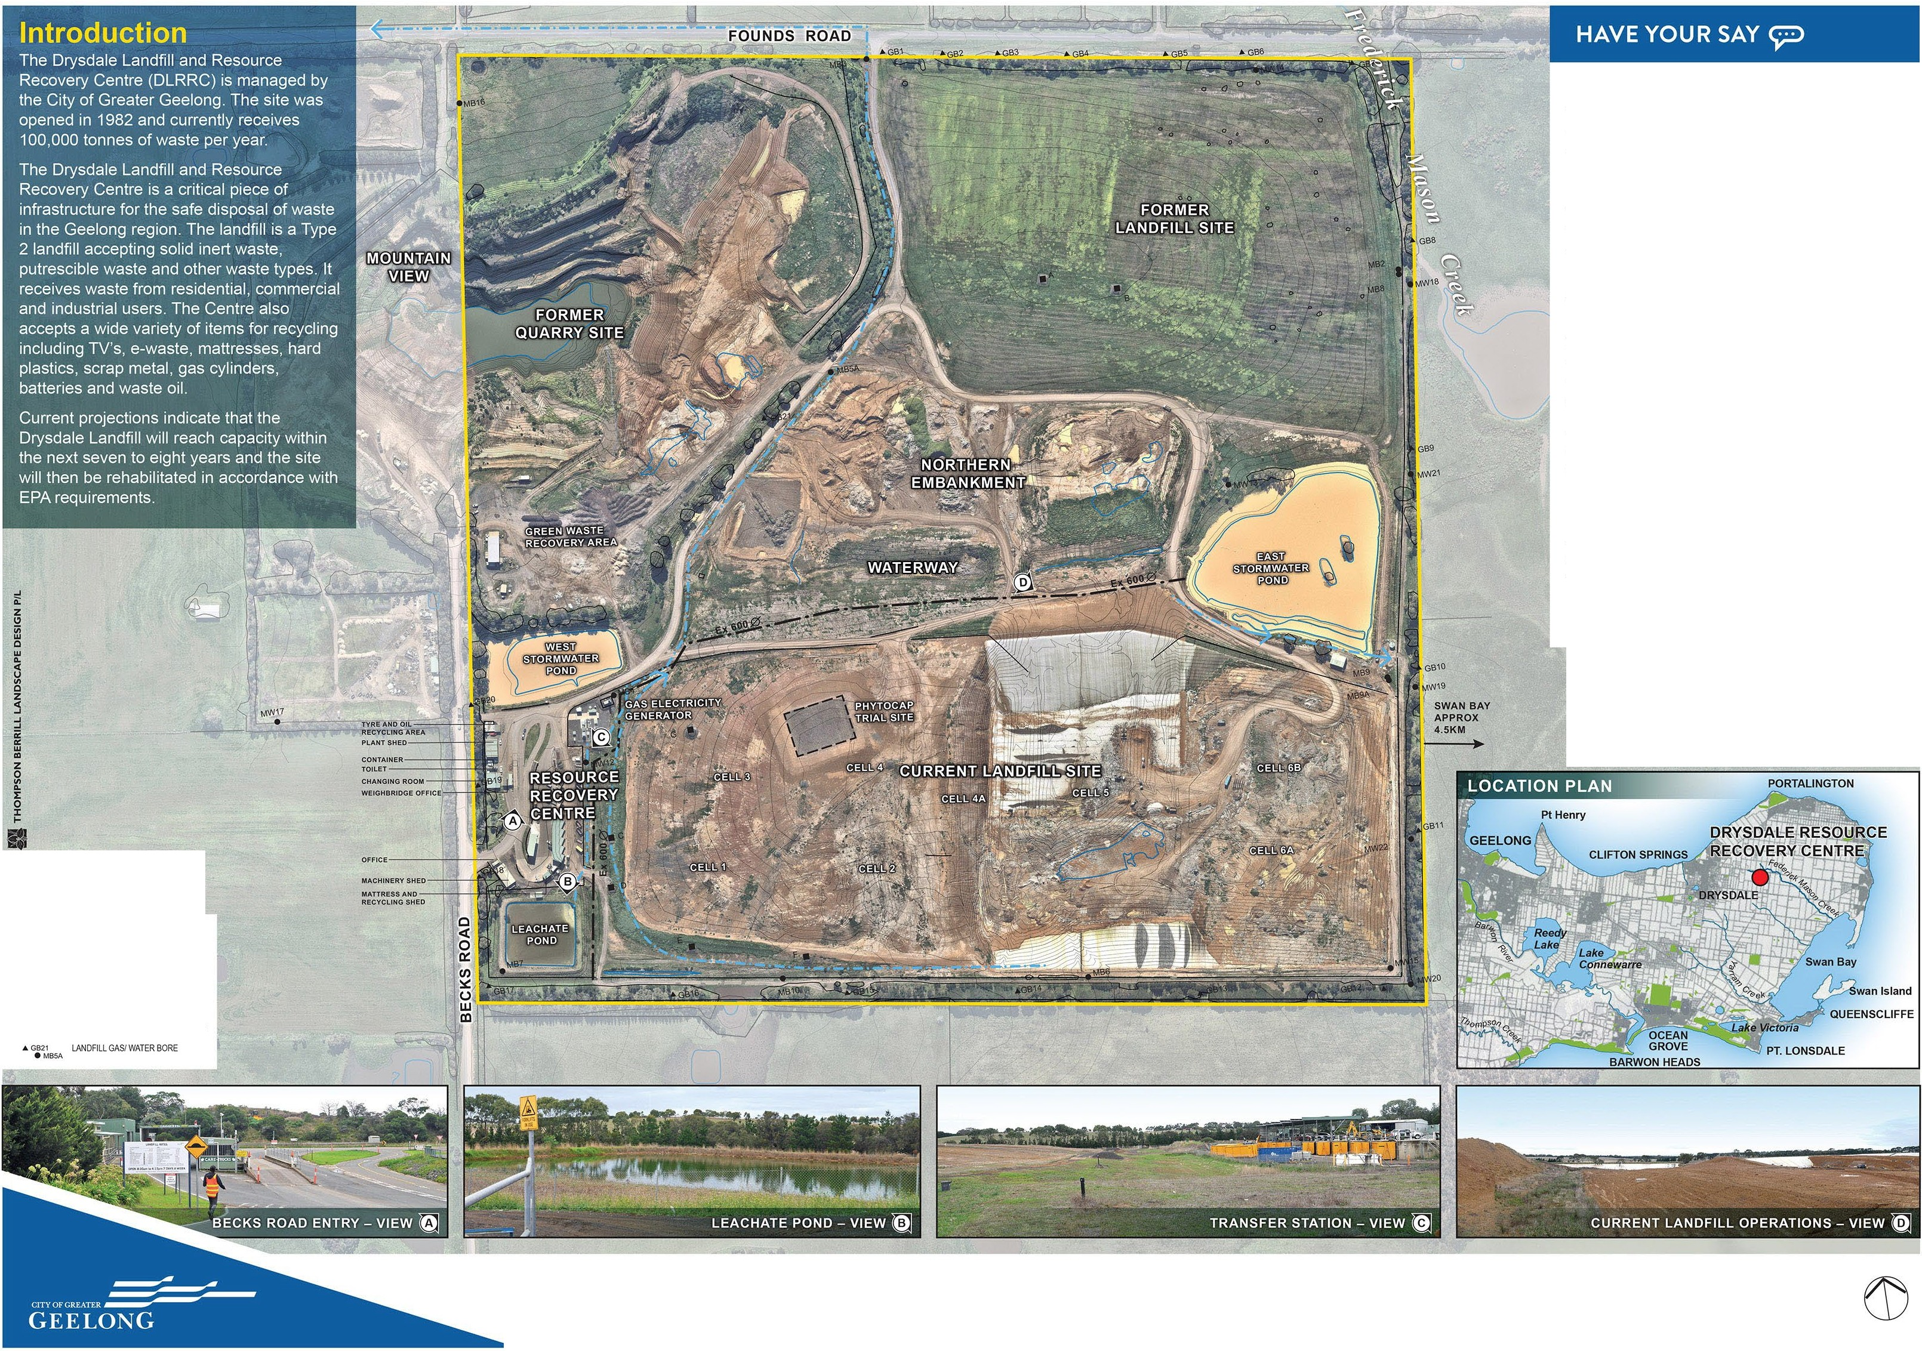EXISTING CONDITIONS I ti: I
DRYSDALE LANDFILL LANDSCAPE PLAN

AUGUST 2021
DRAWING 1OF 4
SCALE 1:2000 (@Al

HAVE YOUR SAY
0
This is only one of three rehabilitation options currently being considered and your comment and feedback is welcome and can be provided via the City of Greater Geelong's website yoursay.geelongaustratia.com.au/DLPCLP or via e•mail to Jack Taylor, Project Engineer, JTaylor2@geelongcity.vic.gov.au by Wednesday 13 October 2021.

-{X&ST..c;V(C(T,UOI' -L".-'-1; QUARRTCUF'(N(:EO
--
at(EKUECAA$ST
RE.STRIClEDJiCC£SSNt£A
0
WOOOlNCIRE\1:Cil£1AIJCR = 0,StN;ONS(JU-O
0
"""""""'"""'°"'""'
""™"""
OOOOPAI04'0llEO
WAre,MAYR(Vt<;ETATl;ltl ."."."."'"""

D OAREA
•••••• l'ROf'OS(t)f{Ol$1ll;WI'

C-.SOORACTllHPOMS
"""""""'
•

tlOCATMON..'I')
"""""'°'""" X¢ N;USSGA.lt:

....
d)
□-"""'"""""

<[Y-

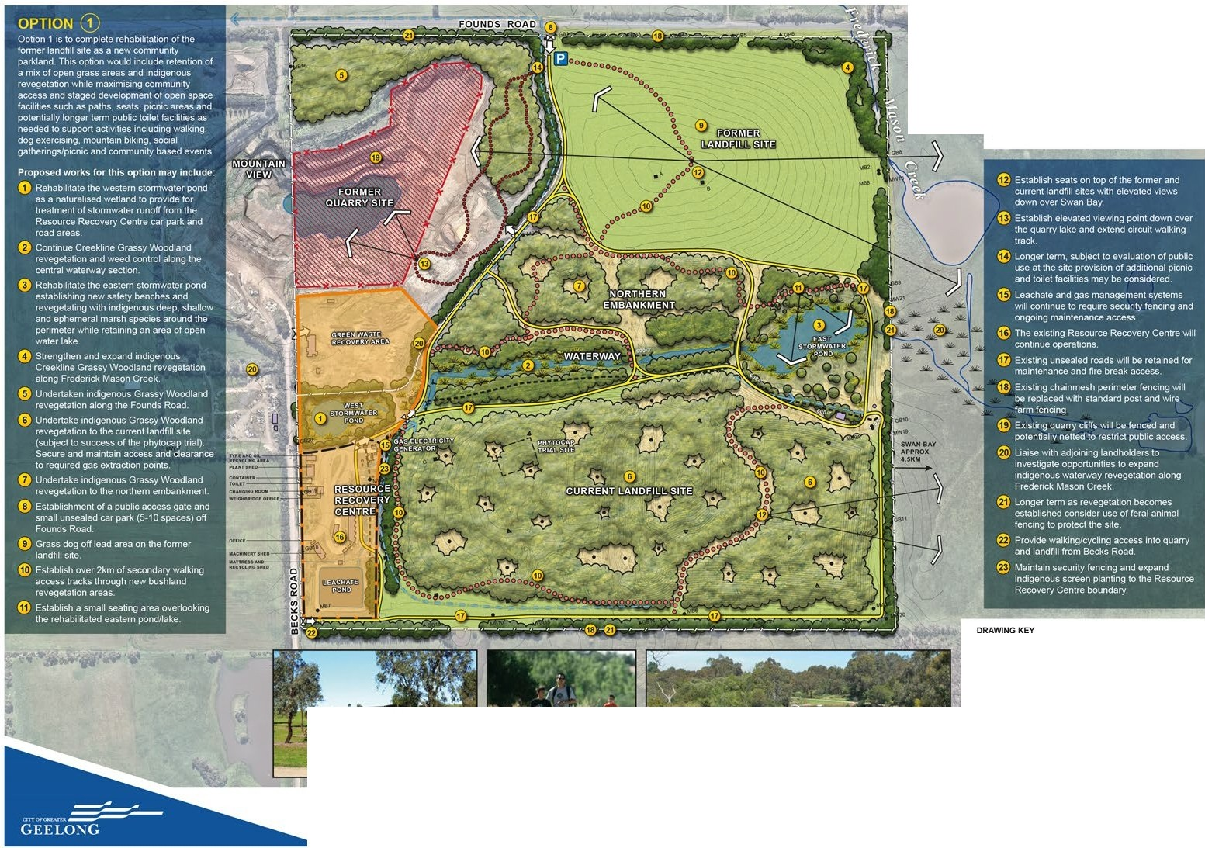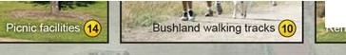OPTION G) - COMMUNITY ACCESS LANDFILL SITE
DRYSDALE LANDFILL LANDSCAPE PLAN
I­
LL
4
c::
0

AUGIJST201' DRAWING 20f 4 SCALE1:2000 (.a)AI

This is only one of three rehabilitation options currently being considered and your comment and feedback is welcome and can be provided via the City of Greater Geelong's website yoursay.geelongaustralia.com.au/DLPCLP or via e-mail to Jack Taylor, Project Engineer, JTaylor2@geelongcity.vic.gov.au by Wednesday 13 October 2021.

EXISTING VEGETATION QUARRY CUFF FENCED RESTRICTED ACCESS AREA
..
CREEKLINEGRASSY
-
WOODLAND REVEGETATION == EXISTINGUNSEALEO
QUARRY REVEGETATION ACCESS ROAD

0 AREA(MODIFIEDJ
0

0 0 0 0 : E A ;ONOARY

GRASSY WOODLAND
REVEGETATION •••••• PROPOSED PEDESTRIAN

WATERWAY REVEGETATION
PATH

000000 POTENTIAL MOUNTAIN BIKE

SLASHEDGRASSEDAREA TRACK

INDIGENOUS GRASSLAND GAS EXTRACTION POINTS GROUNDCOVER ,w (INDICATIVE ONLY) REVEGETATIONAREA

RESOURCE RECOVERY
X¢ ACCESS GATE

D CENTRE -cf KEYVIEWS

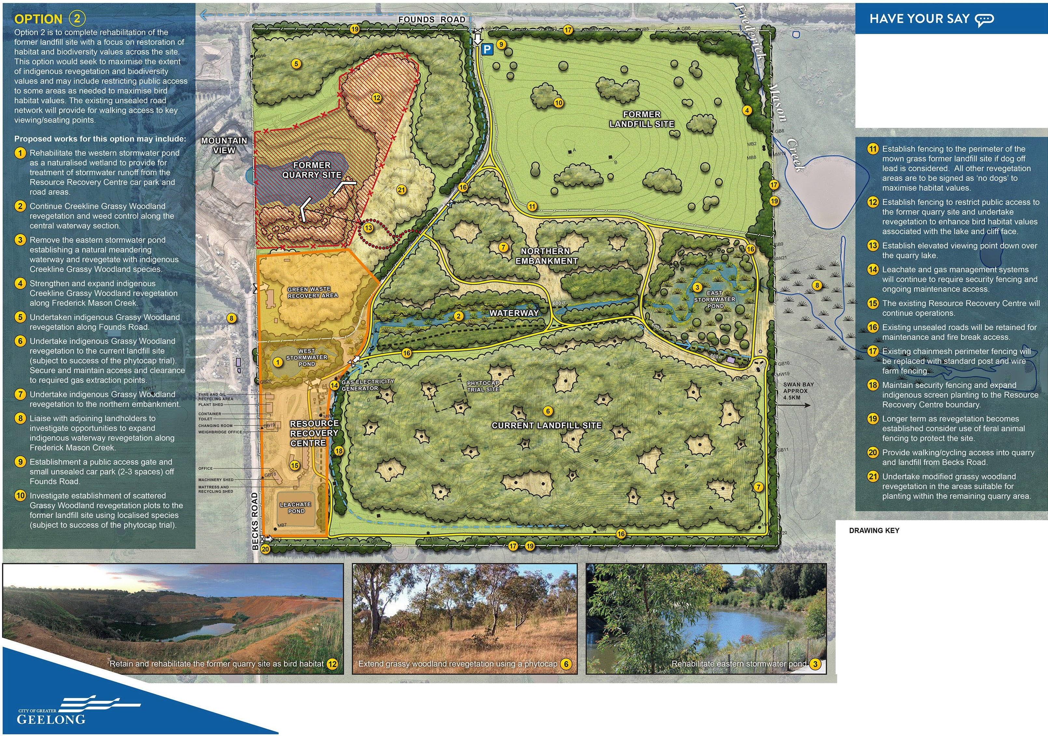OPTION@ - ENVIRONMENTAL LANDFILL SITE

DRYSDALE LANDFILL LANDSCAPE PLAN

<(
c::
Cl

AUGUST 2021
DRAWING 3 OF 4
SCALE 1:2000 (a) Al

This is only one of three rehabilitation options currently being considered and your comment and feedback is welcome and can be provided via the City of Greater Geelong's website yoursay.geelongaustralia.com.au/DLPCLP or via e-mail to Jack Taylor, Project Engineer, JTaylor2@geelongcity.vic.gov.au by Wednesday 13 October 2021.

EXISTING VEGETATION INDIGENOUSGRASSlAND GROUNDCOVER
-
CREEKLINEGRASSY REVEGETATIONAREA
WOODLAND REVEGETATION
D

GRASSY WOODLAND
REVEGETATION
RESOURCE RECOVERY CENTRE

EXISTING UNSEALED

WATERWAY REVEGETATION ACCESS ROAD
SLASHED GRASSED AREA X¢ ACCESS GATE
GAS EXTRACTION POINTS (INDICATIVE ONLY)

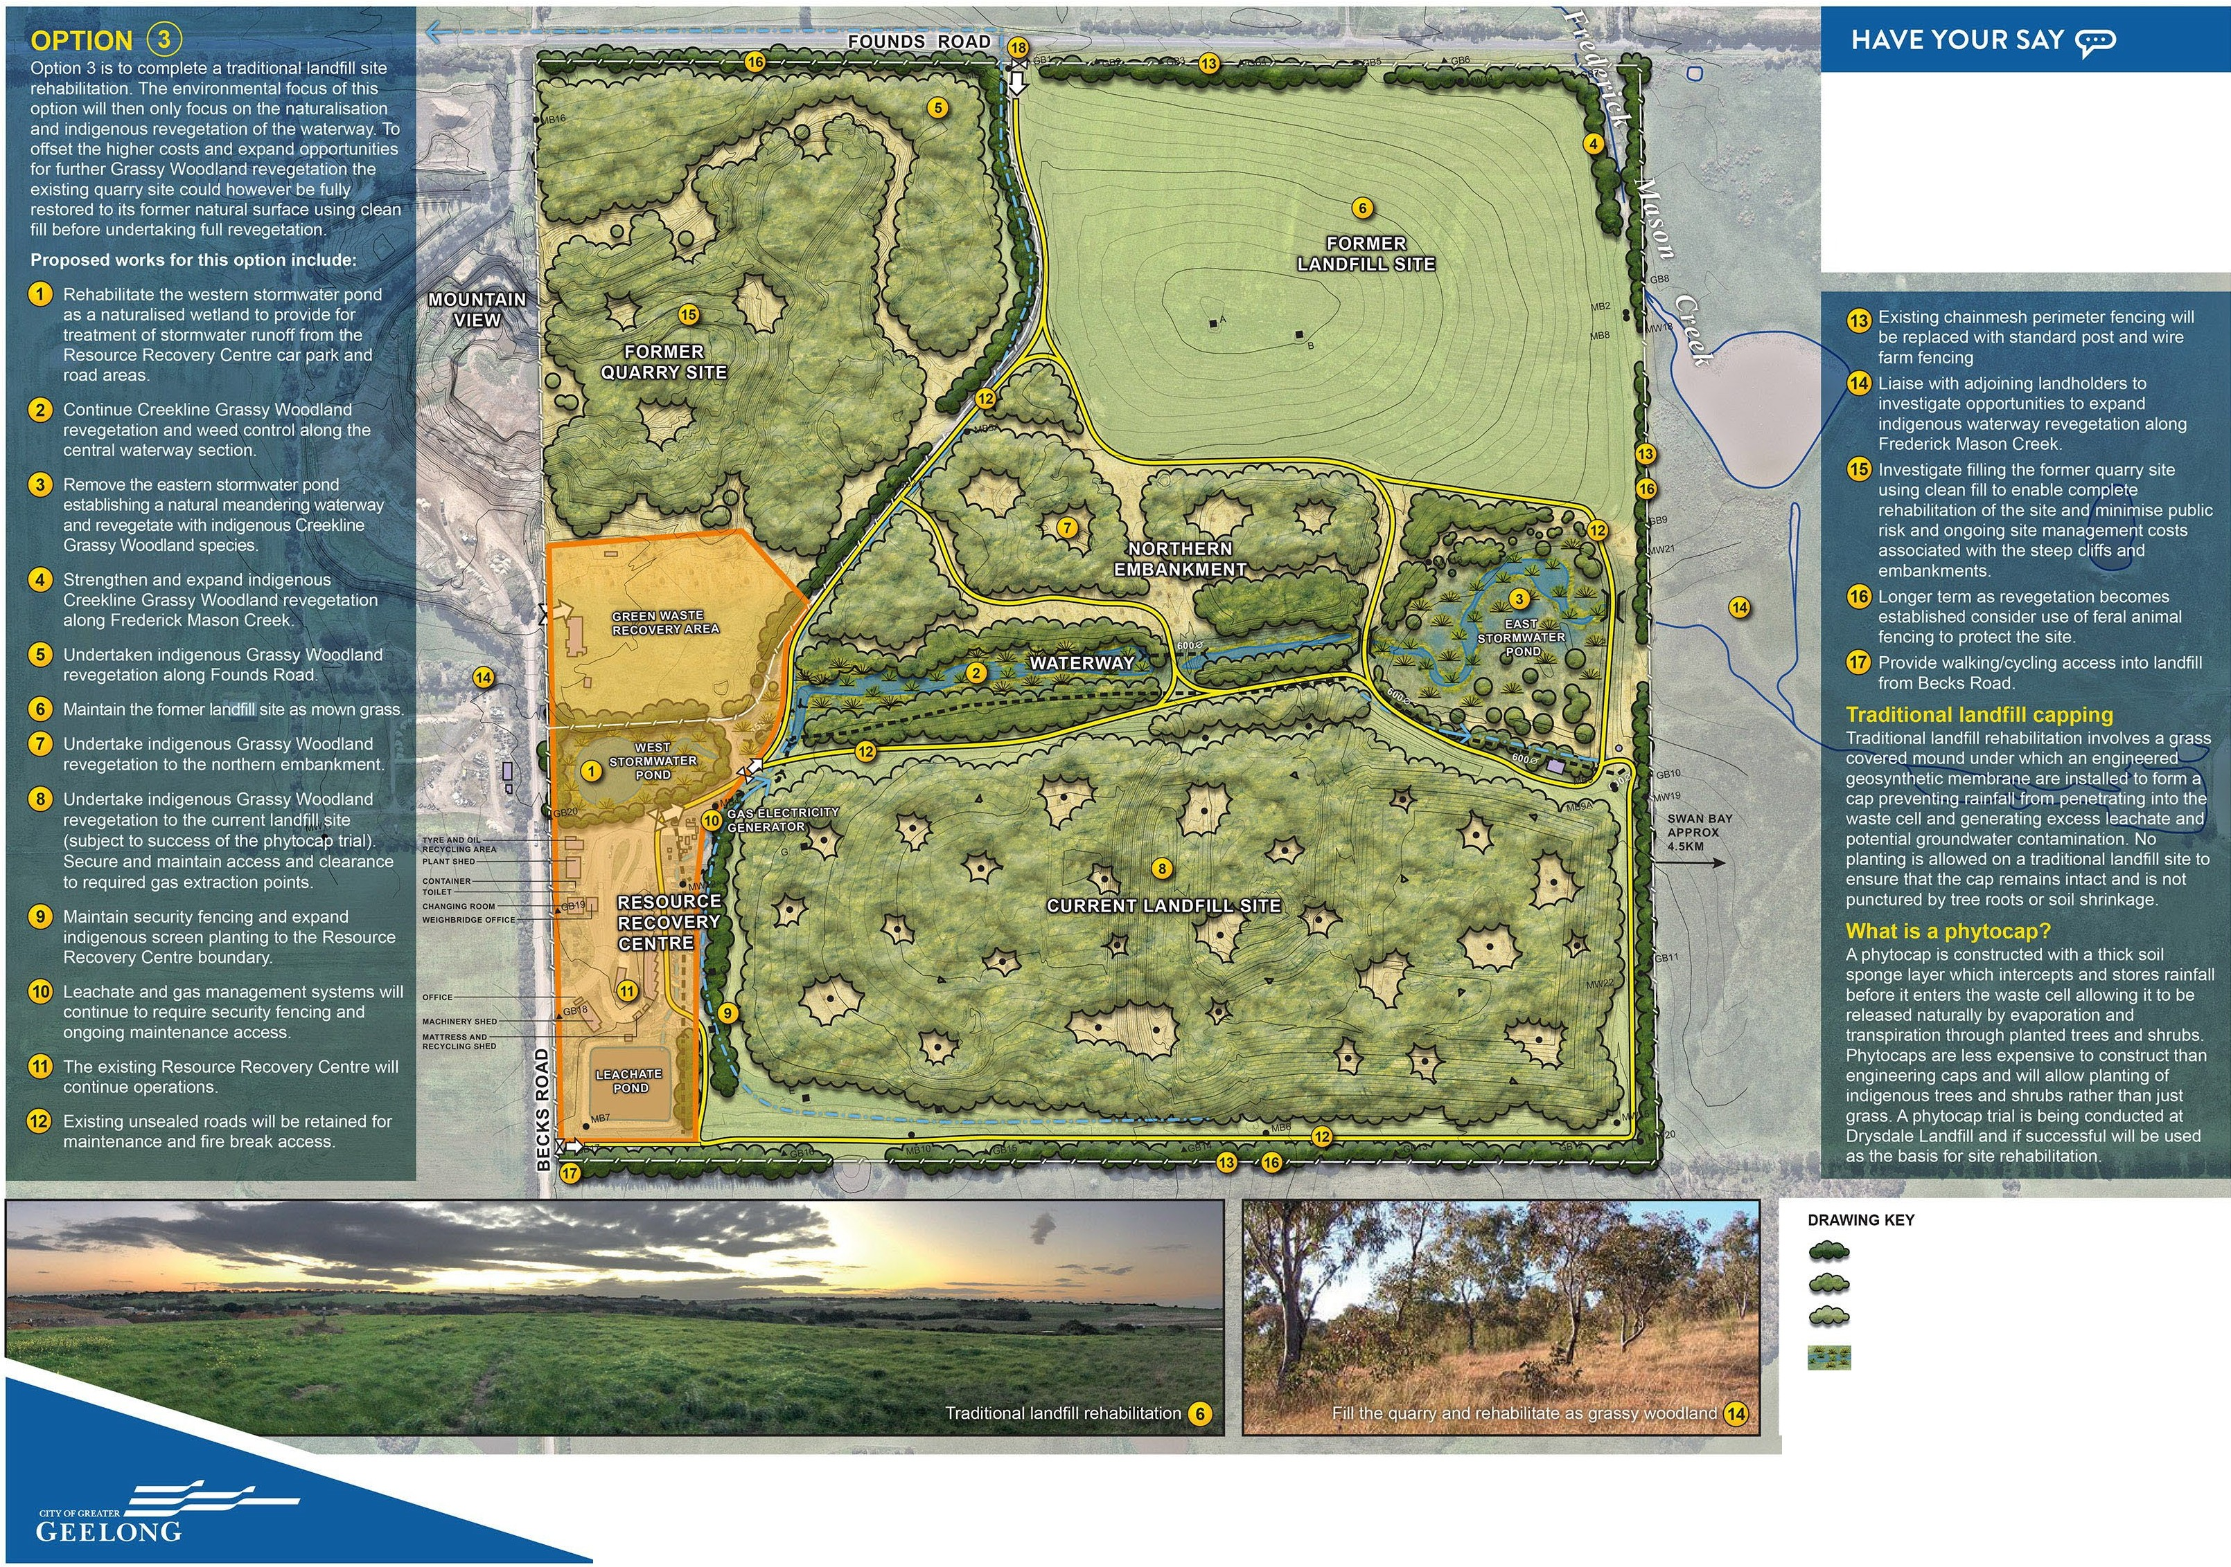OPTION@ - TRADITIONAL LANDFILL SITE

DRYSDALE LANDFILL LANDSCAPE PLAN

<(
c::
Cl

AUGUST 2021 DRAWING40F4 SCALE 1:2000 (a) Al

