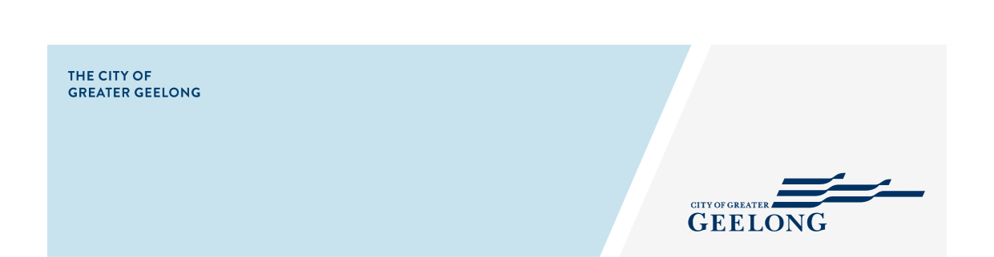

GRIFFIN GULLY JETTY UPGRADES

community engagement summary report

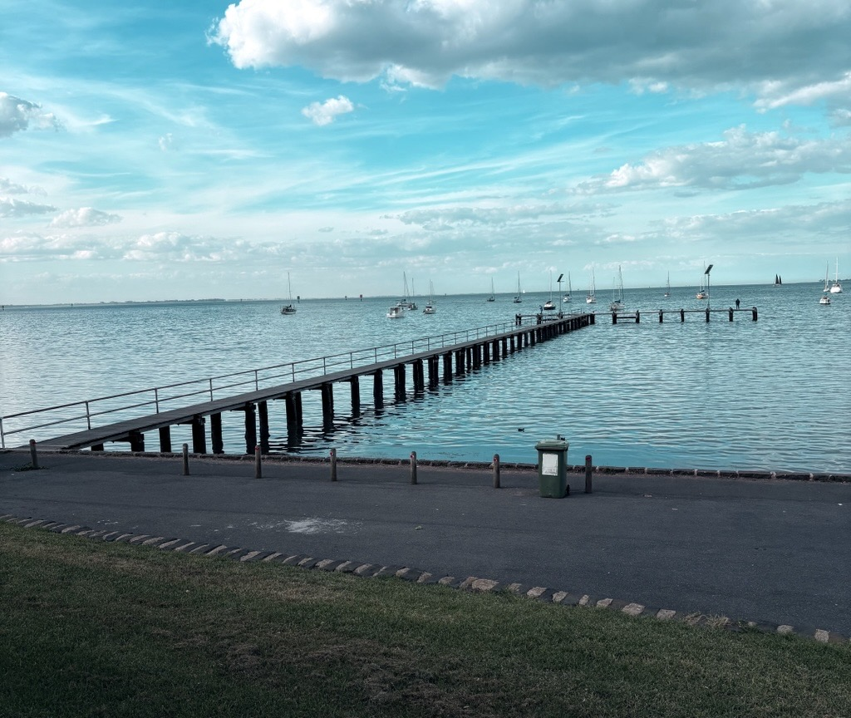
community engagement summary
Introduction
To improve accessibility and comply with Disability Discrimination Act (DDA) requirements, the City is upgrading Griffins Gully Jetty by widening the existing walkway from 1.5 metres to 1.8 metres. As part of these works, the City also proposes to enhance the jetty's functionality and user experience through the installation of new lighting, upgraded balustrades consistent with those at Rippleside Jetty, and additional amenities such as seating and fishing rod holders.
While the widening of the walkway has already been designed and will not be changed as part of this engagement, the City sought input from the community and key stakeholders to inform the selection of additional features.
The engagement process provided valuable insights into who uses the jetty, how it is used, and the improvements users would most like to see. This feedback has enabled the City to make more informed design decisions that better reflect community needs and expectations. The engagement process also strengthened the City's relationship with stakeholders, having been initiated in response to feedback from a community member during an on-site meeting with City engineers.
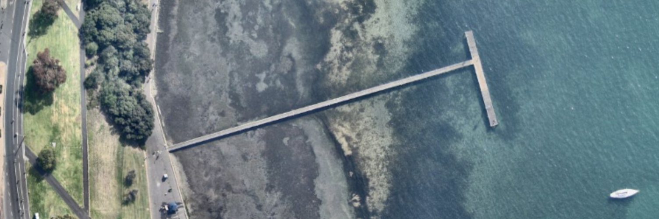
eNGAGEMENT
Feedback on the Griffin Gully Jetty Upgrades consultation has now closed, thank you to everyone who provided feedback, your contribution is valued and appreciated.
Community engagement ran from 14 May to 30 June 2026. Community engagement was to seek your feedback and ideas on features that could make the jetty more enjoyable and user-friendly for the community. This could include things like improved lighting, additional seating, rod holders, or other practical additions. This feedback will help inform the final design.

Over the course of the consultation period the City reached the following achievements:


2
66 online surveys were completed.
405 views of the Have Your Say page.
47 DAYS
of engagement

People shared their stories with us.

DATA METHODOLODY
Participation in this engagement was self-selected, and anyone could respond.

HOW WE ENGAGED

A project specific engagement page was developed to provide project information and methods to engage with the City.
An online survey was used to provide our stakeholders and community to have their say. A hard copy of the survey was available upon request.
A storyboard was also available for our community to share their stories about Griffin Gully Jetty.
Written submissions were open during the public engagement period. Feedback could be provided by email or mail.
Communications
This project employed a targeted communications strategy to maximise engagement with people who use the jetty. To reach this key audience, the City implemented two complementary communication approaches.
- Three A-frame size signs were placed on or near Griffins Gully. Two were placed on Griffins Gully Jetty and one was placed in the carpark. These signs informed people of the community engagement with a QR code which would take them to the “Have Your Say” website.
- A news page was created on the City’s webpage detailing the project and providing a link to the “Have Your Say” website.

what we heard

PARTICIPATION
During the 47 days of engagement:
- 66 people completed surveys on the ‘Have Your Say’ page
- Majority of respondents were regular users of Griffins Gully Jetty
- Respondents used the jetty for a variety of activities, most prominently walking and fishing.
When asked how often they visit the jetty. More than 20% of survey respondents stated they use it daily with approximately 37% using it weekly. This indicates that the jetty is used regularly by many members of the community, suggesting it plays an important role in everyday recreation and access.

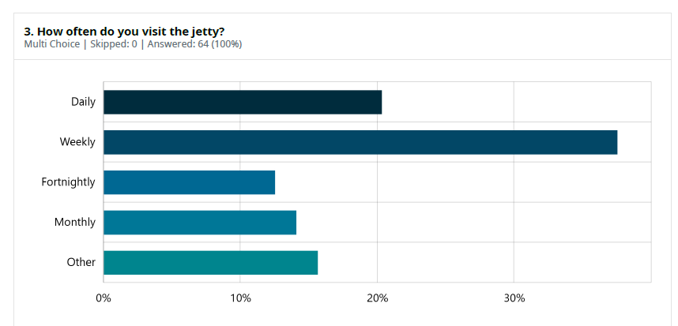
When asked about their primary reason for visiting the jetty, being part of their walk was the most common response, followed closely by fishing and sightseeing. These results highlight the jetty’s diverse recreational value, providing opportunities for everyday exercise, leisure activities and enjoyment of the surrounding environment.
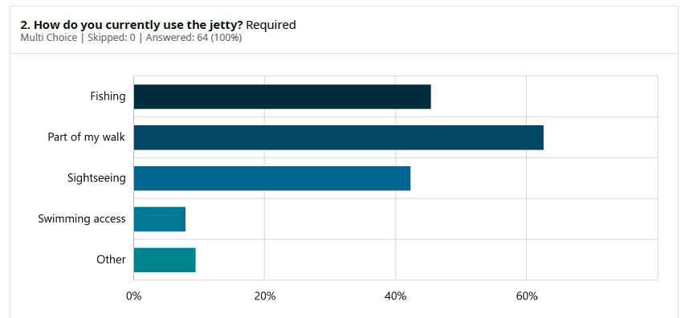

When we asked whether they experienced any barriers when using the jetty, more than 70% of survey repsondents said No.

KEY FINDINGS

Feedback from survey participants highlights a desire for improved safety, accessibility, and amenity at the jetty. While some appreciate the ongoing maintenance and upgrades, concerns are raised about potential trip hazards, inadequate lighting and the need for better facilities such as tables and seating. There's also a strong sentiment for preserving the natural views and accommodating diverse user needs, including those with disabilities and families with children.
There were concerns raised over the lack of toilet facilities in the area. New toilet facilities are outside the scope of this project, though these concerns will be passed on to the relevant department.
OVERALL KEY FINDINGS
The engagement provided a great overview of the jetty’s popularity with a variety of users daily. The key objective of this engagement was to find what features stakeholders would like added to the structure that could improve their experience.
Stakeholders were given a survey to complete that allowed the ranking features that could be added to the jetty to make visits more comfortable. The options were as follows: seating, shade structures, shelter from wind, lighting, lifesaving equipment, edge markers, rod holders, and other.
What did the data tell us?
- Overall seating was ranked the highest of all additions
- Respondents also ranked lighting and rod holders very highly, coming in 2nd and 3rd, respectively
- Whilst shade structures and shelter from wind were also popular options, they were also placed low on a substantial number of lists. Some respondents mentioned the visual impact of adding structures such as these. “Please consider people watching the sunrise without structures blocking this. People sit in their car and watch it rise and do photography. Shade would block the view.”
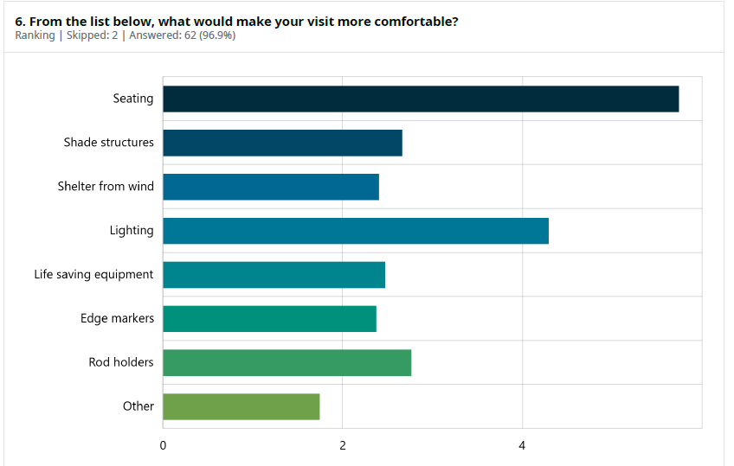

OVERARCHING THEMES
Six overarching themes that came through in the responses from our community include:
- Safety – Respondents mentioned the need for wider and safer walkways on the jett for ease of access onto the jetty.
- Accessibility and Inclusivity - A significant theme is the need for improved accessibility for all users, including those with mobility issues, disabilities, and families with children.
- Amenities and Facilities – Amenities were brought up multiple times, desired additions include seating, tables, and fishing rod holders.
- Lighting and viewpoints – Respondents often mentioned they would like more lighting and spoke about the importance of viewpoints on the jetty.
- Environmental – Some respondents spoke on the importance of maintaining and enhancing the environmental values of the area. Some also suggested the opportunity to add environmental features to the jetty such as artificial reefs and see through panels.

Some verbatim comments we heard from our community
I don't have the ability to sit on the pier any more, I have mobility issues, it would be great if seating could be included
Definitely wider would be better. It does not feel safe when walking side by side with railing on one side because it is narrow.

A wonderful asset and great that it will be made more accessible. People in wheelchairs do not feel secure on Wangim Walk, so this will provide a more stable place to get out over the water.

What you said/What we are doing

You said | What We Are Doing
Respondents mentioned feeling unsafe with the current width of the jetty and potential trip hazards with the older decking and the entrance to the jetty. | We are widening the jetty to 2m wide with kickers making the walkway 1.8m. This will allow for safer access onto the jetty for people of all abilities. The older decking will be replaced with new marine grade timber, that will be regularly maintained to prolong its life expectancy.
The need for improved accessibility for all users, including those with mobility issues, disabilities, and families with children was also raised. | Along with the widening of the jetty, the City is also planning to incorporate new features such as seating to allow the public to rest when reaching the end of the jetty. The handrails will be replaced with new handrailing consistent with Geelong’s other jetties.
The lack of amenities was brought up multiple times, desired additions include seating, tables, and fishing rod holders. | We will incorporate additional seating, extra lighting, upgraded handrails, kick rails and fishing rod holders into the jetty upgrade.
Concerns have been raised over the current inadequacy of the current lighting, and the importance of not blocking viewpoints. | New solar lighting will be placed along the approach of the jetty.
Some respondents raised concerns over the potential environmental impacts of a large project, whilst others suggested the opportunity to add environmental features to the jetty such as artificial reefs and see through panels. | The City will require the successful contractor to submit an environmental management plan before works commence. Works will be conducted on the structure above the water only, which will minimise impact to marine life.  The City is currently investigating opportunities to introduce an artificial reef at Griffins Gully as part of a separate project.
Concerns were also raised over the cost of the project. | This project will be partially funded by Better Boating Victoria as they look to improve the communities access to the water and fishing locations. The City will also undergo a competitive tender process to ensure the successful contractor provides the best value for money.
conclusion / next steps

The community engagement process has played an important role in shaping the Griffins Gully Jetty Upgrade. Feedback received has informed the inclusion of additional seating, safety lighting, upgraded handrails, kick rails and fishing rod holders, alongside the planned widening of the jetty to improve accessibility, safety and overall user experience.
The City is planning to commence the project in 2027, after the peak season. Prior to construction, the successful contractor will be informed of the additions outlined above. All required approvals and permits will be obtained before a competitive tender process is undertaken to appoint a qualified contractor. Once these steps are complete, construction of the Griffins Gully Jetty upgrades will begin.

