The City Of
Greater Geelong

Council plan 2025-29

Engagement report

  - MAY 2025

Contents
Executive Summary 4
Background 4
Engagement Overview 4
Key Findings 4
Next Steps 4
Introduction 5
About this Report 5
Project Background 5
Engagement Purpose 5
How we engaged 6
Have Your Say online platform 6
Survey 6
‘Fund it’ exercise 6
Pop-up conversations 6
Who we engaged 7
Demographics 7
What we heard 9
Key Findings overview 9
Community Vision 9
Priority areas 9
Funding priorities 10
Health and wellbeing priorities 11
What we have done and next steps 14
What we have done 14
Next Steps 14
Appendix A – Survey 15
Have your say for the new Council Plan 2025-29 15
Section 1 - Our Community Vision 16
Section 2 - Council Plan 2025-2029 17
Section 3 - Municipal Public Health and Wellbeing 19
Section 4 - Our Assets 22

Executive Summary

Background
The Council Plan 2025-29 Engagement Report provides an overview of the findings from the online and face-to face community engagement activities conducted July-September 2024 to inform development of the new Council Plan 2025-29.
The engagement aimed to gain a better understanding of the community’s priorities for the municipality and to gather feedback on key planning considerations including health and wellbeing and future asset management.
In addition to the above engagement activities, a panel of community members was also convened to deliberate on what the priorities of the council should be. A separate report has been prepared for this process.

Engagement Overview
To ensure a wide range of community members could participate, the engagement process provided multiple ways to get involved including:
- an online survey and deliberative funding activity
- face-to-face pop-up sessions
- hard copy (paper) survey on request
Participation opportunities were promoted through social media, media releases, and local newspapers.

Key Findings
The community's feedback highlighted several priority areas:
- Environment and Climate Action: Strong emphasis on tackling climate change and promoting sustainable practices.
- Infrastructure and Public Spaces: Need for better maintenance of parks, gardens, and improved cycling and walking infrastructure.
- Health and Wellbeing: Focus on mental health, preventing violence, and reducing harm from alcohol, drugs, and tobacco.
- Arts and Culture: Desire for more support for arts and cultural activities, especially for youth.
- Economic Development: Support for local businesses and tourism to drive economic growth.

Next Steps
The findings from this engagement inform the development of the Council Plan 2025-29.
Following Council endorsement, the draft plan will be available for community consultation allowing further input and refinement before final adoption.

Introduction

About this Report

The purpose of this report is to provide an overview of the findings from the online and in person community engagement conducted July-September 2024 as part of the overall community engagement on Council Plan 2025-29.

Project Background
In Victoria, a Council Plan is a four-year strategic document required by the Local Government Act 2020. It outlines a council's vision, objectives, and strategies based on community engagement and long-term plans like the Community Vision, Municipal Public Health and Wellbeing Plan and Asset Management Plan. The plan must be adopted by the October following a council t

Engagement Purpose
The purpose of this engagement was to gain a better understanding of the community’s priorities for the municipality and to gather feedback on:
- the Community Vision - Greater Geelong: A Clever and Creative Future;
- Council’s priorities over the Council Plan term;
- municipal public health and wellbeing, and;
- future asset management
Results will then be used alongside other data, including a deliberative community panel to inform the development of the draft Council Plan 2025-29.

How we engaged
The community were invited to provide feedback both online and face to face between 8 July and 15 September 2025. Opportunities to participate were promoted using the following methods:
- Social media posts
- Email to subscribers to the City’s online engagement platform, Have Your Say (HYS)
- Media releases and articles in local newspapers
- Promotion on screens the City’s Swim, Sport, and Leisure facilities.

Have Your Say online platform
The primary method of engagement, the City’s HYS platform online engagement platform, was designed to provide multiple options for community to submit feedback including a survey and a deliberative funding exercise.

Survey
The survey asked questions to:
- test the validity of the current Community Vision
- understand the community’s priority focus areas
- determine the health and wellbeing priorities of the community
- help determine the preferred approach to managing the City’s assets

‘Fund it’ exercise
The community was able to complete an exercise of prioritising the spending of an imaginary $100 budget. Given each focus area could only have a maximum of $20 allocated to it, respondents could choose up to five priority areas.

Pop-up conversations
Thirteen in person pop-up sessions were held across the four Council wards (in place at the time of delivering the engagement):

Locations
Brownbill Ward – Friday, 6 September 2024
Geelong West - Geelong West Town Hall, 153 Pakington St, Geelong West
Central Geelong – Westfield Geelong
Newcomb – Newcomb Central Shopping Centre, 71 Bellarine Highway (Aldi Mall)
Bellarine Ward – Saturday, 7 September 2024
Barwon Heads – Frank Ellis Reserve Playground, 2-60 Flinders Parade
Drysdale - Boronggook Drysdale Library forecourt, 2-8 Wyndham Street
Portarlington - Portarlington Rotunda, Newcombe Street
Kardinia Ward – Saturday, 27 July 2024
Belmont – Belmont Library forecourt, High Street
Highton – Highton Village shops, Belle Vue Avenue
Armstrong Creek - Armstrong Creek Shopping Centre, 40 Main Street
Windermere Ward – Saturday 27 July – Sunday 28 July 2024
Lara – Austin Park playground and skatepark, 5A Walkers Road
Corio Village - Corio Village Shopping Centre
(City Customer Service Centre)
Hamlyn Heights - Vines Road shopping strip (outside IGA)
Lara - Lavender Drive Reserve, 2-28 Lavender Drive (Community Planting Day)

Who we engaged

Demographics
A total of 73 responses to the ‘Fund it’ exercise were received.
A total of 192 responses to the survey were received. Of these respondents:
- 187 (97%) of respondents were local residents
- 49 (25%) were employed in the area
Figure 1 – Breakdown of survey respondents’ connection to Greater Geelong (respondents could select more than one connection)
The largest proportion of survey responses were from those aged between 35-49 years (32%) and 60-69 years (28%):
Figure 2 - Breakdown of survey participation by age

There was also a higher proportion of women than men:

Figure 3 - Breakdown of survey participation by gender
The following provides a detailed breakdown of survey participation by identified groups, the highest being parent/guardian (34%), the migrant community (12%), and people with a disability (7%):

Figure 4 - Breakdown of survey participation by identified groups

The highest levels of response were from people who lived in the following suburbs:
- Geelong
- Belmont
- Highton

Figure 5 - Breakdown of survey participation by suburb

What we heard

Key Findings overview

COMMUNITY VISION

Do you think the current Community Vision still reflects the Greater Geelong community and the direction we want to head? (0: No, not all to – 10: Yes, Completely)

Figure 6 - Breakdown of support of current Community Vision
Verbatim responses from Vision free text fields:
“We really need to continue to improve access in and out of the city by ways other than a private car.”
“Council is providing fewer and fewer services and has made little dent in providing better transport. Far too pro war in orientation. Wouldn't even consider motions or petitions on Palestine. Very disappointing.”
“I agree with all”
“All 9 aspirations continue to resonate with where we need to head as a community”

Priority areas
The top five priority areas selected in the community survey were:
- Environment, climate actions & natural resources
- Parks, gardens and reserves
- Roads and bridges
- Recycling, waste and resource recovery
- Community programs and venues

Figure 7 - Breakdown of survey priority areas by selection
Verbatim responses from Priority free text fields:
“Environmental protection and net zero”
“Working to make our parks, playgrounds, reserves and active sporting areas the best they can be”
“Focus Council resources on the Council controlled road network and advocate for a greater disbursement from State & Federal Governments for their controlled road networks.”
“Recycling waste resource recovery”
“Art and Culture + Community programs and venues - It seems that these two are closely connected or could be better connected by supporting community through the use of currently underutilised assets.”
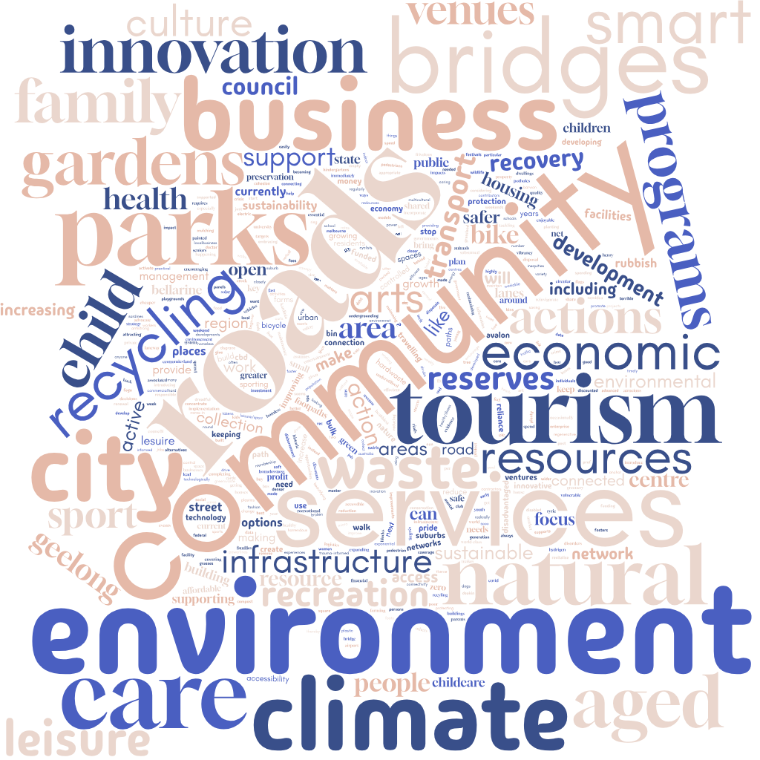

Figure 8 – Common themes from community priorities

Funding priorities
Figure 9 - Breakdown of funding allocation

Health and wellbeing priorities
Tell us which five Victorian State Government health and wellbeing priorities you think should be a focus for Greater Geelong in 2025-2029 (% selected)
Figure 10 - Breakdown of health and wellbeing priorities

Do you or other people you know find it difficult to access City of Greater Geelong programs?

Figure 11 – Responses to “Do you or other people you know find it difficult to access City of Greater Geelong programs?”

Why do you think you or other people you know find it difficult to access City of Greater Geelong?

Figure 12 – Responses to “Why do you think you or other people you know find it difficult to access City of Greater Geelong programs?”

Would you prefer us to renew existing assets or create new assets? (%)
Figure 13 – Response to “Would you prefer us to renew existing assets or create new assets?”

Would you prefer Council provide more flexible, multipurpose buildings or more targeted, single purpose buildings? (%)

Figure 14 – Response to “Would you prefer Council provide more flexible, multipurpose buildings or more targeted, single purpose buildings?”

Would you prefer us to invest more in our natural assets or built environment assets? (%)

Figure 15 – Response to “Would you prefer us to invest more in our natural assets or built environment assets?”

Would you prefer higher quality assets that may be further away or standard quality assets that are closer to where you live? (%)

Figure 16 – Response to “Would you prefer higher quality assets that may be further away or standard quality assets that are closer to where you live?”
Which do you think is a better way of measuring how well council assets are performing? (%)

Figure 17 – Response to “Which do you think is a better way of measuring how well council assets are performing?”

Are there community facilities that do not exist in Greater Geelong that you believe Council should consider providing? (%)

Figure 18 – Response to “Are there community facilities that do not exist in Greater Geelong that you believe Council should consider providing?”

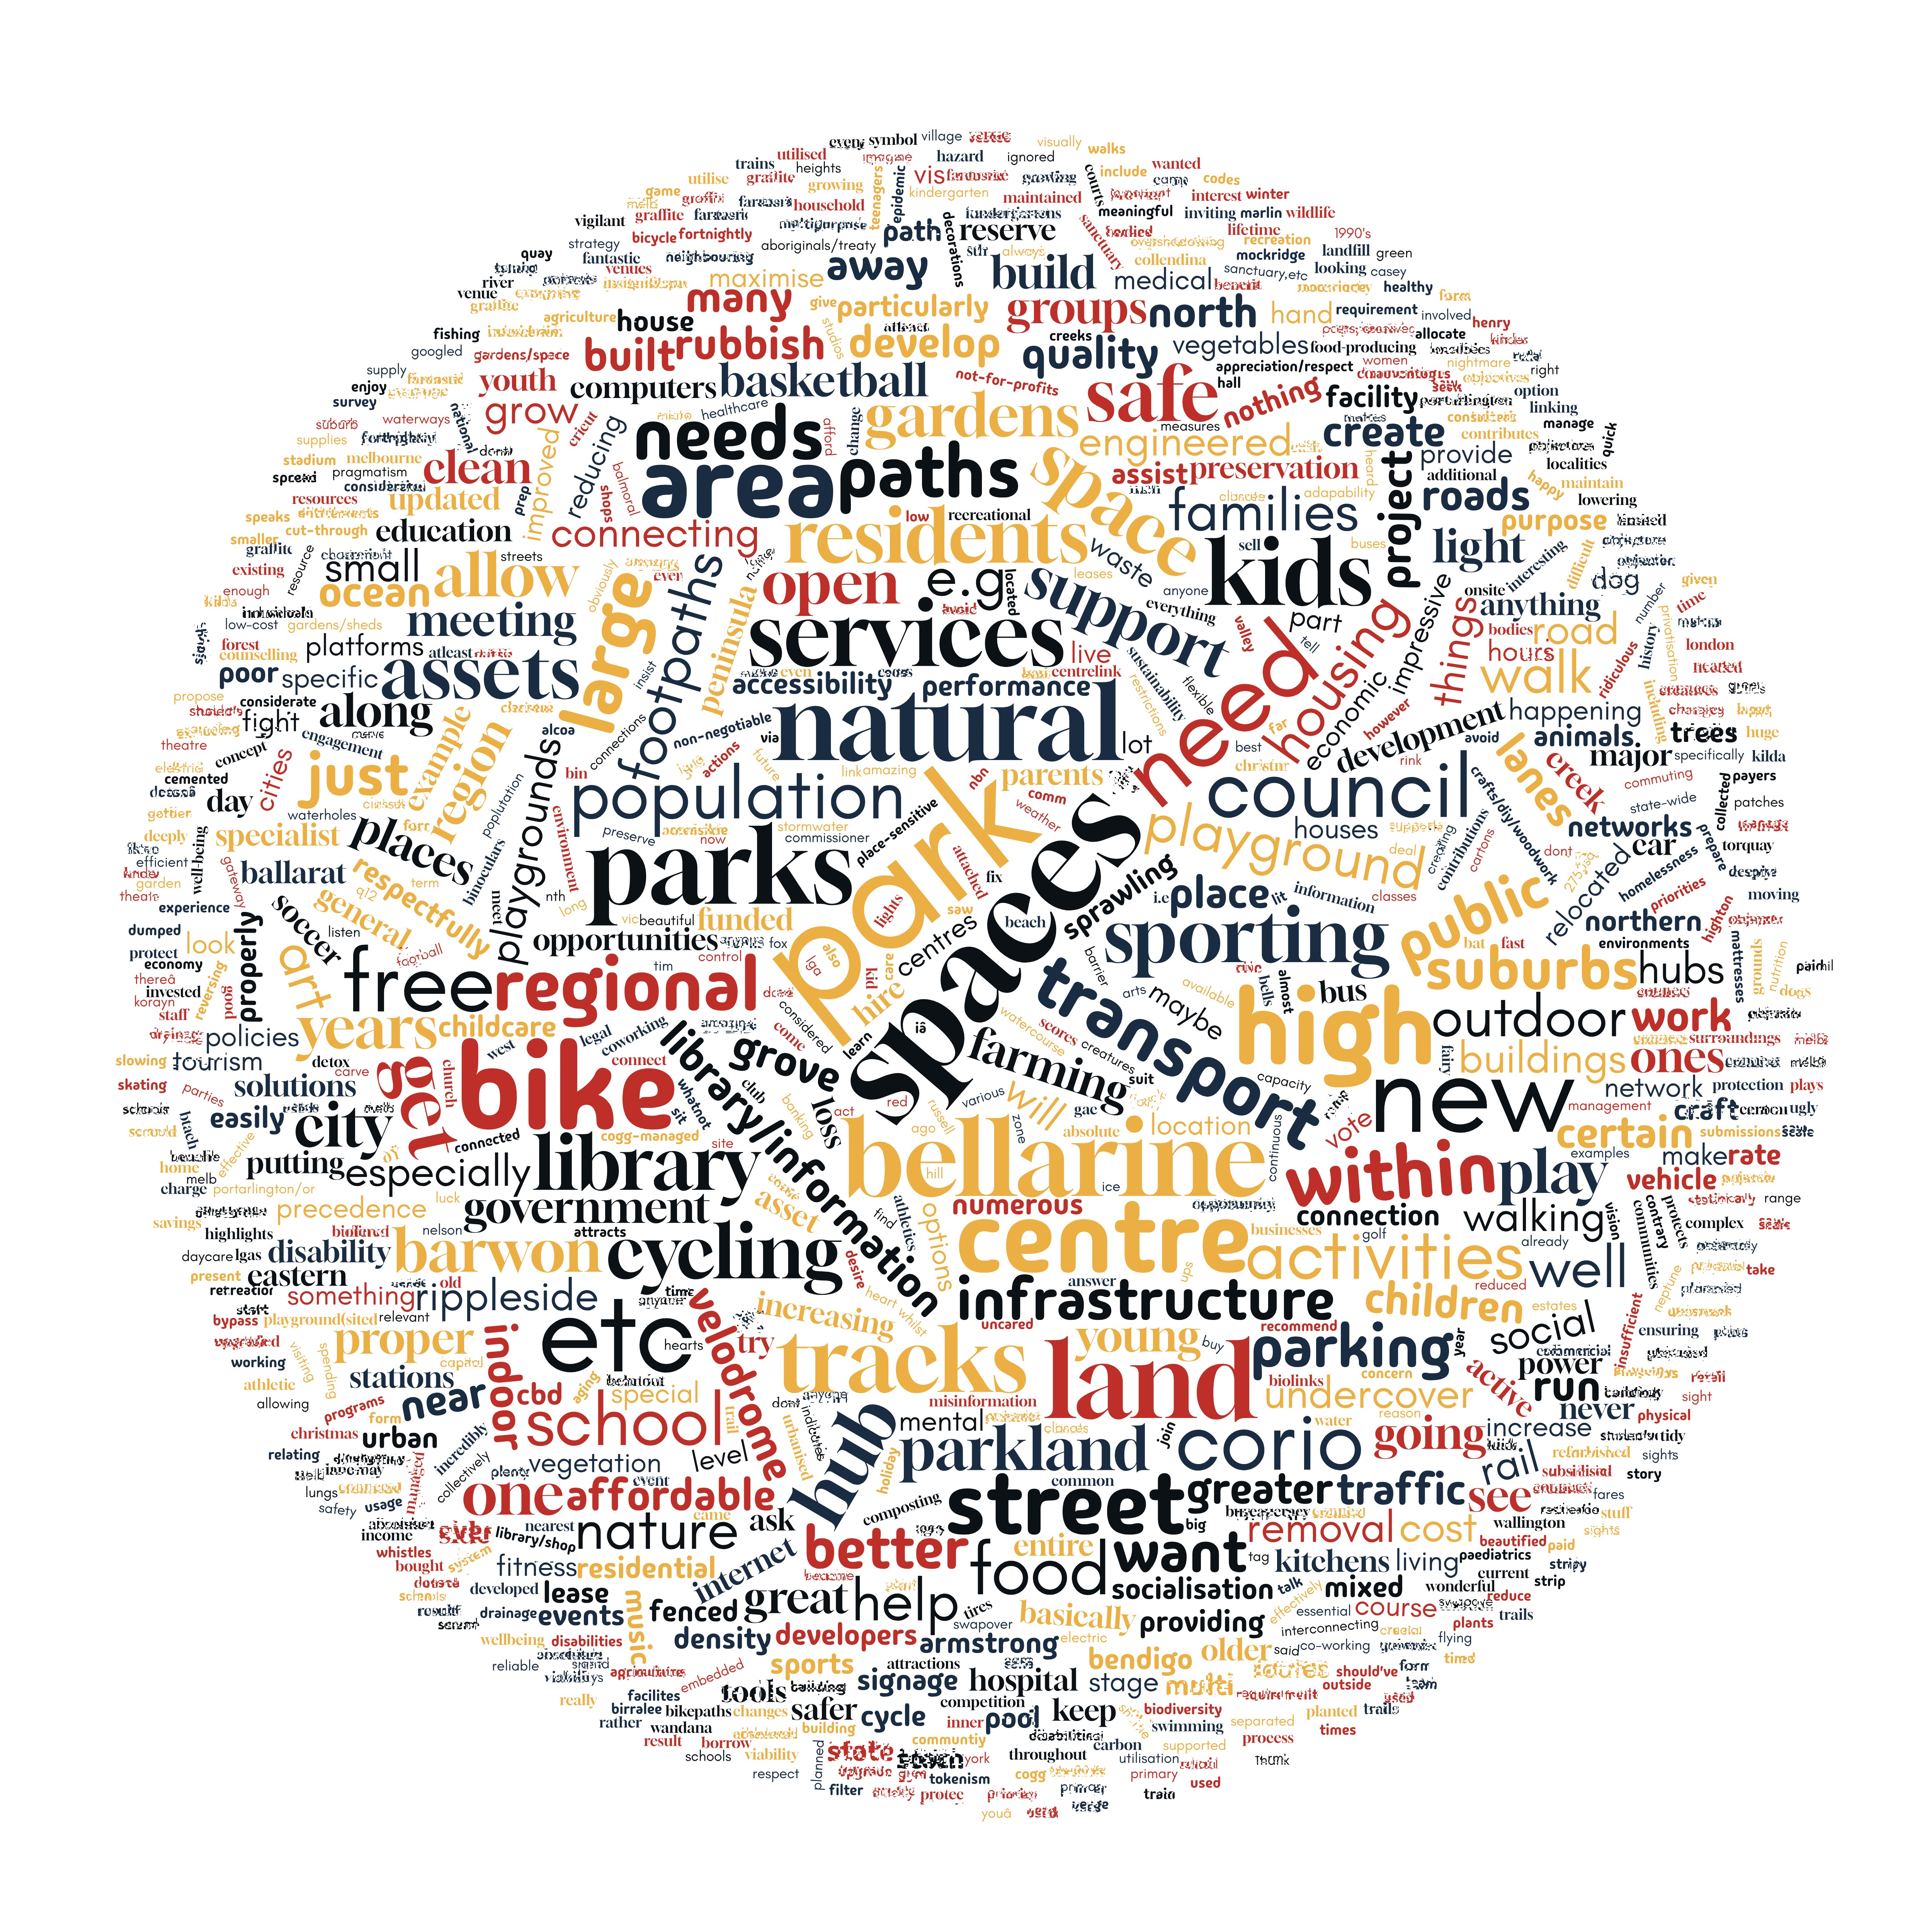
What assets do you think Council should provide?
Figure 19 – Responses to “What assets to you think Council should provide”?
“Enough basketball courts to house the growing population of kids who want to play basketball”
“A proper clean, green public transport system”
“Fenced dog parks”
“Outdoor undercover playground, outdoor undercover gym facilities”
“More live music venues :)”

feedback through informal channels
The engagement also attracted five comments on social media across two posts. These comments broadly reflected the sentiment and themes gathered through the formal engagement process.

Community engagement areas for improvement
Attending areas of high pedestrian activity such as shopping centres yielded lower rates of engagement than expected. This is likely because the engagement phase covered such a broad concept and the entire municipality.
Higher rates of engagement from pop up and promotional activities are more likely to be achieved when the project is more specific to a location. Hosting in person sessions and promotional activities are still considered an important component of engagement on strategy development and opportunities for improvement will be identified for future engagements.
Engaging with young people proved to be a challenge. Additional avenues to attract feedback from younger community members should be considered in future engagements.

What we have done and next steps

What we have done
The findings from this engagement will be included in information provided to Council in the development of the Council Plan, its strategic direction and objectives.

Next Steps
Following endorsement by Council, the draft plan will be available for a period of four weeks for community consultation.

Appendix A – Survey


Council Plan 2025-2029 Survey
Help us refresh the Greater Geelong Vision and shape our Council Plan 2025-2029
Your reflections will help assess whether the ‘Clever and Creative Future’ Vision for Greater Geelong, established through community consultation in 2017, still aligns with the community's aspirations for 2047.
Your ideas will also provide advice into Council’s major long-term plans for 2025-2029, including:
- 2025-29 Council Plan (including the Municipal Public Health and Wellbeing Plan)
- 2025-35 Financial Plan (including Revenue and Rating Plan)
- 2025-35 Asset Management Plan
- 2025-26 Annual Budget.
This survey will take approximately 10-15 minutes to complete and has 6 sections along with optional questions about you:
- Our Community Vision
- Council Plan 2025-29
- Health and Wellbeing
- Our Assets
- About you
- Contact Details
Your responses, which remain anonymous, will be aggregated and contribute to defining the priorities and aspirations of the Greater Geelong community.

Privacy Statement 

Have your say for the new Council Plan 2025-29
Introduction
- Check this box to indicate that you have read, and agree to the privacy statement provided for this consultation (Required)
Yes

- Do you agree to receive email updates about the Council Plan 2025-29 project?
(Required)
Yes please
No thank you

- Which of the following best describes your connection to the area? (Required)
You can select multiple options.
I am a local resident
I am employed in the area
I own a business in the area
I am a visitor to the area
I am studying or training in the area
Other - Write In

Our Community Vision

Section 1 - Our Community Vision
This is the Greater Geelong Community Vision that was developed in consultation with the community in 2017:
By 2047, Greater Geelong will be internationally recognised as a clever and creative city- region that is forward looking, enterprising and adaptive and cares for its people and environment
The community said this meant Greater Geelong
- has business diversity that inspires a broad range of education and employment opportunities attracts start-ups, innovative businesses and a can-do attitude
- uses a variety of affordable technologies to provide universal digital access
- makes travel between suburbs easier through a network of pedestrian and cycle paths
- excites local and international visitors who are interested in its events, festivals, landscapes and food
- is designed to create an active street culture and vibrant public spaces
- has a strong sense of community and uplifts its vulnerable community members
- is designed around people and makes the best use of technology and sustainable living
- is devoted to research and encourages economically viable, environmentally sound and socially responsible solutions to its challenges
- has a global outlook and is connected to the world by technology
- recognises the uniqueness and significance of its natural environments.

The 9 aspirations within the Vision are:

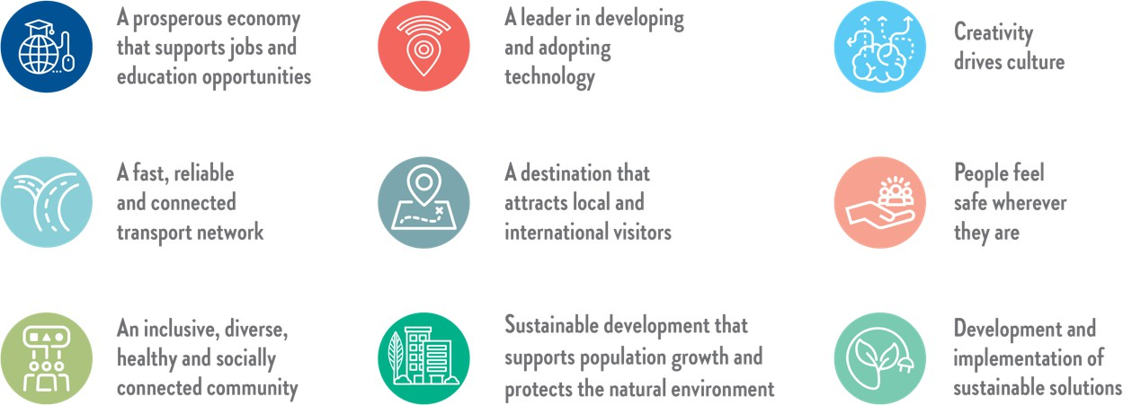

- Do you think the current Community Vision still reflects the Greater Geelong community and the direction we want to head? (Required)
Move the slider left or right with 0 being not at all and 10 being completely

0 10
No, not at all Yes, completely

- We'd love to hear why you gave this response (optional)

Section 2 - Council Plan 2025-2029
Council will focus on several areas that work towards achieving our Community Vision.
- When developing our Council Plan for 2025-29, which five of the following areas do you believe Council should place a higher priority on over the next four years? Required
Click on the blocks to select your preferences.

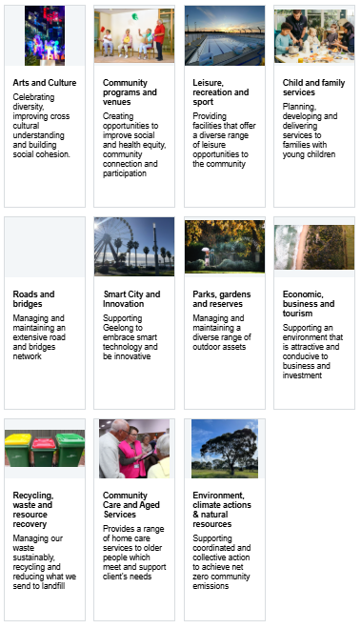

Based on the focus areas you selected, what would you say are the top 3 priority programs, services or projects Council should invest in over the next four years?
- Priority 1 (Required)

- Priority 2

- Priority 3

- Do you have any final comments about the Community Vision or Council Plan that you would like to add?

Municipal Public Health and Wellbeing

Section 3 - Municipal Public Health and Wellbeing
This section includes a list of health and wellbeing priorities identified by the Victorian State Government. Council is to select five State priorities that we believe best align to the health and wellbeing challenges in Greater Geelong.
The World Health Organisation defines health as:
Health is a state of complete physical, mental and social well-being and not merely the absence of disease or infirmity.

- Tell us which five Victorian State Government health and wellbeing priorities you think should be a focus for Greater Geelong in 2025-2029 (Required)
For each priority you select, you will be asked if you have ideas about how Council or other Greater Geelong organisations could address the priority:
Improving sexual and reproductive health
Reducing harm from tobacco and e-cigarette use
Improving wellbeing
Increasing healthy eating
Increasing active living
Reducing harm from alcohol and drug use
Tackling climate change and its impacts on health
Preventing all forms of violence
Decreasing antimicrobial resistance across human and animal health
Reducing injury

- How can we make places (our environments) in Greater Geelong healthier?
Think about where you live, learn, work, study or play and consider the built, natural and economic environment.

- Do you or other people you know find it difficult to access City of Greater Geelong programs?
Programs could include youth programs, community grants, parenting programs, learn to swim etc.
Yes
No

- Why do you think you or other people you know find it difficult to access City of Greater Geelong programs?
Please select all that apply.
Lack of awareness
Transportation issues
Scheduling conflicts
Language barriers
Accessibility issues
Cost
Cultural differences
Lack of childcare
Perceived relevance
Bureaucracy
Safety concerns
Social stigma
Lack of trust
Technology barriers
Financial constraints
Limited promotion
Geographic location
Lack of support systems
Competing priorities
Negative past experiences
Other

Our Assets

Section 4 - Our Assets
The below questions have to do with how you would like us to manage our community assets and facilities.
Council assets are things owned by a local government or council that can include buildings, parks, vehicles, and equipment. These assets are used to provide services and support to the community.
Each of the following questions are designed to understand your preferred approach to our assets, when answering think about things like cost, proximity, equity and sustainability.

- Would you prefer us to renew existing assets or create new assets? (Required)
Select one answer only
Renew the assets we already have where possible
Construct new assets and facilities, while retiring old ones

- Would you prefer Council provide more flexible, multipurpose buildings or more targeted, single purpose buildings? (Required)
Prioritise flexible, multipurpose buildings
Prioritise targeted single purpose buildings

- Would you prefer us to invest more in our natural assets or built environment assets? (Required)
Natural assets for example are waterways, coastal and land habitat, trees and reserves. Built assets for example are roads, drainage, footpaths and bridges.
Prioritise investing in the enhancement and preservation of our natural assets
Prioritise investing in our built environment assets

- Would you prefer higher quality assets that may be further away or standard quality assets that are closer to where you live (Required)
For example, a large, state-of-the-art playground that is 5km away or a smaller, simpler playground that is 500m away
Higher quality assets that may be further away from my home
Lesser quality assets but that are closer to my home
- Which do you think is a better way of measuring how well council assets are performing? (Required)
Prioritise asset performance through financial impact
Prioritise asset performance through financial impact, how well they serve their purpose, and how often they are used

- Are there community facilities that do not exist in Greater Geelong that you believe Council should consider providing? (Required)
Yes
No

About You
Before you go, can you tell us a little bit about you? In this section we are asking for information about you to help us understand who we are hearing from in the community. Any information you provide will be de-identified (i.e. anonymous) from your survey responses and managed in line with the City of Greater Geelong Privacy Policy (https://www.geelongaustralia.com.au/governance/documents/item/2c891c3b.aspx)

- Town or Suburb
Where you currently reside.

- Age Group
Under 18
18-24
25-34
35-49
50-59
60-69
70-84
85+

- What is your gender?
This information enables us to consider the impact of Council service on people if different genders. This will help us to ensure that our services are equitable and meeting the needs of the Geelong Community
Man
Woman
Non-binary
Prefer not to say
Self-described (please specify)

- Do you identify as any of the following?
Please select all that apply
Aboriginal origin
Torres Strait islander origin
Both Aboriginal and Torres Strait Islander
Migrant Refugee
Asylum Seeker LGBTIQA+
Carer Parent/Guardian
Person with a disability
English Is not my first language
None of the above

- Are you a member of a City of Greater Geelong Advisory Committee or Council?

Contact details

Please complete this section if you said you'd like to be kept up to date about this project.
- First Name

- Last Name

- Email (optional)

- Best contact number

Thank you
Please click the "Submit" button at the end of the survey to ensure that the City receives your feedback.
SUBMIT
Thank you for your time and feedback, both are valued.

