The City Of
Greater Geelong

INDENTED HEAD WOODLAND NATURE Reserve Master Plan

  - final Engagement report
  - august 2022

Contents
Introduction 3
Engagement Purpose 3
About this Report 3
How we engaged 4
Who have we engaged? 6
Survey respondent breakdown 6
What we heard 7
Breakdown of findings 7
Overall support of Master Plan 7
Aspirations of the local area 7
Key messages 7
Key message 1 – protect and enhance biodiversity 8
Key message 2 – Environmental protection and passive recreation 8
Sub-Theme – Providing more recreation areas 9
Sub-Theme – Children’s play/ sporting area 9
Sub-Theme – Walking trails 9
Key message 3 – cultural heritage 9
Key message 4 – improved social wellbeing through connection to nature 10
Other feedback 10
CFA/ Emergency access 10
Dog Walking 10
How we are responding 11
Key message 1 – protect and enhance biodiversity 11
Key message 2 - environmental protection and passive recreation 11
Key message 3 – cultural heritage 11
Key message 4 – improved social wellbeing through connection to nature 11
Conclusion 12

ACKNOWLEDGEMENT OF COUNTRY
The City of Greater Geelong acknowledges the Wadawurrung People as the Traditional Owners of this land.
It also acknowledges all other Aboriginal and Torres Strait Islander People who are part of the Greater Geelong community today.

Introduction
In late-2021, we started a project to design the first Indented Head Woodland Nature Reserve Master Plan and provide a consolidated vision for the future of the reserve.
The reserve is owned by the City and has a total area of approximately 13.6 hectares. It is managed by the City’s Nature Reserves Team with the aim of protecting its natural and cultural values and improving the quality of the biodiversity. The area was declared a nature reserve on the 11 June 2019, following a land exchange between the City and a developer. The land exchange was led and supported by the community, especially the Indented Head Community Association.
The site is characterised by open, cleared areas of exotic grassland to the north and west, interspersed by a wetland/woodland complex, containing large old trees and a small creek. Most of the site has been modified from previous agricultural activities (ie; grazing), land clearing and weed invasion. There are no paths or formal access.
Conservation management activities commenced in 2019 undertaken by the City’s Nature Reserves Team. These activities include but are not limited to.
- bush regeneration through weed management,
- measures to prevent unauthorised vehicle access to the site (such as bollards and fencing), and
- slashing to reduce biomass cover in the woodland understorey.
The Friends of Indented Head Woodland formed in 2019. The group meets twice a month to undertake targeted weed control activities.

Engagement Purpose
The key aim of this engagement was to gain insight into community views about the draft plan, and the future needs of the park. We also wanted to build community awareness of the project and strengthen relationships with, and between, all key stakeholder groups.

About this Report
This report summaries the community engagement process we used to seek feedback on the draft master plan and how that feedback has influenced the final plan.
This report consolidates the feedback received from the community through the engagement process. The report also highlights how this feedback has been incorporated into the final plan.
The information contained in this report is intended to continue the community engagement process and keep the community informed.

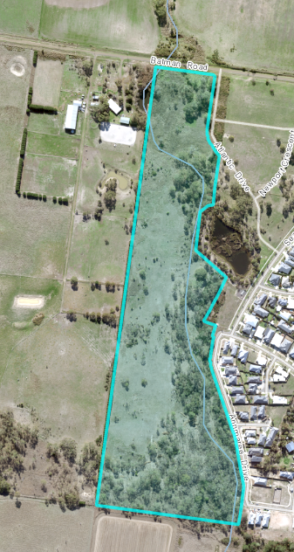
Image 1: Indented Head Woodland Nature Reserve

How we engaged
The total community engagement period was conducted over two separate sessions totalling over 2 months. The Concept plan stage was released on the 14th of December 2021 to the 21st of January 2022. The release of the Draft plan stage commenced on the June 1st to June 30th 2022.
Our core engagement was conducted via the Have Your Say online platform. The main form of comment from the public was undertaken via an online survey which was developed and targeted for the potential user groups of the reserve. The statistics below illustrate the total visits to the Have Your Say (HYS) page over the two consultation periods.
15
Online written submissions
64
Surveys completed – Stage 2

982
HYS – Stage 2
585
HYS – Stage 1

In total, there were over 1500 visits of the Have Your Say project page over the two engagement periods, which converted to 108 contributions. To encourage community participation, the platform offered social maps, survey, and submission form. This was also supported by phone and email contacts. Both engagement periods had a strong local participation rate.


44
Surveys completed – Stage 1

The engagement was promoted via many channels, including direct mailout, posters in the park, a media release, and the City’s Facebook page. A hard copy of the survey was made available at the Indented Head General Store. Two copies of the Masterplan were on public display within the Indented Head township. The City also provided copies of the HYS notification postcard to every resident within the township.

Over the course of both consultation periods the City reached the following achievements.

750
HYS postcards delivered to residents
NEWS
7
Print adverts in local newspapers
69 DAYS
Total engagement
Signs in the Reserve
7
49 likes, 1750 hits  SOCIAL MEDIA |  |  | 

Engagement details
Have Your Say online platform | An online ‘Have Your Say’ project page was designed to share relevant information to encourage community feedback. The initial release of a Concept Plan occurred in Dec 2021 and the feedback period was open for 6 weeks closing on 21st of Jan 2022. After feedback was collated, the Draft Masterplan was released for community feedback on the 1st of June 2022 for 4 weeks and closed on the 30th of June 2022.  Maps of the draft masterplan were provided on the HYS page to allow respondents to post specific feedback on their areas of interest in addition to a survey and open submission option.
Survey (online and hardcopy) | The survey was available on online and/or in hard copies.  The online survey was the core feedback tool provided targeting people with 10-15 minutes of available time. 108 surveys were completed. The survey sought feedback on the vision and objectives, recommendations, and any issues that the community had with the future use and development of the park. The survey included some information and about peoples use and connection to the park.
Submission form | The submission form enabled people to provide more detailed open-ended feedback on any aspect of the draft master plan.
Email | A project specific email address was created enabling people to provide feedback through a third medium. 8 people provided email feedback about the plan.
Phone calls | The Project manager’s name and City Services phone number was provided on all posters and flyers that went out with the mailout. This enabled people who may not access to the internet to provide feedback. A call back option was also provided on the webpage for those wanting to speak to an officer at a suitable time. We did not receive any calls about the project.
Drop-in sessions | An onsite drop-in session was held on 9th Of January 2022 November at the Indented Head Community Hall, following the easing of COVID 19 restrictions, to provide face-to-face engagement with our project manager. A PowerPoint presentation was delivered to residents and members of the Indented Head Association. Approximately 35 community members were present. Attendees were encouraged to discuss issues and provide comment on the original Concept Plan.

Who have we engaged?
The Indented Head Woodland Nature Reserve is an important natural area, representing several rare vegetation communities remaining on the Bellarine. Due to this we targeted residents and groups to provide opportunities to engage and appreciate the natural values of this reserve into the future.
In total, 116 people participated in the Indented Head Woodland nature Reserve Masterplan engagement process. 86 per cent engaged online, and 14 per cent engaged via written survey.
The engagement reached a representative sample of the intended target audience and was a success in terms of its reach amongst the community.

Survey respondent breakdown
The online survey included several demographic questions. Figure 1 illustrates 94 per cent of respondents were Indented Head residents. This is understandable considering the HYS process was targeted at the local community. The remaining 6 per cent were all members of communities found on the Bellarine.

Figure 1: Survey respondents by Location
.

When asked about the age demographic of our contributors it strongly reflected the representation of the Indented Head community. The Bureau of Statistics states that the predominant age bracket in Indented Head is 60-69 years. Indented Head is a retirement community and the contributions reflected this (see Figure 2).

Figure 2: Survey respondent by age Demographic

What we heard
The level of engagement gives us a high degree of confidence that the feedback we received was representative of the community’s views and aspirations for the park and, importantly, their views on the draft plan.
All feedback was analysed to tease out key themes and specific issues that needed to be reflected on and, where appropriate, incorporated into the plan.
There has been the expected amount of response as expected. The community consultation for this Masterplan was targeted to the local community of Indented Head and its immediate surroundings. The data received strongly reflects this approach. Therefore, the City is satisfied with the response to the draft Master Plan. There is an overwhelming amount of support for the City to maintain and preserve the natural values of the Reserve whilst incorporating ‘soft” infrastructure for community to enjoy and appreciate these natural values.
The first questions in the survey revealed feedback that was generally very positive with:

- 72 per cent of survey respondents ‘very supportive’ or ‘supportive’ of the overall draft master plan.
- 63 per cent of survey respondents ’very supportive’ and ‘supportive’ that the plan reflected the aspirations of the local area
- 90 per cent of survey respondents ‘very supportive’ and ‘supportive’ of protecting the natural values of the Reserve.
The City delivered the Masterplan to reflect feedback five key messages. These have been ranked in terms of the level of feedback:

- Protect and enhance biodiversity
- Environmental protection and passive recreation
- Cultural Heritage
- Improved social wellbeing through connection to nature

Breakdown of findings

Overall support of Master Plan
As Figure 4 shows, more than 70 per cent of survey respondents supported the draft Master Plan overall. This was further validated through feedback from face-to-face discussions and paper survey submissions.
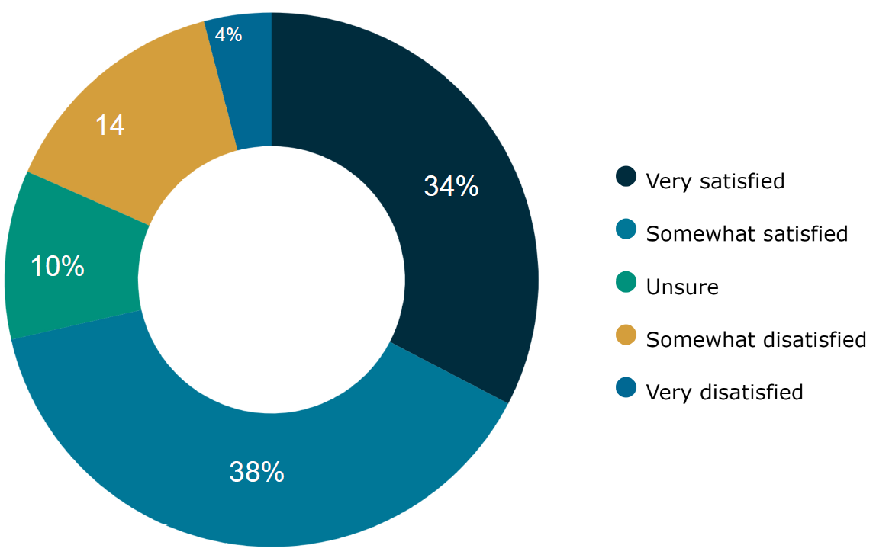
Figure 3: Survey respondent support of draft plan
The 7 submissions that illustrated a ‘somewhat’ dissatisfaction to the plan were mainly concerned about ongoing urban development in the area and the calling for Council to increase their allocation of places for nature. Therefore, inadvertently expressions of concern also somewhat supported the vision of the plan.

Aspirations of the local area
The draft master plan also asked if the key messages reflected the future aspirations of the local area. The survey respondent results strongly reflected the results in the overall support for the plan. 65% illustrated their support in this area with only 7 submissions reflecting that the plan does not reflect the aspirations of the local area. Many of these comments mentioned infrastructure or material that the City will be implementing into the reserve during the implementation phase of this plan. For example, signage, pedestrian access and linkages, and sentiments towards stopping future development.

Key messages
Across all forms of feedback, there has been an expected level of response to the draft master plan, with many respondents having views on a variety of different aspects of the plan. Overall, however, each respondent had a clear area of focus in their feedback, and that was to protect the natural values of the reserve and enable the community to enjoy these values.
Because of the variety of comments during this process, the most common have been reflected in relation to in each key message.

Key message 1 – protect and enhance biodiversity
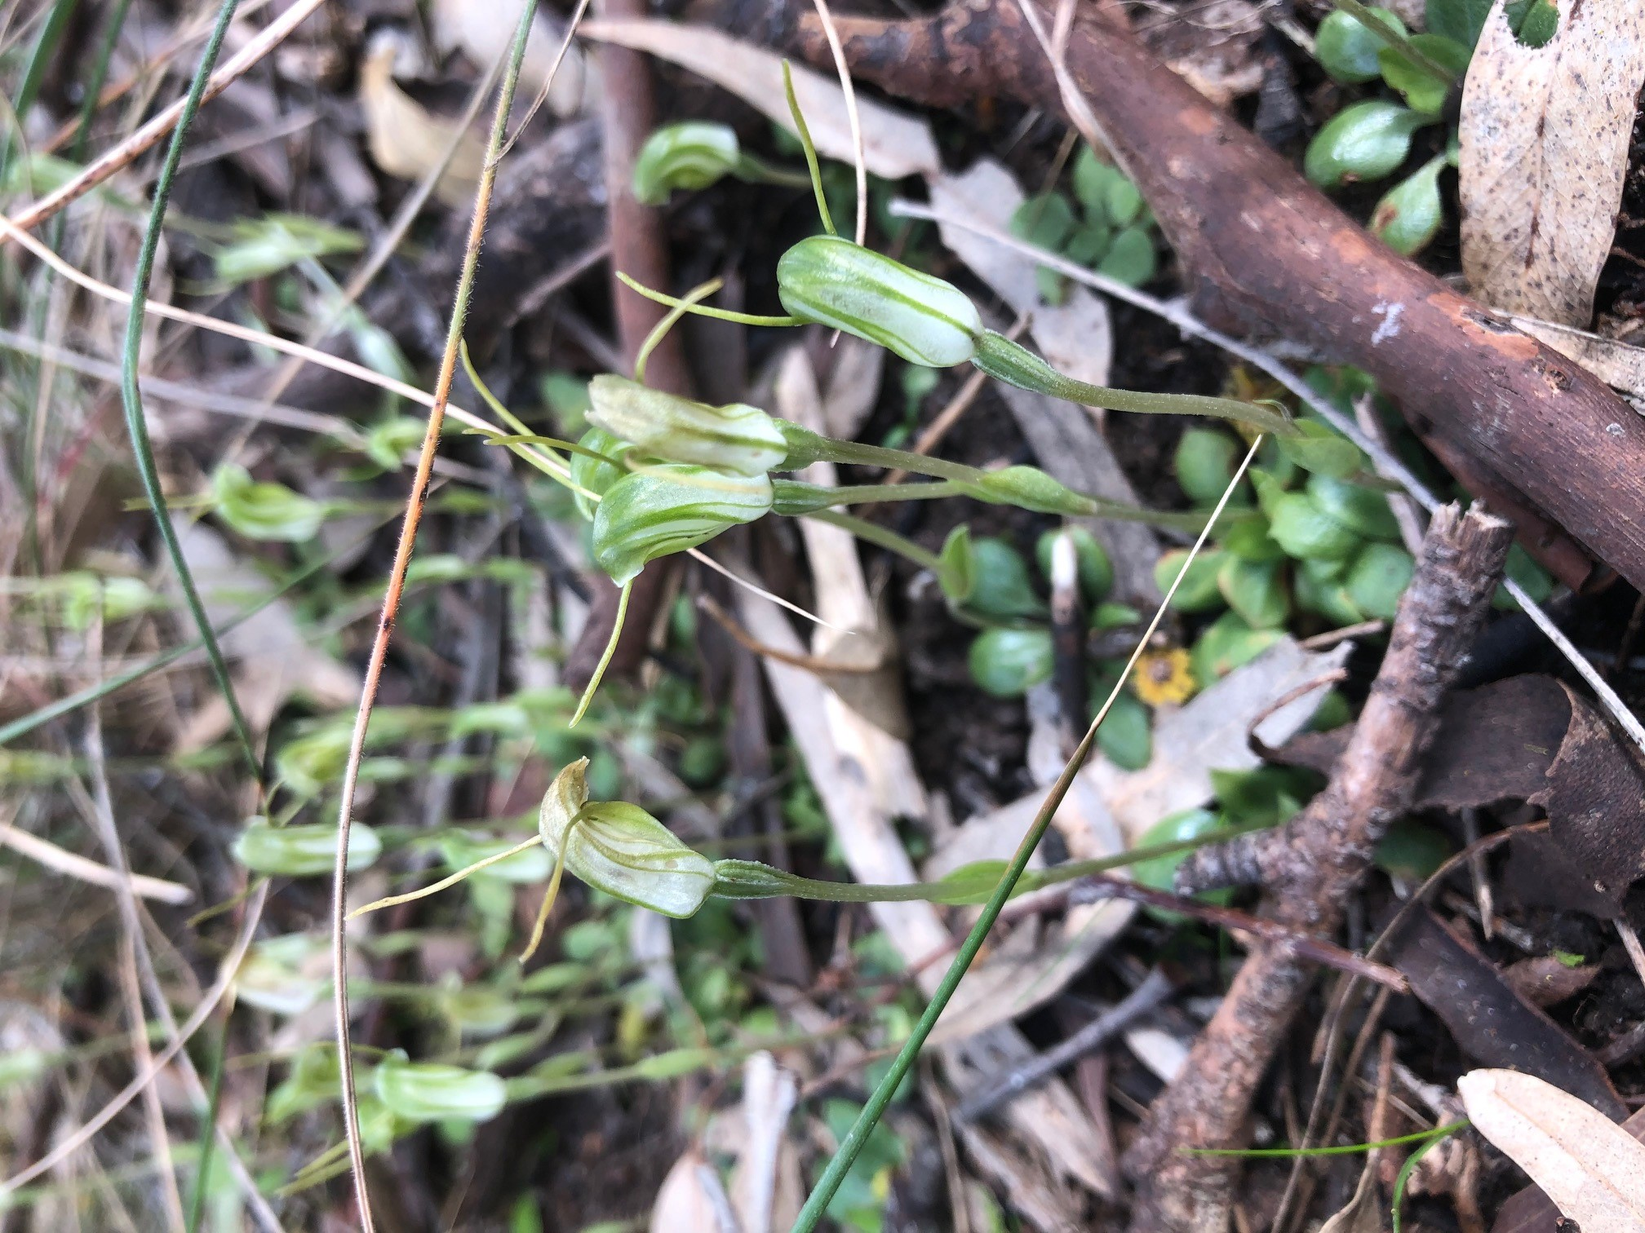
Image 2: Dwarf Greenhood Petrostylis nana, in Indented Head Nature Reserve. Photo Andrew Quick

The protection of the natural assets of the reserve resounded as the strongest support for this plan. Over Ninety of the respondents made comment about how important it is to protect this reserve for its flora and fauna. In general respondents were in favour of protecting the native flora and fauna of the area, with resounding support to ensure the protection of the mature trees and habitat in the reserve. There were also comments from several respondents illustrating that the community could get more involved in community plantings and revegetation efforts within the reserve. There was also particular comment made about preserving the beauty of the area for future community members to appreciate.

“An opportunity to protect and enhance this place and to provide remnant bushland for flora and fauna in an area that is under pressure from residential development”
“Agree wholeheartedly with the Values, Experiences, and Goals. Support the placing of a Trust for Nature Covenant onto the reserve”
“The effort being made to try and conserve one of the remaining remnant scrub and bush on the peninsular.”

Key message 2 – Environmental protection and passive recreation
Just as passionately as the community wish to preserve the natural values of the reserve, the feedback received also indicates that the community is very invested in the maintenance and protection of the environmental aspects of the reserve, in particular the passive recreation area.
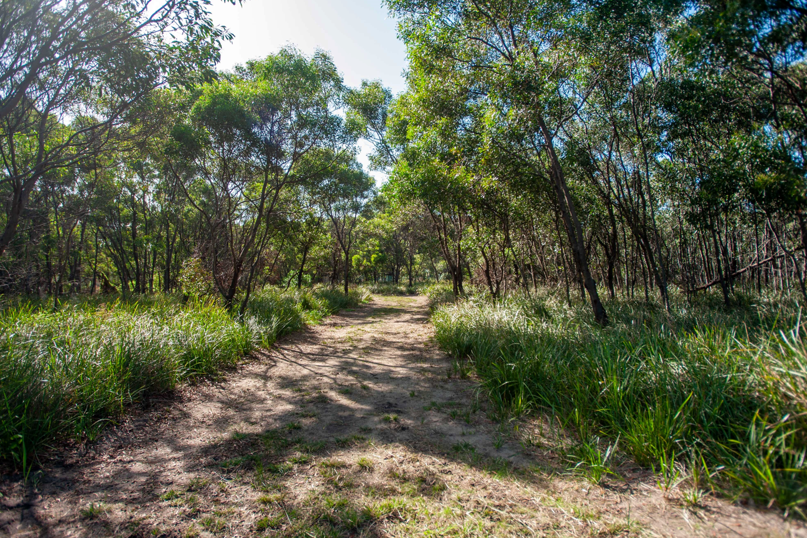
Image 3: Passive Recreation Area

Although 90% of respondents commented on how important it is for the plan to protect the environmental values of the reserve, almost the same amount of comment was received regarding providing opportunities for passive recreation. This message was clearly the second most significance of all comments received during the consultation process. Over 80% of respondents wanted to see access into the reserve, around 50% of these were concerned with providing access but not at the expense of degrading the environmental values of the reserve. There were over 45 points of discussion on the topic of providing the passive recreation of the area, whilst also respecting the fauna and flora within the reserve.
It was extremely clear in the feedback that several the respondents are already using the reserve for passive recreation as a way of connecting with nature and are very keen to see this developed as part of the reserve in this plan.
“Finally Indented Head will have green spaces for all. Accessible and careful consideration of the local fauna and flora”
“Natural beauty of the area is kept/protected. Residence can enjoy it! Looking forward to using it for peaceful walks!
“The creation of the plan will open” up a lovely section of our woodland and gives access to all of our residents and visitors”

Sub-Theme – Providing more recreation areas
Feedback around this key message also involved a clear message that more recreational areas are required within the Indented Head area. The centred on having the option to use parts of the reserve for other recreation activities such as picnicking and dog walking. The plan referred to excluding dogs and placing a Trust for Nature covenant on the land for permanent environmental protection. It is worth noting that 4 respondents made comment about enforcing ‘dogs on lead” illustrating support for dog control and protection of environmental values. Juxtaposing this opinion was several comments concerned with the level of infrastructure for use by people and dogs. More than 3 times as many comments were made in concern of this topic rather than support of it. Therefore, this is being considered a minor concern of the community when compared to the support for the protection of the reserve.

Sub-Theme – Children’s play/ sporting area
During the inception of this nature reserve there were numerous comments from the community about providing more ‘play areas or ‘active recreational facilities’ in the Indented Head area. For quite some years now, the City has been highlighting the need to conserve this reserve and has considerably increased its biodiversity over the past 4 years of management. The consultation process has highlighted an overwhelming support for preserving the natural values of this reserve. In total 5 comments were received about incorporating additional recreational facilities within the reserve, this equates to 7% feedback suggested that a children’s play/ active sport facilities should be part of the plan.

Sub-Theme – Walking trails
The consultation process also asked the community to make comment on the design of the proposed walking trails. There was an overwhelming support for the track network proposed in the plan. Several respondents referred to connecting to an existing ‘local’ walking trail to the south of the reserve which will be considered as part of the implementation phase of this plan.
“Strongly support the long boardwalk at the southern end of the Reserve, no other solution as this area is low and regularly flooded after rain but needs railings for safer walking for all abilities.”

Key message 3 – cultural heritage
Approximately 15% of the comments from respondents referred to the cultural values/ concerns in the reserve. All of these comments were in support of the plan and illustrated the linkage between preserving the environmental values and cultural values at the same time. During the community consultation period, the plan referred to renaming the reserve in respect to the Wadawurrung. Given the overwhelming support for the protection of the cultural value of the reserve the City will undergo the renaming of the reserve during the implementation of this plan.
I'm excited that the aim is to preserve what is left, and to raise awareness and the collaboration with the traditional owners of the land”
“recognition of the cultural significance of the Reserve and the fact that consultation with the Wadawurrung Traditional Owners has and is occurring”
“Managing the water ways and retaining the biodiversity. Keeping the reserve protected. Naming the reserve with respect to the indigenous peoples of the land.”

Key message 4 – improved social wellbeing through connection to nature
During the consultation process, respondents referred to the importance of the connection between wellbeing and the natural environment. Many supporters of the preservation of the natural values of the reserve highlighted this topic. The design of the plan was to ensure the importance of the connection between social wellbeing and natural spaces. Based on these connections there is an overwhelming support for the plan.
Several respondents highlighted that even though there is a strong support for this message in the plan, it will be important to maintain the natural values so that this experience does not degrade over time.
“the opportunity to develop a long-term strategy and deliver action in progressive stages to develop, preserve and conserve a fairly intact area of native vegetation with inclusion for community accessibility and immersive experiences which will provide health and social benefits for the local community”

Other feedback

CFA/ Emergency access
The recommendation in the draft master plan, to maintain unmitigated access for emergency vehicles into the reserve was highly supported. Several respondents stated that the local community would like to see that emergency services and fire management authorities have access to the reserve. As part of this plan the local CFA brigade have been consulted. The existing emergency access will be maintained and remain usable by fire management vehicles.

Dog Walking
There were various comments made throughout the feedback about the provision of appropriate areas for dog walking. All these comments were highlighting areas for dogs to be ‘on lead’ in the reserve. Some respondents felt there should be more consideration in the master plan for people who use the reserve to walk their dogs, while the overwhelming majority stated that infrastructure needed to be implemented to eliminate dogs from entering the reserve.

How we are responding
The key purpose of seeking community input is to ensure the master plan reflects the needs and aspirations of the community.
The project team reviewed and considered all feedback and key themes in preparation of the final plan, incorporating the following overall statements.


Key message 1 – protect and enhance biodiversity
Based on the feedback provided around this theme, there have been no changes made to the master plan in relation to the protection of the biodiversity of the reserve. The master plan identifies:
- Protection of native flora and fauna.
- Infrastructure to allow the free movement of wildlife through the reserve.
- Trust for Nature Covenant.
- Ongoing protection and enhancement of the Red Gum trees in the reserve.
- Ongoing weed management work to continue to build on the natural values of the reserve.


Key message 2 - environmental protection and passive recreation
Based on the feedback provided around this theme there have been no changes made to the master plan in relation to the passive recreation area. The master plan identifies:
- Protection of native flora and fauna.
- Implementation of walking trails.
- Providing passive recreation opportunities for the appreciation of nature and social wellbeing.


Key message 3 – cultural heritage
Community feedback identified support for enabling the protection of the cultural heritage of the reserve. Most instances the community expressed an interest in finding ways to foster and develop this for management of the reserve into the future.
- The development of the plan has been developed in consultation with the Wadawurrung Traditional Owner Aboriginal Corporation.
- CoGG will undergo a process of renaming the reserve to reflect the indigenous cultural values of the reserve which are reflected by the Wadawurrung.
- CoGG will facilitate opportunities for the Wadawurrung to be further involved in the future direction of the reserve.


Key message 4 – improved social wellbeing through connection to nature

Feedback around this theme highlighted a desire from the community to ensure that the construction will enhance this opportunity. The master plan identifies:
- Ensure a balance between environmental protection and environmental experience.
- Where possible develop inclusive and ‘all-ability’ access.
- Attempt to provide linkages and plan for future path networks.

other feedback
- The City will maintain the reserve and always facilitate full access of the CFA and other emergency vehicles.
- Given the level of support for the protection of nature and the low level of response the City received regarding facilitating dog walking activities within the reserve, the City will continue to develop dog regulations and a Trust for Nature Covenant on the reserve. Dogs will not be permitted within the reserve.

Conclusion
All feedback and proposed responses have been discussed with individual stakeholder groups and incorporated into the final master plan.
Both the updated plan and this report will be tabled for discussion and endorsement at the November 2022 Council meeting.

