The City Of
Greater Geelong

Draft Plan for Nature

2026-2036

Contents
Acknowledgement of Country 3
Executive Summary 4
Introduction 6
How we engaged 10
Drivers of change 12
Strategic Direction 17
Landscapes: Values, Threats and Opportunities 20
Across Djilang 21
Barwon Plain 22
Bellarine 23
Basalt Plains 24
Geelong City Landscape 25
Little River 26
Northern Uplands 27
Goal 1: Wadawurrung Country and Values 30
Goal 2: Protections 31
Goal 3: Connections and Restoration 33
Goal 4: Community and Partnerships 36
Goal 5: Climate change and Supporting Nature 38
Biolinks Areas 40
Action Plan 42
Implementation and renewal 47
Monitoring and evaluation 48
MAPS 1-6: Environment Values 50
MAPS 7-12: Protection Measures 56
Appendix 1: Threatened Species and Ecological Communities Summary 62
Appendix 2: Threatened Species and Ecological Communities 63
Appendix 3: Environment Volunteer Groups and Networks 67
Appendix 4: Biolink Areas 69

Acknowledgement of Country

We acknowledge the Wadawurrung People as the Traditional Owners of the Land, Waterways and Skies. We pay our respects to their Elders, past, present and emerging. We acknowledge all Aboriginal and Torres Strait Islander people who are part of our Greater Geelong community today.
We acknowledge the Wadawurrung Traditional Owners for their insights shared during the development of this Plan for Nature. The City of Greater Geelong is committed to supporting the Wadawurrung people care for and heal Country, and to play an increasing role in managing the natural environments of the City.

Executive Summary
The City of Greater Geelong draft Plan for Nature 2026–2036 sets out how we will identify, protect, restore and enhance our region’s biodiversity in the context of rapid population growth and climate change. It responds to the ongoing loss of native plants, animals and ecosystems, and recognises that a healthy natural environment is essential to our region’s future health, liveability and resilience.
The Plan is grounded in partnership. It acknowledges the Wadawurrung Traditional Owners as original custodians of Country and recognises the deep connection between nature, culture and wellbeing. It has been shaped through extensive engagement with Wadawurrung, the community, environmental groups, government agencies and City staff.
The Plan is guided by five strategic goals in key areas:
1. Wadawurrung Country and Values
2. Protections
3. Connections and Restoration
4. Community and Partnerships
5. Climate Change and Supporting Nature.
A place-based approach underpins the Plan. Six landscapes guide local action across urban, rural, coastal and waterway environments. The plan’s targets focus on achieving outcomes across both public and private land, recognising that we need action at all scales. A rolling two-year Action Plan ensures we can adapt, measure and respond as we implement.
By working collaboratively with the community, Traditional Owners, landholders and partner agencies, the Plan for Nature provides a clear pathway to halt biodiversity decline, build resilience and ensure nature continues to support people and place, now and into the future.

ACRONYMS
CMA – Catchment Management Authority
City – City of Greater Geelong
CVA – Cultural Value Assessment
DEECA – Department of Energy, Environment and Climate Action
EPBC Act – Commonwealth Environment Protection and Biodiversity Conservation Act 1999
FFG Act – Victorian Flora and Fauna Guarantee Act 1988
PV – Parks Victoria
TfN – Trust for Nature
WTOAC – Wadawurrung Traditional Owner Aboriginal Corporation.
glossary
Biodiversity – the variety of all life on earth (animals, plants, fungi, microbes), their interactions and the natural patterns they form. This includes the variety (or diversity) of species, the variety within species (genetic diversity) and the variety of ecosystems.
Biolink/area – geographical area that is a priority for protection and restoration of biodiversity combining corridors, zones and nodes.
Biolink/corridor (C) – geographical area that provides suitable conditions for animal and plant movement through the landscape.
Biolink/habitat node (HN) - geographical area of habitat >10 hectares comprising either remnant vegetation or wetlands
Biolink/restoration node (RN) - geographical area mostly >100 hectares owned by one entity where habitat can be restored
Biolink/priority corridor (PC) – geographical area such as a major river, coastal zone or wetland that is highly significant for animal and plant movement through the landscape.
Biolink Zones (Z) - geographical area > 100 hectares comprising multiple habitats nodes highly significant for biodiversity.
CALD Communities – Culturally and linguistically diverse communities.
Ecosystem – a unique community of living and non-living organisms interacting as a system.
Ecosystem services – the benefits provided to humans through the transformation of natural resources (including land, water, vegetation and atmosphere) into essential goods and services, such as clean air, water and food.
Flora – plant species.
Fauna – animal species.
Habitat – an area for a species which has the right structure and composition of native vegetation to provide food and shelter and opportunities for breeding.
Habitat connectivity – the connections available in the landscape for flora and fauna to access resources and to retain natural patterns of movement and dispersal.
Nature Kit – a statewide online mapping and data exploration tool for biodiversity data integration and decision support.
No net loss – under Victoria’s native vegetation removal regulations, the ‘no net loss’ objective ensures that biodiversity value is not reduced when native vegetation is approved for removal. This is achieved through an avoid, minimise, and offset hierarchy.
Stewardship – in a catchment context involves both individual and collective efforts in managing natural systems to generate intergenerational benefits for the environment, people and place.

Introduction
Purpose of the plan
This Plan for Nature is an investment in protecting, enhancing and restoring biodiversity in the City of Greater Geelong. Now, more than ever, it is critical that we take stock and do what we can to reverse the trend of loss of our critical and unique ecosystems and our native plants and animals. To do this, we will need to work closely with the community, Wadawurrung Traditional Owners and regional stakeholders.
The purpose of this Plan for Nature aligns with the Victorian Government’s broader commitment to biodiversity. The Government recognises that biodiversity has an intrinsic right to exist, thrive and flourish regardless of whether it provides tangible benefits to humans, and all Victorians have a duty to protect biodiversity. The City supports this commitment by ensuring that natural habitat and areas of important biodiversity are identified, protected, connected and restored.
Vision
The Plan for Nature vision has been designed to align with the City’s Environmental Strategy Goal of:
Protect, enhance, and restore our region’s biodiversity
Our region
The City of Greater Geelong (City) is in south-western Victoria, approximately 75km south-west of Melbourne centred around Corio Bay. Covering 1,247 square kilometres, it includes a large part of the Bellarine Peninsula. Our region is made up of the city of Geelong, surrounding suburbs, rural and coastal townships and rural, agricultural and coastal landscapes, including the lower Barwon River. With a population of nearly 290,000, Geelong is Victoria’s largest regional city and the leading commercial centre for south-western Victoria.
Our region hosts a diverse mix of urban, rural and coastal environments. Many areas, particularly along waterways and the coast, are set aside as public nature reserves that support remnant indigenous vegetation and a diverse range of plants and animals. These include many protected species of international, national or state significance.
Our waterways include the Barwon and Moorabool rivers, lakes, small creeks and estuaries, which provide habitat for a range of freshwater and riparian species. Alongside these waterbodies the region hosts extensive coastline areas, including Corio and Port Phillip bays, that include intertidal mudflats, rocky reefs, sandy beaches and escarpments that provide important habitat for marine and bird life.
Our region hosts 11,639 hectares of wetlands, including significant areas within the Port Phillip Bay (Western Shoreline) and Bellarine Peninsula Ramsar Site. Designated under the Ramsar Convention on Wetlands of International Importance, this site includes Swan Bay, the Lake Connewarre complex, Limeburners Bay and the wetlands around Avalon and Point Wilson. Together, these areas provide critical habitat and refuge for many threatened and migratory bird species of both local and international significance.

Wadawurrung values
The Wathaurong (Wadawurrung) people are the Traditional Owners of this region and are today represented by the Wadawurrung Traditional Owners Aboriginal Corporation (WTOAC). For thousands of generations, Wadawurrung people have cared for Country. In Wadawurrung knowledge, the coast, wetlands, grassy and volcanic plains of the Dja (Country) were formed by Bundjil the Eagle, the Ancestor Creator. The name “Geelong” comes from the Wadawurrung word for the region “Djilang” which means “tongue of land”.
Wadawurrung culture and livelihoods are deeply connected to the region’s biodiversity, with dja (land) and warre (sea) Country seen as one. The inland plains, waterways, coast and warre Country provided abundant food, shelter, medicine and clothing to sustain thousands of generations of Wadawurrung people.
Many animals once common on Wadawurrung Country, like the Fat-tailed Dunnart are now rare. Kwenda (Bandicoot), Yoorn (Spotted-tail Quoll) and the Eastern Barred Bandicoot are now extinct or rarely seen in this landscape.
Together, these animals, plants and people make Country healthy.
The now threatened Victorian Volcanic Grasslands (most recent estimates suggest between 1 to 5% remain,,) were once full of food grasses, snakes, lizards, frogs, moths, birds and animals, providing enough food resources for the Wadawurrung people to live there permanently and year-round. The coastal dunes are layered with living places and hearths from the many generations of Wadawurrung ancestors living, harvesting, sharing meals, trading and practising ceremony. The sandy beaches, rock pools, rocky platforms and reefs continue to be places of abundance for harvesting food and resources like crustaceans, shellfish and kelp.
“Most of the large animals, including Go-yin (wallabies), Goim (kangaroos), Walert (possums), ducks and swans were hunted and processed by men using boomerangs and spears. Buniya (eels) were caught in eel traps and water birds were caught in nets that our women wove and made from plant fibres, a practice we continue today. The sea provides bountiful sources of crayfish, abaolone, mussles, oysters, pipis and fish”
~ Wadawurrung Traditional Owners
The region’s waterways were rich in eels, fish and waterbirds. The name ‘Barwon’ comes from parwan, meaning “magpie” or “great wide”, and the Wadawurrung refer to yulluk (great river) that runs from the barre (mountains) to the warre (ocean). Coastal waters have long provided abundance with kelp forests supporting diverse marine life and the Wadawurrung harvesting rock lobster and abalone for food, and kelp to use as water carriers. Australia’s largest stretch of registered cultural sites in Australia occurs along the coastline of the Wadawurrung (Paleert Tjaara Dja).

Post-colonisation landscape
European settlement dates from 1836, with land largely used for farming, grazing and vineyards. Major development occurred in the post-war years, particularly during the 1960s and 1970s, driven by industrial growth, public housing and migration. Population growth shifted to the Bellarine Peninsula in the 1980s, then in the 1990s to the fringe urban areas of Grovedale, Highton, St Albans Park, Wandana Heights and Waurn Ponds, and outlying areas of Lara, Leopold and Ocean Grove. More recently growth has centred in Armstrong Creek, Mount Duneed and Curlewis as well as to Geelong’s north and west.
Close proximity to Melbourne, an affordable and diverse housing market, good transport links and lifestyle opportunities continue to drive strong population growth. An additional 152,000 people are expected to live here by 2036 – an average annual growth rate of 2.5 per cent.
Long-term land clearing and urban expansion have left little remnant native vegetation, much of it small and fragmented. Larger remaining areas include the Brisbane Ranges National Park, Wurdi Youang (You Yangs) Regional Park, Barwon River, Lake Connewarre State Game Reserve, Barwon Bluff Marine Sanctuary and Swan Bay.
Table 1. City of Greater Geelong at a glance
The region at a glance
Total Land Area | 1,247km²
Population | 289,565
River Basins | Barwon and Moorabool Basins
Major Waterways | Barwon, Moorabool and Little River
Traditional Custodians | Wadawurrung
Wetlands of National Importance | Lake Connewarre State Wildlife Reserve, Avalon, Point Wilson/Limeburners Bay and Swan Bay, all part of Port Phillip Bay (Western Shoreline) and Bellarine Peninsula Wetlands Ramsar site
Bioregions | Victorian Volcanic Plains, Otway Plains and Central Uplands bioregions
Land Use | Primary production is the major land use, followed by residential land
Largest Contributors to the Regional Economy | Manufacturing, extractive industries and tourism, especially the Bellarine Peninsula and the coast. Agricultural production is modest, but important and valued in the municipality’s north  Recent drivers of Geelong’s economic growth include health care, education, construction and retail
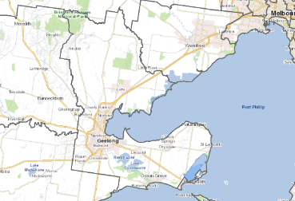
Figure 1. City of Greater Geelong
The bigger picture
The Plan for Nature has been informed by international, national, state and local conventions, legislation, strategies and policies.
The State of Victoria has over 25 pieces of legislation and over 30 strategies that relate to environmental management. Those relevant to this Plan for Nature are listed below in Table 2.
Table 2. Planning Hierarchy
Level | Strategy/Agreement
City of Greater Geelong | - Our 30-year vision  - Our Council Plan 2025–29  - Environment Strategy 2020-2030.
International conventions, agreements, legislation, and policy | - Kyoto Protocol 1997  - The Ramsar Convention on Wetlands 1971  - United Nations Framework Convention on Climate Change Paris Agreement 2015  - United Nationals Sustainable Development Goals  - Bilateral migratory bird agreements
Commonwealth context | - Environment Protection and Biodiversity Conservation Act 1999.
Victorian context | - Environment Protection Act 1970  - Flora and Fauna Guarantee Act 1988  - Planning and Environment Act 1987  - Local Government Act 1989  - Aboriginal Heritage Act 2006  - Catchment and Land Protection Act 1994  - Climate Change Act 2017  - Water Act 1989  - Rivers of the Barwon (Barre Warre Yulluk) Action Plan 2021  - Victoria’s Climate Change Strategy 2026-2030  - Victorian Waterway Management Strategy 2013  - Protecting Victoria's Environment - Biodiversity 2037.
Regional context | - Paleert Tjaara Dja Let’s make Country good together: Wadawurrung Country Plan: 2020-2030  - Corangamite Regional Catchment Strategy 2021 - 2027  - Port Phillip and Western Port Regional Catchment Strategy 2021 -2027  - Healthy Waterways Strategy 2018-2028: Port Phillip and Westernport, Victoria  - Corangamite Waterway Strategy 2014 - 2022  - Kitjarra-dja-bul Bullarto langi-ut masterplan 2023.

How we engaged
This Plan has been shaped through extensive engagement with Wadawurrung Traditional Owners, community-based environment and Landcare groups, local naturalists, the wider community, agency stakeholders and City staff.
Find further information about the consultation process and engagement methods used in the Plan for Nature Community Engagement Summary Report 2025.
Table 3. How we engaged with community and stakeholders in developing the Plan for Nature
Wadawurrung Traditional Owners | Community-based environment groups | The wider community | Agency stakeholders | Geelong City Council staff
Regular meetings with the Wadawurrung Traditional Owner Aboriginal Corporation over the period 2021 – 2024.  One walk on Country with Traditional Owners. | Presentations to the Nature Stewards and Community Nature Group Celebration during the engagement campaign during Oct 2023 – Jan 2024.  Community group mail out to key volunteer environment groups during the 2022/23 engagement campaign.  Two meetings with a community technical advisory group, which included representatives from community-based environment groups in the City and local conservationists. | A wide community engagement campaign was held during Oct 2022 – Jan 2023 which included:  - a tailored project website, which hosted three survey formats and invited photo submissions  - information stalls at regional events  - promotional material distributed to community centres  - open house sessions at the City’s office  - social media posts  - presentations to the Youth Council. | Two meetings with an agency stakeholder technical advisory group.  Input via the 2022/23 engagement campaign.  Two biolink workshops in March 2023 and January 2024. | Two meetings with a Council staff technical advisory group.  Meetings with the City’s Sustainable Advisory Committee and Councillors from the Environment portfolio.  One staff workshop to identify key actions, held in June 2024.  Councillor workshop in November 2025.
What we heard

What people value about nature in the City
Survey respondents identified the following values:
- Native flora and fauna, especially the contribution they make to people’s wellbeing in urban areas
- Opportunities for recreation provided by natural reserves
- Enjoyment of waterways and beaches
- Remnant intact habitat such as large old trees
- Benefits nature provides to psychological, physical and emotional wellbeing
- Accessibility and diversity of natural areas around the City.

The natural places people enjoy most
- Barwon and Moorabool River corridors are one of the community’s favourite natural places in the City.
- You Yangs Regional Park and the coastal reserves are also enjoyed by many people.
- Some people also identified natural parklands, wetlands, grasslands of the Victorian Volcanic Plains and woodland reserves as favourite places by some people.
- Many respondents also nominated natural areas not listed in the survey, most commonly the Bellarine Peninsula, Serendip Sanctuary, Edwards Point, Ocean Grove Nature Reserve, St Leonards and Breamlea – Thompson’s Creek estuary and wetlands.
Many of the sites valued by people are not managed directly by the City. Some are managed by Parks Victoria, such as the You Yangs Regional Park and Serendip Sanctuary. Others occur across public and private land tenures, like the grasslands of the Victorian Volcanic Plains. Breamlea estuary and wetlands exist on the border with Surf Coast Shire. We need partnerships and cooperation between the City, other public land managers and private landholders.

Perceived threats to nature
- Extensive habitat loss or fragmentation, subdivision and development pressures, and barriers to wildlife movement were identified as the most urgent threats. It is likely that these threats are perceived to be interlinked, as many respondents expressed concern about the effect of urban development on remnant habitat and wildlife movement.
- Climate change impacts, pest animals (rabbits, foxes, feral cats), loss of hollow-bearing trees, weed invasion, herbicides, pesticides and other air pollutants, and urban stormwater runoff were all listed as other significant threats to nature in the City.
- Additional threats include littering, rubbish dumping and plastic pollution in waterways, disturbance by domestic dogs and cats, duck shooting and the associated pollution of wetlands with shooting debris, and the invasive Indian myna.

Opportunities for enhancement
Survey respondents identified the following opportunities to enhance nature, in order of perceived importance:
- Establish wildlife corridors across the landscape linking existing habitat
- Greater use of land use planning controls and other regulatory tools to protect existing natural areas and biodiversity
- Support for community groups and landholders to undertake nature restoration works
- More opportunities for the community to become engaged in nature projects
- Managing people’s impact to parks and reserves where there are high natural values
- Collaborative projects between agencies and the community for on ground nature works
- Long term stewardship and protection programs aimed at land conservation, such as covenants and acquisition
- Connection to Country of the Wadawurrung people.
There was an overwhelming common concern about the impact of increasing population growth and land use change on nature, particularly remnant habitat and wildlife movement. Many people want to see more restrictions placed on housing development to preserve and restore native habitat within urban areas, as well as establishing corridors to support wildlife movement across an otherwise fragmented landscape.
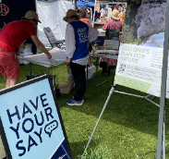 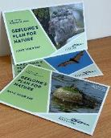 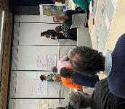
Figure 2. Community drop-in session at the Geelong Waterfront Market, Plan for Nature Postcards and City workshop

Drivers of change

The City is undergoing substantial population growth. Together with Bendigo and Ballarat, Greater Geelong is expected to absorb half of all growth outside metropolitan Melbourne by 2036.
At the same time, climate change is driving a drier, warmer future. Together, these pressures will intensify impacts on our natural environment.
We need a more coordinated response to protecting and managing nature to ensure the City can continue to support and enhance the liveability of our region.
Climate change
The Barwon region has already become drier and warmer, a trend expected to continue. Changes include rising temperatures, more variable rainfall , sea level rise and stronger winds. By the 2050s, some predictions suggest Geelong’s climate will resemble Shepparton’s climate today. Extreme weather events such as droughts, bushfires, heavy rain and heatwaves are also expected to become more frequent (see Figure 4).
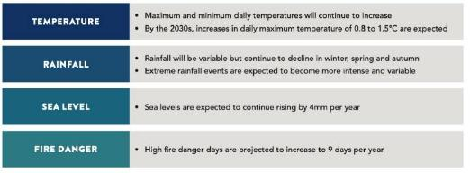
Figure 3. Climate projections for the Barwon Region
Biodiversity in Victoria, including in the City, has declined significantly since European settlement due to land clearing, fire, pest plants and animals, land development, altered hydrological regimes and water pollution. Climate change is likely to amplify these threatening processes, reducing the ability of native plants and animals to adapt and increasing the risk of loss or extinction of local populations and species.
Below are some of the changes that may shape the City ‘s natural environment.

Native vegetation and waterways
Extended dry periods and drought with reduced rainfall and higher temperatures will impact availability of soil moisture and water for surface and groundwater systems. This will change the composition of vegetation communities, with some species replaced by those better suited to warmer, drier conditions. Grassland species may also change in response to elevated carbon dioxide and shifting soil moisture levels.
Old remnant trees are particularly vulnerable to altered wetting and drying cycles, extreme heat and bushfire. These trees’ hollows, expansive canopies and complex branch structures provide irreplaceable habitat for a range of native mammals, birds, insects and reptiles. They also play a vital role in nutrient cycling, carbon sequestration and water regulation. The death of these trees reduces habitat and releases stored carbon back into the atmosphere.
Bushfires are expected to become more frequent and intense, favouring fast-growing, fire-tolerant species and increasing soil erosion, nutrient loss and sedimentation of waterways and impacts on wildlife.
Along the coast, sea level rise and stronger storms threaten vulnerable Bellarine and Corio Bay ecosystems. Over time, the natural inward migration of coastal vegetation communities, such as saltmarsh and mangrove, forced to migrate inland, may be lost as they hit sea walls, road infrastructure and other impediments.
More frequent and intense rainfall is increasing stormwater run-off that could affect aquatic ecosystems such as wetlands, streams and estuaries. We already have examples where the combination of increased urban development (and impervious surfaces) coupled with rainfall changes is impacting the natural hydrology of the Sparrovale Wetlands Reserve - Ngubitj yoorree and the coastal wetlands between Ocean Grove and Point Lonsdale.

Native fauna
Our most threatened ecological communities like Coastal Saltmarsh and threatened species like Orange-bellied Parrot and Hooded Plover are most vulnerable to climate change.
Changes in temperature, rainfall and sea level are altering habitats, reducing food and shelter and shifting where species can survive. More frequent and intense bushfires are shrinking unburnt habitat, while rising seas are likely to reduce coastal vegetation and impact the wildlife populations that depend on these environments.
Higher temperatures change the timing of life cycle events and distribution for animals and plants. Those with highly specific habitat requirements, limited dispersal ability or fragmented habitats may be most affected, leading to more local extinctions.
Drying wetlands and waterways will affect aquatic species by reducing water availability and quality, while increasing water temperatures, dissolved oxygen levels and risk of toxic algal blooms.
Climate change is likely to favour more-tolerant, faster-breeding invasive species, adding more pressure to native species through competition for dwindling food sources, increased predation and habitat loss.

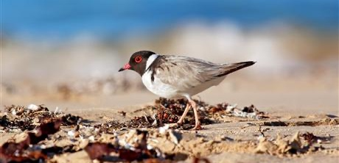
Figure 4. The endangered Hooded Plover
The Hooded Plover (which is nationally listed as vulnerable) will experience the compounding impacts of climate change. Coastal erosion and sea level rise will threaten their habitat, while growing beach use (including dogs) will further disturb. Habitat loss through the incursion of sea wheat grass and ongoing predation by foxes and native birds add further pressure, reducing the Hooded Plover ‘s ability to survive.

Cultural impact
Climate change has significant and distinct impacts for Indigenous people, affecting culture, knowledge and spiritual connection to Country. Declining biodiversity, changing ecosystems and increasing species loss reduce access to resources central to cultural practices. Wadawurrung people are already seeing the loss of kelp forests, dramatic changes in sea life, rising sea levels and risk to cultural sites.
Climate change is also disrupting Indigenous seasons, with environmental triggers occurring at different times. The long absence of cultural burning for centuries has altered ecosystems across Country and limited opportunities to heal and regenerate Country. Wadawurrung knowledge recognises fire as intrinsic for managing Dja (Country), particularly in the context of harsher weather patterns and longer fire seasons.
Indigenous knowledge, shaped by thousands of generations living with Country, is vital for guiding climate adaptation and supporting healthy landscapes into the future.
Population growth
The City’s recent strong population growth is likely to continue. The population is expected to grow to 441,984 by 2046, an increase of more than 44% on the current estimated resident population. The main factors contributing to this phenomenon are:
- Geelong feeds off broader population increases in Australia, Victoria and Melbourne.
- According to 2021 census data, Geelong gains population via migration from overseas, interstate and within Victoria particularly south-west Victoria, which is likely to continue.
- House prices are lower than Melbourne and there is less traffic congestion. New transport upgrades provide good access to Melbourne’s job market and services and local employment opportunities are growing.
This population growth has led to rapid urban expansion, particularly in Armstrong Creek and on the Bellarine at Leopold, Ocean Grove and Drysdale/Clifton Springs. Future growth will continue to be focus on Armstrong Creek and the Northern and Western Geelong Growth Areas, the largest regional urban expansion in Victoria, comprising over 5,300ha. Growth on the Bellarine may be more limited due to support for maintaining its character through planning controls guiding land use, management and development for the next 50 years.
Without adequate planning, the significant population growth and urban expansion will continue to put pressure on biodiversity and the remaining natural areas in the City. Only a careful, collaborative response can prevent further loss and fragmentation of remnant vegetation and protect and restore ecological communities that are already threatened or endangered, such as the grassland communities to the City’s north.
Land use change
Since European settlement, widespread vegetation clearing for agriculture, horticulture, industry and townships has significantly reduce native vegetation across the City. Most remaining native vegetation is now found in public reserves and parks, protecting important habitat remnants that have been largely cleared elsewhere. Around 12,094ha (approximately 9.7%) of City land is permanently protected, including Parks Victoria managed land, City nature reserves and private land protected under Trust for Nature covenants. Outside these areas, native vegetation is mostly threatened and largely fragmented, occurring in small patches along roadsides, waterways and the coast, or scattered across private property.
The consequences of native vegetation loss are well-known and include reduced biodiversity, increased salinity, soil erosion, and deteriorating water quality in our rivers, creeks and wetlands.
Without appropriate planning and management, several land use changes may continue to contribute to the loss, fragmentation and degradation of native vegetation in the City. These are:
- Widespread urban development and expansion into previously agricultural or natural areas, leading to potential removal or fragmentation of remaining patches of vegetation. This includes removal or fragmentation of old habitat trees, woodland habitats and grasslands
- Increased built infrastructure, including utilities and roads, which has expanded to service a fast- growing population
- Subdivision of larger farms to meet increased demand for lifestyle properties – a trend particularly evident across the Bellarine. Subdivision can lead to further removal of native vegetation to make way for housing and services and can increase the threat to wildlife from domestic pets and introduction of garden weeds.
- Offsets required under Victoria’s Planning and Environment Act 1987 and the state’s Native Vegetation Removal Guidelines to mitigate the net loss of biodiversity from a planning development are commonly purchased outside the City. This leads to further biodiversity loss within the City, contributing to the ongoing fragmentation of threatened ecosystems.
In recent years, the City’s nature reserves nearly doubled from around 700ha to 1,358ha, largely through land transferred as development offsets. While the total area has grown, many new reserves are small and fragmented, raising concerns about their long-term ecological quality and resilience.
Pest plants AND animals
Pest plants and animals are a major problem in the City. They compete with native species for resources, prey on native fauna, damage habitats and disrupt ecosystems. Established pest animals in the region include rabbits, foxes, feral cats and deer, with several invasive species well-established despite their declaration under the Catchment and Land Protection Act 1994.
Pest plants also threaten biodiversity and agriculture by invading native vegetation, providing shelter for pest animals, increasing fire fuel loads and, in some cases, reducing land values.

[insert page image as a section break]

Strategic Direction

The Plan for Nature forms a key part of the City’s broader environmental program. It provides detailed direction on how we can achieve our goal of protecting, enhancing, and restoring biodiversity in line with the Environment Strategy 2020-2030 and, more broadly, our community vision. Achieving these goals requires sustained investment in biodiversity. Without it, we cannot achieve this goal or contribute to the community aspiration of:
By 2047, Greater Geelong will be internationally recognised as a clever and creative city-region that is forward looking, enterprising and adaptive, and cares for its people and environment.
Specifically, the Environment Strategy 2020-2030 and Plan for Nature will focus on delivering the following components of the community vision:
- Sustainable development that supports population growth and protects the natural environment
- Development and implementation of sustainable solutions.
The Plan for Nature specifies five goals, each with defined outcomes, targets and actions, which align with and support the guiding principles of Goal 4 in the Environment Strategy.
Figure 6 outlines the strategic foundation of the Plan for Nature.
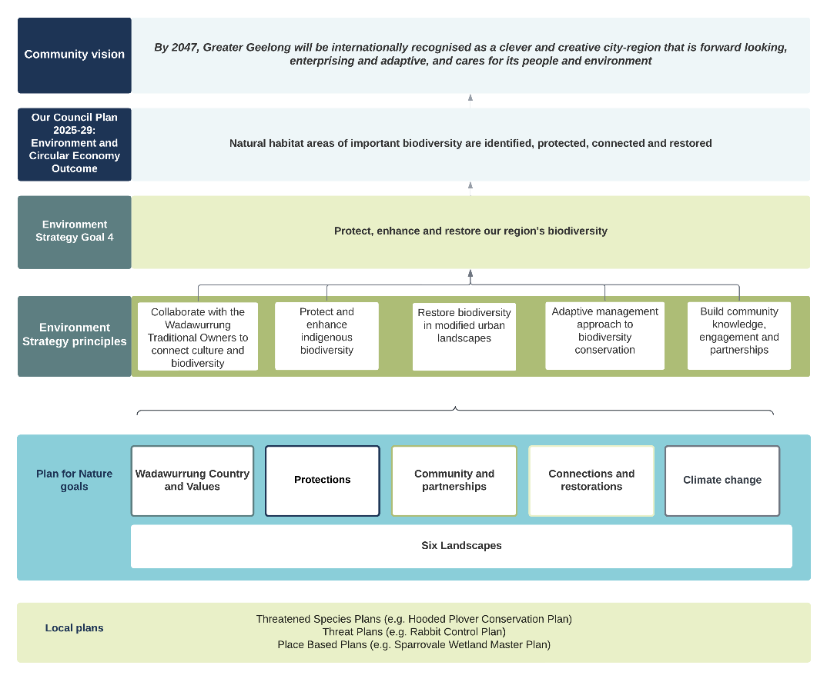
Figure 5. Strategic foundation of the Plan for Nature
Structure of the Plan for Nature
The Plan for Nature sets long-term (10 year) strategic objectives and targets for each of the five goals. These higher-level objectives will be implemented over the life of the Plan. Underpinning this is a shorter-term Action Plan, comprising a series of actions that will be implemented over two years. Many of the short-term actions are place-based and will apply to one of six landscapes (refer next section), while some actions will apply to the whole of the City. The Action Plan will be reviewed and updated every two years on a rolling basis.
State of Nature reports have been prepared for each of the six landscapes and describe the current state of biodiversity, threats and opportunities. Key species have also been identified for each landscape and are documented in this Plan.
Figure 7 provides an overview of the elements of the Plan for Nature, which are described in detail in the following sections.
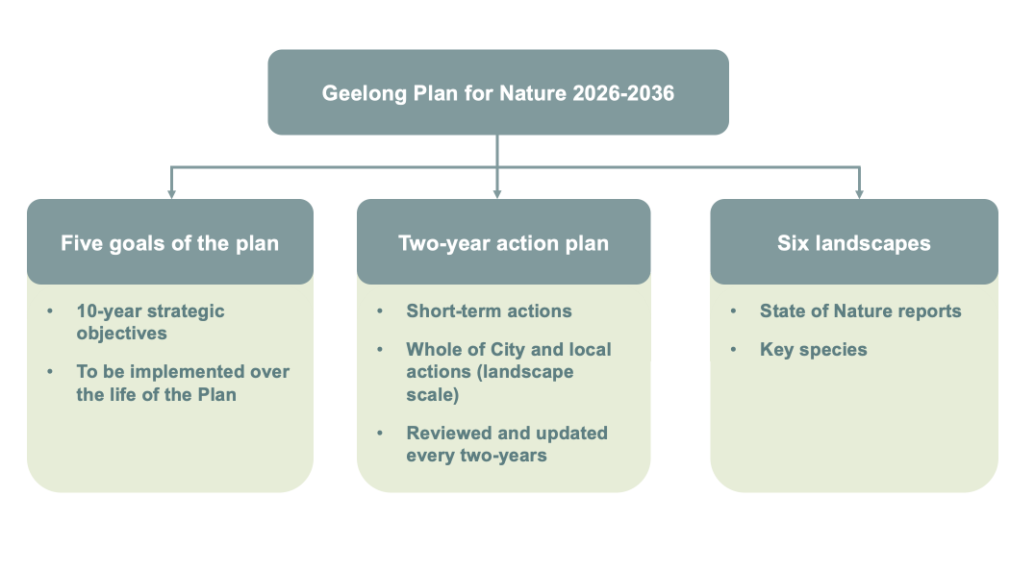
Figure 6. The elements of the Geelong Plan for Nature 2026-2036

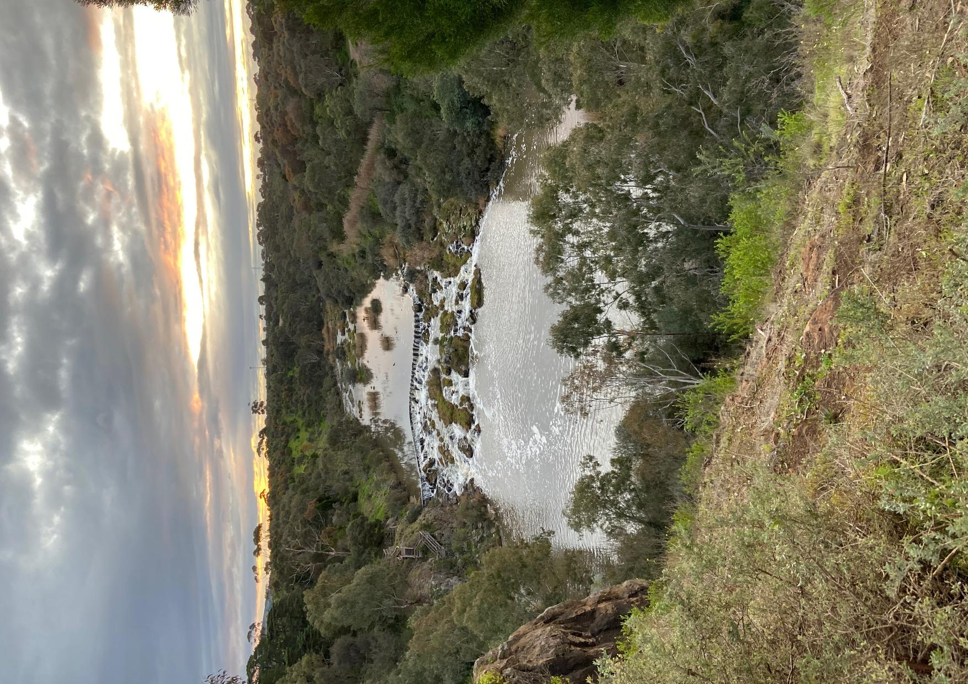

Landscapes: Values, Threats and Opportunities
overview
The Plan for Nature has also adopted six landscapes. These areas align with the landscapes (or local areas) described by the Corangamite Catchment Management Authority (CMA) and Melbourne Water in the Corangamite and the Port Phillip and Western Port Regional Catchment Strategies (refer to Figure 7).
These are areas with common features based on demographics, land use, vegetation, geology, geomorphology, soil, topography, hydrology, climate, bioregions and connectivity. The six landscapes described in this Plan allow for more detailed, place-based planning and more locally focused management of biodiversity values.
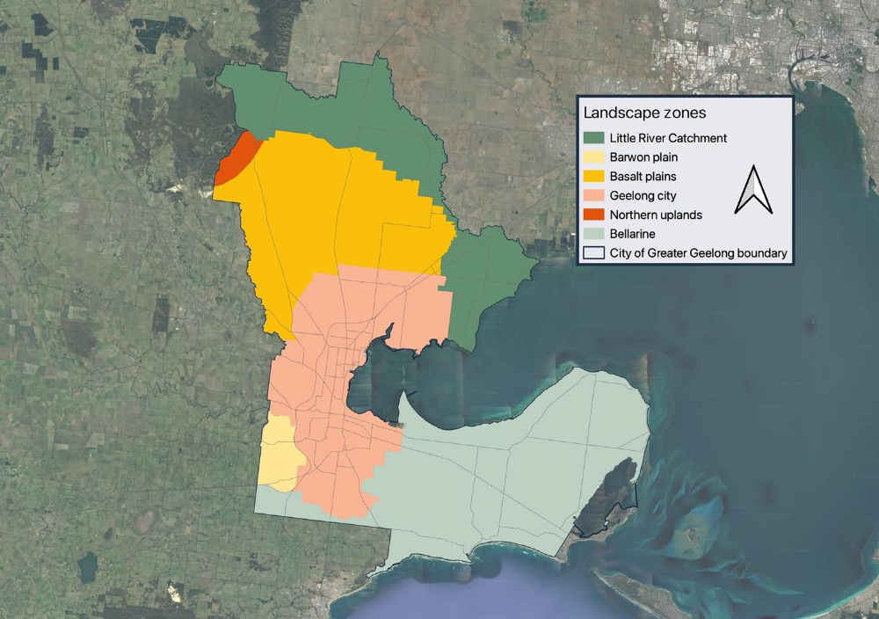
Figure 7. Landscapes or local areas that occur in the City of Greater Geelong (as based on the Corangamite and Port Phillip and Western Port Regional Catchment Strategies)
This section describes each of these landscapes, its current condition, as well as the key threats and opportunities for its biodiversity. Localised, short-term (two-year) actions have been identified for each landscape (as well as some actions that apply across the whole City), which build on longer-term strategic objectives. The first section provides a snapshot for the entire municipality.
More details about the state of nature have been developed for each landscape as part of the development of this Plan. This information provides a more in-depth account of the state of biodiversity, trends, threats and opportunities pertaining to each landscape. This is information is available by contacting the City.

Across Djilang
The Wadawurrung connection to Geelong, known as “Djilang”, is a powerful lens for understanding the region’s landscapes and biodiversity. Djilang, the “place of the sea bird over the white cliffs”, spans warre (sea), coastal wetlands, estuaries, saltmarshes, inland waterways including the Parwan (Barwon River), grassy plains, hills and woodlands. Once, the rich habitats were connected and uninterrupted, reflecting Wadawurrung belief that warre and dja (land) are inseparable.
The diverse landscape supports a rich array of flora and fauna, including migratory and resident birds, native mammals such as the Go-yin (wallabies) and Walert (possums), fish, amphibians and reptiles.
While Djilang is still a place of significant biodiversity, the landscape has been profoundly changed by urban growth, agriculture, industry, introduced species and climate change. It’s now fragmented, with remaining patches of remnant vegetation scattered across the City. Though limited, what remains is critically important, supporting species that were once widespread and are now threatened.
We must act now and work together with Wadawurrung and our growing community to protect and restore biodiversity across Djilang.
Current condition
- Highly fragmented landscape, with patches of remnant vegetation remaining that are mostly threatened, with very significant biodiversity values
- Stands of scattered and isolated old trees exist across the landscape, particularly in the north
- Areas of very high biodiversity value exist across the Ramsar wetlands, including expansive and diverse areas of saltmarsh vegetation
Table 4 provides a snapshot of some nature indicators for the municipality.
Threats
The threatening processes impacting biodiversity across the City are discussed in detail in this Plan (refer to the Drivers of Change section). The main threats are:
- Climate change
- Population growth
- Land use change
- Pest plants and animals.
Opportunities
- Creating landscape scale biolinks to increase habitat connectivity
- Supporting Wadawurrung Traditional Owners to have a more prominent role in Caring for Country
- Increasing the diversity in community participation and engagement in biodiversity conservation across the City
- Stronger planning protections for biodiversity across the City
- Partnerships with Corangamite CMA, Melbourne Water, Parks Victoria and other key stakeholders.

Barwon Plain
The Wadawurrung know the Barrabool Hills as barro aabil, meaning “place of rounded hills”. Prior to European colonisation, the landscape was mostly open woodlands of drooping sheoak, acacias and banksias, with a diverse ground layer of herbs and grasses. Pure grasslands covered the elevated areas and stands of river red gums and swamp gums lined the Barwon River.
Farmers cleared most of the area, harvesting sheoak for firewood and replacing native perennial grasses with exotic pastures and crops. Key natural values of the Barwon Plain landscape are the Barrabool Hills, the Barwon River and Waurn Ponds Creek.
Current condition
- Very few examples of intact remnant vegetation remain
- No City managed nature reserves (other than roadsides) or any other public land for nature conservation
- The best remaining remnant vegetation exists along the Barwon River corridor.
Map 1 shows the mapped extent of existing remnant vegetation, its biodiversity conservation significance and old trees
Map 7 shows protection measures
Table 4 provides a snapshot of some nature indicators for the Barwon Plains.
Threats
- Climate change
Figure 8. Map of the Barwon Plain landscape
- Pest plants and animals
- Population growth and urban development in surrounding areas
- Loss of old ‘habitat’ trees.
Opportunities
- Waterways (Barwon River and Waurn Ponds Creek) as biolink corridors
- Private land restoration
- Partnerships with Deakin University to restore Waurn Ponds Creek.

Key species
Bundjil (Wedge-tailed Eagle Aquila audax)
Australia’s largest bird of prey, the Wedge-tailed eagle has a wingspan up to 2.3 m and a distinctive wedge-shaped tail. On the Barwon Plains, they favour the open country and large old trees for locating prey and building their nests. They can be seen perched on trees or soaring high overhead.
According to the Wadawurrung, Bundjil, often depicted as a Wedge-tailed Eagle, is an ancestral spirit who created the land, water, sky and people of the wider landscape. Protecting old habitat trees and reinstating Bundjil habitat in this landscape is very important.
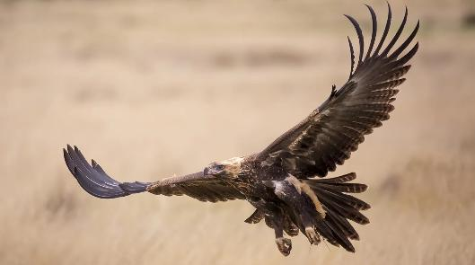
Figure 9. Bundjil (Wedge-tailed Eagle)

Bellarine
The Bellarine’s name comes from the Wadawurrung word Bellawiyn, meaning “resting by the fire”. Before European settlement, the Bellarine Peninsula was dominated by extensive open eucalypt woodlands. Very little remnant vegetation remains today, the largest being the Lake Connewarre Complex including extensive saltmarsh and mangroves. Lake Connewarre and Swan Bay form part of the Port Phillip Bay (Western Shoreline) and Bellarine Peninsula Ramsar Site, including important saltmarsh habitat, seagrass habitat, wetlands and an estuarine environment where Barwon River meets the sea. The area also supports marine parks and habitat for threatened species such as Orange Bellied Parrot, Swift Parrot and Hooded Plover.
The Bellarine landscape has evolved over thousands of years and supports high biodiversity. For the Wadawurrung people, the connected chain of ponds from the Barwon River to Reedy Lake, Hospital Swamps, Lake Connewarre and Estuary Bay are linked through Connewarre (Black Swan) Dreaming.

Current condition
- Highly fragmented landscape, with patches of remnant vegetation along the thin shoreline strip and within wetlands
- Remaining patches of remnant vegetation are mostly threatened with significant biodiversity values
- Grassy woodlands have been significantly reduced
- Large trees have been extensively cleared
Figure 10. Map of the Bellarine landscape
- Highly engaged community
- Small coastal tributaries on the bayside are largely degraded.
Map 2 shows the mapped environmental values.
Map 8 shows protection measures.
Table 4 provides a snapshot of some nature indicators for the Bellarine.
Threats
- Climate change
- Population growth and urban development
- Continued fragmentation and loss of habitat
- Loss of old ‘habitat’ trees
- Pest plants and animals.
Opportunities
- Blue carbon opportunities, for example, south-east Bellarine, at the Point
- Protection of old habitat trees and woodlands
- Increased habitat connectivity, especially along coastal creeks of the Bellarine
- Working with Wadawurrung Traditional Owners at priority sites
- Strengthened and diversified volunteering opportunities
- Reviewed and amended planning controls.

Key species

Superb Fairy-wren (Malurus cyaneus)
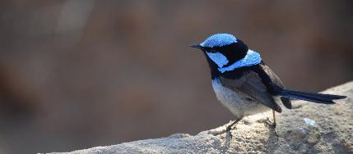
Found in the open eucalypt woodlands of the Bellarine, where it inhabits dense understorey, the Superb Fairy-wren is usually seen in pairs or small groups. They have also adapted to urban parks and gardens across the Peninsula. The male’s breeding plumage is unmistakeable, with a light blue cap, ear tufts and cheeks,
Figure 11: A breeding male Superb Fairy-wren
a black eye-strip, dark blue-black throat, brown wings and a white breast and belly. The adult female is mostly brown, with white throat, breast and belly. They forage mostly on the ground, eating insects, small seeds and fruits.

Basalt Plains

The Basalt Plains landscape area is part of a larger landscape system extending west from Greater Geelong. It’s home to known rare and threatened species and significant and endangered vegetation communities like native grasslands. Threatened species include the Grassland Earless Dragon, Growling Grass Frog, Striped Legless Lizard, Golden Sun Moth and Spiny Rice-flower.
Other significant natural features include highly biodiverse Wurdi Youang (You Yangs or “big hill”) and part of Anakie Youang (Mt Anakie or “little hill”). Hovells Creek is a key waterway connecting the Basalt Plains to Limeburners and Corio Bays.
Current condition
- Native grasslands lack diversity and are fragmented
- Extensive stands of old trees remain on Hovells and Sutherlands creeks and in the higher country
- Some of the best examples of remnant grasslands occur on City managed roadsides, for example, Old Melbourne Road.
Map 3 shows the mapped extent of existing remnant vegetation, its biodiversity conservation significance and old trees.
Map 9 shows protection measures.
Table 4 provides a snapshot of some nature indicators for the Basalt Plains.
Threats
- Continued loss, degradation and fragmentation of grassland habitat on private land
- Climate change
- Pest plants and animals
- Loss of old ‘habitat’ trees.
Opportunities
Figure 12. Map of the Basalt Plains landscape
- Private land conservation focused on grasslands, grassy woodlands and old habitat trees
- Protection and enhancement of biolink corridors along Hovells and Sutherlands creeks
- Supporting Wadawurrung Traditional Owners to undertake cultural burning
- Protection of high value roadsides
key species
Pobblebonk Frog or Eastern Banjo Frog (Limnodynastes dumerilii)
The common, burrowing frog is found in waterways and farm dams across the Basalt Plains. It is easily identified by its distinctive loud “bond” or “plonk” call likened to a banjo string being plucked, making it great for surveys, even if it can’t be seen. Adults grow up to 7.5 cm long, with a brown to green colouring and distinctive warty back, orange or yellow mottling on the sides, and a pale back yellow stripe from under eye to shoulder.
Restoring habitat along Hovells and Sutherlands creeks will help support local populations.

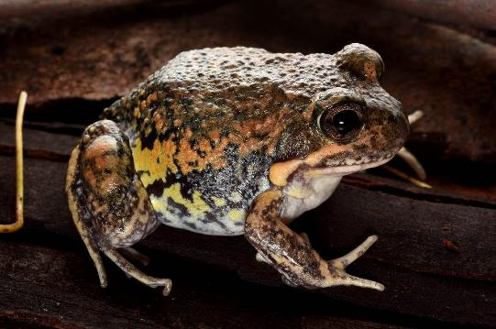
Figure 13. Pobblebonk Frog

Geelong City Landscape
Geelong’s name comes from the Wadawurrung word Djilang, meaning “tongue of land”. Spanning more than 28,000 hectares, the city landscape encompasses the urban centres of both Geelong and Lara. Despite its population density, important natural values remain. These include habitat within public reserves, coastal wetlands and saltmarshes, along waterways including the Barwon River, Waurn Ponds Creek and local creeks, areas of remnant native grasslands in open spaces and roadsides, and the nationally significant Grey Headed Flying Fox Camp at Eastern Park.
The Barwon River (Parwan) flows through the city centre. Wadawurrung consider the Barwon and its connected waterways and wetlands as a living entity. Stands of river red gum, woolly tea tree and silver wattle line the river and over 100 bird species live here, along with the water rat (Rakali), platypus and swamp wallaby.
Warre (sea) country strongly shapes Geelong’s identity. The coastline from Limeburners Bay through Avalon to Point Wilson is part of the Port Phillip Bay (Western Shoreline) and Bellarine Peninsula Ramsar Site, supporting saltmarshes, seagrasses and estuarine habitats.

Current condition
- Highly urbanised environment
- Most remnant vegetation exists in public land reserves, especially linear reserves along waterways and the coastline, and in nature reserves and open space areas
- Higher proportion of environmental volunteer groups than other landscapes (except the Bellarine).
Map 4 mapped environmental values .
Map 10 shows protection measures.
Table 4 provides a snapshot of some nature indicators for the Geelong City.
Threats
- Climate change
- Expansion of urban areas into natural habitats
- Greater pressure (disturbance and pollution) on waterways, wetlands, and remnant vegetation.
Opportunities
Figure 14. Map of the Geelong City landscape
- Supporting community restoration of habitat corridors along urban waterways
- Working with Wadawurrung Traditional Owners on public land reserves
- Blue carbon opportunities in coastal saltmarsh areas
- Community engagement activities (Gardens for Wildlife, Nature Strip Plantings, Geelong Nature Forum).
Key species

Perridak (Platypus Ornithorhynchus anatinus)
The Platypus is a unique egg-laying mammal, known as a monotreme, found in the Barwon and Moorabool Rivers other waterways across Geelong. It is semi-aquatic and difficult to see, spending much of its time feeding in streambeds or sheltering in burrows along riverbanks, beneath vegetation roots, or among rocks and debris. Ideal Platypus habitat includes waterways with earth banks, shady native vegetation, logs and gravel substrates that support microinvertebrate (a main food source). Protecting and restoring Geelong’s in-stream and riparian habitats is essential to survival of Platypus in the Geelong City Landscape.
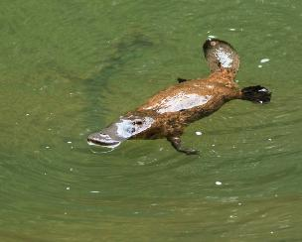
Records of Platypus in the Barwon and Moorabool Rivers around Geelong are increasing, but the last recorded sighting in the Warun Ponds Creek was in 2003.
Figure 15. Perridak (Platypus)

Little River
The Little River, Worrin-yaloke, flows from the Brisbane Ranges to Port Phillip Bay, forming large coastal wetlands. Lake Borrie, Spit Nature Conservation Reserve and the Western Treatment Plant are all part of the Port Phillip Bay (Western Shoreline) and Bellarine Peninsula Ramsar Site. Together they support important habitat including kelp and seagrass beds, marine meadows, intertidal salt and freshwater marshes, sandy shorelines and mudflats.
Before the landscape beyond the Brisbane Ranges was largely cleared, River Red Gum (Eucalyptus camaldulensis) were the dominate tree species, scattered sparsely across the plains and along Litte River and other waterways. Bandicoots (Kwenda) and spotted tail quolls (Yoorn) were abundant on the grasslands, where they played crucial roles in maintaining soil and ecosystem health.
The Wadawurrung have a long connection with this landscape and were practicing sedentary agriculture long ago.

Current condition
- High biodiversity values contained in public land reserves
- High value roadsides surrounding the Brisbane Ranges
- Most native grasslands have been destroyed or degraded.
Map 5 mapped environmental values .
Map 11 shows protection measures.
Table 4 provides a snapshot of some nature indicators for the Little River.
Threats
- Climate change
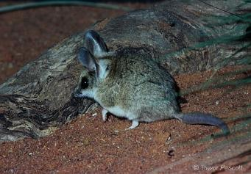
- Pest plants and animals
- Loss and degradation of high value roadside vegetation
- Continued loss and degradation of grassland habitat on private land.
Opportunities
- Blue carbon opportunities in intertidal areas
Figure 16: Fat-tailed Dunnart
- Reviewed and amended planning controls
- Protection of high value roadsides
- Private land conservation focused on grasslands and grassy woodlands
- Working with Wadawurrung Traditional Owners
- Habitat connectivity and restoration along Little River
- Partnerships with Melbourne Water.
Key species
Figure 17. Map of the Little River landscape

Fat-tailed Dunnart (Sminthopsis crassicaudata)
This small native marsupial lives in grasslands and open woodlands of the Victorian Volcanic Plains, where cracking clay soils provide shelter and foraging habitat. It has yellow-brown fur, large ears and a pointed nose, and stores fat in its tail to survive low food periods. The Fat-tailed Dunnart is listed as threatened under the Victorian Flora and Fauna Guarantee Act (1988) with threats including habitat loss, competition from pest animals, predation by feral cats and foxes, and accidental harm through vermin control.
In the 1980s survey work around the Western Treatment Plant recorded several sites containing Fat-tailed Dunnarts some with multiple individuals. Very few have been recorded since.

Northern Uplands
The City includes a small section of the Northern Uplands landscape encompassing private land to the southwest of the Brisbane Ranges. This small section includes large areas of intact remnant vegetation remaining on private land, and the presence of old trees.
For the Wadawurrung people, this landscape including the nearby Brisbane Ranges, holds great cultural, social and spiritual significance.
Current condition
- High biodiversity values on private land, including large, old trees and standing dead trees
- High value roadsides.
Map 6 mapped environmental values
Map 12 shows protection measures
Table 4 provides a snapshot of some nature indicators for the Northern Uplands.
Threats
- Climate change – drier, hotter, more extreme events, longer fire season, migration/loss of native species and old trees
- Pest plants and animals
- Loss and degradation of high value roadside vegetation.
Figure 18. Map of the Northern Uplands landscape
Opportunities
- Protection of high value roadsides
- Private land conservation
- Protection of old habitat trees
- Supporting Wadawurrung Traditional Owners to undertake cultural burning
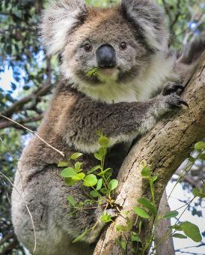
- Wildlife road crossings
Figure 19. Ngaambulmum (Koala)
- Koala habitat protection and restoration
- Partnership with Koala Clancey Foundation.
Key species

Ngaambulmum (Koala Phascolarctos cinereus)
Koalas rely on eucalyptus forests for both food and shelter. Across the Geelong region, threats include habitat loss, urban development, disease, vehicle strikes, dog attacks and climate change.
Regular monitoring of Koalas in the Geelong region by Koala Clancey indicate Koala numbers are in decline.
The Northern Uplands biolink retains quality habitat and old eucalypts on private land that support Koalas while extending habitat connections from the Brisbane Ranges National Park towards the You Yangs and Moorabool River.

Table 4 provides a snapshot of some indicators across the municipality (Djjlang) and the six landscapes.

Theme | Djilang | Barwon Plain | Bellarine | Basalt Plains | Geelong City | Little River | Northern Uplands
Remaining remnant vegetation and wetlands (estimated) | 18% | 1% | 15% | 21% | 8% | 31% | 65%
Hectares managed by the City for nature conservation | 1,358 (ha) | 1.3 (ha) | 845 (ha) | 19 (ha) | 465 (ha) | 8.5 (ha) | 19 (ha)
% of the total area in the municipality protected in the conservation estate | 9.7% |  | 13.7% | 7.7% | 3.4% | 14% | 5.9%
Number of Ecological Vegetation Classes (EVCs) mapped (including mosaics) | 69 | 7 | 31 | 29 | 34 | 35 | 16
% of rare, vulnerable, and endangered EVCs mapped |  | 86% | 94% | 90% | 100% | 80% | 63%
Number of threatened species and ecological communities | 191
Number of Threatened species and ecological communities listed under the EPBC Act | 42 | 6 | 24 | 21 | 31 | 27 | 1
Number of species listed under the EPBC Act with habitat on City managed land | 24 | 6 | 21 | 12 | 19 | 18 | 1
Number of caring for environment, citizen science, and network groups | 73 | 1 | 34 | 5 | 29 | 3 | 1
Number of caring for environment, citizen science, and network groups involved in managing City nature reserves. | 36 |  | 18 |  | 17 | 1

Refer Appendix 1, 2 and 3 for a list of threatened species and ecological communities, and a list of volunteer environmental groups and networks.

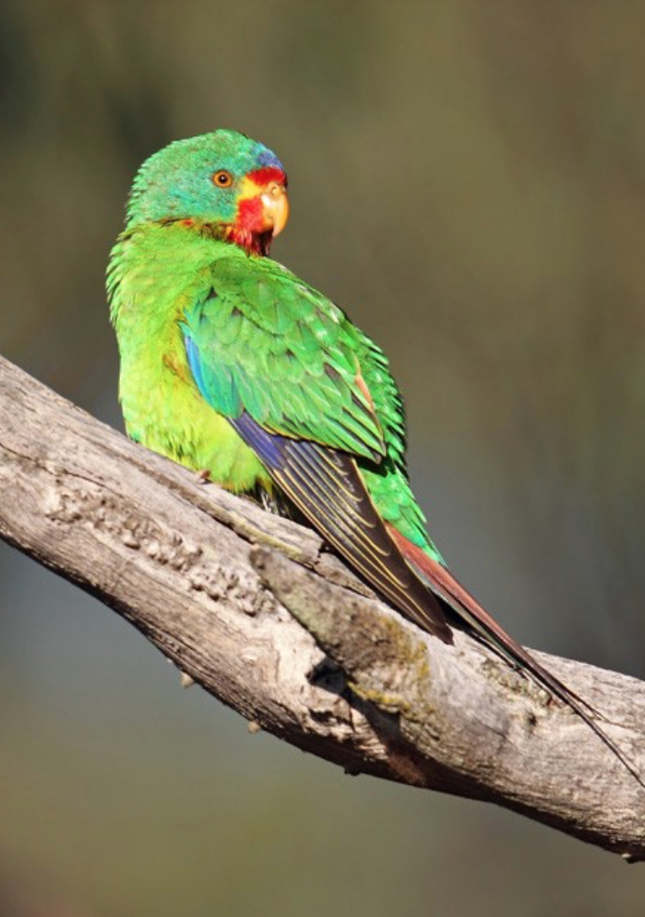
Figure 8. The elements of the Geelong Plan for Nature 2025-2035

Goal 1: Wadawurrung Country and Values
We will support Traditional Owners to care for and heal Country. As the original custodians of this landscape, Wadawurrung Traditional Owners hold deep knowledge of caring for Country built over thousands of generations. We have much to learn from the Wadawurrung in how we protect nature.
context
Colonisation dispossessed Wadawurrung and other First Nations peoples of their Country. Protecting biodiversity in the Geelong region will also protect and restore connection to Wadawurrung cultural practices by preserving important totem species, bush foods and medicines.
This plan provides opportunities for Wadawurrung to apply their knowledge and skills in managing and conserving the City’s natural environment, while enabling others to learn from their stewardship of Country.
Through ongoing collaboration, we will work with Wadawurrung to understand cultural values across the landscape, manage nature reserves of high cultural and/or ecological value, and support the use of Wadawurrung language, stories and cultural practices in the City’s natural areas.
This Plan supports a stronger, ongoing role for Wadawurrung in Caring for Country, and aligns with the principles and goals of Paleet Tjaara Dja, the Wadawurrung Country Plan.
Strategic objectives
- Wadawurrung have an increasing role in the management of the City’s nature reserves
- Wadawurrung are leading identification, protection and management of cultural values
- More Wadawurrung language, stories and cultural practice are embedded within the City’s nature reserves.
targets
- Five (5) nature reserves feature active collaborative relationships between Wadawurrung and the City
- Two (2) completed Cultural Values Assessments (CVAs) of cultural landscape areas
- Wadawurrung language, stories or cultural practice adopted for
        - new nature reserves
        - five (5) existing nature reserves.
- 74% of the area of City land managed as nature reserve falls within areas of cultural heritage sensitivity

Goal 2: Protections
The City’s remaining native vegetation and habitat are limited and increasingly vulnerable. To maintain biodiversity, we must prioritise protection and restoration of what remains and avoid further loss. This requires a strong focus on planning, protection mechanisms, and collaborative action to safeguard what we have and support recovery over time.
context
Only small, highly fragmented areas of remnant vegetation and habitat remain across the City on both public and private land. While limited, these remnants are vital for biodiversity, providing critical habitat for threatened flora and fauna species that have adapted over thousands of years to exist in these vegetation communities. These patches also offer complexity in vegetation age and structure that can take years to replicate, supply seeds for collection and conservation, and serve as important benchmarks to guide future revegetation efforts.
The City’s internationally significant wetlands are vital biodiversity strongholds. They support tens of thousands of waterbirds and other wildlife, including rare and threatened species. These wetlands provide crucial breeding and feeding grounds and help reduce the impacts of climate change through providing natural flood mitigation, shoreline stabilisation and storm protection.
Habitat is also found throughout the City in places such as our gardens and backyards, parks and green spaces, waterways, street trees, rooftop gardens and coastal areas. Together these areas provide important refuges for wildlife.
With so little habitat remaining in the City, preventing further loss and protecting and enhancing what remains is critical.
Biolink areas have been identified throughout the City to guide where protection, connection and restoration actions will be prioritised. Further details are provided in Goal 3. Refer also to Map 13 and Appendix 4 for further detail.

Protecting biodiversity through land use planning and other mechanisms
The City’s conservation estate covers just 9.7% of the municipality and includes land protected by Parks Victoria, Corangamite CMA, Barwon Water, Coastal Committees of Management and the City, and a small portion of private land under Trust for Nature covenants. By protecting and conserving this conservation estate, and seeking opportunities to expand it, we will contribute to Australia’s national ’30 by 30’ target to conserve 30% of landmass and marine areas by 2030.
Several wetlands in the City are listed under the Ramsar Convention as part of the Port Phillip Bay (Western Shoreline) and Bellarine Peninsular Ramsar site. This includes much of the Lake Connewarre wetland system, Swan Bay, Point Wilson / Limeburner’s Bay and the Avalon coastal area. These wetlands are recognised internationally for their significant biodiversity and habitat values.
Beyond the conservation estate, small patches and linear strips of remnant vegetation persist along waterways, coastal areas, and roadsides and on private land. The Greater Geelong Planning Scheme provides regulatory mechanisms to protect and enhance vegetation and habitat values over the long-term, including the Vegetation Protection Overlay (VPO), Environmental Significance Overlay (ESO) and Significant Landscape Overlay (SLO). The Rural Conservation Zone (RCZ) guides subdivision and planning requirements for development and works that are compatible with conservation values, while the Public Conservation and Resource Zone (PCRZ) outlines permitted and prohibited activities that support the conservation purposes of the zone. Refer Map 7 to 12.
Protection of native vegetation is also regulated under Clause 51.17 of all Victorian Planning Schemes, with the most recent approvals associated with new urban development. Despite the City’s planning permit and compliance processes, illegal vegetation removal continues to occur.
We need greater emphasis on securing biodiversity offsets within the City, rather than outside it. Securing offsets locally will help protect remaining vegetation and strengthen long-term biodiversity outcomes for the City.

Protecting biodiversity on private land
Significant remnant vegetation and biodiversity also exist on private land, but only a small proportion is permanently protected, such as through conservation covenants. Working with private landholders is essential to protecting, enhancing and preventing any further loss. The City can support this through education, incentives and collaboration with organisations such as Landcare and Trust for Nature. Conservation covenants, such as those administered by Trust for Nature, offer a permanent means to safeguard native vegetation on private land. The City can help encourage their uptake through incentives and support for sustainable land management practices.

Building internal capacity to protect and enhance nature
Building the skills, knowledge and collaboration of City staff and contractors is key to embedding biodiversity protection across all areas of our work. Improving ecological understanding helps ensure biodiversity is considered in planning, infrastructure delivery, community programs and day-to-day decisions.
Providing practical training, tools and guidance will build confidence to act for nature, while stronger collaboration across City departments will support shared outcomes such as improved liveability, wellbeing and community health. Integrating biodiversity into corporate policies and processes enables the City can lead by example and deliver best-practice environmental outcomes.
STrategic objectives
- More high-quality remnant vegetation in biolink areas on private land is protected though appropriate zones or overlays that recognise environmental values
- More areas of remnant vegetation are permanently protected across both public and private land
- Threatened species and their habitats are better protected in City’s nature reserves, open spaces and roadsides
- A greater proportion of vegetation offsets are secured within the City
- Fewer instances of vegetation removal occur without a permit
- Nature considerations are embedded into the City’s policies, strategies and operational procedures across all key departments.
TARGETS
- A higher level of protection is applied to remnant vegetation in biolink areas
- Conservation protection established for all remnant biodiversity patches larger than 10 hectares within biolink areas
- The total area of remnant vegetation within the City’s conservation estate or other public protected areas is increased
- The total area of biodiversity permanently protected on private land increases (e.g., via Trust for Nature covenants or other protection mechanisms)
- Five (5) City owned Nature Reserves are permanently protected through Trust for Nature Covenants or Section 69 Agreements
- Conservation action plans are in place to better protect threatened species and their habitat in City managed nature reserves, open space and roadsides
- A greater proportion of biodiversity offsets are secured within the City rather than elsewhere
- The annual rate of vegetation clearing without a permit, including the loss of old trees, declines
- More formal processes that protect nature are integrated into the City’s policies, strategies and operational procedures.

Goal 3: Connections and Restoration
Healthy, biodiverse-rich ecosystems depend on being well-connected and resilient. To do this we must link remnant vegetation, restore degraded areas and create new habitat so native plants and animals can move, adapt and survive. Building this resilience is key, especially as our climate changes.
context
The City has a responsibility to restore and expand native vegetation and habitat, so biodiversity is protected, strengthened and does not continue to decline. This commitment aligns with Victorian Government targets for achieving a net gain in the extent of habitats by 2037 and recognises the importance of nature for community health and wellbeing, and for future generations.
In a changing climate, restoring, connecting and expanding habitat is essential to help species survive and adapt. This includes supporting natural regeneration, undertaking revegetation programs, reconnecting fragmented habitats, restoring degraded waterways and wetlands, increasing habitat across urban areas and reducing threats such as pest plants and animals. Climate change is likely to amplify existing threats and reduce resilience of flora and fauna species to adapt. Species in highly fragmented landscapes are more vulnerable, as their ability to easily migrate in response to pressures is reduced. Well-connected, healthy habitats give our remaining species the best chance to persist and adapt to current and future pressures.

Public reserve management
The City manages a network of nature reserves providing important habitat for native plants and animals, including many threatened species. The reserves range from small 1 hectare urban parks to large reserves over 100 hectares with high biodiversity value. Even smaller reserves can be important for protecting remnant vegetation and supporting wildlife.
While some reserves have conservation or master plans, many are outdated or incomplete, and some reserves have no plan in place. This makes it difficult to guide investment and prioritise action. Reviewing and updating management plans, particularly for reserves supporting threatened species, is a key priority.
Pest plants and animals are a major pressure across the City. They compete with native species for resources, prey on native fauna, cause erosion and other physical disturbances, and can affect ecosystem functioning. Established pest animals in the region include rabbits, foxes, feral cats and deer. Invasive animals declared under the Catchment and Land Protection Act 1994, such as rabbits and foxes, are well established in the municipality. Pest plants are a risk to regional biodiversity, they invade native vegetation, provide habitat for pest animals and increase fire fuel loads.
We need to review regulations at City reserves of high wildlife value, such as coastal reserves, that provide critical habitat for threatened species like the Hooded Plover. Current practices such as dogs on beaches pose a key threat to native wildlife. Hooded Plovers rely on the narrow strip of coastal land between the sea and dunes, which is already under pressure from climate impacts. Alleviating avoidable pressures, such as dogs in key habitat areas, will help build species’ resilience.
Domestic and feral cats also threaten native wildlife. Cats prey on a wide range of native animals including reptiles, birds, mammals, frogs and invertebrates. Research suggests that on average, each pet cat allowed to roam (even for only part of the day or night) kills 186 reptiles, birds and mammals per year in Australia, including 110 native animals. That averages out to more than two native animals per cat per week. The City has a key role in the managing domestic cats and may consider measures such as a cat curfew to reduce impacts on wildlife, particularly at night.
Feral cats will continue to be targeted in broader pest management programs and in conjunction with surrounding land managers, such as Barwon Coast Committee of Management and Parks Victoria.

Linear reserves
The City manages rural roadsides, which can support high quality native vegetation and provide important wildlife corridors. Some of the most intact and diverse remnant vegetation occurs in the roadside reserves, with around 300 kilometres (540 hectares) of significant roadsides mapped across rural areas. In Western Victoria about 30 percent of known native grasslands occur on roadsides and within the City, the Old Melbourne Road between Lara and Little River is Geelong’s largest roadside grassland reserve.
Urban nature strips also provide opportunities for restoring biodiversity, while delivering other community benefits. When planted with native vegetation, they can provide nesting and feeding sites for native animals, increase insect diversity, connect green spaces, help manage stormwater, help cool neighbourhoods and improve air quality. The City supports residents to plant their nature strips through our Nature Strip Guidelines and Specifications (2024).
Waterways and rail reserves form additional linear nature corridors, such as along the Bellarine Rail trail Reserve, offering valuable connectivity across the landscape. Even degraded creeks and small tributaries can be restored to improve habitat links.
Many community groups already have strong connections to their local waterways, and people tend to connect most with places close to home, regardless of their condition. This presents a real opportunity to engage the community in restoring biodiversity and improving connectivity across the City’s waterways.

Biolinks Areas
Biodiversity corridors (or biolinks) are connected areas of habitat across the landscape. They allow plants and animals to move between habitats to find food, water and shelter. By improving connectivity, biolinks help species adapt to climate change, provide refuge and support the natural movement of wildlife. They also help to reduce future greenhouse gas emissions by storing carbon within native vegetation.
Map13 highlights the key biodiversity areas and connections within the City. These include riparian vegetation corridors along waterways such as the Barwon River, and along roadsides and the coastal fringe, as well as biodiversity zones (including Avalon, Brisbane Ranges and Lake Connewarre), along with key habitat and restoration nodes. The City has also identified and mapped biolink opportunities in each of the six landscapes as detailed in the Landscapes section above.
The Biolink areas set the priority for where we will target protection, connection and restoration actions. Refer Map 13 and Appendix 4 for further detail.

Supporting Wildlife
Built-up areas also play an important role in supporting wildlife. Urban parks, private gardens, street trees, waterways and built infrastructure can provide shelter, food and movement pathways for many native species. Wildlife in urban areas is more exposed to risks such as vehicle strikes, attacks by pets, entanglement and ongoing habitat loss, which can result in injury or displacement. The City recognises the important role of wildlife carers and community responders who support injured and orphaned animals. It will continue to work with partners to improve awareness, reduce risks to wildlife and support effective responses to wildlife injury and care across the municipality.

Private land conservation
Achieving real biodiversity outcomes requires restoration action across both public and private land. Alongside permanently protecting remnant vegetation through planning controls and conservation covenants, the City will work with and support private landholders to restore and expand biodiversity on their properties. This includes encouraging natural regeneration, revegetation and threat management, and participation in building biolinks and connectivity across the landscape, especially for woodlands, grasslands and old trees. Stewardship incentives such as small grants or rate-based mechanisms may be used support these actions.
Urban residents also have an important role to play. Programs such as Gardens for Wildlife support community members to create more biodiverse, wildlife-friendly gardens. Residents can also contribute to the City’s goal of achieving 30% urban canopy cover by planting trees in backyards and on nature strips.

Strategic objectives
- More biolinks are established across the City landscape
- Biodiversity restoration on private land continues to increase
- Habitat on City managed land expands and improves in quality
- Wildlife in areas with high community interaction areas such as roads and new development sites are actively protected
- Populations of the City’s six (6) key wildlife species are increasing
- Residents in “nature-poor” suburbs gain access to more natural open space and more opportunities to connect with nature.
targets
- 150,000 indigenous plants established, and 50 hectares of habitat restored within City managed biolink areas
- 10 hectares of vegetation added to nature reserves through natural regeneration
- 1,000 hectares of biodiversity restoration works completed on private land within biolink area though City supported incentive programs
- High threat weeds effectively controlled across City-managed nature reserves and roadsides
- Pest animal numbers reduced within City managed nature reserves and roadsides
- Dogs managed in high value wildlife areas, including City-managed coastal reserves
- A cat curfew introduced in the City’s urban areas.
- Biodiversity restoration increased across open space reserves within biolink areas.

Goal 4: Community and partnerships
Lasting protection and restoration of the City’s biodiversity and natural assets can only be achieved through strong partnerships and an engaged community. By working together to share knowledge, pool resources, and strengthen stewardship, we can create real change that endures for future generations.
CONTEXT
Research shows that connecting people with nature enriches lives, improves health and wellbeing, and fosters positive environmental attitudes and values that can promote a lifelong relationship with nature. Connecting people with nature can also be the catalyst that drives environmental stewardship. We are committed to supporting, improving, and expanding the environmental volunteer sector in the City. This aligns with the Victorian Government’s target of five million Victorians acting to protect the natural environment by 2037 and the City’s own Environment Strategy 2020-30 target to engage 100,000 people in nature education and conservation by 2030.

Environmental volunteering
The City benefits from a strong network of individuals and community groups who actively restore habitat, protect threatened species and waterways, and help to deliver sustainability programs. Around 90 environmental volunteer groups operate across the City, most focused on caring for nature, including 36 groups that work on City managed land. Refer Appendix 3 for further details.
Engagement is also growing across schools and other public and private organisations. Many primary schools participate in environmental programs, reflected in high levels of involvement in the Geelong Nature Festival. Corporate interest is also increasing, with organisations keen to engage their staff in local conservation activities. For example, the City has partnered with the Geelong Football Club to offer Geelong AFLW members a Green Cats membership option. Geelong AFLW players have joined the City to plant trees along the Moorabool River at Fyansford over two consecutive years since 2023.
Community preference is shifting toward practical, outdoor and short-term volunteering, such as planting and clean-up events. These activities are consistently popular and align with volunteer data from across Victoria, where increasingly people are seeking meaningful, one-off event-based volunteering opportunities as opposed to long-term commitments.
Volunteering across the City is uneven, with most groups based on the Bellarine (46%) and in the Geelong City area (41%). Across the city, around 81% of volunteer environment groups focus on caring for nature, citizen science or network activities.
Research highlights several challenges facing the environmental volunteering sector. While people continue to sign up to volunteering, they are committing fewer hours than in the past. Increasing time pressures within the community make it more difficult to attract new volunteers and sustain a reliable volunteer workforce. Environmental volunteers also tend to be older than the wider volunteering sector, and the sector lacks diversity, with fewer volunteers from culturally and linguistically diverse (CALD) communities, who are more likely to engage in informal rather than structured volunteering.
A 2018 volunteer survey explored what would encourage and support people to participate in environmental volunteering. The findings show that volunteers are looking for:
- Greater flexibility in how and when they volunteer, so they can balance their contribution with family, work, study and caring responsibilities.
- More event-based volunteering that allows for short-term meaningful commitments. They also want these opportunities easier to find, as they are not always accessible or readily available.
- Meaningful volunteer roles and recognition for their efforts. Many volunteers want to feel valued by the organisations they work with, while some are seeking to volunteer through their workplace or are looking for pathways to employment and skills development.
- Simplified administration and legal requirements to make it easier for both volunteer groups and individual volunteers to participate.

Private land stewardship
Although the City has many active environmental volunteer groups, many are working on public land reserves or on private land via an existing landholder connection. To strengthen biodiversity outcomes, we also need to work directly with individual landholders (especially those not already involved with a volunteer group such as Landcare) to protect and enhance habitat on their property and its long-term stewardship. The City can help by providing incentives to encourage landholders to apply for conservation covenants or adopt other sustainable land management practices.

Agency partnerships
Caring for nature in the City also requires strong collaboration with our agency partners (particularly the Corangamite CMA, Barwon Water, Melbourne Water and the Department of Energy, Environment and Climate Action (DEECA), as well as other public land managers (e.g. Parks Victoria and coastal committees), policy makers, private businesses and industry. Nature isn’t bound by management boundaries, so it is essential that we coordinate our efforts with other agencies and neighbouring municipalities. The private sector can also play an important role in the protection and enhancement of nature in Geelong.

Connecting people with nature in “nature poor” areas
Across the City there are areas where nature, and access to natural areas, is scarce. We refer to these areas as being “nature poor” and examples include our northern suburbs. All residents should be able to experience and benefit from access to nature, regardless of where they live. In nature poor areas, we need to retrofit existing open space areas to include more natural landscapes that offer residents opportunities for nature connection. In addition, new developments should be required to meet strengthened standards that broaden the traditional open space contributions to include passive recreation and direct access to natural environments.
Strategic objectives
- A wider and more diverse cross-section of the community is contributing to nature conservation across the City
- Biodiversity knowledge and awareness continue to increase across the City and the wider community
- Stronger partnerships are supporting and enhancing biodiversity outcomes across the City.
TARGETS
- An increased number of Geelong residents are connected and engaged with nature
- Participation in the Geelong Nature Festival and other community-based nature activities increases
- Twenty (20) activities are delivered to target CALD community participation in environmental education and nature related activities
- Twenty (20) activities are delivered to target participation of younger people in environmental education and nature related activities
- There is an increase in the number of Geelong residents volunteering for nature-related activities
- Participation in citizen science programs continues to increase
- Baseline levels of community awareness and participation are established through surveys.

Goal 5: Climate change and supporting nature
Evidence shows that ecological change in response to climate change is unavoidable, widespread and substantial. Our ability to manage biodiversity through these changes depends on understanding how ecosystems might change and identifying places where biodiversity has the greatest potential to persist into the future.
context
The City’s natural assets will be impacted by climate change. These impacts are well documented and have already been discussed in this Plan (refer to Drivers of Change above).
Our focus must shift to building the resilience of natural systems to adapt and persist under a changing climate. The City’s natural assets are adaptive as they have persisted through climate change in the past, however, their capacity to continue to adapt has been compromised by changes such as fragmentation, competition for water use and the introduction of non-native plants and animals.
The best way we can help nature adapt to climate change will be largely reflected in how we manage our catchments and landscapes into the future. However, the potential scale, timing and severity of a changing climate may mean our traditional approaches may not be enough. We may have to change or even transform how we manage these systems, because the natural assets themselves may change dramatically.
Our adaptation approach includes three levels of response:
- Resilience – where the magnitude of change is small and predictable. Adaptation can occur in the form of incremental changes to current management of natural assets, for example, fencing waterways to exclude stock allowing these areas to recover and strengthen their natural resilience, or removing dogs from sensitive wildlife areas to alleviate their compounding impact on vulnerable species.
- Transition – where the magnitude of change is greater and less predictable. This requires more substantial change to current management of natural assets and the introduction of new measures. For example, changing water regimes at wetlands, such as the Sparrovale Wetland Reserve Nubitj-yoorree, to allow vulnerable species to adapt to projected reductions in stream flows.
- Transformation – where change is extensive, and the level of uncertainty is high, requiring fundamental changes to the management of natural assets. Examples include the relocation of fish populations from small climate vulnerable creeks to larger permanent waterways to ensure populations persist, or the creation of artificial reef to mitigate coastal climate change impacts and create new habitat for vulnerable marine species.
Supporting climate adaptation also creates opportunities for the City, such as the creation of new habitats and green spaces that will benefit the community. Public open spaces across the City can contribute to habitat restoration and ecological connectivity, and the City has committed to restoring biodiversity within modified urban landscapes through the City’s Environment Strategy. Urban open spaces, which include parks, gardens, recreational reserves, drainage reserves and streetscapes, will become increasingly important refuges for native wildlife and the community, as the climate warms. These spaces can also help reduce the heat island affect in the City. Urban greenspaces may also play an important role in allowing movement of species across the landscape in response to changes in climate and other pressures.
The protection of blue and teal carbon ecosystems presents another important opportunity for the City to achieve greater biodiversity outcomes, build the resilience of natural systems to respond to climate change, limit the amount of carbon released into the atmosphere and contribute to carbon emission offsets. Blue carbon is the carbon stored in coastal and marine ecosystems. Teal carbon is the carbon stored in inland freshwater wetlands. Protection of these ecosystems provides protection from coastal storm surges and inland flooding and helps to mitigate erosion.
These ecosystems provide habitat for a range of estuarine and freshwater species including migratory bird and commercially important fish species (supporting both mature and juvenile life stages). They also contribute towards improved water quality and nutrient cycling. Across the City, there are significant opportunities to protect and restore blue and teal carbon ecosystems.
The City of Greater Geelong has already taken an innovative approach to combat coastal erosion and inundation on the Bellarine Peninsula, while creating new habitat. Projects such as the Ramblers Reef Foreshore Project in Portarlington and the Eco Reef in Clifton Springs are prime examples. Since the installation of the Ramblers Reef in 2018, the project has expanded beach and foreshore habitat and reduced coastal inundation events. Seagrass is also thriving again the shallow waters, further enhancing ecological health.
Strategic objectives
- The impacts of climate change on natural areas are understood, and adaptation and mitigation measures are embedded in decision making
- A greater number of blue and teal carbon ecosystems in the City are protected and restored
- City open space reserves provide improved outcomes for nature as the climate changes
- Stormwater is managed to avoid negative impacts on the natural environment.
targets
- Considerations of climate change impacts on nature are embedded into all relevant decision making
- An increased number of nature and eco-system-based solutions are implemented to minimise the negative impact of climate change on natural systems
- The extent of blue and/or teal carbon ecosystems protected and restored increases
- Integrated water management solutions are applied in growth areas to reduce impacts of stormwater on receiving environments and nature.

Biolink Areas

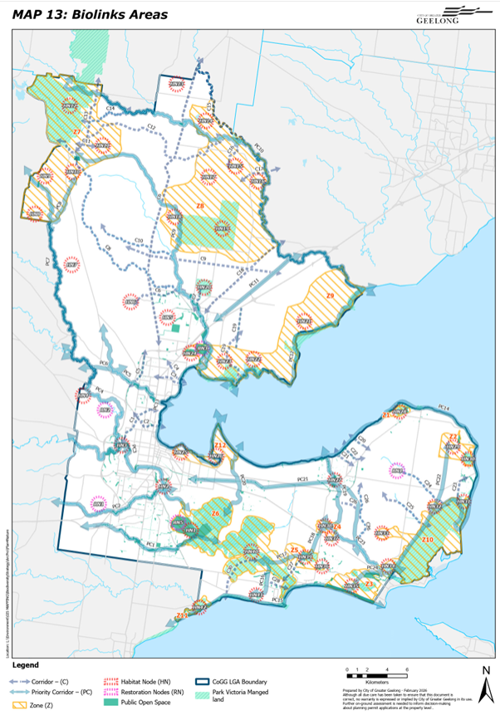
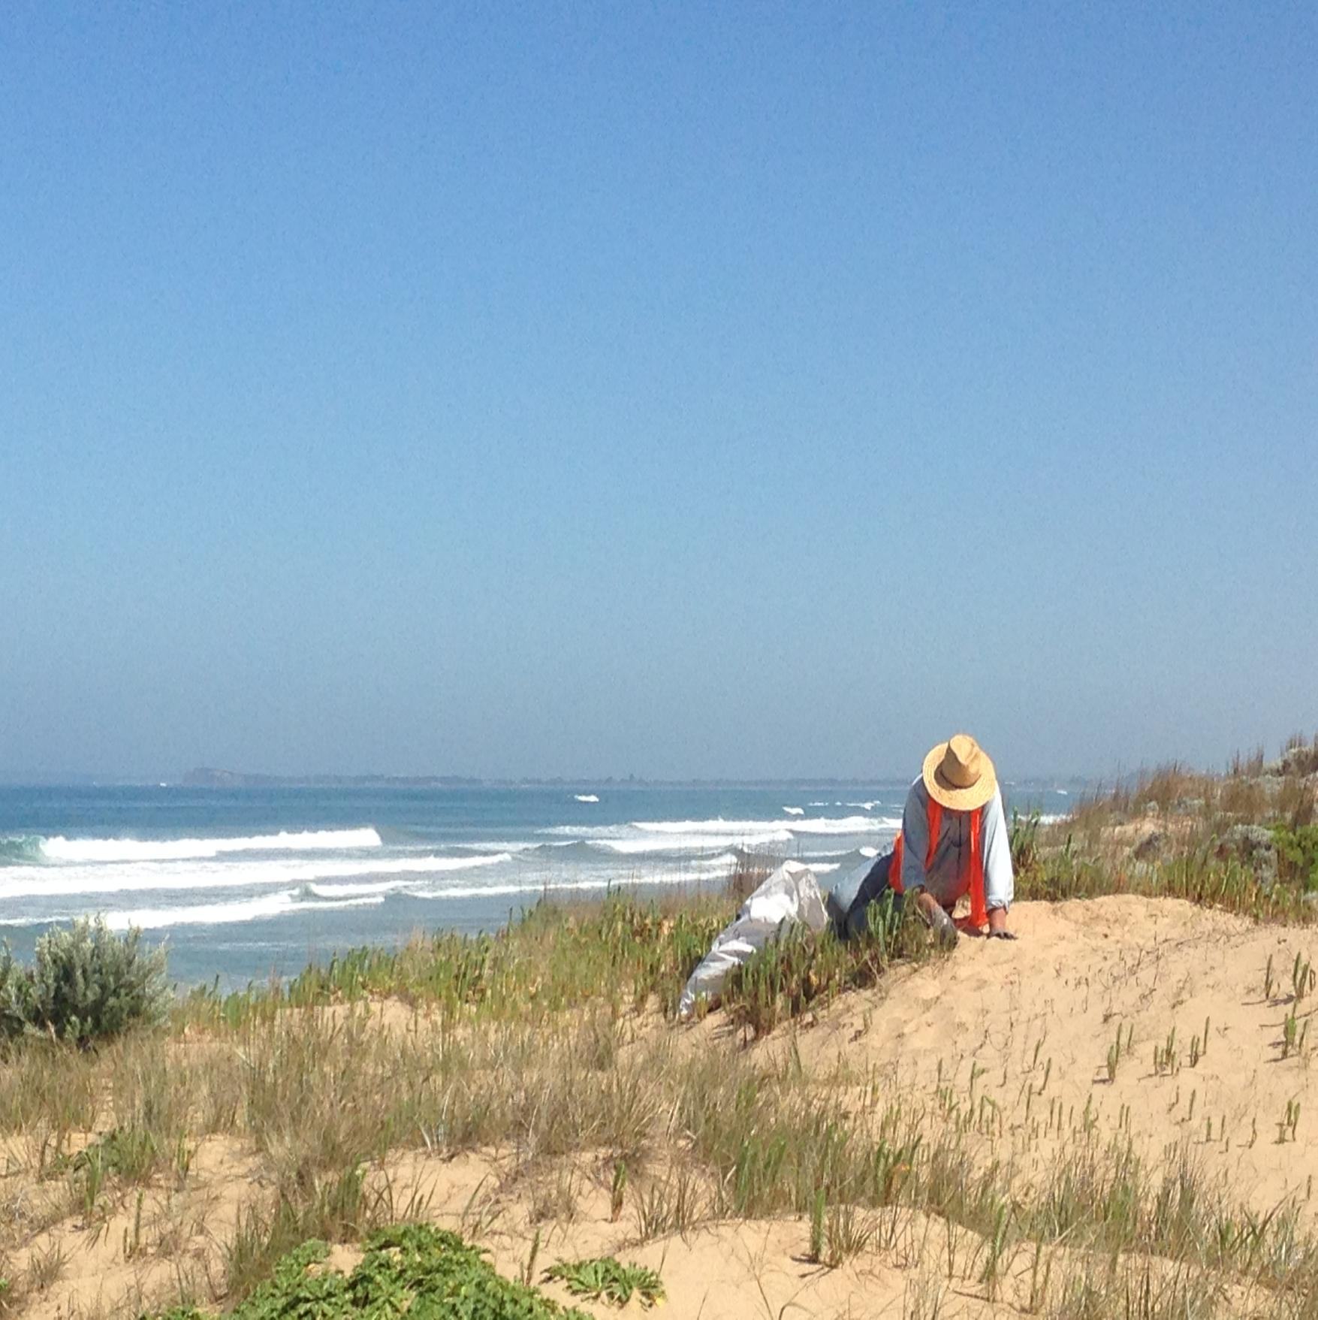

Action Plan
This section of the Plan presents the actions that the City will deliver to help achieve the ten-year strategic objectives and targets for each of the five Goals. The actions are short-term, intending to be delivered over the next one to two years, after which the action plan will be reviewed and updated. These short-term actions are outlined in Table 4 below. While some actions apply to a specific landscape, others will be implemented City wide.
Note **supplementary actions to be implemented if time and resources allow.
The landscapes are described as:
Djilang – Geelong wide (whole of municipality) | BaP – Basalt Plains | Bell – Bellarine | BwP – Barwon Plains
GC – Geelong City | LR – Little River | NU – Northern Uplands
Table 5. Plan for Nature actions to be delivered over the next three years
Goal | Strategic objectives (10 years) | Targets (10 years) | Actions (2 years) | Landscape |  |  |  |  |  |  | Resourcing
 |  |  |  | Djiang | BaP | Bell | BwP | GC | LR | NU | Resourcing
Wadawurrung Country & Values | - Wadawurrung have an increasing role in management of the City’s nature reserves  - Wadawurrung are leading identification, protection and management of cultural values  - More Wadawurrung language, stories and cultural practice are embedded within the City’s nature reserves. | - Five (5) nature reserves feature active collaborative relationships between Wadawurrung and the City  - Two (2) completed Cultural Values Assessments (CVAs) of cultural landscape areas  - Wadawurrung language, stories or cultural practice adopted for  - new nature reserves  - five (5) existing nature reserves. | - Meet with Wadawurrung Traditional Owners Aboriginal Corporation (WTOAC) three (3) times each year to support collaborative actions that strengthen connections between culture and nature. |  |  |  |  |  |  |  | BAU
Wadawurrung Country & Values |  |  | - Identify City nature reserves where WTOAC can lead or partner in conservation management, and undertake two (2) traditional ecological practices, for example, cultural burning. |  |  |  |  |  | - X |  | BAU
Wadawurrung Country & Values |  |  | - **a) Identify and prioritise landscapes suitable for Cultural Values Assessment by WTOAC  b) Commence one (1) Cultural Values Assessment. |  |  |  |  |  |  |  | Resource Required
Wadawurrung Country & Values |  |  | - a) Incorporate Wadawurrung language and stories at two (2) existing City nature reserves, through naming, interpretative displays and/or other activities  b) Prioritise new nature reserves for similar treatment, aligning with the City’s Place Naming Policy 2025. |  |  |  |  |  |  |  | BAU
Protections | - More high-quality remnant vegetation in biolink areas on private land is protected though appropriate zones or overlays that recognise environmental values  - More areas of remnant vegetation are permanently protected across both public and private land  - Threatened species and their habitats are better protected in City's nature reserves, open spaces and roadsides  - A greater proportion of vegetation offsets are secured within the City  - Fewer instances of vegetation removal occur without a permit  - Nature considerations are embedded into the City's policies, strategies and operational procedures across all key departments. | - A higher level of protection is applied to remnant vegetation in biolink areas  - Conservation protection established for all remnant biodiversity patches larger than 10 hectares within biolink areas  - The total area of remnant vegetation within the City's conservation estate or other public protected areas is increased  - The total area of biodiversity permanently protected on private land increases (e.g., via Trust for Nature covenants or other protection mechanisms)  - Five (5) City owned Nature Reserves are permanently protected through Trust for Nature Covenants or Section 69 Agreements  - Conservation action plans are in place to better protect threatened species and their habitat in City managed nature reserves, open space and roadsides  - A greater proportion of biodiversity offsets are secured within the City rather than elsewhere  - The annual rate of vegetation clearing without a permit, including the loss of old trees, declines  - More formal processes that protect nature are integrated into the City's policies, strategies and operational procedures. | - a) Review the planning scheme, including the environmental zones and overlays, and develop management standards to ensure stronger recognition and protections for areas of environmental significance within biolink areas. Priority target areas include:  - high quality remnant vegetation listed under the EPBC Act and/or an endangered, vulnerable, depleted or rare EVC (Ecological Vegetation Class)  - habitat areas larger than 10 hectares  - remnant vegetation patches that combine to form large, connected areas  - large old remnant trees.  b) The City planning team to prepare a staged program to update environmental zones and overlays  c) Complete two (2) planning scheme amendments that improve protections for areas of environmental significance. |  |  | - 1 |  |  | - 3 |  | Resource Required
Protections |  |  | - a). Secure permanent protection for two (2) City owned Nature Reserves through Trust for Nature Covenants or Section 69 Agreements.  b) Actively promote and support private landholders to establish Trust For Nature covenants through the City’s incentives program. |  |  |  |  |  |  |  | BAU/Grant
Protections |  |  | - **Prepare a conservation action plan to provide a protection and management framework for threatened species and their habitats located on City managed land. |  |  |  |  |  |  |  | Resource Required
Protections |  |  | - Prepare two (2) conservation plans for EPBC listed species located on City managed land:  1. Grey Headed Flying Fox  2. Growling Grass Frog. |  |  |  |  |  |  |  | BAU
Protections |  |  | - **a) Develop guidelines to promote retention of important habitat not protected under native vegetation regulations; for example, planted areas of vegetation, and large old, planted trees, as well as for wildlife without threatened species protection  b) Develop a process to better support wildlife (e.g. kangaroos) in areas of high community interaction like roads and new development areas  c) Promote the Hollows Hunt App, ensuring the information is readily accessible for decision making. |  |  |  |  |  |  |  | Resource Required
Protections |  |  | - **a) Investigate funding opportunities to acquire more land for nature reserves, prioritising high-quality vegetation and habitat not commonly represented in reserves  **b) Advocate for Open Space Development Contributions to support the expansion of nature reserves. |  |  |  |  |  | - 1 |  | Resource Required
Protections |  |  | - **a) Identify priority sites within the City suitable for retaining future vegetation offsets.  **b) Assess the costs and benefits of purchasing land with high quality remnant vegetation for offset purposes.  **c) Actively promote benefits of participating in the vegetation offset market to private landowners. |  |  |  |  |  |  |  | Resource Required
Protections |  |  | - a) Improve access to high quality biodiversity information to support better decision making for the protection and management of nature  b) Review the City’s biodiversity mapping program, identify gaps, determine future directions, and undertake updated mapping  c) Use technology to improve biodiversity mapping and provide better community access and input  d) Develop a process to consolidate all City-wide biodiversity mapping into a central system, starting with reserve handovers  e) Use Artificial Intelligence (AI) to develop an index that tracks the City’s response to nature to inform decision making. |  |  |  |  |  |  |  | BAU/Grant
Protections |  |  | - Develop a methodology to enable natural assets to be accounted for in the City’s corporate asset accounting systems. |  |  |  |  |  |  |  | BAU/Partnership
Protections |  |  | - a) Develop a City-wide Environmental Incident Reporting System  b) Educate landowners about native vegetation regulations and their responsibilities, targeting identified compliance hotspots  c) Actively promote and enforce relevant local laws relevant to the protection and management of nature. |  |  |  |  |  |  |  | BAU
Protections |  |  | - a) Introduce mandatory Green Card Accreditation requirements for relevant City staff and contractors  b) Deliver two (2) Green Card Training opportunities for City staff and contractors. |  |  |  |  |  |  |  | BAU
Connections & Restoration | - More biolinks are established across the City landscape  - Biodiversity restoration on private land continues to increase  - Habitat on City managed land expands and improves in quality  - Wildlife in areas with high community interaction such as roads and new development sites are actively protected  - Populations of the City's six (6) key wildlife species are increasing  - Residents in "nature-poor" suburbs gain access to more natural open space and more opportunities to connect with nature. | - 150,000 indigenous plants established, and 50 hectares of habitat restored within City managed biolink areas  - 10 hectares of vegetation added to nature reserves through natural regeneration  - 1,000 hectares of biodiversity restoration works completed on private land within biolink areas though City supported incentive programs  - High threat weeds effectively controlled across City-managed nature reserves and roadsides  - Pest animal numbers reduced within City managed nature reserves and roadsides  - Dogs managed in high value wildlife areas, including City-managed coastal reserves  - A cat curfew introduced in the City's urban areas.  - Biodiversity restoration increased across open space reserves within biolink areas. | - a) Reestablish priority corridors across the City and develop a staged implementation plan.  b) Prioritise regreening programs within City managed corridors  c) Establish 30,000 indigenous plants across City-managed priority corridors, and through natural regeneration, create 10 hectares of new habitat. |  |  |  |  |  |  |  | BAU
Connections & Restoration |  |  | - a) Expand the landowner incentives programs to include rural properties within biolink areas  b) Complete 300 hectares of biodiversity restoration works on private land within biolink areas. |  |  |  |  |  |  |  | BAU
Connections & Restoration |  |  | - Facilitate adoption of the City Biolinks Plan though a Memorandum of Understanding (MOU) with Landcare networks and environment groups. |  |  |  |  |  |  |  | BAU
Connections & Restoration |  |  | - a) Prepare a conservation action plan for nature reserves to guide restoration and management  b) Increase the extent of vegetation in nature reserves by three (3) hectares through natural regeneration  c) Establish a monitoring program to map biodiversity quality improvements at ten (10) nature reserves. |  |  |  |  |  |  |  | BAU
Connections & Restoration |  |  | - **Develop a method to capture and report on the contribution of natural regeneration to increasing indigenous habitat |  |  |  |  |  |  |  | BAU
Connections & Restoration |  |  | - Prepare an indigenous planting procedure, including standards around local provenance, indigenous street trees and plant selection within biolink areas, and a review of the Indigenous Plants of the Geelong Region. |  |  |  |  |  |  |  | BAU
Connections & Restoration |  |  | - Select suitable indigenous street trees and plants for nature strips within approximately 200 metres either side of a priority corridor. |  |  |  |  |  |  |  | BAU
Connections & Restoration |  |  | - Prepare guidelines and standards for nature reserves in new development areas. |  |  |  |  |  |  |  | BAU
Connections & Restoration |  |  | - Identify and prioritise opportunities to increase urban biodiversity and nature connection in “nature-poor” suburbs |  |  |  |  |  |  |  | Partnerships
Connections & Restoration |  |  | - a) Investigate opportunities to provide artificial habitat infrastructure to support wildlife (for example, sprinklers for the Grey Headed Flying Fox Camp, wildlife road crossings, floating pontoons for water birds, old piles)  b) Deliver two (2) habitat enhancement infrastructure projects. |  |  |  |  |  |  |  | Capital Projects
Connections & Restoration |  |  | - **Identify high priority roadsides for nature conservation and increase management programs in these areas. |  |  |  |  |  |  |  | BAU
Connections & Restoration |  |  | - Review and expand the Rabbit Action Plan to include other pest animals such as foxes, deer and feral cats. |  |  |  |  |  |  |  | BAU
Connections & Restoration |  |  | - **Prepare a proposal to implement a cat curfew in the City’s urban areas, drawing on the best available research and examples from other municipalities, |  |  | - X |  |  |  |  | BAU
Connections & Restoration |  |  | - In high value wildlife areas managed by the City, continue to identify dogs-on-leash or dog exclusion zones through the Domestic Animal Plan and Dogs in Public Places Policy. |  |  |  |  |  |  |  | BAU

Goal | Strategic objectives (10 years) | Targets (10 years) |  | Actions (2 years) |  | Landscape |  |  |  |  |  |  | Resourcing
 |  |  |  |  |  | Djiang | BaP | Bell | BwP | GC | LR | NU | Resourcing
Community & Partnerships | - A wider and more diverse cross-section of the community is contributing to nature conservation across the City  - Biodiversity knowledge and awareness continue to increase across the City and the wider community  - Stronger partnerships are supporting and enhancing biodiversity outcomes across the City. |  | - An increased number of Geelong residents are connected and engaged with nature  - Participation in the Geelong Nature Festival and other community-based nature activities increases  - Twenty (20) activities are delivered to target CALD community participation in environmental education and nature related activities  - Twenty (20) activities are delivered to target participation of younger people in environmental education and nature related activities  - There is an increase in the number of Geelong residents volunteering for nature-related activities  - Participation in citizen science programs continues to increase  - Baseline levels of community awareness and participation are established through surveys. |  | - ** a) Prepare a community engagement, participation and awareness plan that provides a framework for connecting people to nature  **b) Increase understanding of the barriers experienced by minority groups (ability, age, ethnicity) to engage in nature conservation, and identify opportunities to support their participation |  |  |  |  |  |  |  | BAU/Grant
Community & Partnerships |  |  |  |  | - Continue to deliver the Geelong Nature Festival every two (2) years and nature week/month activities every alternate year. |  |  |  |  |  |  |  | BAU
Community & Partnerships |  |  |  |  | - Partner with two (2) City festivals and events to promote nature to a larger, more diverse community (for example Youth Festivals, Design Week). |  |  |  |  |  |  |  | BAU
Community & Partnerships |  |  |  |  | - Build community involvement in citizen science and monitoring programs to support the City’s (6) key wildlife species. |  |  |  |  |  |  |  | Partnerships
Community & Partnerships |  |  |  |  | - a) Continue to support and build capacity of the City’s Caring for Nature volunteer groups and hold an annual event/activity  b) Facilitate formation of two (2) new Caring For Nature Volunteer groups  c) Increase the opportunities for people to volunteer for nature without needing to join a formal community group. |  |  |  |  |  |  |  | BAU/Partnerships
Community & Partnerships |  |  |  |  | - Engage urban residents in nature conservation through the Gardens for Wildlife program and Nature Strip Plantings initiative, with priority given to properties within 200-metres of a priority corridor or zone. |  |  |  |  |  |  |  | BAU/Partnerships
Community & Partnerships |  |  |  |  | - **Establish a ‘schools for wildlife’ program and engage six (6) schools. |  |  |  |  |  |  |  | BAU/Partnerships
Community & Partnerships |  |  |  |  | - Continue to deliver the Nature Stewards course annually. |  |  |  |  |  |  |  | BAU
Community & Partnerships |  |  |  |  | - **Develop a procedure to support corporate groups to fund and participate in nature-based volunteering. |  |  |  |  |  |  |  | BAU
Climate Change and Supporting Nature | - The impacts of climate change on natural areas are understood, and adaptation and mitigation measures are embedded in decision making  - A greater number of blue and teal carbon ecosystems in the City are protected and restored  - City open space reserves provide improved outcomes for nature as the climate changes  - Stormwater is managed to avoid negative impacts on the natural environment. |  | - Considerations of climate change impacts on nature are embedded into all relevant decision making  - An increased number of nature and eco-system-based solutions are implemented to minimise the negative impact of climate change on natural systems  - The extent of blue and/or teal carbon ecosystems protected and restored increases  - Integrated water management solutions are applied in growth areas to reduce impacts of stormwater on receiving environments and nature. |  | - Develop guidelines to embed climate change considerations in strategic planning for natural areas, including recommendations for vegetation community migration zones. |  |  |  |  |  |  |  | BAU
Climate Change and Supporting Nature |  |  |  |  | - a) Identify opportunities to protect and restore blue and teal carbon ecosystems within both City managed and private land  b) Develop a proposal to access the blue carbon market, creating further incentives for protecting and restoring coastal environments through the Tidal restoration of blue carbon ecosystems method  c) Deliver one (1) blue carbon restoration project. |  |  | - X |  |  | - X |  | BAU/ Capital Project/Grant/Partnership
Climate Change and Supporting Nature |  |  |  |  | - a) Identify suitable locations to restore intertidal and marine environments using nature-based solutions such as living seawalls, reefs and piles, and seagrass and mangrove restoration  b) Deliver two (2) marine restoration projects. |  |  | - X |  |  | - X |  | Capital Project/Grant
Climate Change and Supporting Nature |  |  |  |  | - Implement integrated water management solutions to reduce stormwater impact on natural saline ecosystems, including Sparrovale Wetlands Reserve - Ngubitj yoorree, Moonahwarri, Limeburners Bay and Avalon. |  |  | - X |  |  |  |  | Partnership/Grants/BAU

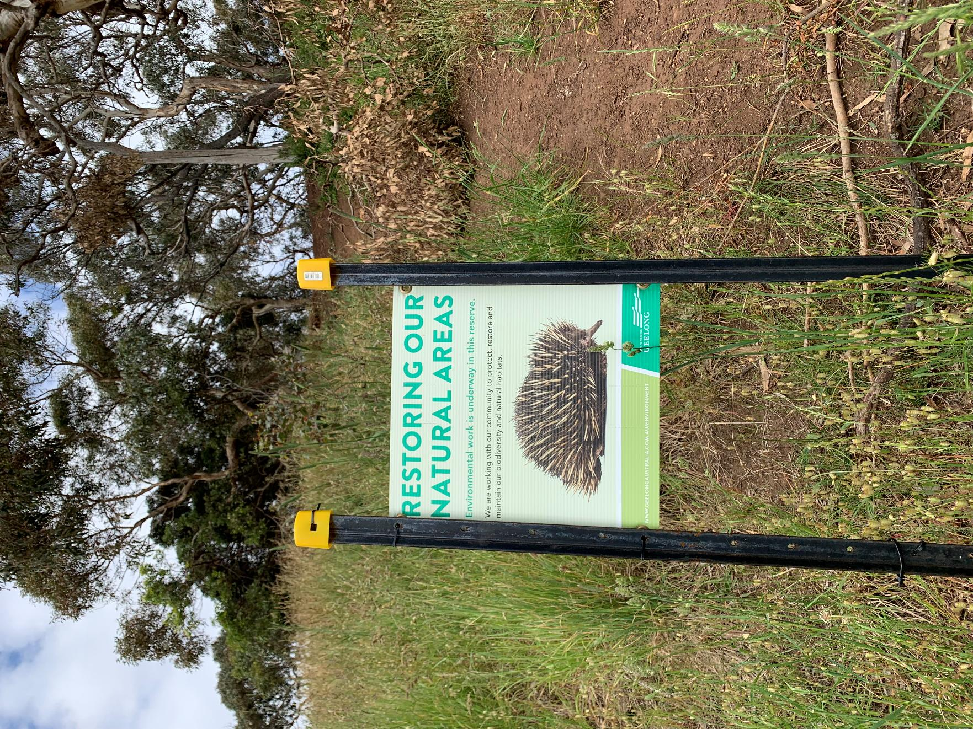

Implementation and renewal
Successful governance and implementation of the Plan rely on a combination of long-term and annual monitoring, along with regular evaluation, to ensure actions can be adapted and improved or better targeted over time.
This section outlines the process renewing the implementation of the Plan.
The shorter-term Action Plan will be reviewed and updated every two years on a rolling basis, while the broader Plan will undergo a major update every 10 years. The higher-level 10-year strategic objectives will be evaluated at the end of the Plan’s life in 2036.

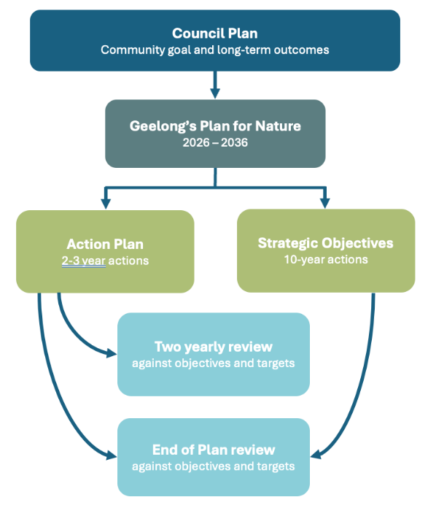
Figure 20. Plan and timing for implementation and review

Monitoring and evaluation
The City is committed to ongoing monitoring and evaluation, as these processes formalise the collection of insights gained through implementing the Plan. They also support continuous improvement by ensuring that lessons are used to inform future actions.
A key focus for evaluating the Plan’s success will be tracking progress against the targets set under each of the five goals.

Table 6. Monitoring requirements
WHAT NEEDS MONITORING | BASELINE EXISTS | WHEN?
The extent and variety of protected natural habitat. | - Nature Reserves – 1358 hectares  - Conservation Estate - 9.7%  - City Biodiversity Mapping 2024  - Protection Measures (as per mapping 2026). | Annual
Habitat quality and condition of nature reserves. | Sparrovale Wetlands Reserve - Ngubitj yoorree,  Old Melbourne Road Grassland  Buckley Park Foreshore reserve. | Five yearly
Status of conservation management plans for threatened species. | Hooded Plover Conservation Action Plan Latham’s Snipe Plan | Five yearly
Connectiveness of priority corridors. | TBD.
Extent of blue and/or teal carbon habitat that is protected. | - Southeast Bellarine Biolink Blue carbon mapping  - Swan Bay Incentive Program  - The Point Blue Carbon Mapping  - Shell Foreshore Mapping  - City Biodiversity Mapping 2024  - Corangamite CMA Mapping. | Five yearly
Geelong residents’ engagement with nature. | - 73 Caring for Nature Groups  - Attendance at Geelong Nature Festival (no.)  - Attendance at other nature events (no.)  - Nature Stewards Alumni (no.) | Biennial
No. of nature reserves where language, stories or cultural practice is established. | Number of nature reserves where language, stories and cultural practice exist. | Five yearly

The evaluation of the success of this Plan will also be guided by the following themes and key evaluation questions (KEQs).
Table 7. Themes and Key Evaluation Questions
THEMES | KEY EVALUATION QUESTIONS (KEQs)
Plan design  Focuses on whether the governance and actions were appropriately designed to deliver the intended targets (and goals) | Was the design of the Plan appropriate to deliver the intended outcomes?
Plan implementation  Focuses on whether the actions of the Plan were delivered as planned and seeks to identify how these approaches have ensured efficient and cost-effective delivery. | To what extent have the Plan actions been delivered as planned?
 | To what extent was the delivery good value for money?
Plan impact  Focuses on what the Plan has achieved to date against the intended targets (and goals).  At the end of the Plan term, the focus is also on the legacy of the program and to what extent the impact of the actions will extend beyond the life of the Plan (long-term outcomes). | To what extent did the actions lead to the achievement of the targets?
 | What impact will the actions have beyond the life of the Plan?

MAPS 1-6: Environment Values
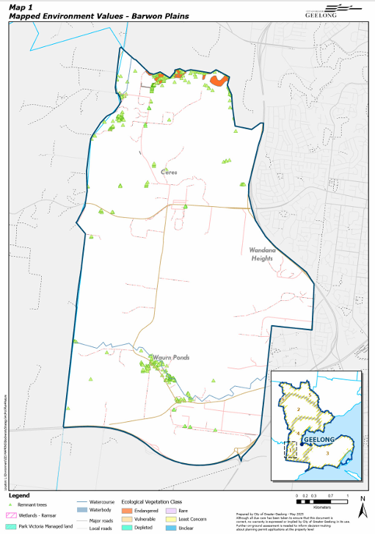

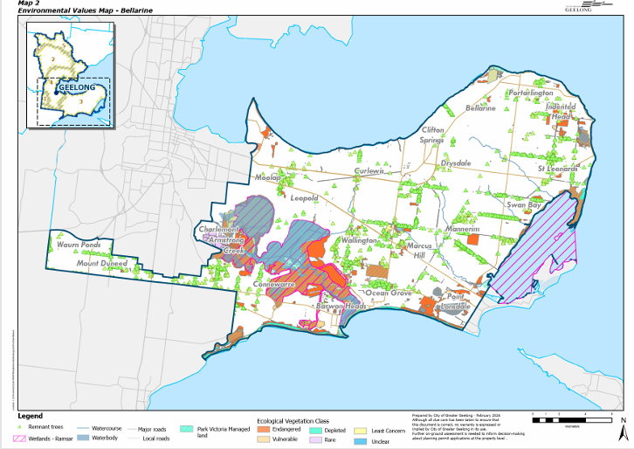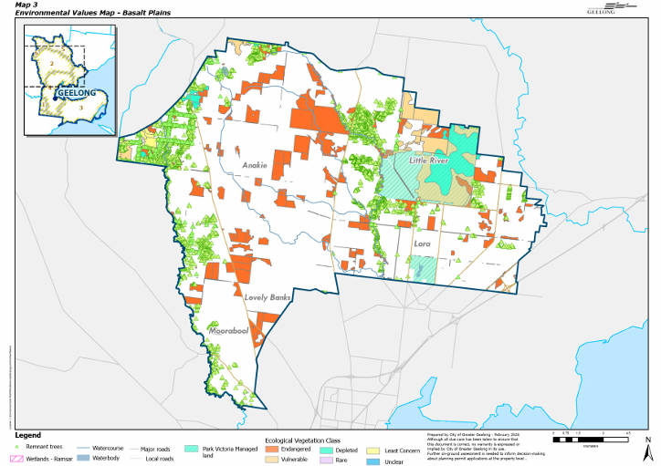
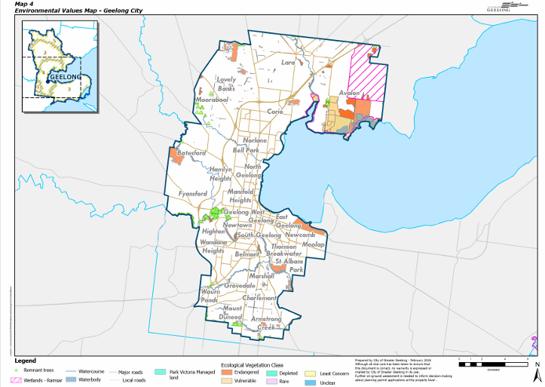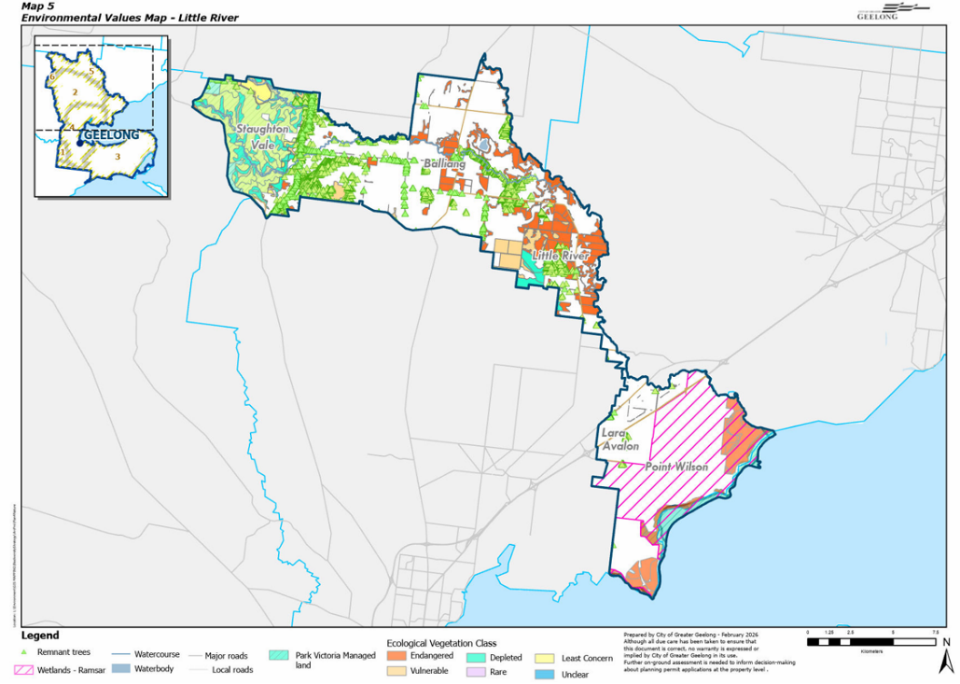
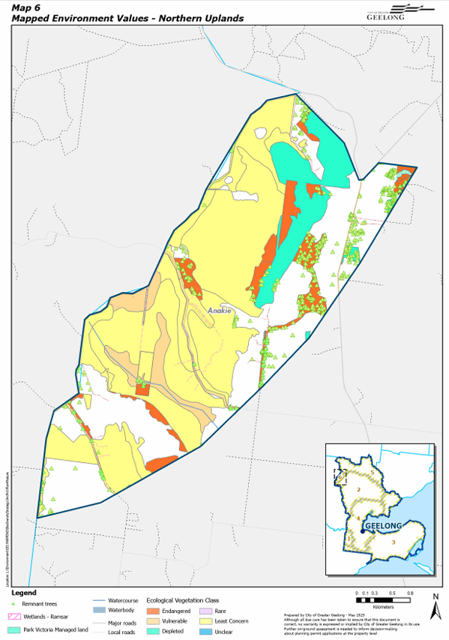

MAPS 7-12: Protection Measures
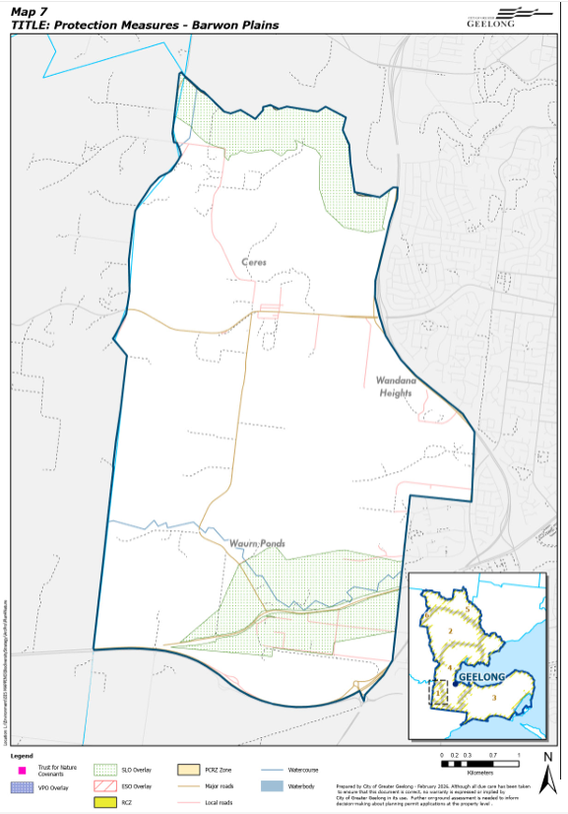
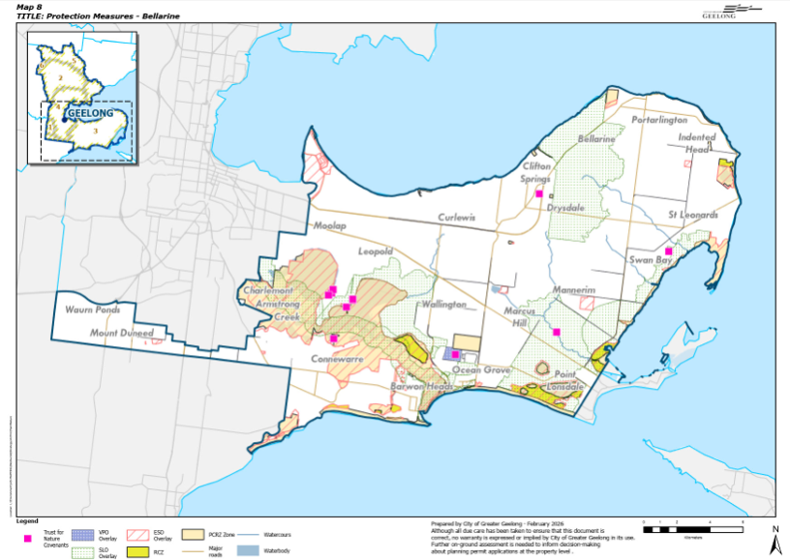
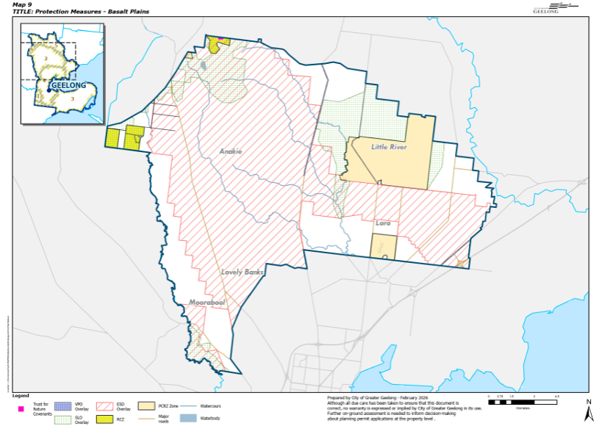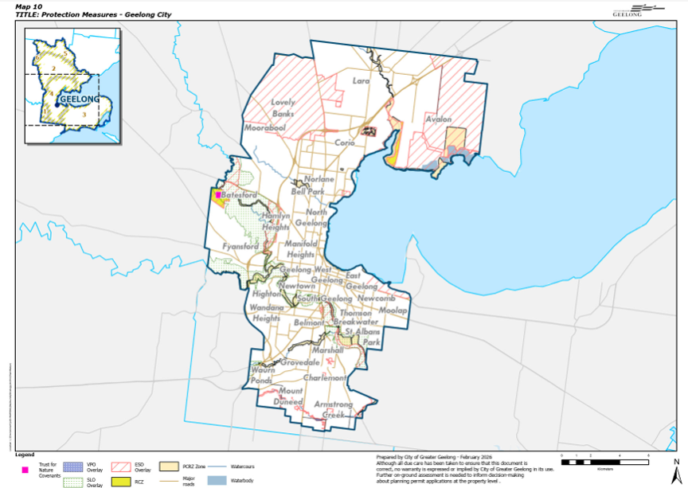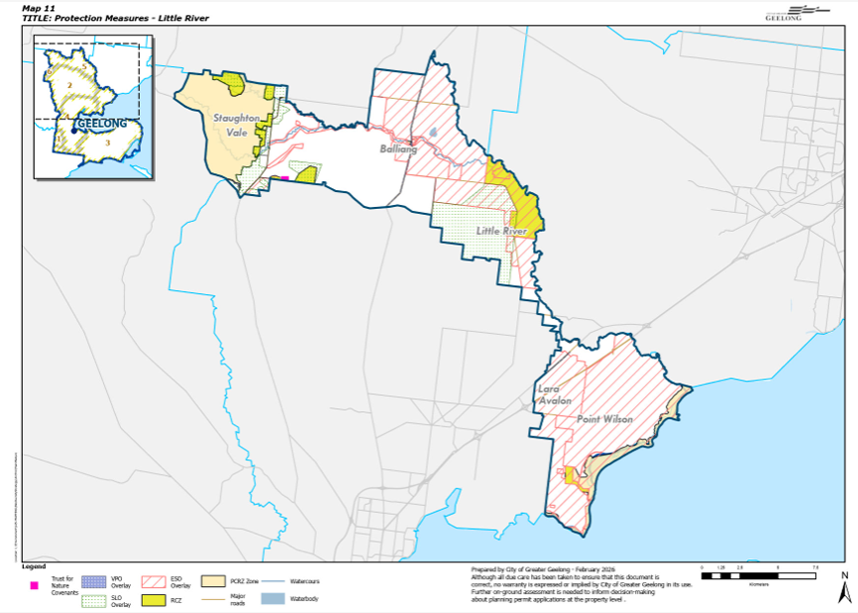
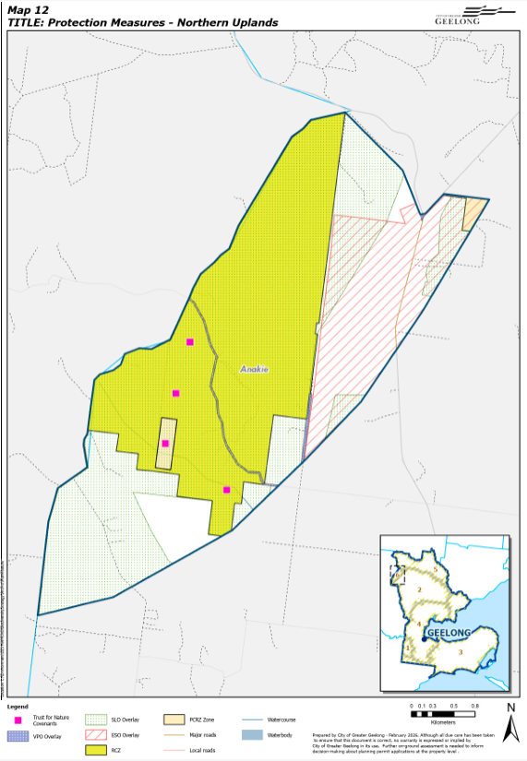

Appendix 1: Threatened Species and Ecological Communities Summary

TAXONOMIC GROUP | THREATENED TOTAL | EPBC LISTED | EPBC SPECIES AND CATEGORY OF THREAT | CR EN | CE SPECIES
Mammals | 9 | 2 | Grey Headed Flying Fox (V)  Southern Brown Bandicoot (E) | 0
Birds | 62 | 14 | Australian Bittern (E)  Gang-gang Cockatoo (E)  Hooded Plover (V)  Latham's Snipe (V)  Lesser Sand Plover (E)  Painted Honeyeater (V)  Red Knot (V)  Sharp-tailed Sandpiper (V)  Shy Albatross (E) | 5 | Eastern Curlew  Great Knot  Orange-bellied Parrot  Plains Wanderer  Swift Parrot
Reptiles | 4 | 3 | Stripped Legless Lizard (V)  Glossy Grass Skink (V) | 1 | Grassland Earless Dragon
Amphibians | 2 | 1 | Growling Grass Frog (V) | 0
Fish | 5 | 2 | Australian Grayling (E)  Yarra Pygmy Perch (V) | 0
Invertebrates | 9 | 1 | Golden Sun Moth (V) | 0
Plants | 91 | 14 | Clover Glycine (V)  Spiny Peppercress (V)  Swamp Everlasting (V)  Small Golden Moths (E)  Fragrant Leek-orchid (E)  Dense Leek-orchid (V)  Ornate Pink-fingers (V)  Matted Flax Lily (E)  White Sunray (E)  Button Wrinkle Wort (E)  Large-headed Fireweed (V)  Adamson's Blown-grass (E)  Purple Eyebright (E) | 1 | Spiny Rice-flower
Ecological Communities | 9 | 5 | Subtropical and Temperate Coastal Saltmarsh (V)  Grey Box (Eucalyptus microcarpa) Grassy Woodlands and Derived Native Grasslands of South-eastern Australia (E) | 3 | Natural Temperate Grasslands of the VVP  Grassy Eucalypt Woodland of the VVP  Seasonal Herbaceous Wetland of the Temperate Lowland Plains
Total | 191 | 42 |  | 10

Appendix 2: Threatened Species and Ecological Communities

Taxonomic Group | Common Name | Scientific Name | EPBC - Category of Threat | FFG - Category of Threat | Habitat on City Managed Land | Barwon Plain | Basalt Plains | Cities Geelong | Bellarine | Northern Uplands | Little River
mammal | Brush-tailed Phascogale | Phascogale tapoatafa |  | V |  |  |  |  |  | yes | yes
mammal | Burrunan Dolphin | Tursiops australis |  | CE |  |  |  | yes | yes |  | yes
mammal | Common Bent-wing Bat | Miniopterus schreibersii |  | CE
mammal | Common Dunnart | Sminthopsis murina |  | V
mammal | Fat-tailed Dunnart | Sminthopsis crassicaudata |  | V |  |  | yes |  |  |  | yes
mammal | Grey-headed Flying-fox | Pteropus poliocephalus | V | V | yes | yes | yes | yes | yes |  | yes
mammal | Platypus | Ornithorhynchus anatinus |  | V |  |  |  | yes
mammal | Southern Brown Bandicoot | Isoodon obesulus obesulus | E | E |  |  | yes | yes | yes |  | yes
mammal | Southern Right Whale | Eubalaena australis |  | E |  |  |  |  | yes
bird | Australasian Bittern | Botaurus poiciloptilus | E | CE | yes |  | yes | yes | yes |  | yes
bird | Australian Little Bittern | Ixobrychus dubius |  | E |  |  |  |  | yes
bird | Australian Painted Snipe | Rostratula benghalensis |  | CE |  |  |  |  | yes
bird | Australasian Shoveler | Anas rhynchotis |  | V |  |  |  |  | yes
bird | Barking Owl | Ninox connivens |  | CE |  |  |  |  |  | yes | yes
bird | Black Falcon | Falco subniger |  | CE |  |  | yes | yes | yes |  | yes
bird | Black-tailed Godwit | Limosa limosa |  | E |  |  |  |  | yes
bird | Blue-billed Duck | Oxyura australis |  | V |  |  |  |  | yes
bird | Brolga | Antigone rubicunda |  | E |  |  |  | yes | yes |  | yes
bird | Bush Stone-curlew | Burhinus grallarius |  | CE |  |  |  | yes
bird | Caspian Tern | Hydroprogne caspia |  | V |  |  |  | yes | yes
bird | Chestnut-rumped Heathwren | Calamanthus pyrrhopygius |  | V |  |  |  |  |  |  | yes
bird | Common Sandpiper | Actitis hypoleucos |  | V |  |  |  |  | yes |  | yes
bird | Diamond Dove | Geopelia cuneata |  | V
bird | Diamond Firetail | Stagonopleura guttata |  | V |  |  | yes |  |  |  | yes
bird | Eastern Curlew | Numenius madagascariensis | CE | CE | yes |  |  | yes | yes |  | yes
bird | Eastern Great Egret | Ardea alba modesta |  | V |  |  |  | yes | yes
bird | Elegant Parrot | Neophema elegans |  | V
bird | Fairy Tern | Sterna nereis |  | CE |  |  |  |  | yes
bird | Freckled Duck | Stictonetta naevosa |  | E |  |  |  |  | yes
bird | Gang-gang Cockatoo | Callocephalon fimbriatum | E | E | yes | yes | yes | yes | yes |  | yes
bird | Great Knot | Calidris tenuirostris | CE | CE | yes |  |  | yes | yes |  | yes
bird | Greater Sand Plover | Charadrius leschenaultii |  | V
bird | Grey Goshawk | Accipiter novaehollandiae |  | E |  |  |  | yes | yes
bird | Grey Plover | Pluvialis squatarola |  | V
bird | Grey-crowned Babbler | Pomatostomus temporalis |  | V
bird | Grey-headed Albatross | Thalassarche chrysostoma |  | E
bird | Grey-tailed Tattler | Tringa brevipes |  | CE
bird | Gull-billed Tern | Gelocheilidon nilotica macrotarsa |  | E |  |  |  |  | yes |  | yes
bird | Hooded Plover | Thinornis rubricollis | V | V | yes |  |  |  | yes
bird | Hooded Robin | Melanodryas cucullata cucullata |  | V
bird | Latham's Snipe | Gallinago hardwickii | V | V | yes | yes | yes | yes | yes |  | yes
bird | Lesser Sand Plover | Charadrius mongolus | E | E | yes |  |  | yes | yes |  | yes
bird | Lewin's Rail | Lewinia pectoralis |  | V |  |  |  |  | yes |  | yes
bird | Little Eagle | Hieraaetus morphnoides |  | V |  |  | yes |  |  |  | yes
bird | Little Egret | Egretta garzetta nigripes |  | E |  |  |  |  | yes
bird | Little Tern | Sternula albifrons |  | CE |  |  |  |  | yes |  | yes
bird | Magpie Goose | Anseranas semipalmata |  | V |  |  | yes
bird | Major Mitchell's Cockatoo | Cacatua leadbeateri |  | CE
bird | Masked Owl | Tyto novaehollandiae |  | CE
bird | Musk Duck | Biziura lobata |  | V |  |  |  |  | yes
bird | Northern Giant-Petrel | Macronectes halli |  | E |  |  |  |  | yes
bird | Orange-bellied Parrot | Neophema chrysogaster | CE | CE | yes |  |  | yes | yes |  | yes
bird | Pacific Golden Plover | Pluvialis fuva |  | V |  |  |  |  | yes |  | yes
bird | Painted Honeyeater | Grantiella picta | V | V |  |  | yes |  |  |  | yes
bird | Plains-wanderer | Pedionomus torquatus | CE | CE |  |  | yes | yes |  |  | yes
bird | Plumed Egret | Ardea intermedia plumifera |  | CE
bird | Powerful Owl | Ninox strenua |  | V |  |  |  |  |  | yes | yes
bird | Red Knot | Calidris canutus | V | E |  |  |  | yes | yes |  | yes
bird | Ruddy Turnstone | Arebaria interpres |  | V
bird | Sharp-tailed Sandpiper | Calidris acuminata | V | V | yes |  |  | yes | yes |  | yes
bird | Shy Albatross | Diomedea cauta | E | E | yes |  |  |  | yes
bird | Southern Giant-Petrel | Macronectes giganteus |  | E |  |  |  |  | yes
bird | Speckled Warbler | Chthonicola sagittata |  | E |  |  |  |  |  |  | yes
bird | Swift Parrot | Lathamus discolor | CE | CE | yes | yes | yes | yes | yes | yes | yes
bird | Terek Sandpiper | Xenus cinereus |  | V |  |  |  |  | yes
bird | Wandering Albatross | Diomedea exulans |  | CE
bird | Whimbrel | Numenius phaeopus |  | E |  |  |  |  | yes
bird | White-bellied Sea-Eagle | Haliaeetus leucogaster |  | E |  |  |  |  | yes |  | yes
bird | White-faced Storm-Petrel | Pelagodroma marina |  | E |  |  |  |  | yes
bird | Wood Sandpiper | Tringa glareola |  | E |  |  |  |  | yes
bird | White-throated Needletail | Hirundapus caudacutus |  | V |  |  |  | yes
reptiles | Victorian Grassland Earless Dragon | Tympanocryptis pinguicolla | CE | CE |  |  | yes | yes |  |  | yes
reptiles | Striped Legless Lizard | Delma impar | V | E | yes |  | yes | yes |  |  | yes
reptiles | Glossy Grass Skink | Pseudemoia rawlinsoni | V | E | likley |  |  | yes | yes
reptiles | Tussock Skink | Pseudemoia pagenstecheri |  | E
amphibians | Brown Toadlet | Pseudophryne bibronii |  | E
amphibians | Growling Grass Frog | Litoria raniformis | V | V | yes | yes | yes | yes | yes |  | yes
fishes | Agassiz's Glassfish | Ambassis agassizii |  | E
fishes | Australian Grayling | Prototroctes maraena | E | V | yes |  |  | yes | yes
fishes | Australian Mudfish | Neochanna cleaveri |  | E
fishes | Macquarie Perch | Macquaria australasica |  | E
fishes | Yarra Pigmy Perch | Nannoperca obscura | V | E | yes | yes |  | yes | yes
crustaceans | Hairy Burrowing Crayfish | Engaeus sericatus |  | V
crustaceans | Otway Burrowing Crayfish | Engaeus fultoni |  | V
crustaceans | Ghost Shrimp | Pseudocalliax tooradin |  | E
insects | Fiery Jewel Butterfly | Hypochrysops ignitus ignitus |  | E
insects | Large Ant Blue Butterfly | Acrodipsas brisbanensis |  | E
insects | Large River Damselfly | Caliagrion billinghursti |  | V
insects | Small Ant Blue Butterfly | Acrodipsas myrmecophila |  | E
insects | Golden Sun Moth | Synemon plana | V | V |  |  | yes | yes |  |  | yes
insects | Yellow Sedge-skipper Butterfly | Hesperilla flavescens |  | E |  |  |  | yes | yes
echinoderms | Sea-cucumber species | Thyone nigra |  | E
Brassicaceae | Hairy Shepherd's Purse | Microlepidium pilosulum |  | CE
Brassicaceae | Forest Bitter-cress | Cardamine papillata |  | E
Brassicaceae | Spiny Peppercress | Lepidium aschersonii | V | E | yes |  |  | yes | yes
Brassicaceae | Western Bitter-cress | Cardamine lineariloba |  | E
Thymelaeaceae | Spiny Rice-flower | Pimelea spinescens subsp. spinescens | CE | CE | yes |  | yes | yes |  |  | yes
Malvaceae | Salt Lawrencia | Lawrencia spicata |  | E
Malvaceae | Coast Hollyhock | Malva preissiana s.s. (white-flowered coastal form) |  | E
Orchidaceae | Mauve-tuft Sun-orchid | Thelymitra malvina |  | CE
Orchidaceae | Crimson Sun-orchid | Thelymitra X macmillanii |  | V
Orchidaceae | Small Golden Moths | Diuris basaltica | E | CE |  |  |  | yes
Orchidaceae | Brittle Greenhood | Pterostylis truncata |  | CE
Orchidaceae | Sharp Greenhood | Pterostylis X ingens |  | V
Orchidaceae | Fragrant Leek-orchid | Prasophyllum suaveolens | E | CE |  |  |  | yes
Orchidaceae | Naked Beard-orchid | Calochilus imberbis |  | CE
Orchidaceae | Large White Spider-orchid | Caladenia venusta |  | E
Orchidaceae | Winter Sun-orchid | Thelymitra hiemalis |  | CE
Orchidaceae | Slender Pink-fingers | Caladenia vulgaris |  | V
Orchidaceae | Naked Sun-orchid | Thelymitra circumsepta |  | E
Orchidaceae | Dense Leek-orchid | Prasophyllum spicatum | V | CE |  |  |  | yes
Orchidaceae | Swamp Diuris | Diuris palustris |  | E
Orchidaceae | Mentone Greenhood | Pterostylis X toveyana |  | E
Orchidaceae | Green Leek-orchid | Prasophyllum lindleyanum |  | E
Orchidaceae | Ornate Pink-fingers | Caladenia ornata | V | E |  |  |  |  |  |  | yes
Orchidaceae | Matted Flax-lily | Dianella amoena | E | CE | yes |  | yes |  |  |  | yes
Orchidaceae | Arching Flax-lily | Dianella sp. aff. Longifolia |  | CE
Casuarinaceae | Buloke | Allocasuarina luehmannii |  | CE
Poeae | Coast Fescue | Poa billardierei |  | E
Poeae | Dune Poa | Poa poiformis var. ramifer |  | E
Mimosaceae | Cup Wattle | Acacia cupularis |  | CE
Mimosaceae | Rough Wattle | Acacia aspera subsp. parviceps |  | E
Mimosaceae | Coast Wirilda | Acacia uncifolia |  | E
Mimosaceae | Snowy River Wattle | Acacia boormanii |  | E | ?
Fabaceae | Clover Glycine | Glycine latrobeana | V | V |  |  |  | yes
Fabaceae | Southern Swainson-pea | Swainsona behriana |  | E
Fabaceae | Small Scurf-pea | Cullen parvum |  | E
Fabaceae | Scented Bush-pea | Pultenaea graveolens |  | E
Fabaceae | Golden Bush-pea | Pultenaea gunnii subsp. tuberculata |  | V
Fabaceae | Wiry Bossiaea | Bossiaea cordigera |  | E
Fabaceae | Tough Scurf-pea | Cullen tenax |  | E
Fabaceae | Swamp Bush-pea | Pultenaea weindorferi |  | E
Fabaceae | Hoary Bush-pea | Pultenaea daltonii |  | V
Polygalaceae | Small Milkwort | Comesperma polygaloides |  | CE
Asteraceae | Swamp Everlasting | Xerochrysum palustre | V | CE |  |  |  |  | yes
Asteraceae | Velvet Daisy-bush | Olearia pannosa subsp. cardiophylla |  | E
Asteraceae | White Sunray | Leucochrysum albicans subsp. tricolor | E | E |  |  | yes
Asteraceae | Lanky Buttons | Leptorhynchos elongatus |  | E
Asteraceae | Branching Groundsel | Senecio cunninghamii var. cunninghamii |  | E
Asteraceae | Satin Daisy-bush | Olearia minor |  | E
Asteraceae | Button Wrinklewort | Rutidosis leptorhynchoides | E | E | yes |  | yes | yes | yes |  | yes
Asteraceae | Pale Swamp Everlasting | Coronidium gunnianum |  | CE
Asteraceae | Large-headed Fireweed | Senecio macrocarpus | V | CE |  |  | yes | yes |  |  | yes
Asteraceae | Basalt Podolepis | Podolepis linearifolia |  | E
Asteraceae | Cut-leaf Burr-daisy | Calotis anthemoides |  | CE
Proteaceae | Small-flower Grevillea | Grevillea micrantha |  | CE
Proteaceae | Smooth Grevillea | Grevillea rosmarinifolia subsp. glabella |  | E
Proteaceae | Golden Grevillea | Grevillea chrysophaea |  | V
Proteaceae | Brisbane Range Grevillea | Grevillea steiglitziana |  | E
Amaranthaceae | Hairy Tails | Ptilotus erubescens |  | CE | yes |  |  |  | yes
Plumbaginaceae | Yellow Sea-lavender | Limonium australe |  | E
Chenopodiaceae | Marsh Saltbush | Atriplex paludosa subsp. paludosa |  | E
Chenopodiaceae | Coast Saltwort | Salsola tragus subsp. pontica |  | E
Chenopodiaceae | Fragrant Saltbush | Rhagodia parabolica |  | V
Myrtaceae | Yarra Gum | Eucalyptus yarraensis |  | CE
Myrtaceae | Melbourne Yellow-gum | Eucalyptus leucoxylon subsp. connata |  | E
Myrtaceae | Bellarine Yellow-gum | Eucalyptus leucoxylon subsp. bellarinensis |  | CE
Myrtaceae | Gum-barked Bundy | Eucalyptus goniocalyx subsp. laxa |  | V
Euphorbiaceae | Coast Bitter-bush | Adriana quadripartita |  | E
Poaceae | Small-flower Wallaby-grass | Rytidosperma monticola |  | E
Poaceae | Purple Blown-grass | Lachnagrostis punicea subsp. semibarbata |  | E
Poaceae | Adamson's Blown-grass | Lachnagrostis adamsonii | E | E |  |  |  | yes | yes
Poaceae | Straw Wallaby-grass | Rytidosperma richardsonii |  | E
Poaceae | Rye Beetle-grass | Tripogonella loliiformis |  | E
Poaceae | Salt Blown-grass | Lachnagrostis robusta |  | E
Juncaceae | Creeping Rush | Juncus revolutus |  | E
Cyperaceae | Hoary Rapier-sedge | Lepidosperma canescens |  | E
Solanaceae | Austral Tobacco | Nicotiana suaveolens |  | E
Lamiaceae | Snowy Mint-bush | Prostanthera nivea var. nivea |  | R #
Verbenaceae | Grey Mangrove | Avicennia marina subsp. australasica |  | E
Plantaginaceae | Winged Water-starwort | Callitriche umbonata |  | E
Orobanchaceae | Rough Eyebright | Euphrasia scabra |  | E
Orobanchaceae | Purple Eyebright | Euphrasia collina subsp. muelleri | E | E |  |  | yes
Orobanchaceae | Buloke Mistletoe | Amyema linophylla subsp. Orientalis |  | CE
Loranthaceae | Drooping Mistletoe | Amyema pendula subsp. longifolia |  | CE
Zosteraceae | Tasman Grass-wrack | Heterozostera tasmanica |  | E
Zosteraceae | Australian Grass-wrack | Heterozostera nigricaulis |  | E
Juncaginaceae | Tiny Arrowgrass | Triglochin minutissima |  | E
Juncaginaceae | Prickly Arrowgrass | Triglochin mucronata |  | E
Zygophyllaceae | Coast Twin-leaf | Roepera billardierei |  | E
Geraniaceae | Pale-flower Crane's-bill | Geranium sp. 3 |  | E
Geraniaceae | Austral Crane's-bill | Geranium solanderi var. solanderi s.s. |  | E
community | Natural Temperate Grasslands of the Victorian Volcanic Plains |  | CE | CE | yes |  | yes | yes |  |  | yes
community | Grassy Eucalypt Woodland of the Victorian Volcanic Plains |  | CE | CE |  |  | yes |  |  |  | yes
community | Seasonal Herbaceous Wetland of the Temperate Lowland Plains |  | CE | CE | yes |  | yes |  | yes |  | yes
community | Subtropical and Temperate Coastal Saltmarsh |  | V | V | yes |  |  | yes | yes |  | yes
community | Grey Box (Eucalyptus microcarpa) Grassy Woodlands and Derived Native Grasslands of South-eastern Australia |  | E |  | yes
community | Coastal Moonah (Melaleuca lanceolata subsp. lanceolata) Woodland Community |  |  | Th | Yes |  |  |  | yes
community | Western (Basalt) Plains Grassland community |  |  | Th |  |  | yes |  | yes |  | yes
community | Western Basalt Plains (River Redgum) Grassy Woodland Floristic Community 5504 |  |  | Th
community | Grey Box - Buloke Grassy Woodland Community |  |  | Th
References:
Atlas of Living Australia - https://www.ala.org.au/
Flora and Fauna Guarantee Act 1988 Threatened List, September 2025
Threatened species under the EPBC Act - DCCEEW
SWIFFT - State Wide Integrated Flora and Fauna Teams - Threatened Species - https://www.swifft.net.au/
Victorian Biodiversity Atlas

Appendix 3: Environment Volunteer Groups and Networks
GROUP | LOCATION | ACTIVITY
Barwon Plain
Barrabool Hills Landcare Group | Barrabool Hills | Caring for Landscapes
Basalt Plain
Anakie Community Garden | Anakie | Sustainable Living
Laracare | Lara | Caring for Landscapes
Moorabool Catchment Landcare Group | Bacchus Marsh | Caring for Landscapes
Moorabool Environment Group | Bacchus Marsh | Caring for Landscapes
Mt Rothwell Friends | Mt Rothwell | Caring for Landscapes
Bellarine and Surfcoast
100% Clean Bellarine | Barwon Heads | Sustainable Living
Barwon Estuary Project | Barwon Heads | Caring for Landscapes
Barwon Heads Community Arts Garden | Barwon Heads | Sustainable Living
Barwon Heads Landcare Group | Barwon Heads | Caring for Landscapes
Barwon Region Alliance for Community Energy (BRACE) | Barwon Heads | Sustainable Living
*Beach Patrol - Bellarine | Ocean Grove | Caring for Landscapes
Bellarine Catchment Network | Queenscliff | Networks / Other
*Bellarine Landcare Group | Bellarine Peninsula | Caring for Landscapes
Bellarine Landcare Nursery | Drysdale | Caring for Landscapes
Bellarine Landcare Rabbit Action Group | Mannerim | Caring for Landscapes
*Bellarine Peninsula Orange-bellied Parrot Regional Group | Bellarine Peninsula | Citizen Science
*Birdlife Australia - Bellarine Peninsula | Bellarine Peninsula | Citizen Science
Boomerang Bags – Leopold | Leopold | Sustainable Living
Born Wild Community | Bellarine Peninsula | Caring for Landscapes
Breamlea Coast Action | Breamlea | Caring for Landscapes
*Breamlea Community Association | Breamlea | Caring for Landscapes
*Clifton Springs Curlewis Coastcare | Clifton Springs | Caring for Landscapes
Connewarre Landcare Group | Connewarre | Caring for Landscapes
*Drysdale Clifton Springs Curlewis Association | Drysdale | Caring for Landscapes
*Friends of Begola Wetlands | Ocean Grove | Caring for Landscapes
*Friends of Buckley Park Foreshore | Ocean Grove | Caring for Landscapes
Friends of Edwards Point Wildlife Reserve | St Leonards | Caring for Landscapes
*Friends of Indented Head Woodland | Indented Head | Caring for Landscapes
*Friends of Moonah Park | Barwon Heads | Caring for Landscapes
Friends of Ocean Grove Nature Reserve | Ocean Grove | Caring for Landscapes
Friends of Point Richards Flora and Fauna Reserve | Portarlington | Caring for Landscapes
*Friends of Ramblers Road Foreshore | Portarlington | Caring for Landscapes
*Friends of the Basin Reserve | Drysdale | Caring for Landscapes
*Friends of the Bellarine Rail Trail | Leopold | Caring for Landscapes
Friends of the Bluff | Barwon Heads | Caring for Landscapes
*Friends of the Hooded Plover - Bellarine | Ocean Grove | Caring for Landscapes
Friends of The Lobster Pot | Barwon Heads | Caring for Landscapes
Ocean Grove Coastcare | Ocean Grove | Caring for Landscapes
*Ocean Grove Community Association | Ocean Grove | Caring for Landscapes
Ocean Grove Park Inc | Ocean Grove | Caring for Landscapes
Ocean Grove Rotary | Ocean Grove | Sustainable Living
Queenscliff Indigenous Nursery | Queenscliff | Caring for Landscapes
*Repair Café Bellarine | Ocean Grove | Sustainable Living
Swan Bay Environment Association | Swan Bay | Caring for Landscapes
Transition Network/Towns - Barwon Heads | Barwon Heads | Sustainable Living
*Weekday Weeders | Ocean Grove | Caring for Landscapes
Australian Parents 4 Climate Action - Geelong and Bellarine | Bellarine Peninsula | Sustainable Living
Geelong Cities
Australian Conservation Foundation | Geelong | Caring for Landscapes
Avalon Landcare Group | Lara | Caring for Landscapes
*Batesford - Fyansford - Stonehaven Landcare Group | Batesford | Caring for Landscapes
*Bats of Geelong | Geelong | Caring for Landscapes
*Beach Patrol - Geelong | Geelong | Caring for Landscapes
Boomerang Bags - Armstrong Creek | Armstrong Creek | Sustainable Living
Boomerang Bags - Norlane | Norlane | Sustainable Living
*Coiro Bay Angling Club | Geelong | Caring for Landscapes
*Conservation Volunteers Australia | Statewide | Networks / Other
Corio Landcare | Corio | Caring for Landscapes
Dog Rocks Flora and Fauna Sanctuary | Batesford | Caring for Landscapes
*Field Naturalists - Geelong | Geelong | Caring for Landscapes
Fishcare Victoria Inc -Geelong and Bellarine | Geelong | Caring for Landscapes
*Friends of Buckley Falls | Highton | Caring for Landscapes
*Friends of Cowies Creek | Cowies Creek | Caring for Landscapes
*Friends of Geelong Botanic Gardens | Geelong | Caring for Landscapes
*Friends of Jerringot Wetlands | Geelong | Caring for Landscapes
*Friends of Kevin Kirby Reserve | Herne Hill | Caring for Landscapes
*Friends of Rippleside Park & Environs Inc [FORPE] | Drumcondra | Caring for Landscapes
*Friends of Waurn Ponds Creek | Waurn Ponds | Caring for Landscapes
*Gardens for Wildlife - Geelong | Geelong | Caring for Landscapes
Gardens for Wildlife - Point Lonsdale | Point Lonsdale | Caring for Landscapes
*Geelong Environment Council Inc | Geelong | Caring for Landscapes
Geelong Intrepid Landcare | Geelong | Caring for Landscapes
Geelong Landcare Network | Geelong | Networks / Other
Geelong Repair Café | Highton | Sustainable Living
Geelong Sustainability Group | Geelong | Sustainable Living
*Greening Australia | Corio | Networks / Other
Highton Rotary | Geelong | Sustainable Living
Serendip Sanctuary Volunteers | Lara | Caring for Landscapes
*Sparrovale Wetlands Waterwatch | Charlemont | Citizen Science
St Luke's Uniting Church Environment Action Group | Highton | Caring for Landscapes
Transition Network/Towns - East Geelong | East Geelong | Sustainable Living
Transition Network/Towns - Geelong (Transition Streets) | Norlane | Sustainable Living
Urban Upcycle | Grovedale | Sustainable Living
Victorian Serrated Tussock Working Party | Geelong | Networks / Other
Wathaurong Community | North Geelong | Caring for Landscapes
Little River
*Brisbane Ranges Landcare Group | Anakie | Caring for Landscapes
Friends of the Brisbane Ranges | Anakie | Caring for Landscapes
Little River Community Landcare | Little River | Caring for Landscapes
Northern Uplands
Koala Clancy Foundation | Staughton Vale | Networks / Other
*Groups that work on City managed land

Appendix 4: Biolink Areas

Biolink Areas
Corridors (C): geographical area that provides suitable conditions for animal and plant movement through the landscape
Priority Corridor (PC): geographical area such as major rivers, waterways, coast and wetlands that are highly significant for animal and plant movement through the landscape
Zone (Z): geographical area > 100 hectares comprising multiple habitat features and highly significant for biodiversity
Habitat Node (HN): geographical area of habitat >10 hectares comprising either remnant vegetation or wetlands
Restoration Node (RN): geographical area mostly >100 hectares owned by one entity where habitat can be restored through revegetation/direct seeding
BIOLINK NAME | BIOLINK NUMBER | DESCRIPTION | VALUES
Fyansford Unused Rail Reserve | C1 | Extends from the old cement works to the Geelong Railway | Provides a restoration link between the Moorabool River and Cowies Creek
Rippleside | C2 | Links Fyansford Unused Rail link to the Bay via Geelong Golf Course, Saleyard and Council managed crown land | opportunities to connect corridors and restore habitat in urban landscape
Cuthbertson Creek | C3 | Princess Highway to the Bay at Geelong Port | opportunity to restore a habitat corridor in urban landscape
Shell Creek | C4 | Through Viva to the Bay | opportunity to restore a habitat corridor in urban landscape
Easement South of Geelong Ring Road to Cowies Creek | C5 | Easement South of Geelong Ring Road to Cowies Creek | opportunities to connect corridors and restore habitat in urban landscape
Hovells Creek Tributary (1) | C6 | Northern Conservation Reserve to Hovells Creek | EPBC: Natural Temperate Grassland, Golden Sun Moth, Stripped Legless Lizard
Bacchus Marsh Roadside | C6 | Bacchus Marsh Roadside - from Geelong city to | EPBC: Golden Sun Moth
Hovells Creek Tributary (2) | C7 | Hovells Creek to Serendip Sanctuary | EPBC: Grassland Earless Dragon  Serendip Sanctuary
Hovells Creek Tributary (3) | C8 | Mt Anakie to Barwon Prison through to Hovells Creek | corridor restoration opportunity, Fat-tailed Dunnart
Peak School Road | C9 | Peak School Road from Old Melbourne Road to the unused section on the west of Bacchus Marsh Road. Includes Blairs Road. | EPBC: Natural Temperate Grassland, Spiny Rice-flower
Hovells Creek Tributary (4) | C10 | North of Peak School Road to Hovells Creek | corridor restoration opportunity
Granite Roadside | C11 | Granite Roadside from Staughton Vale Road to Hovells Creek | Grassy Woodland Hills Herb-rich Woodland roadside that links other corridors, large old remnant trees
Sandy Creek | C12 | Along Sandy Creek through proposed solar farm joining Stony Creek west of Mt Rothwell | corridor restoration opportunity, Fat-tailed Dunnart
Staughton Vale Roadside | C13 | Staughton Vale Roadside from Ballan Road to Murphy's Road | Melbourne Yellow Gums, Grassy Woodland, Plains Grassy Woodland, large old remnant trees, one of the largest old redgums known in the City in the triangle reserve, Brisbane Ranges National Park (adjoins), crosses Stony Creek, Little River
Stony Creek | C14 | Stony Creek - connects the Brisbane Ranges to Little River | Grassy Woodland, large old remnant trees, koalas, corridor restoration opportunity
Balliang Creek | C15 | Sharkey Property - part of link that flows into the Little River | Buloke Woodland, Large old remnant trees
Mt Rothwell to Little River | C16 | Revegetation out the front of Mt Rothwell, Smith property to Worthy. | EPBC: Natural Temperate Grassland, Matted Flax Lily  koalas, koala Clancey Project Area (partnership with Melbourne Water), habitat restoration works, old remnant trees, Fat-tailed Dunnart, raptors
Western Grassland Reserve | C17 | Little River tributary | Future Western Grassland Reserve, Fat-tailed Dunnart, raptors
Melbourne - Geelong Railway | C18 | Lara to Little River | EPBC: Natural Temperate Grassland
Avalon | C19 | Gillet's Road to Avalon Coast - stops at the Princes Highway - almost makes it to the Old Melbourne Road Biolink. Includes the Cheetham Saltworks | Ramsar site -migratory birds  EPBC: Natural Temperate Grassland, Coastal Saltmarsh, Spring Rice-Flower
Scarborough Creek | C20 | Western creek that flows into the bay at Clifton Springs | opportunity to restore a habitat corridor in urban landscape
Clifton Springs Golf Course Creek West | C21 | Creek flows from beyond Portarlington Road to the Bay | corridor restoration opportunity
Clifton Springs Golf Course Creek East | C22 | Creek flows from near Portarlington Road to the Bay | Close to a patch of Old Sheoak, Podolepis sp, Ptilotus macrocephalus, corridor restoration opportunity
Ibbotson's | C23 | North South Link between Indented Head and St Leonards | Diverse patch of Grassy Woodland at McCarthys Reserve with over 60 different species many rare on the Bellarine  Supports connection between Edwards Point, Salt Lagoon & The Bay
Masons Creek | C24 | Masons Creek and tributaries flowing to Swan Bay - Port Phillip Marine National Park - from Drysdale Landfill | Ramsar site - migratory birds  Swan Bay - Port Phillip Marine National Park, corridor restoration opportunity, remnant vegetation
McDonald Creek | C25 | Small creek on private land flowing into Swan Bay - Port Phillip Marine National Park | Ramsar site - migratory birds  Swan Bay - Port Phillip Marine National Park, corridor restoration opportunity, remnant vegetation
Yarram Creek North | C26 | Yarram Creek and tributaries connecting to the Drysdale and Wallington corridors | corridor restoration opportunity
Ocean Grove | C27 | Ocean Grove Nature Reserve to Lake Connewarre | EPBC: Swift Parrot, Latham's Snipe,  Black Falcon, Royal Spoonbill, Grey Goshawk, Bellarine Yellow Gum, Hoary Rapier-sedge
Barwon Heads | C28 | Includes Barwon Heads Village Park and the Warrenbeen ESO Area | Coastal Moonah Woodland, Royal Spoonbill, Bellarine Yellow Gum, Moonahs, large old remnant trees, Leafy Greenhood, Coast Twin-leaf, Coast Wirilda
Bluestone School | C30 | North south link across private land linking Lake Connewarre with Thirteenth Beach | Brolga, Coast Fescue, Coast Bitter-bush
Sparrovale Wetlands Reserve - Ngubitj yoorree | HN1 | Sparrovale Wetlands Reserve - Ngubitj yoorree | EPBC: Growling Grass Frog, Yarra Pygmy Perch, Orange Bellied Parrot, Spiny Peppercress  Nationally significant number of Sharp-tailed sandpipers (6000+) observed 2021  Yellow Sedge-skipper Butterfly, migratory birds, adjoins Ramsar sites, 4km of Barwon River frontage
Belmont Wetlands | HN2 | Belmont Common, Jerringot, Barwon Golf Course, Breakwater wetlands, Aquaduct Park | EPBC: Latham's Snipe  migratory birds, brolgas, high quality wetlands adjoin the Barwon River
Barwon - Moorabool River Confluence | HN3 | Barwon - Moorabool River Confluence | cultural values, platypus, large old remnant trees, confluence of the Barwon and Moorabool Rivers
Dog Rocks and Honeys Woodland | HN4 | Dog Rocks and Honeys Woodland | koalas, platypus, large old remnant trees, Moorabool River Frontage
Lara Golf Course | HN5 | Lara Golf Club in Lara | Potential restoration opportunity
Northern Conservation Reserve | HN6 | Northern Growth Area - Conservation Reserve - Staceys Road | EPBC: Natural Temperate Grassland, Stripped Legless Lizard, Golden Sun Month
Sutherland Creek Woodlands | HN7 | Sutherland Creek Woodlands | large old remnant trees- River Red Gums, Grey Box, close to priority corridor, Plains Grassy Woodland
Lynch Road Grassy Woodlands | HN8 | Lynches Road Grassy Woodland | koalas, Manna Gum Woodland
Northern Uplands Dry Forests | HN9 | Northern Upland dry Forests | large old remnant trees - box iron bark forest, Melbourne Yellow Gums, Redbox, Red Stringy bark, koalas, Jolly's Reserve
Anakie Woodlands | HN10 | Anakie Woodland | koalas, remnant vegetation, large old remnant trees, Scoria Cone Woodland
Granitic Hills Woodland | HN11 | Granitic Hills Woodland | remnant vegetation, large old remnant trees - Melbourne Yellow Gum, Manna Gum, Red Stringbark
Brisbane Ranges | HN12 | PV managed Brisbane Ranges National Park and adjoining private land | Brisbane Ranges National Park, koalas, large old remnant trees, high quality remnants
Swamp Road Swamp and Woodland | HN13 | Swamp Road Swamp and Woodland | hihg quality lignum swamp,
Sharkey's Swamp and Buloke Woodlands | HN14 | Sharkeys Swamp and Buloke Woodland | EPBC: potential Grey Box - Buloke Grassy Woodland Community  large old remnant trees - bulokes
Mt Rothwell | HN15 | Mt Rothwell Little River - private wildlife sanctuary | 473 hectares of predator free safe haven for native wildlife, native grasslands and grassy Woodlands, koalas, adjoins future Western Grassland Reserve
Little River - Ripley Road Grasslands | HN16 | Little River Ripley Road/ Kirk Bridge Road Grasslands and Shrublands | EPBC: Natural Temperate Grassland, Stripped Legless Lizard  high quality remnant vegetation, Fat-tailed Dunnart, Cunningham Skink
Ford Proving Ground | HN17 | Ford Proving Grounds and associated private land to the north of the You Yangs | EPBC: potential Grey Box - Buloke Grassy Woodland Community  high quality remnant, large old remnant trees - Yellow Box
Wooloomanata Station | HN18 | Wooloomanata Station | large old remnant trees - redgums, Plains Grassy Woodland, Creekline Grassy Woodland
You Yangs | HN19 | PV Managed You Yangs | You Yangs
Serendip | HN20 | PV Managed Serendip | Serendip
Western Treatment Plant | HN21 | Western Treatment Plant | Ramsar site - migratory birds  EPBC: Subtropical and Temperate Coastal Saltmarsh, Orange-bellied Parrot  Fat-tailed Dunnart
Avalon Airport South | HN22 | Avalon Airport - south | Ramsar site - migratory birds  EPBC: Subtropical and Temperate Coastal Saltmarsh, Orange-bellied Parrot  Fat-tailed Dunnart
Cheatham Saltworks - including Avalon Coast | HN23 | Cheatam Saltworks - including Avalon Coast | Ramsar site - migratory birds  EPBC: Subtropical and Temperate Coastal Saltmarsh, Orange-bellied Parrot  Fat-tailed Dunnart
Corio Grassland | HN24 | Corio Grassland, Shell Parade | EPBC: Natural Temperate Grassland  partly City owned partly private
Eastern Park, GBG and Golf Course | HN25 | Eastern Park, GBG and East Geelong Golf Course | EPBC: Grey Headed Flying Fox  Nationally significant GHFF Camp, native grasslands
Moolap Saltworks and Point Henry | HN26 | Moolap Saltworks and Point Henry | Proposed Ramsar site  EPBC: Subtropical and Temperate Coastal Saltmarsh, Orange-bellied Parrot
Drysdale Wetlands - Lake Lorne and McLeods Waterholes | HN27 | Drysdale Reserves including the Basin, Belchers, Lake Lorne, McLeods Waterhole and associated remnants on private land | EPBC: Latham's Snipe  City nature reserves - The Basin, Belchers, Lake Lorne, McLeods Waterhole, high quality remnants on private. Heathy Woodland, large old remant trees and grass trees, mirgoraoty birds, water birds
Portarlington Reserve and Point Richards Flora Reserve | HN28 | Portarlington Reserves and adjoining private land | EPBC: Subtropical and Temperate Coastal Saltmarsh, Orange-bellied Parrot, Red-capped plover breeding site
Indented Head woodlands | HN29 | Indented Head Woodland Nature Reserve, Barwon Water and Private Land | EPBC: Latham's Snipe  Large Old Trees - Redgums
Salt Lagoon and Sheoak Woodland | HN30 | PV Salt Lagoon, adjoining City nature reserve and private land remnants | EPBC: Subtropical and Temperate Coastal Saltmarsh  mirgaorty birds
Edwards Point Wildlife Reserve | HN31 | PV managed Edwards Point Wildlife Reserve | EPBC: Subtropical and Temperate Coastal Saltmarsh, Orange-bellied Parrot  Edwards Point Wildlife Reserve, migratory birds
Anderson Roadside woodlands and saltmarsh | HN32 | Grassy Woodland remnants on private land and roadsides - Grassy Point Road and Anderson Road | Grassy Woodland remnants on private land and roadsides - Grassy Point Road and Anderson Road, Sheoak Woodland
Swan Bay Road Sheoak woodland | HN33 | Swan Bay Road remant sheoak woodland | Approximately 60 hectares Sheoak Woodland likely the largest remaining on the Bellarine Peninsula
Swan Bay south and Yarram Creek | HN34 | Swan Bay south and Yarram Creek | EPBC: Subtropical and Temperate Coastal Saltmarsh, Orange-bellied Parrot  Grassy Woodland, high quality remnants
South-east Bellarine wetlands Moonahwarri and Moonah Woodland | HN35 | PV managed Lake Victoria and smaller lakes (Moonahwarri), Coastal Moonah Woodland | EPBC: Subtropical and Temperate Coastal Saltmarsh, Hooded Plover  Large patch of Coastal Moonah Woodland, migratory Birds, adjoins Buckley Park Foreshore Reserve, State Significant Landscape, Flows into nearby Swan Bay Marine Park and Ramar Wetland
Kingston Park and surrounding remnants | HN36 | Kingston Park Nature Reserve and surrounding Remnants | EPBC: Swift Parrot  Grassy Woodland, large old remnant trees, Bellarine Yellow Gums, wildflowers and native grasses
Maddens Woodlands | HN37 | Mannerim Woodland Marcus Hill | adjoins Murk Ngubitj Yarram Yaluk and Yarram Creek, high quality remnant vegetation, Grassy Woodland and Heathy Woodland
The Grubb Road woodlands Wallington | HN38 | Grubb Road Woodlands, Wallington | EPBC: Swift Parrot,  near Murk Ngubitj Yarram Yaluk and Yarram Creek, high quailty remnant vegetation, large old remnant trees, Grassy woodland and Heathy Woodland
Ocean Grove Nature Reserve and surrounds | HN39 | Ocean Grove Nature Reserve, Yellow Gum Nature Reserve and associated Grassy Woodland remnants on private land | EPBC: Swift Parrot  Ocean Grove Nature Reserve, Yellow Gum Nature Reserve, Grassy Woodland, Bellarine Yellow Gum Woodland, large old remnant trees - Bellarine Yellow Gums and Manna Gums, kookaburra, echidna
Lake Connewarre | HN40 | Lake Connewarre Barwon River Corridor | Ramsar site - migratory birds  EPBC: ubtropical and Temperate Coastal Saltmarsh, Orange-bellied Parrot
Murtnaghurt Wetland and 13th Beach Golf Course | HN41 | Murtneghurt Wetland, 13th Beach Golf Course and Barwon Heads Golf Course | EPBC: Subtropical and Temperate Coastal Saltmarsh  Murtnaghurt wetland, migratory birds, Coast Fescue, good quality remnant vegetation
Breamlea Flora and Fauna Reserve | HN42 | PV Managed Breamlea Flora and Fauna Reserve and Karaf Wetland | EPBC: Subtropical and Temperate Coastal Saltmarsh, Hooded Plover  migratory birds
Armstrong Creek Corridor | PC1 | Armstong Creek Headwaters to Sparrovale Wetland Reserve | large old remnant trees, Dooliebeal Reserve, remnants, cultural values, riparian restoration
Waurn Ponds Creek | PC2 | Waurn Ponds Creek from City boundary to Breakwater Wetlands | EPBC: Yarra Pygmy Perch, Latham's Snipe  platypus, cultural values, riparian restoration
Barwon River | PC3 | Barwon River connecting the coast to the City boundary | Ramsar site - migratory birds  EPBC, Gang-gang cockatoo, Latham's Snipe, Australian Grayling, Yarra Pygmy Perch,  major wildlife corridor from the coast eventually through to the Otways, cultural values, platypus, large old remnant trees, riparian restoration
Moorabool River | PC4 | From Redgum Island to Sutherlands Creek | major wildlife corridor from the confluence of the Barwon River eventually through to the Wombat Forest and Brisbane Ranges hinterland, cultural values, platypus, koalas, large old remnant trees, riparian restoration
Cowies Creek | PC5 | Cowies Creek | EPBC: Growling Grass Frog  cultural values, riparian restoration
Ballarat Rail Reserve | PC6 | Extends from Evans Road to the Moorabool River linking Cowies Creek to the Moorabool River | opportunities to connect corridors and restore habitat in urban landscape
Sutherland Creek | PC7 | Starts up at the Brisbane Ranges in the north of the City joins the Moorabool River north of Batesford | Large old remnant trees, koalas, Jolly's reserve
Anakie Creek | PC8 | Sutherlands Creek to Hovells Creek | corridor restoration opportunity, remnant vegetation
Hovells Creek | PC9 | Extends from the northern uplands through the basalt plains joining Corio Bay at the Ramsar site | Ramsar site - migratory birds  Large old remnant trees, koala habitat
Little River | PC10 | From the Bay to Brisbane Ranges | Ramsar site - migratory birds  EPBC: Natural Temperate Grasslands, Subtropical and Temperate Coastal Saltmarsh, Orange-bellied Parrot  Western Treatment Plant, Fat-tailed Dunnart, raptors
Old Melbourne Roadside | PC11 | From Lara to Little River | EPBC: Natural Temperate Grassland, Spiny Rice-flower  Native grassland with diversity of species including wildflowers, three chain road reserve
Limeburner's Bay to Little River Coast | PC12 | Little River to Limeburner's Bay | Ramar site - migratory birds  EPBC: Subtropical and Temperate Coastal Saltmarsh, Orange-bellied Parrot  Burrunan Dolphin, Western Treatment Plant, Hovells Creek, Little River
Corio Bay | PC13 | Limeburner's Bay to Point Henry on the coast | Ramsar site - migratory birds  EPBC: Subtropical and Temperate Coastal Saltmarsh, Grey Headed Flying Fox  Plains Grassland, Shell Foreshore, Hovells Creek, Burrunan Dolphin, Rakali, Fiddler Rays
Bellarine Bay Coast | PC14 | Point Henry to Point Lonsdale | Ramsar site - migratory birds  EPBC: Subtropical and Temperate Coastal Saltmarsh, Orange-bellied Parrot  Edwards Point Wildlife Reserve, Swan Bay - Port Phillip Marine National Park
South Bellarine Ocean Coast | PC15 | Ocean coast between Breamlea and Point Lonsdale | EPBC: Subtropical and Temperate Coastal Saltmarsh, Hooded Plover  migratory birds, Breamlea Flora and Fauna Reserve, Murtnaghurt wetland, Barwon Bluff Marine Sanctuary, Moonahwarri Wetlands (adjoins), Coastal Moonah Woodland, large old remnant trees, spinifex grassland, Barwon Heads and Thirteen Beach Golf Clubs, State Significant landscape (DAL), Double-banded Plover, Red-capped Plover
Murtnaghurt | PC16 | North south link including existing crown land connecting Lake Connewarre via Murtnaghurt to the coast | EPBC: Subtropical and Temperate Coastal Saltmarsh  Murtnaghurt wetland, migratory birds, Coast Fescue
Yellow Gums | PC17 | Ocean Grove Nature Reserve to Lake Connewarre | Grassy Woodland, Bellarine Yellow Gum, large old remnant trees
Wallington | PC18 | Ocean Grove Nature Reserve to Wallington, Murk Ngubitj Yarram Yaluk and Swan Bay Road | Grassy Woodland, Sheoaks, Leafy Greenhood
Drysdale | PC19 | Murk Ngubitj Yarram Yaluk, Griggs Creek to the Bay at Clifton Springs | EPBC: Latham's Snipe  migratory birds, Murk Ngubitj Yarram Yaluk (Barwon Waters new Nature Reserve), Belchers Reserves, Basin Reserve, Lake Lorne, McLeod's Waterhole, Griggs Creek, large old remnant trees, Heathy Woodland, Grassy Woodland, wedge-tailed eagles
Leopold | PC20 | Green Wedge between Geelong and Leopold linking Lake Connewarre to the Bay | Ramsar site - migratory birds  large old remnant tree, corridor restoration opportunity
Bellarine Rail Trail | PC21 | Rail Reserve extending from Geelong to Queenscliff | Ramsar site - migratory birds  Major link between Geelong and Swan Bay, Swan Bay - Port Phillip Marine National Park, corridor restoration opportunity, remnant vegetation. Could link all the way to the Barwon River through the Show Grounds and roadsides
Grassy Point Road | PC22 | Roadsides - Anderson, Manifold, Grassy Point Road | Grassy Woodland, wildflowers and native grasslands
Yarram Creek South | PC23 | Murk Ngubitj Yarram Yaluk along Yarram Creek to Swan Bay Swan Bay - Port Phillip Marine National Park | Ramsar site - migratory birds  Murk Ngubitj Yarram Yaluk (new Barwon Water Nature Reserve), Yarram Creek headwaters, Swan Bay Swan Bay - Port Phillip Marine National Park, wedge-tailed eagles, corridor restoration opportunity
Moonahwarri to Swan Bay | PC24 | Lake Victoria to Swan Bay - Port Phillip Marine National Park | Ramsar site - migratory birds  EPBC: Subtropical and Temperate Coastal Saltmarsh, Hooded Plover  Swan Bay - Port Phillip Marine National Park, Coastal Moonah Woodland
Deakin Biodiversity Restoration | RN1 | Deakin Waurn Ponds Campus | habitat restoration across the Deakin Waurn Ponds Campus aligned to their Biodiversity Strategy
Batesford Quarry | RN2 | Batesford Quarry | Restoration of the Batesford Quarry as part of the NWGGA
Corio Landfill | RN3 | Old Landfill site adjoining Limeburner's Bay and Hovell's Creek with | restoration opportunities for wildlife
Drysdale Landfill | RN4 | Extensive habitat restoration opportunity when landfill closes - aligned to a Master Plan | Extensive habitat restoration opportunity when landfill closes - aligned to a Master Plan
Sparrovale Wetlands Reserve - Ngubitj yoorree | RN5 | Sparrovale Wetlands Reserve - Ngubitj yoorree | Extensive habitat restoration opportunity at Sparrovale Wetlands Reserve - Ngubitj yoorree aligned to the Master Plan
Brisbane Ranges and Hinterland | Z1 | Brisbane Ranges National Park, Adjoining private land, Northern Upland dry Forests, Lynches Road Grassy Woodland | Mt Anakie, Scoria Cone Woodland, large old remnant trees,
Wurdi Youang | Z2 | You Yangs, Wooloomanata Station, Ford Proving Grounds and associated private land to the north of the You Yang, Mt Rothwell, Little River Ripley Road/ Kirk Bridge Road Grasslands and Shrublands, Sharkeys Swamp and Bullock Woodland | You Yangs, Wooloomanata Station, Ford Proving Grounds and associated private land to the north of the You Yang, Mt Rothwell, Little River Ripley Road/ Kirk Bridge Road Grasslands and Shrublands, Sharkeys Swamp and Bullock Woodland
Avalon | Z3 | Western Treatment Plant, Corio Grassland, Cheatam Saltworks - including Avalon Coast, Avalon Airport - south, Corio Landfill | Ramsar site - migratory birds  EPBC: Subtropical and Temperate Coastal Saltmarsh, Orange-bellied Parrot
Moolapio | Z4 | Botanic Gardens, Eastern Park and East Geelong Golf Course  Moolap Saltworks and Point Henry | future Ramsar site - migratory birds  EPBC: Subtropical and Temperate Coastal Saltmarsh, Grey Headed Flying Fox  Native Grasslands
Point Richards | Z5 | Portarlington Reserves and adjoining private land | EPBC: Subtropical and Temperate Coastal Saltmarsh, Orange-bellied Parrot, Red-capped plover breeding site
Indented Head Woodland and Coast | Z6 | Indented Head Woodland Nature Reserve, PV managed Salt Lagoon, adjoining City nature reserve and private land remnants | EPBC: Subtropical and Temperate Coastal Saltmarsh, Latham's Snipe, large old remnant trees, Grassy Woodland
Swan Bay and surrounds | Z7 | Edwards Point Wildlife Reserve  Grassy Woodland remnants on private land and roadsides - Grassy Point Road and Anderson Road | Ramsar site - migratory birds  EPBC: Subtropical and Temperate Coastal Saltmarsh, Orange-bellied Parrot  Grassy Woodlands - Sheoak Woodlands
Moonahwarri | Z8 | South East Bellarine Coast and Wetlands | EPBC: Subtropical and Temperate Coastal Saltmarsh, Hooded Plover  State Significant Landscape, Migratory Birds, Coastal Moonah Woodland
Wallington Woodland | Z9 | Grubb Road Woodlands, Mannerim Woodland Marcus Hill | EPBC: Swift Parrot
Ocean Grove Woodland | Z10 | Ocean Grove Nature Reserve, Yellow Gum Reserve and associated Grassy Woodland remnants on private land  Kingston Park and Surrounding Remnants | EPBC: Swift Parrot  Grassy Woodland, large old remnant trees, wildflowers
Lake Connewarre Wetland System | Z11 | Lake Connewarre Wetland System to Barwon River Estuary & Sparrovale Wetlands Reserve - Ngubitj yoorree | Ramsar site, migratory birds  EPBC: Subtropical and Temperate Coastal Saltmarsh, Orange Bellied Parrot, Sharp-tailed Sandpiper, Growling Grass Frog, Yarra Pygmy Perch, Spiny Peppercress  Sparrovale Wetlands Reserve - Ngubitj yoorree, nationally significant number of Sharp-tailed sandpipers (6000+) observed 2021, Brolgas
Breamlea | Z12 | Breamlea Flora and Fauna Reserve, Karaf Wetland, Thompsons Creek Estuary, | EPBC: Subtropical and Temperate Coastal Saltmarsh, Hooded Plover  migratory birds

Biolink Area Information

Corridors
Biolinks for the Greater Geelong area were identified in collaboration with community and industry experts via a series of workshops between 2020 and 2024. These workshops included:
1. Three workshops to develop the Bellarine biolinks map on 21 February 2020, 31 July 2020 and 25 August 2020.
2. Two further workshops to develop biolinks for the rest of Greater Geelong on 16 March 2023 and 30 January 2024.
These biolinks are called ‘Corridors’ in the Plan for Nature.

Priority Corridors
During the consultation process, we have identified several key biolinks that will be a focus of the City’s conservation programs going forward. These key biolinks are called ‘Priority Corridors’.

Nodes
During community workshops, large patches of native vegetation and habitat were identified and recorded. If these were over 10 hectares in size they were initially identified as being a ‘Biodiversity feature’. (Biodiversity features were included in the Bellarine Peninsula Distinctive Areas and Landscapes Statement of Planning Policy 2023). These habitat areas have been recorded across the whole municipality and have been called ‘nodes’ in the Plan for Nature. Most Corridors will connect to at least one Node.

Zones
There are several areas across Greater Geelong that support regionally significant biodiversity and are often much larger than 10 ha in size. These are the City’s biodiversity hotspots, and are called ‘zones’ in the Plan for Nature. Zones often incorporate multiple Nodes and are linked by Priority Corridors.

References
Practical Ecology - Native Veg Mapping Private Land (Moderate to Very High Confidence only) - 2024
Sundew Ecological - Native Veg Mapping Private Land -2024 - 2025
Crown Land - Native Veg Aerial Photo Analysis
City of Greater Geelong - Native Vegetation - Reserves & Roadsides 2013 -2019
Native Veg Aerial Photo Analysis
Remnant vegetation mapping community/stakeholder workshops 2019
Biolink community/key stakeholder workshops March 2023 and January 2024

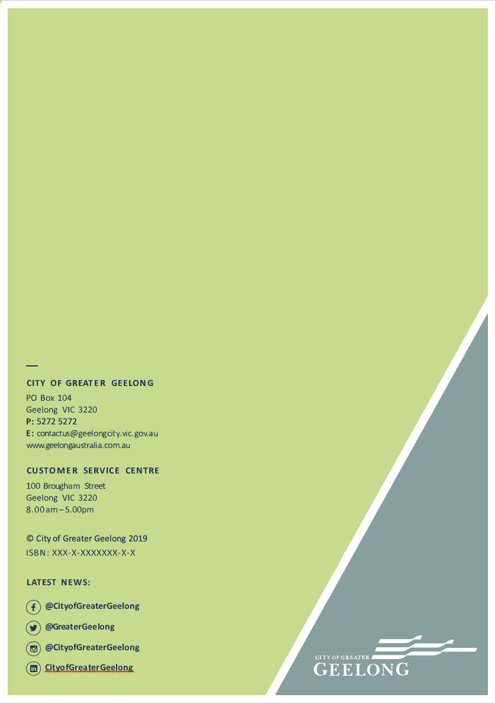

Wurriki Nyal
137-149 Mercer Street, Geelong
8.00am – 5.00pm
WADAWURRUNG COUNTRY
PO Box 104, Geelong VIC 3220
P: 5272 5272
E: contactus@geelongcity.vic.gov.au
www.geelongaustralia.com.au

Department of Environment, Land, Water and Planning (2017) Biodiversity 2037. Victorian State Government, Melbourne.
City of Greater Geelong (2025) Our Council Plan 2025-29. City of Greater Geelong, Victoria.
Australian Bureau of Statistics (2024) Region Summary: Greater Geelong. URL: https://dbr.abs.gov.au/region.html?lyr=lga&rgn=22750 (Accessed 7 Feb 2026)
City of Greater Geelong (2020) Environment Strategy 2020-30. City of Greater Geelong, Victoria.
City of Greater Geelong (2025) Reconciliation Action Plan - Wadawurrung Aboriginal history. URL: (https://www.geelongaustralia.com.au/ (Accessed 18 December 2025).
State Wide Integrated Flora and Fauna Teams (SWIFFT) URL: https://www.swifft.net.au/cb_pages/team_linear_reserves_project.php (Accessed 20 March 2025)
Grassy Plains Network URL: https://grassyplains.net.au/grasslands/ (Accessed 20 March 2025)
Corangamite CMA URL: https://ccma.vic.gov.au/projects/victorian-volcanic-plains/ (Accessed 20 March 2025)
Wadawurrung Traditional Owners Aboriginal Corporation (WTOAC) (2020) Paleert Tjaara Dja – Healthy Country Plan 2020-30. WTOAC, Victoria.
Australian Bureau of Statistics (2024) Region Summary: Greater Geelong. URL: https://dbr.abs.gov.au/region.html?lyr=lga&rgn=22750 (Accessed 6 Feb 2026)
DEECA. (2025). Australian Water Resource Council Major River Basins of Victoria [Dataset]. https://discover.data.vic.gov.au/dataset/awrc-major-river-basins-of-victoria.
Australian Government (2019) Directory of Important Wetlands. URL: https://www.environment.gov.au/cgi-bin/wetlands/search.pl?smode=DOIW (Accessed 6 Feb 2026)
idcommunity (2021) City of Greater Geelong: community profile. URL: https://profile.id.com.au/geelong/about (Accessed 6 Feb 2026)
G21 (2013) G21 Regional Growth Plan. G21, Geelong, Victoria.
Image source: URL: https://www.vic.gov.au/know-your-council (Accessed 6 Feb 2026)
Migratory Bird Agreements: JAMBA (Japan-Australia, 1974), CAMBA (China-Australia, 1986), and ROKAMBA (Republic of Korea-Australia, 2006)
Victoria in Future 2019, p 9.
City of Greater Geelong (2021) Climate Change Response Plan. City of Greater Geelong, Victoria.
Department of Environment, Land, Water and Planning (2015) Climate-ready Victoria: Barwon South West. Victorian Government, Melbourne.
City of Greater Geelong (2021) Climate Change Response Plan. City of Greater Geelong, Victoria.
Clarke, JM., Grose, M., Thatcher, M., Round, V. & Heady, C. (2019) Barwon Climate Projections 2019. CSIRO, Melbourne.
ibid.
Image source: https://www.geelongaustralia.com.au/hoodedplover/article/item/8cf5b098da0360a.aspx (Accessed 29 Dec 2024)
Wadawurrung Traditional Owners Aboriginal Corporation (2020) Paleert Tjaara Dja – Wadawurrung Country Plan. WTOAC, Victoria.
ibid
City of Greater Geelong population forecast https://forecast.id.com.au/geelong (Accessed 6 Feb 2026).
Australian Bureau of Statistics (ABS) (2021) Census of Population and Housing, Usual Residence Data.
https://www.dcceew.gov.au/environment/epbc/approvals/strategic-assessments/geelong-growth-areas (Accessed 6 Feb 2026)
Corangamite Catchment Management Authority (2024) Corangamite Regional Catchment Strategy. Corangamite CMA, Colac.
Corangamite CMA (2021) Summary of Local Areas. URL: https://corangamite.rcs.vic.gov.au/local-areas/summary-of- local-areas/ (Accessed 26 August 2024)
Native Vegetation – City of Greater Geelong Biodiversity Mapping 2013 - 2025
Birdlife Australia (2024) Wedge-tailed Eagle. URL: https://birdlife.org.au/bird-profiles/wedge-tailed-eagle/ (Accessed 25 August 2024).
Native Vegetation – City of Greater Geelong Biodiversity Mapping 2013 - 2025
Native Vegetation – City of Greater Geelong Biodiversity Mapping 2013 - 2025
Australian Museum (2021) URL: https://australian.museum/learn/animals/frogs/eastern-pobblebonk-frog/ (Accessed 18 Dec 2025)
Native Vegetation – City of Greater Geelong Biodiversity Mapping 2013 - 2025
Native Vegetation – City of Greater Geelong Biodiversity Mapping 2013 - 2025
State Wide Integrated Flora and Fauna Teams (SWIFFT) URL: https://www.swifft.net.au/cb_pages/sp_fat-tailed_dunnart.php (Accesed 18 Dec 2025)
Native Vegetation – City of Greater Geelong Biodiversity Mapping 2013 - 2025
Department of Environment, Land, Water and Planning (2017) Biodiversity 2037. Victorian State Government, Melbourne.
Nature reserves layer in the City’s Public Open Space spatial data (Accessed Dec 2025).
Section 69 of the Conservation, Forests and Lands Act 1987
Department of Environment, Land, Water and Planning (DELWP) (2017) Protecting Victoria’s Environment – Biodiversity 2037. Victorian State Government, Melbourne.
Threatened Species Recovery Hub (date n/a).The impact of cats on Australian wildlife. URL: https://www.nespthreatenedspecies.edu.au/media/dehnttbf/7-4-the-impact-of-pet-cat-impacts_f.pdf (Accessed 6 March 2025)
Department of Environment, Land, Water and Planning (2022). My Victorian Waterway: Social research to understand the community’s connection to Victorian waterways. Full report prepared by Quantum Market Research for the Victorian State Government, Melbourne.
https://www.dcceew.gov.au/environment/biodiversity/conservation/wildlife-corridors ((Accessed 29 December 2024).
Department of Environment, Land, Water and Planning (2017) Biodiversity 2037. Victorian State Government, Melbourne.
ibid.
Department of Environment, Land, Water and Planning (2018) Victorians Volunteering for Nature: Environmental Volunteering Plan. Victorian State Government, Melbourne.
ibid.
Corangamite Catchment Management Authority (2024) Corangamite Regional Catchment Strategy. Corangamite CMA, Colac.
ibid.
Vic Catchments (2024) Blue and teal carbon investment opportunities in Victoria. URL: https://viccatchments.com.au/wp-content/uploads/2024/06/Blue-and-Teal-Carbon_FINAL-WEB-1.pdf (Accessed 25 August 2024)

