The City Of
Greater Geelong

Community engagement report

Fair Access Policy

  - APRIL 2024

Contents
Executive summary 3
Background 4
Community Engagement 5
Methodology 5
Engagement metrics: 6
Engagement tools and techniques 7
Communications 7
Who we engaged with 7
Results: what we heard 8
Support 8
Satisfaction 8
Principles 9
Concerns 9
Positives 9
General feedback 10
Sample verbatim comments 10
Conclusion and next steps 11

Executive summary
The City of Greater Geelong’s Fair Access Policy addresses known barriers experienced by women and girls in accessing and using community sports infrastructure.
The policy has been developed in response to the Victorian Government Fair Access Policy Roadmap.
The policy aims to progressively build the capacity and capabilities of the City of Greater Geelong and associated stakeholders in identifying and eliminating systemic causes of gender inequality in policy, programs, communications, and delivery and allocation of community sports and recreation infrastructure.
This report presents the broad range of values, ideas, concerns and aspirations by community members during the engagement period.
Feedback from the community indicated support for the draft Fair Access Policy.
The City would like to thank the participants who generously shared their time and ideas throughout the engagement process.

Background



Gender inequality persists within Victoria's sports and recreation sector, with a significant gap in female participation and leadership representation evident across all levels of the Victorian sporting and recreation industry.
As a defined outcome of the Gender Equality Act 2020, all councils are required from 31 March 2021 to conduct Gender Impact Assessments (GIA) on all new policies, programs, communications, and services, including those up for review, which directly and significantly impact the public (Gender Equality Act 2020). The access and use of community sports infrastructure is an example of a policy that has a direct and significant impact on the public.
The City’s Fair Access Policy will include principles and approaches to address known barriers experienced by women and girls in accessing and using community sports and active recreation facilities, services and programs.
The policy aligns with the Victorian Government Fair Access Policy Roadmap and responds to requirements of the Gender Equality Act 2020.

Community Engagement

Methodology
From 28 March to 30 April 2024 the community was invited to provide feedback on the City’s draft Fair Access Policy aimed at enhancing opportunities and access to facilities and sporting surfaces for women, girls in sport and recreation within the Geelong region. This initiative is essential for the City to effectively increase inclusivity and improve participation in sports and recreational activities.
The emphasis of the engagement with the community was to seek feedback to help the City make decisions to increase and improve opportunities for women and girls in sport and recreation within the Geelong region.
Utilising the City’s Have Your Say page the City asked for feedback on six guiding principles and commitments under the Fair Access Policy Roadmap. These are:

Principle 1 – Infrastructure
Commitment – Community sports and active recreation infrastructure are genuinely welcoming, safe and inclusive.

Principle 2 – Roles in Sport
Commitment – Women and girls will be encouraged to participate in all aspects of community sport and active recreation including as a player, coach, administrator, official, volunteer and spectator.

Principle 3 – Allocation and Scheduling
Commitment – Women and girls will have fair access to and use of community sport and recreation infrastructure which is of the highest quality, at the most convenient location and times and includes new opportunities and sports.

Principle 4 – Leadership
Commitment – Women and girls should be equitably represented in leadership and governance roles.

Principle 5 – Culture and Environment
Commitment – Encourage and support all user groups who access community sport and active recreation infrastructure to understand, adopt and implement gender equitable access and use practices that are genuinely welcoming, safe and inclusive.

Principle 6 – Reward, Celebrate and Prioritise.
Commitment – Prioritise access, use and support to all user groups who demonstrate ongoing commitment to gender equitable access and use of allocated infrastructure.

Each principle includes a set of actions to deliver on the commitment.

Engagement metrics:


14
Hardcopy surveys completed.
202
people visited the Have Your Say page.
Quick Polls were completed.
6

34 DAYS
of engagement

Data methodology
The engagement was open to everyone.
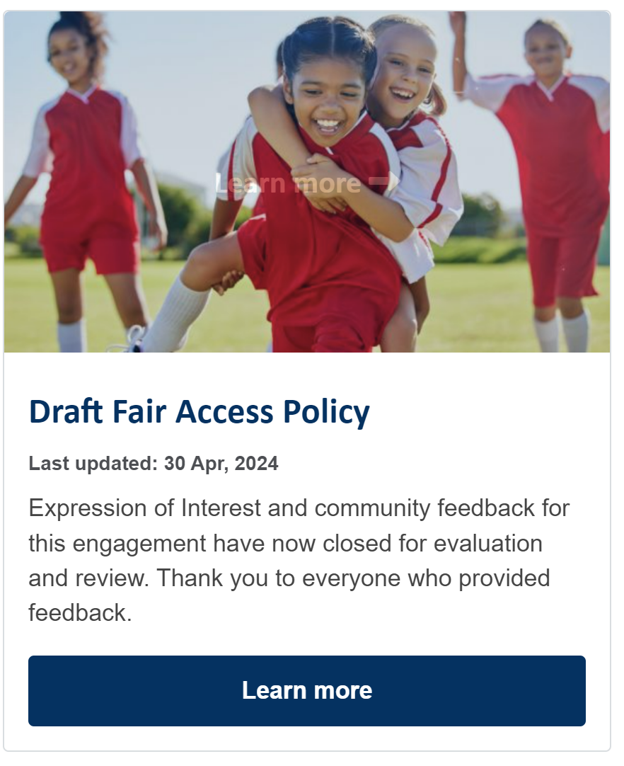
Figure: Have Your Say social media tile.

Engagement tools and techniques
A standalone page for this engagement was created to provide specific project information, including the draft policy, the background report and draft evaluation framework plus explanatory material.
A range of engagement tools and techniques were used to provide different types of opportunities for stakeholders and community to have their say. The main tools and techniques are explained in further detail below.
HOW WE ENGAGED
Have Your Say Online Portal  yoursay.geelongaustralia.com.au | An online HYS project page was designed to share relevant information to encourage community feedback on the draft Fair Access Policy - https://yoursay.geelongaustralia.com.au/draft-fair-access-policy
Survey (online and hardcopy) | An online survey was provided through the HYS page and as a printable document and was available throughout the engagement period. The objective of the survey was to capture community feedback on the policy.
Quick Poll | An online quick poll was also provided for community to indicate their support for the draft City of Greater Geelong Fair Access Policy.
Email | The community was invited to share their feedback by email - comrec@geelongcity.vic.gov.au.

Communications
The City advertised through City’s media outlets – City news, a dedicated HYS page and promoted through the Sports club monthly newsletter as well as asking the Sporting Associations to promote the opportunity to submit feedback.

Who we engaged with
During 28 March to 30 April 2024 more than 200 people visited the City’s Have Your Say page. The city received feedback from twenty online submission, 14 hard copy surveys and six online quick polls. Through the survey, the community was invited to share demographic data. More than 85% of respondents identified as female, the age groups were well distributed, with the highest participant group was aged 35-49. Suburbs were well dispersed across the region reflecting the importance of the policy for the City.
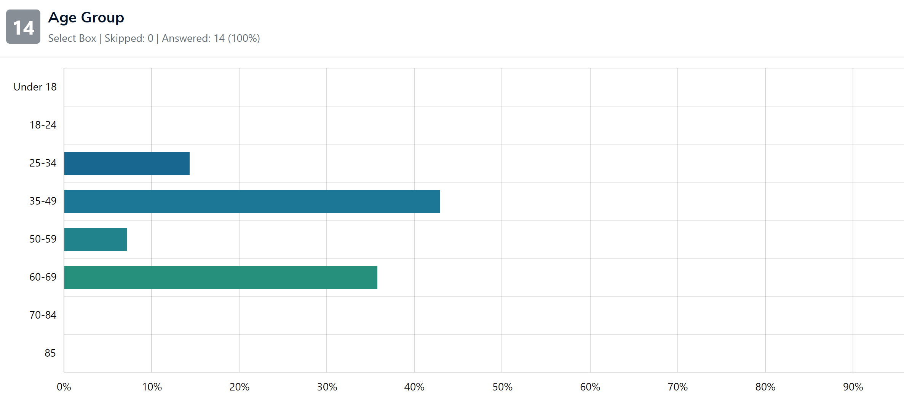

Results: what we heard

Support
Feedback from the community highlighted support for the draft Fair Access Policy.
More than 85% of survey respondents affirmed their overall support for the draft policy in its entirety. Additionally, 67% of respondents from a quick poll also indicated support for the proposed policy.
Females represented the majority of survey respondents, with 11 indicating ‘Yes’ and 1 indicating ‘No’. Males had an equal response for ‘Yes’ and ‘No’. Non-binary individuals, those who preferred not to say, and others did not provide any response to this question.

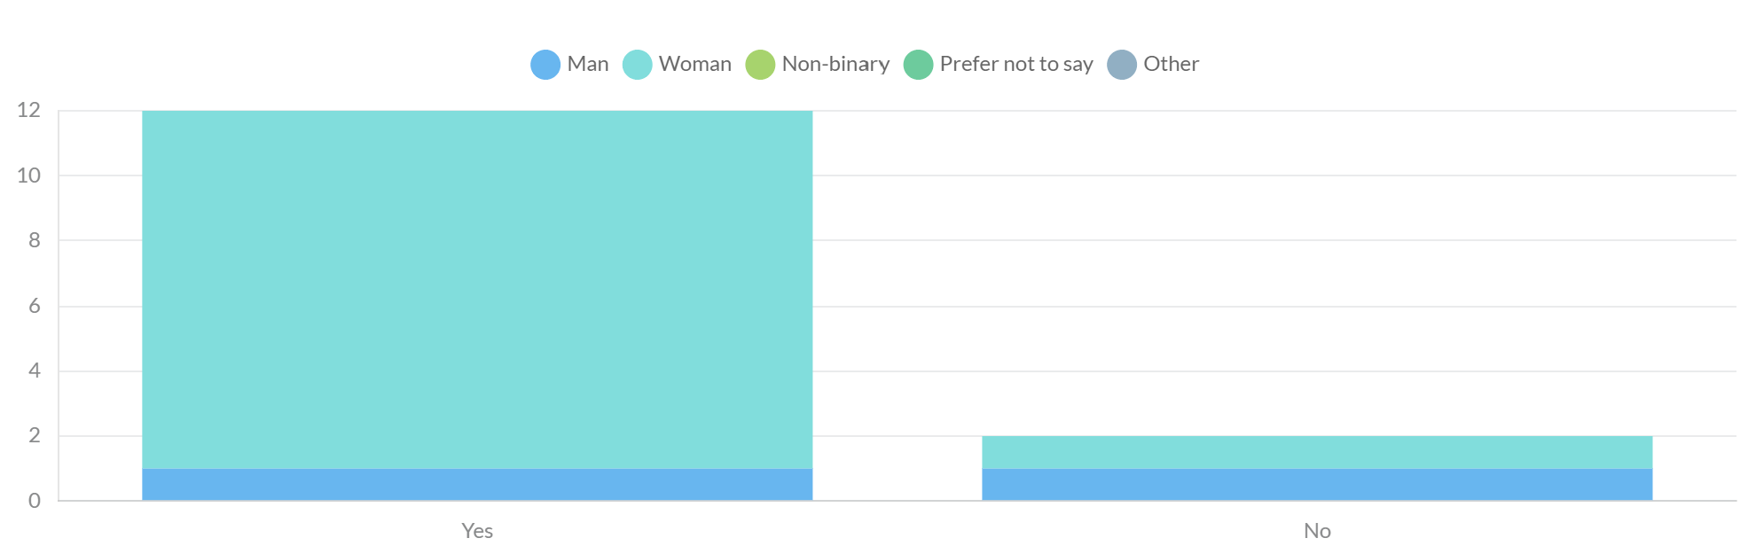

Satisfaction
When asked their satisfaction rating of the policy, we heard 71.43% were very satisfied or somewhat satisfied, 7.14% were unsure and 21.43% were somewhat dissatisfied or very dissatisfied.

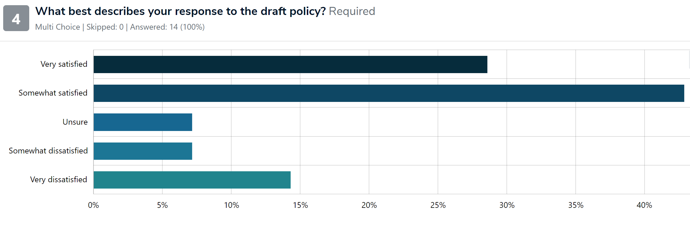

Principles
Positive support for the each of the principles was received.

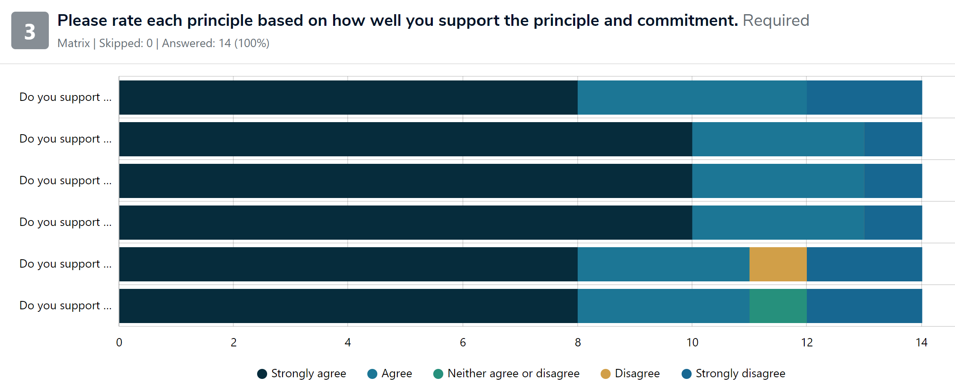

Figure above - Principles in order from top (#1) to bottom (#6).
#1 – Infrastructure #2 – Roles in Sport #3 – Allocation and Scheduling #4 – Leadership #5 – Culture and Environment #6 – Reward, Celebrate and Prioritise

Concerns
We asked if there were any concerns with the policy. In response, 64% of respondents indicated concerns with the implementation and the translation of policy into action. Other concerns included ensuring the safety and inclusivity of sports, particularly regarding the use of change rooms and facilities by individuals who may identify differently from their birth gender.

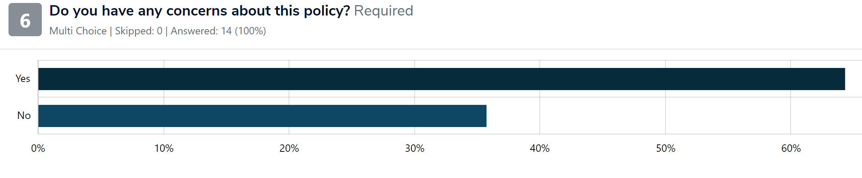

Positives
Respondents were asked what excited them about the policy. The emerging themes emphasised the need for addressing inequalities, promoting inclusivity, ensuring safety and access to resources and advocating for fairness and quality in sport participation.
- There was a clear focus on addressing structural inequalities that females face in participating in physical activity – concerns about safety and access to infrastructure for females to participate in sports, including the need for well-lit facilities.
- The importance of creating opportunities for inclusive participation from the broader community, while supporting the most active clubs and individuals.
- Women in leadership capacities across boards in sport
- Recognition of the importance of documenting policy for transparency and accountability

General feedback
Respondents were given the opportunity to provide general feedback on the policy. Themes that emerged from this data were:
- The need for communication to ensure the wider community understand and support the policy to be implemented.
- Recognition of the need to address negative behaviours, such as criticism and anti-social behaviour towards females in sport which act as barries to participation.
- Support for sporting clubs to create welcoming safe and inclusive environments.

Sample verbatim comments
Sport makes women stronger; it is possible that when women are stronger male violence will decrease.

It is not plain language, why are you not straight forward with your agenda, when you say excited not in a good way.

The importance it places in committing to placing women in leadership capacities across the board, as well as the creation of inclusive sporting environments, not just for participants and supporting staff (umpires being the most often used example), but for spectators as well. This is crucial if we are to drive the growth of women's sport in the Geelong region.

Conclusion and next steps
The primary objective behind this community engagement initiative was to gather valuable insights and perspectives on the draft Fair Access Policy. Community participation and feedback has been invaluable in shaping a policy that truly reflects the diverse needs and concerns of our community.
Moving forward, we are committed to incorporating your input to ensure that the final policy promotes fairness, transparency, and inclusivity in sports. Thank you for your active involvement and contribution to this important process. Together, we can create a sporting environment that is equitable and supportive for all.



