The City Of
Greater Geelong

2025 GEELONG youth survey

Engagement report

  - December 2025

Contents
Executive Summary……………………………………………………………… 3
Introduction……………………………………………………………………….. 4
Project Background……………………………………………………………….. 4
Engagement Purpose……………………………………………………………... 4
About this Report………………………………………………………………….. 4
How we engaged…………………………………………………………………. 5
Snapshot……………………………………………………………………………. 5
Have Your Say Online Platform………………………………………………….. 5
Survey……………………………………………………………………………….. 5
Engagement projects with Vocational Major (VM) students………………….. 6
Engagement with services and schools………………………………………… 6
Secondary school lunch time visits………………………………………..…….. 6
In person engagement activities…………………………………………........... 6
Youth Council Advisory Committee……………………………………………… 7
Promotion…………………………………………………………………………… 7
School engagement……………………………………………………………….. 7
Who we engaged…………………………………………………………………. 9
Education facilities…………………………………………………………………. 9
Parents, guardians and community members……………………………......... 9
Who actively engaged…………………………………………………………….. 10
Geographic Dispersion of survey respondents aged 12-25………………….. 11
What we asked……………………………………………………………………. 13
Summary Findings……………………………………………………………….. 15
Age and Gender……………………………………………………………………. 15
Underrepresented Communities…………………………………………………. 16
Connection to Community………………………………………………………… 16
Engagement in Geelong Community……………………………………………. 17
Top 10 issues for young people………………………………………………….. 18
Top 10 issues of personal concern for young people…………………………. 18
Perception vs Reality: Top issues for young people in Greater Geelong…… 19
Barriers to Participation in Geelong……………………………………………… 20
How Young People in Geelong Spend Their Free Time ……………………… 20
Key Themes from Youth Feedback (Ages 12–25)…………………………….. 21

Executive Summary

The 2025 Youth Survey was undertaken to better understand the experiences, needs and priorities of young people aged 12-25 across Greater Geelong. This is the first time the City has delivered a comprehensive youth-focused survey at this scale, recognising young people as a historically underrepresented group in council engagements. Over 3,500 people participated across three tailored surveys: young people, parents/carers and community members, and staff from educational institutions. The insights collected will guide youth development service delivery and support a coordinated, evidence-based approach to working with young people.

A wide-ranging engagement process ensured strong reach and participation, including school-based engagement projects with Vocational Major (VM) students, in-school lunchtime activations, promotion and engagement via the City’s youth hubs, consultation with the Youth Council Advisory Committee, community events, and online promotion through the City’s Have Your Say platform and social media channels. Engagement took place across 55 days between March and May 2025 and was supported by extensive collaboration with secondary schools, local youth services, and community partners.

Young people represented the largest respondent group, with 3,341 participants aged 12–25 completing the survey. Most were aged between 12–17, reflecting the strong school-based engagement methods. The survey captured participation from 57 of Geelong’s 60 suburbs, ensuring a broad geographic and demographic spread. The data also provided valuable insights into underrepresented communities, including LGBTQIA+ young people, those living with a mental health condition, neurodiverse young people, and those living with a disability.
The findings paint a detailed picture of both the challenges young people face and the opportunities for council to support them. While vaping, mental health and financial stress were widely perceived as major issues, young people’s personal concerns centred more strongly on school pressures, mental health and financial stress. More than half of respondents felt moderately connected to their community, and many contribute through work, volunteering and participation in local activities. However, young people also identified practical barriers to engagement, including cost, lack of awareness, transport limitations, timing and location of activities.

Young people also shared how they spend their free time, with social connection emerging as a consistent theme. Most enjoy spending time with friends or family, participating in creative activities such as music or movies, or playing sport. Feedback provided through open-ended questions highlighted a strong desire for more youth-friendly activities and events, greater inclusion, improved safety, better advertising of opportunities, and affordable, accessible programs. These themes reflect young people’s aspirations for a city where they can participate, feel represented, and access opportunities that support their wellbeing and growth.

Overall, the Youth Survey offers a rich evidence base for planning and collaboration across council and community sectors. It clearly demonstrates that young people in Greater Geelong want to be heard, want to belong, and want to participate and that with the right support and opportunities, they can contribute meaningfully to the future of their city.

Introduction

Project Background
In 2025, a youth survey was delivered by the City to capture the thoughts, opinions, and needs of young people across Greater Geelong.
The Youth Survey also gained insights from those who work with young people across local organisations and schools, parents and carers of young people, as well as any interested community members.
This is the first time that the City has undertaken a comprehensive survey of its young people aged 12-25, a population group widely acknowledged as an underrepresented cohort across the City’s engagement processes and opportunities.
The survey results will inform and guide the youth development unit’s service delivery so that it meets the needs and requirements of young people.
The data has been gathered and analysed internally and will be shared with internal departments at the City, and with our external partners, who can utilise the valuable feedback provided throughout this report.
The Youth Survey has provided the City with statistically significant data on young people that will help guide our engagement and program development with and for young people across Geelong over the next 18 months.

Engagement Purpose
The purpose of this engagement was to:
- Gather demographic information about young people aged 12-25 in Greater Geelong.
- Understand how connected young people feel to the Geelong community.
- Gain insight into what survey respondents believe the top issues are for young people in Geelong.
- Gain insight into young people’s top issues of personal concern.
- Understand how the Youth Development Unit can better work with secondary schools across Geelong.
- Gather the thoughts, opinions, and observations of supportive adults.
- To inform and guide the Youth Development Unit’s service delivery over the next 18 months to ensure that the City is responsive to the needs of young people across Greater Geelong.

About this Report
The purpose of this report is to:
- Share the engagement process followed, including the planning, delivery, and execution of the youth survey.
- Present the analysis of youth survey results so that others can benefit from the findings.

How we engaged

Snapshot
The primary methods of engagement were:
- Have Your Say (HYS) Platform
- Engagement projects with Vocational Major (VM) students focusing on upskilling, and capacity building to promote the youth survey across three secondary schools in Term One.
- Five secondary school lunch time visits to promote youth survey completion across Greater Geelong in Term One.
- Consultation with the Geelong Youth Council Advisory Committee in 2024 and 2025.
- One Community Conversation held at the Nest Youth Hub on the 14 May.
- Two activations at Westfield Shopping Centre to promote and encourage survey completion in March and April 2025.
- Engagement through drop-in programming at The Nest and The fOrT in Term One and across the Easter school holidays.
- Engagement through in-school program delivery across Greater Geelong in Term One.
- Engagement directly with schools and local services in Term One.
When engaging with young people, it is important to meet them where they are at, in the places and spaces they are comfortable in, and familiar with. Therefore, it was important for youth development staff to be actively seeking out young people across the various settings listed above. We did not assume young people would know about our youth survey, how to access it, or what benefit it would have on the community, so we communicated with them directly at every opportunity.
The youth survey was championed by all staff in the Youth Development Unit and could not have been achieved without each staff member taking an active role in delivery of the survey.
The engagement period was between 24 March to 18 May 2025 for a total of 55 days.

Have Your Say Online Platform
The City’s Have Your Say (HYS) online platform was used to capture the voices of young people and the community through a newly designed HYS page linking community members to one of three youth survey’s.

Survey
The three youth surveys were targeted to three separate cohorts including:
- Young people aged 12-25 years old.
- Parents, carers, grandparents, those working with young people, and community members.
- Staff or volunteers from educational institutions.
The three distinct surveys allowed us to:
- Gather insights of young people’s needs, experiences, and opinions directly from young people.
- Gain the insights of those who live or work with young people, or any interested community member who would like to share their observations of young people.
- To understand how we can more effectively work with and support our local schools and educational facilities, the third survey provided the opportunity for staff to share their insights and observations of young people but also provided schools with an opportunity to share feedback on how the City can better work with schools in the future.

Engagement projects with Vocational Major (VM) students
Projects were delivered in partnership with VM students and teachers across Clonard College, Belmont High School, and St Joesphs College. Through the delivery of a five-week program, youth development staff provided students with an opportunity to work on a community project, seeking the views and opinions of young people.
Each class of up to 30 students learnt the importance of having a say in their community and using their voice to engage with council. Through the delivery of this program, staff provided students with an overview of all the council engagement opportunities available to them.
Youth development staff worked to build students capacity to promote and present the youth survey within their schools to encourage uptake and participation. Students were tasked with writing a pitch about the youth survey and why it was important of have a say in their community. Students then delivered their pitches to their peers in the hope they would be encouraged to complete the survey.
Each VM class presented to their peers either via a whole school or year level assembly, or in classroom sessions. These youth led presentations drove significant survey participation rates within the three school environments, capturing 395 responses from Belmont High School, 332 at Clonard College, and 116 at St Joesph’s College.

Engagement with services and schools
Secondary schools and youth services from across Geelong were provided with letters, information, links, and marketing materials to promote and encourage their young people to participate. All secondary schools were offered the opportunity for youth development staff to attend the school and facilitate a lunch time youth survey activation activity.

Secondary school lunch time visits
Youth Development staff attended five secondary schools during lunch time periods to promote the youth survey. These lunch time drop ins were advertised on the school online platform a few days prior, as well as on the day. An announcement delivered across the public address (PA) system was also utilised to remind students immediately before lunchtime that staff would be present.
Participation was driven through creative incentives designed to make involvement appealing and rewarding. Staff hosted a free barbeque to draw students in, distributed movie tickets as a prize for active engagement, and handed out lollies to participants, fostering a sense of fun and recognition that encouraged greater involvement.
Hardcopy surveys and iPads were utilised as students are not permitted to have their mobile devices with them during the school day. Over 500 hardcopy surveys were completed across the five schools. Once completed, staff then input the data manually into the HYS platform.

In person engagement activities
Many other engagement methods were used to promote and encourage young people and community members to participate in the survey. All youth development staff were briefed on the importance of the youth survey and encouraged to promote it at every opportunity.
Youth development staff have significant contact with young people through attendance at schools, delivering programs, out in the community, and across our youth hubs and drop-in locations. Staff spoke with young people across these opportunities and supplied hard copy surveys where appropriate.
Staff attended the Geelong Westfield shopping centre with a popup stall and encouraged community members and young people to complete the survey.
Staff and members of the 2025 Youth Council Advisory Committee participated in a Community Conversation with Councillors, other City staff and community members at The Nest Youth Hub in central Geelong.

Youth Council Advisory Committee
The 2024 Youth Council members provided input and advice on the design of the youth survey. Members provided their advice and feedback about the questions including the language and readability, advised on the length of the survey, and how best to market it broadly.
The 2025 Youth Council members all completed the youth survey during a Youth Council and led efforts to drive engagement across their schools and personal networks. They championed the initiative by sharing marketing collateral, presenting at school assemblies, and briefing teaching staff, ensuring the survey reached a wide audience and achieved strong awareness and participation.

Promotion
The engagement was promoted using the following methods:
- Poster containing a QR code distributed to youth hubs drop-ins, schools, community spaces, and put up around the Geelong community attracted 1,175 clicks.
- Promotional postcards containing a QR code distributed to schools, community spaces and places, youth hubs and community areas attracted 119 clicks.
- Paid advertising was utilised on social media including Instagram and Spotify.
- The Geelong Youth Instagram page included a post pinned to the top of the page from 24 March attracting 1,802 views and 23 shares and a reel on 30 March which attracted 780 views and 20 shares.
- The Geelong Youth Facebook page included a post on 24 March which attracted 1,387 views and 23 shares and a reel on 30 March that attracted 233 views.
- The Geelong Youth Council, and the City’s corporate social media channels as well as the City’s Linked In page were also utilised to promote the youth survey.
- A video was developed featuring young people championing the youth survey used to advertise on social media and at Village Cinemas in Geelong over the Term One school holidays.
- Three media releases were developed and shared throughout the engagement process including on 24 March notifying community that the survey was open on 16 May notifying of the extended consultation period and 7 July which provided a quick wrap up of the raw number of submissions received and the preliminary insights.
- Advertisements and promotions across City News attracting 14 clicks.
- Promotion on digital screens in Wurriki Nyal Civic Precinct and on screens at Geelong Regional Library Corporation branches attracted 33 clicks.

School engagement
Thank you to all schools who participated in organised activities, shared promotions, and encouraged students to participate in the youth survey. Below the bar graph visually represents the school’s where students who completed the survey attended. Those that participated in VM projects, i.e Clonard College, Belmont High School, and St Joseph’s College had fantastic success at engaging their students. North Geelong Secondary College, Bellarine Secondary College, Newcomb Secondary College, and Kardinia International College either actively shared the survey promotions within the school setting or hosted the youth development team at their school at a lunch time engagement activity which significantly increased participation rates. Without active school engagement and assertive community outreach, the youth survey would not have captured the number of respondents that it did, so thank you again to all the schools who supported this initiative.

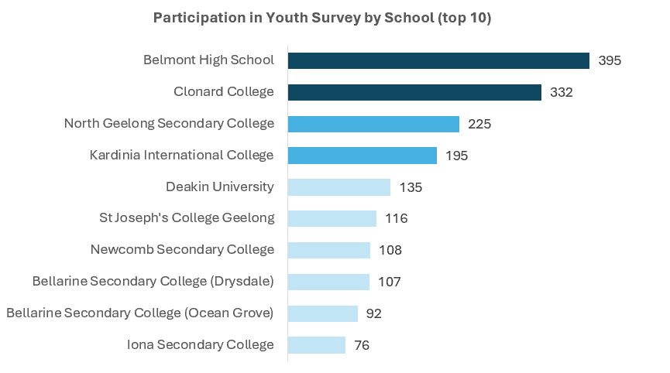

Who we engaged
The City’s Youth Development Unit planned to engage the following cohorts:
- Young people aged 12-25 years old
- Parents, carers, grandparents, those working with young people, and community members
- Staff or volunteers from educational institutions
Our main objective was to capture the feedback and advice of young people aged 12-25 years old through the youth survey, therefore we spent considerable effort to market and promote directly to this cohort.
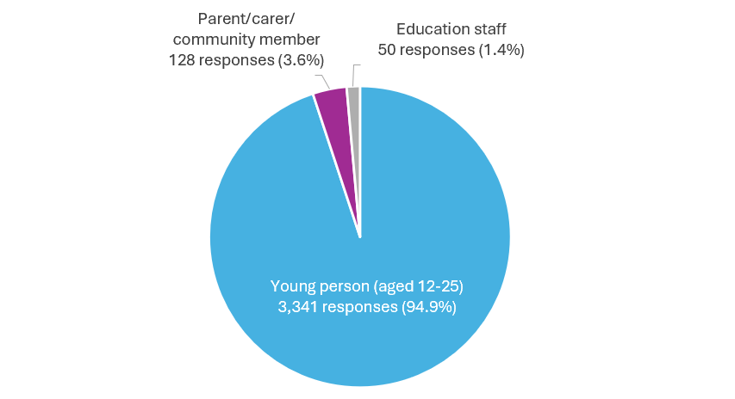
A total of 3,519 people participated in the youth survey with a breakdown of participants shown in the pie graph below.

Education facilities
The City heard from 50 respondents who work at an education facility. These respondents represented 10 schools or campuses across Geelong.

Parents, guardians and community members
The City heard from respondents who identified as:
- Parents or guardians – 99 selections
- People who work with young people – 35 selections
- Volunteers with young people – 16 selections
- Interested community members – 29 selections
Respondents could select multiple options. Figures represent total selections, not unique individuals.

Who actively engaged
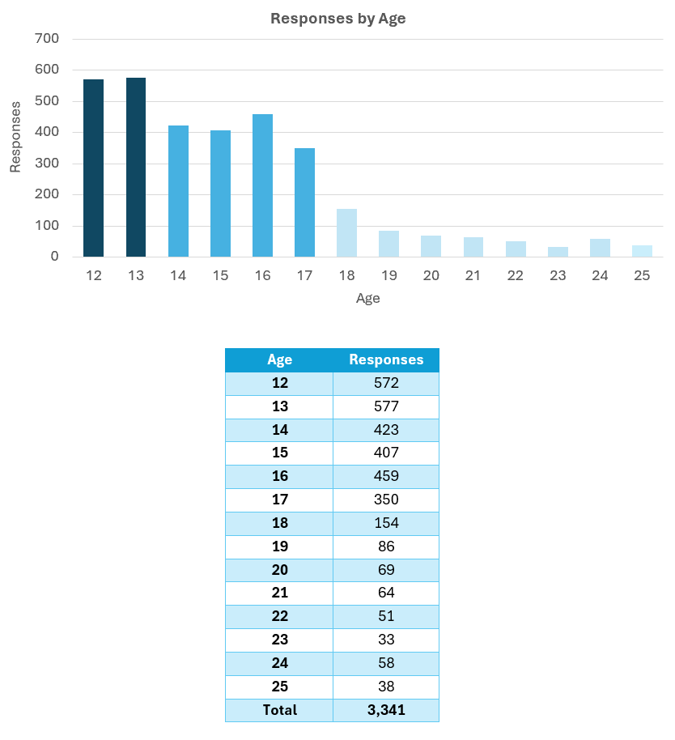
The City heard from a total of 3,341 young people aged between 12-25. Over 80% of respondents were aged between 12-17, which was likely due to the high level of secondary school engagement undertaken. Please note demographic information will be provided within the result findings section of this report.

Geographic Dispersion of survey respondents aged 12-25
Majority of the survey respondents aged 12-25 lived in either Highton, Belmont, Geelong, Corio, Armstrong Creek, Lara or Ocean Grove. However, representation across 57 of the 60 suburbs in Geelong has been captured as demonstrated in the map and bar graph, illustrating a full breakdown of the suburb profile of respondents aged 12-25.

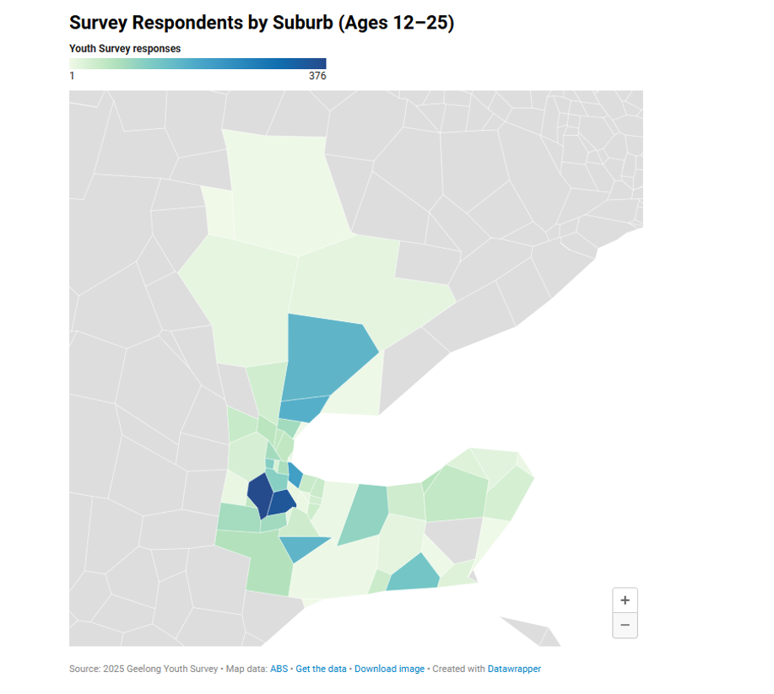
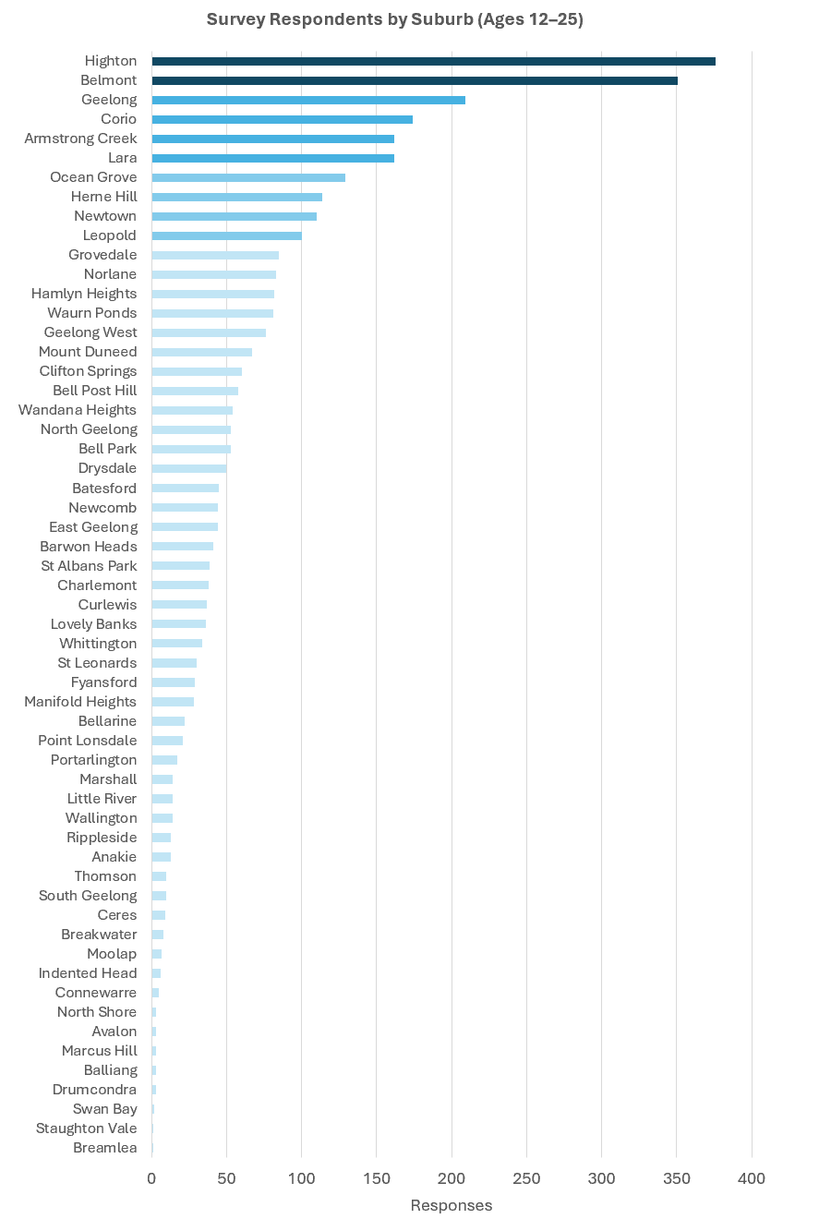

What we asked

Three surveys were created to capture relevant information from each of the three defined population groups below:
- Young people aged 12-25 years old
- Parents, carers, grandparents, those working with young people, and community members
- Staff or volunteers from educational institutions
A mixture of both qualitative and quantitative questions was asked to respondents across the three surveys. These mixed methods approach, helped staff to understand responses more fully, capture key themes, and provide respondents with the opportunity to provide specific and unique feedback.
In the pages following, a full breakdown of questions asked, and responses received has been provided.
Below is a quick snapshot of the question themes the from each survey:

Young people aged 12-25 years old
- Demographic information
- Engagement in work, school, with services and community
- Community connection
- Perceived issues affecting young people in Greater Geelong
- Personal issues of concern
- How young people like to spend their time
- What, if any of the City’s youth programs or activities they have participated in
- Barriers to engagement
- How young people find out about the City’s youth opportunities
- Opportunity to provide further feedback

Parents, carers, grandparents, those working with young people, and community members
- Who they are (parent, carer, community member)
- What they see as the biggest challenges for young people
- What prevents young people from engaging with youth related programs and opportunities
- Whether they are aware of the City’s youth programs and opportunities
- What they see as young people’s interests
- How the City’s youth team can better support those aged 12-25
- Opportunity to provide further feedback or advice to the City’s youth team

Staff or volunteers from educational institutions
- Name of Education facility
- What they see as the top issues for young people at their education facility
- What prevents young people from engaging in programs and opportunities
- Whether they are aware of the City’s youth programs and opportunities
- How the City can better support education facilities
- Whether any staff are trained in City run programming i.e YMHFA
- Opportunity to provide further feedback or advice to the City’s youth team.

Summary Findings
12- 25 year olds

Age and Gender
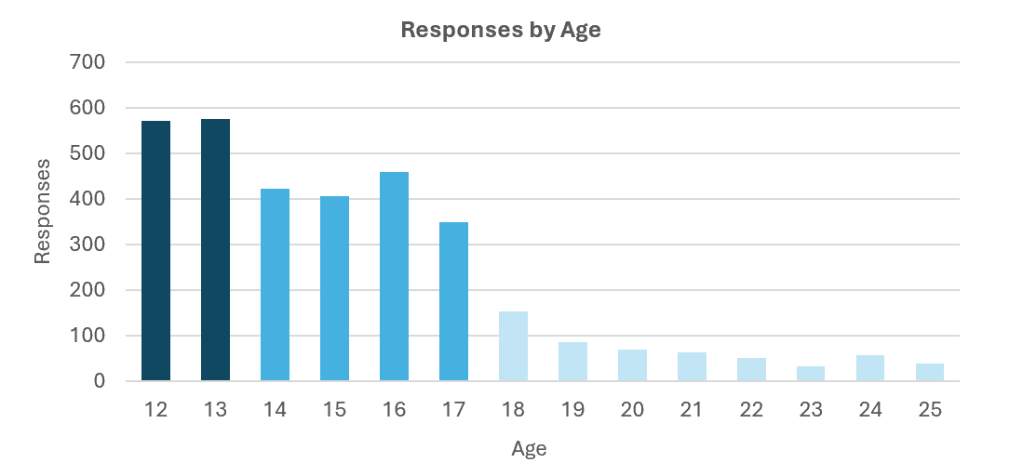
The bar graph below shows a breakdown of the age ranges of respondents aged 12-25 years old. There is fantastic representation from the younger age cohorts, however participation tapers off considerably after 17 years of age. High engagement within the 12–17-year-old age range is likely due to in school engagement in the youth survey.

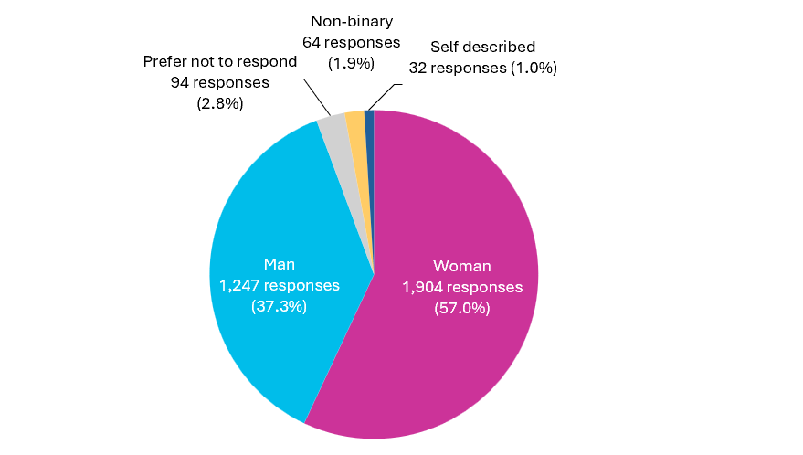
The pie graph below illustrates the gender identity of respondents aged 12-25 years old. Majority of responses were obtained from those identifying as ‘woman’ (57.0%), followed by those identifying as ‘man’ (37.3%), those who preferred not to respond (2.8%), those identifying as non-binary (1.9%) and those who self-described (1.0%).

Underrepresented Communities
The below graph provides an overview of the demographic information of those aged between 12-25 years old. Those identifying as LGBTQIA+ (14.8%), those who live with a mental health condition (14.5%), those who identify as neurodiverse (13.3%), and those living with a disability and/or chronic illness (6.8%), represent the highest respondent rates among youth. However, majority of respondents (65.2%), did not identify with any of the below population groups.

A significantly smaller proportion of respondents identified with or as the following groups, culturally and linguistically diverse (CALD) (4.0%), as Aboriginal or Torres Strait Islander (2.8%), as someone who has caring responsibilities in the home (1.6%), someone who identifies as a refugee or asylum seeker (1.4%), as someone who is living with an addiction (1.3%), as a young parent (0.9%) or as someone who has spent time in the youth justice system (0.4%).

Connection to Community
Majority of respondents aged 12-25 (64.0%) selected 50 or higher when asked how connected they felt to the Geelong community from 0 to 100 (that is 0 = none sense of belonging, 100 = very strong belonging).

A smaller number of respondents selected between 0-40 (36.0%), which unfortunately still represents a significant number of respondents who feel disconnected. As illustrated in the graph below, majority of respondents selected 50, followed by 60, 70, 40 and 80 options. Overall, this represents that young people feel moderately connected to their community.
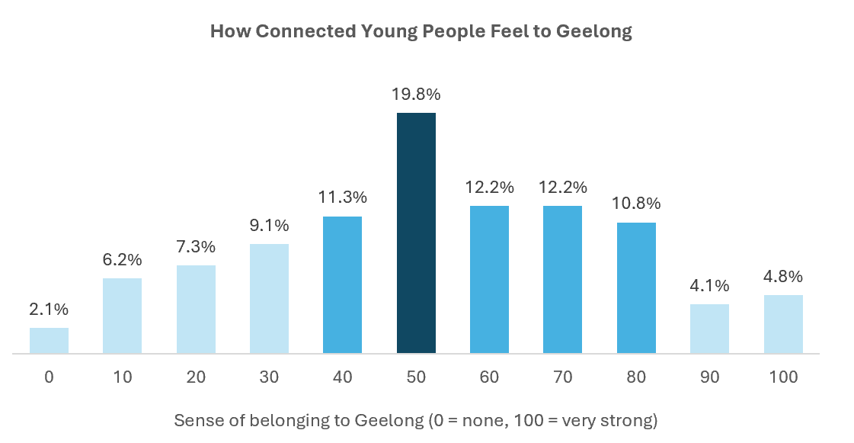

Engagement in Geelong Community
Those aged 12-25 years old contribute significantly to the Geelong community. Many young people spend their free time in Geelong (53.7%), over a quarter of all young people are employed in Geelong (27.4%) and a similar proportion interact with services in Geelong (26.9%). Some young people also volunteer in Geelong (11.3%), others have indicated that they work or study outside of Geelong (4.4%) and a similar proportion (4.3%) have indicated that they are disengaged from work or study in Geelong, or anywhere else.
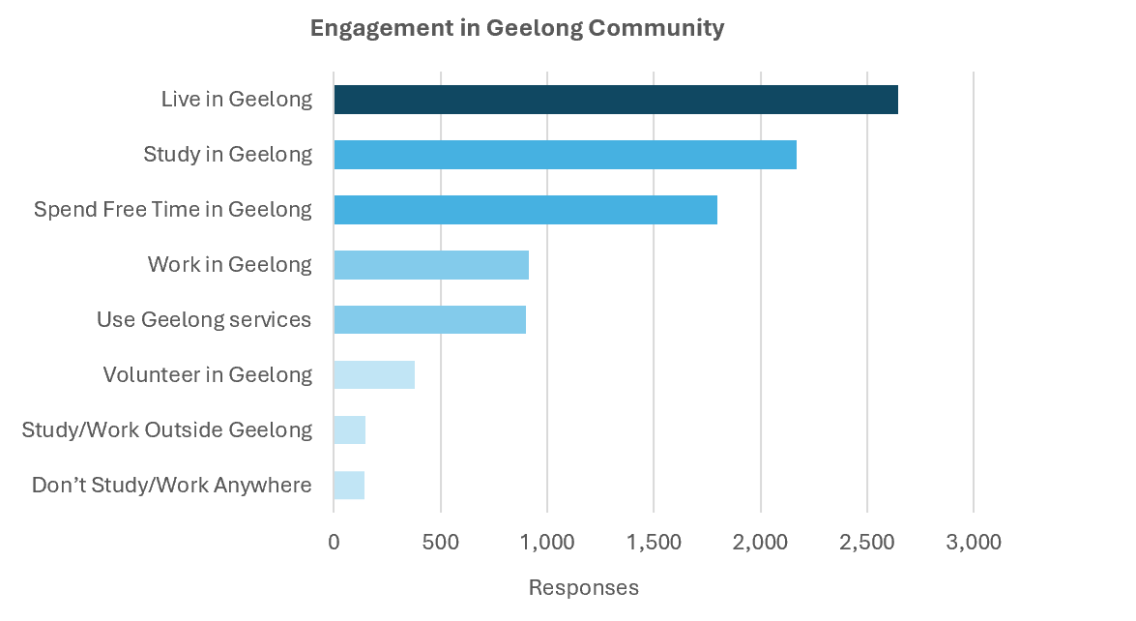

Top 10 issues for young people
Vaping tops the list of perceived issues - But is it really the biggest issue?
When asked what they believe are the top issues facing young people in Greater Geelong, respondents overwhelmingly pointed to vaping, mental health, and financial stress. But do these perceptions align with young people's lived experiences?

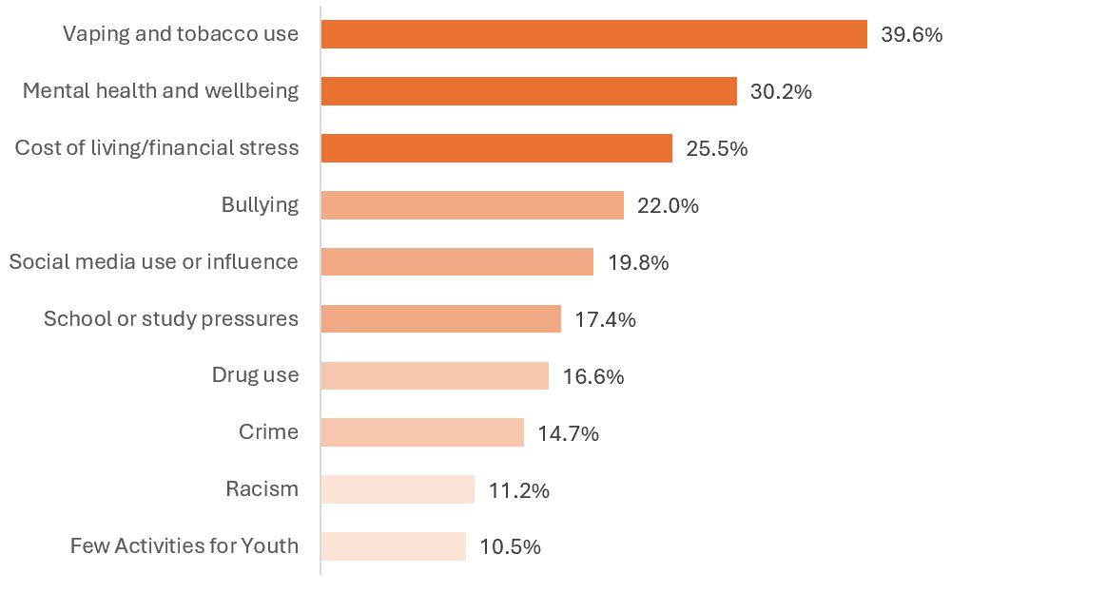

Top 10 issues of personal concern for young people
What Young People Really Worry About - It's Not Just Vaping!
While vaping dominates public perception, young people in Greater Geelong say their biggest challenges are school pressures, mental health, and financial stress.
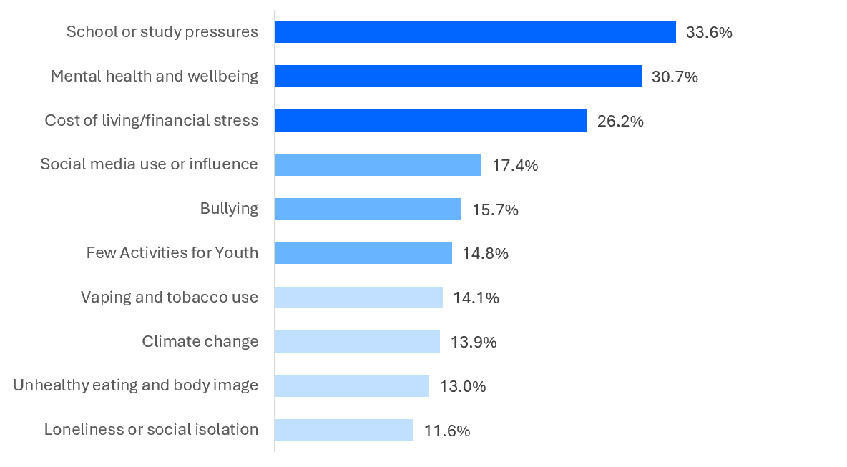

Perception vs Reality: Top issues for young people in Greater Geelong
(Sorted by issue of personal concern)

Perceptions don’t always match reality. While study pressures are underestimated, issues like vaping and drug use are seen as bigger problems than young people report.
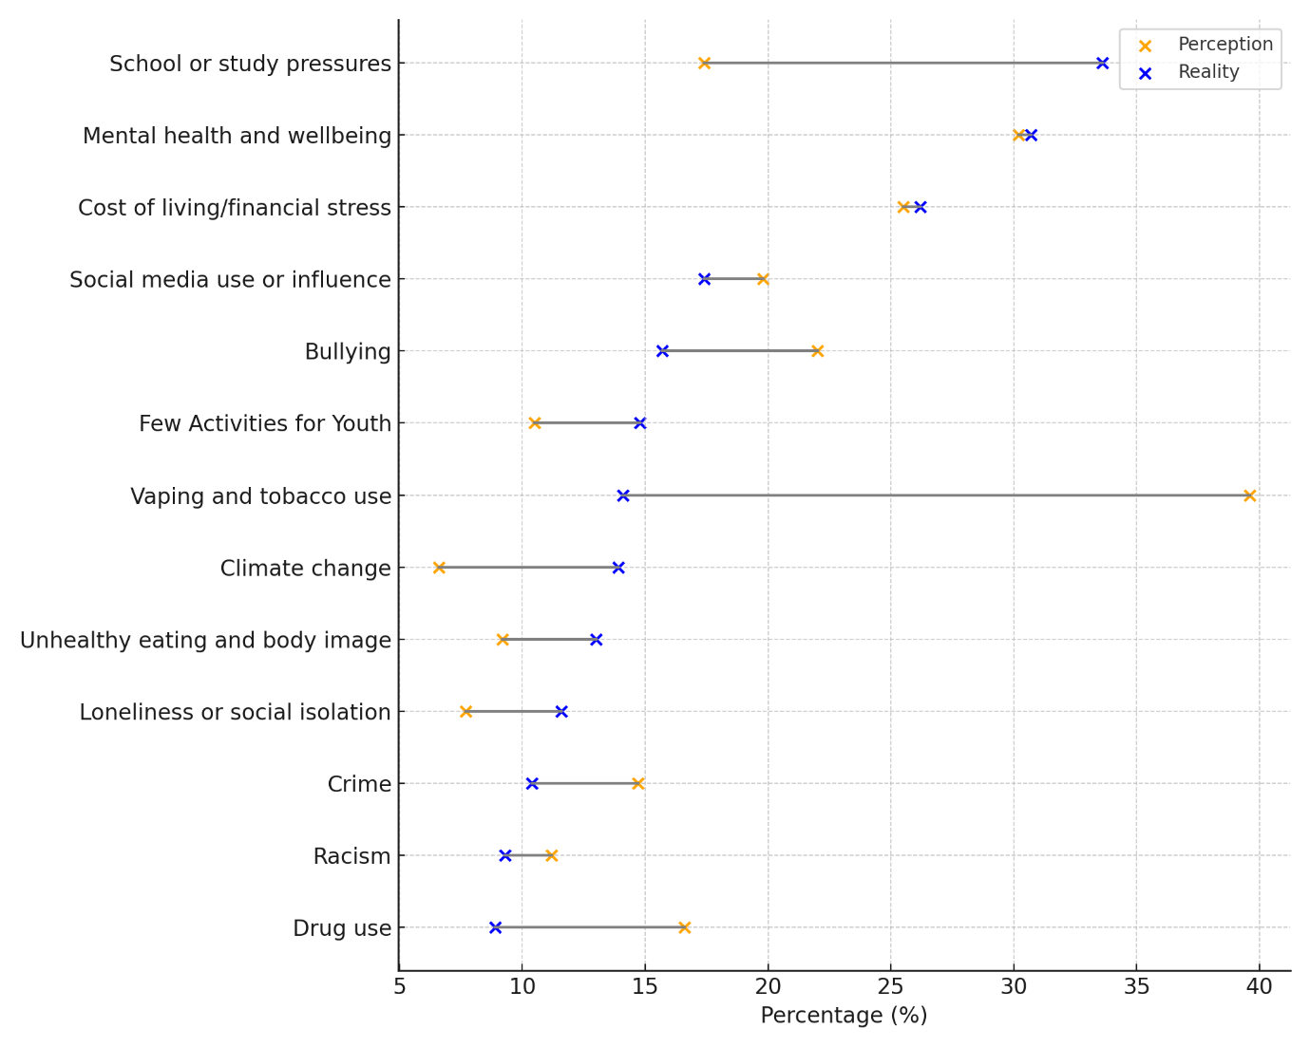

Barriers to Participation in Geelong
Young people identified several key barriers that prevent them from attending or enjoying activities, places, or events in Geelong. The most significant barrier is cost, with 45.9% of respondents saying that activities are too expensive or not financially accessible.

A lack of information is the second major barrier, with 42.7% reporting that they don’t know what’s on or struggle to find information about youth-friendly opportunities. Transport also emerged as a substantial obstacle (34.5%), suggesting that distance, limited services, or reliance on others for transport affects young people’s ability to participate.

Two additional factors, location (30.4%) and timing (30.1%), round out the top five barriers. Young people noted that events or activities are often held too far away or at times that don’t suit their schedules, making it difficult for them to get involved.

Together, these findings highlight the practical and logistical barriers, namely cost, information, transport, distance, and timing have the greatest impact on young people’s ability to participate in community life.

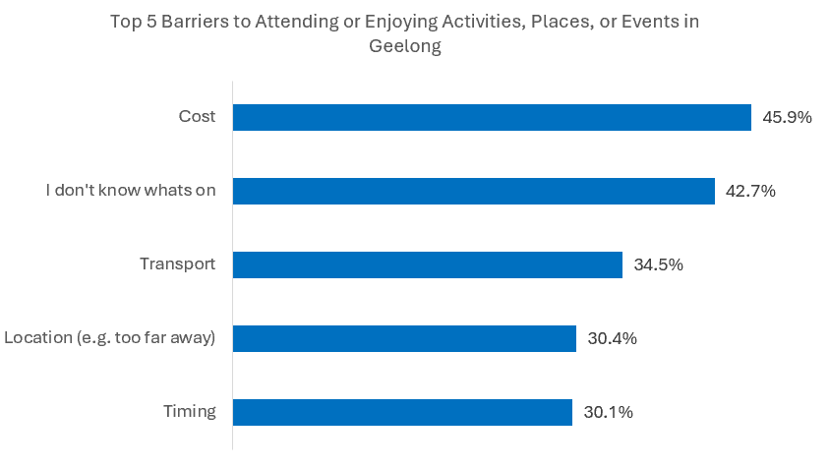

How Young People in Geelong Spend Their Free Time
The top free time activity for young people aged 12–25 is hanging out with friends, with 79% of respondents selecting this as something they regularly do. Social connection clearly plays a central role in how young people choose to spend their downtime.

Other popular activities included listening to music or playing an instrument (53%), along with playing sport (50%). Entertainment based activities were also common, with 49% engaging in movies or streaming. Finally, 48% reported spending time with family, highlighting that both peer and family relationships are important aspects of young people’s free time.

Overall, the data shows that young people value social activities, creative expression, and entertainment, with a strong emphasis on spending time with the people who matter to them.
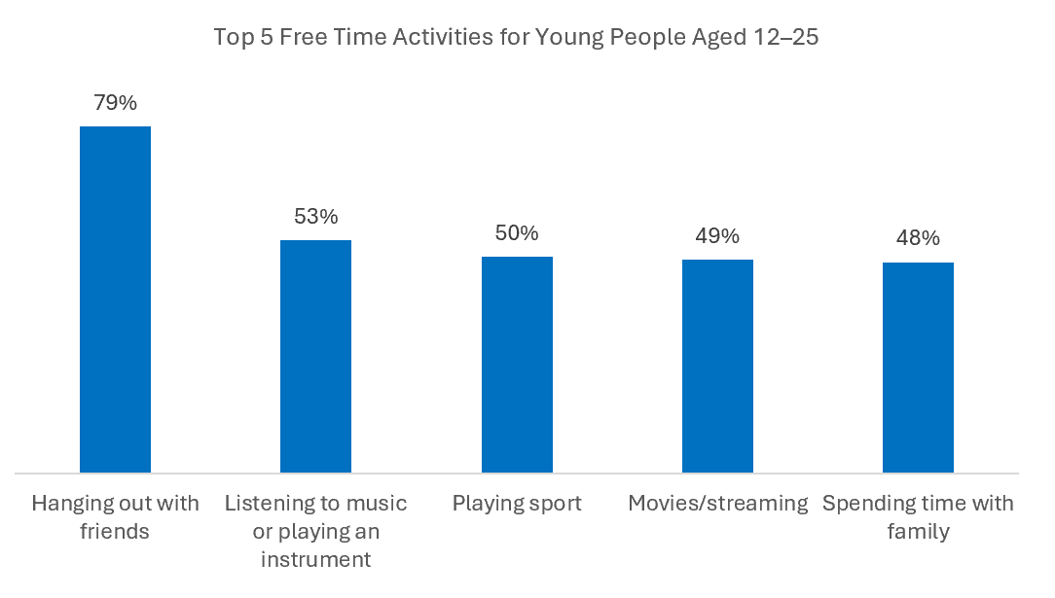

Key Themes from Youth Feedback (Ages 12–25)
The 2025 Youth Survey invited young people aged 12–25 to share what they need, what matters to them, and how Geelong can better support their wellbeing, connection and participation. More than 500 young people provided open ended feedback, offering rich insights into their priorities, challenges and aspirations.

Overall, young people expressed a strong desire for more activities, events and youth-friendly spaces. Many also called for greater inclusion and representation, emphasising the importance of being seen, heard and involved in decision-making. Practical barriers such as safety, affordability, transport, and lack of awareness of what’s available were also common.

The following section outlines the major themes that emerged from the feedback, supported by selected quotes that reflect the experiences and language of local young people.

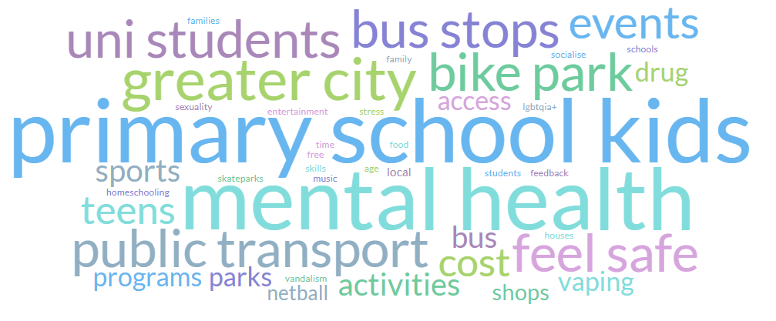

More Activities and Events
Young people want more activities, events, and opportunities that feel relevant, fun and engaging. They also want clearer pathways to participate in creative, recreational and community-based programs.

- “A lot of programs are centred towards younger people, which is great, we need programs for youth, but it’s harder as a young adult to find something interesting, with people my own age”.

- “I’d love to see more free events for young people in Geelong, like outdoor movie nights, live music, or casual hangout spaces. More youth-friendly activities at Eastern Beach or shopping centres would be great too”.

- “I would love to see more art competition or gallery opportunity for young artists”.

Youth Inclusion and Representation
Many young people feel that their ideas and voices are not always heard or valued. They want more inclusive decision-making processes, better representation of diverse identities, and ways to actively shape programs and initiatives.

- “I would love to see more youth representation at the clear front of community development, with youth voice and emerging leaders being celebrated and encouraged to participate in local issues and policies”.

- “It’d be cool if there were more ways to get involved in stuff or have a say in what happens around Geelong. And maybe better ways to find out what’s on like a page or app just for youth events and programs”.

- “Creating more accessible platforms for young people to share their experiences and concerns whether through events, online, or creative projects”.

Safety and Crime Concerns
A significant number of young people expressed concerns about safety, particularly in public spaces, shopping centres and at night. Many noted an increase in antisocial behaviour and a need for cleaner, safer environments.

- “Our city is dirty and there is to many sketchy, scary people and life is too expensive”

- It would great to see an effort to prevent vandalism of our community spaces and to repair the damage quickly when it does happen so people can still use the space”

- “I suggest a bit more of a focus on cracking down on racism, homophobia and sexism in the community”.

- “The amount of crime and loitering in central Geelong is scary and I don't feel safe in certain areas of the city, such as Malop Street”.

Improved Advertising and Awareness
Young people frequently said they don’t hear about programs, events or opportunities until it’s too late. They want more effective communication using platforms they actually use.

- “Please advertise more, I'd like to come, I just don't know”

- “It would be amazing to have the general council post more about youth opportunities as there are many individuals unaware of the Geelong Youth accounts”.

- “Focus on increasing advertising and awareness of the available programs and opportunities. Many young people may not know about the great events, workshops, or support services that are offered”.

Community and Social Connection
Young people expressed a strong desire for places where they can meet others, connect, and feel part of a community. They want welcoming spaces that foster social interaction and belonging.

- “I would love to see more initiatives aimed at fostering social connection and physical activity for young people in their 20s.

- “I do homeschooling and I would like to also meet kids my age who also do homeschooling.”

- “There’s a lack of sense of place and community in Geelong. Improvements to aesthetics and resources in Geelong can help”.

Affordability and Cost of Living
Cost is a major barrier preventing young people from participating in activities, events, programs and services. Many emphasised the need for free or low-cost options.

- “I think giving more affordable options, I’d be more inclined to step out of my comfort zone, but money stops me it’s too expensive to actually try and live”.

- “I’d love to see more free or low-cost events for young people in Greater Geelong, especially in areas like fitness, outdoor activities, and creative arts”.

- “The cost of living for youth is crazy and most of us are extremely anxious about getting into the housing market”.

Public Transport Improvements
Young people rely heavily on public transport but report issues with infrequent services, discomfort, and poor accessibility. Improved transport is seen as essential for participation.

- “I would really like more accessible transport so that people can travel who are not able to drive”.

- “The transportation here has been lacking, it’s hard to get around when buses are running late every day and are never on time or on schedule”.

- “I think there needs to be better public transport. Especially from Ocean Grove to Drysdale at the bare minimum”.

Mental Health Support
Access to mental health services is a priority for young people. They want more youth-friendly, accessible and timely support options embedded in community settings.

- “I think there needs to be more action and awareness on mental health or even a fun run raise awareness for mental health”.

- “Mental health is a big issue that I have struggled with my whole life, and I don’t think that there is actually enough support for young people like me in the Greater Geelong area”.

- “Please consider the epidemic of vaping we're seeing in Geelong. The health and wellbeing of young people is at risk”.

Youth Employment Opportunities
Young people spoke about difficulty finding work and wanting more opportunities to gain skills, experience and independence.

- “More opportunities for youth to give back to the community”

- “Hire more young people in the council”.

- “It would be helpful to have more career development programs, such as internships or mentorship opportunities with local businesses and professionals”.

Environmental Sustainability
Young people want action on sustainability, climate awareness, and local environmental issues. They expressed interest in both education and practical change.

- “I would like to see more youth events driven around eco-friendly behaviours and how we can all make a difference. Such as growing native plants at home to care for Australian wildlife and bugs. Recycling tips. Upcycling workshops. Homemade recipes for detergent/household cleaners etc”.

- “More education on environmental impacts and sustainability e.g. which stuff goes in the right bin”.

- “Have activities about climate change and work towards saving the planet”.

