The City Of
Greater Geelong

DRAFT fair play policy

Engagement report

  - OCTOBER 2025

Contents:
Executive Summary: 3
Introduction 4
Project background 4
Engagement purpose 4
About this report 4
How we engaged 5
Snapshot 5
More detail 5
Who we engaged 6
Who we planned to engage 6
Participation 6
Who actively engaged 6
What we heard 7
Next Steps Error! Bookmark not defined.
Next Steps 9

Executive Summary
The City of Greater Geelong is committed to fair, transparent, and sustainable management of community sporting facilities. The draft Fair Play Policy (2026–2029) provides a consistent framework for equitable facility access, fees, and strategic investment to support community sport participation.
A 30-day consultation on the draft Policy was undertaken from July 23 to August 22, 2025 targeted sporting clubs, peak bodies, schools, and community members. Engagement included the Have Your Say online portal (2,679 visits), information and drop-in sessions (5 sessions), one-to-one meetings with 15 clubs, online submissions (25 received), a Project Working Group consisting of representatives from and targeted social media communications reaching over 36,000 people.

Key feedback themes received:
- Fees and Affordability - Clubs supported manageable fees with the introduction of proportionate fees generating lots of interest.
- Facility Maintenance - Respondents emphasised the value of safe, well-maintained facilities and sought transparency about service levels and maintenance schedules.
- Equity and Inclusion - Support for inclusive practices, with participants encouraging the City to consider how clubs can help achieve more gender equitable outcomes.
- Booking and Shared Use - Greater flexibility and a new centralised booking system to improve booking processes and support greater opportunities for shared use.
- Sports Lighting as Standard Provision - Strong support for Council to manage sports lighting with a transparent maintenance and capital upgrade program.

The feedback from the community affirmed the Policy’s focus and provided guidance to refine implementation. Insights from the consultation has directly informed the final Fair Play Policy to ensure it balances sustainability with community need.

Engagement highlights
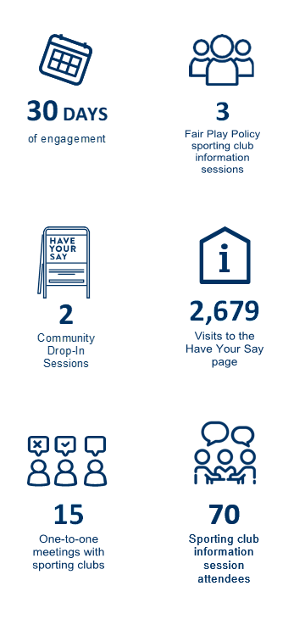

Introduction

Project Background
The City of Greater Geelong has developed the draft Fair Play Policy (2026-2029), which provides a consistent framework for the fees associated with the use and management of community sporting facilities.
The draft Policy aims to ensure that all clubs and user groups have equitable access to facilities, that fees and charges are applied fairly, and that decision-making is guided by clear principles. It also seeks to support the growth of participation in community sport and recreation while balancing the City’s responsibility to maintain and invest in its facility network.
The purpose of the draft Policy engagement was to:
- Inform community sporting clubs, peak bodies, and user groups about the Policy.
- Seek feedback on its proposed principles, fee structures, and management approaches.
- Understand impacts of the Policy on a wide range of stakeholders within the community, including seasonal tenants, casual users, and schools.
- Ensure transparency in how the Policy was developed and applied.
- Refine the Policy based on practical insights and feedback before final adoption by Council.
Engagement activities were designed to capture a broad cross-section of views, build shared understanding of the City’s responsibilities, and strengthen partnerships with community sport organisations.

Engagement Purpose
The City carried out engagement on the draft Policy to inform, consult, and collaborate with the community and key stakeholders. The primary purposes were to:
- Inform stakeholders: Ensure sporting clubs, peak bodies, schools, casual users, and the wider community understood the Policy’s principles, fee structures, and management approaches.
- Support decision-making: Provide the City with evidence-based insights from clubs and community members based on their feedback and to assist them in creating a deeper understanding of the Policy’s proposed positions.
- Build awareness: Strengthen awareness of the City’s responsibilities, the Policy framework, and operational processes among sporting clubs and community users.

About this Report
This report summarises the engagement findings on the draft Policy, highlighting community and stakeholder feedback. It is intended to inform the next steps, including shaping the final Policy, and provide transparency about how the engagement was planned, delivered, and the outcomes achieved.

How we engaged

SNAPSHOT


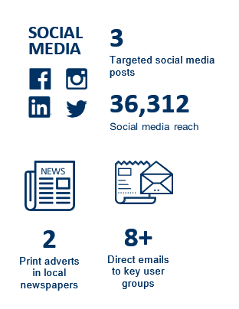

MORE DETAIL
The engagement methods were chosen to address the needs and barriers of different groups. The Have Your Say portal provided convenient online access, whilst after-hours information and drop-in sessions allowed volunteer club representatives to participate, one-to-one meetings offered tailored guidance, and targeted emails and social media raised awareness and encouraged participation. This approach ensured meaningful consultation, maximised input from sporting clubs, and provided opportunities for the broader community to contribute.

Who we engaged

Who we planned to engage
The engagement was primarily targeted at sporting clubs, as they are the main users of outdoor recreation facilities and would be directly affected by the draft Fair Play Policy. Other key stakeholders included peak sporting bodies, schools, casual users, and the wider community, who may have an interest in utilising our recreation facilities. Engagement was city-wide but focused on clubs to ensure input from those most directly impacted and able to demonstrate how the Policy would be applied in practice.

Participation
During the 30 days of engagement more than 110 people directly engaged with the City. Of these 88% engaged online through providing submissions on the Have Your Say page and 12% engaged in person through meetings and our face-to-face events. The below graphs indicate the type of user that engaged with us via the Have Your Say page and the sentiment of their feedback.
Chart 1
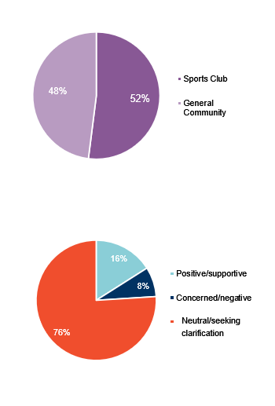

Chart 2
Chart 2 indicates that the majority of respondents had feedback that was neutral and/or they were seeking clarification on the Policy positions. Most were seeking clarity around whether their sporting club would be eligible for proportionate fees, how the sports lighting maintenance program will roll out, and more detail regarding the levels of service and infrastructure renewal programs. Each respondent who provided a written submission was responded to directly either via email, phone or in-person.

Who actively engaged
The engagement successfully reached the primary target audience. Participation largely went as planned, with over 110 people engaging through online submissions, information sessions, drop-in sessions, and one-to-one meetings. While the engagement was open to the broader community, fewer casual users and schools participated, despite targeted emails being sent to all existing school user groups. Methods that were particularly effective in encouraging participation included targeted emails to clubs, after-hours club-focused information sessions, and the Have Your Say online portal.

What we heard
Fees and Affordability
Many clubs noted the importance of keeping hire fees manageable for volunteer-run, not-for-profit organisations. While there was broad understanding of the need for sustainable funding, some groups felt fee increases may be challenging. The proportionate fee structure option received positive feedback with clubs eager to utilise this where possible.
Our response: We acknowledge the vital role volunteers play in activating facilities and delivering sport across our community. In response to concerns raised, the City confirms that fees will largely remain unchanged, aside from standard CPI/nominal adjustments. Fee increases will only occur where a re-classification has taken place (e.g. following capital upgrade). In such cases, affected clubs were contacted directly to discuss the proposed changes and provide feedback. For clubs experiencing financial hardship, support is available through the City’s Financial Hardship Policy to assist with fee payments.
PAVILION CLASSIFICATION QUERY
Some sporting clubs queried their pavilion classification change from Large to Extra Large under the new Policy.
Our response: The new Extra Large classification affects approximately 12 pavilions with footprints in excess of 600m2. The larger pavilion sizes require additional maintenance by the City, which results in increased costs. As a result, an additional fee of $400 per season will apply for seasonal hire. This is in line with applying the proposed calculation within the Policy of 0.15% of the total asset replacement value. Support for clubs can be provided in line with the City’s Financial Hardship Policy should they be unable to meet their financial commitments under this new classification.
Facility MAINTENANCE AND RENEWAL
Respondents emphasised the value of safe, well-maintained facilities and sought transparency about service levels and maintenance schedules. Feedback highlighted renewal/upgrade programs.
Our response: The City recognises the importance of maintaining safe and consistent facilities. Through the Policy’s hierarchy and service levels, each facility is classified to ensure comparable infrastructure across similar classifications—reflecting the diversity of the City’s facility stock. These service levels are indicative rather than prescriptive, as maintenance needs vary depending on factors such as surface type, usage, and irrigation requirements. At each hierarchy level, the City aims to deliver infrastructure and services aligned with the Policy and relevant sporting facility guidelines. In regard to renewal or upgrade programs, this information sits adjacent to the Fair Play Policy but work by officers is currently being undertaken to enable greater understanding and clarity of how renewal programs are allocated and prioritised.
Equity, Access, and Inclusion
There was recognition by respondents of the Policy’s equity focus, with participants encouraging the City to consider additional measures such as incentives for clubs that demonstrate inclusive practices.
Our response: The City’s Fair Access Policy is referenced throughout the Fair Play Policy which ensures that clubs are following inclusive practices in the use and program of recreation facilities. The Fair Access Policy will be relied on to support gender equity outcomes, and the preparation of the Fair Play Policy has included the development of a Gender Impact Assessment.
Booking Processes and Shared Use
Stakeholders welcomed the Policy’s intent to encourage shared use of facilities. Some sought greater flexibility in seasonal bookings, particularly where full-day allocations are not always required, and suggested more transparent systems to support casual users. A centralised booking platform with public availability was seen as an important step to support greater usage.
Our response: The proportionate fee structure within the draft Fair Play Policy will enable greater flexibility where exclusive access of playing fields is not required. Extensive examples of the proportionate fee structure were demonstrated to those who attended the club information nights. A new booking system that has greater capabilities to encourage shared usage and multi-use/greater-use of facilities is currently in progress. The new booking system will be integral in supporting the efficient roll out of the policy.
SPORTS LIGHTING
Council’s commitment to taking on responsibility for sports lighting was strongly supported, with many acknowledging the financial relief this provides to clubs. Feedback suggested a clear, transparent process for prioritising upgrades and maintenance in a fair way.
Our response: Managing the sports lighting maintenance program is an operational consideration that will be ascertained following the final Policy’s endorsement. This process will be communicated with clubs prior to implementation.
Overall Support
Many community members expressed general support for the direction of the draft Fair Play Policy, particularly its focus on transparency, and improved management of lighting and maintenance. The feedback received provides valuable insights that has helped to refine the final Policy.
Community engagement successes
Several engagement methods were particularly effective in reaching stakeholders and encouraging participation:
- Have Your Say online portal: Provided an accessible way for clubs and community members to learn about the Policy and submit feedback; it received 2,679 visits over the 30-day period.
- Information sessions: After-hours sessions for clubs allowed volunteers to attend and ask questions directly, with ~70 club representatives participating.
- One-to-one meetings: Over 15 tailored sessions enabled detailed discussion and clarification of Policy elements, which stakeholders found highly valuable.
- Community drop-in sessions: Offered additional opportunities for those unable to attend information sessions, supporting broader inclusion. These weren’t as well subscribed, however due to extensive sporting club information sessions, the lack of uptake in the broader community drop-in sessions is not of a concern to the project team.
- Targeted communications: Emails, social media posts, and fact sheets successfully raised awareness and directed stakeholders to engagement opportunities; ads reached 36,312 people with 2,747 click-throughs to the portal.

Next Steps

Next Steps
The insights gathered during the consultation phase will be used to refine the final Fair Play Policy, which is scheduled to be presented to Council for final consideration at the November 2025 meeting. Attached to the Council Report will be this document, which will then later be uploaded to the Have Your Say portal. This will round out the engagement and loop back to our stakeholders, and finalise the policy ready for implementation from 2026.

