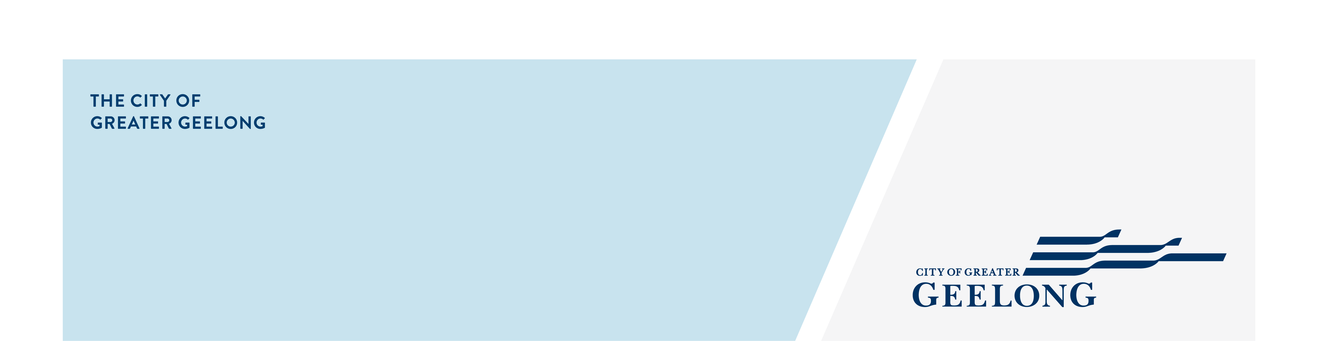
MUNICIPAL

ROAD MANAGEMENT PLAN

REVIEW
community engagement summary
Prior to public consultation held in July/August 2025, the City held two community workshops (53 registrations received) and 3 internal stakeholder workshops to test key elements of the Municipal Road Management Plan and gather early feedback.
On 23 July, 2025, the City commenced broader community engagement on the Municipal Road Management Plan Review. When engaging on the draft plan, we asked the community to review the draft and provide their comments on the Plan:
- Defects
- Inspections frequencies.
- Response times and
- any additional comments they had.

In total we received 13 submissions. 8 submissions related to mix of defects, inspections, and response times. A further 5 submissions were not directly related to the Plan and were passed on to relevant Departments for consideration and action. Several comments related to concerns about bike paths and footpaths. These have been documented separately from the Plan.
We thank everyone for their contributions.

The changes made to the Plan are based on community and stakeholder feedback and officer recommendations. They can be found here or in the Document Library section of the project page.

The Plan was adopted by Council at their Ordinary Council Meeting on 28 October, 2025.

Over the course of this consultation period the City reached the following achievements:




2
Community workshops.

Over 50 people registered for the workshops.
People visited the Road Management Plan project page.
343?1
13
Surveys were completed
30 DAYS
of engagement
3
Internal stakeholder workshops



Newspaper advertisements
2
SOCIAL MEDIA
11,972
Reach/Impressions
244
Actions (Clicks, reactions,
shares, comments etc.)

Next Steps
The review process is now officially closed, and the City has commenced operating in accordance with the updated plan as of 29 October 2025.

