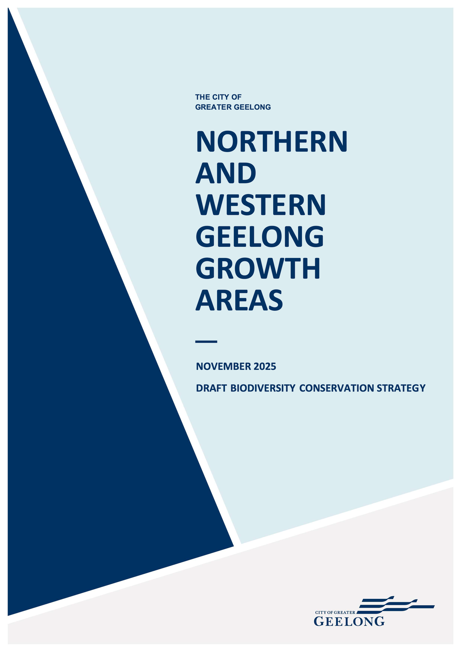

Acknowledgement of country
Greater Geelong is located on the traditional lands of the Wadawurrung people. The land was created by the great ancestor spirit, Bunjil, the wedge-tailed eagle. Wadawurrung territory extends from the great dividing range in the north to the coast around Port Phillip Bay.
The City acknowledges the Wadawurrung people as the traditional owners of this land who to this day practice their culture and uphold the dignity of their ancestors.

DOCUMENT TRACKING
This document was prepared on behalf of the City of Greater Geelong by Biosis and Open Lines.
PREPARED BY:
Open Lines, Biosis
REVIEWED BY:
Mitchell Deaves (Biosis)
Peter Hemphill, Heather Tolley, Tom Holden (Open Lines)
VERSION CONTROL:
VERSION: | Public re-exhibition version
DATE: | November 2025

Contents
1 Introduction 1
1.1 Purpose of the BCS 1
1.2 Area covered by the BCS 2
1.3 Structure of the BCS 2
2 Biodiversity outcomes and guiding principles 4
2.1 Biodiversity outcomes 4
2.2 Guiding principles 6
3 Biodiversity values and threats 8
3.1 Landscape context 8
3.2 Biodiversity values within the Growth Areas 12
3.3 Key threats to biodiversity values within the Growth Areas 26
4 Conservation program 28
4.1 Introduction 28
4.2 Policy context 28
4.3 Avoidance and minimisation of impacts 32
4.4 Mitigation of impacts 47
4.5 Residual impacts and offsets 50
5 Implementation 54
6 Assurance 55
APPENDIX A: ASSESSMENT AGAINST STATE PLANNING AND REGULATORY REQUIREMENTS FOR BIODIVERSITY
References A

List of Figures
Figure 1-1: Area covered by the BCS 3
Figure 3-1: Key landforms 9
Figure 3-2: Protected areas 11
Figure 3-3: Native vegetation, TECs, and threatened flora in the NGGA 14
Figure 3-4: Biodiversity values in the WGGA 15
Figure 3-5: Fauna records and habitat in the NGGA 19
Figure 3-6: Golden Sun Moth habitat categories in the NGGA 20
Figure 3-7: Potentially suitable areas for Victorian Grassland Earless Dragon 23
Figure 3-8: Hydrological values of the WGGA 25
Figure 4-1: Biodiversity areas within the NGGA 37
Figure 4-2: Northern Conservation Area 38
Figure 4-3: Eastern Conservation Area and gully avoidance area 39
Figure 4-4: Biodiversity areas within the WGGA 42
Figure 4-5: Cowies Creek Conservation Area 43
Figure 4-6: Moorabool River corridor and Moorabool avoidance area 44

List of Tables
Table 2-1: National level biodiversity outcomes (taken from the EPBC Plan) 5
Table 2-2: State and local level biodiversity outcomes 5
Table 2-3: Implementation outcome 5
Table 3-1: Total area of EVCs present within the Growth Areas 16
Table 4-1: Key policy considerations for the City 29
Table 4-2: Key biodiversity actions from the Framework Plan for the Growth Areas 33
Table 4-3: National level commitments in relation to mitigation 48
Table 4-4: State level commitments in relation to mitigation 48
Table 4-5: National level commitments in relation to offsets 51
Table 4-6: State level commitment in relation to offsets 52
Table 4-7: Consideration of criteria in Table 11 of the Assessor’s Handbook 53
Table 5-1: Steps to implement the conservation program and commitments from the BCS 54

Abbreviations and terms
Acronyms | Meaning
BCS | Biodiversity Conservation Strategy
DCCEEW | Commonwealth Government Department of Climate Change, Energy, the Environment and Water (DCCEEW)
DEECA | Victorian Government Department of Energy, Environment and Climate Action
DTP | Victorian Government Department of Transport and Planning
EPBC Act | Commonwealth Environment Protection and Biodiversity Conservation Act 1999
FFG Act | Victorian Flora and Fauna Guarantee Act 1988
FPAL | Finalised priority assessment list
IBRA | Interim Biogeographic Regionalisation for Australia
KPI | Key Performance Indicator
LGA | Local Government Area
MERI | Monitoring, evaluation, reporting and improvement
MNES | Matters of National Environmental Significance
NGGA | Northern Geelong Growth Area
NVPP | Native Vegetation Precinct Plan
NWGGA | Northern and Western Geelong Growth Areas
P&E Act | Victorian Planning and Environment Act 1987
PPF | Planning Policy Framework
PSP | Precinct Structure Plan
SAR | Strategic Assessment Report
TEC | Threatened ecological community
ToR | Terms of Reference
UGZ | Urban Growth Zone
VPP | Victoria Planning Provisions
WGGA | Western Geelong Growth Area
WIK | Works in Kind

Terms / Abbreviations | Definition
BCS guiding principles | A set of principles to guide both the preparation of the BCS and the decisions that will need to be made as part of the strategy’s implementation
Biodiversity areas | Biodiversity areas support biodiversity values within the Growth Areas and provide opportunities to protect, manage and restore biodiversity. Biodiversity Areas are identified in the BCS as either:  - Strategic Conservation Areas  - Landscape Connections
Conservation Management Plan | The document used to provide for the protection and ongoing management of the biodiversity values within each strategic conservation area
Construction Environmental Management Plans | A plan developed to ensure appropriate environmental management practices are implemented during the construction phase of a project
Cowies Creek Conservation Area | The section of Cowies Creek within the WGGA to be protected and managed for conservation purposes under the Plan
Development land | Specified land within the Strategic Assessment Area where development under the Plan is proposed to occur
Development under the Plan | The broad term used to describe all development occurring under the Plan. This includes the following classes of actions:  - Urban and commercial development  - Industrial development  - Rural development  - Supporting infrastructure and services  - Environmental management"
Eastern Conservation Area | Area of land within the NGGA to be avoided for conservation purposes under the Plan
External infrastructure | Development comprising the supporting infrastructure and services class of action and the environmental management class of action that is located outside of Growth Areas but within the Strategic Assessment Area
Gully avoidance area | Area of land within the NGGA to be avoided under the Plan
Landscape Connection | Area of land with the NWGGA where the urban structure and landscape design facilitates green and blue infrastructure and co-benefits to biodiversity through the use of biodiversity sensitive urban design approaches.
Land subject to development | Development land within the Growth Areas subject to all classes of actions under the Plan
Moorabool avoidance area | Area of land within the WGGA to be avoided under the Plan
Moorabool River corridor | Area of land within the WGGA to be avoided under the Plan
Natural Temperate Grassland | The nationally threatened ecological community Natural Temperate Grassland of the Victorian Volcanic Plain
Northern Conservation Area | Area of land within the NGGA to be avoided for conservation purposes under the Plan
Specific mitigation measures | Additional mitigation measures beyond those delivered through the existing planning system to address specific risks to MNES associated with the implementation of the Plan
Stakeholder engagement strategy | A process for stakeholder engagement to guide the City in undertaking ongoing engagement with key stakeholders over the life of the Plan
Standard mitigation measures | Mitigation measures delivered by the Victorian planning system through the PSP process, existing provisions in the Greater Geelong Planning Scheme, and the planning permit process
Strategic conservation area | Areas within the Growth Areas that will be avoided from development and protected and managed for conservation in-perpetuity
The City | The City of Greater Geelong
The Executive Committee | The Northern and Western Geelong Growth Areas EPBC Plan Executive Committee
The Framework Plan | Northern and Western Geelong Growth Area Framework Plan
The Growth Areas | Northern and Western Geelong Growth Areas
The Minister | Commonwealth Minister for the Environment and Water
The Plan | The Northern and Western Geelong Growth Areas EPBC Plan
Works in Kind | A contribution in lieu of payment of the biodiversity levy amount

Introduction
The City of Greater Geelong (the City) has identified two key areas for urban growth in Geelong’s northwest, known as the Northern and Western Geelong Growth Areas (the Growth Areas). The Growth Areas were identified through several State planning strategies for future growth. The City subsequently developed the Northern and Western Geelong Growth Areas Framework Plan (the Framework Plan) (The City of Greater Geelong, 2021). The Framework Plan describes the existing site context of the Growth Areas and sets out:
- Broad future urban structure of the Growth Areas, including potential areas suitable for environmental protection
- A vision and set of urban development objectives for each Growth Area
- A set of actions to be implemented through future planning processes
Development within the Growth Areas will lead to impacts to biodiversity values of national, State and local significance. This Biodiversity Conservation Strategy (BCS) has been developed to address these impacts and guide the delivery of positive outcomes for the biodiversity values that are present within the Growth Areas.
The Victorian planning system under the Planning and Environment Act 1987 (P&E Act) is the key delivery framework for development within the Growth Areas and the implementation of the BCS.
To further support development in the Growth Areas and to protect matters of national environmental significance (MNES), the City is undertaking a strategic assessment under Part 10 of the Environment Protection and Biodiversity Conservation Act 1999 (EPBC Act). This enables a landscape scale assessment and approval of a suite of development actions under the EPBC Act and provides the opportunity to deliver improved environmental and development outcomes compared to project-by-project assessments through strategic consideration of biodiversity issues.
To give effect to the strategic assessment process, the City has prepared the Northern and Western Geelong Growth Areas EPBC Plan (the EPBC Plan). The BCS forms an implementation document for this Plan.
For further information and context about the strategic assessment, please refer to the NWGGA:
- EPBC Plan for a full description of the strategic assessment including development, conservation, and assurance
- Strategic Assessment Report (SAR) for a detailed assessment of the impacts of development in the Growth Areas on MNES and evaluation of the commitments and measures to address these impacts
- Funding Program for details about how implementation of the Plan will be funded
- Commitments and Measures document for the specific commitments and measures that will be implemented

Purpose of the BCS
The purpose of the BCS is to:
- Identify the national, state and local biodiversity values that are present in the Strategic Assessment Area and set out a conservation program for providing genuine, long-term positive results for those biodiversity values
- Set out how the conservation elements of the EPBC Plan for the Strategic Assessment Area will be implemented including through avoiding and minimising, mitigating, and offsetting residual impacts in accordance with the mitigation hierarchy (DSEWPC, 2012; DELWP, 2017c)
- Guide the preparation of Precinct Structure Plans (PSPs) and subsequent development within the Strategic Assessment Area to ensure the outcomes are consistent with State biodiversity policy
The Growth Areas have been identified as key locations for urban growth in Geelong and some level of impact to biodiversity is unavoidable within this context. This strategy focuses conservation efforts on the most important biodiversity values and integrating actions to improve biodiversity within urban areas where this is appropriate.
The BCS satisfies the delivery of two key actions (Action N1.3.1 and W1.3.1) of the Framework Plan for the protection of biodiversity in the Growth Areas. The Framework Plan states that an “overarching biodiversity conservation strategy will be prepared for the growth area[s] that provides high level guidance for the management of nationally and state significant biodiversity values…The strategy will spatially identify how outcomes for matters of national environmental significance will be delivered…” (The City of Greater Geelong, 2021).
While the BCS helps identify how the conservation elements of the EPBC Plan will be implemented, it does not form part of the Plan to be endorsed by the Minister under Part 10 of the EPBC Act.

Area covered by the BCS
The area covered by the BCS is the same area covered by the EPBC Plan, known as the Strategic Assessment Area, and is shown in Figure 1-1.
The area covered includes the:
- Northern Geelong Growth Area (NGGA) – this covers 2,103.9 ha and occurs in the Lovely Banks locality
- Two northern precincts within the Western Geelong Growth Area (WGGA) located north of the Midland Highway (Creamery Road and Batesford North), which covers 767.2 ha and occurs in the Bell Post Hill/Batesford localities
The remaining precincts of the WGGA, comprising the Batesford South, McCanns Lane, and Merrawarp Road precincts, have been excluded from the strategic assessment and the BCS due to a lack of information and resolution relating to a range of factors needed to support and rationalise a full assessment. This includes the anticipated development demand and timing, and the detailed plans for decommission and rehabilitation of the active Batesford Quarry. It is envisaged that separate strategic planning and assessment and approval processes will occur for the remaining WGGA land.
The BCS does not address the areas that relate to the external infrastructure class of action which will occur outside the Growth Areas, and which is dealt with in the EPBC Plan.

Structure of the BCS
The BCS is structured as follows:
- Section 2 defines the biodiversity outcomes that will be delivered and the principles that guide both the preparation and implementation of the BCS
- Section 3 describes the biodiversity values and threats relevant to the Strategic Assessment Area
- Section 4 describes the conservation program relating to the Strategic Assessment Area
- Section 5 describes the steps required to implement the conservation program and commitments from the BCS
- Section 6 summarises the approach to assurance for the BCS
- The Appendix provides an assessment against state biodiversity policy to support the BCS
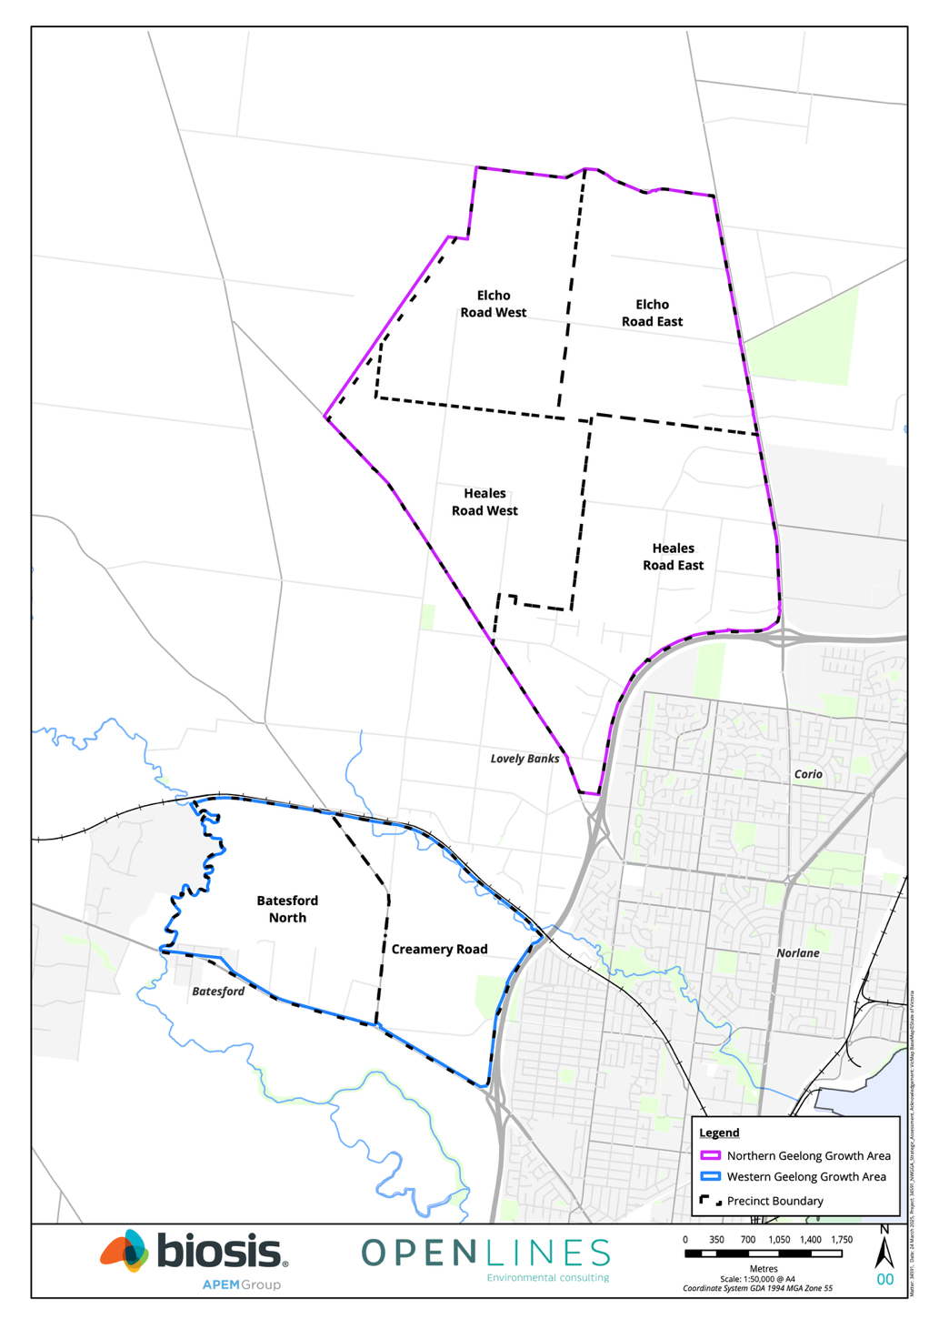
Figure 1-1: Area covered by the BCS

Biodiversity outcomes and guiding principles

Biodiversity outcomes
This section describes the outcomes that will be provided for the biodiversity values within the Growth Areas. It describes the outcomes framework that is used, and sets out the biodiversity outcomes for national, state and local values that will be achieved through implementation of the BCS.

Outcomes framework
The BCS applies an outcomes framework to clearly set out what will be achieved for biodiversity. The framework is based on program logic principles and aligns with the framework used in the EPBC Plan. It supports accountability and transparency by providing the basis and set of benchmarks for monitoring, reporting, and ongoing evaluation and adaptive management of the BCS.
The outcomes framework for the BCS is comprised of four components:
- A broad objective which identifies the contribution that the outcomes of the BCS will make to biodiversity
- Outcomes which are the positive impacts or changes to biodiversity values that are needed to achieve the overall objective of the BCS. The outcomes are set out in relation to:
  - National level biodiversity outcomes (these are taken from the EPBC Plan)
  - State and local biodiversity outcomes which are specific to the BCS
  - An implementation outcome for the BCS
- Commitments which are the direct results of implementing the measures that are expected to lead to the achievement of the outcomes. Some commitments are drawn from the EPBC Plan and others are specific to the BCS
- Measures which are the specific actions that will be undertaken to meet the commitments. Measures are not defined in the EPBC Plan. The BCS defines the full suite of the measures needed to implement the commitments at all levels

Numbering of outcomes, commitments and measures
To provide clarity, different numbering systems are used to distinguish the national level versus state and local level outcomes, commitments and measures.
National level outcomes and commitments provided in the Plan and their associated measures are identified using cardinal numbers (e.g., 1, 2, 3 etc).
State and local outcomes, commitments provided in the BCS, and their associated measures are identified using Roman numerals (e.g., i, ii, iii etc).

Objective
The objective of the BCS is to:
Provide genuine, long-term, positive outcomes for the national, state and local biodiversity values that are present within the Growth Areas
This objective is supported by outcomes, commitments and measures.

National level biodiversity outcomes
The national level outcomes for biodiversity are defined in the EPBC Plan. Table 2-1 presents the outcomes 1 to 7 from the EPBC Plan that relate directly to biodiversity.
Table 2-1: National level biodiversity outcomes (taken from the EPBC Plan)
No. | Outcome
1 | Populations of Golden Sun Moth and Striped Legless Lizard are maintained within the Northern Conservation Area
2 | The extent and condition of Natural Temperate Grassland is maintained within the Eastern Conservation Area
3 | Impacts to habitat for Golden Sun Moth, Striped Legless Lizard and Natural Temperate Grassland within the gully avoidance area will be avoided and minimised
4 | Potentially suitable habitat attributes for Victorian Grassland Earless Dragon within the Northern Conservation Area will be protected and managed to support potential recovery of the species
5 | The long-term viability of the important population of the Growling Grass Frog along Cowies Creek is supported through the protection and enhancement of habitat
6 | The protection and management of land outside of the Growth Areas makes an important contribution to the recovery efforts for Natural Temperate Grassland, Golden Sun Moth and Striped Legless Lizard in Victoria
7 | Matters of national environmental significance associated with the Moorabool avoidance area, as well as other waterways, riparian areas and wetlands are protected from any adverse impacts of development under the Plan

State and local level biodiversity outcomes
The state and local level biodiversity outcomes that will be achieved through implementation of the BCS are set out in Table 2-2. These outcomes recognise that the national level outcomes will also provide a range of benefits to state and local values and seek to minimise duplication by focusing on the additional positive impacts or changes to biodiversity values that are needed at the state and local level.
Table 2-2: State and local level biodiversity outcomes
No. | Outcome
i | Strategic conservation areas within the Growth Areas are protected and managed to provide for the long-term protection of biodiversity values
ii | Precinct design and delivery enhances biodiversity and connectivity within the Growth Areas
iii | Biodiversity offsets for impacts to state values are calculated at the precinct scale and provided as development proceeds

Implementation outcome
The implementation outcome for the BCS is set out in Table 2-3.
Table 2-3: Implementation outcome
No. | Outcome
iv | Implementation of the BCS is effective, timely, and cost efficient

Commitments and measures
The commitments and measures to deliver the outcomes are discussed throughout Section 4 and provided in full in the Commitments and Measures document.

Guiding principles
A set of principles were developed to help guide both the preparation of the BCS and the decisions that will need to be made as part of the strategy’s implementation. The principles build on the work undertaken for the Melbourne Strategic Assessment’s BCS (DEPI, 2013) and are consistent with, and support the:
- Goals, principles and directions of the City’s Environment Strategy (The City of Greater Geelong, 2020) for protecting and enhancing the region’s biodiversity
- Objectives and actions of the Framework Plan (The City of Greater Geelong, 2021) for protecting biodiversity and waterways within the Growth Areas
The guiding principles of the BCS are focused on providing genuine, long-term, positive outcomes for the national, State and local biodiversity values that are present within the Growth Areas.
The principles are set out below under the following categories:
- Consultation and engagement
- Decision-making
- Mitigation hierarchy
- Conservation planning
- Implementation

Consultation and engagement
- Consult with the community during preparation and implementation of the BCS
- Collaborate with the Wadawurrung Traditional Owners and use traditional knowledge of country to improve biodiversity planning and management practices
- Increase community understanding and involvement in biodiversity conservation activities

Decision-making
- Consider the protection and enhancement of biodiversity in advance of PSP preparation and at a strategic level to improve biodiversity outcomes and address cumulative impacts of urban development within the Growth Areas
- Use the best available ecological information to make decisions. This includes information from detailed ecological surveys, historical species records, native vegetation and species habitat modelling, and expert advice
- Ensure decisions around protecting and enhancing biodiversity are focused on achieving genuine, long-term biodiversity benefits. This includes the application of conservation planning principles (see Section 2.2.4)
- Consider relevant biodiversity policy guidelines and plans, including actions statements under the Flora and Fauna Guarantee Act 1988 (FFG Act) and conservation advices and recovery plans under the EPBC Act

Mitigation hierarchy
In accordance with both Commonwealth and State biodiversity laws, mitigate impacts on biodiversity through a hierarchy of:
- First – avoid impacts
- Second – minimise impacts
- Third – offset where residual adverse impacts are unavoidable

Conservation planning

Strategic conservation areas
Identify strategic conservation areas within the Growth Areas by prioritising areas that:
- Support remnant biodiversity patches larger than 10 hectares
- Provide connectivity across the landscape. For example, waterways and larger connected patches of vegetation
- Are considered likely to be viable in the long-term. For example, this includes areas that:
  - Are in better condition and trend
  - Have the potential to be restored for ecological benefit
  - Have the potential to be managed effectively
- Support threatened ecological communities and/or habitat for threatened species
- Support multiple biodiversity values

Landscape Connections
Identify opportunities for biodiversity sensitive urban design in the Growth Areas through:
- Integrating biodiversity and biodiversity connectivity into urban landscapes and infrastructure design through the preparation of the PSP and detailed landscape design
- Restoring biodiversity to local parks, roadsides, open space reserves, waterways, escarpments, linear trails and streetscapes using Ecological Vegetation Classes (EVCs), natural regeneration techniques and indigenous plants of local provenance
- Restoring habitat into urban landscapes through the establishment of indigenous tree, shrub and understory plantings and other habitat elements such as wetlands, logs, rocks and stags
- Restoring degraded waterways and wetlands to create habitat and ecologically healthy water flows
- Minimise breaks and barriers in landscape connections through the detailed design at precinct planning

Strategic offsets
Where offsets are needed, apply a strategic approach to maximise opportunities for:
- Implementation of a funding program that facilitates sustainable funding for the strategic delivery of commonwealth offsets
- The early delivery of a significant proportion of the offset liability
- Securing and managing areas of land that meet at least one of the following strategic landscape criteria:
  - Protection of larger land parcels compared to typical project-by-project offsets
  - Located within a key biodiversity corridor and improves connectivity across the landscape
  - Connected to an existing conservation reserve

Implementation
Design the BCS to ensure that it will be successfully implemented. This includes consideration of the:
- Administrative efficiency and complexity of the BCS
- Funding arrangements for implementation
- Governance arrangements for implementation
- Risks around the delivery of offsets over the life of the BCS

Biodiversity values and threats
This section describes the biodiversity values and the threats to those values within the Growth Areas. It provides:
- Discussion of the landscape context within which the Growth Areas occur
- Description of the national, State and local biodiversity values within the Growth Areas
- An overview of the key threats to biodiversity within the Growth Areas

Landscape context

Bioregion
The Growth Areas sit within the Southern Volcanic Plain bioregion (Interim Biogeographic Regionalisation for Australia), otherwise described in Victoria as the Victorian Volcanic Plain bioregion. . The bioregion is characterised by broad basaltic plains, interspersed with areas of lakes and swamps. Native grasslands occur in areas where basalts are older and more weathered to produce heavy clays which are generally fertile yet poorly drained. Younger occurrences of relatively unweathered lava flows occur as stony rises, and support thin soils and woodland vegetation (Dahlhaus et al., 2003; Williams, 2022).

Geology and soil
The bioregion was created by volcanic activity which occurred between approximately 4.5 million to 10,000 years ago. Volcanic activity was mostly from many small volcanoes which created lava flows of basalt, which filled in valleys and created broad plains. There are some occurrences of more explosive eruptions in the region which created circular craters which today contain lakes and swamps (Williams, 2022).
Today, the geology of the Growth Areas is dominated by areas of basalt, interspersed with areas of alluvial deposits (associated with the Moorabool River) and aeolian deposits (associated with Cowies Creek). The areas of basalt are characterised as plains with poorly developed drainage and with shallow bedrock. Aeolian deposits tend to be characterised as plains with unconsolidated sedimentary deposits, and areas of alluvium are described as unconsolidated sediment occurring as terraces, floodplains, and coastal plains (DELWP, 2022a).

Topography and surface hydrology
The topography of the NGGA is varied. A largely flat, elevated area occurs in the north-western and central areas of the Growth Area. Along the eastern section of the Growth Area, an escarpment occurs, with the landscape falling steeply towards the east, draining into the Hovells Creek catchment, upstream of Limeburners Bay. In the south-west of the Growth Area, the land slopes downwards towards the south-west, draining into the Cowies Creek catchment.
The topography of the WGGA is also varied. The central area of the WGGA is largely flat. The north-eastern corner of the Growth Area slopes towards the north-east, draining into the Cowies Creek catchment. The western section of the Growth Area is steep and drains westwards, into the catchment of the Moorabool River. A small section of the south-eastern corner of the Growth Area slopes gently towards the south-east, also flowing into the catchment of the Moorabool River.
There are three catchments which the Growth Areas are hydrologically linked to via overland flow (see Figure 3-1):
- Moorabool River catchment, which occurs to the south of the Growth Areas. The Moorabool River flows south, joining the Barwon River at Fyansford. The Barwon then continues to flow south, into the Lake Connewarre Complex, part of the Port Phillip Bay (Western Shoreline) and Bellarine Peninsula Ramsar site. This wetland complex then drains into the ocean at Barwon Heads
- Hovells Creek catchment, which occurs to the east of the northern half of the Strategic Assessment Area. This catchment contains Limeburners Bay, part of the Port Phillip Bay (Western Shoreline) and Bellarine Peninsula Ramsar site, and drains southward into Corio Bay
- Cowies Creek catchment, which occurs to the east of the central and southern half of the Strategic Assessment Area. This creek drains eastward into Corio Bay

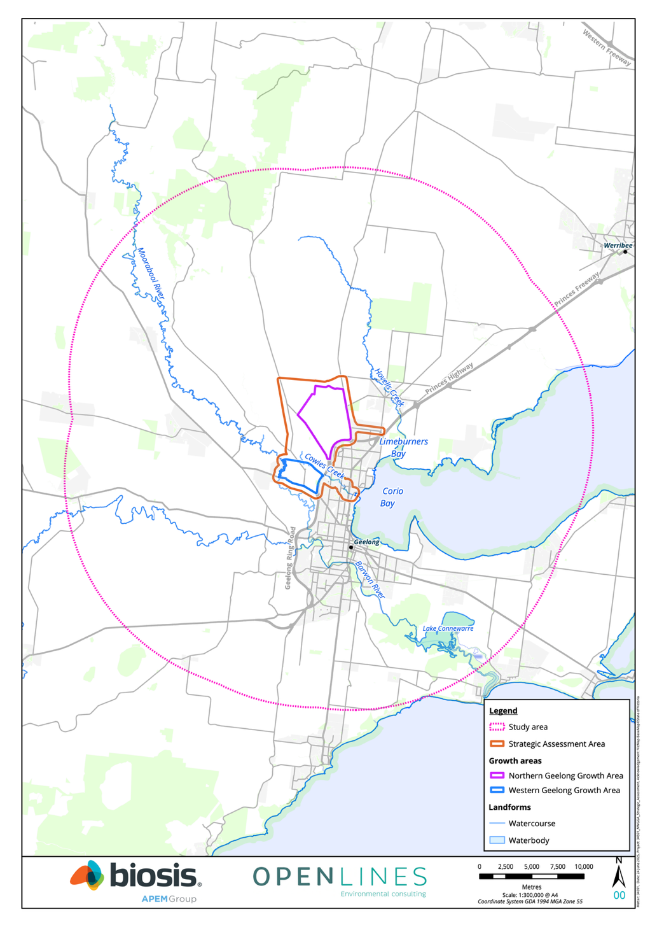
Figure 3-1: Key landforms

Past and current land use
The traditional owners of the land are the Wadawurrung Aboriginal people, a recognised tribe consisting of 25 clans (family groups), which form part of the larger Kulin Nation of Aboriginal people. The Country known now as Geelong was occupied for at least 45,000 years by traditional owners prior to European Settlement (Rowe, 2021).
There are a number of registered Aboriginal places across the Growth Areas, comprised mostly of stone artefacts. There has been limited archaeological investigation within the Growth Areas, and the available data may not accurately reflect land use by the Wadawurrung people. Preliminary Aboriginal site sensitivity mapping has indicated areas of high archaeological potential along the waterways on the WGGA and one area in the NGGA near to a registered stone artefact (The City of Greater Geelong, 2021).
Today, the Growth Areas primarily include land which has been developed for agricultural purposes. The NGGA is largely open treeless pasture, primarily used for pastoral and cropping activities, in conjunction with rural residential housing. The WGGA includes a mix of existing land uses, including agriculture, recreation reserves, Council-managed reserves, rural and medium density housing, and educational facilities.

Parks, reserves or other protected areas
Due to substantial agricultural land use and intensification, the bioregion has become one of the bioregions most depleted of native vegetation in Victoria. As of 2003, only 4.5 per cent of the bioregion still had a cover of native vegetation. Further, as of 2003, less than 1.2 per cent of the bioregion was in a formal conservation reserve (DSE, 2003b).
There are minimal parks, reserves or other protected areas within the Growth Areas (see Figure 3-2), however a community use recreation area approximately 0.3 hectares in size is located along the Moorabool River just north of Midland Highway.

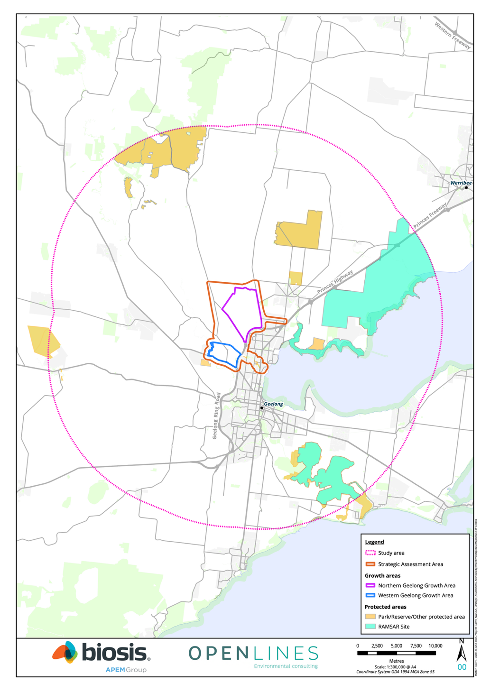
Figure 3-2: Protected areas

Biodiversity corridors surrounding the Growth Areas
Biodiversity corridors surrounding the Growth Areas are mostly concentrated along riparian corridors, with remnant grassland occurring in modified agricultural context much like within the Growth Areas.
Cowies Creek and the Moorabool and Barwon Rivers contain several ephemeral and minor tributaries which feed into wetland areas that support native flora and fauna habitat on private and public land with various grades of active conservation management.
Remnant indigenous vegetation and fauna in the Growth Areas are considered important to the biodiversity of the wider locality. Without appropriate management, losses resulting from direct and indirect degradation processes will inevitably mean the loss of most biodiversity. The protection and management or waterways within the Growth Areas will therefore play a significant role in the conservation of vital vegetation and habitat.
An important biodiversity linkage is formed by connections between the Moorabool River Reserve, Dog Rocks Sanctuary, the vegetated area south of Dog Rocks Sanctuary (known as Honey Woodland), Dog Rocks Reserve and Red Gum Reserve. This biodiversity linkage has been strengthened with additional planting along Dog Rocks to the south to improve fauna connections to the grasslands to the south.

Biodiversity values within the Growth Areas

Assessment of the Growth Areas
The biodiversity values of parts of the Growth Areas are documented within Existing Ecological Conditions: Northern and Western Geelong Growth Areas, July 2021, prepared by Ecology and Heritage Partners (EHP, 2021).
Between November 2019 and December 2020, over 200 person days were spent surveying native vegetation, ecological communities and significant flora and fauna species. Site assessments were restricted to parcels/properties where access was permitted. These areas are referred to as the ‘surveyed areas’. This resulted in a total of approximately 33% of the NGGA and 13% of the WGGA (area subject to the EPBC Plan) not being subject to on-ground assessments, referred to as the ‘unsurveyed areas’.
In January 2022, the City provided an opportunity for those with land included within the EHP 2021 assessment area to supply further information for consideration in the development of the Part 10 Strategic Assessment. The intention was for additional information to be submitted for consideration where landholders had concerns with mapping anomalies and/or assumptions. The City assessed submissions against set evaluation criteria, which led to minor changes to the EHP 2021 dataset.
In early 2023, the Victorian Grassland Earless Dragon Tympanocryptis pinguicolla (VGED) was rediscovered west of Melbourne. Much of the City of Greater Geelong LGA is identified as being within the species potential habitat. In late-2023, the City engaged Biosis to undertake habitat assessments and targeted surveys (Biosis, 2024) involving the following three key steps:
- Initial habitat assessment to determine investigation areas for VGED within the Growth Areas and to exclude clearly unsuitable habitat
- Targeted surveys within areas of potentially suitable habitat (i.e. the investigation areas) to search for individuals of the species
- Habitat suitability assessments within areas of potentially suitable habitat to identify and map habitat attributes for the species

Overview
The condition of the environment within the Growth Areas varies. Most of the area is highly modified due to agricultural land use and is largely dominated by non-native species. Native vegetation and terrestrial fauna habitat are limited to areas which have not been historically subject to cropping, and to riparian corridors. Where native vegetation is present, much of it is highly modified with a low diversity of native species and lacking in suitable vegetation structure (EHP, 2021).
The existing level of disturbance within the Growth Areas is consistent with the broader landscape trend within the bioregion, where the vast majority of the bioregion has been developed for agriculture (DSE, 2003b).
Despite this, the Growth Areas support a range of biodiversity values in areas which have been subject to reduced levels of historical disturbance. These values are documented below and are discussed in relation to the following attributes:
- Native vegetation
- Flora
- Fauna
- Waterways and wetlands

Native vegetation

Ecological Vegetation Classes
Three Ecological Vegetation Classes (EVCs) have been either recorded in the surveyed areas or are modelled to occur in the unsurveyed areas of the Growth Areas. These include:
- Low Rainfall Plains Grassland (EVC_132_63)
  - Contiguous patches within the northern portion of the NGGA. Scattered patches throughout the remaining balance of the NGGA, particularly along the eastern and southern portion of the Growth Area
  - Scattered patches throughout the WGGA, with some larger patches concentrated in the east, west and southern portions
- Creekline Grassy Woodland (EVC 68) along Cowies Creek frontage on the northern boundary of the WGGA
- Floodplain Riparian Woodland (EVC 56) along the Moorabool River frontage across the western extent of the WGGA
Figure 3-3 and Figure 3-4 show the mapped EVCs in the surveyed areas as well as (2005) DEECA modelled mapping within the Growth Areas.
A summary of the total area of EVCs present within the Growth Areas is provided in Table 3-1.
EVCs that were assessed and mapped across the Growth Areas are broadly consistent with extant (2005) DEECA modelled mapping that shows both Growth Areas to contain discrete areas of Plains Grassland (EVC 132), with areas adjacent to the Moorabool River modelled as Floodplain Riparian Woodland (EVC 56) (DELWP, 2005; EHP, 2021).
Higher quality patches of Plains Grassland within the NGGA meet the condition thresholds to be considered Natural Temperate Grassland; while several patches have been classified as the State significant Western (Basalt) Plains Grassland vegetation community (WBPG) (EHP, 2021).
Since the time of the EHP site assessments, subsequent assessments have been undertaken by Biosis which have confirmed that the extent of Plains Grassland (EVC 132) has deteriorated significantly. Successive years of relatively high rainfall has promoted significant grass growth and has been particularly advantageous to high threat perennial grassy weeds such as Toowoomba Canary-grass Phalaris aquatica and particularly Chilean Needle-grass Nassella neesiana. While subsequent dry years may result in a decline in Toowoomba Canary-grass, without intensive active management the conversion of Plains Grassland to a dominance of Chilean Needle-grass is likely to be permanent.
Commonly observed native flora species recorded in grassland habitats included Short Wallaby-grass Rytidosperma carphoides, Striped Wallaby-grass Rytidosperma racemosum var. racemosum and Veined Spear-grass Austrostipa rudis subsp. rudis. River Red-gum Eucalyptus camaldulensis was the dominant tree species within the WGGA, however several non-indigenous planted eucalypt species also occur throughout the Growth Areas, particularly around dwellings and/or farm sheds/maintenance areas.

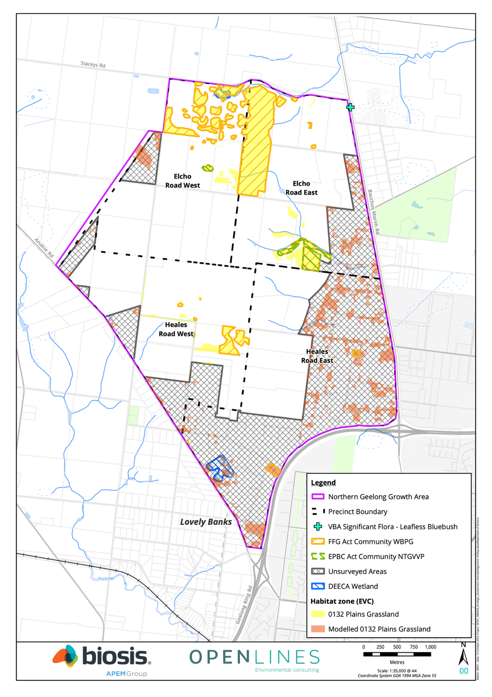
Figure 3-3: Native vegetation, TECs, and threatened flora in the NGGA
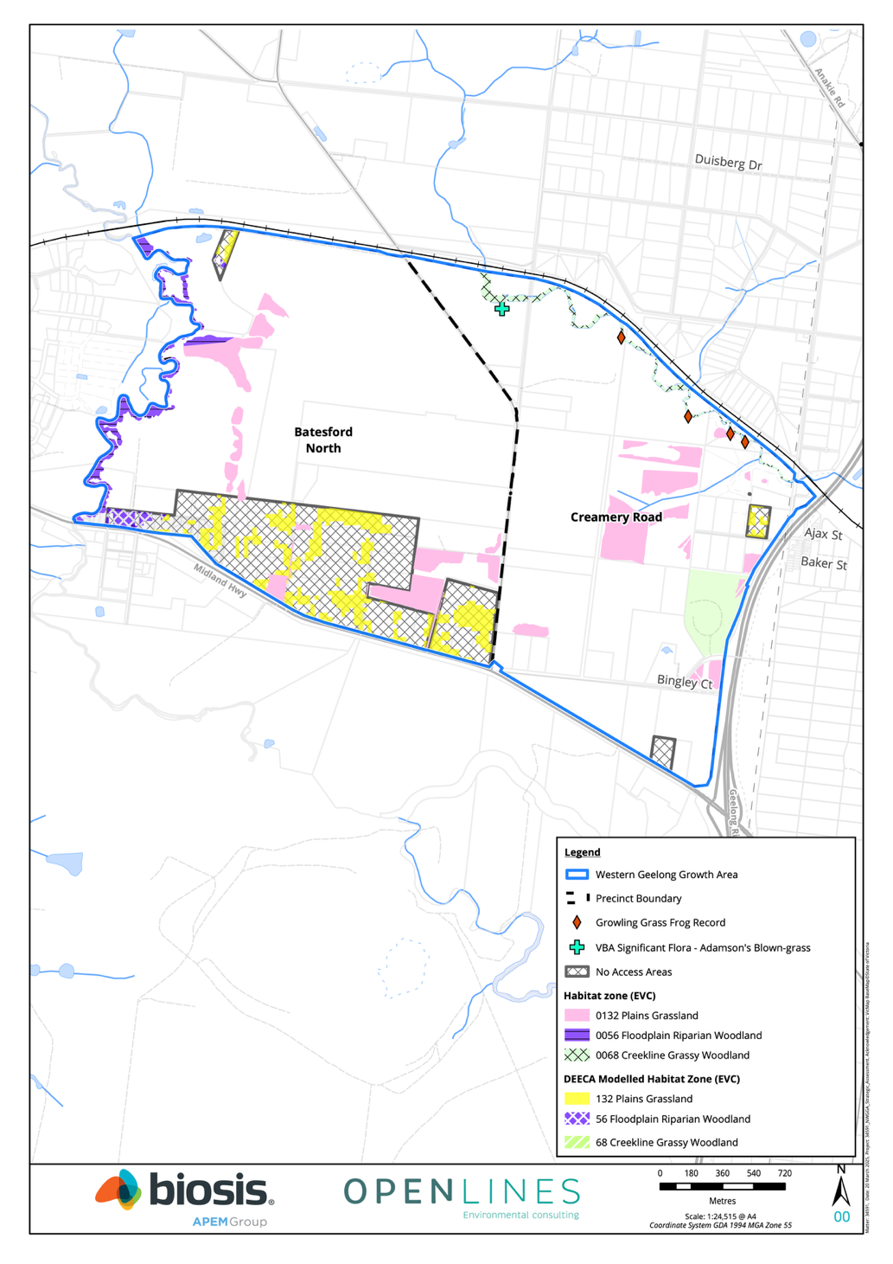
Figure 3-4: Biodiversity values in the WGGA
Table 3-1: Total area of EVCs present within the Growth Areas
Ecological Vegetation Class | Biodiversity Conservation Status | NGGA surveyed areas (hectares) | NGGA unsurveyed areas (hectares) | WGGA surveyed areas (hectares) | WGGA unsurveyed areas (hectares)
Plains Grassland (EVC 132) | Endangered | 146 ha | 111.959 ha* | 41.479 ha | 29.399 ha*
Creekline Grassy Woodland (EVC 68) | Endangered | - | - | 4.859 ha | -
Floodplain Riparian Woodland (EVC 56) | Endangered | - | - | 23.107 ha | 2.252 ha*
*2005 DEECA EVC mapping

Threatened ecological communities
The following threatened ecological communities have been identified within the surveyed areas of the NGGA:
- 12.7 ha of the nationally listed ecological community Natural Temperate Grassland
- 123.8 ha of the FFG Act listed ecological community WBPG
No threatened ecological communities (either nationally listed or State listed) have been identified within the surveyed areas of the WGGA.
Natural Temperate Grassland within the NGGA occurs in a heavily modified form. This is reflected in its Site Condition Habitat Score (a score out of 75) which, when standardised, amounts to totals of either 16 or 24 out of 75 with an understorey score of 5/25. The later reflect the presence of less than 50% of the expected number of lifeforms in this community while still supporting more than a 50% cover of native perennial tussock-grasses.
Examples of Natural Temperate Grassland within the NGGA also typically have a weed cover of greater than 25% of the vegetation present, with high threat weeds such as Chilean Needle-grass being relatively common. Areas of Natural Temperate Grassland with a relatively extensive cover of high threat, perennial, grassy weeds have relatively low resilience to ongoing weed invasion. This makes Natural Temperate Grassland within the NGGA highly vulnerable to an ongoing rapid decline in condition, to the extent where the community can be expected to fail the required condition criteria to be defined as the TEC within relatively short timeframes (less than a decade).
There is potential for additional native vegetation and TECs to occur within the unsurveyed areas of the NGGA and WGGA.
Figure 3-3 and Figure 3-4 show native vegetation and ecological communities within the Growth Areas.

Flora
Between November 2019 and August 2020, targeted surveys for six nationally listed threatened flora species were undertaken within the surveyed areas of Growth Areas, including: Adamson's Blown-grass Lachnagrostis adamsonii, Matted Flax-lily Dianella amoena, Clover Glycine Glycine latrobeana, Button Wrinklewort Rutidosis leptorrhynchoides, Large-headed Fireweed Senecio macrocarpus and Spiny Rice-flower Pimelea spinescens subsp. spinescens.
No nationally listed threatened flora species were recorded within the surveyed areas, although Adamson’s Blown-grass has been assumed to be present along the Cowies Creek corridor within the WGGA based on relatively recent historical records, and the presence of suitable habitat (EHP, 2021). One State significant flora species, Leafless Bluebush Maireana aphylla was recorded at the north-eastern boundary of the NGGA.
It is considered highly unlikely that any additional threatened national or State flora species occur within the surveyed areas of the Strategic Assessment Area due to the ongoing land use of the site resulting in the absence of suitable habitat, and the highly modified condition of the understory (EHP, 2021) (see Part 4 of the SAR).

Fauna
Between December 2019 and December 2020, targeted surveys for five nationally listed threatened fauna species were undertaken within the surveyed areas of Growth Areas, including: Golden Sun Moth Synemon plana (GSM), Delma impar (SLL), Growling Grass Frog Litoria raniformis (GGF), Australian Grayling Prototroctes maraena and Little Galaxias Galaxiella toourtkoourt.
Targeted surveys recorded SLL and GSM within the NGGA and GGF in Cowies Creek within the WGGA.
Targeted surveys for the Australian Grayling and Little Galaxias within the WGGA did not identify the species. However, the Australian Grayling is considered likely to be present within the broader catchment area. It is noted that the Corangamite CMA has proposed to remove barriers within the Moorabool River which currently prevent fish accessing habitat further upstream adjacent to the WGGA. Future planning for the WGGA PSPs should assume the presence of the Growling Grass Frog, Australian Grayling and Little Galaxias following the removal of these barriers (EHP, 2021).
Between September 2023 and May 2024, detailed habitat assessments and targeted surveys for VGED were undertaken in areas identified as containing potential VGED habitat during the initial habitat assessment. Targeted VGED surveys focused on sections of grassland with the greatest likelihood of containing a remnant population, based on the visual quality and availability of habitat attributes. No VGED were recorded.
A single state significant fauna species Aythya australis (Hardhead) was incidentally observed within the NGGA during EHP surveys, although it is considered unlikely that the species would maintain a resident population within the Growth Areas. The Eastern Great Egret Ardea modesta and Black Falcon Falco subniger have recently been recorded in close proximity to the Growth Areas, and it is likely that these species would use to the Growth Areas for opportunistic forage, or as a steppingstone throughout the broader landscape. An active Platypus Ornithorhynchus anatinus burrow was observed within the Moorabool River.
More recent surveys in 2024 for VGED recorded several small vertebrate species listed under the FFG Act, including the Tussock Skink Pseudemoia pagenstecheri and Fat-tailed Dunnart Sminthopsis crassicaudata.

Striped Legless Lizard
Targeted surveys for SLL recorded 45 individuals within the NGGA under ten different tile grids.
Based on the location of the confirmed records of the species and quality and extent of habitat, 103.89 hectares of confirmed SLL habitat is mapped within the NGGA. Sites where the species was recorded generally represent the most suitable areas of habitat for SLL within the NGGA. These areas supported a high cover of surface rock, cracking soils and tussock-forming grasses providing inter-tussock space. The high cover of surface rock at these sites also precludes regular slashing, which maintains a high biomass and dense tussock structure throughout the year.
An additional 76.3 ha of suitable habitat is also mapped within the NGGA. Although the species was not recorded in these areas, this habitat is considered suitable for the species due to it comprising predominantly native grassland with cracking soils and surface rock.
Despite targeted surveys being undertaken between September and December at a time when SLL was known to be present in the NGGA, no SLL were recorded in the WGGA. EHP 2021 found that the removal of native vegetation, high levels of grazing, pasture improvement and cultivation across the WGGA has contributed to the decline of high quality habitat for the species. They concluded that it is highly unlikely that a population of SLL is present within the Creamery Road and Batesford North precincts of the WGGA.
Approximately 47 ha of potential habitat for SLL is modelled to occur within the unsurveyed areas of the NGGA.
The following threats to SLL are potentially relevant to implementation of the Plan and BCS:
- Direct habitat removal
- Habitat degradation from rock collection or destruction
- Spread of weeds
- Predation by cats
- Inappropriate fire regimes
Figure 3-5 shows SLL habitat and records within the Growth Areas.

Golden Sun Moth
Targeted surveys within the Growth Areas recorded GSM within the NGGA. The species was not detected within the WGGA. The results of the targeted surveys have informed baseline habitat mapping for GSM.
The species Conservation Advice notes the importance of native habitat compared to non-native habitat and identifies high quality habitat as “medium to large sites containing native grassland with an abundant component of larval food species (i.e., Rytidosperma spp. and/or Austrostipa spp.) with low weed cover, inter-tussock spaces, and land-use/management that is consistent with the ecological values of the site” (DAWE, 2021).
The EHP surveys found the Growth Areas to be dominated by non-indigenous grasses and weeds (i.e., pasture grasses), which reflects the region’s long history of agricultural use. Much of the indigenous vegetation and terrestrial fauna habitat remaining within the Growth Areas was found confined to riparian corridors in the WGGA (i.e., Moorabool River, Cowies Creek), or agricultural areas not subjected to historical cropping. Native vegetation, where present, was highly modified, generally lacking structure and exhibiting a low diversity of native species.
Subsequent site visits as part of the strategic assessment process, as well as the results of landholder commissioned surveys, have confirmed these findings and shown an increased prevalence of weeds since the time of the EHP surveys in 2019 and 2020. This indicates a declining trend in the condition of native vegetation (Peter Wlodarczyk pers comms.).
Despite the abundance of GSM records within the NGGA, it is unlikely the NGGA would qualify as an important or high-quality area due to the level of weeds, land modification, and rate of decline. To distinguish between native vs non-native habitat for the assessment of impacts to GSM and to reflect this declining trend in condition, habitat within the surveyed areas of the Growth Areas has been mapped according to categories. GSM habitat within the assessed areas therefore comprises (see Figure 3-6):
- 21.1 ha of higher potential native habitat, which identifies the habitat areas with the greatest likelihood of supporting native vegetation based on the result of EHP surveys and the more recent landholder surveys
- 65.5 ha moderate potential native habitat, which identifies the habitat areas that have the potential to still support native vegetation identified through the EHP surveys, but recognising the declining trend in condition observed elsewhere in the Growth Areas and lack of more recent surveys for these areas
- 44.4 ha of lower potential native habitat, which identifies the habitat areas which have likely declined since the time of EHP surveys and are no longer expected to support native vegetation, based on the results of more recent landholder surveys
- 545.3 ha of non-native habitat, which identifies areas of GSM habitat which do not support native vegetation
Approximately 90 ha of GSM habitat is modelled to occur within the unsurveyed areas of the NGGA.
The following threats to GSM are potentially relevant to implementation of the EPBC Plan and BCS:
- Predation by cats
- Inappropriate fire regimes
- Direct habitat removal
Figure 3-5 and Figure 3-6 shows GSM habitat and records within the Growth Areas.

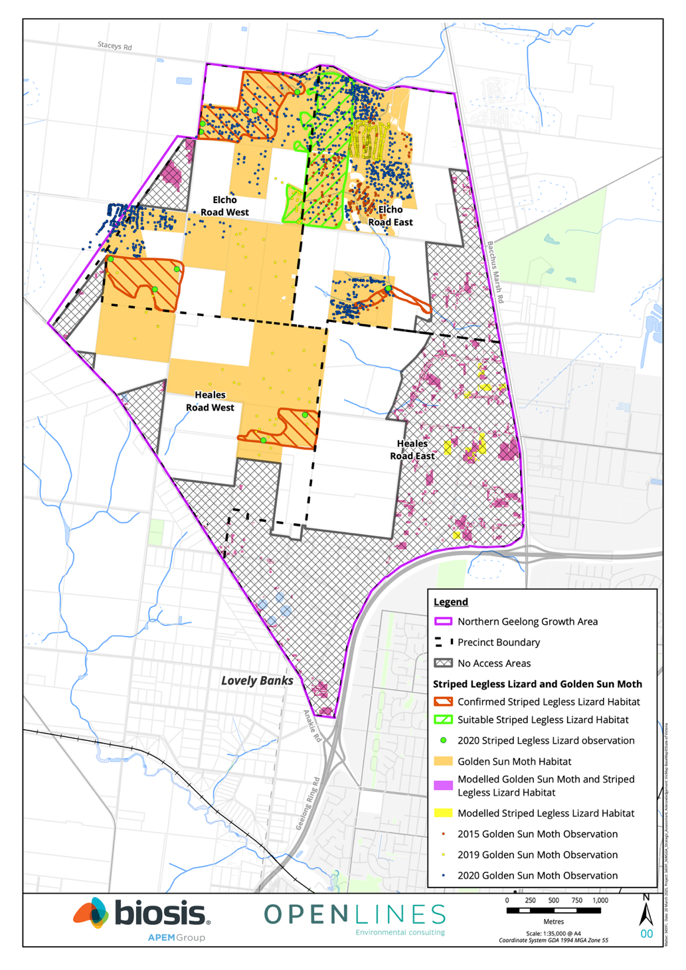
Figure 3-5: Fauna records and habitat in the NGGA
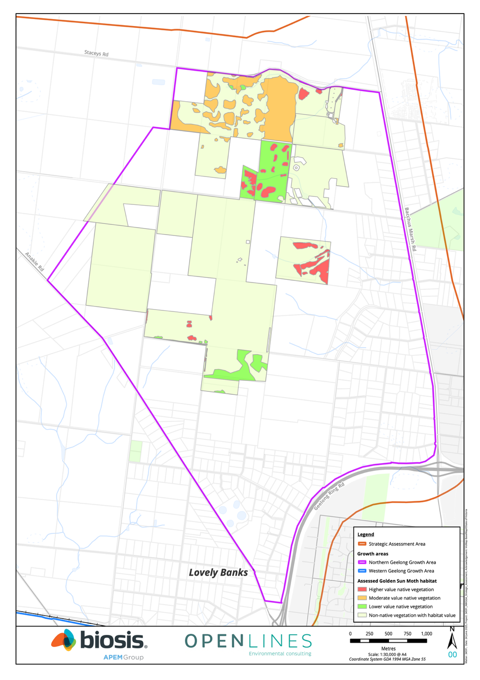
Figure 3-6: Golden Sun Moth habitat categories in the NGGA

Growling Grass Frog
Targeted surveys along Cowies Creek in the WGGA recorded approximately 50 GGF individuals across four sites. EHP 2021 considered that the area supported an important population (particularly because it contained a range of key habitat attributes) and that Cowies Creek was an important habitat corridor through the growth area.
GGF has also been recorded downstream of the WGGA within Cowies Creek on several occasions. These records appear to have some level of connectivity with the frogs in the WGGA and are likely to form part of a larger, connected metapopulation.
The number and location of GGF records within Cowies Creek suggests that the corridor supports an important, connected metapopulation of the species. Records stretch for more than 3.5 km along the creek and suitable habitat extends beyond this distance.
The available information suggests that the Cowies Creek metapopulation is comprised of a range of discrete, breeding populations of GGF that are connected along the creek corridor. Despite previous development in the area the species is persisting and metapopulation dynamics are still operating.
There are no records of the species upstream from the WGGA and that area appears to have much more limited GGF habitat values due to historic land use. It is considered less likely that the species is present in this location on a permanent basis.
The following threats to GGF are potentially relevant to implementation of the Plan and BCS:
- Habitat degradation and/or modification caused by:
  - Changed hydrological regimes
  - Deterioration of water quality and any introduction of pollutants and biocides
- Fragmentation and isolation of populations
- Increases in artificial lighting
- Introduction of cats
Figure 3-4 shows GGF habitat and records within the Growth Areas.

Victorian Grassland Earless Dragon
Much of the Geelong region, including both Growth Areas, is identified as ‘species or species habitat likely to occur’ as per DCCEEW’s species distribution map.
Biosis undertook both targeted surveys and detailed habitat assessments between January and May of 2024 (Biosis, 2024). No VGED were recorded within the NWGGA during the targeted surveys.
The habitat suitability assessment was designed to complement the targeted surveys and understand the presence of a range of environmental factors which may be key habitat attributes for VGED. The purpose of this assessment was to provide data to help understand the potential value of areas of grassland within the NWGGA for VGED.
The data collected during the detailed habitat assessments was used to inform the VGED habitat attribute analysis (Biosis & Open Lines, 2024) which involved a range of analysis methods and scenarios to understand the potential value of the NWGGA for VGED. The focus of this analysis was on the NGGA. Although one property was accessed for detailed habitat assessments in the WGGA, it was considered unlikely to provide potential habitat value for VGED due to the level of weed cover and de-rocking on the site. In the NGGA, the habitat attribute analysis found that the general environmental condition and availability of habitat attributes for VGED. A large portion of the areas analysed exhibit high weed cover / low native vegetation cover, de-rocking, and land management practices which are likely to be unsuitable for VGED (particularly cropping and ploughing) (Biosis & Open Lines, 2024).
The analysis concluded that there are seven patches in the NGGA which are more likely to be of potential value for VGED (see Figure 3-7). These patches were consistently highlighted under different approaches to the analysis, and amount to 121.4 ha in total (Biosis & Open Lines, 2024). In addition, there is 91.8 ha of areas assumed to support potentially suitable habitat attributes which could not be accessed by Biosis.
The degraded condition of these areas, combined with the agricultural landscape of the Growth Areas and lack of contemporary or historical detection in the NWGGA, suggests that the NWGGA is unlikely to harbour a remnant population of VGED. However, the location of the NWGGA within the modelled distribution of the species, and presence of potentially suitable habitat attributes for VGED, mean that the Growth Areas could have a role in the potential recovery of the species.
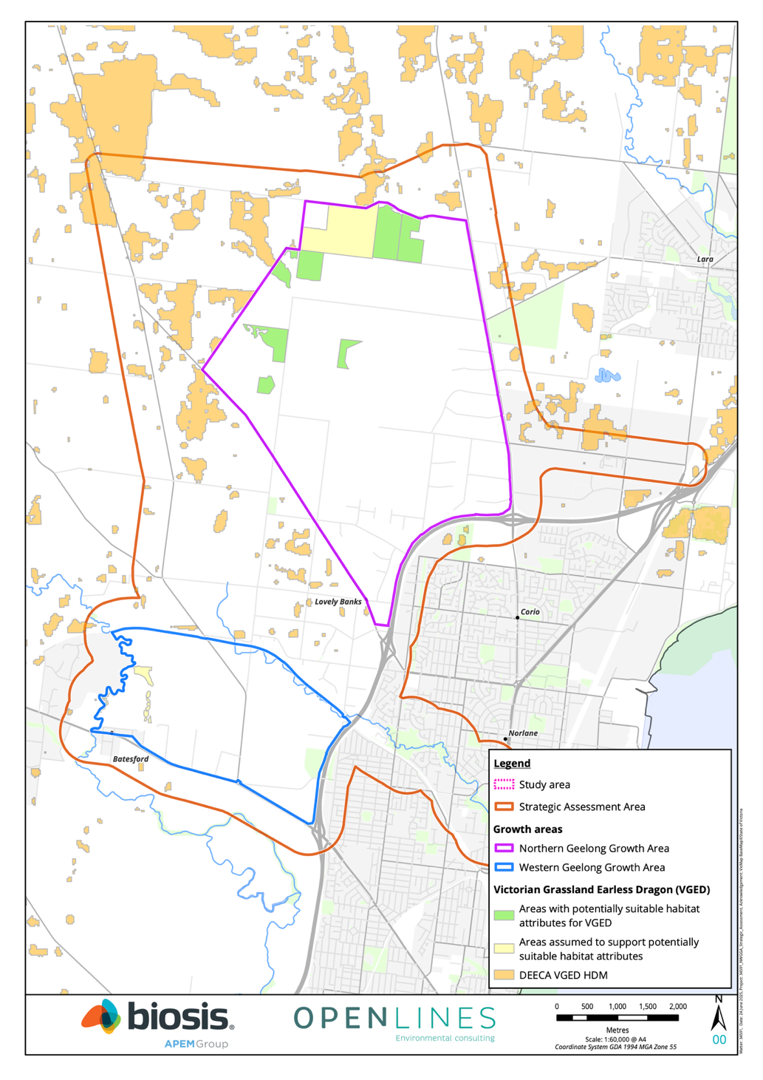
Figure 3-7: Potentially suitable areas for Victorian Grassland Earless Dragon

Waterways
At a state and local level, the WGGA includes two significant waterways, the Moorabool River and Cowies Creek (see Figure 3-8).
Historically, the Moorabool River has been diverted twice from its natural alignment to facilitate limestone extraction at the Batesford quarry. Its current extent runs north-south along the WGGA’s western boundary and continues to dissect the broader growth area south of Midland Highway in an east-west direction. The Moorabool River departs from the Growth Areas extent in the south-west at the Lewis Bandt Bridge in Herne Hill and flows for approximately 2.3 kilometres before joining the Barwon River.
Cowies Creek runs from the north-west to the south-east for 2.6 kilometres within the northern boundary of the WGGA. Cowies Creek originates from a series of wetlands in the Moorabool River north-west of the WGGA extent. Cowies Creek departs from the WGGA and enters Port Phillip Bay (Western Shoreline) 3.4 kilometres downstream.

Wetlands
There are no Ramsar, or nationally significant wetlands mapped within the Growth Areas.
DEECA modelling indicates that the Growth Areas contains two wetland formations, as well as a number of dams used to support rural residences within the Growth Areas.
The NGGA contains two DEECA modelled wetland formations, totalling 10.38 ha. The first of these corresponds to a wastewater treatment plant adjacent to Anakie Road. The second of these appears to be related to two small farm dams (from aerial observations) located in the NGGA Conservation Area. This area was mapped as Plains Grassland (EVC 132) by EHP (2021a). Overland flows within the NGGA, including ephemeral drainage lines, discharge into Corio Bay, which includes part of the Port Phillip Bay (Western Shoreline) and Bellarine Peninsula Ramsar site, complex of wetlands of international importance.
The WGGA does not contain any DEECA mapped wetland formations. The Moorabool River runs north to south along the western boundary of the WGGA and connects to the Barwon River approximately 7 km south. The system then flows into Lake Connewarre further downstream, part of the Port Phillip Bay (Western Shoreline) and Bellarine Peninsula Ramsar site.

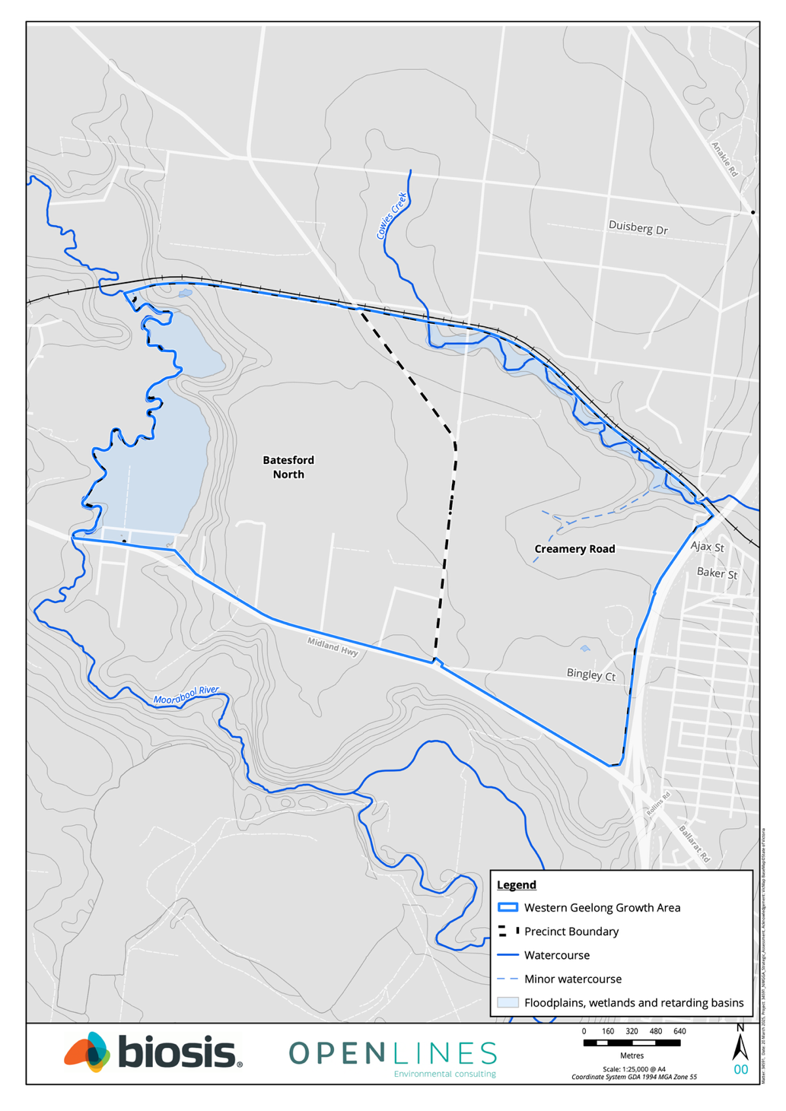
Figure 3-8: Hydrological values of the WGGA

Key threats to biodiversity values within the Growth Areas
A key threat to biodiversity values within the Geelong locality is loss of habitat for development. The region surrounding Geelong has historically been heavily developed for agricultural production, resulting in substantial losses of native vegetation (DSE, 2003b). The city of Geelong itself has also long been a centre of development in Victoria and has been the second largest city in Victoria since the 1930’s (Victorian Places, 2015). Historical development and clearing have resulted in loss of native vegetation and landscape degradation, reducing habitat availability and quality for native species.
Geelong’s population is continuing to grow, with an anticipated 2.5 per cent annual growth rate, and is anticipated to have an additional 500,000 residents by 2050 (The City of Greater Geelong, 2021). Careful management is required to minimise impacts of development to support this forecast increase in population.
Other key environmental threats within the region include:
- Invasive species, including pests and weeds
- Modification of water systems, including historical construction of infrastructure such as dams and weirs, ongoing water abstraction, and water pollution from agricultural and urban sources
- Disturbance pressures upon habitats used recreationally
- Climate change
Each of these is discussed briefly below. Refer to the detailed impact assessments in Part 4 of the SAR for further detail on how these threats relate to the key MNES.

Invasive species
As a result of extensive historical development, there is a high density of weeds within the Geelong locality. For instance, surveys conducted within the Growth Areas found a high density of weeds and introduced pasture species across most of the surveyed areas (EHP, 2021). Weeds also pose a threat within the wider region, including within the Port Phillip Bay (Western Shoreline) & Bellarine Peninsula Ramsar site (DELWP, 2020).
Pest animals are also present within the region. Within the Growth Areas, there is evidence the sites are occupied by rabbits, hares and foxes (EHP, 2021). Other invasive species, such as pigs, goats, are likely to also be present within the region. It is not considered possible to eradicate existing pests within the region and therefore asset protection approaches are considered the most effective management mechanism to minimise potential impacts to MNES (EHP, 2021).
Weeds listed as noxious under the Catchment and Land Protection Act 1994 (CaLP Act) were recorded during the various on-ground assessments, including Chilean Needle-grass, African Box-thorn, Spear Thistle, Artichoke Thistle, Patterson’s Curse, Bathurst Burr, Serrated Tussock and Sweet Briar. Similarly, there is evidence that the NWGGA is currently occupied by several pest fauna species listed under the CaLP Act, including Red Fox, European Rabbit and European Hare.

Water system modification
All of the major watercourses within the Geelong region have experienced environmental impacts from development.
In-stream dams or similar barriers are located in Moorabool Rivers (upstream of Geelong) (CCMA, 2014). Dams pose a range of threats to riverine environments, including acting as barriers to fish passage, through altering characteristics of the water (such as water temperature and oxygen content), and through artificially altering water levels.
Water extraction from the Moorabool River occurs to support consumptive and agricultural purposes. Current environmental water allocations for both of these rivers are not sufficient to meet environmental needs into the future (DELWP, 2021a).
The environmental values of the Moorabool River, Barwon River, Hovells Creek, and Lake Connewarre Complex are all threatened by indirect impacts from agricultural and urban development within these catchments, including grazing pressures, invasive species, poor water quality, erosion and sedimentation, and degradation of native vegetation (CCMA, 2014).

Recreational Disturbance
The Geelong locality is a popular destination for recreational purposes. Development of the Growth Areas will increase human activity in the vicinity of the Growth Areas, which can impact natural areas including conservation areas protected under the EPBC Plan and existing reserves. Recreational disturbance can be caused by:
- Trampling of flora species and disturbance to flora and fauna habitat
- Track creation
- Rock removal and disturbance
- Rubbish dumping and disturbance from associated clean-up activities
- Timber collection and removal of dead wood
- Illegal collection of flora and fauna species
- Dog walking
- Recreational activities such as mountain-biking, four-wheel driving, and horse riding

Climate change
Climate change is rapidly emerging as one of the most significant threats to ecosystems and biodiversity (Prober et al., 2019). Victoria’s climate is among the driest and most variable globally, and ecosystems in Victoria are particularly vulnerable to climate change (Jin, Cant and Todd, 2009). Various changes in Victoria’s climate have been recorded in recent decades: temperatures have increased by over 1.0°C since 1910, and fire season length and severity has increased. Future projections forecast that Victoria will continue to experience increased temperatures, in addition to less rainfall and more extreme weather events (DELWP, 2019). Victoria’s Climate Change Strategy, released in 2021, outlines the Victorian Government’s approach to managing climate change, including emissions reductions targets and measures to build climate resilience (DELWP, 2021c).
More locally in the Geelong region, climate change poses specific threats through:
- Sea level rise, which particularly threaten coastal and estuarine habitats, including the Port Phillip Bay (Western Shoreline) & Bellarine Peninsula Ramsar site (DELWP, 2020)
- Increased storm intensity and frequency, which is likely to exacerbate the impacts of sea level rise (DELWP, 2020)
- Decreased water availability, which threatens water supply within the region and environmental values (CCMA, 2014; DELWP, 2021a)

Conservation program

Introduction
This Chapter describes the conservation program of the BCS and how it will be implemented.
The purpose of the conservation program is to:
- Ensure development in the Growth Areas avoids and minimises, mitigates, and offsets impacts to national, State and local biodiversity values
- Ensure outcomes in the BCS are achieved
- Implement the EPBC Plan’s conservation framework
The conservation program has been developed in accordance with the offset mitigation hierarchy (DSEWPC, 2012; DELWP, 2017c) and the biodiversity objectives of the Framework Plan. The mitigation hierarchy requires impacts on biodiversity values to be firstly avoided and minimised to the greatest extent practicable, and then mitigated. The remaining residual impacts can then be offset.
The conservation program sets out commitments and measures that will be delivered for:
- Avoiding and minimising impacts to biodiversity values (see Section 4.3)
- Mitigating impacts to biodiversity values (see Section 4.4)
- Offsetting residual impacts to biodiversity values (see Section 4.5)
The commitments for the conservation program will be implemented through a series of detailed measures that are provided in the Commitments and Measure document.

Policy context
The Victorian Government’s Planning for biodiversity: guidance (DELWP, 2017e) aims to assist local government to use the planning system to meet the objectives of the Planning Policy Framework (PPF) in relation to the protection and conservation of Victoria’s biodiversity. The guidelines state that strategic planning is the most effective process under the planning system to protect and conserve biodiversity (DELWP, 2017e).
Key steps outlined for effective strategic planning include considering broader strategic policies and strategies, identifying areas of high biodiversity value, identifying where there is demand for development and resolving conflicts between development and biodiversity values, and choosing planning tools to protect high biodiversity value areas (DELWP, 2017e).
Strategic planning provides many benefits to biodiversity, including the:
- Ability to identify high biodiversity value areas at a landscape scale
- Best opportunity to effectively avoid and minimise impacts by directing development away from high biodiversity value areas and co-ordinating offsets to compensate for impacts strategically
- Ability to understand and address cumulative impacts of multiple developments within an area
The allocation of the proposed conservations areas has been based on a strategic planning process that consider the social, economic and environmental considerations, the ecological data and policy guidance outlined in Table 4-1.
Table 4-1: Key policy considerations for the City
Strategic consideration | Policy | Influence on the conservation program
Clause 12.01-1S – ‘Protection of biodiversity’ of the Victoria Planning Provisions | - Use biodiversity information to identify important areas of biodiversity, including key habitat for rare or threatened species and communities, and strategically valuable biodiversity sites  - Strategically plan for the protection and conservation of Victoria’s important areas of biodiversity  - Ensure that decision making takes into account the impacts of land use and development on Victoria’s biodiversity, including consideration of:  - Cumulative impacts  - Fragmentation of habitat  - The spread of pest plants, animals and pathogens into natural ecosystems  - Avoid impacts of land use and development on important areas of biodiversity  - Consider impacts of any change in land use or development that may affect the biodiversity value of national parks and conservation reserves or nationally and internationally significant sites, including Ramsar, JAMBA, CAMBA, and ROKAMBA sites | The BCS uses the best available information to understand biodiversity values, identify priority areas and support decision making. Section 3.2 describes the ecological survey data, species database records, habitat and vegetation modelling.  The BCS is part of a strategic planning process undertaken by the City to identify areas for development and growth to meet economic, social and planning challenges and protect high biodiversity value areas.  The strategic planning process for the Growth Areas involved several key steps that are consistent with the steps outlined in Planning for biodiversity: guidance (DELWP, 2017e). It has led to the avoidance of the most important biodiversity in the Growth Areas within strategic conservation areas.  These are high biodiversity value areas that contain the most important national, State and local biodiversity values in the Growth Areas and are considered likely to be viable in the long-term because of their size, condition, shape and location in the landscape  The BCS was informed by a strategic assessment process that assessed the impacts of the development in the Growth Areas on MNES in the NWGGA Strategic Assessment Report. This included long and short-term impacts, direct and indirect impacts, and cumulative impacts. The NWGGA Strategic Assessment Report also considers potentially threatening processes including the fragmentation of habitat and the spread of pest plants and animals and pathogens.  The impacts of the development on State biodiversity values, including cumulative impacts in the context of past native vegetation removal, will be assessed during precinct planning through the preparation of NVPPs at the precinct scale.  The BCS includes commitments and measures that are expected to adequately manage the potential indirect impacts of the development on the Port Phillip Bay (Western Shoreline) and Bellarine Peninsula Ramsar site.
Clause 12.01-1L – ‘Protection of biodiversity’ of the Victoria Planning Provisions | Ensure that land use and development enhances areas of native vegetation and other habitats | The conservation program will protect:  - The largest habitat area for Striped Legless Lizard in the NGGA  - A substantial area of habitat for Golden Sun Moth in the NGGA  - All habitat for Growling Grass Frog within the WGGA  - Habitat potentially important for the recovery of Victorian Grassland Earless Dragon  - Multiple other national, State and local biodiversity values  - Areas of key habitat connectivity across the Growth Areas  - Riparian areas that will help maintain ecological processes and water flows and quality
The Framework Plan, incorporated into the Greater Geelong Planning Scheme at Clause 11.02. | The biodiversity-related urban development objectives of the Framework Plan for each Growth Area are:  - “Protect and regenerate biodiversity and cultural heritage values of the natural and constructed waterways along the Lovely Banks monocline and heritage values of the Elcho Homestead”  - “Protect and regenerate biodiversity and cultural heritage values along the Barwon and Moorabool Rivers, Cowies Creek and the Dog Rocks Sanctuary and establish vegetated constructed waterways” | Key natural landscape features are highlighted by the framework plan for protection. In response the allocation of strategic conservation areas includes the river corridors and land on and adjacent the monocline.
Environmental Significance Overlay 4 – Grasslands within the Werribee Plains hinterland, within the Greater Geelong Planning Scheme | - To prevent a decline in the extent and quality of native vegetation and native fauna habitat of the Victorian Volcanic Plain.  - To enhance the environmental and landscape values of the area.  - To avoid the fragmentation of contiguous areas of native vegetation or native fauna habitat  - To ensure that any use, development or management of the land is compatible with the long-term conservation, maintenance and enhancement of the grasslands  - To avoid the destruction of habitat for native fauna resulting from the modification of land form and disturbance of surface soils and rocks  - To enable areas of environmental significance, due to their native vegetation or habitat values, to be identified | The statement of environmental significance for ESO4 states the native vegetation of the Victorian Volcanic Plain is some of the most depleted vegetation in Victoria. Although the vegetation has been extensively cleared, some large areas of native vegetation remain that are also important for several threatened species, including Spiny Rice-flower and Striped Legless Lizard.  Development within the Growth Areas will lead to the removal of native vegetation and habitat on some land within ESO4.  Despite the BCS leading to the removal of native vegetation and habitat within the ESO, the strategic management of large conservation reserves will lead to improved outcomes for native grasslands compared to individual permit applications under the ESO 4 requirements, as the detailed ecological assessment and avoid, minimise and offset requirements have been applied in a strategic planning context rather than a site by site basis.  A detailed assessment against the ESO objectives is provided in Appendix A.
Section 4B of the Flora and Fauna Guarantee Act (FFG Act) (the FFG Act ‘biodiversity duty’) | The FFG Act imposes a duty on public authorities to ‘give proper consideration to’ the Act’s objectives in performing any of their functions that may impact on biodiversity, as well as consider several other additional matters.  The duty applies to the City of Greater Geelong in relation to the development of the BCS as there is a reasonable expectation that the carrying out of this function may impact biodiversity. It is important to note that:  - Meeting the duty requires the City to give ‘proper consideration’ to the Act’s objectives and several other matters rather than mandating specific outcomes that the City must achieve for biodiversity  - The City is required to comply with the duty in a manner which is consistent with the proper exercise of its functions under any other Act. The duty does not override the City’s other statutory obligations. The duty does not prevent the City from exercising its statutory powers and discretion to weigh biodiversity matters against other matters it is required to consider when making decisions, such as social or economic objectives under the Planning and Environment Act 1987 | The preparation of the BCS has been informed by the objectives of the FFG Act duty. This includes strategic planning, assessing impacts and establishing a set out outcomes and commitments and measures to address the impacts of the development on biodiversity values.  For State and local biodiversity values, the outcomes and commitments are designed to ensure no net loss to biodiversity because of the removal of native vegetation. This is consistent with the objectives of State planning policy set out in the PPF and this FFG Act objective  Unavoidable impacts on nationally listed matters will be offset outside the Growth Areas. The outcome for these offsets in the BCS is that they will make an important contribution to the recovery efforts for these matters consistent with this FFG Act objective to recover threatened species and communities so their status improves.  A detailed assessment against the FFG Act duty is provided in Appendix A.
The City of Greater Geelong Environment Strategy 2020-2030 | Key directions are (in part):  Protect and enhance indigenous biodiversity prioritising:  - Remnant biodiversity patches larger than 10 hectares  - Threatened indigenous biodiversity species and communities  - Under-represented Ecological Vegetation Classes  - Establishment of biolinks to reduce habitat fragmentation  - Protection of remnant old trees  Restore indigenous biodiversity and habitat to support ecologically healthy waterways, estuaries and wetlands  Restoring biodiversity in modified urban landscapes by:  - Restore habitat into urban landscapes through the establishment of indigenous tree, shrub and understory plantings and other habitat elements such as wetlands, logs and stags  - Restore degraded waterways and wetlands to create habitat and ecologically healthy water flows | Protection and restoration of landscapes are central to the City’s strategy and that is reflected in the approach to the BCS.  The City’s strategy seeks to protect patches greater than 10 hectares and this is reflected in the guiding principles.  Restoration of habitat in urban landscapes can be embedded in the design guidelines and the City’s future management of the Growth Areas through the delivery of urban development.  The future management of public realm areas would need to be tailored to the biodiversity outcomes sought for key areas.

Avoidance and minimisation of impacts
Avoidance of impacts from development in the Growth Areas is a priority at both a national and State level and is the first step in the mitigation hierarchy. The avoidance process provides opportunities to avoid and protect areas of high biodiversity value and is fundamental to a determination that commitments adequately address the likely impacts on biodiversity and in reducing the need for offsets to address the impacts of the development.
Avoidance is defined in the BCS as any land not directly impacted by development within the Growth Areas.

Description of biodiversity areas
Biodiversity areas support biodiversity values within the Growth Areas and provide opportunities to protect, manage and restore biodiversity. They provide a key contribution to the delivery of the BCS outcomes set out in Section 2.1.
The guiding principles (Section 2.2) identify two categories of land within the Growth Areas that relate to biodiversity. They are:

Strategic conservation areas
The primary purpose of the strategic conservation areas is the protection, management and restoration of biodiversity values within key locations of the Growth Areas. The identification of these areas requires a sufficient level of data to provide confidence in the conservation outcomes that can be delivered and support and justify the necessary level of commitment to protect these areas. The guiding principles around conservation planning in the BCS (see Section 2.2) were applied to identify the strategic conservation areas. These include consideration of:
- Biodiversity values
- Connectivity
- Ecological viability
Secondary uses within the strategic conservation areas may be possible where these do not compromise the biodiversity values or reduce the ability to manage the areas. For example, secondary uses may include social infrastructure such as walking trails, or infrastructure to manage stormwater.

Landscape connections
Landscape connections are not avoidance areas and are better described as restoration areas and are described further in Section 4.3.6. The description is provided in this section to provide context for how strategic conservation and landscape connections can complement each other in the future urban areas.
Landscape connections are locations within the Growth Areas which may be suitable for less intensive use or development, such as open space or waterways, and where opportunities may exist for providing co-benefits for biodiversity through the infrastructure siting and design phase. Their primary purpose is not conservation. However, they may provide a contribution to biodiversity protection and enhancement where that is complementary to the primary purpose of the area.
The Framework Plan has been used to inform the identification of landscape connections and refined with additional information about the future urban structure of the Growth Areas since the Framework Plan was completed.

Identifying avoidance areas
The BCS considered the proposed development for the Growth Areas set out in the Framework Plan and applied a strategic planning process to consider and resolve conflicts between areas identified as high biodiversity value and areas proposed for development in the Framework Plan and the policies and strategies outlined above. This avoidance planning comprised three processes:
- Strategic level planning to locate the Growth Areas and identify initial avoidance priorities
- Locating and designing the development within the Growth Areas to avoid impacts
- Future precinct and site-scale planning

Strategic level planning
The avoidance process commenced at a landscape scale and informed the location of the Growth Areas.
The process was undertaken through a range of regional and State-scale processes. Relevant documents associated with this process include the G21 Regional Growth Plan (Geelong Region Alliance, 2013) and Plan Melbourne 2017–2050 (Victoria State Government, 2017). This process considered a wide range of factors across the broader region, including:
- The locations and characteristics of landscape features including protected matters and environmental values
- The locations of existing development and infrastructure
- The overall suitability of the site for delivering development objectives
Once the location of the Growth Areas was determined, high level strategic planning was completed through preparation of the Framework Plan. This process was based around urban development objectives and planning themes. Consideration of biodiversity values was one of the factors involved in planning decisions during this process. The Framework Plan identifies priorities for avoidance and minimisation that are reflected in a set of actions.
Key actions relating to avoidance of biodiversity in each of the Growth Areas are presented in Table 4-2 and how those actions influence the BCS.
Table 4-2: Key biodiversity actions from the Framework Plan for the Growth Areas
Action | Growth Area | Influence on the BCS
A network of linear corridors will be created to promote biodiversity linkages within neighbourhoods that connect between conservation areas, waterways and the open space network Corridors may be located as illustrated in Plan 9 and Plan 17 of the Framework Plan | Northern  Western | Informed identification of landscape connections
Any conservation areas that are identified will prioritise the protection and enhancement of local indigenous flora and fauna species | Northern  Western | Informed requirement for conservation management plans
The integrated transport network will protect, minimise impacts and revegetate roadside vegetation | Northern  Western | Ecological surveys have included roadside vegetation to ensure all impacts and opportunities for avoidance are accounted for
Stormwater drainage management will minimise the downstream impacts on the Port Phillip Bay (Western Shoreline) and Bellarine Peninsula Ramsar Site | Northern  Western | Inclusion of additional mitigation measures to protect the Ramsar site
A Native Vegetation Precinct Plan will be prepared for each precinct to determine the presence and management of significant flora, fauna and ecological communities | Northern  Western | The preparation of an NVPP for each PSP will be undertaken
‘Green-blue’ connections will be designed to promote flora and fauna by distributing water to soil through natural infiltration and irrigation. Waterways illustrated on Plan 7 and Plan 15 of the Framework Plan will be designed to provide sufficient corridor width to establish continuous riparian reserves that allow for biodiversity values to thrive | Northern  Western | Informed identification of landscape connections
Individual detailed master plans that outline the protection and enhancement of river and creek corridors will be prepared and incorporated within the relevant precinct structure plan including:  - Cowies Creek, between Geelong Ring Road and Geelong-Ballan Road  - Moorabool River, between Midland Highway and Geelong-Ballarat Railway | Western | Informed process for confirming boundaries and management objectives for the strategic conservation areas

Growth Area level planning
Following adoption of the Framework Plan, the preparation of the BCS has informed planning to refine the outcomes at a Growth Area level. This included:
- Detailed ecological surveys across the NGGA and the northern portion of the WGGA between November 2019 and December 2020 by Ecology and Heritage Partners (EHP) (described previously in Section 3.2.1)
- Consideration of the need for further avoidance based on the results of surveys
- Detailed analysis of a range of avoidance alternatives to inform decisions on the optimal layout for the Growth Areas
In considering these survey results, it was found that:
- Further avoidance and minimisation of impacts to high biodiversity value areas was required within the NGGA
- The avoidance outcomes within the Framework Plan for WGGA were appropriate in the context of the biodiversity values in the northern portion of the WGGA
- Further ecological investigations and confirmation of avoidance planning would be needed in the southern precincts of the WGGA closer to the time of planning and development for these areas
A key aim of the City in defining further areas for avoidance within the NGGA was to identify high value biodiversity with the best potential for long term viability. The existing level of threats, particularly high priority weeds, is leading to rapid environmental decline in many parts of the NGGA. This has meant that merely avoiding impacts to biodiversity by not allowing development to occur is unlikely to provide a conservation outcome for those values as there is a high likelihood they will degrade over time without intervention. Instead, protection, restoration and ongoing management of these areas is needed to ensure their long-term viability.
It was recognised that identifying additional areas for avoidance to those already identified within the Framework Plan would have significant social and economic implications. The City used a decision making framework, known as structured decision making (SDM), to help define priority areas for further biodiversity avoidance while also understanding and accounting for the social and economic ramifications of any decision.
The SDM projects addressed the following question: What is the optimal layout of development and avoidance within the Northern Geelong Growth Area? The City undertook a structured decision making (SDM) process in 2022 to determine the optimal layout of the NGGA (Gregory et al., 2010). This layout was provided in the documents released for public exhibition in 2023.
Prior to exhibition of the documents, VGED was rediscovered in Victoria in January 2023. Following rediscovery, detailed work was undertaken for the project including targeted surveys and detailed habitat assessments in the Growth Areas (Biosis, 2024), and a habitat attribute analysis which used a range of analysis to understand the potential value of the NGGA for VGED (Biosis & Open Lines, 2024).
An additional SDM process was undertaken for the project in 2024 (see Supporting Document C to the SAR). This process considered both the information collected during the VGED survey program and habitat attribute analysis, and government agency and community feedback from the first round of public exhibition.
To identify the optimal avoidance layout for the NGGA the SDM process considered three decision objectives and seven performance criteria. The decision objectives covered environmental, social, and economic issues and were:
- Maximise the avoidance and protection of biodiversity
- Maximise the supply of housing delivered in the precinct
- Ensure the cost of the conservation program is feasible
Multiple different alternative layouts and scales of avoidance across the NGGA were evaluated against these objectives. The layout that performed best has been incorporated into the Plan as the Northern Conservation Area, Eastern Conservation Area and gully avoidance area.
The conservation areas that must be avoided and retained for conservation area outlined below.

Northern Geelong Growth Area strategic conservation areas
The NGGA includes three strategic conservation areas:
- Northern Conservation Area in the Elcho Road East and Elcho Road West precincts
- Eastern Conservation area in the Elcho Road East precinct
- Gully avoidance area in the Elcho Road East precinct
The strategic conservation areas within the NGGA are identified in Figure 4-1.
The NGGA strategic conservation areas were confirmed by the City through the SDM process that led to confirmation of additional areas for conservation that were not identified in the Framework Plan. These conservation areas:
- Support multiple important biodiversity values protected under Commonwealth and State legislation
- Focus on the largest mapped habitat area for Striped Legless Lizard within the NGGA and a substantial area of mapped habitat for the Golden Sun Moth
- Provide restoration potential for Striped Legless Lizard and Golden Sun Moth in potentially suitable areas not currently mapped as habitat
- Protect the largest patch of Natural Temperate Grassland within the NGGA
- Protect a large area with potentially suitable habitat attributes for Victorian Grassland Earless Dragon which may support the recovery of the species
- Maintain landscape connectivity west of the NGGA

Northern Conservation Area
The Northern Conservation Area is located in the north-west of the Growth Area. It is approximately 135 ha in size and supports the following biodiversity values (Figure 4-2):
- 55 ha of mapped native vegetation (Plains Grassland EVC 132)
- 119.5 ha of habitat for the Golden Sun Moth
- 77.7 ha of habitat for the Striped Legless Lizard
- 125.3 ha of habitat potentially important for the recovery of Victorian Grassland Earless Dragon
- Landscape connectivity west of the NGGA through the existing powerline easement
The Northern Conservation Area forms part of the offset commitments for the EPBC Plan.
The key aim of the Northern Conservation Area is to protect and manage habitat for Striped Legless Lizard and Golden Sun Moth, and areas with potentially suitable habitat attributes for Victorian Grassland Earless Dragon in perpetuity. It will do this by:
- Protecting habitat supporting populations of Striped Legless Lizard and Golden Sun Moth
- Improving the condition of habitat for Striped Legless Lizard and Golden Sun Moth
- Protecting and improving potentially suitable areas for the recovery of Victorian Grassland Earless Dragon
- Restoring habitat for Striped Legless Lizard within 550 Elcho Road
- Where possible, increasing the area of occupied habitat for the Striped Legless Lizard through regeneration or restoration of any potentially suitable areas
The Northern Conservation Area will be a success if:
- The populations of Striped Legless Lizard and Golden Sun Moth persist and remain viable over the long term
- Habitat for Striped Legless Lizard and Golden Sun Moth is retained and condition improves over time
- Habitat attributes for Victorian Grassland Earless Dragon are managed to support potential recovery of the species

Eastern Conservation Area
The Eastern Conservation Area is located in the Elcho Road East precinct. It is approximately 6.7 ha in size and supports 6.7 ha of mapped Natural Temperate Grassland (Figure 4-3). The Eastern Conservation Area forms part of the offset commitments for the EPBC Plan.
The key aim of the conservation area is to protect and manage Natural Temperate Grassland in perpetuity. It will do this by:
- Protecting Natural Temperate Grassland
- Managing Natural Temperate Grassland to maintain extent and improve condition over time
The Eastern Conservation Area will be a success if Natural Temperate Grassland is retained and managed to improve in condition over time.
The Eastern Conservation Area is adjacent to the gully avoidance area (discussed further below), which is known to support a population of Striped Legless Lizard. Whilst not a key success factor, there is potential to undertake regeneration and/or restoration activities to facilitate the expansion of Striped Legless Lizard individuals into the Eastern Conservation Area.

Gully avoidance area
The gully avoidance area is an area of land in the Elcho Road East precinct supporting the following biodiversity values (Figure 4-3):
- 3.4 ha of habitat for Striped Legless Lizard
- 4.6 ha of habitat for Golden Sun Moth
- 4.7 ha of mapped native vegetation of which 3.7 ha is Natural Temperate Grassland
The Gully Avoidance Area does not form part of the offset commitments for the EPBC Plan.
The key aim of the avoidance area is to protect habitat for Striped Legless Lizard, Golden Sun Moth and Natural Temperate Grassland. It will do this by:
- Protecting habitat for Striped Legless Lizard, Golden Sun Moth and Natural Temperate Grassland through avoidance and restriction of development
- Providing connectivity to the Eastern Conservation Area to facilitate potential expansion of the range of the Striped Legless Lizard
The gully avoidance area will be a success if its biodiversity values are maintained over time.

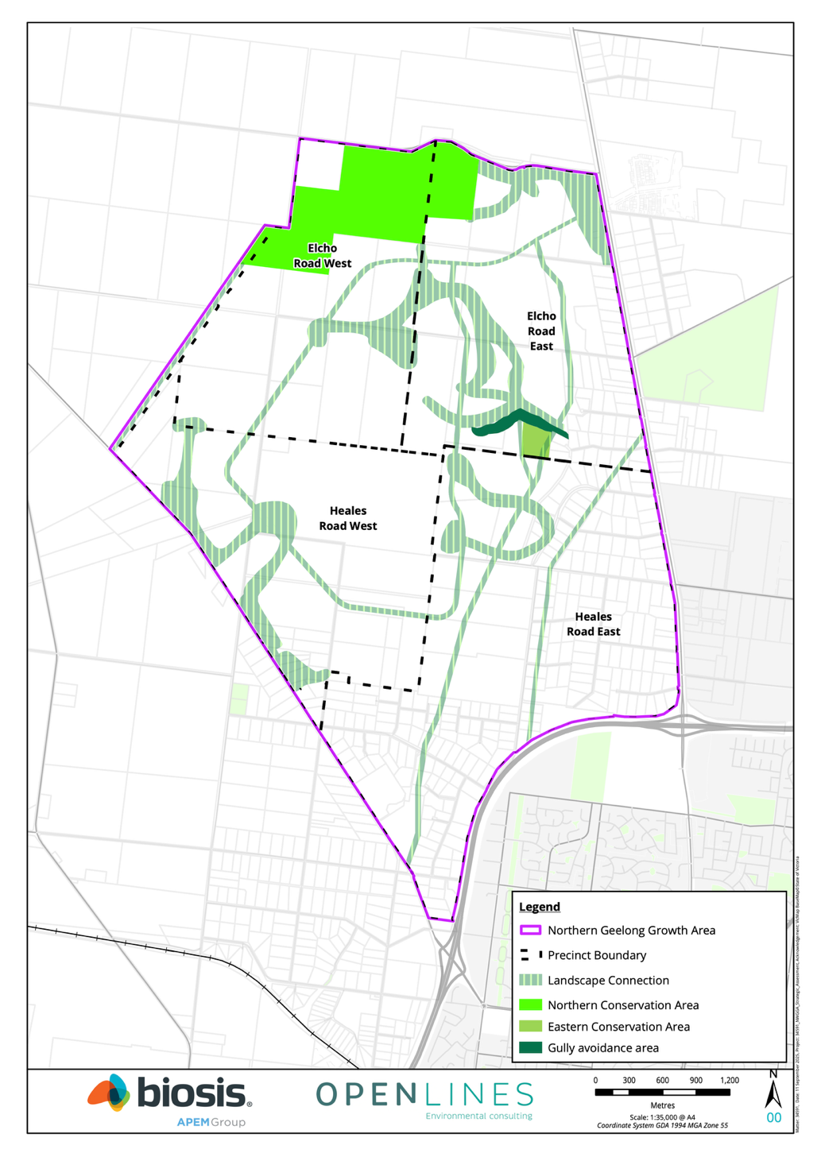
Figure 4-1: Biodiversity areas within the NGGA
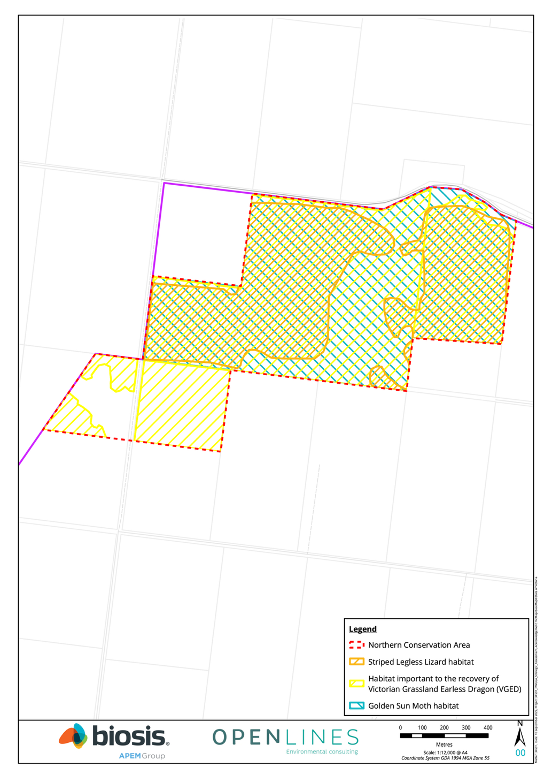
Figure 4-2: Northern Conservation Area
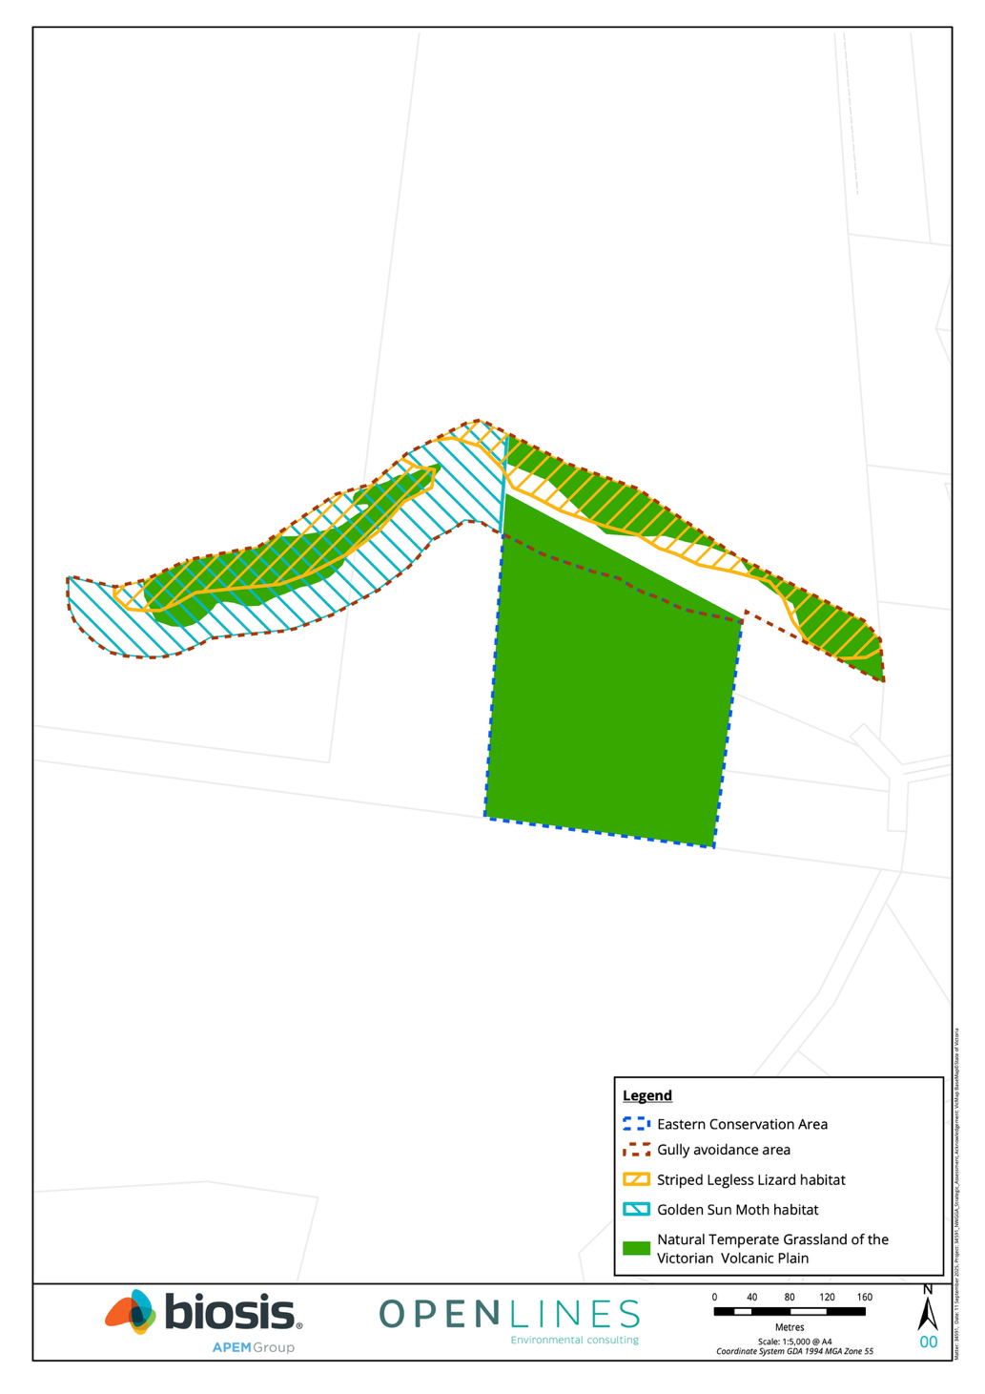
Figure 4-3: Eastern Conservation Area and gully avoidance area

Western Geelong Growth Area biodiversity areas
The WGGA includes two strategic conservation areas:
- Cowies Creek Conservation Area in the Creamery Road precinct
- Moorabool avoidance area in the Batesford North precinct
The strategic conservation areas within the WGGA are identified in Figure 4-4.
Additionally, the strategic planning process identified one additional strategic conservation area, the Moorabool River corridor, to protect State and local biodiversity values within the Growth Areas. While this area may have some benefits for MNES, it was not identified in the Plan as being needed for the protection of MNES. This area is discussed further below.
The strategic conservation areas and the avoidance area will be established to:
- Protect and regenerate biodiversity values along the creek/river corridors. This supports one of the Framework Plan’s urban development objectives which identifies Cowies Creek and the Moorabool River as priorities for the protection and regeneration of creek and river corridors
- Protect cultural heritage values. There are a range of sites of cultural heritage significance in the creek/river corridors and the conservation areas will provide a level of protection for these. This supports the same urban development objective in the Framework Plan as the one that relates to biodiversity
- Provide for some social and stormwater infrastructure within the precinct that is sympathetic to the protection of biodiversity and heritage values. Social infrastructure may include walking trails and some open space facilities

Cowies Creek Conservation Area
The Cowies Creek Conservation Area (Figure 4-5) supports:
- An important population of the Growling Grass Frog that is connected to a larger metapopulation downstream, as well as all remaining habitat for Growling Grass Frog in the WGGA
- A previously known record of Adamson’s Blown-grass
- Areas of mapped Creekline Grassy Woodland (EVC 68)
A key aim of the Cowies Creek Conservation Area will be to support the persistence of the Growling Grass Frog within the WGGA and maintain the metapopulation dynamics with the broader Cowies Creek metapopulation downstream. It will do this by:
- Protecting high quality instream habitat
- Helping to improve the condition of lower quality instream habitat
- Protecting terrestrial habitat in buffer areas adjacent to the creek
- Regenerating areas of terrestrial habitat that are degraded through historical land uses
- Providing for the creation of off-stream habitat
Cowies Creek downstream of the WGGA provides habitat for the connected metapopulation of Growling Grass Frog that occurs along the creek. There are a range of opportunities to enhance habitat within this area to support:
- Long-term viability of the metapopulation
- Persistence of the species within the WGGA
The following habitat enhancement works for Growling Grass Frog will be considered as part of a detailed design process for the area downstream of the WGGA:
- The creation of one or more off-line wetlands to create habitat for the species
- Vegetation management to improve habitat quality for the species
- Infrastructure changes to improve connectivity for the species under the Bluestone Bridge along Cowies Creek

The Cowies Creek Conservation Area will be a success if:
- The population of Growling Grass Frog persists and remains viable over the long term
- Habitat for Growling Grass Frog and potential habitat for Adamson's Blown-grass is retained and condition improves over time
- Metapopulation dynamics of Growling Grass Frog are retained with downstream populations of the species

Moorabool River Corridor and Moorabool avoidance area
The Moorabool River Corridor and Moorabool avoidance area (Figure 4-6) is located alongside the western edge of Batesford North and flows south to join with the Barwon River.
The avoidance and protection of the Moorabool River Corridor and adjacent floodplain and escarpment will protect a range of state and local biodiversity values.
The Moorabool River is an important biodiversity habitat corridor between the Brisbane Ranges National Park and the Barwon River, and sustains critical ecological processes for native fish, macroinvertebrates, mammals, birds, and vegetation communities (CCMA, 2016). The river supports a diversity of native vegetation along the length of the waterway. EVCs which have been modelled and mapped adjacent to the Moorabool River include Low Rainfall Plains Grassland (EVC 132_63), Plains Grassy Woodland (EVC 55), Floodplain Riparian Woodland (EVC 56) and Stream Bank Shrubland (EVC 851) (DELWP, 2005). The river also provides habitat for a number of native fish, including the Tupong (Pseudaphritis urvillii), Southern Pygmy Perch (Nannoperca australis), Australian Grayling (Nannoperca obscura), Common Galaxias (Galaxias maculatus) and Spotted Galaxias (Galaxias truttaceus) (CCMA, 2022). The river also supports the state significant Eastern Grey Egret (Ardea alba modesta) (CCMA, 2014). Growling Grass Frog has been recorded in the lower reaches of the Moorabool, near to the convergence with the Barwon River.
The Moorabool avoidance area supports:
- 7 ha of areas assumed to support potentially suitable habitat attributes for Victorian Grassland Earless Dragon
- 6.8 ha of mapped native vegetation (Plains Grassland EVC 132)
- 0.3 ha of mapped Floodplain Riparian Woodland (EVC 56)
The key aim of the avoidance area is to enhance the ecological values of the river corridor, floodplain and adjacent escarpment.
The avoidance and protection of the Moorabool River Corridor will contribute to landscape connectivity between the upper reaches of the Moorabool, through to the Barwon River and the downstream Lake Connewarre Wetland Complex (this forms part of the Port Phillip (Western Shoreline) and Bellarine Peninsula Ramsar Site).
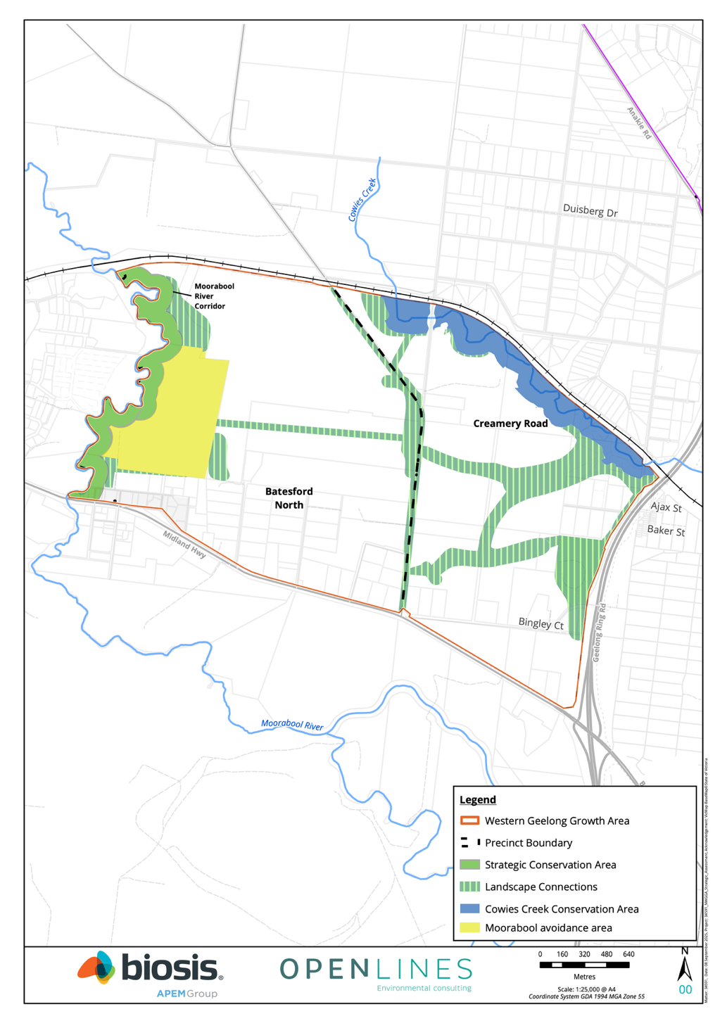
Figure 4-4: Biodiversity areas within the WGGA
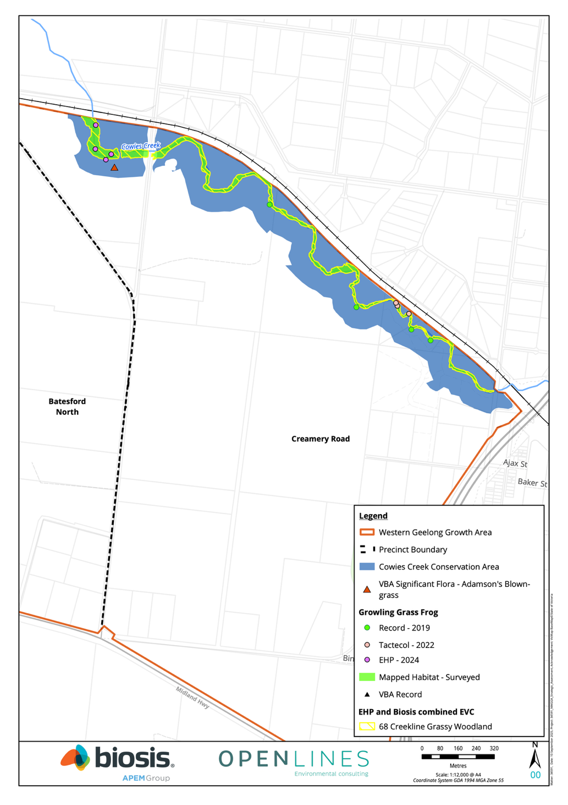
Figure 4-5: Cowies Creek Conservation Area
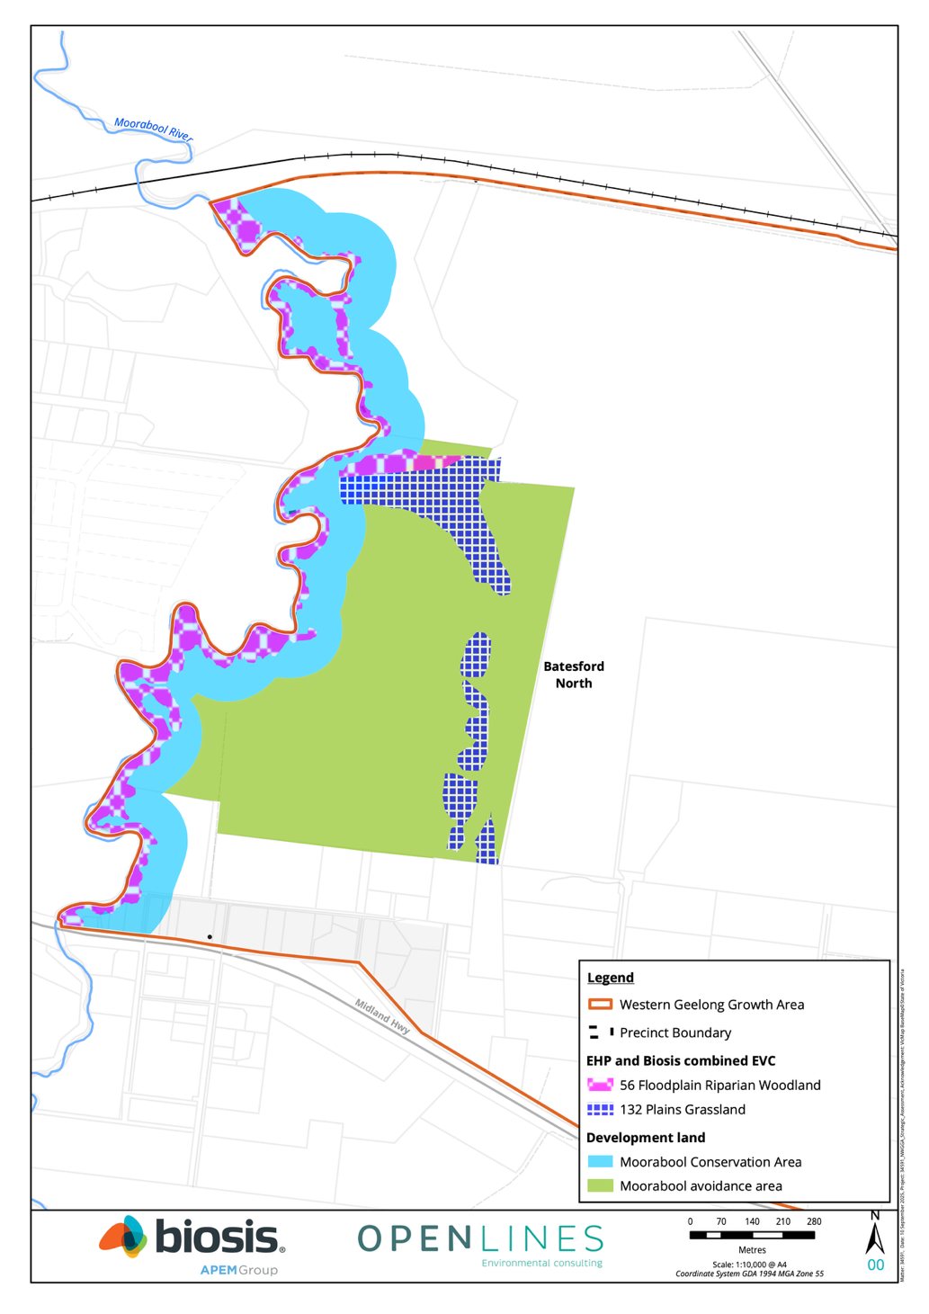
Figure 4-6: Moorabool River corridor and Moorabool avoidance area

Implementation processes and mechanisms to protect and manage biodiversity areas
Planning to finalise strategic conservation area boundaries
The boundaries of the Northern Conservation Area, Cowies Creek Conservation Area, Gully avoidance area and the Moorabool River corridor and Moorabool avoidance area are indicative and will be finalised following further detailed review and/or precinct planning.
Northern Conservation Area
The boundary of the Northern Conservation Area will be finalised following public exhibition and prior to submission of the final Plan to the Commonwealth for endorsement under Part 10 of the EPBC Act. The City is working through a process to ensure implementation of the Northern Conservation Area is feasible, timely, and delivers the desired conservation outcomes for MNES.
Gully avoidance area
The boundary of the Gully avoidance area will be finalised at the time of precinct planning, having regard to:
- Avoiding impacts to Natural Temperate Grassland and habitat for SLL and GSM
- Utility infrastructure siting and design
- Precinct connectivity and interface design
- Practical management
A plan that outlines the design, protection and enhancement of the avoidance area will be prepared and incorporated within the Elcho Road East PSP.

Cowies Creek Conservation Area
The boundary of the Cowies Creek Conservation Area will be finalised to ensure the conservation area includes all areas of habitat that may be needed to support the continued persistence of the Growling Grass Frog within the WGGA, including areas of habitat that may be used for breeding, foraging and movement.
One of the key considerations in finalising the boundary will include maintaining an appropriate corridor width to protect terrestrial habitat and buffer the instream habitat for Growling Grass Frog. Two guiding documents will be used for designing and managing the conservation area in relation to Growling Grass Frog – Growling Grass Frog Habitat Design Standards (DELWP, 2017b) and the Growling Grass Frog Crossing Design Standards (DELWP, 2017a).
It is also noted that the Growling Grass Frog Significant Impact Guidelines (DEWHA, 2009):
- Identify removal or degradation of habitat within 200 m of a water body as a likely significant impact to the species
- Recommend that buffer zones of at least 200 m around water bodies and dedicated terrestrial habitat corridors of at least 100 m be retained in avoiding and land from development and designing conservation areas
The topography of Cowies Creek and the current land use within the Creamery Road Precinct is not considered conducive to a buffer distance of 200 m. There is a significant break of slope at approximately 100 m from the creek line which is likely to represent the edge of the potential terrestrial habitat for the species. Beyond the break of slope there are significant areas of cropping and a lack of suitable habitat. This suggests that a layout that is based on the break of slope as the edge of the conservation area would be appropriate. This would maintain an average corridor width of approximately 100 m from the stream. Given the current use of Cowies Creek by the species, this is considered appropriate for the long term protection of the population in the WGGA.
The decision on the boundary of the conservation area would also consider the ephemeral stream that runs into Cowies Creek in the precinct, and the potential for that area to provide additional habitat for the species.

Moorabool River corridor and Moorabool avoidance area
The boundaries of the Moorabool River corridor and Moorabool avoidance area will be finalised to ensure the areas:
- Retain and incorporate biodiversity values associated with the river corridor in the strategic conservation area boundary including remanent vegetation.
- Utilises the full extent of the floodplain and escarpments and adjusted to reflect local topography
- Reflects the relevant priorities or standards in the Corangamite Waterway Strategy 2014-2022
- Includes a minimum of 100 m of riparian land from the top of bank within the Batesford North PSP
A master plan that outlines the protection and enhancement of the river corridor will be prepared and incorporated within the Batesford North PSP.

Planning controls and mechanisms to secure land
The strategic conservation areas will be protected through several planning controls as well as security agreements to ensure the protection of the land for conservation in-perpetuity.
The planning controls include:
- Identifying the strategic conservation areas in relevant PSPs as land to be protected for conservation in the urban structure maps of the precinct, to direct development away from these areas
- Applying an appropriate environment zone to the strategic conservation areas under the Greater Geelong Planning Scheme, to limit the use and development that can occur within the strategic conservation area
- Identifying the native vegetation in the strategic conservation areas as ‘to be retained’ within the relevant NVPPs, to ensure a permit is required to remove that native vegetation
Three of the strategic conservation areas have been identified as a priority for protection and management under the Plan:
- The Northern Conservation Area in the NGGA
- The Eastern Conservation Area in the NGGA
- Cowies Creek Conservation Area in the WGGA
The Northern Conservation Area and Eastern Conservation Area will be purchased and/or vested in the City as reserves to be managed for conservation purposes and will be managed in perpetuity as Commonwealth offset sites.
The other strategic conservation areas will be vested to the City or the Victorian Government as part of subdivision of the adjacent land as encumbered land. Where a lot does not contain developable land the City or Victorian Government will need to consider strategic purchase to secure the waterway corridors and conservation land.
The use of the Public Acquisition Overlay may be required by the City to secure strategic conservation areas.

Conservation management plans
The City will prepare and implement Conservation Management Plans (CMPs) over the life of the Plan to provide for the protection and ongoing management of the biodiversity values within the Northern Conservation Area, Eastern Conservation Area, and the Cowies Creek Conservation Area.
CMPs will be prepared in accordance with the Commonwealth Environmental Management Plan Guidelines (DoE, 2014). The CMP for Cowies Creek will also be prepared in accordance with the Growling Grass Frog Habitat Design and Crossing Standards (DELWP, 2017a).
Each CMP is proposed to include the following information, as relevant:
- Objectives of the CMP
- Boundaries of the conservation areas
- Native vegetation to be retained as identified in the relevant NVPP for the precinct
- Extent and condition of biodiversity values in the areas, including habitat and records
- Management actions and arrangements to protect, and where appropriate, restore, the biodiversity values of the conservation areas, including management methods, standards and techniques, roles and responsibilities, timing for implementation, funding and monitoring and reporting
- For the Northern Conservation Area, managing the threat of cat predation for Striped Legless Lizard and Victorian Grassland Earless Dragon
- For the Cowies Creek Conservation Area identify any locations suitable for public access points, walking paths/trails, passive recreation, and water management assets and associated infrastructure
The City proposes to fund the implementation of the CMPs using the implementation fund established under the Plan’s funding framework. The funding framework is described in Section 7-4 of the Plan, and the specific measures for funding are provided in the Commitments and Measures document.
Monitoring will be undertaken as part of the implementation to ensure that performance of each CMP is understood, and to ensure that management is responsive and adapts to any changing circumstances.
A draft of each CMP will be provided to DCCEEW, DEECA, Corangamite Catchment Authority and Wadawurrung Traditional Owners for consideration and comment prior to its finalisation and approval by the City.

Creating landscape connections
While the conversion of the growth areas to urban development will irreversibly change the ecological character and biodiversity values there is an opportunity to create urban environments that respect and restore aspects of the landscape.
The strategic conservation areas will provide the key network of conservation reserves, and these reserves will be complemented by a network of landscape connections that utilise biodiversity sensitive design interventions.
In areas nominated as landscape connections shown on Figure 4-1 and 4-2, the preparation of PSPs and landscape plans for resulting subdivisions should:
- Design areas of open space, local parks, recreation reserves, trails, landscape and amenity areas, heritage sites and land encumbered by infrastructure where possible to connect and buffer strategic conservation reserves and connect other green and blue areas within the landscape and promote the integration of biodiversity features
- Utilise water sensitive urban design principles to provide drainage infrastructure, such as wetlands, channels or detention basins that integrate biodiversity features and promote the connectivity within the landscape
- Retain and restore existing planted native and remanent vegetation in existing road reserves to create fauna connections
- Minimise the crossing of waterways to and linear reserves to reduce barriers to fauna connectivity
- Provide understorey and ground cover vegetation within landscape connections
- Consider significant view lines along landscape connections between urbanised and natural areas to promote connections with nature and the use of these assets
- Landscape design and planting schedules for landscape connections should reproduce the EVC that would have occurred naturally in the area – predominately Plains Grassland throughout the growth area
- Landscaping provided in landscape connections should:
  - Represent at least 30% of the original communities EVC diversity
  - Be based on the EVC benchmark tree densities
  - Ensure all plants are indigenous and of local providence
  - Where appropriate include other habitat elements such as wetlands, logs, rocks and stags
- Protect structurally sound old remnant and planted native trees within pocket parks or incorporate into road design to also maintain landscape and amenity values

Mitigation of impacts
Mitigating impacts to biodiversity values is the second step in the mitigation hierarchy. The mitigation process reduces how likely or significant unavoidable impacts may be and further reduces the need for offsets.
In addition to minimising impacts through the avoidance planning process, impacts on biodiversity values will be further minimised by managing development to mitigate indirect impacts on biodiversity values that are avoided or that occur outside the Growth Areas. Development within the Growth Areas has the potential to lead to a range of indirect impacts that may adversely affect surrounding biodiversity values. These impacts relate to:
- Altered fire regimes
- Changes to water flows and water quality
- Disturbance due to noise, dust, or light
- Disturbance from increased public access to natural areas
- Fauna mortality and barriers to movement
- Inadvertent impacts on adjacent habitat or vegetation
- Predation or competition by pest or domestic fauna
- Spread of infection or disease
- Spread of weeds
The BCS will seek to minimise these impacts by, including requirements to implement:
- Standard mitigation measures delivered through the planning system. The Victorian planning system will deliver a range of standard mitigation measures through the development and implementation of PSPs and the provisions of the Greater Geelong Planning Scheme. These include measures such as stormwater management, erosion control, and management of construction sites
- Additional specific mitigation measures to address key biodiversity values associated with waterways, riparian areas and wetlands, and to protect the strategic conservation areas are required and outlined below. These additional specific mitigation measures were defined through the assessment of the indirect impacts of the development on MNES in the EPBC Strategic Assessment Report. While these address specific risks to MNES associated with waterways, riparian areas and wetlands, and other biodiversity values within the strategic conservation areas, these additional measures will also minimise impacts to State and local biodiversity values
- Requirements to prepare and implement Conservation Management Plans for each of the strategic conservation areas
Table 4-3: National level commitments in relation to mitigation
No. | Commitment
13 | Standard mitigation measures will continue to be implemented to minimise the indirect impacts of the development on MNES in accordance with the requirements of the Greater Geelong Planning Scheme (The City of Greater Geelong, 2022), as updated from time to time, and generally in accordance with the Framework Plan (The City of Greater Geelong, 2021)
14 | The following additional specific mitigation measures will be implemented to minimise the indirect impacts of the development on the NGGA Conservation Area and Cowies Creek Conservation Area:  - Establish a conservation interface for the conservation areas  - Design and baffle public lighting in accordance with National Light Pollution Guidelines for Wildlife to prevent light spill and glare within the Cowies Creek Conservation Area  - Prepare Construction Environmental Management Plans for construction works on land immediately adjacent to the conservation areas
15 | Additional specific mitigation measures will be implemented to minimise the indirect impacts of the development on MNES associated with waterways, riparian areas and wetlands including:  - EPBC listed threatened and migratory birds  - Galaxiella toourtkoourt (Little Galaxias)  - Litoria raniformis (Growling Grass Frog)  - Nannoperca obscura (Yarra Pygmy Perch)  - Prototroctes maraena (Australian Grayling)  - Lachnagrostis adamsonii (Adamson’s Blown Grass)  - Port Phillip Bay (Western Shoreline) and Bellarine Peninsula Ramsar site
Table 4-4: State level commitments in relation to mitigation
No. | Commitment
iv | Conservation Management Plans will be prepared and implemented for the protection and ongoing management of biodiversity values within each of the strategic conservation areas
v | The following additional specific mitigation measures will be implemented to minimise the indirect impacts of the development on the environmental values of the strategic conservation areas:  - Establish a conservation interface for each strategic conservation area  - Design and baffle public lighting in accordance with National Light Pollution Guidelines for Wildlife to prevent light spill and glare within the strategic conservation areas  - Prepare Construction Environmental Management Plans for construction works on land immediately adjacent to the strategic conservation areas

Implementation of mitigation
Mitigation measures for biodiversity values will mostly be determined and implemented through the Victorian planning system as development proceeds (see Appendix A). This will deliver a range of standard mitigation measures that will address many of the potential indirect impacts of development within the Growth Areas.
The assessment of potential indirect impacts to MNES in the EPBC Strategic Assessment Report identified several additional specific mitigation measures beyond those that will be delivered through the existing planning system. These are required to address specific risks to MNES associated with waterways, riparian areas and wetlands, as well as other environmental values within conservation areas. These specific mitigation measures will also provide additional protection to State and local biodiversity values.
Any potential indirect impacts of development on Victorian biodiversity values will be assessed under the planning permit process at the time development is proposed. While the additional specific mitigation measures are expected to benefit and minimise impacts to the key environmental values (both MNES and Victorian values), the planning permit process may determine further additional mitigation measures are needed to address specific matters.

Implementation of additional specific mitigation measures

Waterways, riparian areas and wetlands commitment
The commitment relating to mitigating impacts on waterways, riparian areas and wetlands will be implemented through the preparation of technical studies to understand the key risks from development on MNES associated with Hovells Creek and the Moorabool River. These studies aim to:
- Address risks associated with changes to water quality and hydrology from the development in the Growth Areas
- Identify measures, standards or targets to mitigate impacts on MNES including, as relevant:
  - Water quality parameters
  - Water retention and flow management requirements
  - Limits on extraction or use
  - Habitat buffer requirements
  - Monitoring and reporting
Guidelines will be prepared based on the results of these studies to guide the preparation of PSPs and decisions on planning permits and permit conditions to ensure risks to MNES in relation to these impacts are adequately managed. A planning scheme amendment or other appropriate process will be undertaken to ensure the guidelines are considered during the preparation of PSPs and in decisions on planning permits and permit conditions.
Stormwater infrastructure and ongoing stormwater management will also be designed to be sympathetic to and not notably alter habitat for the Growling Grass Frog within downstream reaches of Cowies Creek.
To ensure an appropriate level of assurance for this commitment, monitoring and reporting on the inclusion of these specific mitigation measures in PSPs and/or as conditions on permits will be undertaken as part of the monitoring program and annual progress reporting under the Plan’s MERI program.

Planning for interfaces to conservation areas
In areas adjacent to strategic conservation areas, the preparation of PSPs and landscape plans for resulting subdivisions should:
- Establish a conservation interface for each strategic conservation area
- Locate active and passive recreation areas and stormwater infrastructure adjacent to strategic conservation areas where possible to maximise the separation of the strategic conservation areas from urban development
- Avoid back fences to strategic conservation reserves
- Provide a conservation interface street to strategic conservation area that provides for public access alongside the conservation reserve and maximises the buffer to the urban development
- Provide fire breaks and bushfire setback requirements within the urban development
- Provide fencing and landscape treatments that delineate the strategic conservation area from adjacent land use and manage access to the reserve in accordance with the objectives in the conservation management plan
- Design and baffle public lighting in accordance with National Light Pollution Guidelines for Wildlife to prevent light spill and glare within the strategic conservation areas
- Prepare Construction Environmental Management Plans for construction works on land immediately adjacent to the strategic conservation areas

Residual impacts and offsets
Offsetting impacts to biodiversity is the final step in the mitigation hierarchy. It is intended to compensate for any residual adverse impacts that remain after impacts have been avoided, minimised and mitigated. Offsets are required in relation to both Commonwealth and State regulatory processes.

Residual impacts from the development within the growth Areas

Matters of national environmental significance
The development under the Plan will result in the following residual impacts to MNES in the NGGA:
- Natural Temperate Grassland – 5.4 ha
- Striped Legless Lizard – 130.8 ha
- Golden Sun Moth – 624 ha (noting that 490.3 ha of this comprises areas of non-native vegetation)
- Habitat potentially important for the recovery of Victorian Grassland Earless Dragon – 44.2 ha
There will be no residual adverse impacts to MNES in the WGGA, and offsets are not necessary for development in that location.
A detailed assessment of the residual impacts of the development on MNES is provided in the Part 4 of the SAR.

State values
In addition to MNES, residual adverse impacts will also occur to native vegetation protected by State biodiversity policy
Within the NGGA, development will result in residual adverse impacts to 79.6 ha of mapped Low rainfall Plains Grassland (EVC 132_63). Within the WGGA, development within Creamery Road and Batesford North will result in residual adverse impacts to 35.2 ha of mapped Low rainfall Plains Grassland (EVC 132_63).
The impacts presented here are calculated conservatively by assuming that any land outside of the strategic conservation areas will be impacted. It is likely that there will be additional avoidance within the landscape connections for some of these values.

National offset commitments
Offsets are a requirement under the EPBC Act for residual adverse impacts to MNES. The EPBC Plan establishes a strategic offsets package which is designed to meet the principles of the EPBC Act Offsets Policy (Commonwealth of Australia, 2012) and maximise the benefits to MNES from applying a strategic approach. It does this through prioritising early offsetting with good landscape context.
Conservation planning science (e.g., (Gordon et al., 2011; Gordon and Peterson, 2019)) confirms the benefits of these approaches and supports the premise that the EPBC Plan’s approach to offsets will be substantially stronger than what would occur under standard project-by-project approvals.
A detailed description of the EPBC offsets package is provided within Supporting Document D to the SAR, and a brief summary is provided here.
The EPBC Plan makes several national level commitments in relation to offsets (see Table 4-5). These commitments will lead to:
- Protection and management of the Northern and Eastern Conservation Areas to provide benefits for Natural Temperate Grassland, SLL, GSM, and habitat that may be important for the recovery of VGED
- Protection and management of the remaining offsets for Natural Temperate Grassland, SLL and GSM outside the Growth Areas
- Delivery of early offsets (by the end of year 5) for each MNES
- Offset delivery keeping pace with and occurring ahead of impacts
Table 4-5: National level commitments in relation to offsets
No. | Commitment
4 | The Northern Conservation Area will be established in perpetuity to avoid and protect 77.7 ha of habitat for Striped Legless Lizard, 119.5 ha of habitat for Golden Sun Moth and 125.3 ha of habitat potentially important for the recovery of Victorian Grassland Earless Dragon
5 | A Conservation Management Plan will be prepared and implemented for the protection and ongoing management of Striped Legless Lizard, Golden Sun Moth and Victorian Grassland Earless Dragon within the Northern Conservation Area
6 | The Eastern Conservation Area will be established in perpetuity to avoid and protect 6.7 ha of Natural Temperate Grassland
7 | A Conservation Management Plan will be prepared and implemented for the protection and ongoing management of Natural Temperate Grassland within the Eastern Conservation Area
16 | Offset sites will be established to meet the following targets:  - 13.9 ha of Natural Temperate Grassland  - 331.2 ha of known habitat for Striped Legless Lizard  - 500.7 ha of known habitat for Golden Sun Moth  These offsets will be delivered through a combination of:  - The Northern and Eastern Conservation Areas (Commitments 4 and 6), and  - Strategic offset locations outside of the NGGA to meet the balance of the offset targets
17 | Offset delivery will keep pace with and occur ahead of impacts within the NGGA

Implementation of the EPBC offsets package
The EPBC offsets package will be implemented through a set of detailed measures which are set out in the Commitments and Measures document and are discussed in detail in Supporting Document D to the SAR. In summary, implementation is designed to ensure successful delivery and address the risks associated with a large scale, strategic approaches to offsets.
In particular, implementation of the offsets package will:
- Be coordinated and managed by the City
- Focus on offset sites that are as large as possible and well placed in the landscape to maximise the long term conservation outcomes. Offset sites should be located as close to the Growth Area as possible. However, if it can be shown that a greater conservation benefit for the impacted protected matter can be achieved by providing an offset further away, then this will be considered
- Use accepted mechanisms to secure and manage sites in-perpetuity
- Apply a set of contingency steps if offsets are not tracking appropriately

State offsets Commitments
The following State level commitment is made in relation to offsets:
Table 4-6: State level commitment in relation to offsets
No. | Commitment
vi | State offsets to compensate for the loss to biodiversity from the removal of native vegetation will be provided in accordance with the Guidelines for the removal, destruction or lopping of native vegetation (DELWP, 2017c)

Implementation of State offsets
As per the commitment, State offsets and will be delivered according to the requirements of the Guidelines for the removal, destruction or lopping of native vegetation. The detailed measures to implement the State offset commitment are set out in the Commitments and Measures document.
Preparation of Native Vegetation Precinct Plans
NVPPs will be prepared as part of each PSP process, which will identify native vegetation to be retained and removed across each precinct. NVPPs will outline the offset requirements for native vegetation that can be removed and will detail the obligations for each property within the precinct. NVPPs and planning permits issued for use and development will require offset obligations to be met prior to impacts occurring.

Securing of native vegetation offset credits
The securing of State offsets will be the responsibility of the individual proponent based on their proposed level of impact. It is expected that proponents will secure offsets through the existing Victorian Native Vegetation Credit Register (NVCR).
Ongoing management, monitoring and reporting on the secured offsets will occur through DEECA’s standard processes.
Co-location with Commonwealth offsets
State biodiversity policy requires native vegetation offsets to be secured within the same LGA or CMA region in which the impacts occur. For the Growth Areas this includes the Greater Geelong LGA or the Corangamite CMA. However, at the Commonwealth level, offsets are only required to be like-for-like in terms of the values (or MNES) that are being impacted. This means that suitable offsets can be delivered some distance from development as long as they are protecting the same MNES and associated habitat that is being impacted.
The co-location of State offsets with Commonwealth offsets is preferable in terms of cost efficiencies (i.e., reducing the need to purchase separate offsets). However, potential third-party offset sites supporting the MNES that are being impacted within the Growth Areas are either extremely scarce or unavailable elsewhere within the Greater Geelong LGA or Corangamite CMA. Competing interests such as other preferable land-uses and high land values contribute to this issue. Therefore, it is expected that State offsets will be decoupled from the Commonwealth offsets and delivered separately.
If proponents are successful in finding and securing a site that can achieve co-location of State and Commonwealth offsets and offset registration timing aligns, then co-located offsets would be viable, subject to DEECA and DCCEEW approval processes.

Past removal of native vegetation and assumed and consequential losses
The City will consider cumulative impacts in the context of past removal of native vegetation and assumed and consequential losses at a precinct scale through the preparation of PSPs and NVPPs for each precinct.
State policies in relation to native vegetation removal, including the Native Vegetation Guidelines, do not provide for the assessment of native vegetation removal at a Growth Area scale. To the extent that the policies set out in the Native Vegetation Guidelines are relevant in a strategic planning context, they are applicable at a precinct scale.
The Growth Areas comprise six PSP and NVPP areas. Each PSP and NVPP will be the subject of a separate planning approval process under the Planning and Environment Act 1987 (PE Act), and relevant policies in the Native Vegetation Guidelines in relation to native vegetation removal will be considered and applied at that stage of the planning process.
The Native Vegetation Guidelines are required to be considered by the City when preparing each of the planning scheme amendments for the nine PSPs within the Growth Areas, and are required to be applied by the City when developing each of the NVPPs. In these circumstances, the Growth Areas are best understood as a series of separate projects comprising each PSP, NVPP and associated planning scheme amendment.
This precinct-scale approach further supported by guidance in the Assessor’s Handbook (DELWP, 2018). The Assessor’s Handbook includes a set of criteria in Table 11 of the handbook and descriptions and examples at pages 48 to 50 to help determine if development should be considered as a single project or multiple separate projects.
The criteria in Table 11 of the Assessor’s Handbook and a brief response to each is set out in Table 4-7. The guidance in the handbook supports the consideration of State policies in relation to native vegetation removal at a precinct scale.
This precinct-scale approach is also consistent with the current approach across Victoria in areas of large scale urban development, where in practice, individual PSP and NVPPs are commonly treated as a separate project in the application of State policies in relation to native vegetation removal.
Table 4-7: Consideration of criteria in Table 11 of the Assessor’s Handbook
Criteria | Response
Is the entire project planned by one applicant? | The City is preparing a series of separate and distinct PSPs and NVPPs which will be the subject of individual planning scheme amendments within the Growth Areas over a period of approximately 10 to 15 years
Will the project receive a single approval? | Each PSP and NVPP will receive a single approval via an associated planning scheme amendment (rather than the Growth Areas receiving a single approval)
Will the project be funded to meet a single objective? | Each PSP will be prepared and funded to achieve multiple objectives, and those objectives will not be defined until the relevant PSP is prepared. Funding agreements with different landholders will facilitate the individual PSPs
Were all components or stages of the project planned together? | All components of an individual PSP and NVPP will be planned together at a level of detail that allows an assessment of native vegetation removal. Conversely, when the Framework Plan was implemented in the planning scheme, the components of the Growth Areas were not planned together at a level enabling this assessment
Are all components or stages of the project reliant on each other? | All components of an individual PSP and NVPP are reliant on each other and are planned together and introduced via a specific planning scheme amendment. The six PSPs within the Growth Areas are not wholly reliant on each other, and can progress individually in the absence of the other PSPs
Are the individual components or stages or the project in close proximity? | The components of the individual PSPs and NVPPs are interconnected and in close proximity to each other. The individual precincts which make up the Growth Areas are not all in close proximity to each other

Risks associated with offset availability and delivery certainty
One of the key risks in relation to both Commonwealth and State offsets are potential challenges in finding and securing suitable offsets over time. It is anticipated that there will be a diminishing supply of suitable offset sites over time due to declining environmental values and competition in the offset market as other large projects also seek to offset their impacts.
At a minimum, the delivery of offsets will need to keep pace with the timing of impacts. There is a risk that development could be stalled where there is a delay in finding and securing offsets.
To minimise this risk eventuating, the EPBC Plan commits to securing a significant proportion of Commonwealth offsets early when it is anticipated that the offset market will be less constrained. This also drives improved conservation outcomes due to the benefits of advanced offsetting. Analysis about likely State offsetting requirements suggests that risks around offset availability is likely to be substantially lower.

Implementation
The steps required to implement the conservation program and commitments from the BCS are set out in Table 5-1.
Table 5-1: Steps to implement the conservation program and commitments from the BCS
Action | Timing | Responsibility
Undertake a planning scheme amendment to the Greater Geelong Planning Scheme to update the Framework Plan and Clause 11.02 to:  On the future urban structure include the:  - Northern Conservation Area  - Eastern Conservation Area  - Gully avoidance area  - Cowies Creek Conservation Area  - Moorabool avoidance area  In Clause 11.02 include:  - Strategy to confirm the protection of the strategic conservation areas and avoided areas for conservation purposes.  - Introduce the Funding Framework to provide for the coordinated funding and delivery of offsets in the Northern Growth Area. | Immediately following Council adoption of the EPBC Plan and BCS | City of Greater Geelong – Strategic Planning
Apply the public acquisition overlay to properties identified for conservation purposes where a strategic purchase by the City or Victorian Government is required. | As required to facilitate land acquisition | City of Greater Geelong – Strategic Planning
Incorporate biodiversity sensitive urban design responses into the preparation of PSPs to facilitate the landscape connections shown in the BCS. | During preparation of a PSP | City of Greater Geelong – Strategic Planning
Prepare NVPPs for each precinct based on the retention of native vegetation identified in the BCS. | Concurrently with the preparation of the BCS | City of Greater Geelong – Strategic Planning
Prepare ecological and water studies for the Hovells Creek and Moorabool River to ensure that stormwater from development does not directly or indirectly the downstream RAMSAR wetland and local biodiversity values. | During the preparation of the Elcho Road East PSP and Batesford North PSP. | City of Greater Geelong – Strategic Planning
Prepare conservation management plans for the Northern Conservation Area, Eastern Conservation Area and Cowies Creek Conservation Area. | Concurrently with the PSP containing the conservation area | City of Greater Geelong – Environmental Planning
Ensure that preparation of PSPs including strategic conservation areas includes appropriate consideration of the conservation interface and future development is required to prepare and comply with a construction environment management plan for works within or adjacent to a conservation reserve. | During the preparation of the UGZ schedule and requirements and guidelines in the PSP | City of Greater Geelong – Strategic Planning and Environmental Planning
Apply appropriate zoning (e.g. public conservation and resource zone) to strategic conservation areas and avoidance areas when preparing precinct structure plans | During the preparation of the PSP and UGZ schedule | City of Greater Geelong – Environmental Planning
Prepare landscape and planting guidelines for public and private development within and adjacent to blue-green infrastructure and identified as landscape connections. | Prior to subdivision applications being considered in the growth areas | City of Greater Geelong – Environmental Planning

Assurance
Delivery of the BCS is supported by, and builds on, the assurance framework set out in Section 6 of the EPBC Plan to help ensure that implementation is successful. There are significant efficiencies in applying the same assurance approach to deliver both the national and State level commitments and measures that are set out in the BCS.
A high-level summary of the approach to assurance is presented here with details provided in the EPBC Plan and the Commitments and Measures document.
The key elements of assurance are:
- A strong set of governance arrangements to support delivery of the commitments and measures. The City will lead implementation and work with regulators, developers, landholders and other stakeholders to implement the BCS
- A funding program established by the EPBC Plan to implement the national level commitments and measures. This will be supported by additional funding through standard PSP and development processes to implement State level commitments and measures
- Implementation of a monitoring, evaluation, reporting and improvement (MERI) program to provide a system for understanding if outcomes and commitments are being achieved, communicating to regulators and the public, and adapting implementation as needed. The State level outcomes, commitments and measures will be integrated into the MERI program established by the EPBC Plan
- A compliance program to ensure commitments and measures that relate to third-parties are implemented appropriately

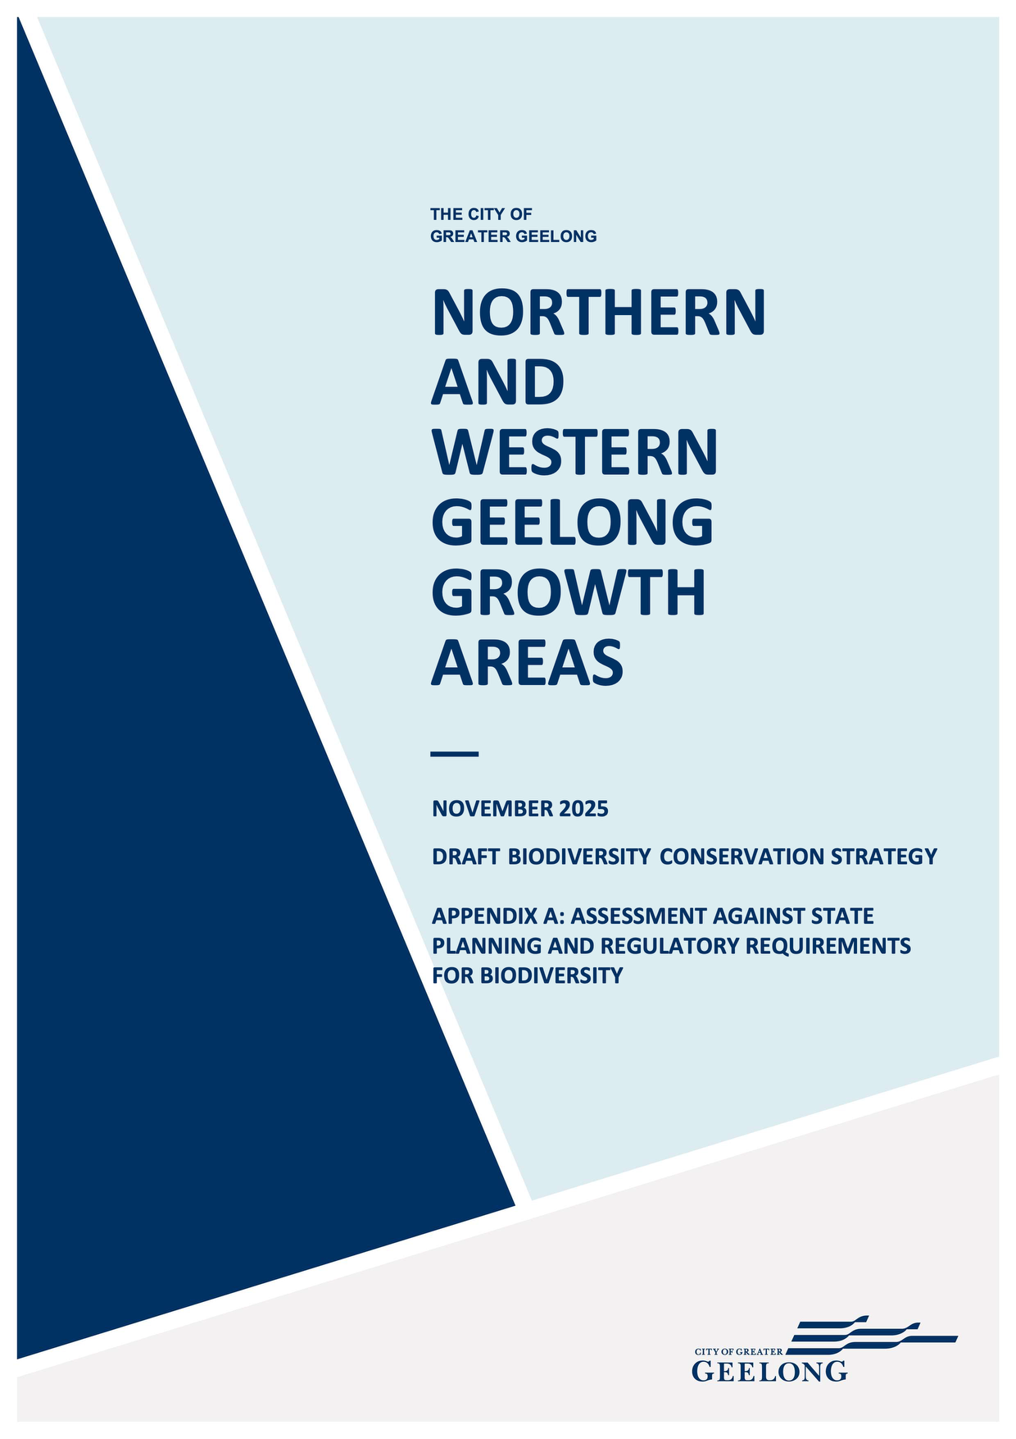

DOCUMENT TRACKING
PREPARED BY:
Tom Holden (Open Lines)
REVIEWED BY:
Heather Tolley, Peter Hemphill (Open Lines)
Mitchell Deaves (Biosis)
VERSION CONTROL:
VERSION: | Public re-exhibition version
DATE: | November 2025

Contents of Appendix A
Assessment against state policies 1
Introduction 1
Planning Policy Framework Clause 12.01 ‘Biodiversity’ 1
ESO4 – Grasslands within the Werribee Plains Hinterland 4
FFG Act ‘biodiversity duty’ 8
References A

Assessment against state policies

Introduction
This section provides responses to each of the specific requirements of:
- PPF Clause 12.01 ‘Biodiversity’
- Environmental Significance Overlay 4
- Section 4B of the Flora and Fauna Guarantee Act (FFG Act) (the FFG Act ‘biodiversity duty’)
It draws on and refers to the more detailed descriptions for how the City has addressed considerations that are common across these key State planning and regulatory requirements for biodiversity in Appendix A.

Planning Policy Framework Clause 12.01 ‘Biodiversity’
The PPF is the policy content of planning schemes. The PPF provides context for spatial planning and decision-making by planning and responsible authorities. A planning policy includes objectives (a statement of what a policy seeks to achieve) and strategies (statements that outline how an objective is to be achieved). A planning policy may also include policy guidelines, which indicate how an objective can be met and how a strategy can be implemented.
A planning authority must take into account the PPF when preparing an amendment to a planning scheme. A responsible authority must take into account and give effect to the PPF when it makes a decision under the planning scheme, such as a decision to grant a permit for use or development.

Clause 12.01-1S
Clause 12.01-1S – ‘Protection of biodiversity’ includes an objective to ‘protect and enhance Victoria’s biodiversity’ and identifies a range of strategies to achieve this objective, and is assessed in Table 13.
Table 13: Assessment against Clause 12.01-1S
Strategies | Response
Use biodiversity information to identify important areas of biodiversity, including key habitat for rare or threatened species and communities, and strategically valuable biodiversity sites | The BCS uses the best available biodiversity information to identify important areas of biodiversity and inform decisions to protect biodiversity within the Growth Areas (see Section 3.2.1). This information included:  - Ecological surveys across the majority of the Growth Areas by Ecology and Heritage Partners (EHP, 2021)  - Species records obtained through the VBA (DELWP, 2022b)  - DELWP habitat and vegetation modelling (DELWP, 2005, 2017d)  State and local biodiversity values will be further considered during precinct planning through the preparation of NVPPs and to meet any additional requirements of the Greater Geelong Planning Scheme
Strategically plan for the protection and conservation of Victoria’s important areas of biodiversity | The BCS is part of a strategic planning process undertaken by the City to identify areas for development and growth to meet economic, social and planning challenges and protect high biodiversity value areas (see Section 2.2.4)  The strategic planning process for the Growth Areas involved several key steps that are consistent with the steps outlined in Planning for biodiversity: guidance (DELWP, 2017e). It has led to the avoidance of the most important biodiversity in the Growth Areas within strategic conservation areas. These are high biodiversity value areas that contain the most important national, State and local biodiversity values in the Growth Areas and are considered likely to be viable in the long-term because of their size, condition, shape and location in the landscape  Furthermore, the City’s strategic approach to offsetting MNES under the EPBC Plan aims to protect and conserve important areas of biodiversity outside the Growth Areas and maximise the biodiversity benefits of offsetting MNES. This approach will also benefit State biodiversity values with habitat in the Growth Areas, including Golden Sun Moth and Striped Legless Lizard. This strategic approach to offsetting will be achieved through two key approaches:  - Prioritising advanced offsetting, early in the life of the Plan  - Strategic site selection that focuses on large sites that are well located in the landscape. Priority will be given to offset sites that are larger and adjacent to and/or connected to other patches of habitat (including reserves) and that could form broad habitat corridors across the landscape  The strategic delivery of offsets is described in the NWGGA Strategic Assessment Report (see Chapter 29.3)
Ensure that decision making takes into account the impacts of land use and development on Victoria’s biodiversity, including consideration of:  - Cumulative impacts  - Fragmentation of habitat  - The spread of pest plants, animals and pathogens into natural ecosystems  - Avoid impacts of land use and development on important areas of biodiversity | The BCS was informed by a strategic assessment process that assessed the impacts of the development in the Growth Areas on MNES in the NWGGA Strategic Assessment Report and informed the development of the commitments and measures in the BCS to address these impacts. This included long and short-term impacts, direct and indirect impacts, and cumulative impacts. The NWGGA Strategic Assessment Report also considers potentially threatening processes including the fragmentation of habitat and the spread of pest plants and animals and pathogens. The overall beneficial and detrimental impacts of the development and BCS, taking into account the commitments and measures in the BCS to address these, are also evaluated  The impacts of the development on State biodiversity values, including cumulative impacts in the context of past native vegetation removal, will be assessed during precinct planning through the preparation of NVPPs and to meet any additional requirements of the Greater Geelong Planning Scheme.  There is no guidance as to how cumulative impacts should be considered to meet; including how cumulative impacts should be defined or the scale at which these impacts should be assessed. The City has therefore sought to meet these obligations relating to cumulative impacts in three different ways:  - By meeting the cumulative impact requirements relating to past vegetation removal that are set out in the Native Vegetation Guidelines  - In developing the BCS and implementing the strategic biodiversity planning steps at the Growth Area scale. By planning for biodiversity at this scale, as opposed to site or precinct scale planning, this process has delivered some of the key elements of cumulative impact assessments. Namely, understanding how biodiversity values are represented and distributed at a broader landscape scale in order to:  - Avoid and manage the most important and viable areas for long-term protection  - Identify corridors or linkages across the landscape  - Most appropriately focus development and impacts on the areas with the least biodiversity value  - In undertaking a cumulative impact assessment as part of the strategic assessment under Part 10 of the EPBC Act. This assessment is presented in the Strategic Assessment Report and aimed to:  - Understand cumulative impacts and threatening processes to MNES in the Study Area, which included the NGGA, the northern two precincts in the WGGA, the bordering ‘strategic assessment area’ and the landscape within a 20 km radius of that area  - Understand how development under the Plan may contribute to or exacerbate these threatening processes  - Evaluate the adequacy of the EPBC Plan's proposed avoidance, mitigation, and offset commitments in relation to these threatening processes
Avoid impacts of land use and development on important areas of biodiversity | The BCS was informed by an avoidance planning process undertaken for the development within the Growth Areas to avoid and minimise impacts to biodiversity values (see Section 4.2). The BCS avoids and protects ‘strategic conservation areas’, which contain the most important national, State and local biodiversity values in the Growth Areas and are considered most likely to be viable in the long-term because of their size, condition, shape and location in the landscape
Consider impacts of any change in land use or development that may affect the biodiversity value of national parks and conservation reserves or nationally and internationally significant sites, including Ramsar, JAMBA, CAMBA, and ROKAMBA sites | Three areas of the Port Phillip Bay (Western Shoreline) and Bellarine Peninsula Ramsar site occur within the Study Area (Point Wilson/Limeburners Bay, Werribee/Avalon, and Lake Connewarre Complex). The potential impacts of the development on the ecological character of this site are assessed in Chapter 22 of the NWGGA Strategic Assessment Report and relate to:  - Changes to water flows and quality  - Disturbance from increased public access to natural areas  The BCS includes commitments and measures that are expected to adequately manage the potential indirect impacts of the development on the Port Phillip Bay (Western Shoreline) and Bellarine Peninsula Ramsar site. These include:  - Continuing to implement standard mitigation measures to minimise the indirect impacts of the development in accordance with the requirements of the Greater Geelong Planning Scheme  - Implementing specific mitigation measures to minimise the indirect impacts of the development on protected matters associated with waterways, riparian areas and wetlands including:  - Galaxiella toourtkoourt (Little Galaxias)  - Litoria raniformis (Growling Grass Frog)  - Prototroctes maraena (Australian Grayling)  - Lachnagrostis adamsonii (Adamson’s Blown-grass)  - Port Phillip Bay (Western Shoreline) and Bellarine Peninsula Ramsar site

Clause 12.01-1L
Clause 12.01-1L – ‘Protection of biodiversity’ includes a single strategy, and is assessed in Table 14.
Table 14: Assessment against Clause 12.01-1L
Strategy | Response
The City has considered this PPF strategy in developing the BCS. The BCS establishes a set of outcomes and commitments and measures that will protect and restore and enhance biodiversity and ecological processes. These are set out in the BCS and include the protection and management of the:
- Northern Conservation Area
- Eastern Conservation Area
- Gully avoidance area
- Cowies Creek Conservation Area
- Moorabool River Corridor
- Moorabool avoidance area
Together, these areas will protect:
- The largest habitat area for Striped Legless Lizard in the NGGA
- A substantial area of habitat for Golden Sun Moth in the NGGA
- All habitat for Growling Grass Frog within the WGGA
- Multiple other national, State and local biodiversity values
- Areas of key habitat connectivity across the Growth Areas
- Riparian areas that will help maintain ecological processes and water flows and quality

ESO4 – Grasslands within the Werribee Plains Hinterland
Schedule 4 to clause 42.01 ESO ‘Grasslands within the Werribee Plains Hinterland’ is an overlay shown on the Greater Geelong planning scheme map as ESO4. The ESO was applied by the Victorian Government in 2010 through planning scheme amendment VC68. This was introduced to support the objectives of Delivering Melbourne’s Newest Sustainable Communities, which included a review of Melbourne’s urban growth boundary and the identification of four new growth areas for Melbourne, and the outcomes of the Melbourne Strategic Assessment conducted under Part 10 of the EPBC Act. Melbourne’s new growth areas are resulting in impacts to native grasslands of the Victorian Volcanic Plain. ESO4 applies to areas of native grasslands and associated vegetation communities within the City of Greater Geelong and a similar control applies to several other local government areas on the volcanic plain to provide an additional level of protection to these areas. The ESO was intended to be revised within a few years on the basis of more detailed mapping of native grasslands across the Werribee Plains, to better target the ESO to the most important areas (DSE, 2009).
As part of the permit application process for use of development or to subdivide land, the ESO requires proponents to prepare a flora and fauna assessment for the land, including a flora and fauna survey and habitat hectare assessment, and a land and environmental management plan, including measures for revegetation, and weed and pest animal management.
The statement of environmental significance for ESO4 states the native vegetation of the Victorian Volcanic Plain is some of the most depleted vegetation in Victoria. The Werribee Plains hinterland, which is part of the volcanic plain, formerly supported extensive areas of native grasslands that integrated with other vegetation communities, including woodland communities in riparian areas. Although the vegetation has been extensively cleared, some large areas of native vegetation remain that are also important for several threatened species, including Spiny Rice-flower and Striped Legless Lizard. The Statement of environmental significance concludes:
[Despite the loss and degradation of native vegetation] … a range of conservation assets are present and significant opportunities exist to establish relatively large areas and networks of areas that are managed sympathetically for conservation. Such networks could include a range of vegetation types and land tenures and relatively large and intact areas of open grassland, grassy woodland and wetland communities.
Development within the Growth Areas consistent with the biodiversity outcomes of the BCS would lead to the removal of native vegetation and habitat on some land within ESO4. This would comprise land that is not included in areas to be avoided and protected under the BCS through strategic conservation areas.
Despite the BCS leading to the removal of native vegetation and habitat within the ESO, the City considers the BCS is consistent with the environmental objectives of the ESO4 (see Table 15). The City also considers the BCS is likely to improve outcomes for native grasslands compared to individual permit applications under the ESO 4 requirements, as the detailed ecological assessment and avoid, minimise and offset requirements have been applied in a strategic planning context (see Table 15 and further discussion of the benefits of strategic planning in Section 4.2.
ESO4 is proposed to be removed from areas identified for urban development in the Framework Plan as part of the planning scheme amendment to implement the BCS and the outcomes from the EPBC Plan (see Section 1.3 of the BCS). The ESO4 will be retained on the land within the Northern and Eastern Conservation Areas to provide additional protection to these areas.
Table 15: Response against each environmental objective of ESO4
Objective of ESO4 | Response
To prevent a decline in the extent and quality of native vegetation and native fauna habitat of the Victorian Volcanic Plain | The City considers that the BCS will ensure the development in the Growth Areas does not lead to a decline in the extent and quality of native vegetation and fauna habitat of the Victorian Volcanic Plain. This outcome is being achieved through:  - Strategic planning – the BCS was developed as part of a strategic planning process (see Section 4.2). Strategic planning is the most effective planning process to protect and conserve biodiversity (DELWP, 2017e). The strategic planning process has led to the avoidance and protection of the most important biodiversity in the Growth Areas within the strategic conservation areas. These are high biodiversity value areas that contain important national, State and local biodiversity values and are considered likely to be viable in the long-term because of their size, condition, shape and location in the landscape. Strategic planning has also enabled a strategic approach to offsetting MNES under the EPBC Plan (see NWGGA Strategic Assessment Report Chapter 29.3), which aims to protect and conserve important areas of biodiversity outside the Growth Areas and maximise the biodiversity benefits of offsetting MNES. This approach will also benefit State biodiversity values with habitat in the Growth Areas, including Golden Sun Moth and Striped Legless Lizard. This strategic approach to offsetting will be achieved through two key approaches:  - Prioritising advanced offsetting, early in the life of the Plan  - Strategic site selection that focuses on large sites that are well located in the landscape from a biodiversity perspective. Priority will be given to offset sites that are larger and adjacent to and/or connected to other patches of habitat (including existing reserves) and that could form broad habitat corridors across the landscape  - Assessing the impacts of the development on biodiversity values and understanding the implications of these impacts for the persistence of biodiversity values in the Growth Areas. For nationally listed matters, this was done through the NWGGA Strategic Assessment Report. For State and local biodiversity values, this will be done during precinct planning through the preparation of NVPPs and to meet any additional requirements of the Greater Geelong Planning Scheme. NVPPs will be prepared in accordance with Clause 52.16, including the Native Vegetation Guidelines (DELWP, 2017c)  - Establishing a set of outcomes and commitments and measures in the BCS to address the impacts of the development on biodiversity values and the implications of these impacts for the persistence of biodiversity values  The outcomes, commitments and measures will be monitored and adaptively improved if necessary over time to ensure they are achieved and that biodiversity values are protected in the long-term
To enhance the environmental and landscape values of the area | The City considers that the BCS will enhance the environmental and landscape values of the Geelong area. The BCS establishes a set of outcomes and commitments and measures that will protect and enhance biodiversity values and ecological processes within the landscape  These include the protection and management of the strategic conservation areas within the Growth Areas. The primary purpose of these conservation areas is the protection, management and restoration of biodiversity values, including native grasslands and fauna habitat. Conservation Management Plans will be prepared and implemented for the areas that will include management actions to improve the condition of Natural Temperate Grassland and habitat for Striped Legless Lizard and Golden Sun Moth in the northern Growth Area, and Growling Grass Frog along riparian corridors in the Western Growth Area  The BCS also provides for a strategic approach to offsetting MNES under the EPBC Plan (see NWGGA Strategic Assessment Report Chapter 29.3). This approach will also benefit State biodiversity values with habitat in the Growth Areas, including Golden Sun Moth and Striped Legless Lizard. This approach improves the outcomes of offsetting and ensures the BCS contributes to this ESO objective of enhancing the landscape values of the area
To avoid the fragmentation of contiguous areas of native vegetation or native fauna habitat | The City considers the BCS avoids fragmentation of the most important areas of native vegetation and fauna habitat in the Growth Areas. The BCS was informed by an avoidance planning process undertaken for the development within the Growth Areas to avoid and minimise impacts to biodiversity values (see Section 4.3.2). The BCS will protect and manage strategic conservation areas, which contain the most important national, State and local biodiversity values in the Growth Areas and are considered most likely to be viable in the long-term because of their size, condition, shape and location in the landscape  The strategic conservation areas will avoid and protect:  - The largest habitat area for Striped Legless Lizard in the NGGA  - A substantial area of habitat for Golden Sun Moth in the NGGA  - Multiple other national, State and local biodiversity values  - Areas of key habitat connectivity across the Growth Areas  The BCS identifies several further opportunities to avoid and minimise impacts on biodiversity values in the Growth Areas within biodiversity opportunity areas and investigation areas. Opportunities for further avoidance and minimisation within these areas will be considered further during precinct planning through the preparation of NVPPs and to meet any additional requirements of the Greater Geelong Planning Scheme. The BCS includes commitments and measures to consider further avoidance within these areas, and identifies through precinct profiles the opportunities and priorities that should be considered in making decisions on further avoidance of these areas during precinct planning  The BCS also includes commitments and measures to minimise the impacts of the development on surrounding native vegetation and other biodiversity values, including requirements to implement:  - Standard mitigation measures delivered through the planning system  - Additional specific mitigation measures to address key biodiversity values associated with waterways, riparian areas and wetlands, and to protect the strategic conservation areas  - Requirements to prepare and implement conservation management plans for each of the strategic conservation areas
To ensure that any use, development or management of the land is compatible with the long-term conservation, maintenance and enhancement of the grasslands | The City considers that the BCS will ensure the development in the Growth Areas is compatible with long-term conservation and enhancement of native grasslands. This outcome is being achieved through the key processes identified above in the response to the first ESO objective
To avoid the destruction of habitat for native fauna resulting from the modification of land form and disturbance of surface soils and rocks | The City considers that the BCS avoids and minimises impacts to the most important areas of native fauna in the Growth Areas within the four strategic conservation areas (see response to the third ESO objective above). It also identifies several further opportunities to avoid and minimise impacts on native vegetation in biodiversity opportunity areas and investigation areas
To enable areas of environmental significance, due to their native vegetation or habitat values, to be identified | The City considers that the BCS uses the best available biodiversity information to identify important areas of native grasslands and associated vegetation communities that are the focus of protection under the ESO (see Section 4.2). This information included:  - Ecological surveys across the majority of the Growth Areas by Ecology and Heritage Partners (EHP, 2021)  - Species records obtained through the VBA (DELWP, 2022b)  - DELWP habitat and vegetation modelling (DELWP, 2005, 2017d)  State and local biodiversity values will be further considered during precinct planning. This includes through the preparation of NVPPs and any additional requirements of the Greater Geelong Planning Scheme  NVPPs will be prepared in accordance with the requirements of Clause 52.16 and the Native Vegetation Guidelines, which specify the biodiversity information required to prepare these plans

FFG Act ‘biodiversity duty’
The FFG Act imposes a duty on public authorities to ‘give proper consideration to’ the Act’s objectives in performing any of their functions that may impact on biodiversity, as well as consider several other additional matters. The intent of the duty is to:
- Strengthen government leadership and accountability for biodiversity outcomes in Victoria (Parliament of Victoria, 2018), which is a key theme of Protecting Victoria’s Environment – Biodiversity 2037 (DELWP, 2017f)
- Ensure whole-of-government consideration of biodiversity in decision-making (Parliament of Victoria, 2018)
- Support regulatory frameworks for assessing and minimising impacts to biodiversity by encouraging early consideration of biodiversity in decision making, before regulatory approval is required (DELWP, 2021b)
The new duty came into effect on 1 June 2020 and applies to all levels of the Victorian Government, including an administrative office, government department, council, public entity and state-owned enterprises.
The duty applies to the City of Greater Geelong in relation to the development of the BCS as there is a reasonable expectation that the carrying out of this function may impact biodiversity. It is important to note that:
- Meeting the duty requires the City to give ‘proper consideration’ to the Act’s objectives and several other matters rather than mandating specific outcomes that the City must achieve for biodiversity
- The City is required to comply with the duty in a manner which is consistent with the proper exercise of its functions under any other Act. The duty does not override the City’s other statutory obligations. The duty does not prevent the City from exercising its statutory powers and discretion to weigh biodiversity matters against other matters it is required to consider when making decisions, such as social or economic objectives under the Planning and Environment Act 1987
The FFG Act provides that the Minister may make guidelines in relation to the proper consideration of the Act’s objectives and help define what is reasonably expected under the duty. No guidelines have currently been made.
Assessment against the FFG Act ‘biodiversity duty’
Section | Response
4B (1) A Minister and a public authority must give proper consideration to the objectives of this Act, so far as is consistent with the proper exercising of their functions  The objectives of this Act are— | -
- To guarantee that all taxa of Victoria's flora and fauna, other than taxa specified in the Excluded List, can persist and improve in the wild and retain their capacity to adapt to environmental change | The City has given proper consideration to this objective in developing the BCS. This has been done through:  - Strategic planning – the BCS was developed as part of a strategic planning process (see Section 4.2). Strategic planning is the most effective planning process to protect and conserve biodiversity (DELWP, 2017e). The strategic planning process has led to the avoidance and protection of the most important biodiversity in the Growth Areas within four strategic conservation areas. These are high biodiversity value areas that contain important national, State and local biodiversity values and are considered likely to be viable in the long-term because of their size, condition, shape and location in the landscape, including their connectedness to other areas of native vegetation and habitat. Strategic planning has also enabled a strategic approach to offsetting MNES under the EPBC Plan (see NWGGA Strategic Assessment Report Chapter 29.3), which aims to protect and conserve important areas of biodiversity outside the Growth Areas and maximise the biodiversity benefits of offsetting MNES. This approach will also benefit State biodiversity values with habitat in the Growth Areas, including Golden Sun Moth and Striped Legless Lizard  - Assessing the impacts of the development on biodiversity values and understanding the implications of these impacts for the persistence of biodiversity values in the Growth Areas. For nationally listed matters, this was done through the NWGGA Strategic Assessment Report. For State and local biodiversity values, this will be done during precinct planning through the preparation of NVPPs and to meet any additional requirements of the Greater Geelong Planning Scheme. NVPPs will be prepared in accordance with Clause 52.16, including the Native Vegetation Guidelines (DELWP, 2017c)  - Establishing a set of outcomes and commitments and measures in the BCS to address the impacts of the development on biodiversity values and the implications of these impacts for the persistence of biodiversity values  For nationally listed matters impacted by the development, the outcomes and commitments aim to ensure that these persist within the Growth Areas and their long-term viability will be supported, and that matters associated with waterways, riparian areas, and wetlands are protected from any notable adverse impacts. Unavoidable impacts on nationally listed matters will be offset outside the Growth Areas. The outcome for these offsets in the BCS is that they will make an important contribution to the recovery efforts for these matters  For State and local biodiversity values, the outcomes and commitments are designed to ensure no net loss to biodiversity because of the removal of native vegetation. This is consistent with the objectives of State planning policy set out in the PPF and this FFG Act objective  The outcomes, commitments and measures will be monitored and adaptively improved if necessary over time to ensure they are achieved and that biodiversity values are protected in the long-term
- To prevent taxa and communities of flora and fauna from becoming threatened and to recover threatened taxa and communities so their conservation status improves | The City has given proper consideration to this objective in developing the BCS through the steps outlined above in relation to FFG Act objective (a), including strategic planning, assessing impacts and establishing a set out outcomes and commitments and measures to address the impacts of the development on biodiversity values  For State and local biodiversity values, the outcomes and commitments are designed to ensure no net loss to biodiversity because of the removal of native vegetation. This is consistent with the objectives of State planning policy set out in the PPF and this FFG Act objective  Unavoidable impacts on nationally listed matters will be offset outside the Growth Areas. The outcome for these offsets in the BCS is that they will make an important contribution to the recovery efforts for these matters consistent with this FFG Act objective to recover threatened species and communities so their status improves
- To protect, conserve, restore and enhance biodiversity, including—  - flora and fauna and their habitats  - genetic diversity  - ecological communities  - ecological processes | The City has given proper consideration to this objective in developing the BCS by establishing a set of outcomes and commitments and measures that will protect and restore and enhance biodiversity and ecological processes. These are set out in the BCS and include the protection and management of the:  - Northern Conservation Area  - Eastern Conservation Area  - Gully avoidance area  - Cowies Creek Conservation Area  - Moorabool River Corridor  - Moorabool avoidance area  Together, these areas will protect:  - The largest habitat area for Striped Legless Lizard in the NGGA  - A substantial area of habitat for Golden Sun Moth in the NGGA  - All habitat for Growling Grass Frog within the WGGA  - Multiple other national, State and local biodiversity values  - Areas of key habitat connectivity across the Growth Areas  - Riparian areas that will help maintain ecological processes and water flows and quality
- To identify and mitigate the impacts of potentially threatening processes to address the important underlying causes of biodiversity decline | The City has given proper consideration to this objective in developing the BCS by identifying potentially threatening processes that may cause biodiversity decline and putting in place a set of commitments and mitigation measures to address these. The threatening processes that are impacting biodiversity values within and surrounding the Growth Areas are identified in the BCS (see Chapter 4.3), and are:  - Climate change  - Habitat loss and fragmentation  - Invasive weeds  - Pest animals  - Recreational disturbance  - Water system modification  These relate to several potentially threatening processes listed under the FFG Act. The BCS recognises that the effective management of threatening processes is critical to its successful delivery. The City has made a range of commitments to reduce these threats, including:  - Continuing to implement standard mitigation measures to minimise the indirect impacts of the development in accordance with the requirements of the Greater Geelong Planning Scheme  - Implementing specific mitigation measures to minimise the indirect impacts of the development on biodiversity values associated with waterways, riparian areas and wetlands  - Implementing specific mitigation measures to minimise the indirect impacts of the development on the Northern Conservation Area, Eastern Conservation Area and Cowies Creek Conservation Area  These commitments are set out in the BCS
- To ensure the use of biodiversity as a natural resource is ecologically sustainable | This objective is not relevant to the BCS – the BCS is not facilitating the use of biodiversity as a natural resource
- To identify and conserve areas of Victoria in respect of which critical habitat determinations are made | This objective is not relevant to the BCS – no critical habitat determinations are currently made under the FFG Act
4B (2) A Minister and a public authority, so far as is consistent with the proper exercising of their functions, must give proper consideration to any instrument made under this Act, including— | -
Protecting Victoria’s Environment – Biodiversity 2037 (DELWP, 2017) | The City has given proper consideration to Protecting Victoria’s Environment – Biodiversity 2037 (DELWP, 2017f) in developing the BCS. This strategy establishes a long-term vision, and goals, targets and priorities. The overall statewide targets for the goal ‘Victoria’s natural environment is healthy’ include:  - A net improvement in the outlook across all species by 2037, so that:  - No vulnerable or near-threatened species will become endangered  - All critically endangered/endangered species will have at least one option available for being conserved ex situ or re-established in the wild (where feasible under climate change) should they need it  - A net gain of the overall extent and condition of habitats across terrestrial, waterway and marine environments  Contributing targets in Protecting Victoria’s Environment that are expected to help achieve these overall statewide targets are:  - 1.5 million ha of pest predator control and 1.5 million hectares of weed control in priority locations sustained for 20 years  - 4 million ha of pest herbivore control in priority locations for 20 years  - 200,000 ha of revegetation in priority locations for habitat connectivity by 2037 (an average of 10,000 ha per year)  Priority locations are the areas across Victoria where management actions maximise benefits to threatened and other species. The Growth Areas includes priority locations for the management of several threats, including:  - Pest herbivore control  - Weed control  - Revegetation  The BCS includes commitments and measures consistent with these goals and targets. This includes the protection and management of the Northern Conservation Area, Eastern Conservation Area, Gully Avoidance Area, Cowies Creek Conservation Area, Moorabool River Corridor and Moorabool avoidance area. The Northern Conservation Area overlaps with a priority location for revegetation, and the Moorabool River Corridor overlaps with priority locations for revegetation, pest herbivore and weed control
Action Statements | Action Statements have been prepared for four State-listed species known to occur (as indicated by records or mapped habitat) in the Growth Areas. These are:  - Golden Sun Moth  - Striped Legless Lizard  - Spiny Rice-flower  - Adamson’s Blown Grass  The EHP report (EHP, 2021) identified several other State-listed species with a high likelihood of occurrence in the Growth Areas, however, none of these species have Action Statements prepared for them  The City has given proper consideration to these Action Statements in developing the BCS. The City considers that the commitments in the BCS to address the impacts of the development in the Growth Areas are consistent with the conservation objectives of the Actions Statements and will not undermine or prevent the achievement of these objectives  Golden Sun Moth  The major conservation objective of the Action Statement (DSE, 2004b) is to protect known populations of Golden Sun Moth by:  - Maintaining the seven extant colonies with greater than 500 individuals  - Increasing the number of known populations  - Maximising grassland habitat at the seven sites  - Protecting and enhancing suitable habitat areas to ensure that the percentage cover of Austrodanthonia is greater than 40%  Note that information in the Action Statement is outdated and the species is now known from 164 sites (DAWE, 2021). Of these, 104 sites occur in Victoria  The EPBC Strategic Assessment Report assessed the impacts of development in the Growth Areas on Golden Sun Moth and concluded that the commitments in the EPBC Plan and BCS relating to the avoidance and offsetting of impacts to habitat for the species are expected to maintain a viable population for the species in both the local area and more broadly through the protection and management of strategic offsets. This will be delivered through:  - The management and restoration of habitat values within the Northern Conservation Area to the point where habitat condition, and therefore the viability of the population improves, and the area is regarded as important to the conservation of the species in the region. In the absence of urban development within the NGGA, the condition of the grassland habitat in the Growth Area is likely to continue to decline and the probability of the NGGA Golden Sun Moth population persisting over the long-term is uncertain  - The delivery of strategic offsets external to the Growth Areas, which will identify, protect and manage higher quality areas of Golden Sun Moth habitat that are likely to be important to maintaining the long-term presence of the species across its range into the future  These commitments in the EPBC Plan and BCS to address the impacts of the development in the Growth Areas are considered to be consistent with the conservation objectives of the Action Statement. Further information justifying this conclusion and the adequacy of the commitments for Golden Sun Moth is provided in Part 4 of the EPBC Strategic Assessment Report  Striped Legless Lizard  The major conservation objective of the Action Statement (DSE, 2003a) is to:  - Ensure the Striped Legless Lizard can survive, flourish and maintain its potential for evolutionary development in the wild  The interim target is to:  - Maintain or establish a minimum of five areas of suitable habitat where threats to the species are removed or minimised, with each area supporting a viable population, and the total population being not less than 1000 individuals  The EPBC Strategic Assessment Report assessed the impacts of development in the Growth Areas on Striped Legless Lizard and concluded that the commitments in the EPBC Plan and BCS will avoid and protect the largest area of confirmed habitat for SLL in the Growth Areas within the Northern Conservation Area, which will provide for the long-term persistence of the local population. Furthermore, the management of this area will support population recovery by improving connectivity to enable the species to colonise areas of habitat in the conservation area where the species has not yet been recorded. While development under the Plan will lead to the loss of the remaining three populations in the Growth Areas, the habitat condition and viability of these areas is more marginal compared with the area to be avoided and protected. Despite this, these populations are considered important and their loss will lead to a residual adverse impact on the species. The EPBC Plan and BCS includes commitments to offset this residual impact, including:  - Protection and ongoing management of 74 ha of Striped Legless Lizard habitat within the Northern Conservation Area  - Protection and ongoing management of 301 ha of Striped Legless Lizard habitat outside the Growth Areas  These offsets will be delivered strategically, with a significant proportion secured early and in advance of impacts to the species’ habitat. This package will make an important and positive contribution to the long-term viability of the species and is considered to appropriately compensate for the residual impacts of development  These commitments in the EPBC Plan and BCS to address the impacts of the development in the Growth Areas are considered to be consistent with the conservation objectives of the Action Statement. Further information justifying this conclusion and the adequacy of the commitments for Striped Legless Lizard is provided in Part 4 of the EPBC Strategic Assessment Report  Spiny Rice-flower  The long-term objective of the Action Statement (DSE, 2008) is to:  - Ensure the Spiny Rice-flower can survive, flourish and maintain its potential for evolutionary development in the wild  Other specific objectives include to:  - Secure populations or habitat from incompatible land use  - Improve the condition of habitat  The EPBC Strategic Assessment Report assessed the impacts of development in the Growth Areas on Spiny Rice-flower and concluded that the development is not expected to adversely influence the long-term viability of the Spiny Rice-flower  The assessment determined that Spiny Rice-flower has not been recorded within the Growth Areas, despite targeted surveys. The condition and habitat attributes across the Growth Areas are generally considered to be suboptimal for the species. While there are several records within the broader study area outside the Growth Areas, these populations are unlikely to be adversely affected by development in the Growth Areas. There is some potential for the species to occur within the external infrastructure footprints outside the Growth Areas, noting that existing land use and development within the Strategic Assessment Area reduces the likelihood of an unknown population occurring within these corridors  The EPBC Plan and BCS includes a commitment to ensure that any new population identified through surveys within the external infrastructure corridors will be appropriately avoided and managed to ensure the persistence of any such population in the long-term  This commitment in the EPBC Plan and BCS to address the impacts of the external infrastructure development outside the Growth Areas is considered to be consistent with the conservation objectives of the Action Statement. Further information justifying this conclusion and the adequacy of the commitments for Spiny Rice-flower is provided in Part 4 of the EPBC Strategic Assessment Report  Adamson’s Blown-grass  The long term objective of the Action Statement (DSE, 2004a) is to:  - Allow for an average population size above 250,000 plants, with a minimum of 10 large populations (> 5,000) and with no reduction in extent of occurrence  Other specific objectives include to:  - Protect as far as possible all large or strategic populations  - Provide sufficient secure habitat on private land to allow for natural recolonisation from existing roadside populations or introduction  The EPBC Strategic Assessment Report assessed the impacts of development in the Growth Areas on Adamson’s Blown-grass and concluded that development in the Growth Areas is unlikely to adversely influence the long-term viability of the species. The development will not impact the species directly and the EPBC Plan and BCS includes several commitments to protect the species from any potential impacts from changes in hydrology or the spread of weeds within marginal potential habitat along Cowies Creek in the WGGA  These commitments include protecting and managing the Cowies Creek Conservation Area, including managing potential habitat for Adamson’s Blown-grass within this area to maintain the suitability of the habitat in the long-term. This will positively contribute to the protection of the species in the region  These commitments in the EPBC Plan and BCS to address the impacts of the development in the Growth Areas are considered to be consistent with the conservation objectives of the Action Statement. Further information justifying this conclusion and the adequacy of the commitments for Adamson’s Blown-grass is provided in Part 4 of the EPBC Strategic Assessment Report
Critical habitat determinations | No critical habitat determinations have been made under the FFG Act
Management plans | No management plans have been made under the FFG Act
4B (3) Without limiting subsections (1) and (2), consideration must be given to the potential impacts on biodiversity, including— | -
- Long and short-term impacts; and  - Beneficial and detrimental impacts; and  - Direct and indirect impacts; and  - Cumulative impacts; and  - Impacts of potentially threatening processes | The City has given proper consideration to the potential impacts of the development in the Growth Areas in developing the BCS consistent with this requirement and in accordance with Commonwealth and State regulatory requirements for assessing biodiversity impacts  For nationally listed matters, this assessment was done through the NWGGA Strategic Assessment Report. The NWGGA Strategic Assessment Report assesses long and short-term impacts and direct and indirect impacts, and considers potentially threatening processes (see Chapters 19 to 24) and cumulative impacts (see Chapter 25). The overall beneficial and detrimental impacts, taking into account the commitments and measures to be put in place to address impacts, are also evaluated (see Chapter 29)  For State and local biodiversity values, this assessment, including cumulative impacts in the context of past native vegetation removal, will be done during precinct planning through the preparation of NVPPs and to meet any additional requirements of the Greater Geelong Planning Scheme  NVPPs will be prepared in accordance with Clause 52.16, including the Native Vegetation Guidelines (DELWP, 2017c)
4) The Minister may make guidelines in relation to the proper consideration of the objectives of this Act and the instruments made under it by public authorities. | No guidelines have been made under the FFG Act

References
Biosis (2024) ‘Victorian Grassland Earless Dragon, targeted surveys, and habitat suitability assessment - Geelong Growth Areas’.
Biosis & Open Lines (2024) Victorian Grassland Earless Dragon Habitat Attribute Analysis.
CCMA (2014) ‘Corangamite Waterway Strategy 2014-2024’.
CCMA (2016) ‘Moorabool River Environmental Water Management Plan’.
CCMA (2022) ‘Corangamite Regional Catchment Strategy’. Available at: https://corangamite.rcs.vic.gov.au/.
Commonwealth of Australia (2012) ‘Environment Protection and Environmental Offsets Policy’, (October).
Dahlhaus, P. et al. (2003) ‘Victorian Volcanic Plains Scoping Study’. CSIRO Land and Water.
DAWE (2021) ‘Conservation Advice for Synemon plana (Golden Sun Moth)’, 2021 [Preprint]. Department of Agriculture, Water and the Environment.
DELWP (2005) ‘Native Vegetation - Modelled 2005 Ecological Vegetation Classes (with Bioregional Conservation Status)’. Department of Environment, Land, Water and Planning.
DELWP (2017a) ‘Growling Grass Frog Crossing Design Standards Melbourne Strategic Assessment’. Department of Environment, Land, Water and Planning.
DELWP (2017b) ‘Growling Grass Frog Habitat Design Standards Melbourne Strategic Assessment’. Department of Environment, Land, Water and Planning.
DELWP (2017c) ‘Guidelines for the removal, destruction or lopping of native vegetation’.
DELWP (2017d) ‘Habitat Importance Models’. Department of Environment, Land, Water and Planning.
DELWP (2017e) ‘Planning for biodiversity: guidance’.
DELWP (2017f) ‘Protecting Victoria’s Environment – Biodiversity 2037’.
DELWP (2018) ‘Assessor’s handbook – applications to remove, destroy or lop native vegetation’.
DELWP (2019) ‘Victoria’s Climate Science Report 2019’.
DELWP (2020) ‘Port Phillip Bay (Western Shoreline) & Bellarine Peninsula Ramsar Site Ecological Character Description’. Department of Environment, Land, Water and Planning.
DELWP (2021a) ‘Central and Gippsland Region Sustainable Water Strategy Discussion Draft’. Department of Environment, Land, Water and Planning.
DELWP (2021b) ‘Flora and Fauna Guarantee Act 1988 Public authority duty’.
DELWP (2021c) ‘Victoria’s Climate Change Strategy’. Department of Environment, Land, Water and Planning.
DELWP (2022a) ‘Geomorphology of Victoria’. Dataset published by Department of Environment, Land, Water and Planning.
DELWP (2022b) ‘Victorian Biodiversity Atlas’. Department of Environment, Land, Water and Planning.
DEPI (2013) ‘Biodiversity Conservation Strategy for Melbourne’s Growth Corridors’.
DEWHA (2009) ‘EPBC Act Policy Statement 3.14: Significant impact guidelines for the vulnerable Growling Grass Frog (Litoria raniformis) - Background Paper’. Department of Environment, Water, Heritage and Arts.
DSE (2003a) ‘Action Statement Flora and Fauna Guarantee Act 1988 Striped Legless Lizard’.
DSE (2003b) ‘Biodiversity Action Planning: Strategic Overview for the Victorian Volcanic Plain Bioregion’. Victorian Government Department of Sustainability and Environment.
DSE (2004a) ‘Action Statement Flora and Fauna Guarantee Act 1988 Adamson’s Blown-grass’.
DSE (2004b) ‘Action Statement Flora and Fauna Guarantee Act 1988 Golden Sun Moth’.
DSE (2008) ‘Action Statement Flora and Fauna Guarantee Act 1988 Spiny Rice-flower’. Department of Sustainability and Environment.
DSE (2009) Delivering Melbourne’s Newest Sustainable Communities: Strategic Impact Assessment Report.
DSEWPC (2012) ‘Environment Protection and Biodiversity Conservation Act 1999 Environmental Offsets Policy’.
EHP (2021) ‘Existing Ecological Conditions: Northern and Western Geelong Growth Areas’. Prepared for the City of Greater Geelong.
Geelong Region Alliance (2013) ‘G21 Regional Growth Plan’. G21 Geelong Region Alliance.
Gordon, A. et al. (2011) ‘Assessing the impacts of biodiversity offset policies’, Environmental Modelling & Software, 26(12), pp. 1481–1488. Available at: https://doi.org/10.1016/j.envsoft.2011.07.021.
Gordon, A. and Peterson, I. (2019) Cumberland Subregion Conservation Plan - Vegetation Trend Analysis. Melbourne, Victoria.
Gregory, R. et al. (2010) Structured Decision Making: A practical guide to environmental management choices. Wiley-Blackwell.
Jin, C., Cant, B. and Todd, C. (2009) Climate change impacts on wetlands in Victoria and implications for research and policy. Citeseer.
Parliament of Victoria (2018) ‘2nd Reading Speech Flora and Fauna Guarantee Amendment Bill’, p. p 1608.
Prober, S.M. et al. (2019) ‘Recent climate-driven ecological change across a continent as perceived through local ecological knowledge’, PLOS ONE. Edited by J. Hewitt, 14(11), p. e0224625. Available at: https://doi.org/10.1371/journal.pone.0224625.
Rowe, D. (2021) ‘About Corayo: A Thematic History of Greater Geelong’. The City of Greater Geelong.
The City of Greater Geelong (2020) ‘Environment Strategy 2020–30’.
The City of Greater Geelong (2021) ‘The Northern and Western Geelong Growth Areas Framework Plan.’
The City of Greater Geelong (2022) ‘Greater Geelong Planning Scheme’.
Victoria State Government (2017) ‘Plan Melbourne 2017-2050’.
Victorian Places (2015) ‘Geelong’. Monash University, University of Queensland.
Williams, N. (2022) ‘Southern Volcanic Plain’. University of Melbourne, Ecolinc. Available at: https://grasslands.ecolinc.vic.edu.au/bioregions/southern-volcanic-plain.

