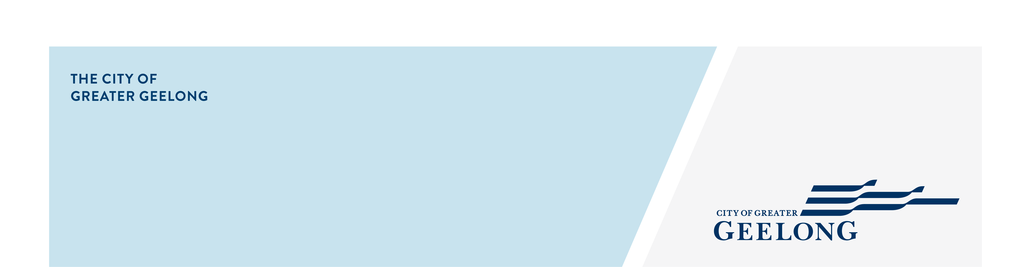
Central Geelong

Stormwater

Management Strategy
community engagement summary

The Central Geelong catchment study has achieved a new milestone.

The second round of community engagement was carried out from 14 May to 13 June 2025.

The study will help stakeholders, including the local community, to build resilience to affects from stormwater. The study forms part of the larger Stormwater Services Strategy which looks to better understand and manage flood risk, stormwater quality, and stormwater reuse.

The study area includes parts of Geelong CBD, Newtown, Geelong West, Manifold Heights, and East Geelong. More information on this study can be found at https://yoursay.geelongaustralia.com.au/CGSMS-1.

Community feedback from the second round of engagement is being used to confirm the flood modelling and proposed solutions before the final strategy is shared in late 2025.

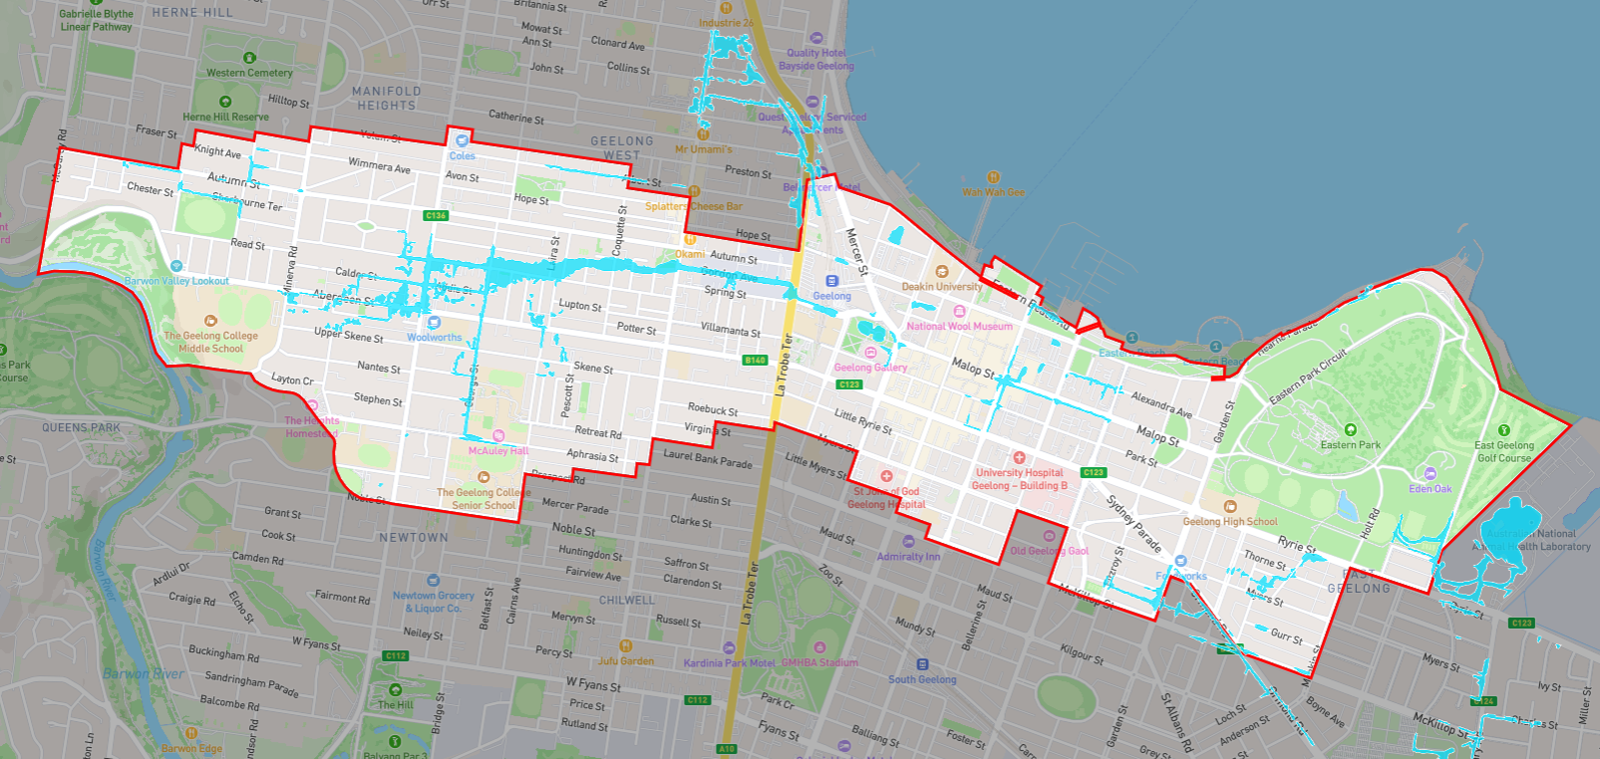
Figure 1: Image of the interactive map

HOW WE ENGAGED
WHAT DID WE DO?
To support this engagement, the dedicated project page on the Have Your Say website was used. This platform allowed community members to access key information about the Central Geelong Stormwater Management Strategy, including updated flood maps and a preliminary list of potential mitigation options. Community members were invited to review these materials and provide their feedback.

An interactive online map was launched showcasing the new flood modelling results. This tool received 63 individual responses, providing valuable local insights.

In addition to the online engagement, three in-person community drop-in sessions were held. These sessions offered community members the opportunity to learn more about the study, ask questions, and share their views directly with the project team. A total of 69 people attended these sessions, which were well received and featured many thoughtful and constructive conversations.

69
People attended the in-person community sessions
Suggestions (comments) from the public left online via social map
63

32
Phone call requests answered
31 DAYS
of engagement (Stage 2)

Communications
The engagement survey was widely promoted using social media posts using platforms such as Facebook and Instagram. In addition, we sent letters directly to property owners and residents within the catchment area, including both residential and commercial properties. This ensured that those most directly affected by the study were informed and had the opportunity to participate.

5,013
People visited the Have Your Say (HYS) page

16,557Letters delivered to the community members
SOCIAL MEDIA
2,401
Reach/Impressions
34
Actions (Clicks, reactions,
shares, comments etc.)

People following the project
1291

WHAT WE HEARD

THE FEEDBACK
- 56% of responses came from community members in Geelong West and Newtown, with others from East Geelong, Geelong, Manifold Heights, and Herne Hill. Feedback came from both residential and commercial properties, reflecting strong engagement across the catchment.

- Around one-third (33%) of respondents raised concerns about insufficient drainage infrastructure, linking it to frequent stormwater flash flooding. There was strong overall support for upgrading the City’s drainage network to better meet current and future community needs.

- 10% of responses pointed to blocked pits and pipes as a cause of localised flooding.

- 17% of community members expressed concerns via the online engagement page and phone calls about the potential impact of flooding on property values and insurance premiums.

- The majority of participants were supportive of the City’s proposed mitigation approach. Many also encouraged further technical investigations and deeper analysis to strengthen the final recommendations.

- The interactive map attracted a total of 63 comments, with most users sharing personal and localised flooding experiences. These insights are proving valuable in validating the new flood modelling results.

- Many described the flooding as rapid-onset and short-lived, occurring without much warning and quickly dissipating once rain stops, confirming the flash-flooding nature of the events in the catchment.

Next Steps

The feedback, experiences, and digital contributions (such as photos and videos) received during this engagement are currently being used to validate the updated flood model for the catchment. In parallel, feedback on mitigation options is being considered as the detailed assessment of potential flood mitigation measures commences.
Looking ahead, there will be one final round of engagement as part of this study:
- Stage 3 – Final Strategy Presentation:
In this stage, the community will be invited to review and provide feedback on the draft Central Geelong Stormwater Management Strategy report. This round of engagement is expected to take place in late 2025.

