The City Of
Greater Geelong

DRAFT

council plan 2025-29

Contents
MESSAGE FROM THE MAYOR AND CEO 3
OUR COUNCIL 4
OUR REGION 5
OUR ORGANISATION 6
HOW WE ADVANCE COMMUNITY OUTCOMES 7
POLICY CONTEXT 8
OUR SERVICES 9
OUR CHALLENGES AND OPPORTUNITIES 10
HOW TO READ THIS DOCUMENT 11
COMMUNITY VISION 12
VISION INDICATORS 13
UNESCO CITY OF DESIGN 14
PLANNING AND REPORTING FRAMEWORK 15
HOW THIS PLAN WAS DEVELOPED 16
STRATEGIC DIRECTION, OBJECTIVES AND INDICATORS 17

MESSAGE FROM THE MAYOR AND CEO
Greater Geelong is one of Australia’s fastest growing regions, and managing this expansion will be crucial to our success over the coming decades.
We have all the key ingredients for a bright future: our coastal lifestyle and city feel – without the big city congestion, bustling ports and airports on our doorstep, world class sporting facilities, a burgeoning advanced manufacturing sector and a thriving arts and cultural scene.
But our region faces many challenges too.
As a Council, we need to find the right balance between new growth areas and developing our CBD and other established suburbs.
We need to transform our CBD into a vibrant hub, enhancing its culture, fostering a sense of community and belonging, and securing our region’s future prosperity.
We need to provide high quality infrastructure for our growing population, amid cost-of-living pressures, inflation and rising building costs.
We need to continue to deliver core services like roads, footpaths, curbs and drains to build a strong community foundation.
We need to do all this while reducing our organisation’s debt and ensuring long-term financial sustainability, creating capacity to adapt to future economic challenges and opportunities.
This requires close collaboration between the City of Greater Geelong and our community to find new and innovative ways to provide essential services more efficiently and effectively.
Our Council Plan 2025-29 sets our strategic direction over the next four years to achieve these aims by delivering on our key objectives:
- Plan, deliver, manage and optimise core and critical infrastructure across our growing region
- Promote, advocate and deliver healthy, caring and equitable outcomes for our communities
- Lead efforts to revitalise and grow our diverse economic precincts.
- Champion our unique heritage and cultural identity
- Protect and enhance our unique and beautiful natural environment
- Commit to the highest levels of integrity, financial stewardship and meaningful community engagement
The plan provides Council with a framework to guide and enhance decision-making, to ensure we maximise the effectiveness of every dollar to achieve the best outcomes for our community.
It also outlines the leadership role the City of Greater Geelong must play to bring together stakeholders to drive progress and innovation, ensuring Greater Geelong prospers.
The Council Plan 2025-29 sets a clear path forward for the next four years and beyond for advancing community outcomes to create a thriving and vibrant Greater Geelong.
Cr Dr Stretch Kontelj OAM – Mayor, City of Greater Geelong
Ali Wastie – CEO, City of Greater Geelong

OUR COUNCIL
Like all local governments, the City of Greater Geelong is made up of two interdependent parts – the Council and the organisation. Collectively, we work together to serve our community.
The Council set the strategic direction for the municipality and make decisions on behalf of the community they’ve been elected to represent. The organisation oversees the day-to-day delivery of all services and functions, guided by the Council, state and federal legislation and various funding agreements.
The role of a Council is to provide good governance in its municipal district for the benefit and wellbeing of the community it serves. This means:
• considering the diverse needs of the local community in decision-making
• establishing strategic objectives and monitoring achievements
• managing resources in a responsible and accountable manner
• advocating local community needs to other communities and governments
• giving everyone the opportunity to participate in the democratic process and decision-making that shapes the community.
As well as performing these roles, our Council provides valuable support to key partner organisations and advocates for projects, programs and initiatives that benefit the region.
In August 2023, an independent electoral structure review recommended to the Minister for Local Government that the City of Greater Geelong move from four multiple councillor wards to eleven single councillor wards. This recommendation was accepted by the Minister. The October 2024 election was held under this structure.
Our Council is made up of eleven elected representatives, called councillors. Each of the eleven councillors represents a different area of Greater Geelong, called a ward. Our current Council was elected for a four-year term on 25 October 2024. The table below lists the councillors elected to these single wards:
Councillor | Ward | Phone | Email
Mayor Stretch Kontelj OAM | Kardinia Ward | 0419 327 303 | Stretch.kontelj@geelongcity.vic.gov.au
Deputy Mayor Ron Nelson | Barrabool Hills Ward | 0429 531 875 | Ron.nelson@geelongcity.vic.gov.au
Emma Sinclair | Charlemont Ward | 0486 012 721 | Emma.sinclair@geelongcity.vic.gov.au
Melissa Cadwell | Cheetham Ward | 0403 821 309 | Melissa.cadwell@geelongcity.vic.gov.au
Elise Wilkinson | Connewarre Ward | 0458 769 380 | Elise.wilkinson@geelongcity.vic.gov.au
Anthony Aitken | Corio Ward | 0434 307 044 | Anthony.aitken@geelongcity.vic.gov.au
Andrew Katos | Deakin Ward | 0461 565 885 | Andrew.katos@geelongcity.vic.gov.au
Eddy Kontelj | Hamlyn Heights Ward | 0455 532 006 | Eddy.kontelj@geelongcity.vic.gov.au
Trent Sullivan | Leopold Ward | 0434 307 050 | Trent.sullivan@geelongcity.vic.gov.au
Rowan Story AM, RFD | Murradoc Ward | 0475 987 029 | Rowan.story@geelongcity.vic.gov.au
Chris Burson | You Yangs Ward | 0488 071 668 | Chris.burson@geelongcity.vic.gov.au

OUR REGION
With a population of over 280,000 people, the City of Greater Geelong is Victoria’s largest regional municipality. Located 75 kilometres south-west of Melbourne, the municipality covers an area of 1,252 km², comprising suburban, coastal and country areas. Greater Geelong is bounded by the Moorabool Shire in the north, Wyndham City Council and the Borough of Queenscliff in the east, and Surf Coast Shire and Golden Plains Shire in the west.

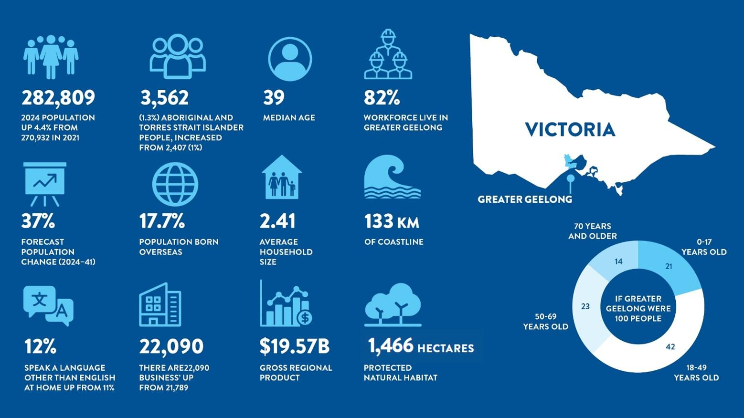
Figure 1 – Greater Geelong Statistics

OUR ORGANISATION
The City of Greater Geelong is an inclusive and flexible organisation. We are one of the largest employers in the Greater Geelong region. We are responsible for:
• delivering services and programs that benefit the whole community, such as waste management and roads
• delivering services and programs for specific communities, such as maternal child health and youth services
• providing support and professional expertise to assist the Council in developing policies and making decisions
• building and maintaining infrastructure, such as local roads and community hubs
• protecting our natural environment, while supporting sustainable development
• supporting economic development that will benefit the whole community
• enforcing legislation that has a local community impact, such as food safety and planning legislation
• engaging with the local community and significant stakeholders to make sure Council decisions are in line with community expectations
• helping our community to plan for, and recover from, natural disasters and other emergencies

CITY OF GREATER GEELONG EXECUTIVE LEADERSHIP TEAM
Ali Wastie | Chief Executive Officer
Anthony Basford | Executive Director City Life
Tennille Bradley | Executive Director Placemaking
Troy Edwards | Executive Director Corporate Services
James Stirton | Executive Director City Infrastructure

HOW WE ADVANCE COMMUNITY OUTCOMES
The role of local government has evolved significantly from its initial focus on constructing roads, bridges, and public buildings. Today, councils provide a diverse array of services, including leisure and recreational facilities, parks and natural asset management, and business services. They achieve this through various methods, which are outlined below.
Deliver: Council directly funds and delivers services and infrastructure for our community, providing services across 30 distinct areas. Examples include managing our leisure and recreation facilities, working with our community to deliver a range of family and children services and the management of the region’s civil infrastructure.
Partner: Council has a strong collaborative approach and facilitates outcomes for its community through creating, building, and maintaining partnerships, promoting opportunities, and building the capacity and capability of community members and organisations. Examples include provide support for local businesses or the delivery of major events.
Advocate: Council advocates to State and Federal Governments on behalf of the Greater Geelong community for funding and delivery of services or infrastructure. Examples include funding for the Armstrong Creek Sports Centre and major road links such as a “Bellarine Link” to enhance east-west travel.

POLICY CONTEXT
The Council Plan guides local decision making and resource allocation for community services, infrastructure, and economic development. Understanding the roles of government ensures local councils:
- Advocate effectively for funding and policy support from higher levels of government.
- Align local priorities with state and federal initiatives for economic growth, sustainability, and public services.
- Empower residents with clear expectations about government responsibilities and understanding of what sits within each level of government’s sphere of control and service delivery.
A well-informed Council Plan strengthens community engagement, strategic planning, and long-term development by aligning priorities to other levels of government.
Level of Government | Role & Legislative Responsibilities | Key Functions & Responsibilities | Revenue Sources
Federal Government | Established by the Australian Constitution, responsible for national and international affairs. It enacts laws through parliament and oversees economic policy, trade, defence, and welfare. | - National Security: Defence, Border Protection, Foreign Policy, Trade Agreements  - Communications & Infrastructure: Telecommunications (NBN, Media), National Highways, Airports  - Economy & Finance: Banking Regulations, Taxation, Centrelink (Welfare & Pensions)  - Health & Social Services: Medicare, NDIS, Aged Care  - Environment & Energy: Climate Policy, Water Management, National Parks  - Justice & Lawmaking: Immigration, Consumer Protection, Copyright | Primary: Income Tax, Corporate Tax, GST  Secondary: Customs Duties, Excise Taxes (Alcohol, Fuel), Import Tariffs, Government Bonds
State Government | Operates under State Constitutions with legislative power over health, education, transport, emergency services, and natural resources. | - Law & Order: State Police, Courts, Prisons, Emergency Services  - Transport & Infrastructure: Public Transport, Highways, Vehicle Registration  - Health & Education: Public Hospitals, Schools, Universities, TAFE  - Environment & Resources: Water Supply, Forestry, Mining Regulation  - Business & Consumer Affairs: Licensing, Fair Trading, Workplace Safety. Supports regional economic development. | Primary: Payroll Tax, Stamp Duty, GST Distribution  Secondary: Land Tax, Gambling Taxes, Vehicle Fees, Fines
Local Government | Created under State Government legislation, responsible for local services, infrastructure, and urban planning. | - Community Services: Libraries, Childcare, Aged Care, Public Housing  - Waste & Environment: Garbage Collection, Recycling, Local Parks  - Urban Planning: Building Permits, Local Roads, Traffic Management  - Public Spaces & Recreation: Parks, Sports Facilities, Public Pools  - Animal Services: Pet Registration, Food Safety Inspections  - Economic Development: Supports small business, tourism, and community economic development.  - Art and Culture: Invests in supporting art, heritage and culture within each community | Primary: Property Rates  Secondary: Developer Contributions, Fees and Charges, State & Federal Grants

OUR SERVICES
The City currently delivers 30 services to support the achievement of the Council Plan (2025-29) strategic objectives.

Service
Arts, Culture and Heritage
Asset and Infrastructure Maintenance
Business Services
Civil Infrastructure Management
Community Wellbeing and Development
Customer Service
Diversity, Equity and Inclusion
Economic Development and Performance
Events
Family and Children
Financial Management
Governance and Risk
Government Relations and Advocacy
Health and Safety
Information Technology Management
Legal and Integrity
Leisure and Recreation
Local Laws
Major Projects
Marketing and Communications
Parks and Natural Assets
People and Culture
Pets and Animals
Planning and Building
Positive Ageing
Strategic Asset Management
Corporate Strategy
Tourism
Waste Management
Youth services

OUR CHALLENGES AND OPPORTUNITIES

financial sustainability
Local governments around the country are facing significant financial sustainability challenges – Greater Geelong included. A few years of extraordinarily high inflation coupled with relatively stagnant income from Victorian government rate caps has created ongoing financial pressure on the city’s operations. The city continuously looks for ways to create financial efficiencies as part of its annual business cycle.

CBD revitalisation
Investment in Geelong's CBD will unlock significant economic growth, enhance urban liveability, and attract private sector investment. This will transform the city into a vibrant, thriving hub for residents and visitors alike. Issues such as decreasing occupancy of Market Square and the attraction of businesses to the CBD, while outside of Council’s directed control, are a priority of our advocacy efforts.

COST OF LIVING
Cost of living challenges in Victoria are significant, with rising housing costs leading to mortgage and rental stress for some. Inflation has increased the average household's annual expenses, while the living wage has risen to keep up with essential costs. Additionally, higher energy and transport costs have further strained household budgets. These issues underscore the need for advocacy for affordable housing initiatives, financial assistance programs, and policies to control inflation.

Lack of available and affordable housing
Like many parts Australia, Greater Geelong is suffering from a lack of housing as well as a lack of affordable housing. Insufficient stock of housing as well as a lack of variety of housing stock can stifle future growth. Additionally, a lack of affordable housing can make it difficult for some workers to move or stay in Greater Geelong, impeding future workforce growth.

Pockets of high socio-economic disadvantage
Greater Geelong has some of the most disadvantaged postcodes in Australia. Future economic development must consider how growth can be accessible and equitable for all residents.

Traffic, congestion and a lack of public transport
Strong growth, traffic and congestion are emerging as issues for our community. Additionally, a lack of public transport has been cited as a growing concern. As the region continues to grow in population, ensuring that residents can access employment centres will be increasingly important and public transport can provide a solution that can also reduce traffic, congestion and greenhouse gas emissions.

Climate change and sustainability
Climate change and sustainability are on-going challenges for everyone. As Greater Geelong continues to grow, efforts need to be made across the municipality to embrace circular economy principles, the transition to renewable energy and sustainable practices.
CORE AND COMMUNITY INFRASTRUCTURE
Rapid population growth continues to strain our current infrastructure. Aging infrastructure and increased community demand for enhanced services in existing areas adds complexity. Securing adequate funding and investment for large-scale infrastructure projects remains a significant challenge, requiring coordination between local, state, and federal governments.

HOW TO READ THIS DOCUMENT

Section | Description
Community Vision | Vision Statement and Vision Aspirations describe the community's 30-year vision for the future of Greater Geelong and guides the Council in planning for the municipality.  Vision Indicators are high-level measures that show if the municipality is achieving the Community Aspirations. Council has a low level of influence on these indicators.
Council Plan | The Strategic Direction guides the work the Council will do over the next four years.  Objectives describe the key areas of focus of the Council Plan.  Outcomes detail what is expected to be delivered as a part of achieving an objective.  Indicators define how we measure our success.
Initiatives  (This section will be added following the completion of community consultation regarding the draft Council Plan 2025-29 and FY26-29 Budget.) | Major initiatives detail work that is critical to deliver on the Council’s objectives and outcomes.  Activities detail the work undertaken by the City to achieve a major initiative.  The role describes how the City is involved in the action, either directly (Deliver) involving others (Partner) or operating in ways to help (Advocate).

COMMUNITY VISION
In 2017, 16,000 members of our community helped to develop a Community Vision that outlined their aspirations for a thriving Greater Geelong (figure 3):
“By 2047, Greater Geelong will be internationally recognised as a clever and creative city-region that is forward looking, enterprising and adaptive, and cares for its people and environment.”
Our Community Vision not only shapes the objectives of the Council Plan 2025-29 but also influences how we execute our work to achieve the desired outcomes for our community. We will be ‘clever and creative’ in implementing the objectives of the Council Plan 2025-29.

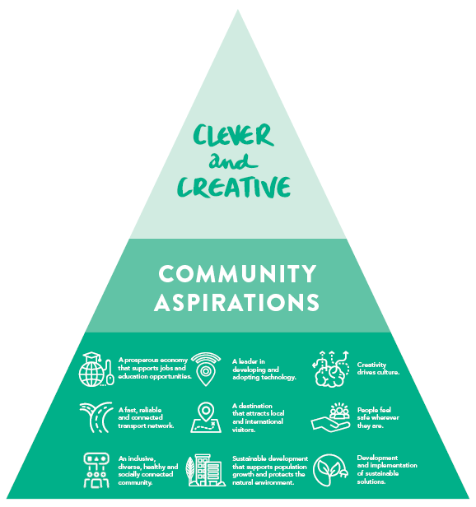
Figure 3 – Community Vision Aspirations

VISION INDICATORS
While some indicators are beyond the direct influence of Council or are measured less frequently, they serve as valuable 'health checks' of the municipality's performance and will be continuously monitored alongside the measures detailed in the Council Plan 2025-29.

INDICATOR | DEFINITION
Gross Regional Product | Wealth generated by businesses, organisations and individuals working in the municipality
Self-rated health of residents | Percentage of residents reporting their health and wellbeing as very good or excellent
Access to regular public transport | Percentage of residences with proximate (400m) access to regular public transport
Visitors to the city-region | Total number of visitors to the city-region per annum
Urban tree canopy cover | Percentage of urban tree canopy cover
Workforce participation | Percentage of Geelong’s population in the labour force
Community carbon emissions | Tonnes of CO2–emissions for the municipality
Level of socio-economic disadvantage | Number of Greater Geelong suburbs in the bottom 20% of the Index of Relative Socio-economic Disadvantage

UNESCO CITY OF DESIGN
Greater Geelong has a long and proud history as a creative city and a leader in design. In October 2017 Greater Geelong was designated a member of the UNESCO Creative Cities Network (UCCN).
The City of Design designation is about using creativity and innovation to build more sustainable, resilient and inclusive communities. It fits perfectly with our community’s 30-year Vision to be internationally recognised as a clever and creative city-region. Greater Geelong is one of 49 (figure 4) Cities of Design in the UCCN.
Our designation opens opportunities to showcase and celebrate our achievements on an international stage. We will learn from and share knowledge to improve our industrial and commercial activities, our urban form and our liveability.
As one of Australia’s fastest growing regional centres, Geelong’s population growth is setting the scene for a design-motivated economy where cleverness in design, creativity and culture are at the heart of everything we do to achieve a sustainable, resilient, inclusive and creative future.
The designation will also support future investment attraction and our on-going economic development into a clever and creative international city.

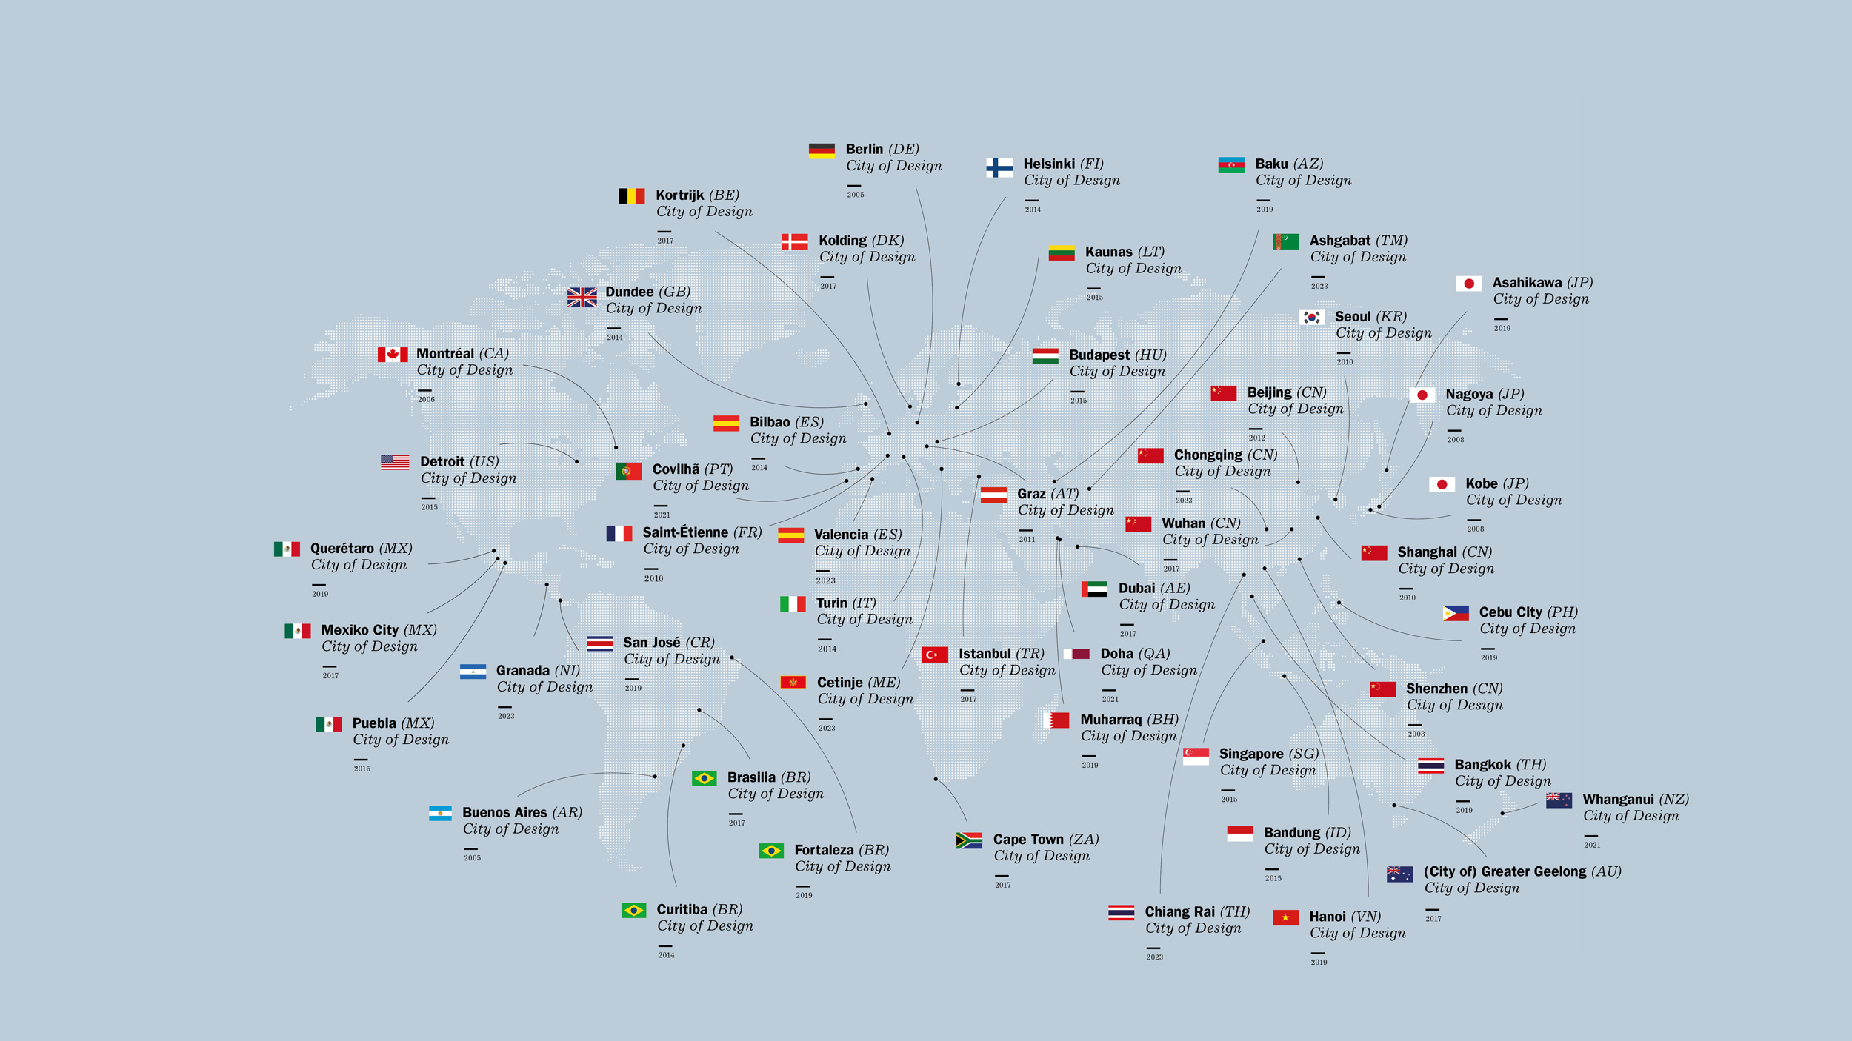
Figure 4 – Cities with a UNESCO City of Design designation

PLANNING AND REPORTING FRAMEWORK
We have developed an integrated, long-term and transparent approach to planning, monitoring and performance reporting that is aligned with our clever and creative vision. The framework has been informed by best practice¹ and helps us set goals, make decisions, prioritise our workload, allocate resources, monitor how we’re going and adapt to changing circumstances that might challenge our progress. As Figure 2 shows, the top layer of this framework is most relevant to our council plan process.
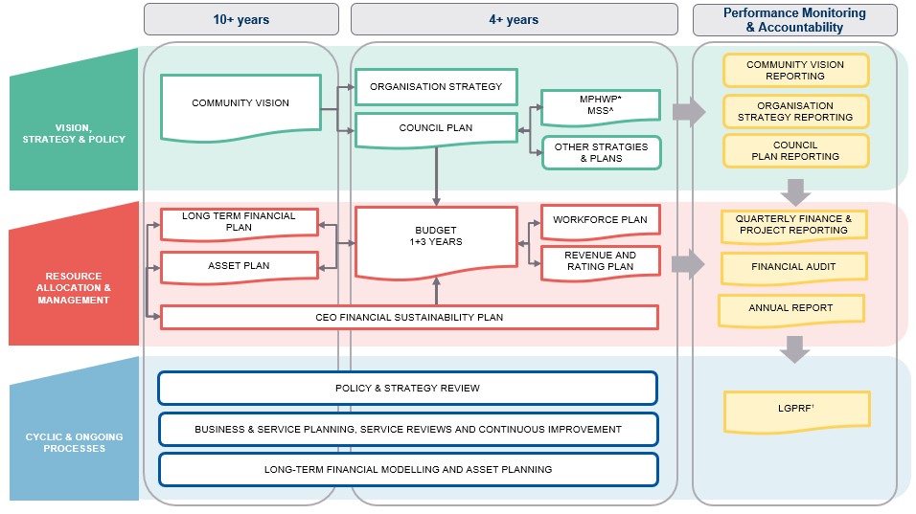
*Municipal Public Health and Wellbeing Plan
^Municipal Strategic Statement
†Local Government Performance Reporting Framework
Note: this shape denotes mandated plans and strategies

Figure 2 – Integrated Strategic Planning and Reporting Framework

¹ Informed by: Victorian Government. (2024). Model Budget 2024-25: Better Practice Guide. Retrieved from https://www.localgovernment.vic.gov.au/__data/assets/pdf_file/0021/205725/Model_Budget_2024-25_Better_Practice_Guide_.pdf.

HOW THIS PLAN WAS DEVELOPED

Development of this plan consisted of several key activities to ensure this document was informed by a robust evidence base, deliberative community engagement and compliance with key legislation.
Phase one: Understanding Context
Review of the Community Vision and its Aspirations:
Our community’s 30-year clever and creative vision: “By 2047, Greater Geelong will be internationally recognised as a clever and creative city-region that is forward looking, enterprising and adaptive, and cares for its people and environment.”
Our aspirations are:
- A prosperous economy that supports jobs and education opportunities
- A leader in developing and adopting technology
- Creativity drives culture
- A fast, reliable and connected transport network
- A destination that attracts local and international visitors
- People feel safe wherever they are
- An inclusive, diverse, healthy and socially connected community
- Sustainable development that supports population growth and protects the natural environment
- Development and implementation of sustainable solutions.
Review of key legislation and policy, including:
- Public Health and Wellbeing Act 2008
- Local Government Act 2020
- Victorian Public Health and Wellbeing Plan 2023–2027
- Gender Equality Act 2020
- Audit of existing City of Greater Geelong strategies and plans. See Appendix (to be added to final version) for a complete list of the City of Greater Geelong’s strategies and plans
- Audit of past community engagements from our Have Your Say platform
- Analysis of 15 planning area profiles.
Phase two: Deliberative Community Engagement (August 2024) and Community Survey (July to September 2024)
The City of Greater Geelong hosted a range of different deliberative engagement activities to ensure that the Council Plan was informed by a real mix of voices in a supported and empowered environment.
- 48 people participated in face-to-face workshops
- The deliberative panel aimed to recreate the demographic profile of Greater Geelong
- Four workshops were held for the panel to deliberate on their priorities for the next four years should be
- The Community Survey was supported by thirteen pop-ups across the four electoral wards (prior to the change to 11 wards).
- The survey asked respondents to order their priorities for the next Council Plan period
- An additional ‘Fund It’ exercise asked the community how they would prioritise spending the City’s budget using a fictional $100 limit. This exercise challenges the community to make ‘trade off’ decisions around how they would allocate funds across the City’s services.
Phase three: Integrating community insights and developing Council priorities (February to March 2025)
The deliberative engagement process and community survey identified a series of community priorities for the future of Greater Geelong. These inputs, as well as the Council’s existing strategic commitments, and information gathered by Councillors through speaking with community members, informed the strategic direction and objectives of the Council Plan.
Phase four: Draft Council Plan for community engagement (May 2025)
The draft Council Plan was released for further community consultation allowing an opportunity for community feedback in May 2025. This provides the community with the opportunity to reflect on how their insights informed the objectives and priorities of the draft Council Plan.
Phase five: Finalisation of Council Plan for endorsement by Council (TBC)
Phase six: Development and delivery of the initiatives of the Council Plan

STRATEGIC DIRECTION, OBJECTIVES AND INDICATORS

Strategic Direction
“We are committed to advancing community outcomes for a thriving Greater Geelong”

STRATEGIC Objectives, Outcomes, and Indicators
STRATEGIC OBJECTIVES | OUTCOMES | INDICATORS | MAJOR INTIATIVES
Core and critical infrastructure  Plan, deliver, manage and optimise core and critical infrastructure across the region | - Responsible and sustainable growth and development.  - Community facilities and public spaces are accessible and fit for purpose.  - Multi-modal transport networks are well-connected and accessible. | - Kilometres of transport infrastructure  - Asset renewal and upgrade expense compared to depreciation  - Provision of open space  - Proportion of housing construction within existing urban areas | - Accelerate planning for housing, employment land and major infrastructure development in response to the Plan for Victoria  - Develop and implement the Public Realm Strategy to guide the landscape character, transport and economic outcomes of key streets  - Develop and commence implementation of a new Integrated Transport Strategy  - Continue to advocate for, invest in, and deliver community sport and recreation infrastructure across Greater Geelong  - Improve and expand regional sporting facilities as part of the Regional Sports Infrastructure Program  - Invest in flood management and mitigation initiatives across Greater Geelong
Healthy and caring community  Identify, promote, advocate for, and deliver equitable health and wellbeing outcomes for our diverse communities | - A community that is fair, compassionate and inclusive.  - Services and facilities that enhance health and wellbeing are accessible to all.  - A community with the resources and capacity to control their health and wellbeing. | - Participation rates in City-operated community services  - Utilisation of the City’s swim, sport and leisure facilities  - Gender+ Impact Assessments completed | - Review Council's role in the delivery of Aged Care services in response to the Commonwealth's Aged Care reforms  - Develop and implement the Domestic Animal Management Plan 2026-29  - Implement the Municipal Public Health & Wellbeing Plan 2025-29  - Ensure equity of access to open space, community sport and recreation facilities and assets across Greater Geelong  - Support participation of women, girls and diverse groups in community sport and recreation
Economic Development  Lead efforts to strengthen our diverse economic precincts and workforce to enhance prosperity across our community | - New businesses, events and investment are attracted to the region.  - Local businesses, industry clusters and precincts are supported to thrive.  - Greater Geelong attracts, retains and develops workforce capacity and capability.  - Sufficient land supply to enable sustainable growth, business expansion and attraction. | - Economic benefit of major events funded by the City  - Supply of employment land  - Businesses supported through the City’s Business Concierge service | - Activate Central Geelong  - Champion First Nations products and services  - Increase visitation to Greater Geelong and The Bellarine  - Attract, support and deliver major events across the region  - Support the growth of Greater Geelong businesses  - Grow Geelong’s cruise tourism sector  - Increase capacity and capability of Greater Geelong's workforce  - Ensure appropriate supply of industrial land across Greater Geelong
Heritage and Culture  Champion our unique heritage and culture | - Increased engagement in arts, culture and heritage experiences across Greater Geelong.  - Increased investment in our creative, cultural and sporting activity hubs.  - Greater Geelong’s diverse culture is shared and celebrated. | - Visitation to the City’s arts & culture facilities/venues in person and online  - Artists, groups and organisations supported by the City (Community Grants Program)  - Aboriginal and Torres Strait Islander cultural projects and participation | - Strengthen Geelong's artists, arts and cultural organisations and creative enterprises  - Celebrate Geelong's unique culture of art and design  - Protect the cultural heritage of Greater Geelong through review of the Geelong Heritage Strategy.
Environment and Circular Economy  Protect and enhance our unique natural environment and surrounds | - Natural habitat and areas of important biodiversity are identified, protected, connected and restored.  - Significant reductions in emissions.  - Increased community resilience to climate change impacts. | - Volume of greenhouse gas emissions from City-managed operations  - Increase habitat on City managed land  - Amount of (kerbside) waste produced each year per household | - Develop and implement the Geelong Strategic Assessment  - Implementation of the Environment Strategy Action Plan  - Upgrade existing resource recovery facilities to prepare for new Food Organics and Green Organics (FOGO) and glass kerbside collection services  - Design, deliver, and renew resource recovery and waste recycling infrastructure for the region
Governance and Integrity  Commit to the highest levels of leadership, integrity, financial stewardship, and meaningful community engagement | - Public funds and assets are used equitably and efficiently.  - Decision making is evidence-based, transparent and strategically aligned.  - Community engagement, strong partnerships and effective advocacy delivers value and impact. | - Delivery of capital project program  - Number of grants secured that support strategic initiatives  - Community engagement and participation opportunities | - Enhance customer service experience  - Strengthen the Council's long term financial sustainability  - Deliver the Service Review Program  - Drive good governance and a strong safety culture  - Increase opportunities for community engagement and contribution in Council decision making

