WAURN PONDS –

Stormwater Management Strategy
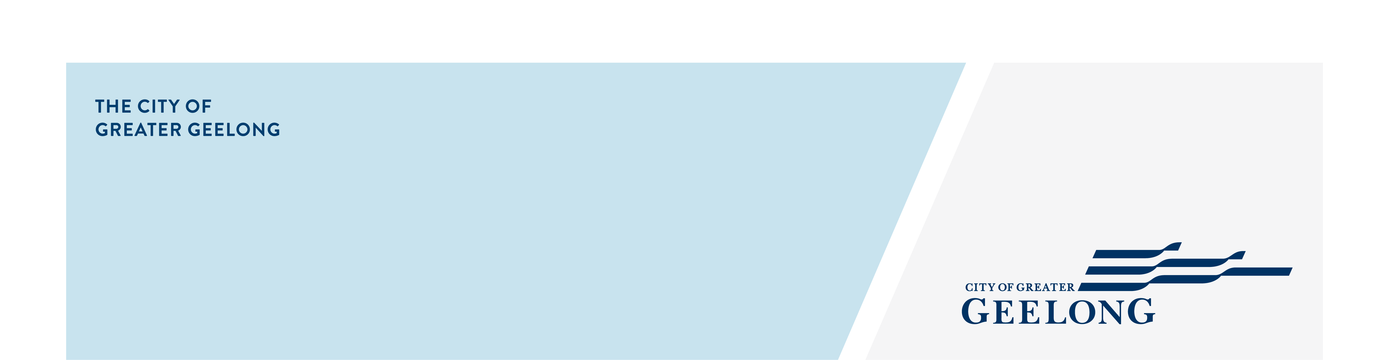

community engagement summary – STAGE 1
PROJECT OVERVIEW
The City of Greater Geelong is undertaking a stormwater study in our Waurn Ponds Catchment. This study will assist the City to:
- Better understand and manage flood risk.
- Better understand stormwater quality impacts on local waterways.
- Seek opportunities for alternate water supply to City managed facilities.
- Plan future drainage upgrades.
The study area takes in parts of Waurn Ponds, Grovedale, Belmont, and Marshall. More information on this study can be found at https://yoursay.geelongaustralia.com.au/wpcsms.

COMMUNITY ENGAGEMENT
We conducted the first round of community engagement between 18 February 2026 to 17 March 2026 to gather the experiences and feedback of residents, businesses, and stakeholders in the study area.
Thank you to members of the community who provided their feedback and shared their experiences. The feedback will be used to validate the catchment model to ensure it reflects their experiences.


454
People visited the Have Your Say (HYS) page.

125
Number of completed online surveys.
Suggestions (comments) from the public left online via social map
17

40
28 DAYS
of engagement (Stage 1)

People following the project.

This engagement aimed to better understand the community’s experiences with flooding, the effectiveness of current flood management measures, and to gather insights on potential solutions to improve flood resilience in these areas.

This information will help to inform
HOW WE ENGAGED

Next Steps or any Verbatim comments and officers can remove which is not applicable.

A dedicated Have Your Say project page was designed to enable the community to share relevant information and provide their feedback. All community members were invited to respond to an online survey and an interactive map.

Feedback was invited over a 4-week period.
A total of 125 surveys were completed, and 17 responses were left on the interactive map.
The community were asked to classify their responses into the four categories below:
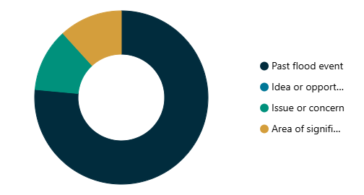

- Past flood event – 76% of responses
- Area of significance – 12% of responses
- Issue or concern – 12% of responses
- Idea or opportunity – no response received

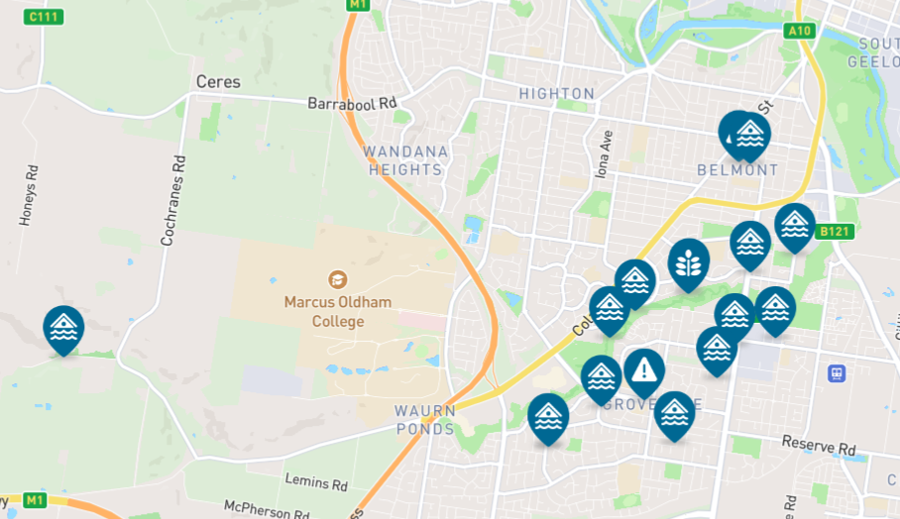

WHO WE ENGAGED WITH

Next Steps or any Verbatim comments and officers can remove which is not applicable.

PARTICIPATION
Most responses were from residents and community members within the study area. We saw a wide variety in the demographics of the residents who responded to the survey. We received feedback from interested community members, property owners, current and past residents, community groups, and business owners.

The vast majority of residents to respond were long term residents who have been living in the area for more than 10 years.

WHat we heard

Next Steps or any Verbatim comments and officers can remove which is not applicable.

THE FEEDBACK
Of the residents who responded, 70% of have experienced flooding on or around their property and 60% are concerned about future flooding.
Most respondents believe flooding has been caused by excess overland water (66%) and blockage of underground drains (59%).

OVERALL KEY FINDINGS
- Most respondents were from the suburbs of Belmont, Grovedale and Waurn Ponds.
- Most respondents are highly impacted and invested, in that they:
- Almost exclusively represent residents, property owners, and interested community members.
- Predominantly are long-term residents living in the area for more than 10 years (57%).
- Majority of residents have first-hand experience of flooding (70%).
- 47% of residents have experienced flooding in the past 1-2 years and 45% of residents have experienced in the past 3-5 years.
- 60% of residents are concerned about future floods.
- Among the residents who have experienced flooding, more than half reported flooding inside homes/dwellings, on the streets, footpaths, or gardens.
- Most respondents said they believe flooding occurred because of both excess overland flow and blocked drains.
NEXT STEPS

Next Steps or any Verbatim comments and officers can remove which is not applicable.
We are currently using the provided feedback, experiences, and digital resources (photos/videos) to validate our catchment model.
We will undertake a floor-level survey of selected properties in the study area to assist with the accuracy of our results.
There will be two further rounds of community engagement during the life of the study.
- Stage 2 – This stage presents draft flood mapping and mitigation options to reduce the impact of flooding on impacted community members. Feedback and suggestions are welcome. This round of engagement is expected to be undertaken at the end of 2026.
- Stage 3 – This stage informs the community by presenting the draft final Waurn Ponds Stormwater Management Strategy. This is expected to occur in 2027.

