The City Of
Greater Geelong

respected, connected and thriving

positive ageing strategy 2021-47

action plan
2022-25

Contents
Introduction 3
CEO Message 4
Mayor’s Message 5
Demographic Profile 6
Action Plan Development 8
Co-design Process 9
Age-friendly Cities 13
2022-25 Action Plan 14
Implementation and Monitoring 27
Evaluation Framework: Telling the story 28
Appendices 29
References 35

October 2022

Acknowledgement of Country

We Acknowledge the Wadawurrung People as the Traditional Owners of the Land, Waterways and Skies. We pay our respects to their Elders, past and present. We Acknowledge all Aboriginal and Torres Strait Islander people who are part of our Greater Geelong community today.

Introduction

Following the release of the our Respected, Connected and Thriving Positive Ageing Strategy 2021-47, we embarked on an innovative co-design process to help build the first three-year action plan.

The co-design process invited our residents to be actively involved in the process. Through involvement, the outcome is meaningful to our residents.

The action plan responds to the key themes of the strategy:

- People, as they age, live in safe, welcoming, and strongly connected local communities
- People, as they age, are respected, supported, and encouraged to participate as active citizens in building strong local communities
- People, as they age, have access to places, spaces, and services.

The themes are based on the World Health Organisation’s Age Friendly Communities Framework, ensuring collective action is grounded in a global evidence base.

The strategy outlines 19 priorities for a more age-friendly community in our City. Some of the priorities are within the scope of the first action plan.

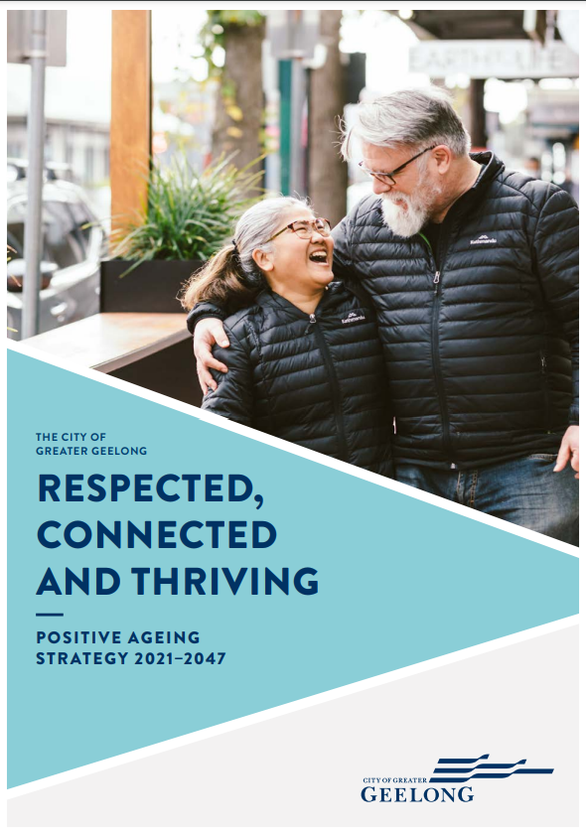
Figure 1: City of Greater Geelong’s Positive Ageing Strategy 2021-47

CEO Message

Welcome to the City’s first action plan for the Positive Ageing Strategy 2021-47.

We are committed to enabling people to age positively in our City. So, in addition to developing the strategy around the eight domains of the World Health Organisation’s Age-Friendly Cities framework, we also wanted to make sure we were informed by the real-life experiences and priorities of our community.

Taking an innovative and collaborative approach, this action plan has been co-designed with community members who are over 55 years of age, as well as relevant local organisations and our employees. The contributions of all those involved have been truly valued and appreciated.

Starting with community conversations involving over 240 people, we formed a design team with interested and engaged older members of our community who, along with other stakeholders, told us the outcomes that were most important to them in these coming three years.

This action plan will help to ensure an age-friendly lens is applied to our work and provide a platform to engage collaboratively with our partners in prioritising the outcomes that our design team voted as most important.

For updates on progress, visit www.geelongaustralia.com.au or contact Customer Service and speak with our Healthy Communities team.

We look forward to working with our community to promote positive and healthy ageing in the City of Greater Geelong.

Kaarina Phyland
Acting CEO
City of Greater Geelong

Mayor’s Message

It is with great pleasure that we bring you this first action plan for the Positive Ageing Strategy 2021-47.

We are committed to ensuring the decisions that support health and wellbeing for people as they age are informed and influenced by the people who live, work, visit or do business in the region.

That’s why we decided to co-design this action plan with older residents themselves, along with local communities, service providers and other stakeholders.

We know that your participation helps us make better decisions and achieve better outcomes.

This action plan outlines the activities that we, along with our partners, will undertake to begin working towards a more age friendly City. It brings together existing work in positive ageing, as well as providing an age friendly lens to current programs and new projects.

In particular, I would like to thank and acknowledge the time and commitment of our Ageing Well Advisory Committee who were active participants in the conversations and co-design process.

Cr Trent Sullivan
Mayor
City of Greater Geelong

Demographic Profile

Population growth and geographic distribution
In 2016, people aged 55 years and over comprised approximately 30 per cent of the population of the City of Greater Geelong. The number of people aged 55 and over is expected to increase by 68 per cent between 2016 and 2041 (from approximately 72,000 to 120,000).
Growth in the number of older residents reflects the wider, rapid growth in our population, which is projected to increase by 64 per cent between 2016 and 2041 (from approximately 240,000 in 2016, to 393,000 in 2041).

Community contribution
Older people make a significant contribution to the community socially and economically: they contribute to the local economy and promote economic sustainability; they provide assistance and care through volunteering and as informal carers; and contribute to civic life and community strengthening through ongoing participation in their local communities.
- Workforce participation: 28.7 per cent of our older residents aged 55 and over are employed, with 33.7 per cent in professional and managerial positions.
- Volunteering: In 2016, 20.5 per cent of our population were engaged in volunteer work. Of the total volunteer population, 37 per cent were aged 55 and over.
- Caring responsibilities: Older people play an important role as informal carers, with 15.1 per cent of people aged 55 and over providing unpaid assistance to others. Of the total carers in our City, 45.5 per cent were aged over 55.
The region’s natural environment and major events attract large numbers of older people for tourism and recreation.

Diversity
Our residents aged over 55 have diverse characteristics.
- Gender: 45.7 per cent of our population aged over 55 are men. Women live longer than men, and account for 71.4 per cent of centenarians in our region.
- Country of birth: 16.3 per cent of residents aged over 55 were born overseas. The top five birth countries are England, Italy, Netherlands, Germany, and Croatia. 10.1 per cent of residents over 55 were born in countries where English is not the main language.
- Main language: 10.6 per cent of our residents speak a language other than English. The main languages of our older residents who are not fluent in English include Croatian; Italian; Macedonian; Greek; Polish; Spanish; Russian; Serbian; Ukrainian and Bosnian.
- Indigenous: Approximately 0.5 per cent of our population aged 45 and over identify as Aboriginal, Torres Strait Islander, or both. National figures show one in five Indigenous Australians (21%) aged 50 and over were removed from their families as part of the Stolen Generation (AIHW, 2021).
- LGBTIQA+: Current national estimates put LGBTIQA+ people as representing 11 per cent of the population. LGBTIQA+ people are likely to be represented by at least the same proportion in older populations (AHRC, 2022).

Gendered Impacts of Ageing
The evidence shows that the experience of ageing is gendered. For example:
- Women live longer than men (WHV, 2017), and as a result, women are more likely to live with multiple chronic health issues (WHV, 2017).
- Single older women have less superannuation (WHV, 2017).
- More older women live alone (WHV, 2017).
- Older women are more likely than men to be living in residential aged care and are the majority of those suffering from dementia (WHV, 2017).
- Women more likely to suffer from intimate partner violence (WHV, 2017).
- Elder abuse is gendered, with women more likely to be victims (AHRC, 2021).
- Homelessness is an issue for older women and single women escaping family violence (AHRC, 2021).
- Women generally have more social networks than men (Pate, 2014).
- Older men are more likely to experience social isolation (Pate, 2014).
- Men are less likely to have physical health checks (Smiley, 2022).
Additional needs for other diverse groups:
- cultural concepts of ageing might differ from universal concepts in caring for others, aged care, living at home for longer, social isolation etc (Vauclair, C et al, 2017).
- Trans and gender diverse older people are also at risk of elder abuse (WHV, 2017).
- Trans and gender diverse older people may fear additional discrimination and harassment when accessing health and aged care (WHV, 2017 and AHRC, 2021).

In implementing the action plan, a gender and social equity lens should be applied to consider the impacts of ageing on different priority groups.

Social and economic disadvantage
Many older people in our City face a number of barriers affecting their health and wellbeing.
- Need for assistance: Approximately 12.6 per cent of our older residents aged over 55 require assistance. The requirement for assistance increases to 45.4 per cent for residents aged 85 and over.
- Income: In 2016, 57.6 per cent of our population aged 55 and over received an average weekly income of $499 or below. Approximately 5.1 per cent received no income. In 2020, 64.7 per cent of our residents aged 65 and over were on the Age Pension (PHIDU, 2021).
- Geography: There are areas within our region requiring greater levels of support. The areas with the highest level of socio-economic disadvantage include: Norlane; North Shore; Whittington; Corio; South Geelong; Thomson; and Breakwater.
- Housing: 24.5 per cent of the population aged 55 and over lives in a lone person household. Older women, and pensioners who are renting, are at increased risk of homelessness.

Action Plan Development

We took the long-term themes and priorities from the Positive Ageing Strategy 2021-47 into the co-design process. Co-design participants helped us to develop guiding objectives and the first three years of actions.

Action Key (refer to action plan tables):

V = Voted action by co-design participants
C = City priority

Short term = 1-2 years
Medium term = 2-3 years
Long term = 3+ years

Co-design Process

The co-design process is flexible, non-linear and allows for new partnerships to form at any stage. The action planning process was designed around key principles of prioritising relationships, sharing power, using participatory means, and building capability.

Participants were invited to Have Your Say via our online engagement platform. Those involved in the initial phase had the opportunity to take part in a Design Forum. Project updates were sent via email, inviting further participation.

Phase 1: Community conversations

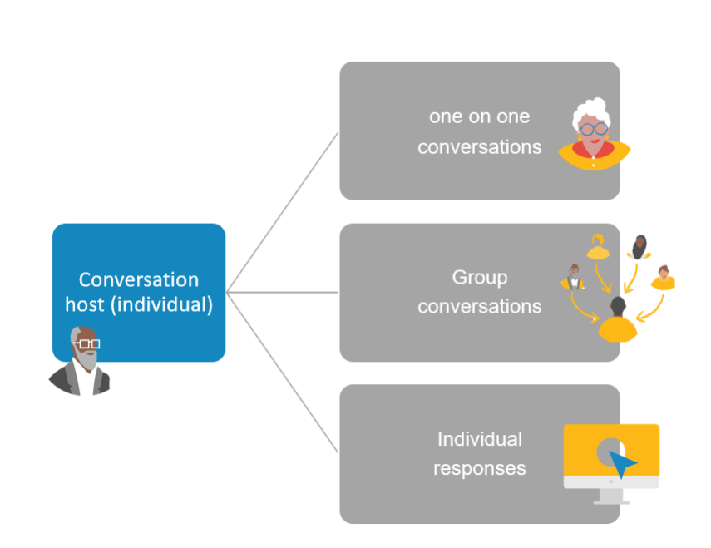
Figure 2: Conversation toolkit participation options

The toolkit posed four questions. Participants were given the option of answering as many questions as they chose. The questions were:

- What makes you feel safe? Imagine a community where, as you age, you will feel completely safe and welcome. What types of things would you like to do? What actions need to take place for you to be able to experience this (either right now, or as you age)?

- What actions would support and encourage you to participate more in your community through work, volunteering, leisure, socialising, or study?

- What are the spaces, places, and services you love the most? What actions should be taken to ensure you can continue to access these as you age?

- What do you think will impact you as you age? What support do you think you may need as you age?

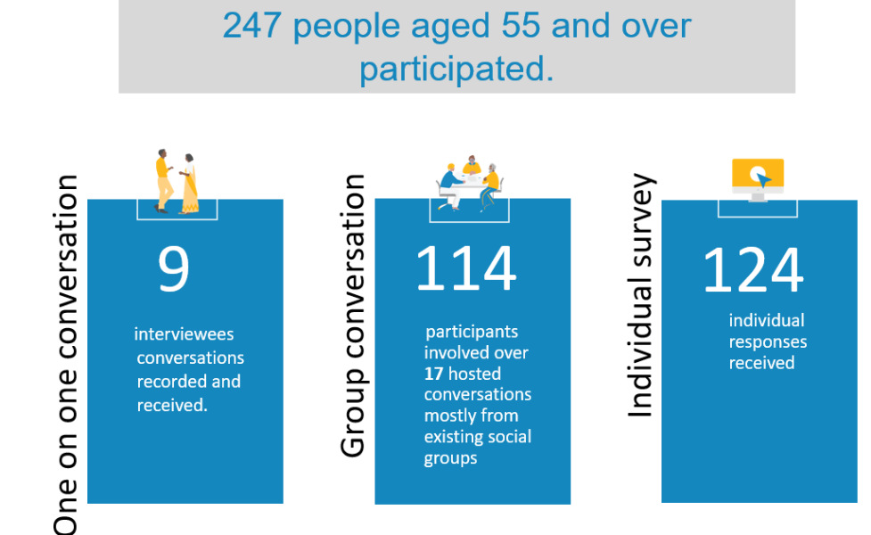
Figure 3: Phase 1 Conversation toolkit participation

Phase 2: Design

A design forum brought together a diverse group of stakeholders including: people with lived experience; service delivery staff; and representatives of the City. The primary objective was to:

- Review insights collected through the Conversation Toolkit findings.
- Design a set of actions that align with key themes of the Positive Ageing Strategy, with a goal of creating an ‘age-friendly’ community within three years.

The forum provided an opportunity for community representatives to develop a deeper understanding of the issues, thus enriching the outputs, strengthening relationships, and paving the way for future collaboration.

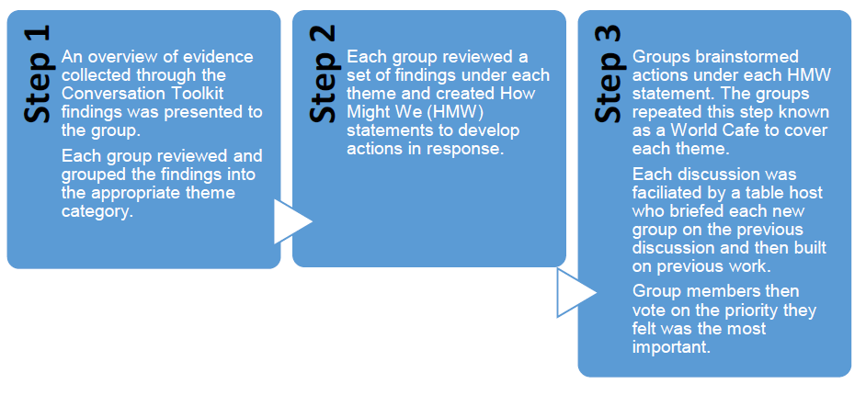
Figure 4: Design process

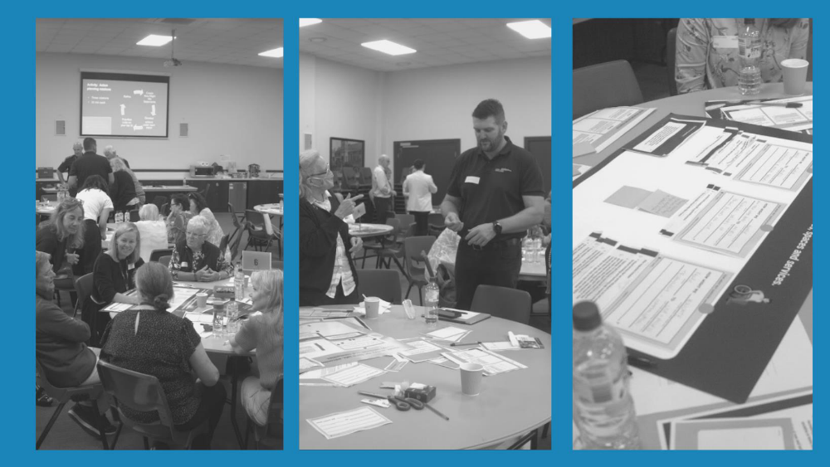
Figure 5: Co-design forum, April 2022

Phase 3: Test and Refine

Phase three ended with co-design participants voting for their top five actions for each of the three themes of the strategy.

Co-design process

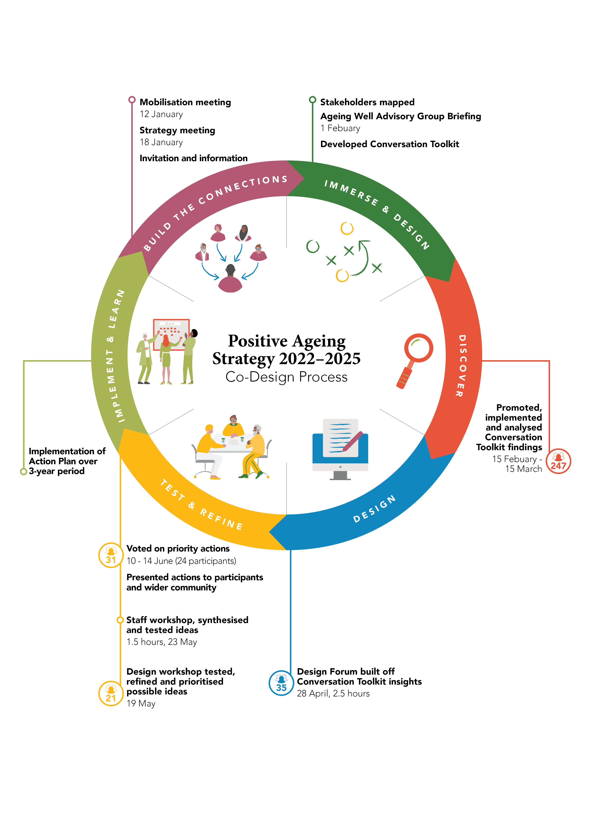
Figure 6: The Co-design Process

Age-friendly Cities

The World Health Organisation’s (WHO) Age-friendly Cities Framework is an internationally recognised guide for governments and communities. Since 2002, it has been promoting healthy and active ageing in urban environments by informing public discussion and action.
Our framework provides a holistic, multi-dimensional approach across a range of domains that are grouped into three environments. It underpins the three themes of the Positive Ageing Strategy 2021-47.

Environments | Age-friendly domains | Positive Ageing Strategy Themes
Physical environment | outdoor spaces and buildings  transportation  housing. | Theme 1:  People, as they age, live in safe, welcoming, and strongly connected local communities
Social environment | social participation  respect and social inclusion  employment  civic engagement. | Theme 2:  People, as they age, are respected, supported, and encouraged to participate as active citizens in building strong local communities
Services and support | community and health services  communication and information. | Theme 3:  As they age, people have equitable access to places, spaces, and services
Figure 7: Age-friendly domains

2022-25 Action Plan

Theme 1 – People, as they age, live in safe, welcoming and strongly connected local communities.
Our focus 2022-25:
- Support people to feel confident to access our public spaces
- Make cities age-friendly and liveable to improve lived experiences and access
- Ensure access to appropriate infrastructure in our community (e.g., park benches, walking paths, housing)
- Support older people to confidently engage services and companies
- Reduce the perception of crime so that older people feel safe to access public spaces
- Ensure our environment facilitates the maintenance of independence for the older community
- Create places for people to connect.

No. | Guiding Objective | Action | Lead | Partner / Support | Measures | Timeframe | Co-designed Outcomes
Priority 1a) Our places, activities and events are intergenerational and welcome older people
 | Support people to feel confident to access our public spaces | Refer to actions 2.3, 2.4 and 2.5
Priority 1b) Activities and events that appeal to the diverse needs and preferences of older people are held in a variety of local neighbourhoods.
1.1 | Support people to feel confident to access our public spaces | Continue to deliver age specific fitness activities (V) | City of Greater Geelong  Leisure and Recreation Services |  | Live Well program reviewed and delivered  Level of participation in Live Well program  Physical activity levels for over 55s (GPHS) | Ongoing | “Age specific fitness activities.”
1.2 | Support people to feel confident to access our public spaces  Make cities age-friendly and liveable to improve lived experiences and access | Incorporate the needs of people as they age into the development of the City’s new Play / Recreation Strategy (or equivalent) (V) | City of Greater Geelong  Social Planning and Investment | City Department:  Capital Projects | Increased awareness of Age Friendly Cities Guidelines within Council  Endorsed Play / Recreation Strategy (to guide future investment in playgrounds, fitness stations, half courts etc) incorporates the needs of people as they age.  Number of new outdoor play spaces delivered by the City (e.g., playgrounds, dog parks, fitness stations) which consider Age Friendly Cities Guidelines | Short term  Short term  Long term | “Advocacy for grants to purchase necessary exercise equipment for seniors.”
Priority 1c) Services and supports are available to enable older people to create and maintain informal networks and social connections
1.3 | Create places for people to connect | Investigate issues and explore future opportunities for senior citizens clubs (C) | City of Greater Geelong  Connected Communities | City Department:  Healthy Communities  Others:  Barwon Health | Discussion paper completed | Short term | “Connect people at retirement age to seniors’ clubs, activities and facilitate online connections.”
1.4 | Identify and promote services on offer for older people | Partner with Geelong Regional Library to promote services, grants, information, and education for older people (C) | City of Greater Geelong  Healthy Communities | Geelong Regional Library Corporation  Neighbourhood Houses Barwon | We will work with Geelong Regional Libraries to promote relevant information to our residents | Short term | “Support to use library - librarians as source of information.”  “Clarity and communication about where people might go to access information.”  “Clarity around age specific services available e.g., in annual local calendar.”
1.5 | Identify and promote services on offer for older people  Support older people to confidently engage services and companies | Promote ways older people can live at home for longer (V) | City of Greater Geelong  Healthy Communities | City Department:  Community Care  Others:  Western Victoria PHN / GPs | Promotional campaign implemented | Medium term | “Campaign to promote ways of how older people can live at home for as long as possible.”  “Having confidence to access services.”
Priority 1d) Housing, (including social housing and residential aged care) is appropriately located in areas that are safe and close to services, and the rest of the community.
 | Ensure our environment facilitates the maintenance of independence for the older community  Ensure access to appropriate infrastructure in our community (e.g., park benches, walking paths, housing) | Refer to the implementation of the City’s Social Housing Plan 2020-41
Priority 1e) Older people feel safe in the community
 | Reduce the perception of crime so that older people feel safe to access public spaces | Refer to actions 1.2, 1.6, 1.7 and 1.8 which all impact feelings of safety
Priority 1f) The amenity and safety of local neighbourhoods is promoted by appropriate footpaths, ramps and pedestrian crossings, good street lighting, public seating, and toilets.
1.6 | Support people to feel confident to access our public spaces | Embed consideration of Age Friendly Cities Guidelines into urban design projects and streetscapes (V) | City of Greater Geelong  Urban Design and Heritage | City Departments:  Strategic Planning  Capital Projects  Engineering Services  Place Management  Social Planning and Investment | Increased awareness of Age Friendly Cities Guidelines within Council  Age friendly cities guidelines are considered in urban design projects. | Short term  Ongoing | “More seating for people to stop and rest in activity precincts and along key walking routes.”
1.7 | Ensure our environment facilitates the maintenance of independence for the older community | Encourage older people to participate in engagement opportunities around social infrastructure planning and budgeting (V) | City of Greater Geelong  Social Planning and Investment | City Departments:  Planning and Growth  Engineering Services  Strategic Asset Management  Finance | Interactive map for current social infrastructure projects promoted to older people  Level of participation from people over 55 years of age in relevant engagement activities  Number of engagement projects related to infrastructure planning (e.g., masterplans) receiving input from those identifying themselves as over 55 | Short term | “Budget and invest in maintenance and evaluation of community assets – ask the community for guidance and identification of key sites and priority locations.”
1.8 | Ensure access to appropriate infrastructure in our community (e.g., park benches, walking paths, housing) | Consider Age Friendly Cities Guidelines in preparing urban design frameworks and Framework plans as appropriate (V) | City of Greater Geelong  Strategic Planning | City Department:  Urban Design and Heritage | Increased awareness of Age Friendly Cities Guidelines within the City  Additional criteria to be considered in UDFs and Framework Plans | Short term  Long term | “Take a design approach to age friendly cities: infrastructure upgrades like seating, accessible buildings, pedestrian only zones.”
V = Voted action by co-design participants; C = City priority
Short term = 1-2 years; Medium term = 2-3 years; Long term = 3+ years

Theme 2 - People, as they age, are respected, supported and encouraged to participate as active citizens in building strong local communities.
Our focus 2022-25:
- Inform people aged 55 years and over of the services available for the next phase of life
- Build confidence that people’s needs will be met as they age
- Ensure people aged 55 years and over feel more included in the community
- Ensure that there is a diverse range of activities available in our community that are accessible, intergenerational, and inclusive to people over the age of 55
- Educate children to understand and connect with older people
- Facilitate multi-age groups to participate in activities
- Change the attitude/stigma around ageing
- Ensure staff who interact with older people have training to see older people as fully capable humans
- Improve societal respect for older people to minimise ageism
- Enable older people who aren’t technical to access financial services for paying accounts online and ensure that we are able to keep pace with tech developments and tools

No. |  | Guiding Objectives | Action | Lead | Partner / Support | Measures | Timeframe | Co-designed Outcomes
Priority 2a) Older people are valued and acknowledged for their past, present, and future contributions
2.1 |  | Inform people aged 55 years of the services for the next phase of life  Ensure people aged 55 years and over feel more included in the community | Utilise the Victorian Seniors Festival to promote activities, achievements, and information for older people (C) | City of Greater Geelong  Healthy Communities | City Departments:  Community Care  Leisure and Recreation  Connected Communities  Others:  Victorian Government  Neighbourhood Houses Barwon  Geelong Regional Libraries Corporation  Cultura | Number of Positive Ageing Grants allocated.  Annual seniors’ festival promotes activities, achievements, and information for older people | Short term | “Expo to promote different activities, achievements, and events for older people.”  “Seniors’ open days.”  “Education opportunities such as forums, workshops, or campaigns that promote services, programs and groups that can improve wellbeing and choice around aged care support.”  “Neighbourhood House Expo.”  “Annual Ageing Well Exhibition.”
2.2 |  | Ensure people aged 55 years and over feel more included in the community | Work with First Nations Elders to understand their priorities for positive ageing (V) | City of Greater Geelong  Healthy Communities | Wathaurong Aboriginal Cooperative  Wadawurrung Traditional Owners Corporation | Engagement with Elders underway | Short term
2.3 |  | Ensure that there is a diverse range of activities available in our community that are accessible, intergenerational, and inclusive to people over the age of 55  Educate children to understand and connect with older people  Facilitate multi-age groups to participate in activities | Identify opportunities for intergenerational activities (V) | City of Greater Geelong | City Departments:  Healthy Communities  Connected Communities  Family Services  Youth Development  Others:  Neighbourhood Houses Barwon  Geelong Regional Libraries Corporation | Opportunities identified and incorporated into organisational planning.  Positive Ageing Grants distributed | Short term | “Program design principle.”  “Promote intergenerational links and cross generational needs (e.g., adopt a grandparent, retirement planning, student placements, history of the army, sharing food and culture, young volunteers in aged care).”  “Intergenerational learning opportunities – finding opportunities to connect younger people to older people for mutual benefit.”  “A focus on transgenerational (intergenerational) activities that are designed to connect people across generations. (examples) Council to identify opportunities.”
2.4 |  | Educate children to understand and connect with older people  Enable older people who aren’t technical to access financial services for paying accounts online and ensure that we are able to keep pace with tech developments and tools | Focus on intergenerational programming in libraries (C) | Geelong Regional Libraries Corporation | Neighbourhood Houses Barwon | Intergenerational programming delivered.  Creative solutions and opportunities to support community initiatives generated.  Increased enjoyment of reading and learning experiences for target groups.  Enhanced English literacy, digital literacy, and critical thinking skills for early years, youth, adults, and older adults. | Short term | “A targeted approach to intergenerational friendly activities and opportunities that cater to a wide range of ages by a range of partners and service providers.”
2.5 |  | Educate children to understand and connect with older people  Facilitate multi-age groups to participate in activities | Explore a pilot intergenerational activity at Grovedale Neighbourhood House with co-located family services (C) | City of Greater Geelong  Family Services | City Department:  Connected Communities  Others:  Neighbourhood Houses Barwon | Intergeneration activity delivered  Budget bid | Medium term | “A targeted approach to intergenerational friendly activities and opportunities that cater to a wide range of ages by a range of partners and service providers.”
Priority 2b) The diverse experiences and views of older people are actively sought, and supported, to inform the development, implementation, and monitoring of our activities
2.6 |  | Ensure people aged 55 years and over feel more included in the community | Promote the use of non-digital engagement methods in City led engagement projects (C) | City of Greater Geelong  Community Engagement | City Departments:  Corporate Communications  Customer Service  Digital Information and Technology | All community engagement projects to include some element(s) of non-digital engagement methods to complement the digital engagement delivery. This could include face to face engagement activities out in the community, hard copy surveys, letter drop, customer service desk support, Translating and Interpreting Service (TIS), one-on-one phone calls/consultations, utilising community groups to promote, target, recruit, and support engagement activities. | Short term | “Keep using non-technical and not digital forms of communication.”
2.7 |  | Build confidence that people’s needs will be met as they age | Keep informed about the impact of Aged Care Reforms and potential role for local government (C). | City of Greater Geelong  Community Care | Federal Government | Clarified role for local government known by 2025 or earlier  Information provided to community about where to access Care Finders on the City’s website and in rates notices. | Medium term | “A liaison person who supports older people to connect into community activities and groups.”
Priority 2c) Older people are depicted positively and without stereotyping in communications and media
2.8 |  | Change the attitude/stigma around ageing  Improve societal respect for older people to minimise ageism | Implement ageism awareness campaign (C) | City of Greater Geelong  Healthy Communities | Municipal Association of Victoria (MAV)  Barwon Community Legal Service | Annual campaign implemented | Short term | “Rebranding what it means to be an ‘old person.’”  “Creating knowledge around respectful interactions.”
Priority 2d) A range of flexible opportunities for older people to continue to develop, use and share their skills and expertise is promoted
2.9 |  | Ensure staff who interact with older people have training to see older people as fully capable humans | Connect with neighbourhood houses, libraries, community groups and local networks to promote information of interest to older people (V) | City of Greater Geelong  Connected Communities | Neighbourhood Houses Barwon  Geelong Regional Libraries Corporation  Community Agencies, Organisations and Services (CAOS) Network |  | Short term | “Utilise local information networks and develop a communication plan.”
2.10 |  | Enable older people who aren’t technical to access financial services for paying accounts online and ensure that we are able to keep pace with tech developments and tools | Promote digital support training offered through libraries and neighbourhood houses, and advocate for training to be delivered in person where possible (V) | Geelong Regional Libraries Corporation | City of Greater Geelong  Neighbourhood Houses Barwon | Enhanced English literacy, digital literacy, and critical thinking skills for early years, youth, adults, and older adults.  Reduced digital exclusion.  Equitable access to libraries and associated long-term living and learning opportunities.  Strong local partnerships.  Improved engagement and community participation for all.  A sense of belonging for volunteers.  Volunteer roles are valued and considered an integral part of the library operation.  Improved access to and engagement with library resources, e-resources, and programs. | Ongoing | “Provide support and training to use digital technology and ensure new digital technology is tested with older people from a range of backgrounds.”  “Provide non-digital training support to access online and digital resources e.g., banking, medical centres.”  “Provide support and training to use digital technology through face-to-face workshops and mentoring.”
Priority 2e) Older workers and employees are embraced and celebrated
Priority 2f) Older people participate in fulfilling arts and cultural activities and actively contribute to the fabric of society
 | Ensure people aged 55 years and over feel more included in the community  Improve societal respect for older people to minimise ageism |  | Refer to actions 2.1 and 2.8
V = Voted action by co-design participants; C = City priority
Short term = 1-2 years; Medium term = 2-3 years; Long term = 3+ years

Theme 3 - People, as they age, have access to places, spaces, and services
Our focus 2022-25:
- Support individuals to safely navigate transport options
- Make it easier for people as they age to get around, access support services, facilities, and enjoy life
- Provide access to transport options that will accommodate people at all stages of their life
- Improve footpath infrastructure

No. | Guiding Objectives | Action | Lead | Partner / Support | Measures | Timeframe | Co-designed Outcomes
Priority 3a) A range of health and support services is available to promote, maintain, and restore health, and support independent living
Refer to actions 1.4, 1.5 and 2.7
Priority 3b) Barriers impeding access to health and community support services are minimised and outreach is provided to vulnerable and disadvantaged people
Refer to action 2.7
Priority 3c) There is timely, accurate and relevant information available about services, activities, and events, including details about cost, accessibility of facilities and transport options
Refer to action 2.1 and 2.9
Priority 3d) There is wide public access, training, and support to use the internet, social media, and digital technologies
Refer to action 2.10
Priority 3e) Transport is affordable, accessible, and available when it is needed
3.1 | Support individuals to safely navigate transport options  Provide access to transport options that will accommodate people at all stages of their life | Incorporate the accessibility and active transport needs of people as they age into the development of the Integrated Transport Strategy (V) | City of Greater Geelong  Engineering Services (Transport) | Department of Transport | Integrated Transport Strategy incorporates needs of older people | Medium term | “Advocate for transport that is affordable and accessible for people with mobility issues.”  “Accessibility varies for people.”
3.2 | Provide access to transport options that will accommodate people at all stages of their life | Scope equitable access to community transport in Greater Geelong (V) | City of Greater Geelong | City Departments:  Engineering Services (Transport)  Healthy Communities  Connected Communities  Community Care  Leisure and Recreation Services  Smart City  Others:  Department of Transport  Volunteering Geelong  Barwon Health  Australian Multicultural Community Services (AMCS)  G21 Regional Alliance | Outcomes of Building Bellarine Connections 2009-2011 project reviewed  Existing community transport promoted  Budget bid / external project funding | Long term | “Community run mini cabs and wheelchair accessible vans.”  “Free bus/shuttle services to key activities and service centres, neighbourhood houses, libraries, shopping.”  “Community bus, like NHS (UK)”
3.3 | Make it easier for people as they age to get around, access support services, facilities, and enjoy life | Advocate for more public transport options such as more buses between towns, better routes, and better promotion (V). | City of Greater Geelong  Strategic Transport | State Government  Department of Transport  Vic Roads  V Line  City Departments:  Corporate Affairs  Local Laws  Engineering | Number of advocacy opportunities undertaken that include age friendly principles  Community satisfaction with transport (new survey data) | Long term | “Advocate for more public transport options such as more buses between towns, better routes, and better promotion.”
3.4 | Improve footpath infrastructure where older people live | Improve pedestrian routes and crossings, particularly between destinations that are important to older people (V) | City of Greater Geelong  Engineering Services (Transport) | City Departments:  Social Planning and Infrastructure  Engineering Services  Connected Communities  Customer Service | Destinations important to older people are identified  Quantity/quality of infrastructure  Budget bid or external funding application | Long term | “Improve footpath infrastructure where older people live.”
 |  | Priority 3f) Parks and open spaces are designed with the needs of older people in mind
 | Make it easier for people as they age to get around, access support services, facilities, and enjoy life | Refer to 1.2
 |  | Priority 3g) Older people have access to facilities, infrastructure, and opportunities to support healthy lifestyles
3.5 | Make it easier for people as they age to get around, access support services, facilities, and enjoy life  Improve footpath infrastructure where older people live | Increase awareness of Age Friendly Cities Guidelines amongst Council departments with influence on infrastructure projects (V) | City of Greater Geelong  Healthy Communities | City Departments:  Engineering Services (Transport)  Capital Projects  Urban Design  Social Planning and Investment | Age friendly principles incorporated into new active transport projects. | Short term | “Make it easier for people as they age to get around, access support services, facilities, and enjoy life.”
V = Voted action by co-design participants; C = City priority
Short term = 1-2 years; Medium term = 2-3 years; Long term = 3+ years

Implementation and Monitoring

implementation

Within the City
We will establish an Implementation Working Group to monitor the progress of actions and provide a forum to discuss age-friendly principles. This group will consist of representatives from key City departments.
External partners
We will engage key partner organisations including: Geelong Regional Libraries Corporation (GRLC); Neighbourhood Houses Barwon; Wadawurrung Aboriginal Traditional Owners Corporation; Wathaurong Aboriginal Cooperative; Cultura; Barwon Community Legal Service; Barwon Health; and Western Victoria Primary Health Network.

Ageing Well Advisory Committee
The Ageing Well Advisory Committee will provide advice to Council about implementing and evaluating the action plan and will guide the annual review process.

monitoring

Annual Progress Reports
We will develop annual progress reports with the Ageing Well Advisory Committee. The reports will be available on our website, www.geelongaustralia.com.au.

Evaluation Framework: Telling the story

The following evaluation framework brings together the themes and priorities of the Positive Ageing Strategy 2021-47 with the actions of the 2022-25 Action Plan to tell the story of how we are contributing to change.

Evaluation Question | What did we do? | How well did we do it? | Is anyone better off?
Evaluation Type | Progress | Impact | Outcome
What is being evaluated? | Action Plan | Strategy Priorities  Guiding Principles | Strategy Themes
Evaluation Method | Annual progress reports  Each action will be reported on annually to measure progress against the following guide:  - Short term: 1-2 years  - Medium term: 2-3 years  - Long term: 3+ years | Case studies  Selected actions will be analysed for:  - how well the actions work towards the priorities of the strategy  - how well the guiding principles of the strategy have been considered in implementation | Population level indicators (e.g., Geelong Preventative Health Survey)  Baseline data will be collected where available  New survey questions will be developed where required  Data will be revisited in 2025, and at regular intervals for the life of the strategy
Reference: Friedman, M. Results Based Accountability, https://clearimpact.com/results-based-accountability/

Appendices

Appendix 1: supporting policies and strategies

Positive outcomes for older people are impacted by a number of other policies and strategies at international, state, and local levels. Implementation of this action plan will be both informed by and add value to these.

Strategy / Policy | Intent
International
World Health Organisation Age Friendly Cities Guide | Provides guidance on the 8 domains for an age-friendly city / community.
Federal
 | No supporting strategies / policies specific to age-friendly communities
State
Ageing Well in a Changing World | Report by the Commissioner for Senior Victorians in 2020, including feedback from a consultation session held in Greater Geelong. This report has informed the development of the state government’s ageing well action plan. It identifies the 8 attributes of ageing well:  - A positive attitude  - Life has purpose and meaning  - Respected and respectful  - Connected to family, friends, and society  - In touch with a changing world  - Safe and secure at home and financially  - Able to manage health issues including mental health  - Able to get around
Ageing Well Action Plan 2022-26 | Underpinned by the principle of ageing in place  Actions to support older Victorians to experience the above eight attributes of ageing well.  Four priority areas:  - Resilient, connected seniors  - Tech-savvy seniors  - Valuing senior Victorians  - Health self-care  Aligned focus areas are intergenerational connections, digital literacy, and reducing ageism.
Local (in alphabetical order)
Access and Inclusion Plan 2018-22 | Under review  Provides information on ways that the City continues to work on building an accessible and inclusive community for all
Asset Management Plan 2022-32 | Outlines how our physical assets will be managed and maintained over the next 10 years, including roads, kerb and channel, bridges, draining and footpaths, as well as social infrastructure such as buildings, open spaces, arts and culture and recreation facilities
Ba-gurrk: Gender Equity Framework & Implementation Plan | New 12-month action plan under development  This framework aims to eliminate barriers and acknowledge and celebrate the crucial role that women and girls play in our economy and our community, and the importance of working together to create an equitable future for all. It acknowledges that older women are at risk of homelessness.
Community Safety Framework | Under development
Integrated Transport Plan | Under development  NB. Department of Transport plan and manage bus routes  Active transport infrastructure is also implemented through the Shared Trails Masterplan and Better Bike Connections project
Multicultural Action Plan 2018-22 | New 12-month action plan under development  This plan guides Council to think, plan and deliver inclusively in response to the diverse needs of our increasingly culturally diverse population.
Municipal Early Years Plan 2018-22 | New Plan under development  This plan aims to improve the health and wellbeing of children aged 0-8 years in the City of Greater Geelong.
Open Space Council Policy | Open Space Strategy – under development  This policy outlines the City’s commitment to the provision and maintenance of open space for the recreational and leisure needs of the community. Its implementation includes the need for seating and shade along linear paths.
Reconciliation Action Plan | Our Reconciliation Action Plan builds on advancing a positive relationship between Aboriginal and Torres Strait Islander Peoples and non-Indigenous people, demonstrating respect and self-determination for local Aboriginal and Torres Strait Islander Peoples ensuring equality of opportunity and access in all dealings with the community.
Vision Zero Geelong: Safe Local Travel 2022-27 | Our Road Safety Strategy outlines an ambitious vision of no deaths and serious injuries on Greater Geelong roads by 2050. It recognises the vulnerability of pedestrians and cyclists by aiming to reduce risks for active transport users.
Social Equity Framework 2022-25 | The Social Equity Framework aims to ensure fair and equitable access to all the City’s services and facilities, regardless of gender, age, background, and ability. It looks at six key areas that support equity: fairness, access, voice, participation, inclusion, and empowerment. It acknowledges that older people face barriers to equity and provides an overarching, whole-of-Council supportive framework for the Positive Ageing Strategy and Action Plan.
Social Housing Plan 2020-41 | The Plan aligns with the City’s Settlement Strategy and its overarching purpose is to facilitate an increase in the supply of social housing. It reflects the community values of access to affordable housing and support for vulnerable community members, acknowledging that older women are at risk of homelessness. The Plan provides a framework designed to meet the housing needs of the lowest income households in the community.
Social Infrastructure Plan – Generation 1 2020-23 | The Plan outlines the needs of our community, including for positive ageing, investment priorities relating to social infrastructure and the way forward to ensure that people know what is planned in the place that they live. It provides Council’s position in intergenerational community hubs. Refer to Appendix 2.  Generation 2 under development

appendix 2: Social Infrastructure Plan – Generation One 2020-23

Community Meeting and Program Spaces Network
The Social Infrastructure Plan outlines the needs of our community, investment priorities and the way forward to ensure that people know what is planned in the place that they live. Generation One of the Plan outlines 13 individual networks covering a diverse range of community places, spaces, and services.
This network specifically relates to community hubs, multipurpose community halls/rooms, neighbourhood houses or community centres, Senior Citizens centres, men’s / community sheds and community gardens.
The network report provides four strategic focus areas for optimising the community spaces network, one of which is to focus on intergenerational community hubs.
Implementation of the Positive Ageing Strategy must align with this direction.
Click here to read the full report.

appendix 3: implementation Tools and Resources

Council on the Ageing (COTA) and Municipal Association of Victoria (MAV)
Age-friendly Cities and Communities: Information Kit for Local Government

Department of Health
Dementia-friendly Environments

Heart Foundation
Healthy Active Ageing

Victorian State Government
Age-Friendly Victoria
Ageing Well Action Plan 2022-26

Victoria Walks
Senior Victorians and walking: obstacles and opportunities, Summary Report 2013

World Health Organisation (WHO)
Age-friendly Cities Framework
Global Age-friendly Cities Guide

Appendix 4: Future action ideas

The following action ideas were developed as part of the co-design process, however, did not receive sufficient votes to be included in the 2022-25 action plan or could not be included due to resourcing concerns.
These action ideas could be considered for future years, or if there are changes to priorities or resourcing within Council.
Action Idea
Theme 1: People as they age live in a safe welcoming and strongly connected local communities.
Investigate and promote the number of accessible toilets in public community settings.
Benchmark Council managed public spaces against Age Friendly Cities Guidelines in key shopping precincts.
Consider feedback from the Ageing Well Advisory Committee on the location of new CCTVs.
Increase understanding of programming and allocation of shared community spaces in our City.
Investigate an awareness campaign to promote use of e-bikes.
Provide a range of courses for participation by older people.
Develop a network of service providers for older people.
Create social connections between older people and people experiencing homelessness.
Promote access free public WiFi.
Promote digital inclusion for older people via a community event.
Investigate suitable tools to enable closing the loop on customer requests.
Develop a localised home safety checklist / resource for engaging contractors.
Theme 2: People, as they age, are respected, supported, and encouraged to participate as active citizens in building strong local communities.
Investigate developing a ‘living librarian’ program with Geelong Regional Libraries.
Identify greater opportunities to promote volunteering in our City, including how and where to find out information.
Testing of new, ‘community-facing’ digital platforms for older people to ensure accessibility.
Partner with Study Geelong to investigate home share opportunities for students.
Theme 3: People, as they age, have access to places, spaces, and services
Investigate options to prioritise parking for older vulnerable people.
Increase awareness amongst local businesses and organisations of the ability to request accessible parking spaces.
Improve infrastructure to encourage active transport.
Consider active transport improvements in Precinct Structure Plans to encourage older people to use active transport (NB: This is focused on long term outcomes).
Facilitate community led walkability audits of priority locations.
Improve lighting for night-time walking in accordance with principles of Community Safety Framework.
Investigate the opportunity for a mobility aids recycling scheme.
Promote My Aged Care to our City.
Understand the investment all levels of government provide for people as they age.

References

Australian Human Rights Commission (AHRC), 2021, Safety and Security for Older Women, National Summit on Women’s Safety, September 2021, accessed 13 September 2022

Australian Human Rights Commission (AHRC), 2022, LGBT older people, accessed 13 September 2022

Australian Institute of Health and Welfare (AIHW), 2021, Aboriginal and Torres Strait Islander Stolen Generations aged 50 and over: updated analyses for 2018-19, accessed 7 December 2022

Pate, A., 2014, Social Isolation: its impact on the mental health and wellbeing of older Victorians, COTA Victoria Working Paper No. 1, accessed 13 September 2022

Public Health Information Development Unit (PHIDU), 2021, Social Health Atlas of Australia, Victoria, Data by Local Government Area, February 2021, Torrens University.

Smiley, J. D., 2022, Why do so many men skip regular health check-ups?’, accessed 13 September 2022

Vauclair, C et al, 2017, Are Asian cultures really less ageist that Western ones? It depends on the questions asked’, International Journal of Psychology, 52(2): 136-144,), accessed 13 September 2022

Women’s Health Victoria (WHV), 2017, Spotlight on older women’s health and wellbeing, December 2017, accessed 13 September 2022

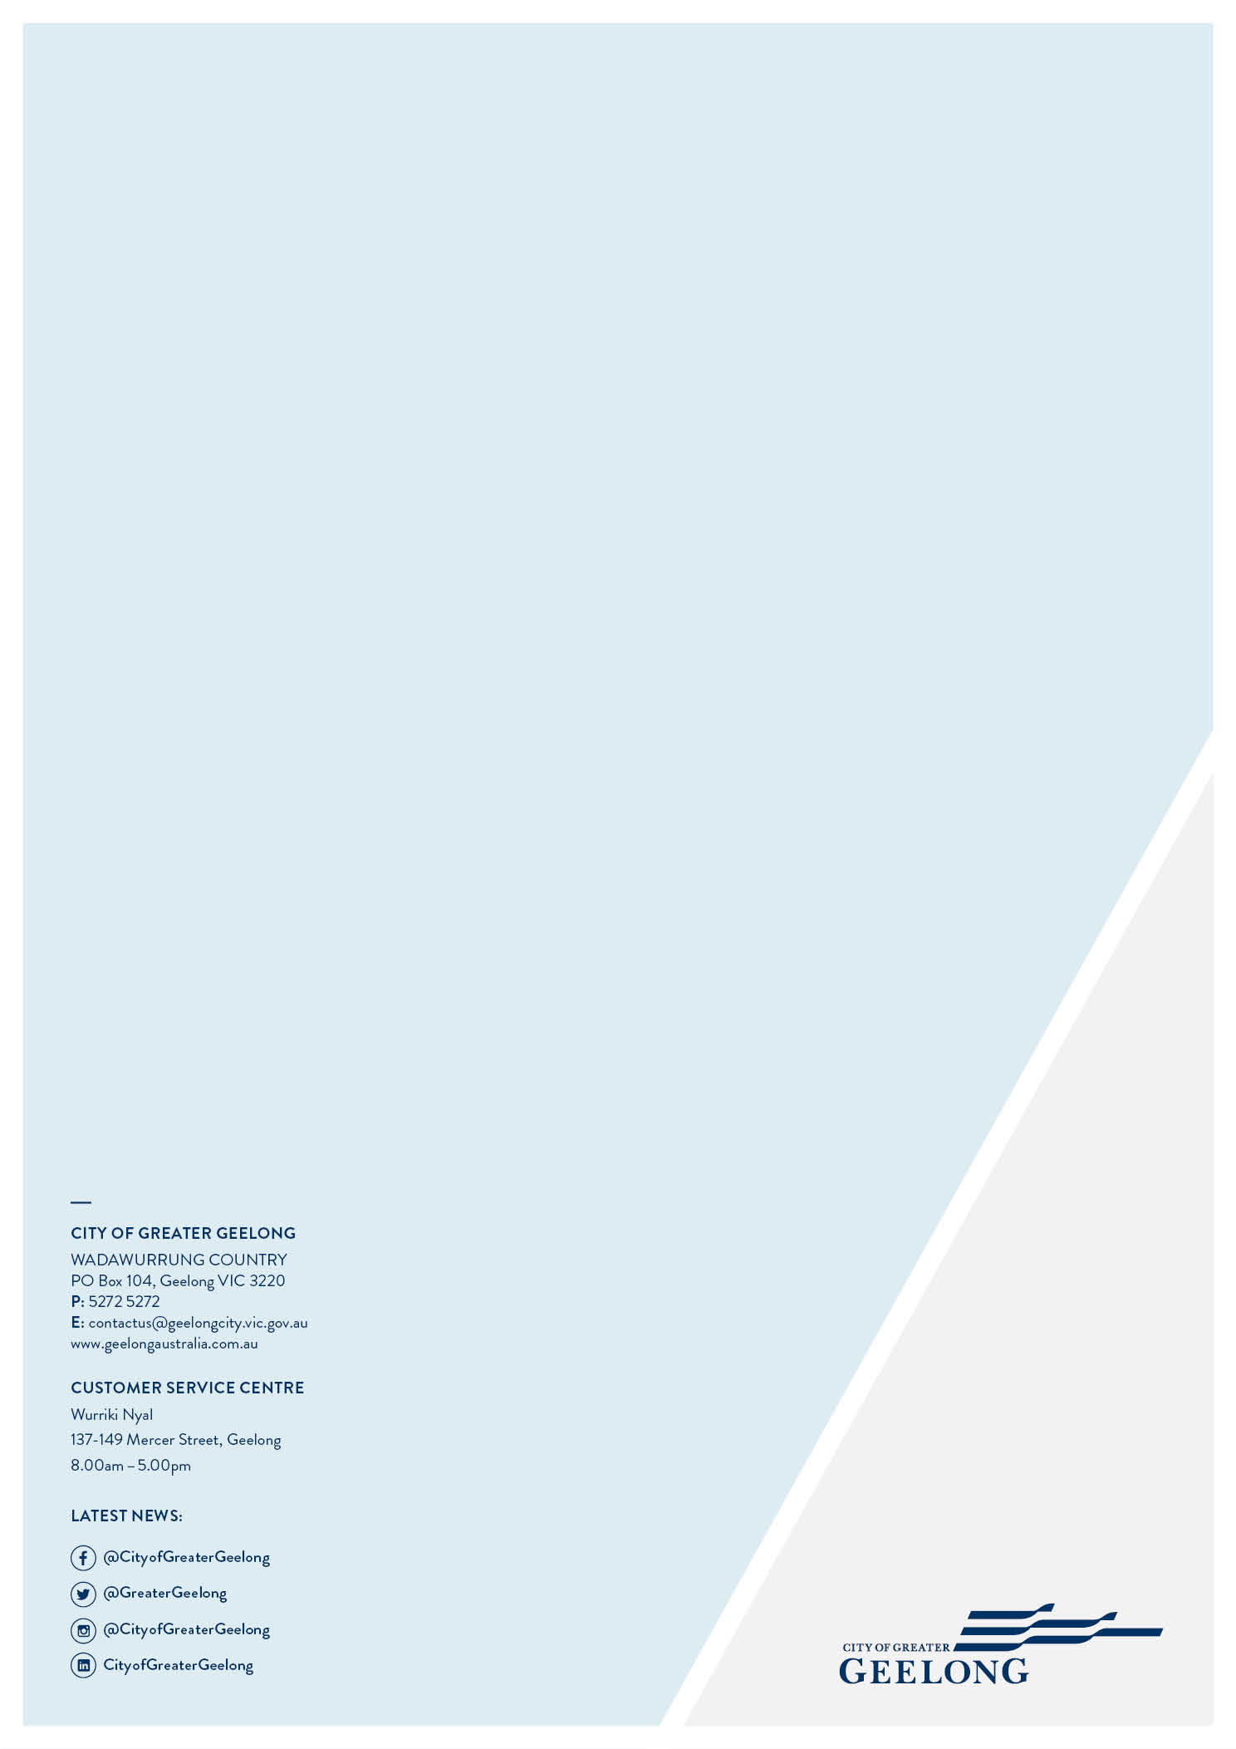

The source for all population data including projections for 2041 (unless otherwise specified) is the id Community website www.forecast.id.com.au/Geelong accessed on 26 February 2021.

