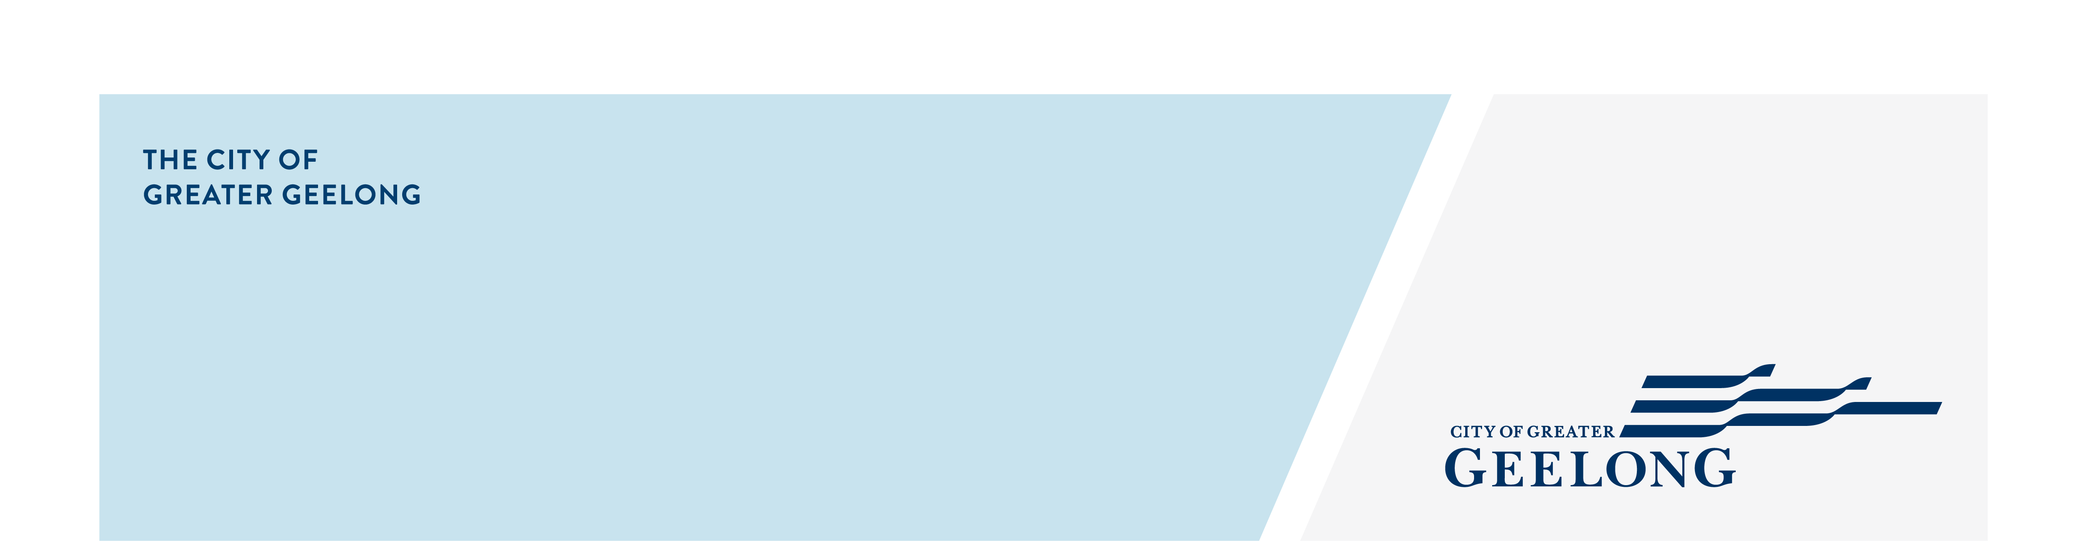
Sparrovale wetlands

master plan

community engagement summary
Feedback on the draft Sparrovale Wetlands Master Plan has closed. The first stage of the community engagement was to seek feedback on the key objectives and priority actions for the new reserve and identify if there are any other issues or opportunities that need to be considered in the development of the plan. A consultation report is being collated and will be made available on Sparrovale Wetlands Master Plan webpage. The master plan process has enormous potential to generate significant environmental and social benefits.


NEWS

4
Media articles in local newspapers
54
Number of people to leave feedback
Visits to the Have Your Say web page.
3196
60 DAYS
of engagement (Stage 1)


People following the project
30
SOCIAL MEDIA
29,600
Reach/Impressions
2,116
Actions (Clicks, reactions,
shares, comments etc.)

Advertising pamphlets delivered
3500

“How will this plan affect the future of duck hunting within the state game reserve?”

“Sanctuary for wildlife.”

what you thought
“The recent addition of 500ha of Sparrovale land is one of the most important additions to the public estate in Geelong’s history.”

“I really like the paths and the connections to the Barwon river trail.”

“It will bring a great landscape to the area and provide a great space for outdoor exercise.”

