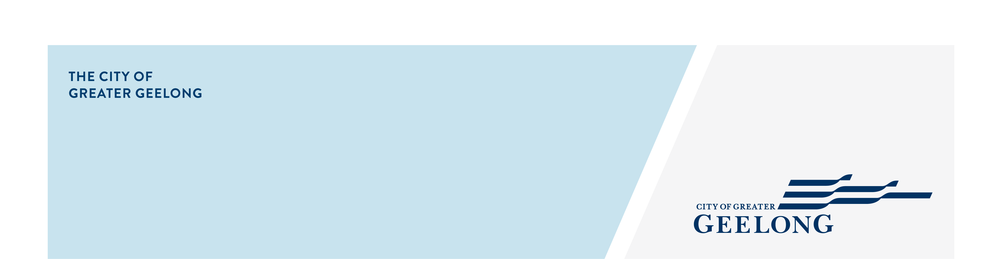
Geelong west community Hub
community engagement summary
The Geelong West Neighbourhood House (GWNH) is the current tenant at Geelong West Community Hub. GWNH secured a 2024-25 Community Infrastructure Grant from the City of Greater Geelong to undertake a feasibility study and concept design for hub upgrades.
Community engagement was undertaken between 5 November and 3 December 2025 to gather feedback on the draft concept plan. The purpose was to ensure the concept plan reflects the values, aspirations, and priorities of those who use and rely on the space as well as the broader Geelong West community.

Suggestions (comments) from the public left online
246

25
Hard copies of surveys received
92
Number of people to leave feedback
28 DAYS
of engagement


Letters delivered
1361
People following the project
15
Emails delivered
567
initial findings and Next Steps
The majority of the respondents were residents from Geelong West and Newtown.
Key Findings:
- The community strongly supports the redevelopment and sees it as a positive way to modernise the building, increase usage, and foster greater connection.
- There is a clear desire for the hub to be accessible, flexible, safe, and welcoming to all.
- Suggestions for improvement are constructive and focus on practical, inclusive, and sustainable enhancements.
Next Steps:
The project team will carefully review and analyse the feedback received and a report a detailed report will be compiled outlining the detailed findings and recommendations for the concept plan.

