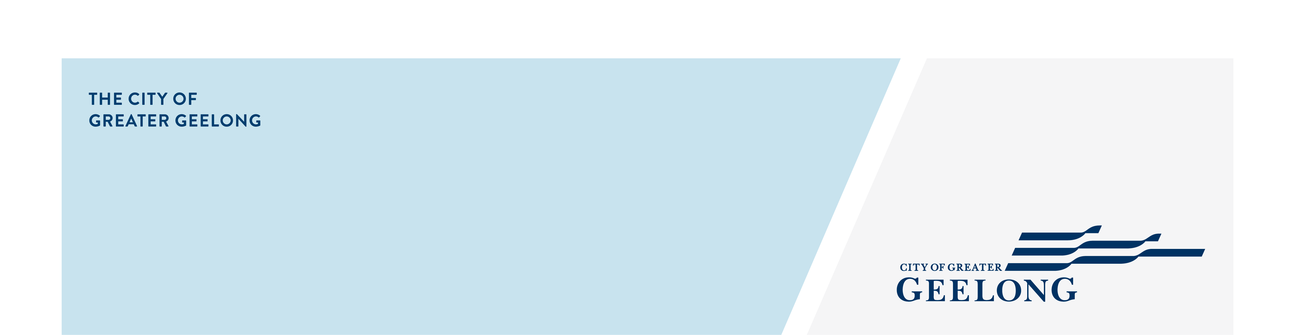
HIGHTON

stormwater

management strategy
community engagement summary
Feedback on the Highton Stormwater Management Strategy consultation has closed. Thank you to everyone who provided feedback, your contribution is valued and appreciated.
From 14 May, 2025 to 13 June, 2025 the community were invited to provide feedback on the strategy to assist the City and relevant authorities to better understand and manage flood risk, stormwater quality impacts on local waterways, and alternate water supply options for the region. The assessment area consists of the following suburbs: Highton, Belmont, Wandana Heights, and Ceres.
Community feedback is a vital part of our planning.
HOW WE ENGAGED WHAT DID WE DO?
Below is a summary of the engagement:

Suggestions (comments) from the public left online via social map
48
151
Number of completed online surveys
702
People visited the Have Your Say (HYS) page
31 DAYS
of engagement (Stage 1)


SOCIAL MEDIA
2,401
Reach/Impressions
34
Actions (Clicks, reactions,
shares, comments etc.)
People following the project
68

Next Steps
Thank you to everyone who contributed to our recent community engagement. The engagement is now closed as we move into the evaluation and review phase.
We really value the experiences shared by our community members. Your feedback will play a key role in validating the catchment model and shaping the deliverables of the strategy.
A summary of the key insights from the engagement will be published on our website once the evaluation process is complete.

