The City Of
Greater Geelong

SOCIAL INFRASTRUCTURE Needs analysis
July 2026

  - WEST FYANS-FYANS STREET PRECINCT STRUCTURE PLAN

Contents
Executive Summary 3
Introduction 4
Purpose of this report 4
Project background 4
Methodology 5
Project Scope 5
Type of Social Infrastructure 5
Desktop Assessment 6
Limitations 6
Infrastructure Catchment 6
Hierarchy 7
Benchmarks 8
Location and Context Review 11
Policy and Strategic Context 11
Plan for Victoria 11
Council Plan 2025-29 11
Geelong Settlement Strategy 2020 11
Geelong Social Infrastructure Plan 2020 – 2023 11
Social Infrastructure Planning and Investment Policy 2020 11
Central Geelong Framework Plan 2023 12
Geelong’s Kindergarten Infrastructure Service Plan 12
Surrounding Context 13
Central Geelong 13
Newtown Demographic Profile 13
Forecast Population 15
Population For West Fyans – Fyans Street Precinct 15
Population For Newtown and The West Fyans – Fyans Street Precinct 15
Supply and Demand Assessment 16
Early Years 16
Key Findings 16
Community Spaces 20
Key Findings 20
Cultural Facilities 23
Key Assessment Findings 23
Appendix 1 – Population Standard Comparison 25

Executive Summary

This report has been prepared by the City of Greater Geelong (the City) to inform the review of the West Fyans – Fyans Street Precinct Structure Plan 2009 (the Structure Plan) and to identify whether additional social infrastructure is required to support the future population and land use change set out in the updated Structure Plan. The Report considers the type and scale of social infrastructure needed to support a well serviced, connected and liveable community.
The Report was prepared using a desktop methodology and focuses on local and district level social infrastructure that is typically planned or delivered by local government. This includes early years facilities, community spaces and cultural facilities.
The Report confirms that the Precinct is already well serviced by existing Social Infrastructure, and that projected population growth does not generate need for new infrastructure within the Precinct. Within 1.5 kilometres of the Precinct there are multiple kindergartens, long day care centres, maternal and child health services, community halls, meeting spaces, neighbourhood houses, community centres, libraries and cultural venues. This level of surrounding provision, together with planned upgrades such as Chilwell Library, means that future residents are expected to have good access to social infrastructure without the need for significant new facility investment within the precinct itself.
The appropriate strategic response is to continue supporting growth through the effective use of existing infrastructure, the delivery of already planned upgrades, and improved accessibility and connectivity between the precinct and surrounding community facilities. This approach is consistent with contemporary policy direction for established urban areas, which prioritises integrated, efficient and adaptable community infrastructure planning in locations undergoing urban renewal and infill development.

Introduction

Purpose of this report
The City of Greater Geelong (the City) is preparing a new Structure Plan for the West Fyans – Fyans Street Precinct. The original Structure Plan for this precinct was prepared in 2009.
The objective of this Report is to identify if any social infrastructure is required to support the future population and land use changes anticipated with the new Structure Plan. It aims to determine the types and scale of social infrastructure particularly those delivered by local government needed to create a well serviced, socially connected neighbourhood.
The City have engaged Glossop Town Planning to prepare the new Structure Plan for the Precinct.

Project background
The Structure Plan (2009) provides the established local planning framework for the precinct and informs the basis for its review and update. Adopted by Council in 2009, the Structure Plan set a long term vision to guide the transition of the area from a predominantly industrial precinct to a mixed use inner urban environment, while retaining key employment functions and celebrating its industrial heritage. The Structure Plan applies to an area of approximately 102 hectares bounded by Shannon Avenue in the west, West Fyans/Fyans Street in the north, Swanston Street in the east and the Barwon River to the south as identified in Figure 1 on the following page. The structure plan envisaged a gradual intensification of residential development to support a future population of approximately 2,000 residents alongside commercial and industrial uses.
Since its adoption, significant changes in strategic policy, population growth expectations, infrastructure planning frameworks and the pace and nature of development within and around the precinct have highlighted the need to review and update the Structure Plan to ensure it remains contemporary and aligned with current state and local policy.
The Community Infrastructure Analysis 2008 prepared for the Structure Plan (2009) provided the original evidence base to inform social and community infrastructure planning for the precinct. The assessment found that existing social infrastructure within the precinct was primarily provided through recreation facilities and open space, with most community, education, health and aged care services located in surrounding areas including Newtown, South Geelong and Belmont. At the time, these facilities were considered generally adequate to absorb additional residential development, provided that safe and convenient access to them was improved, particularly through stronger pedestrian and cycling connections between the precinct and Newtown. The analysis also identified that further residential growth within the precinct would require additional or easily accessible early years and community health infrastructure, including kindergarten, childcare, playgroup facilities and flexible consulting rooms for visiting health and community services. Since the preparation of this assessment, changes in population growth expectations, service provision models, accessibility standards and the scale and timing of anticipated redevelopment have highlighted the need to revisit and update the community infrastructure evidence base to ensure that future planning for the precinct is informed by contemporary data, reflects current community needs, and aligns with current state and local policy directions.
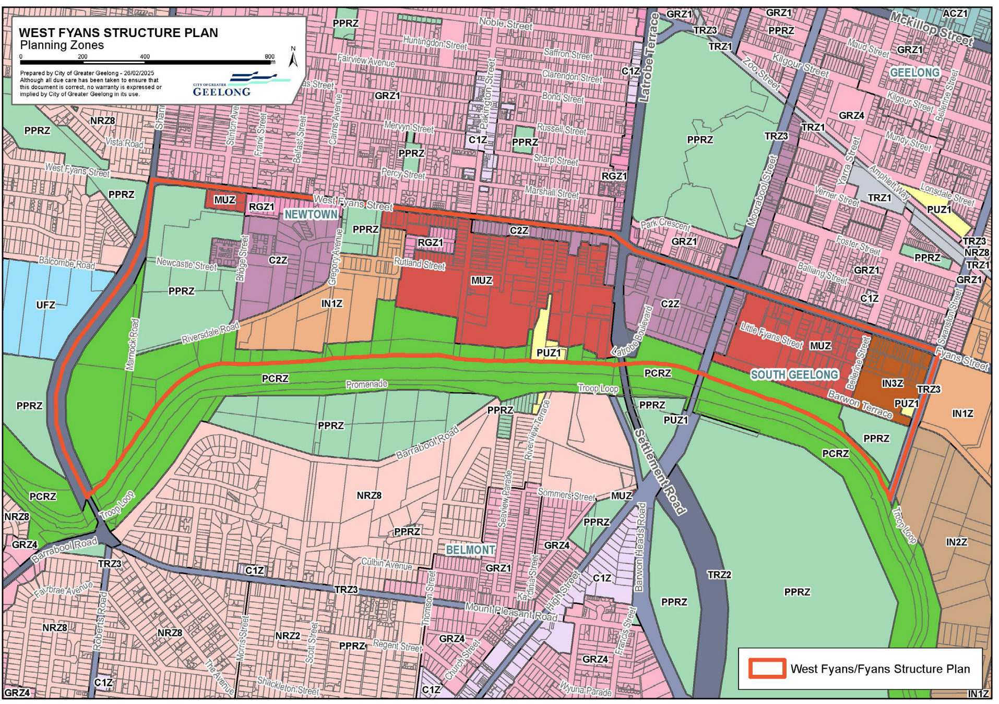
West Fyans – Fyans Street Precinct Area
Figure 1: West Fyans - Fyans Street Precinct Area.

Methodology

Project Scope
This assessment focuses on the required social infrastructure triggered by projected population growth in the West Fyans – Fyans Street Precinct.

Type of Social Infrastructure
Social infrastructure refers to the places and spaces that bring communities together. Where people connect, build relationships, and access important services. It includes both ‘hard’ and ‘soft’ infrastructure. The types of social infrastructure relevant to this assessment is listed in table 2 on the following page. The scope of infrastructure does not include indoor recreation, outdoor courts, sporting fields or public open space.
Table 1: Types of social infrastructure and responsible agents
Category | Type of Facility | Primary Responsible Agent(s)
Education & Training Facilities | Schools (primary, secondary), TAFE, universities. | State Government, Non-Government sector and Commonwealth.
Early Years Facilities | Childcare, kindergarten, playgroups, maternal & child health. | Local Government and Non-Government sector. State Government can provide policy and funding.
Community Spaces | Community centres, neighbourhood houses, halls, meeting rooms, youth spaces, senior services. | Local Government, Non Government sector.
Cultural Spaces | Libraries, museums, art galleries, performance spaces. | Local Government, Geelong Regional Library Corporation, State Government and Non-Government sector.
Health, Safety and Emergency Services | Hospitals, community health, police, ambulance, emergency services, fire stations. | State Government and Commonwealth.
For the purposes of undertaking this assessment social infrastructure serving a local or district catchment that is deliverable by local government was the focus of this report and include services in the following categories:
- Early years
- Community Spaces
- Cultural Spaces

Desktop Assessment
The desktop assessment relies on mapped information and service records held in Council systems at the time of this report. While this provides a consistent baseline for audit and catchment analysis, datasets may not fully reflect recent changes, such as newly opened services, closures, relocations, changes in tenancy, or updated services within existing buildings. Some properties may also have incomplete or outdated information about the services they provide. These factors may affect the accuracy of the infrastructure inventory and the interpretation of local access. No stakeholder or community engagement was undertaken to inform this assessment specifically, though engagement findings from the stakeholder engagement undertaken in April 2025 has been reviewed.

Limitations
This assessment does not evaluate whether existing facilities are fit for purpose, meet contemporary standards, or are configured to support current and future community needs. It also does not include utilisation analysis, such as participation rates, condition audits, compliance issues, or user experience. As a result, a facility may be counted as present within the catchment even if it requires renewal, refurbishment, redesign, or service model changes to function effectively for an expanding and changing population.

Infrastructure Catchment
The role of the infrastructure catchment is to identify the infrastructure currently available to the precinct based on the size and scale of a local neighbourhood. A 20-minute walk equates to approximately 1.5 kilometres. Figure 2 on the following page shows the 1.5 kilometre infrastructure catchment area of the precinct boundary along with the Precinct boundary. The 1.5 kilometre catchment is included to provide a better understanding of the quantity and diversity of community infrastructure currently available. The 1.5 kilometre population catchment includes parts of Belmont, Central Geelong, Highton, South Geelong, Thomson and East Geelong.
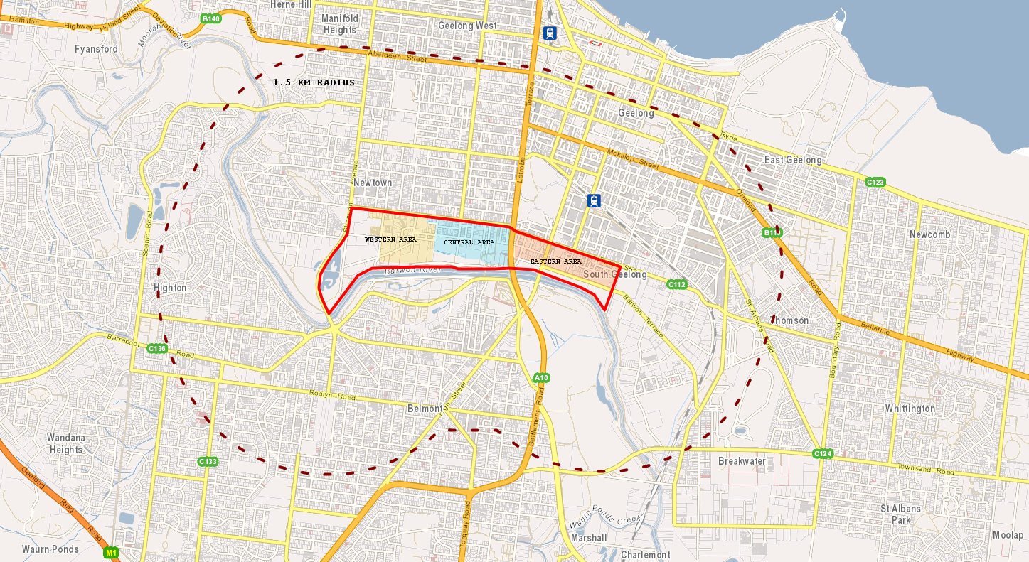
Legend
West Fyans – Fyans Street Precinct Area
1.5km catchment
Figure 2: 1.5km infrastructure catchment to the Precinct

Hierarchy
Community facilities generally operate within a hierarchy of provision, with different scales of infrastructure servicing varying sized catchments in terms of the area and number of people serviced. For example, local community halls generally service local catchments; libraries can service district and regional catchments; and large regional art galleries and performing arts centres will service the municipality. It should be noted that large facilities or higher order facilities can also serve a local and district function. Strategically, this results in a larger number of small, local/neighbourhood facilities, distributed across the City and relatively few large, regional facilities, in key locations.
Current community infrastructure planning framework for both the City and Victorian Planning Authority (VPA) establishes a hierarchy.
- The City’s hierarchy for community facilities consist of three levels, local, district and regional.
- The VPA’s guidelines proposes a hierarchy which consists of five levels, Level 1 – Level 5.
- The proposed social infrastructure hierarchy for this report is shown in Table 2 below.
Table 2: Social Infrastructure Hierarchy
Hierarchy | Role of Social Infrastructure | VPA Hierarchy | Population Catchment
Local | Catchment: Serves a walkable area (approx. 1.5 km / 20-minute walk), focused on the immediate neighbourhood.  Role: Provides every day, accessible spaces that support social connection, basic services, and informal community participation.  Typical Facilities & Services:  - Small community meeting rooms  - Neighbourhood houses/community centres  - Maternal & child health consult rooms  - Early years facilities | Level 1 | Community Facilities – Up to 10,000 people
District | Catchment: Serves several neighbourhoods (multiple suburbs), accessible by short drive or public transport.  Role: Provides larger, more specialised, and coordinated facilities that host structured programs, multipurpose activity, and a broader mix of community services.  Typical Facilities & Services:  - Neighbourhood houses / community centres  - District libraries  - Integrated early years centres  - Youth centres with dedicated programming  - Arts/cultural spaces, makers spaces, activity rooms  - Commercial Kitchen | Level 2 and 3 | Community Facilities – Up to 50,000 people
Regional | Catchment: Serves the whole municipality or the broader region; attracts visitors from outside the local area.  Role: Facilitates major, high capacity or specialised facilities that provide cultural, recreational, civic, and economic functions at a city shaping scale.  Typical Facilities & Services:  - Major performing arts centres and regional theatres  - Regional library and heritage centres  - Museums and regional art galleries  - Convention/exhibition centres  - Civic centres and regional service hubs | Level 4 and 5 | Community Facilities – 150,000 + people

Benchmarks
Benchmarking parameters were defined to establish appropriate measures to assess future need for each social infrastructure type. A comparative analysis of the VPA’s community infrastructure guidelines 2008 and more recently adopted Geelong Social Infrastructure Plan (2020) benchmarks was undertaken and can be viewed at Appendix 1 to this report. This analysis was necessary as the VPA benchmarks were prepared some time ago and are aimed towards growth area provision (rather than established residential areas), and there have been further strategic changes to the requirements for some services since the adopted Geelong Social Infrastructure Plan benchmarks. See a full list of the benchmarks and the service definition used for this report in table 3 below.
Table 3: Recommended social infrastructure benchmarks for West Fyans - Fyans Street Precinct Structure Plan
Facility | Definition | Size (sqm) | Recommended Benchmark
EARLY YEARS FACILITIES
Government provided Kindergarten | Kindergarten is an early childhood education service planned and delivered by a qualified teacher and funded by the State Government. A kindergarten service may be integrated into an early years hub which may also have complementary services such as MCH consulting rooms. Kindergarten can be delivered in a standalone facility, as a sessional service, or integrated into a long day care service. Generally, kindergarten services are provided in a 3-4 room set.  Services may be run by a government, community, or private (for-profit or not-for-profit) provider. This benchmark assumes a 96% participation rate and a 50% market share of kindergartens that are government (state or local) run. |  | 1 room per 33 participating 3 and 4 yr olds.
Maternal and Child Health | Maternal and Child Health (MCH) service provides a range of health promotion, prevention and education services for families with children from birth to school age. The service is provided by council, delivered via consulting rooms that historically were standalone, but are now typically integrated into an early year’s hub or a community centre. MCH infrastructure is typically provided as 2 rooms per site. |  | 1.3 rooms per 1,000 0 to 4 yr olds
Long Day Care | Long Day Care (LDC) is a centre-based early childhood education and care service that provides education and care for children from birth to school age, usually for extended hours across the working day.  Long day care services may deliver funded 3 and 4 Year old kindergarten programs within the long day care setting. |  | 1 licensed place per 3.2 0 to 4 yr olds
COMMUNITY SPACES
Neighbourhood House/Community Centre | A neighbourhood house or community centre is a facility that provides spaces, programs and services where people from a local area can meet, learn, recreate, access support and participate in community life. They offer bookable meeting spaces, event spaces, and activity spaces that can be used by local organisations and the community to deliver programs and activities.  These facilities can be run by council or a not for profit. | 1000 sqm | 1 facility per 20,000 people
Small Meeting Spaces (1-20) | Bookable spaces for general community and service use. They provide flexible spaces for meetings, programs (e.g. seniors groups, playgroups) activities (e.g. art, play, education) and events (e.g. civic events, birthdays, celebrations).  Meeting rooms are multipurpose and available for casual or long term hires and vary in size. They may be standalone facilities or situated within large centres/buildings. Any new meeting spaces should be integrated with other services.  These facilities can be run by council or a not for profit. | 10-30 sqm | 1 space per 4,000 people
Small-Medium Meeting Spaces (21-50) |  | 30-50 sqm | 1 space per 8,000 people
Medium Meeting Spaces (51-100) |  | 50-100sqm | 1 space per 8,000 people
Medium-Large Meeting Spaces (101-200) |  | 100-150 sqm | 1 space per 8,000 people
Large Meeting Spaces (200+) |  | 150-200 sqm | 1 space per 20,000 people
CULTURAL FACILITIES
Local Library | Small library spaces that allow people to browse and borrow books and may include access to 1 or 2 computers. Opening hours are generally limited. Can also function as a community centre with the library running community programs.  The delivery of local libraries is no longer considered best practice provision in metropolitan areas. This is due to the higher population levels seeking access to infrastructure which would then result in multiple smaller local facilities that are not financially viable (capital and operational costs). Local infrastructure is still important for accessibility, however alternative models are usually still considered first, e.g. a mobile library or library kiosk. |  | 1 facility per 25,000 people
District Library | A district library is a major public library facility that serves a broad district‑level catchment, providing a wider range of collections, spaces and services than a local or neighbourhood library, and often acting as a key civic and community hub. |  | 1 facility per 50,000 people
Regional Library | A regional library is a major public library service or facility that serves a large regional catchment, often across multiple municipalities, providing comprehensive collections, specialist services, and strategic support to branch and district libraries within a library network. |  | 1 facility per 200,000 people
Studio / workshop | A publicly owned space used by an artist, designer, or small creative business to create and produce digital and/or physical artwork. Can be a 'clean' studio (ie. printing, laser-cutting, model-making, drawing, sketching, fabric and fashion forms) or a 'wet' studio (screen printing, fabric dyeing, painting, resin work, and other forms that may require specific liquid waste management solutions). These publicly owned spaces are typically supplemented by private studios/workshops. |  | 1 facility per 25,000 people
Rehearsal space | Rehearsal and practice rooms that cater for musical, theatre and dance performances. Venues are generally fitted with features such as sound systems, sprung floors, mirrors, ballet barres, dressing rooms, toilets/showers. These publicly owned spaces are typically supplemented by private rehearsal spaces or restricted access spaces (ie. schools). |  | 1 facility per 30,000 people
Regional Performing Arts/Theatre | Regional performing arts and theatre facilities are higher order cultural venues that serve a regional catchment, providing professional standard spaces for the presentation, production and participation in performing arts and cultural activity, while supporting community use, touring, education and regional cultural identity. |  | 1 facility per 250,000 people
Gallery exhibition space | A dedicated space that supports physical displays (e.g. paintings, sculpture, or historical artefacts) and/or digital display (audio-visual or interactive). These spaces may be a standalone use or incorporated within civic buildings such as performing arts centres or community centres. These publicly owned spaces are typically supplemented by private galleries/ exhibition spaces. |  | 1 facility per 100,000 people

Location and Context Review

Policy and Strategic Context
This section of the report provides an overview of the policy and strategic documents that set strategic direction for social infrastructure for the Precinct and Greater Geelong.

Plan for Victoria
Plan for Victoria provides a clear state level policy framework that supports the preparation of a community infrastructure needs assessment to inform the revised Structure Plan. The Plan prioritises the delivery of housing and population growth in locations that are well serviced by jobs, public transport, community facilities and services, and emphasises compact, connected and liveable neighbourhoods where daily needs can be met close to home. It also includes explicit direction to support active transport, people centred street and public realm design, and the timely coordination of community infrastructure to support growing communities. In this context, a community infrastructure needs assessment provides an essential evidence base to ensure that future community facilities, open space and services in the precinct are appropriately located, staged and aligned with state planning objectives for accessible, walkable and well-serviced neighbourhoods

Council Plan 2025-29
The Council Plan 2025–29 establishes a clear policy framework that supports the preparation of a social infrastructure needs assessment to inform the revised Structure Plan. The Council Plan prioritises the planning and delivery of core and critical infrastructure to enable responsible and sustainable growth, with a specific focus on ensuring community facilities and public spaces are accessible, fit for purpose and responsive to population change. It also emphasises equitable health and wellbeing outcomes and evidence based decision making to guide resource allocation and infrastructure investment across growing and established areas.

Geelong Settlement Strategy 2020
The Settlement Strategy (2021) directs community infrastructure planning in urban infill areas to focus on supporting increased densities through the efficient use, adaptation and upgrading of existing facilities, rather than relying on new standalone infrastructure. It recognises that urban consolidation places additional pressure on community facilities, open space and services, and therefore requires proactive, evidence based assessment of capacity, accessibility and upgrade needs. The Strategy also emphasises integrating community infrastructure with walkable, well connected neighbourhoods and leveraging surrounding catchments to support infill precincts. This provides a clear policy basis that informs the Social Infrastructure Assessment for the Structure Plan.

Geelong Social Infrastructure Plan 2020 – 2023
The Geelong Social Infrastructure Plan 2020–2023 establishes a place based framework for identifying community infrastructure needs, with a strong emphasis on optimising existing assets, addressing service gaps and transitioning from single use facilities to integrated, multi-purpose community infrastructure in established areas experiencing change and intensification.
The precinct sits within Planning Area 10 (Geelong West, Manifold Heights and Newtown). The Social Infrastructure Plan prioritises the Geelong West and Newtown Community Infrastructure and Services Place Based Needs Study, including the investigation of a community hub. The hub has already been demonstrated locally through the transition of the Geelong West Senior Citizens Centre to a community hub in 2021.

Social Infrastructure Planning and Investment Policy 2020
The Social Infrastructure Planning and Investment Policy provide Council’s overarching framework for the planning, prioritisation and delivery of social infrastructure across the municipality. The Policy establishes Council’s role in advocating for, planning, funding and partnering in the delivery of community facilities, open space and services, and sets out the principles and decision making criteria that guide investment in social infrastructure over time.
The Policy emphasises a fair and equitable approach to investment, with decisions guided by evidence of need, community benefit and alignment with Council’s strategic priorities. It promotes place based planning, timely provision of infrastructure to support growth and change, and the efficient use and optimisation of existing assets where possible. The Policy also recognises the importance of partnerships with other levels of government, the community sector and the private sector to maximise outcomes for the community.

Central Geelong Framework Plan 2023
The Central Geelong Framework 2023 is a 30 year plan to support growth and development within Central Geelong which is a major regional activity centre significant on a state and national level. Central Geelong supports numerous regional size community infrastructure from the Geelong Arts Centre, Geelong Regional Library and Geelong Convention and Exhibition Centre. Central Geelong performs a distinct role and is subject to separate strategic planning and staging for community infrastructure. Council intends to assess Central Geelong as its own Statistical Area in the near future, in response to unmet demand for kinder identified in Geelong’s Kindergarten Infrastructure Service Plan and actions identified through the Central Geelong Framework Plan. This assessment therefore avoids duplicating that work and does not draw conclusions about Central Geelong’s needs or priorities.

Geelong’s Kindergarten Infrastructure Service Plan
Geelong’s Kindergarten Infrastructure Service Plan (KISP) supports planning for services and future capital works. It outlines the current capacity and demand for funded kindergarten, capacity for planned infrastructure projects and future demand to be delivered, forecasts unmet demand in the Local Government Area and provides Geelong specific information regarding its early childhood education landscape until the year 2036.
The KISP does not identify any unmet demand for government funded kindergarten within the suburb of Newtown.

Surrounding Context
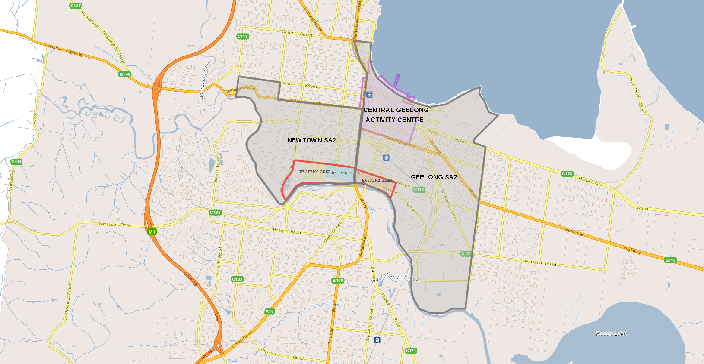
The Precinct is located approximately 1.8 km south - southwest of the main activity centre of Geelong City, within the suburban areas of Newtown and Geelong. See figure 3 below. The site is within proximity to the city centre of Geelong and is supported by numerous community infrastructure facilities of a regional size. The surrounding area is dominated by residential development. Immediately north of the precinct is a large residential area, through which Pakington Street Activity Centre runs along a north/south axis. Lands adjoining the east of the precinct are zoned Industrial 1. Land immediately south of the Barwon River is protected as a Public Park and Recreation Zone.
Figure 3 West Fyans - Fyans Street Precinct and its surrounding area

Central Geelong
Central Geelong is the urban centre of Geelong and a major civic, health, education, transport, retail and cultural destination for both local and regional communities. It performs a distinct regional role within Greater Geelong and is subject to a separate and established strategic planning framework including an adopted community infrastructure strategy as noted earlier in this report. These documents provide direction for the planning, provision and staging of community infrastructure within the city centre and are intended to be reviewed and updated independently over time.
Including Central Geelong within the scope of this analysis would duplicate existing strategic work and pre-empt future policy review processes. Accordingly, community infrastructure needs arising from growth within the Precinct are to be addressed through local and district level provision, supported by the broader municipal network, rather than through reliance on Central Geelong’s regional facilities.

Newtown Demographic Profile
Overall, Newtown is considered a highly advantaged community when compared to the City of Greater Geelong. Newtown has much higher household income rates, lower unemployment rates and higher education levels. Newtown presents less culturally diverse than the broader municipality with 14.5% of residents born overseas and around 8.9% of residents speaking a language other than English at home. Newtown has a population of 10,445 people in 2021 and has had limited growth over the past 10 years. It should be noted that the data used for this analysis is based on Newtown Statistical Area 2 (SA2) from the 2021 census.
Table 4: Newtown Demographic Indicators
Characteristic | Newtown | City of Greater Geelong | How Newtown Compares
Total Population (2021) | 10,445 | 270,932 | Small, established suburb within a large, growing LGA
Recent population growth | Very low (0.5% p.a.) | Strong (2.4% p.a.) | Much more stable, limited growth capacity
Median age | 40 years | 39 years | Slightly older
Children (0–17 years) | 23% | 21% | Higher proportion of children
Older people (60+ years) | 24% | 26% | Lower proportion of older residents
Couples with children | 31% | 27% | Higher concentration of family households
One-parent families | 8.5% | 10.6% | Lower family vulnerability
Lone-person households | 28% | 26% | Slightly higher
Average household size | 2.44 persons | 2.41 persons | Marginally larger households
SEIFA Index of Disadvantage (2021) | 1073 | 1007 | Significantly less disadvantage
Need for assistance (disability) | 3.9% | 6.5% | Lower service dependency
Bachelor degree or higher | 41% | 24% | Much higher educational attainment
Unemployment rate | 3.5% | 4.4% | Lower unemployment
High-income households ($3,000+/week) | 33% | 19% | Much higher household incomes
Median household income | $2,189/week | $1,625/week | Significantly higher
Separate houses | 76% | 85% | Lower share of detached housing
Medium-density dwellings | 24% | 14% | Greater housing diversity
Home ownership (owned or mortgage) | 67% | 66% | Similar
Households renting | 29% | 27% | Slightly higher
Housing costs (rent & mortgage) | Above LGA average | Lower | Greater affordability pressure
Overseas-born residents | 15% | 18% | Less culturally diverse
Language other than English at home | 9% | 12% | Lower linguistic diversity

Forecast Population

Population For West Fyans – Fyans Street Precinct
Understanding projected population growth is essential for estimating future demand for social infrastructure. The social infrastructure needs of the West Fyans – Fyans Street Precinct are assessed from both a precinct level and local catchment perspective which, for the purpose of this assessment is defined by the SA2 in which the precinct is located (Newtown).
The West Fyans – Fyans Street Precinct is expected to experience long term, incremental change, transitioning from an established inner urban industrial and commercial area to a mixed-use precinct with additional housing and employment. Council engaged Charter Keck Cramer (CKC) to prepare a population and employment analysis to inform the 2025 Structure Plan Review. CKC developed three scenarios that estimate the total number of residents and dwellings in the Precinct by 2041. Of the three scenarios, CKC highest growth scenario predicts an increase in population for the precinct by 2,250 and 1,000 dwellings. Council conducted additional modelling to understand the capacity for the precinct and determined development capacity for the precinct can provide for an additional 5,700 people and 2,500 dwellings. For the purpose for this assessment, the expected 5,700 people and 2,500 dwellings will be used to determine service needs.
The broader suburb of Newtown’s current population is 10,407 and accommodates 4,508 dwellings. Newtown is projected to increase by approximately 3,000 people between 2026 and 2041 and the number of dwellings is anticipated to increase by approximately 1,700.
The 2008 Structure Plan anticipated a total precinct population of approximately 2,200 people. To date, growth has been substantially lower, with an estimated resident population of approximately 215 people (ABS 2021). It is assumed that the forecast population for Newtown accounts for this additional growth identified in the 2008 structure plan and is considered accordingly.
Table 5: Forecast population and dwellings for West Fyans - Fyans Street Precinct and Newtown SA2
 | 2026 | 2041 | Change from 2026 to 2041
WEST FYANS – FYANS STREET PRECINCT
Population | 215 | 5,700 | 5,485
Dwellings | 189 | 2,500 | 2,311
NEWTOWN
Population | 10,407 | 13,482 | 3,075
Dwellings | 4,508 | 6,249 | 1,741
Based on Newtown’s population and dwelling projections presented above and the dwelling and population assumptions for the West Fyans – Fyans Street Precinct the projected population for the study area is 16,767 by 2041.
Population yields anticipated for the West Fyans – Fyans Street Precinct and suburb of Newtown are shown in table 6 on the following page. They are calculated using current percentage breakdown for the age cohort reflected in Newtown.
Table 6: Target Population Projections for key Age Cohorts for West Fyans - Fyans Street Precinct and Newtown by 2041
 | Percentage based on Newtown SA2 | West Fyans – Fyans Street Precinct | Newtown
Newborns 0 years old | 0.8% | 44 | 134
Toddlers (1 to 2) | 1.6% | 88 | 268
Pre-schoolers (3 to 4) | 1.6% | 88 | 268
Primary schoolers (5 to 11) | 8.7% | 477 | 1,458
Secondary schoolers (12 to 17) | 9.7% | 532 | 1,626
Tertiary education and independence (18 to 24) | 7.7% | 422 | 1,291
Workforce (25 to 59) | 42% | 2,304 | 7,042
Empty nesters and retirees (60 to 69) | 10.8% | 626 | 1,810
Seniors (70 and over) | 16.8% | 1,895 | 2,816
Total | 100% | 5,485 | 16,767

Supply and Demand Assessment
The Supply and Demand Assessment assesses whether the expected future populations growth for West Fyans – Fyans Street precinct and the Newtown suburb will require new community facilities, or if residents can be supported by services that already exist within the surrounding catchment.

Early Years
Table 8: Early Years demand for Newtown SA2 and West Fyans – Fyans Street Precinct
Facility | Benchmark | Existing Supply | 2041 Demand | Surplus / Gap | Additional Facilities Needed
Kindergarten | 1 room per 33 participating 3 and 4 year old. | 8.4 | 8.1 | + 0.3 | 0
Maternal & Child Health | 1.3 rooms per 1,000 0 to 4 yr olds | 1 | 0.9 | + 0.1 | 0
Long Day Child Care | 1 licensed place per 3.2 0 to 4 yr olds | 1,176 | 209 | + 966 | 0

Key Findings
Kindergarten
The total estimated sessional kindergarten demand for Newtown is approximately 268 licensed places or 8.1 rooms when calculated on an average of 33 children per room. The existing supply within the walkable 1.5km catchment is approx. 8.4 rooms so no additional facilities are required to meet the proposed population increase for West Fyans – Fyans Street Precinct.
The Kindergarten Infrastructure and Service Plan (KISP) for Newtown identifies a substantial existing surplus of 390 15 hour kindergarten places available up to 2036, indicating that current provision within the catchment is more than sufficient to absorb projected growth. While the KISP does not extend to 2041, the surplus significantly exceeds the additional demand arising from the West Fyans population uplift. As such, no additional kindergarten infrastructure is required to meet the forecast needs of the precinct.
Maternal and Child Health
The total need for Maternal and Child Health (MCH) facilities for the projected population of West Fyans – Fyans Street Precinct and Newtown is 1 room. There are currently two MCH within the 1.5km catchment. Chilwell MCH is currently closed and Geelong MCH currently operates as a standalone site with a single nurse. While the identified need is sufficiently provided for, a single stand alone facility lacks built in resilience, has limited support onsite, and are not aligned with the preferred integrated service delivery. The Virgina Todd Community Centre located at 13-15 Clarence Street in Geelong West sits just outside the Newtown SA2. The centre provides Maternal and Child Health services and currently has capacity to be able to assist with growth in the West Fyans – Fyans Street Precinct.
Council is currently undertaking a review of all Maternal and Child Health facilities which identifies the Geelong MCH as a high priority to establish an alternative integrated facility to replace the existing facility.
Long Day Care
The total need for Long Day Care for West Fyans – Fyans Street Precinct and Newtown is 1,176 licensed places. There are 11 long day childcare services within the 1.5km catchment for the precinct.
No additional long day care is needed with the projected increase in population for West Fyans – Fyans Street Precinct and Newtown.
Table 9: Existing early years facilities within 1.5km catchment (Council and Non Council Owned Facilities)
Map Id No. | Name | Owner | Service | Supply | Address | Suburb
3 | All Star Kids | NON COGG | Long Day Child Care | 53 | 19 McKillop Street | Geelong
5 | Bambini Early Learning Centre | NON COGG | Long Day Child Care | 92 | 89 Aphrasia Street | Newtown
7 | Bay City Early Learning Centre | NON COGG | Long Day Child Care | 103 | 16 Little Ryrie Street | Geelong
8 | Bellevue Pre-School | COGG | Kindergarten | 33 | 224A Roslyn Road | Highton
9 | Bond Street Kindergarten | NON COGG | Kindergarten | 55 | 25-35 Bond Street | Newtown
12 | Chilwell MCH Centre (currently closed) | COGG | Maternal & Child Health | 0 | 49 Russell Street | Newtown
13 | City Learning & Care Children's Centre (COGG operated) | COGG | Long Day Child Care | 170 | 249 Pakington Street | Newtown
15 | Federation Children - Newtown | NON COGG | Long Day Child Care | 132 | 215 Aberdeen Street | Newtown
19 | Fyan’s Park Kindergarten | COGG | Kindergarten | 66 | 202-204 West Fyans Street | Newtown
20 | Geelong Children’s Centre | NON COGG | Long Day Child Care | 120 | 21a Lomond Terrace | Thomson
21 | Geelong Grammar School Bostock House | NON COGG | Kindergarten | 26 | 139 Noble Street | Newtown
22 | Goodstart Early Learning Geelong East | NON COGG | Long Day Child Care | 67 | 144-150 McKillop Street | Geelong
24 | Goodstart Early Learning Newtown (closed) | NON COGG | Long Day Child Care | - | 15 Aberdeen Street | Newtown
25 | Paisley Park Early Learning Centre | NON COGG | Long Day Child Care | 88 | 19 Aberdeen Street | Newtown
26 | Maternal & Child Health Centre - Geelong | COGG | Maternal & Child Health | 1 | 160-166 McKillop Street | Geelong
29 | Orana Early Learning Centre | NON COGG | Long Day Child Care | 130 | 21-25 Mitchell Street | Belmont
33 | Newtown Playgroup | COGG | Playgroup |  | 2 Ruthven Street | Newtown
42 | Normanby Street Preschool | COGG | Kindergarten | 33 | 53-55 Normanby Street | East Geelong
46 | Play CC&K (Child Care & Kindergarten) | NON COGG | Long Day Child Care | 122 | 119-125 Roslyn Road | Belmont
49 | Thomson Kindergarten & Pre School | COGG | Kindergarten | 33 | 2C Godfrey Street | Thomson
50 | Young Minds Early Learning Centre | NON COGG | Long Day Child Care | 99 | 223 Yarra Street | South Geelong
51 | St Lukes Uniting Kindergarten Highton | NON COGG | Kindergarten | 33 | 172 Barrabool Road | Highton

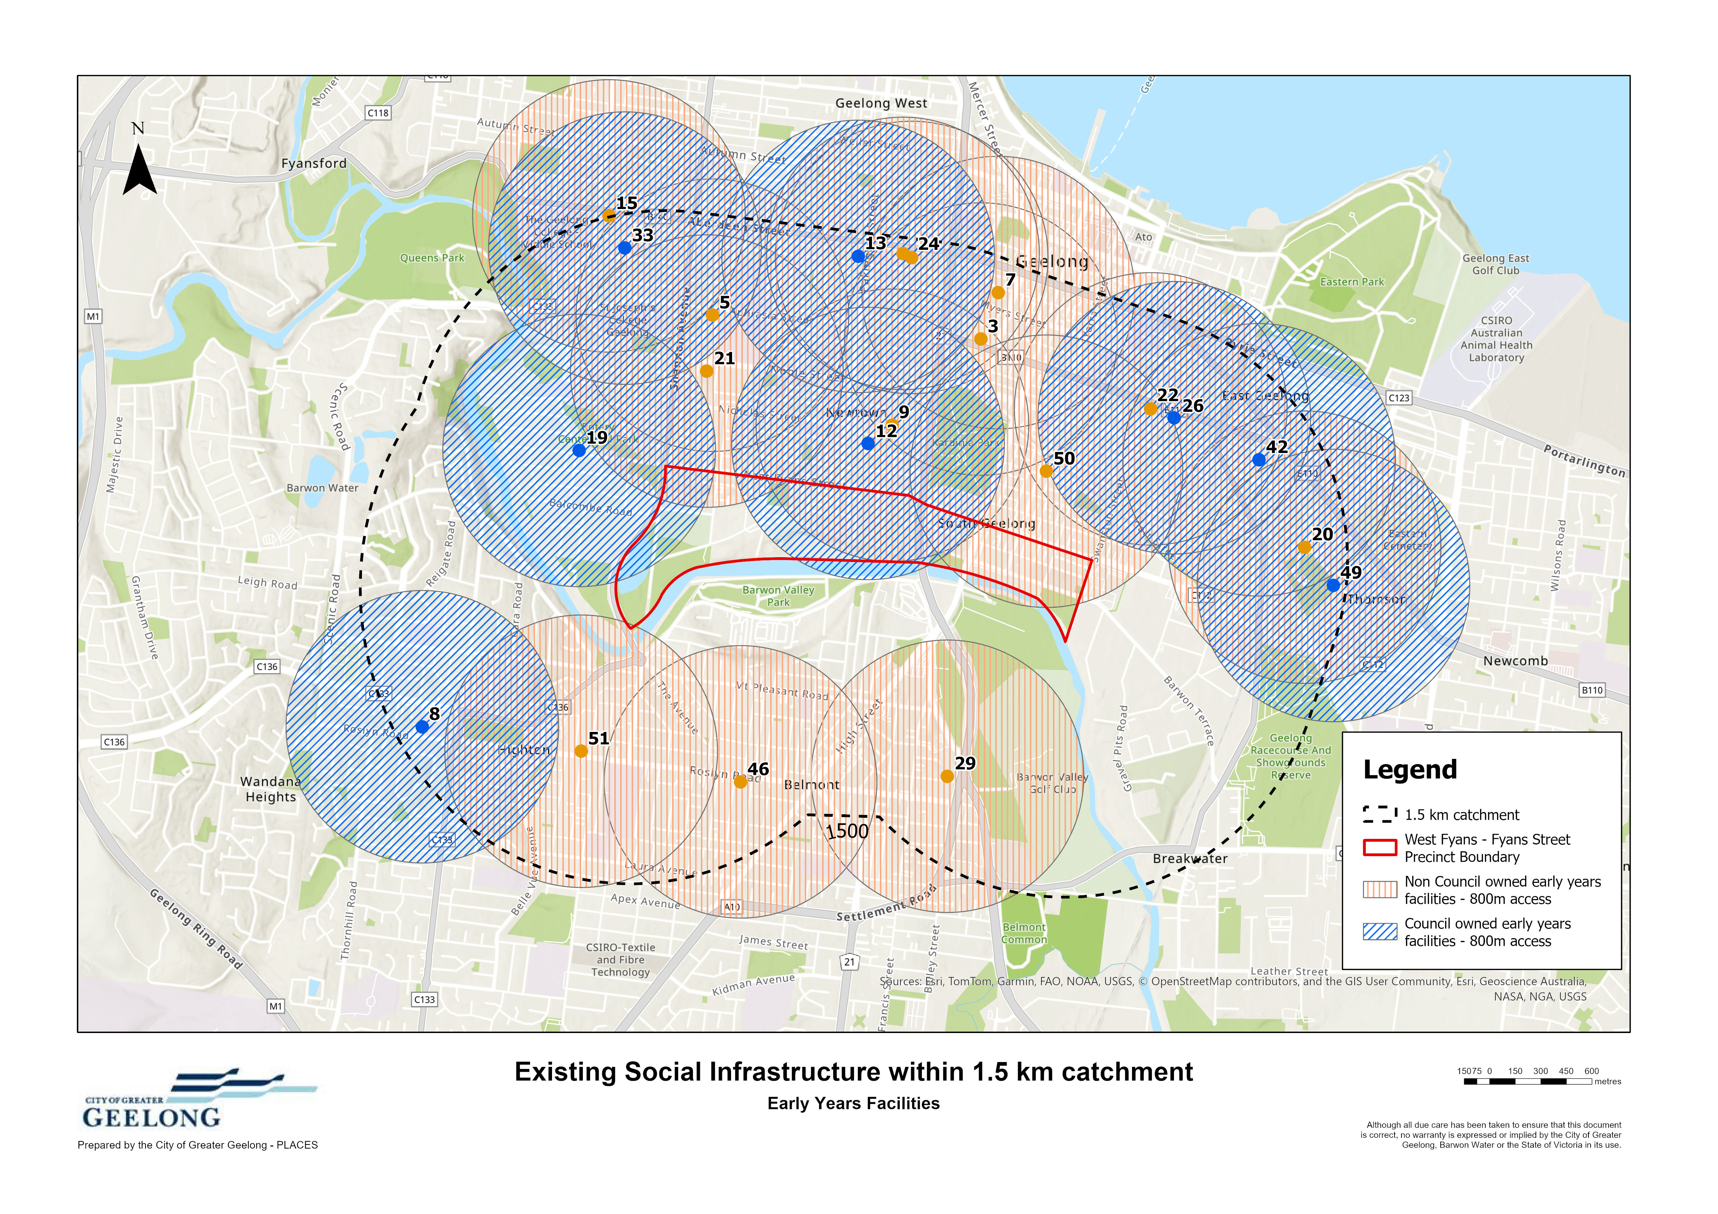
Figure 4: Existing Early Years Facilities within 1.5km catchment to West Fyans - Fyans Street Precinct

Community Spaces
The demand for community spaces is identified below in table 10.
Table 10: Community Space demand for Newtown SA2 and West Fyans – Fyans Street Precinct
Facility | Benchmark | Existing Supply | 2041 Demand | Surplus Gap | Additional Facilities Needed
Neighbourhood House/Community Centre | 1 facility per 20,000 people | 1 | 0.8 | + 0.2 | 0
Small Meeting Spaces (1-20) | 1 space per 4,000 people | 10 | 4.2 | + 5.8 | 0
Small-Medium Meeting Spaces (21-50) | 1 space per 8,000 people | 3 | 2.1 | + 0.9 | 0
Medium Meeting Spaces (51-100) | 1 space per 8,000 people | 5 | 2.1 | + 2.9 | 0
Medium-Large Meeting Spaces (101-200) | 1 space per 8,000 people | 4 | 2.1 | + 1.9 | 0
Large Meeting Spaces (200+) | 1 space per 20,000 people | 2 | 0.8 | + 1.2 | 0

Key Findings
The projected population of 16,767 for Newtown SA2 and West Fyans – Fyans Street Precinct by 2041 does not trigger the need for any further community meeting spaces.
There are 9 community spaces (council owned), comprising community halls or pavilions generally stand along facilities, a community centre and senior spaces within the 1.5km catchment. See table 11 below.
The South Barwon Community Centre located on Mount Pleasant Road
Table 11: Existing community spaces within a 1.5km catchment
Map Id No. | Name | Owner | Service | Supply | Address | Suburb
1 | Belmont - Highton Baptist Church Hall | NON COGG | Community Hall/Pavilion | - | 10-12 McDonald Street | Belmont
2 | All Saints Community Hall | NON COGG | Community Hall/Pavilion | - | 113 Noble Street | Newtown
4 | Newtown Senior Citizens (currently vacant) | COGG | Senior Spaces | 1 med meeting space  1 med-large meeting space | 12 Pescott Street | Newtown
10 | Belmont Park Pavilion | COGG | Community Hall/Pavilion – Meeting Space | 2 small meeting space  1 med meeting space | 162 Barrabool Road | Belmont
14 | Highton District Guides | NON COGG/COGG | Community Hall/Pavilion | - | 1a Patern Street | Highton
23 | Highton (Primary School) Hall | COGG | Community Hall/Pavilion – Meeting Space | 1 large meeting space | 220-222 Roslyn Road | Highton
28 | Geelong Masonic Centre | NON COGG | Community Hall/Pavilion | - | 25-27 Regent Street | Belmont
30 | Highton Hub | NON COGG | Community Hall/Pavilion | - | 257 Roslyn Road | Highton
32 | East Geelong Senior Citizens | COGG | Senior Spaces |  | 2b Godfrey Street | Thomson
34 | East Geelong Meals On Wheels Kitchen | NON COGG/COGG | Social Services | - | 2d Godfrey Street | Thomson
35 | Baptist Hall | NON COGG | Community Hall/Pavilion | - | 3 Aberdeen Street | Newtown
36 | South Barwon Community Centre | COGG | Community Centre – Meeting Space | 6 small meeting room  2 small-med meeting space  1 med meeting room  1 med-large meeting room | 33 Mount Pleasant Road | Belmont
37 | Girl Guides Victoria - Barwon Region | NON COGG | Community Hall/Pavilion | - | 33 Myers Street | Geelong
39 | 1st Belmont Scout Hall | NON COGG | Community Hall/Pavilion | - | 36-38 Rugby Street | Belmont
40 | 1st Highton Scout Hall | NON COGG | Community Hall/Pavilion | - | 43 Barrabool Road | Highton
41 | Kardinia Senior Citizens | COGG | Senior Spaces – Meeting Space | 1 med-large meeting space | 450 Moorabool Street | South Geelong
44 | Chilwell Public Library | COGG | Library – Meeting Space | 1 small meeting space | 51 Russell Street | Newtown
45 | Belmont Senior Citizens | COGG | Senior Spaces – Meeting Space | 1 small meeting space  1 med meeting space  1 large meeting space | 52 Thomson Street | Belmont
47 | The Geelong Scout Heritage Centre | NON COGG | Community Hall/Pavilion | - | 56-58 Russell Street | Newtown
48 | Highton Senior Citizens | COGG | Senior Spaces – Meeting Space | 1 small-med meeting space  1 med meeting space  1 med-large meeting space | 82-86 Barrabool Road | Highton

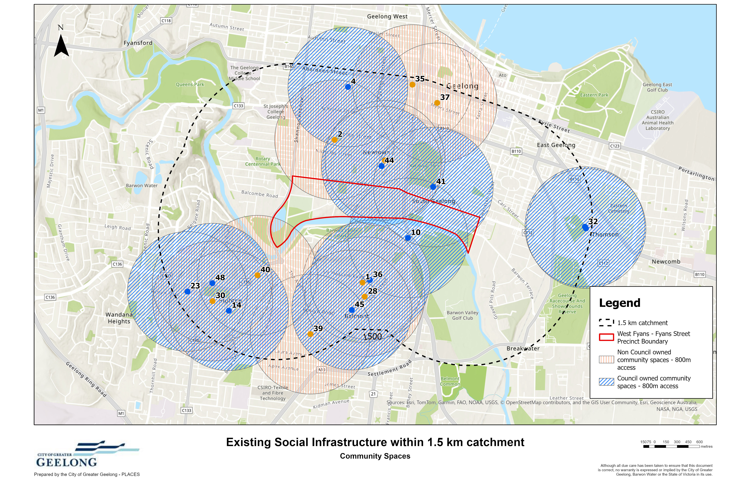
Figure 5: Existing Community Spaces within 1.5km catchment of West Fyans - Fyans Street Precinct

Cultural Facilities
Demand for cultural facilities is outlined in table 12 below.
Table 12: Cultural Facility demand for Newtown SA2 and West Fyans – Fyans Street Precinct
Facility | Benchmark | Existing Supply | 2041 Demand | Surplus Gap | Additional Facilities Needed
Local Library | 1 facility per 25,000 people | 1 | - | - | -
District Library | 1 facility per 50,000 people | 0 | 0.3 | - 0.3 | 0
Studio/workshop | 1 facility per 25,000 people | 0 | 0.7 | - 0.7 | 1
Rehearsal space | 1 facility per 35,000 people | 1 | 0.6 | + 0.4 | 0
Community Art Gallery | 1 facility per 100,000 people | 1 | 0.2 | + 0.8 | 0

Key Assessment Findings
No additional cultural facilities are required to support projected population growth within the Newtown SA2 and the West Fyans – Fyans Street Precinct based on recommended population benchmarks to 2041.
While there are no City owned performing arts or community art galleries within the catchment, the Shearers Arms Gallery in Geelong West just outside of the walkable catchment provides a community exhibition space and studio/workshop spaces to members to the Geelong Arts Society. The Palais Royal performing arts centre in Geelong provides a rehearsal space accessible to Newtown.
The 1.5 kilometre catchment contains a strong range of existing cultural infrastructure including 2 local libraries, 1 district library, museums, historic houses, and performing arts venue.
Table 13: Existing cultural facilities within a 1.5km catchment
Map IdNo. | Name | Owner | Service | Address | Suburb
6 | The Heights | NON COGG | Historical House | 140 Aphrasia Street | Newtown
11 | Belmont Library | COGG | District Library | 163 High Street | Belmont
16 | Geelong Gaol Museum | NON COGG | Museum | 200 Myers Street | Geelong
17 | Highton Library | COGG | Local Library | 200 Roslyn Road | Highton
18 | Shearers Arms Gallery | NON COGG | Community Art Gallery | 202 Aberdeen Street | Geelong West
27 | Barwon Grange | NON COGG | Historical House | 25 Fernleigh Street | Newtown
31 | Palais Royal | NON COGG | Performing Arts | 297-301 Moorabool Street | Geelong
38 | Geelong Sports Museum | COGG | Museum | 356 Moorabool Street | South Geelong
43 | Chilwell Public Library | COGG | Local Library | 51 Russell Street | Newtown

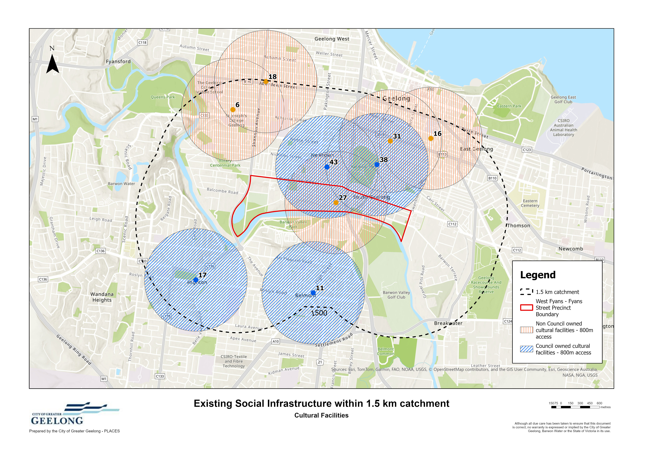
Figure 6: Existing Cultural Facilities within 1.5km catchment of West Fyans - Fyans Street Precinct

CONCLUDING RECOMMENDATION
The supply and demand assessment demonstrates that projected population growth associated with the West Fyans – Fyans Street Precinct does not generate a requirement for new local or district level social infrastructure. Across early years, community spaces and cultural facilities, existing provision within the 1.5 kilometre catchment is sufficient to meet forecast demand to 2041, with capacity supported by a strong mix of Council owned and non Council facilities.

Minor benchmark shortfalls identified for neighbourhood scale studio/workshop spaces do not warrant the delivery of new standalone infrastructure. These gaps can be effectively addressed through optimising the use of existing facilities, supporting adaptable and multipurpose use of community spaces, and leveraging planned upgrades within the surrounding network.

Accordingly, the recommended approach is to accommodate future growth through the continued use and enhancement of existing infrastructure, rather than through new facility provision within the precinct. Priority should be given to improving accessibility and connectivity between the precinct and surrounding services, ensuring future residents can readily access social infrastructure within a walkable catchment. This approach provides an efficient and evidence-based response to growth, consistent with established urban infill and renewal contexts.

Appendix 1 – Population Standard Comparison

Facility | Service | VPA Recommended Provision 2008 | Social Infrastructure Plan 2021 | Recommended Population Standard
EARLY YEARS SERVICES
Kindergarten | 3 (and 4) Year old kinder | 1 single kindergarten per 150 four year old | 1 place per 3-4 yr child | 1 room per 33 participating 3 and 4 yr olds.
MCH dual rooms | Maternal & Child Health | 1 dual facility per 280 children aged 0 | 1 EFT (total service requirements) based on hours per persons aged 0-5 years | 1.3 room per 1000 children aged 0-4
Playgroup | Playgroup (Consulting room per pop 0-5) | 2.1 per 1000 per children aged 0-5 | 2.1 per 1000 per children aged 0-5 | 2.1 per 1000 per children aged 0-5
Long Day Care | Long Day Child Care | 8,000 - 10,000 people | 1 licensed place per 150 persons aged 0-5 years | 8,000 - 10,000 people
COMMUNITY SPACES
Community Meeting Spaces | Neighbourhood House | 10,000-20,000 | 10,000 | 20,000
Community Meeting Spaces | Community Meeting Spaces (1-20) | 4,000 | NA | 4,000
Community Meeting Spaces | Community Meeting Spaces (21-50) | 8,000 | NA | 8,000
Community Meeting Spaces | Community Meeting Spaces (51-100) | 8,000 | NA | 8,000
Community Meeting Spaces | Community Meeting Spaces (101-200) | 8,000 | NA | 8,000
Community Meeting Spaces | Community Meeting Spaces (200+) | 20,000 | NA | 20,000
Multipurpose Spaces | Multipurpose community centres | 8,000-10,000 | NA | 20,000
Multipurpose Spaces | Multipurpose community centres | 40,000-50,000 | NA | Not relevant to this study
CULTURAL SPACES
Library | Central Library |  | 200,000 | Not relevant to this study
Library | District Library | 30,000-60,000 | 50,000 | 50,000
Arts and Culture Facilities | L1 Community Arts and Cultural Facilities | 8,000-10,000 | NA | 10,000
Arts and Culture Facilities | L3 Community Arts and Cultural Facilities | 40,000-60,000 | NA | Not relevant to this study
Arts and Culture Facilities | Regional Performing Arts/Theatre/Cultural |  | NA | Not relevant to this study
Arts and Culture Facilities | Regional Arts Gallery/Centre | 1 per municipality | NA | Not relevant to this study
Arts and Culture Facilities | Convention/Exhibition Centre |  | NA | Not relevant to this study
Arts and Culture Facilities | Civic Centre |  | NA | Not relevant to this study
Arts and Culture Facilities | Museum |  | 30,000 | 30,000
TARGETED SERVICES
Senior Spaces | L1 Seniors Groups (total pop) | 8,000-10,000 | 20,000 | 20,000
Senior Spaces | L3 Seniors Groups (total pop) | 40,000-60,000 | 20,000
Youth Spaces | L1 Youth Facility (total pop) | 8,000 | 20,000 | 20,000
Youth Spaces | L3 Youth Facilities (total pop) | 30,000-60,000 | 20,000
Men’s Shed | Men’s Shed |  | 20,000 | 20,000

