community engagement summary
The City of Greater Geelong invited the community and user groups to provide feedback on the concept plan for a trail from Lara to You Yangs. This report presents the broad range of values, ideas and aspirations expressed by community members and stakeholders during the engagement period, from December 2024 to January 2025.
The City would like to thank the participants who generously shared their time and ideas throughout this stage of the engagement process.

Project background
This project envisions creating a continuous trail that will link the existing Hovells Creek Trail with Serendip Sanctuary and the You Yangs Regional Park. The proposed trail aims to provide a scenic and accessible connection from Lara through to two of the region’s major natural attractions. The Lara to You Yangs Shared Trail will play a key role in connecting communities and promoting tourism within the City of Greater Geelong. As identified in the City’s Shared Trails Master Plan, this trail is a priority for addressing trail connectivity gaps between urban areas, fostering greater engagement with nature and outdoor activities.

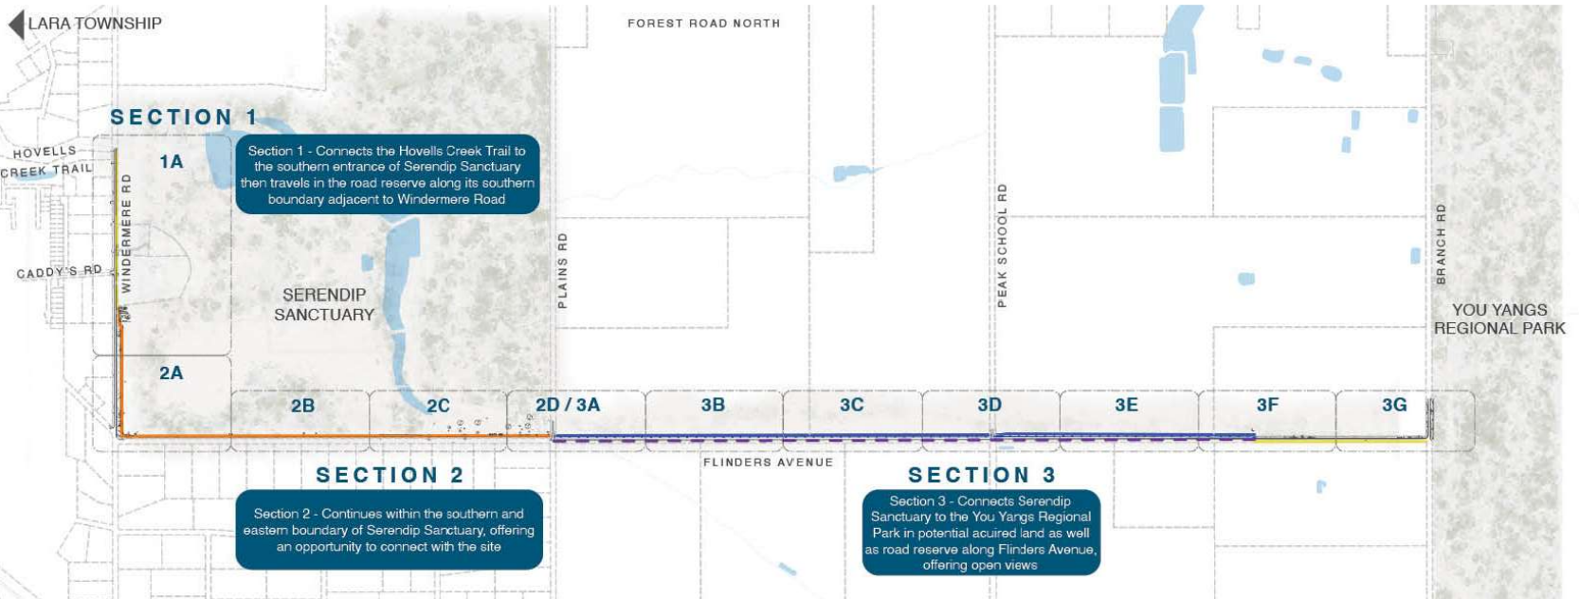
Figure 1 – Lara to You Yangs project site and indicative alignment as featured on the Have Your Say Page.

HOW WE ENGAGED
Community consultation was open from 6 December 2024 to 27 January 2025. The methods and levels of engagement the City used as part of the engagement for the Lara to You Yangs Shared Trail included:
- Letterbox drops to properties directly affected
- Online survey, quick poll and online interactive map via the ‘Have Your Say’ (HYS) online platform to provide feedback on issues and opportunities for the planning project.
- Onsite signage and nearby areas directing people to the HYS page.

The project and engagement activities were promoted and communicated via the City’s Have Your Say platform and social media through an Instagram post and Facebook campaign. The engagement was also promoted via a media release, an article in City News and an article in the Little River News Review.

Quick Poll responses
143

306
Surveys received
Suggestions (comments) from the public left online via Social Map
35

53 DAYS
of engagement


SOCIAL MEDIA
17,715
Reach/Impressions

DATA METHODOLODY
Feedback was received from the community and stakeholders via several different engagement methods. This included an online survey, poll responses and ideas submitted through an online mapping tool. All responses were collated and analysed by engagement method and holistically.
ENGAGEMENT TOOL AND TECHNIQUES
A project specific ‘Have Your Say’ online engagement page was developed to provide project information and ways to engage with the City. A range of engagement tools and techniques were used to provide different types of opportunities for stakeholders and the community to have their say. The main tools and techniques are explained in further detail below.
HOW WE ENGAGED
Have Your Say Project Page (HYS) | An online Have You Say (HYS) project page was designed to share relevant information to encourage community feedback on Lara to You Yangs Shared Trail Concept Plan.  The HYS platform was the main engagement tool yoursay.geelongaustralia.com.au/lara-you-yangs-shared-trail This was used to reach a broad range of stakeholders across the municipality.  Background on the project, the reasons for engagement and the various ways to engage with the project were included on the page. The HYS page also included a link to the Concept Plan. A frequently asked questions (FAQs) section provided detail on some of the considerations of the project.  Visitors to the HYS page had the opportunity to follow the project to stay up to date and receive regular updates as the project progress, as well as the opportunity to share the page to encourage further feedback from the broader community.
Survey | The online survey was the primary means of collecting feedback from the community and key stakeholders. The survey featured a range of questions and provided opportunities for the community to provide comments. Hard copy surveys were available upon request.
Quick Poll | For those who chose not to complete the survey, the quick poll offered a simple way to share their level of support for the project with just one question.
Online Interactive Map | The community was invited to engage through an online mapping tool, where respondents could drop a pin on the map to share ideas or comments specific to locations within the project site.  The contributions could be seen publicly which helped to avoid duplication of comments, and each comment featured a function that allowed people to ‘like’ others comments to emphasise any given contribution on the map.
Posters, Letters, Emails & signage | On site signage with QR codes to the HYS page were installed in multiple locations throughout Lara. They were placed along the Hovells Creek path, Kevin Hoffman Walk, Lara Lake Reserve paths and throughout the shared path network in the Grand Lakes estate. Posters were also on display in the Lara Library/Information Centre, Lara Pool and Coles Community Notice Board.
Social MEdia | The engagement was promoted via an Instagram and Facebook post on 2 January and 16 January 2025
Printed Media | Media releases were circulated to media outlets providing details on the project, the engagement period and a link to the HYS page.  Advertisements in City News public notices section in the following publications:  - Geelong Times, Bellarine Times, Armstrong Creek Times and Geelong Independent  - Little River News Review

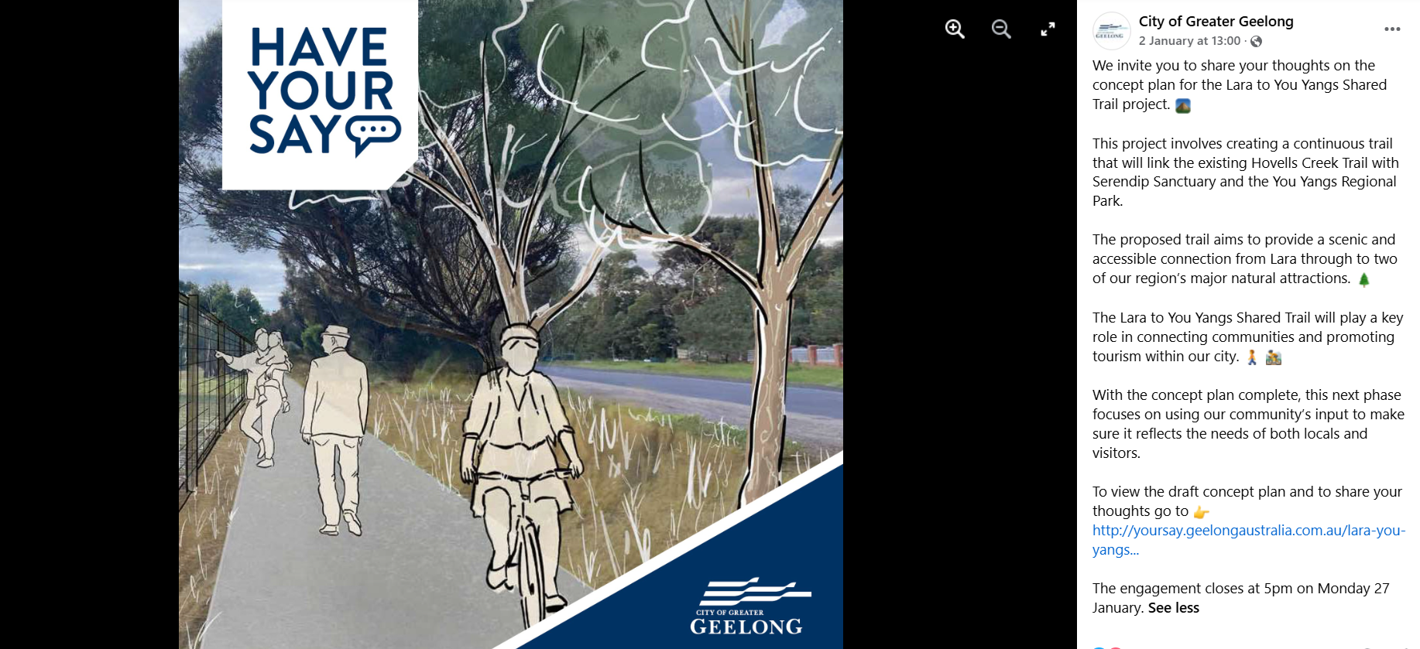
Figure 2 – Social media post informing the community on the project and encouraging engagement.

Who we engaged with
The engagement process for the Lara to You Yangs Shared Trail project aimed to engage a broad network of community members and stakeholders of the Geelong region, in particular locals to the Lara area.
The engagement process set out to understand what excites people about the new concept plan and address any concerns. The engagement also sought to gain specific feedback to help guide future planning stages.

PARTICIPATION

Have Your Say project page
The HYS platform aimed to engage more broadly across the municipality, seeking any feedback via the survey, quick poll and social pinpoint map.
Survey: 306 survey responses were received.
Quick poll: The quick poll asked one question: ‘Do you support the draft Lara to You Yangs Shared Trail Concept Plan?’. Of the 143 quick poll responses received: 125 were supportive, 12 were mostly supportive and 6 were not supportive.
Online interactive map: 35 contributions (‘pins’ dropped) were received from 9 contributors. The contributions were posts on the map, highlighting issues and opportunities for the project.

Demographics

People were invited to share some demographic data with us primarily through our online survey. The following is a snapshot of these people.
Of the 306 survey responses received, we had respondents aged from under 18 to 84 years old.
Our highest participation age groups were between 35–49 years of age, with 32 per cent of respondents in this age group, and a range of 15–25 per cent of respondents within the 25–34, 50–59 and 60–69 age groups.
Figure 3 – Survey participation by age

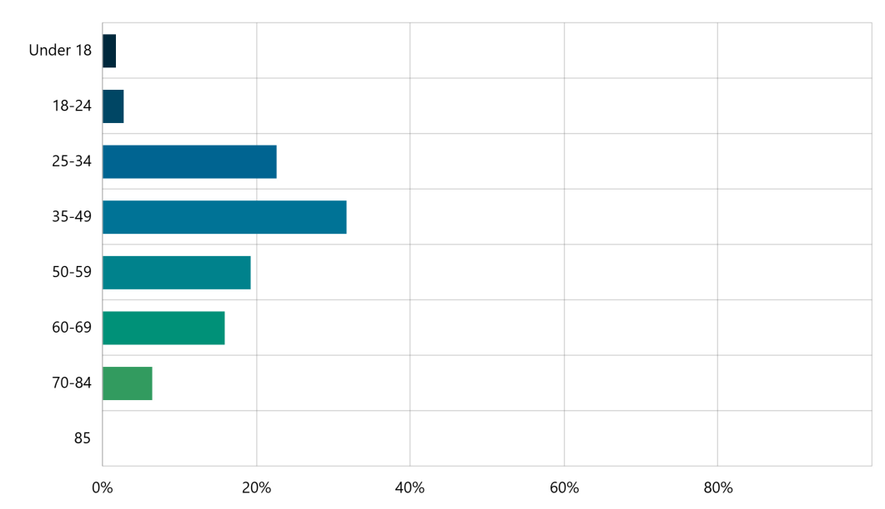

The majority of survey participants were from Lara (70 per cent), with the remaining participants distributed across other suburbs. Participation was relatively evenly split between genders, 46 per cent male and 48 per cent female, with the remaining 6 per cent responding as ‘non-binary’, ‘other’ or ‘prefer not to say’.
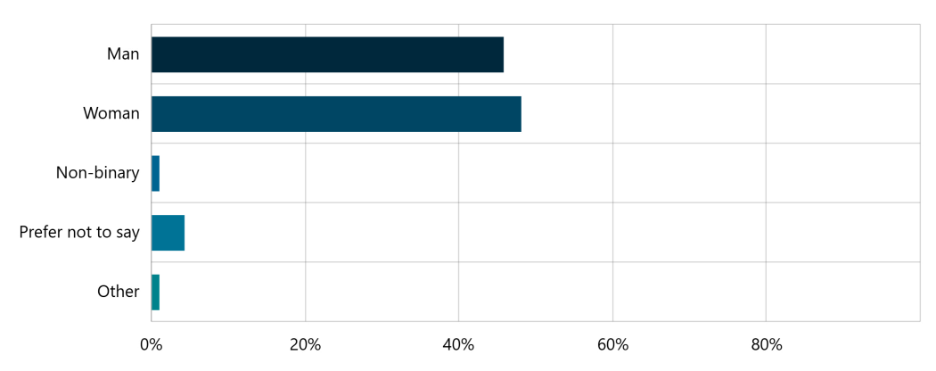
Figure 4 – Survey participation by gender

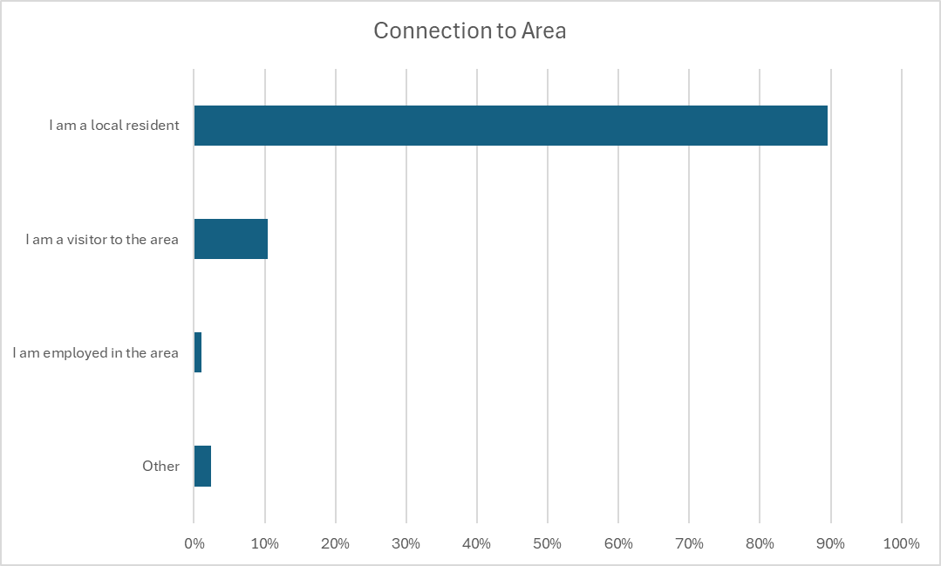

Figure 5 – Survey participation by connection to area

WHAT WE HEARD
The engagement overall received positive and constructive feedback relating to the Lara to You Yangs Shared Trail. Most of the community interest and feedback were from residents of Lara.
Across the survey, quick poll, and social map, a significant majority of participants expressed strong support for the project, sharing their experiences and ideas on shared trail usage. However, some participants voiced their concerns and did not fully support the project.
Participants of the survey and social map told us the aspects of the Lara to You Yang’s trail that they valued the most was the improvement in safety for users.
OVERALL KEY FINDINGS
QUICK POLL
The key question we wished to have answered through this engagement was:
Do you support the Lara to You Yangs Shared Trail Concept Plan?
The quick poll responses were:
- 87.4 per cent (125) of respondents support the draft concept plan
- 8.4 per cent (12) of respondents mostly support of the draft concept plan
- 4.2 per cent (6) of respondents do not support the draft concept plan.

SURVEY
Survey participants were asked to identify their reasons for using the trail, with the option to select multiple responses. Exercise and recreation emerged as highly popular choices.
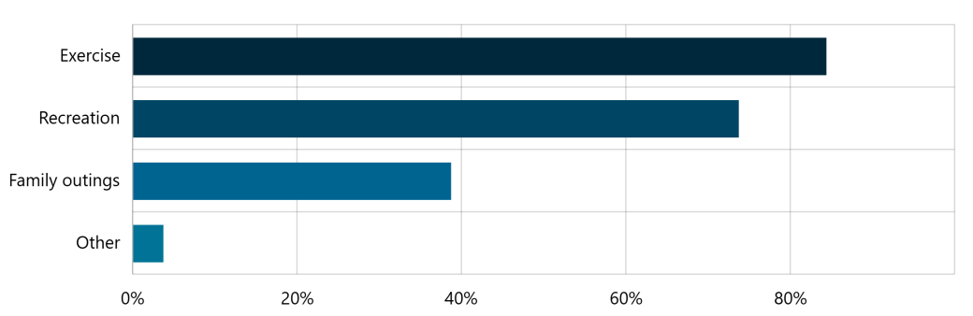
Figures 6 – Reason for using the trail.

76 per cent of survey participants said they were very likely to use the new trail with 4 per cent of respondents saying they would not use the trail or would be unlikely to use it.
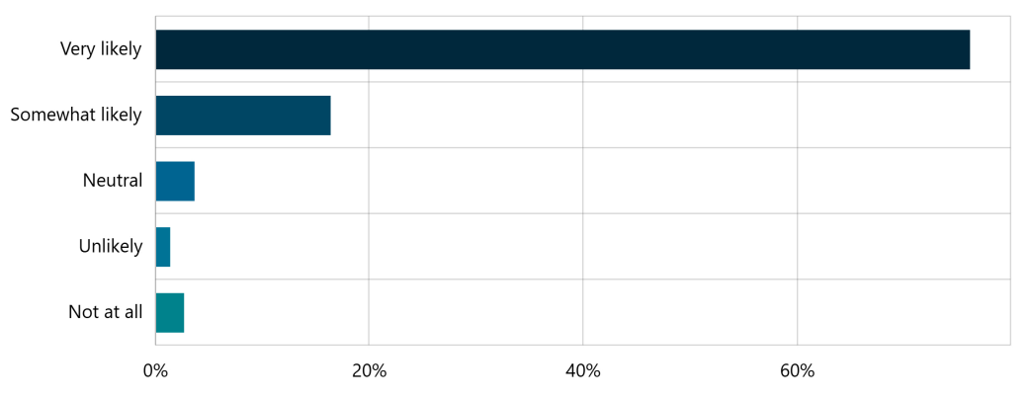
Figures 7 – How likely users are to use the new shared trail.

- What excites you about the shared trail?
Feedback on what people liked about the Lara to You Yangs Shared Trail from the survey provided a range of feedback has been broken down into several overarching themes below.
OVERARCHING THEMES
Many community members are eager to see the trail be built. Several overarching themes came through from the survey responses.

- Improved safety (32%)
- Improved connectivity to the You Yangs (13%)
- Separation from traffic (8%)
- Encourage health, fitness and wellbeing (8%)
- Provides access to nature (3%)
- Tourism benefits (3%)
- Family friendly activities (3%)
- Ability to access without a vehicle (2%)

- Do you have any concerns about the shared trail?
Feedback on the concerns and opportunities about the trail from the survey provided a range of constructive feedback. Of the 295 people that chose to respond to this question, 72 per cent (212) said they had no concerns, whilst 28 per cent (83) said they had some concerns.

OVERARCHING CONCERNS
- Tree and native vegetation removal
- Need for separation of cyclists from other trail users
- Not a priority
- Not enough tree planting proposed
- Lack of resting facilities i.e. seats, toilets, drinking fountains

- Do you have any other specific feedback about the Lara to You Yangs Shared Trail?
OVERARCHING FEEDBACK
- Complete as soon as possible
- Request for resting facilities i.e. seats, toilets, drinking fountains
- Request for wayfinding and other information
- Request for outdoor gym equipment

INTERACTIVE MAP RESPONSES
The feedback provided on the social map gathered a range of issues and opportunities for the Lara to You Yangs Trail concept plan.

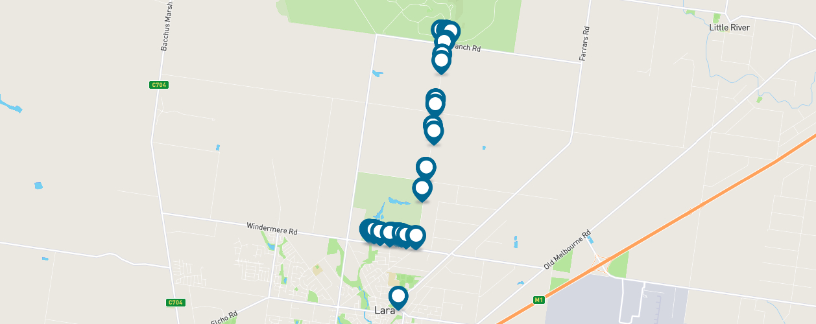

Figure 8 – Interactive map participation relating to issues and opportunities to help inform the concept plan for the project.

A key theme emerging from the interactive map pins was the need for more and safer crossings, including shared user priority crossings.
Figure 9 – Social map participation relating to key themes of participant issues and opportunities comments

Next Steps – advocating for funding and Detailed design

CONCLUSION
The collective feedback from community engagement has been analysed and presented in this report. This report will be shared with the community and used by the City to advocate for funding to progress the project to the detailed design phase. The detailed design will incorporate key community insights and technical considerations to refine the Lara to You Yangs Trail
Further engagement will occur during the detailed design phase to ensure the project aligns with community needs and aspirations. To stay up to date, click on the banner on the Have Your Say page.

