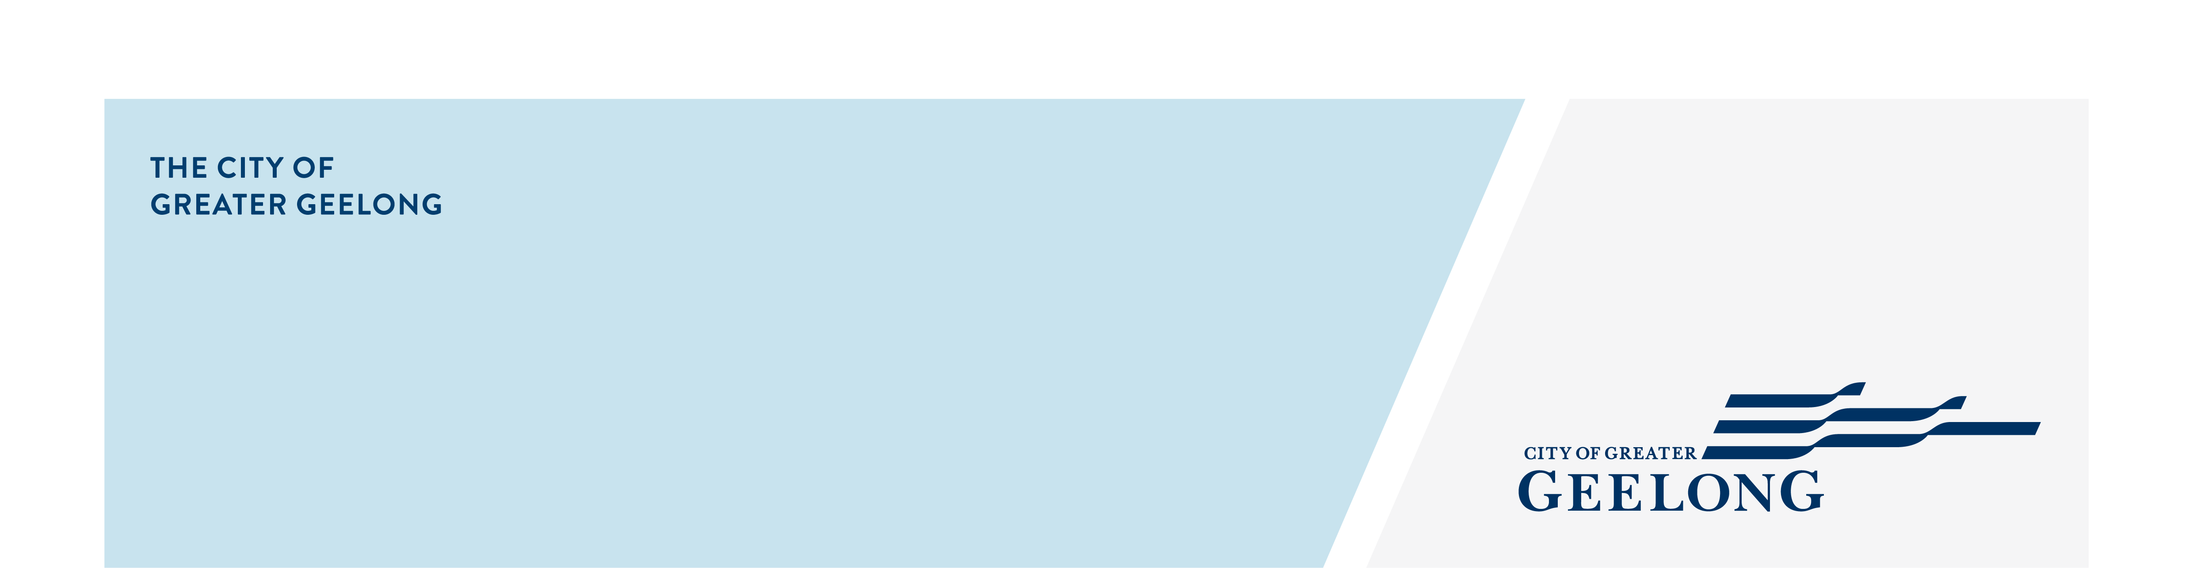
geelong city market

enagement Summary

June 2026
community and Stallholder engagement summary
The City engaged with the attendees and stallholders at the Geelong City Market in January and May 2026 through the Have Your Say online platform and in-person engagement.
Held every Saturday, the market features local and sustainable producers, creatives, and makers offering fresh produce, handmade goods, street food, and entertainment. It provides a vibrant weekly activation for Central Geelong and serves as an important community gathering space.
To support continuous improvement, the City designed surveys to gather community feedback on what they value about the market, ideas for future programming, opportunities to enhance the customer experience, and how to better support both stallholders and visitors.

60% respondents reported being very satisfied
40% reported being satisfied

208 People Engaged
Stage 1: 174 people
Stage 2: 34 people

25 Total Days
of engagement
Stage 1: 24 online, 2 in-person
Stage 2: 1 in-person




74–75% (Stage 1) & 76.5% (Stage 2) visited Central Geelong specifically for the market

76.5% Quarters1
62% Quarters1

62% of respondents indicated they stayed 30–60 minutes, with a further 24% staying 1–2 hours

$
68% Quarters1

Average of 68% participants across both engagement stages also spent locally

Next STEPS
Community engagement for the Geelong City Market, undertaken in January and May 2026, is now complete. Insights from this engagement, together with visitation, economic, and operational data, are informing ongoing improvements. The City, in partnership with Barwon Events, the market operator, remains committed to evolving the market to support long-term sustainability and the continued revitalisation of Central Geelong. The market will continue to refine its offering, strengthen its stallholder mix, and diversify programming to enhance the visitor experience. Further community engagement is planned for August and October 2026.

