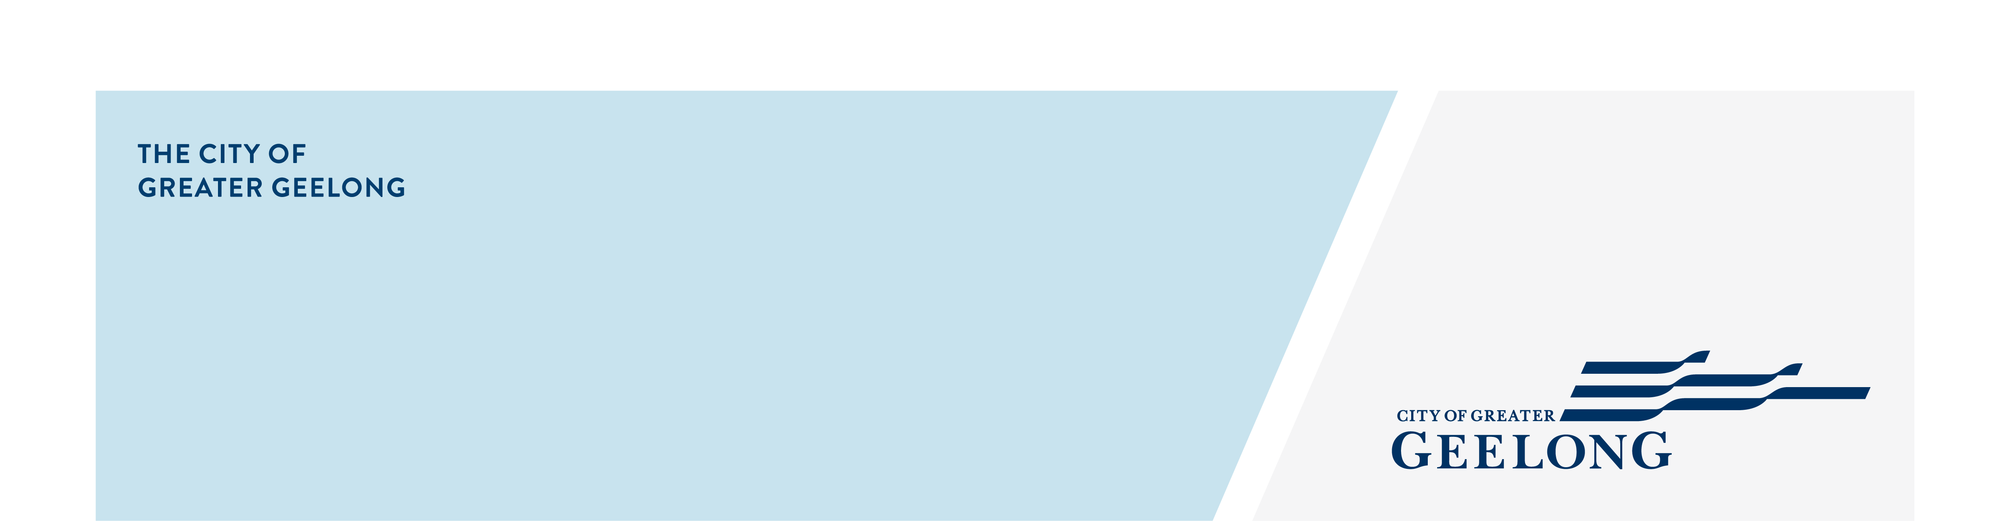
Social Equity Framework

-Engagement Findings

community engagement summary
Brief Summary – This report outlines feedback received during engagement on our draft Social Equity Framework.
The community engagement period ran from 23 February – 23 March 2022. The engagement was conducted via an online survey on the City’s Have Your Say page. In addition, community members were given the opportunity to provide direct feedback to officers in the Healthy Communities Department.
The engagement was advertised via social media, City News, direct email to key stakeholders, via Council Advisory Committees, and to internal staff by direct email and internal newsletters.

We received 13 online submissions, three additional contributions through direct contact with officers, and input via Advisory Committees. There were also seven social media comments.
16
People provided feedback

SOCIAL MEDIA
26,870
Reach/Impressions
301 7
Link clicks Comments
28 DAYS
of engagement

 631

Document downloads



Plus
Contributions from Advisory Committees

Engagement findings
From the survey, four respondents said the Framework met their expectations, five said it didn’t meet their expectations, and four said it was almost there. Nine said they felt something had been missed in the framework, and four said nothing had been missed from their perspective. Two identified as having participated in the development of the draft framework, and nine as not being involved (two did not respond to this question).
Comments from the survey and other feedback fell into four main categories:
- those that did not support Council adopting a framework
- those that were supportive and satisfied with the framework as it is
- those that were supportive and provided detailed, constructive feedback about the content
- and those sharing implementation considerations for the framework.
Despite a modest number of responses, the reach of advertising, number of link clicks, and document downloads reflect positive interest in the Framework. It is likely that those who viewed the documents and did not provide feedback, did not have any significant objections to the Framework or its content.
Next steps
Community feedback on the draft Framework has been noted, and where possible incorporated into the document. This included a review of:
- content relating to the various priority groups
- preferred language
- document accessibility
- definitions and data sources; and
- how links between City’s role, Council Plans and Strategies, and social justice and equity related concepts are explained.

In addition to comments that directly influenced the content of the document, there were a range of comments that will contribute to the development of related implementation and actions plans. These include:
- how places and spaces can be made welcoming and accessible
- how our written and online communication can be more accessible
- actions and measurement
- how we will weigh up funding implications of various equity considerations
- Social Equity Impact Assessments
- how we might address intersectionality; and
- how the City, as an organisation, can reflect these principles and diversity in its own operations.

The revised Framework is due to be considered by Council at the Council Meeting on May 24.

