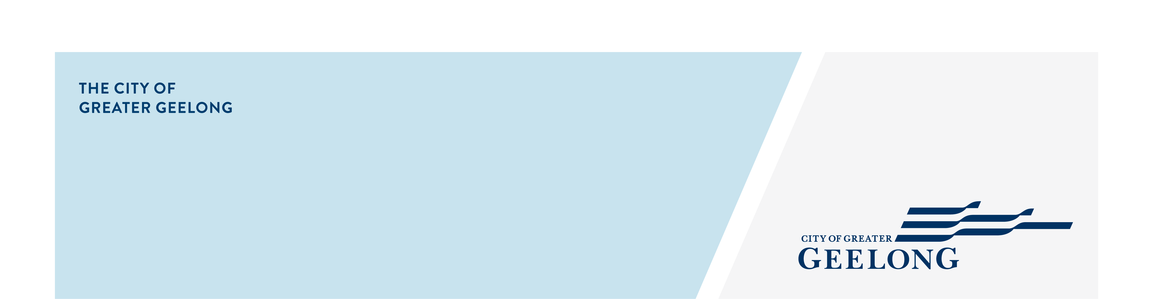
Morena Street reserve

(Gully 3), HIghton

community engagement summary
Feedback on the Morena Street Reserve – Phase 2 has closed, thank you to everyone who provided feedback, your contribution is valued and appreciated.
This stage of community engagement was to seek whether you do/ don’t support the draft concept plan and further feedback on the plans.
Community feedback is a vital part of our planning. Your feedback will be used to inform the final concept plan of the reserve.
Over the course of this consultation period the City reached the following achievements.



75
Online surveys completed.
250
Contributions were received via Survey and Quick Poll collection tools.
28 DAYS
of engagement
14th November 2023 – 11th December 2023
175
Quick poll surveys completed.
1221
Visitors to the Have Your Say page.


SOCIAL MEDIA
18,163
Reach/Impressions
442
Actions (Clicks, reactions,
shares, comments etc.)
People following the project
29

Next Steps
Phase 2 community engagement is closed for evaluation and review. We will be reviewing your responses and this data will be informing the final concept plan. A further engagement report will be released detailing further analysis of the feedback received.
It is anticipated the concept plan will progress to detailed design and construction in 2024.

