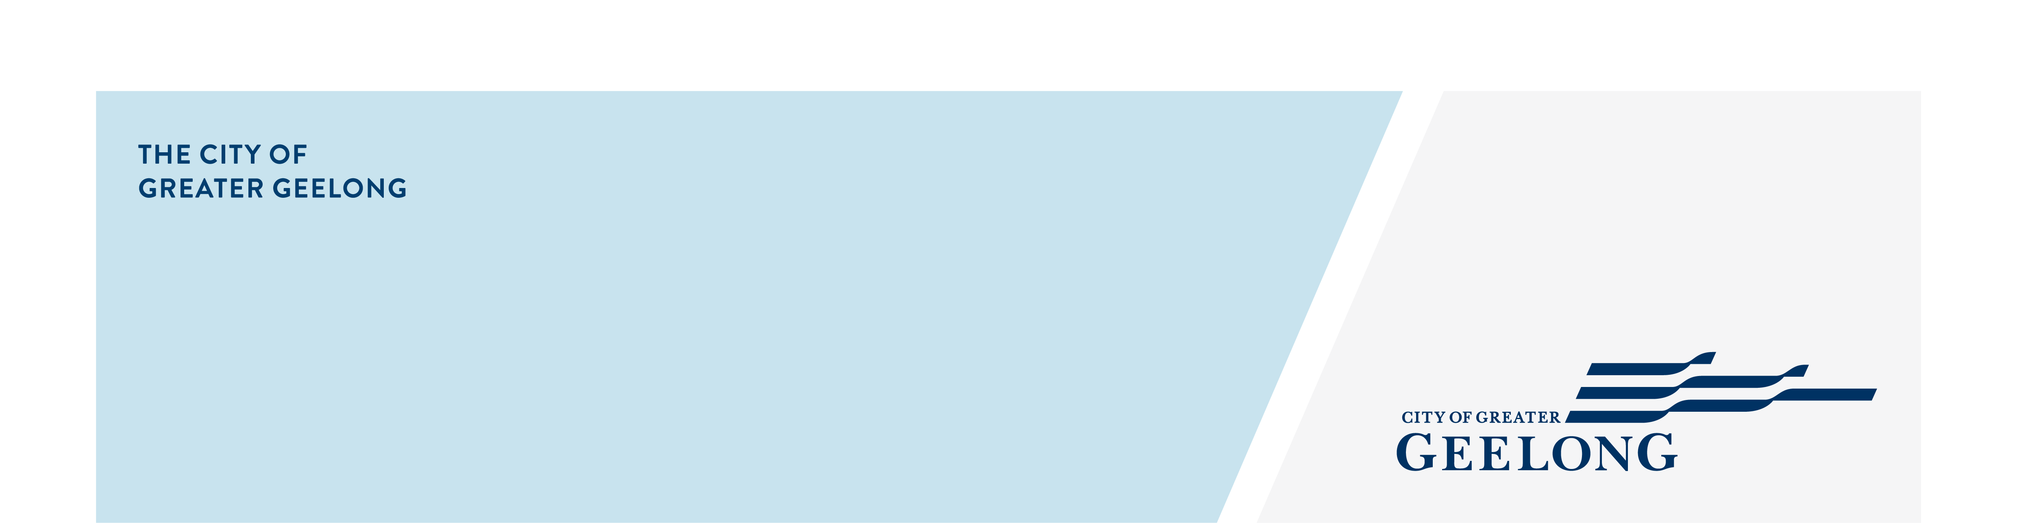
Road Management PLan

Review

community engagement sNAPSHOT
Background / Introduction
The City is currently reviewing their Municipal Management Plan. The purpose of the review is to assess current road maintenance practices while taking into account financial considerations, community expectations, and service delivery priorities.
On 26 February 2021, the City commenced a four-week community engagement program on the Municipal Road Management Plan Review. Using a dedicated Have Your Say project page, we asked the community to have their say on the proposed plan – specifically seeking feedback on our inspection regimes, hazard interventions and repair timelines. The feedback provided will help inform the development of the Road Management Plan prior to adoption by Council by 30 June 2021.


518
website views
NEWS

2
print adverts in local newspapers

24
number of contributions
28 DAYS
of engagement (Stage 3)

SOCIAL MEDIA
6,098
Reach
12,921
Impressions

Next Steps
Community engagement is closed for evaluation. We will be reviewing the results and all relevant submissions will be considered in the development of the final Plan.
Council must adopt the Road Management Plan by 30 June 2021 in accordance with the Road Management (General) Regulations 2016.
Once the Plan has been adopted by Council, everyone who made a submission will be contacted directly via email and notified of the outcome and an update will be provided to the Have Your Say project page.

