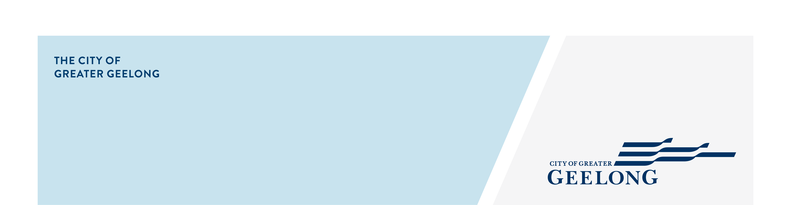
DOMESTIC ANIMAL MANAGEMENT

PLAN- ENGAGEMENT SNAPSHOT

REPORT
community engagement summary

From 10 March to 20 April, the City held a 6-week community engagement where we asked the community to have their say regarding the Domestic Animal Management Plan (DAMP).
Feedback received through this online survey, and through face-to-face (F2F) consultations provided the City with helpful insight into what our community wanted and needed regarding the presence and care of cats and dogs in our community.
Below is a summary of who we heard from, and how we promoted this community engagement.

NEWS

20
print adverts in local newspapers
42 DAYS
of engagement
SOCIAL MEDIA
43,315
Reach on Facebook
1,224
Clicks, reactions,
shares, comments on Facebook and Instagram

754
Online surveys completed via HYS

2

People following the project
58
130+
People attended one of our 6 advertised face to face sessions
Hardcopy surveys were received through Customer Service Centres


Written submissions were received for consideration
6
12

Pop-up feedback sessions across various City reserves and trails

Next Steps

This community engagement is now closed for evaluation, data will now be reviewed and collated, with the findings and themes noted in the DAMP 2026 - 2029 Engagement Report. This Engagement report will then inform the objectives and actions within the drafted Domestic Animal Management Plan 2026 – 2029 and be presented to Council for endorsement before submission to the Victorian Government.

