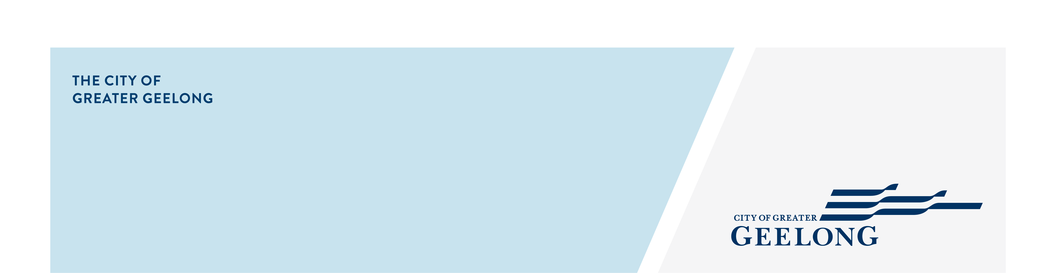
CENTRAL geelong

stormwater

management strategy
community engagement summary
Feedback on the Central Geelong Stormwater Management Strategy consultation has closed. Thank you to everyone who provided feedback, your contribution is valued and appreciated.
From 1 December, 2023 to 31 January, 2024 the community were invited to provide feedback on the strategy to assist the City and relevant authorities to better understand and manage flood risk, stormwater quality impacts on local waterways, and alternate water supply options for the region. The assessment area consists of the following suburbs: Geelong CBD, Newtown, Geelong West, Manifold Heights and East Geelong.
Community feedback is a vital part of our planning.
HOW WE ENGAGED WHAT DID WE DO?
Below is a summary of the engagement:

Suggestions (comments) from the public left online via social map
55
154
Number of completed online surveys
1,511
People visited the Have Your Say (HYS) page
62 DAYS
of engagement (Stage 1)

People following the project
64

SOCIAL MEDIA
27,557
Reach/Impressions
850
Actions (Clicks, reactions,
shares, comments etc.)

Project HYS postcards delivered
137501

Next Steps
Community engagement is closed for further evaluation and review. We really value the experiences shared by the members of our community. The feedback and experiences shared by the community will be used by us in validating the catchment model. This engagement will help us better inform the deliverables of the strategy.
While we are evaluating the responses from the engagement, we will be sharing some of the key findings from the community responses on our website soon.

