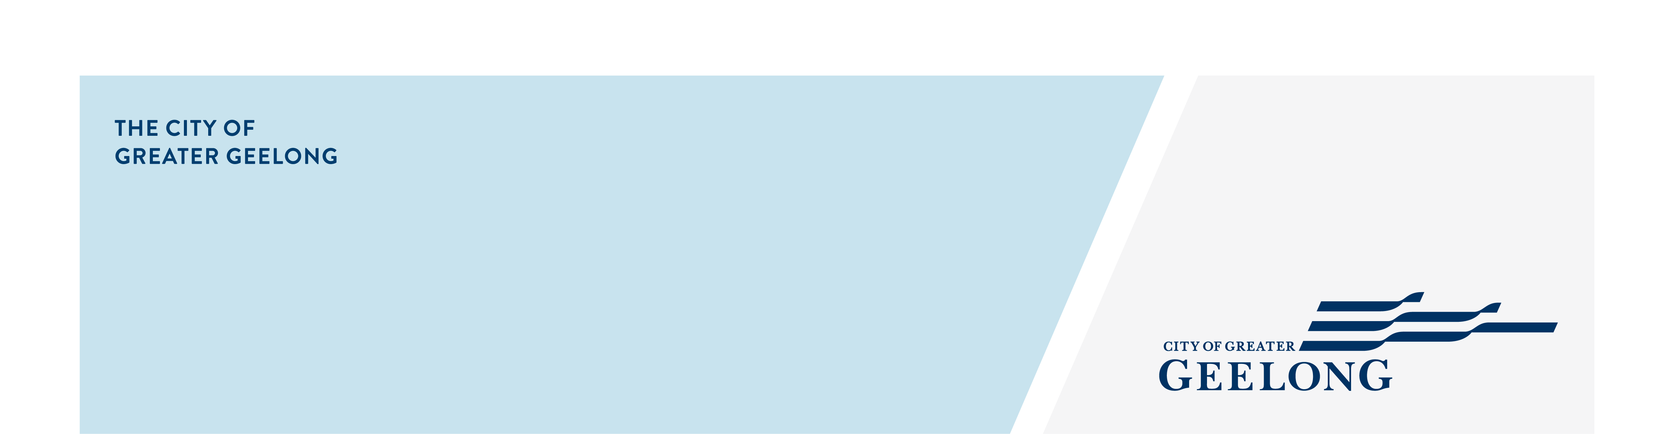
sovereign Drive Recreation Reserve
Draft Master Plan Community
Engagement Summary

community engagement summary
The City of Greater Geelong invited the community to provide feedback on the Sovereign Drive Recreation Reserve Draft Master Plan.
The Sovereign Drive Recreation Reserve Draft Master Plan sets the direction for the reserve’s future development, building on stage 1 completed in 2017. Located in Mt Duneed, the site currently includes an oval, two netball courts, a Men’s Shed, car parking, and vehicle access.
Throughout the master planning process, the following key considerations were identified, including, growing demand from nearby residential development, limited workshop space in the existing Men’s Shed, the absence of essential infrastructure such as a pavilion, changerooms and toilets, and the need to upgrade the access road, netball courts and cricket nets. Design considerations also include improved pedestrian links, and accommodating level changes between stages 1 and 2, while ensuring flexible facilities that support long-term community use.
Community engagement ran from 27 August to 29 September 2025 and included online and face-to-face opportunities. Feedback gathered during this process will help shape the final master plan.

Page views on the HYS platform
1,027
50
Number of people to leave feedback

NEWS

1
Media Release
Advertising pamphlets delivered
622
35 DAYS
of engagement (Stage 4)


People following the project
15

8
Onsite drop in attendees
SOCIAL MEDIA
1,763
Reach/Impressions
17
Actions (Clicks, reactions,
shares, comments etc.)
Total contributions:
(57 Survey)
57

HOW WE ENGAGED
Have Your Say Online Portal  Yoursay.geelongaustralia.com.au | The Have Your Say (HYS) platform was the main engagement tool. Sovereign Drive Recreation Reserve Draft Master Plan | Have Your Say  A quick view map of the draft master plan was provided on the HYS page to allow respondents to easily view the plan.
Online survey | An online survey was published on the Have Your Say project page to seek feedback on the draft master plan.  The survey sought feedback on the community’s support for the plan, any issues with the plans, and any other feedback.  57 responses to the survey were received.
On-site consultation | One x 2 hour onsite drop-in session was held on Saturday 20 September at the reserve.  8 people attended the session.
Social media | The City created a story post that was published on Facebook and Instagram. It was live for 24 hours on Tuesday 16 September.  It had a reach of 1,763 across Facebook and Instagram.
Letterbox drop | Flyers were distributed in the first 2 weeks of the engagement to inform residents nearby the reserve of the engagement.  622 pamphlets were delivered to residents. Flyers were also provided to the nearby Poa Banyul Community Hub, Mirripoa Primary School and Club Armstrong.  Digital and hard copies of the survey were also available upon request.
Media releases | A media release was distributed by the City on 2 September providing information about the master plan and community engagement opportunities.
On-site signage | Four (4) signs were installed on-site at entry points into the reserve, directing people to the City’s Have Your Say page to provide feedback.

draft master plan survey response profile
People were invited to provide demographic information through the online survey, with the following snapshot showing key insights. The majority of respondents (74%) live in Mount Duneed, highlighting that most are local residents and key users of the reserve.
Town or Suburb | Number of Respondents
Armstrong Creek | 9
Belmont | 1
Grovedale | 3
Highton | 1
Mount Duneed | 42
South Geelong | 1

Survey respondents represented a broad mix of age groups, with the highest response rate from those aged 35 to 49.
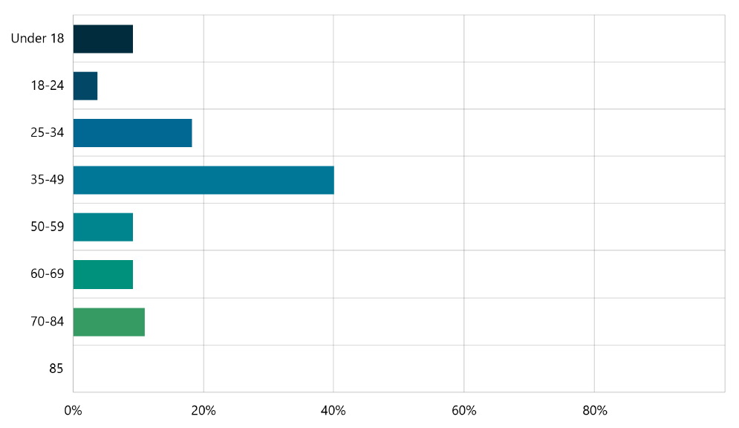

snapshot of what we heard – draft master plan survey results
The survey results showed strong support for the draft master plan, with 96% of respondents supportive of the master plan. 44% of respondents were in full support and 52% were mostly in support.
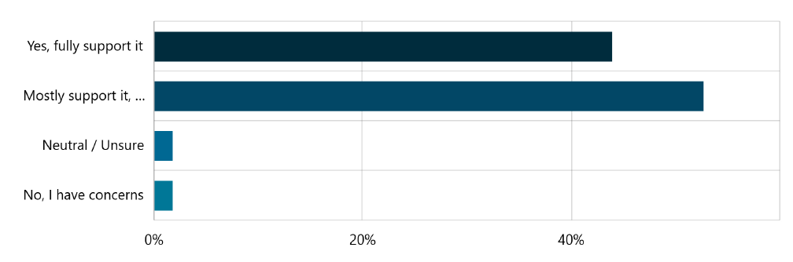

98% of respondents felt that the master plan meets community needs either very well or somewhat well.
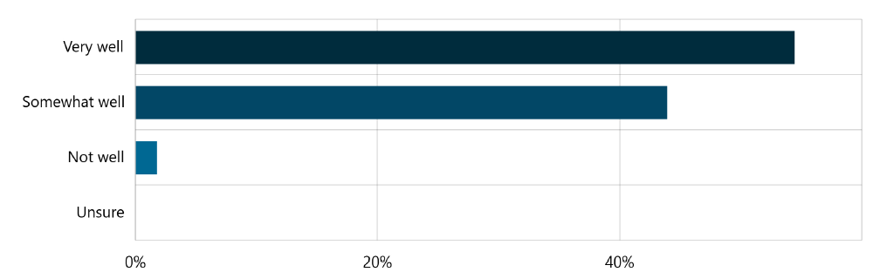

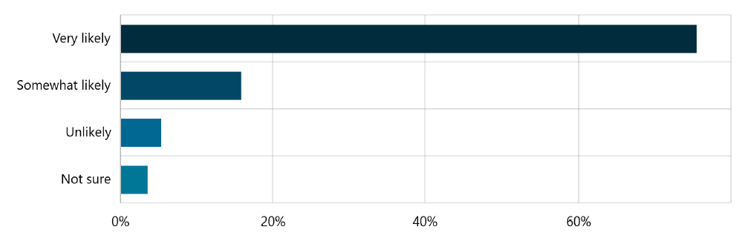
In terms of respondents likelihood to use the reserve once developed, 75% were very likely.

There was a variety of activities that respondents would partake in at the reserve. The main activities were walking/nature trails 73%), dog walking (63%), playing sport (55%) and fitness/outdoor exercise (55%).
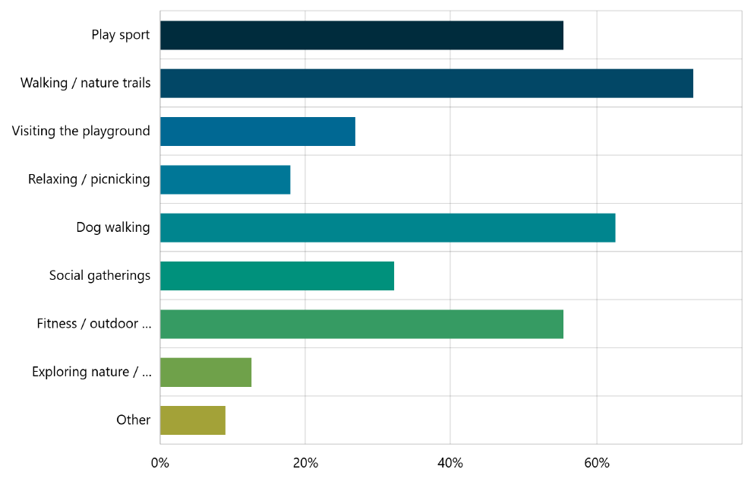

On-site Consultation session
A 2-hour on-site drop-in session was held on Saturday 20 September at the reserve. The session provided an opportunity for residents and interested community members to stop by and ask the project team any questions they had about the proposed master plan.
Eight people attended the session with feedback received being largely positive for the draft master plan with some questions and suggestions for potential improvements and additional opportunities.

Next Steps
The engagement phase is now closed, and feedback is being reviewed and analysed. This information will be used to refine and finalise the master plan.
A detailed report is being prepared to summarise the engagement process, outline the feedback received, and explain how community input has informed the final version of the plan.
The completed master plan will be presented to Council for adoption in December 2025.

