Digital parking in central Geelong
community engagement summary report

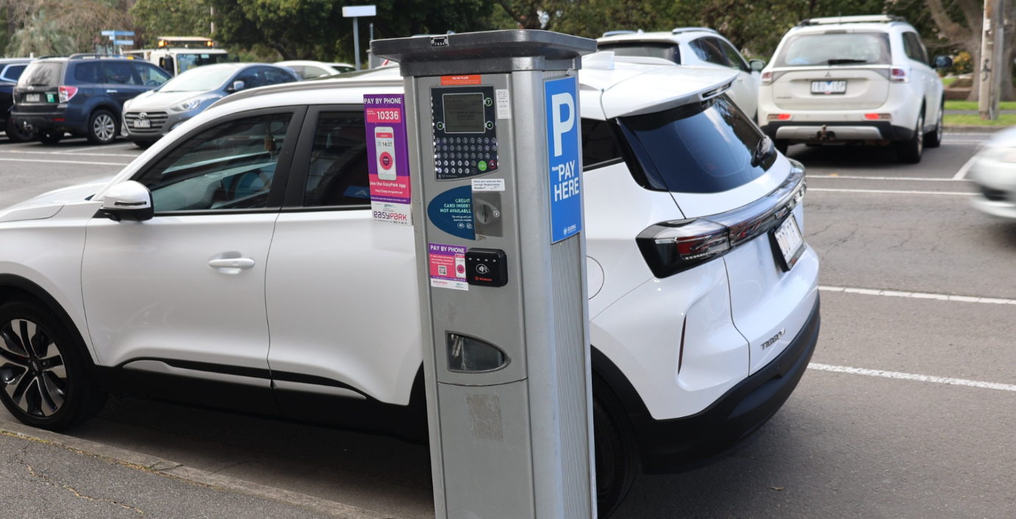

community engagement summary

From 24 September to 15 October 2025, the City of Greater Geelong conducted community engagement on the “Digital parking” project.

The purpose of the engagement was to provide information on the project and gather input from the community on the proposal to transition to digital parking. The change is being considered due to a steady decline in coin payments over the past seven years. By the end of June 2025 around 85% of drivers were now choosing to pay by debit card, credit card, or through the EasyPark app. Since the introduction of free parking in two-hour spaces across central Geelong on 14 July 2025, coin payments have declined further and now make up less than 5% of all payments.

HOW WE ENGAGED

WHAT DID WE DO?
On 24 September 2025, the City commenced community engagement for the digital parking project in central Geelong for a period of 21 days. The emphasis of this engagement was to find out why some community members choose to pay with coins and what the City could do to help people transition to digital payment methods.
Feedback was collected through a dedicated online survey on the City’s Have Your Say (HYS) platform with the opportunity for community to request a hard copy of the survey. Email and written submissions were also an option.
Community feedback plays an important role in our planning process. The insights gathered will help guide decisions aimed at improving service efficiency and reducing costs for ratepayers.

910
Visitors to the Have Your Say page

1 hard copy survey, 7 emails and 1 letter received.
People following the project
16
---------------------------
Kapish Word Add-In
---------------------------
Unable to connect to dataset PR, possibly because the network is unavailable. The exception message was: Null pointer passed in to SWIG wrapper. Function: 'CSharp_TRIMfSDK_TrimMainObjectSearch_internal_getResultIterator___'. File: 'C:\24.4P1\trim\src\api\ApiTrimObjectGen_CSharp.cpp'. Line: 198789.
---------------------------
OK
---------------------------

Surveys completed
497
21 DAYS
of engagement

ENGAGEMENT TOOL AND TECHINQUES
A project specific engagement page was developed to provide project information and methods of ways to engage with the City.
A range of engagement tools and techniques were used to provide different types of opportunities for stakeholders and community to have their say. The main tools and techniques are explained in further detail below.

HOW WE ENGAGED
Have Your Say Online Portal  Yoursay.geelongaustralia.com.au | An online HYS project page was designed to share relevant information to encourage community feedback on Digital parking in Central Geelong.
Survey (online and hardcopy) | An online survey was available with hard copy options available upon request.  The objective of the survey was to find out why people choose to pay with coins and what support the City could offer to help people transfer to digital payment methods.
Written submissions | Open at any time during the public engagement period. Submissions could be provided by email or mail.
Communications
A media release was issued, which was also sent directly to several culturally and linguistically diverse community groups.
Posts were made on the City of Greater Geelong Facebook, Instagram & LinkedIn pages, notifying people about the project and directing them to the HYS page.
Stickers were attached to all parking meters in central Geelong with a QR code linked to the HYS page.



Stickers attached to all parking meters

250
SOCIAL MEDIA
35,428
Reach/Impressions
1,122
Actions (Clicks, reactions,
shares, comments etc.)

Who we engaged with

PARTICIPATION
During the period 24 September to 15 October 2025 more than 900 people engaged with the City about the Digital Parking Proposal.

The community were invited to share some demographic data with us through our HYS page survey. The following is a snapshot of these people.

Town or Suburb
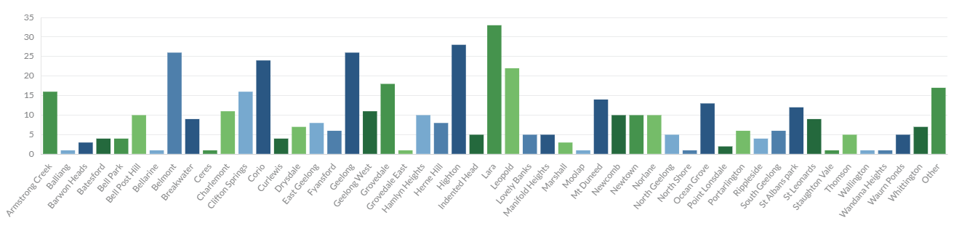

Age Group
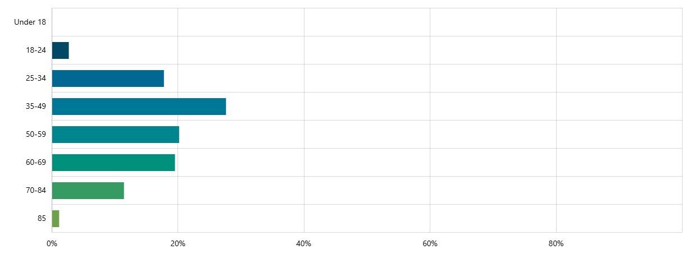

Gender

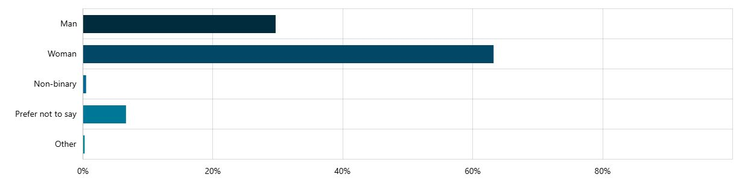

WHAT WE HEARD

Summary

There are more than 2,000,000 parking transactions each year, with less than 5% now being made by coins. Of the 497 people who responded to this survey the vast majority were in favour of keeping coins as a method of payment. This is a small percentage of the people who park in the central Geelong every year.

320 (66%) of respondents indicate they pay for parking using coins and were asked for the reasons why they choose this method. It was clear that many respondents prefer paying with cash because they want to avoid surcharges, have concerns about security and privacy, and see this payment method as a good way to use coins they get in change from other cash transactions.

Survey participants were asked how long they normally park for with 267 (56%) of respondents saying they park for 2 hours or less. The current free parking initiative introduced on 14 July 2025 means that these people no longer need to pay for parking if they only park once per day in 2P areas.

Survey participants were asked what support could be offered to help those currently using coins to transition to digital parking. The top 5 suggestions were:
  - Removing the surcharge
  - Offer more free parking
  - Education & support on how to pay with digital methods
  - Reduce the cost of parking
  - Offer a pre-paid card or permit system.

Survey Responses

- Question: Do you normally pay for parking using coins?

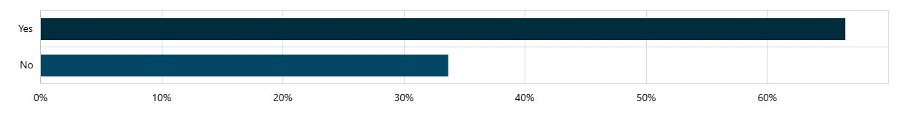

- Question: How regularly do you use parking meters in central Geelong?

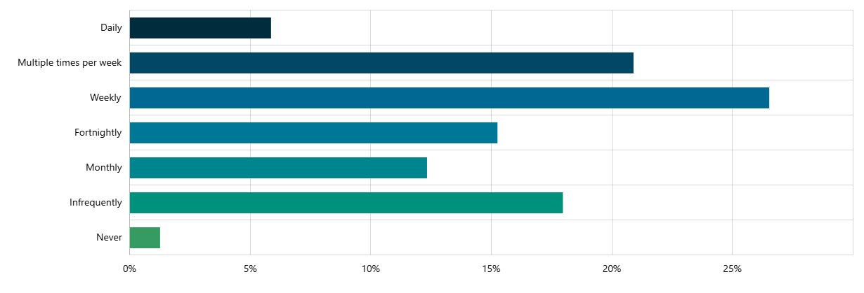

- Question: Do you normally park on-street or in an off-street car park?

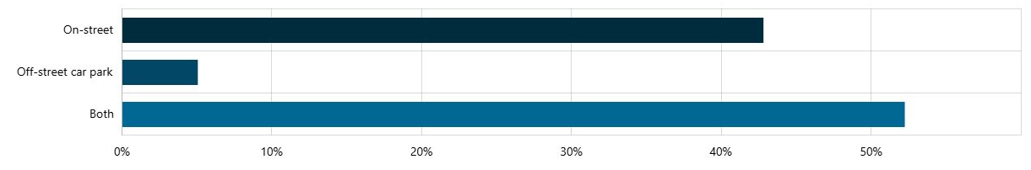

- Question: How long do your normally park for?

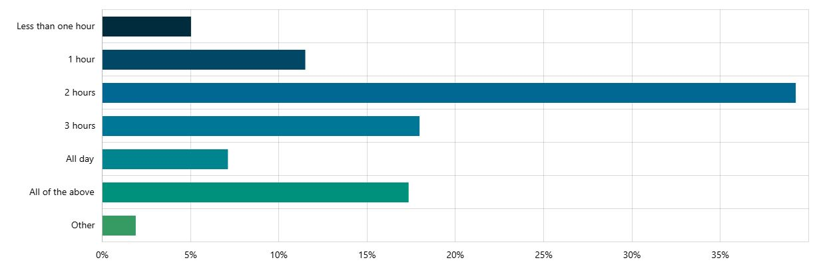

- Question: Can you tell us a little bit about why you prefer to pay for parking with coins?

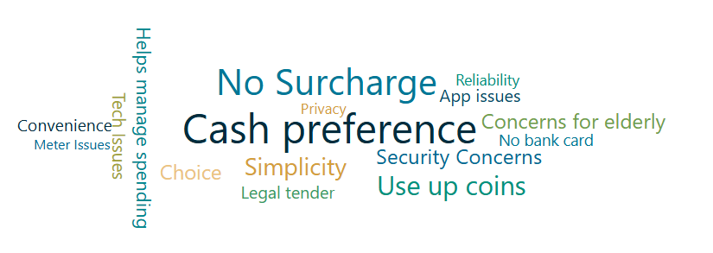

Reason | Number of times mentioned
Cash preference | 110
No Surcharge | 92
Use up coins | 55
Simplicity | 46
Security Concerns | 35
Concerns for elderly | 34
Choice | 33
Helps manage spending | 27
Tech Issues | 23
App issues | 21
Legal tender | 20
Convenience | 19
No bank card | 16
Reliability | 13
Privacy | 12
Meter Issues | 8

- Question: What else could the City do to support people who prefer to pay with cash transition to the digital/cashless system?
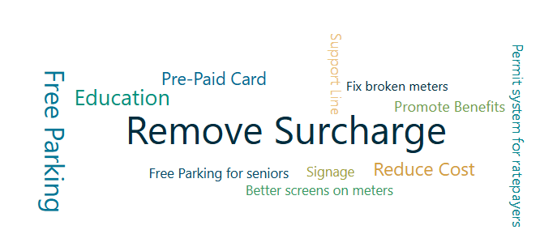
Suggestion | Number of times mentioned
Remove Surcharge | 47
Free Parking | 25
Education | 17
Reduce Cost of Parking | 11
Pre-paid Card | 10
Promote Benefits | 4
Support Line | 4
Permit System for Ratepayers | 2
Better Signage | 2
Free Parking for Seniors | 2
Better Screens/Fix Meters | 3

NEXT STEPS

NEXT STEPS
The insights have been valuable in understanding why people choose to pay with coins and what the City can do to support people transition to digital payment methods.
We will continue reviewing the feedback shared by our customers as we look for opportunities to streamline methods of payment, creating a more efficient and cost-effective system.

