COMMUNITY ENGAGEMENT SUMMARY
PROJECT BACKGROUND
Onsite Wastewater Management Plan
Community Engagement Summary
Feedback on the Onsite Wastewater Management Plan has closed. Thank you to everyone who provided feedback, your contribution is valued and appreciated.
The City invited community feedback in Stage 1 from 2 December 2024 to 20 January 2025 via an online survey. The purpose of this stage was to ensure the Plan reflected local needs and priorities. Community input is essential to shaping effective and sustainable wastewater management solutions. The feedback received in Stage 1 was used to inform the development of the draft Onsite Wastewater Management Plan.
The City then sought further feedback on the draft plan (Stage 2) from 15 September to 13 October 2025, via an online survey, with hard copies available upon request. This stage focused on confirming that the draft addressed key issues and did not place unreasonable burdens on owners or installers of onsite wastewater systems.
HOW WE ENGAGED
A project specific engagement page was developed to provide project information and methods of ways to engage with the City. An online survey was used to capture feedback, as well as the opportunity for a hard copy survey if required.
We wrote to all residents within the City of Greater Geelong and businesses that we were aware had installed wastewater systems within the City, and asked them to complete the online survey.
PARTICIPATION
Over the course of this consultation period the City reached the following achievements:

Visitors to the dedicated have Your Say page.
79
7
Surveys completed.

28 DAYS
of engagement

WHAT WE HEARD

SURVEY RESULTS
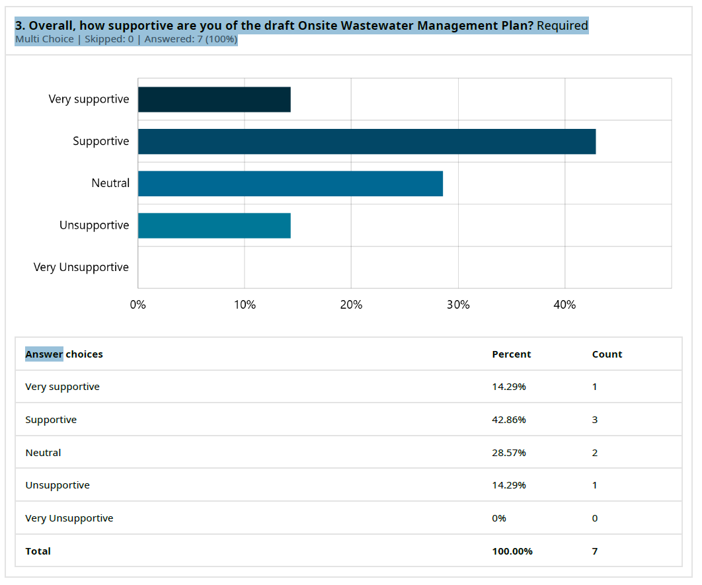
Approximately 57% of survey respondents indicated that they were supportive or very supportive of the plan.
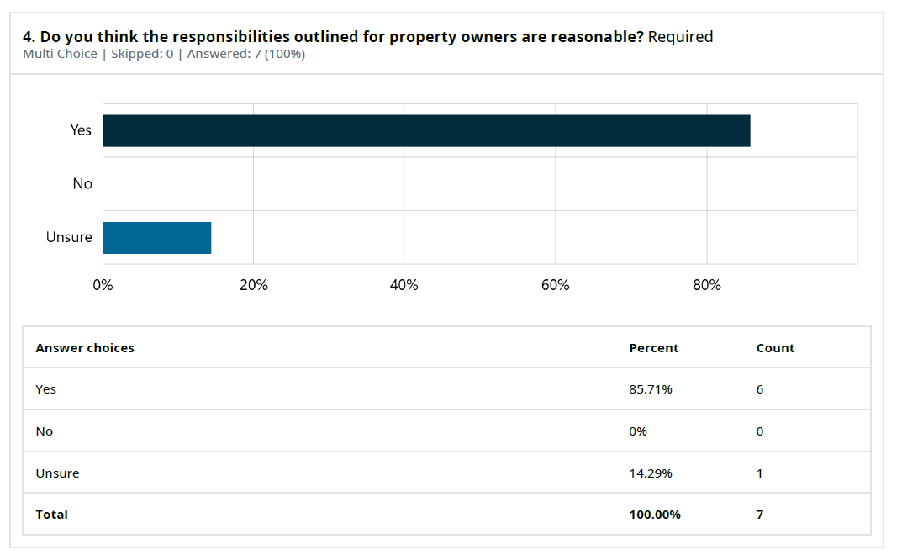
85.71% of survey respondents indicated that the responsibilities outlined for property owners were reasonable with the remaining response were unsure (14.29%).

THE FEEDBACK

Whilst the majority of respondents were supportive of the draft plan, a common theme in the feedback was for additional guidance or advice around maintaining onsite wastewater management systems.
While detailed maintenance guidance is not suitable for inclusion in the plan itself, the City will enhance its website to provide clearer direction on where owners can access maintenance information.

NEXT STEPS

The draft plan Onsite Wastewater Management Plan will now be finalised and formatted before being published on the City’s website.

All registered owners of onsite wastewater management systems will be notified and provided with a link to the final plan. Printed copies will be available on request.

