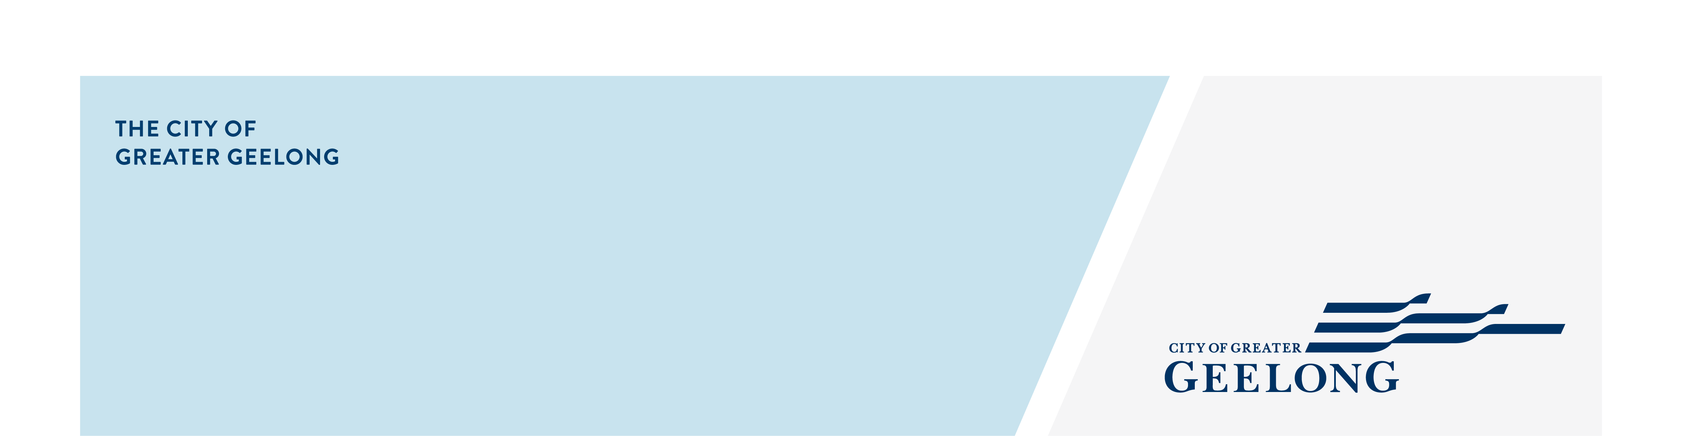
Coastside Drive Recreation

reserve Draft Master Plan

Community Engagement

Summary
community engagement summary
The City of Greater Geelong invited the community to provide feedback on the Coastside Drive Recreation Reserve Draft Master Plan.
The Coastside Drive Recreation Reserve Draft Master Plan will guide planning and developments on the site, ensuring that it can sustainably meet the needs of the community. The master plan is guided by the Armstrong Creek East Precinct Structure Plan (PSP) and Developer Contributions Plan (DCP) (guiding strategic documents for the growth areas development), with options proposed considered against demand assessments, strategic analysis and financial constraints.
Throughout the master planning process, various considerations were identified, including, the constrained budget environment, relatively flat topography, significant protected native vegetation, anticipation of high volumes of vehicular traffic, local pedestrian network integration, flexible pavilion and fields of play, a district level play space, and integration with the primary school and surrounding developments.
Community engagement ran from 23 July to 24 August 2025 and included online and face-to-face opportunities. Feedback gathered during this process will help shape the final master plan.


Page views on the HYS platform
2,596
33 DAYS
of engagement (Stage 4)
227
Number of people to leave feedback
NEWS

3
print adverts in local newspapers


Advertising pamphlets delivered
629
People following the project
52

20
Onsite drop in attendees
Total contributions:
(201 Survey
89 ‘Fund It’ tool
2 emails)
292

HOW WE ENGAGED
Have Your Say Online Portal  Yoursay.geelongaustralia.com.au | The Have Your Say (HYS) platform was the main engagement tool. Coastside Drive Recreation Reserve Draft Master Plan. | Have Your Say  A quick view map of the draft master plan was provided on the HYS page to allow respondents to easily view the plan.
Online survey | An online survey was published on the Have Your Say project page to seek feedback on the draft master plan.  The survey sought feedback on the community’s support for the plan, any issues with the plans, and any other feedback.  201 responses to the survey were received.
You decide – build your park tool | An online ‘Build Your Park’ tool was utilised on the Have Your Say page to allow the community to choose what elements are most important to them for inclusion in the playground design.  89 responses were received though this tool.
On-site consultation | One x 2 hour onsite drop-in session was held on Saturday 9 August at the reserve.  A dotmocracy activity (voting using dots) was used at the popup. The activity involved the community prioritising what type of play equipment elements they liked by placing dots on a range of play equipment images.  20 people attended the session.
Letterbox drop | Flyers were distributed in the first 2 weeks of the engagement to inform residents in close proximity to the reserve of the engagement. Flyers were also provided to the nearby ‘Busy Bees’ childcare centre and Halcyon lifestyle village.
Written submissions | The project manager’s email address was provided on the Have Your Say Page and posters/flyers enabling people to provide feedback through a more direct method  Two written submissions were received via email.
Media releases | A media release went out on 29 July and articles were also run by the Geelong Times, Armstrong Creek Times and the Surf Coast Times.
On-site signage | Four (4) signs were installed on-site at entry points into the reserve, directing people to the City’s Have Your Say page to provide feedback.
Draft master plan survey response profile
People were invited to share some demographic data with us, primarily though our online survey. The following is a snapshot of these people. The majority of respondents (78%) live in Armstrong Creek, indicating they are local residents of the Reserve.
Town or Suburb | Number of Respondents
Anakie | 1
Armstrong Creek | 156
Bell Park | 1
Charlemont | 7
Geelong | 3
Grovedale | 3
Manifold Heights | 1
Mount Duneed | 23
Ocean Grove | 2
Waurn Ponds | 3
Other | 1

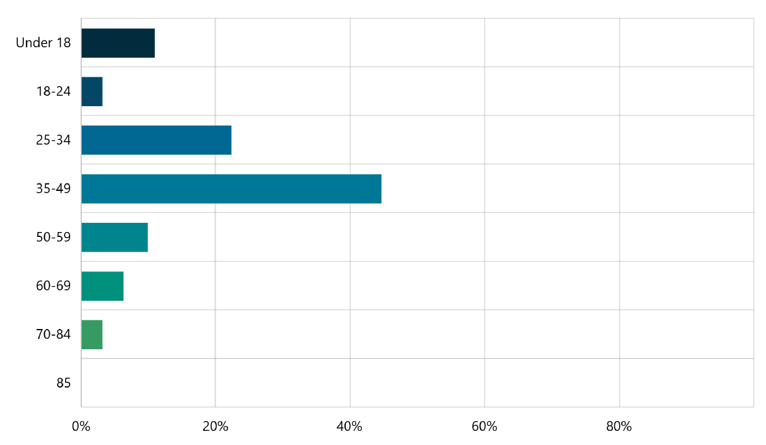
Responses were received from a wide range of age groups, with the largest proportion coming from people aged 35 to 49.

Snapshot of what we heard – Draft Master Plan survey results
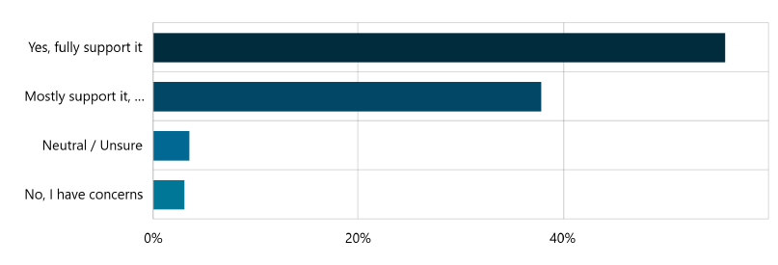
The survey results showed strong community support for the draft master plan, with 94% of respondents supportive of the master plan. More than half of respondents (56%) indicating full support and 38% mostly in support.

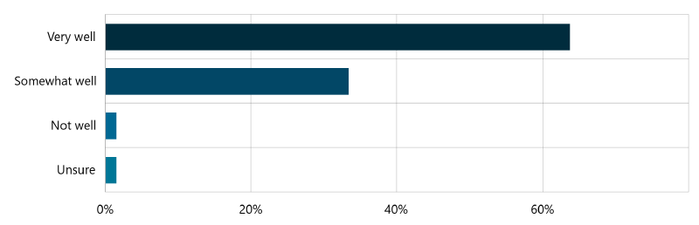
97% of survey respondents also felt that the master plan meets community needs either very well or somewhat well.

Many respondents indicated that they would be very likely to use the reserve when it has been developed.
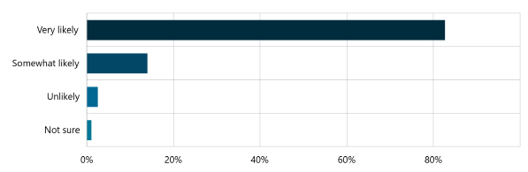

They also identified a range of activities they would likely participate in including sport, walking and using the playground.
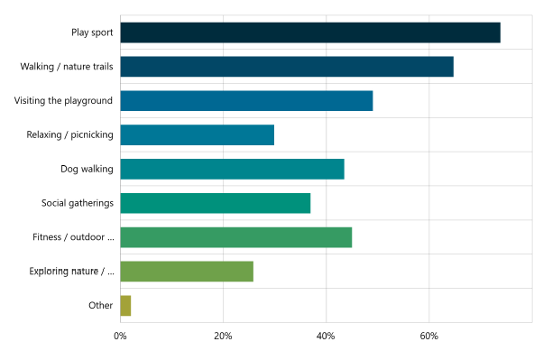

The survey also asked respondents questions to help inform the design of the new play space including what age groups the play space should most cater for, what type of equipment or features they would most like to see, and the style (or colour palate) preferred for the space.

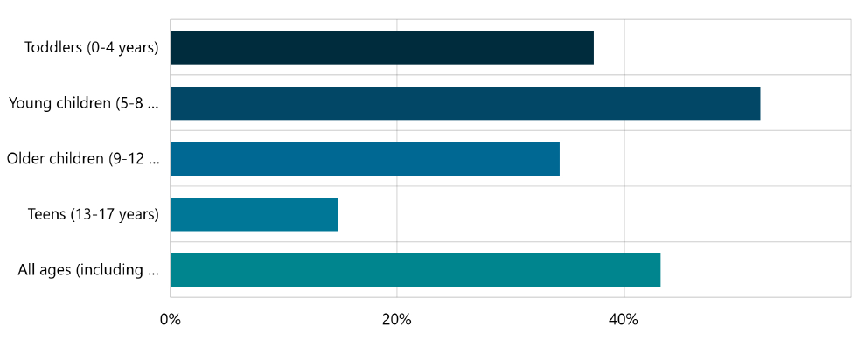

The responses received indicate that multi age play options would be most desirable at this location.
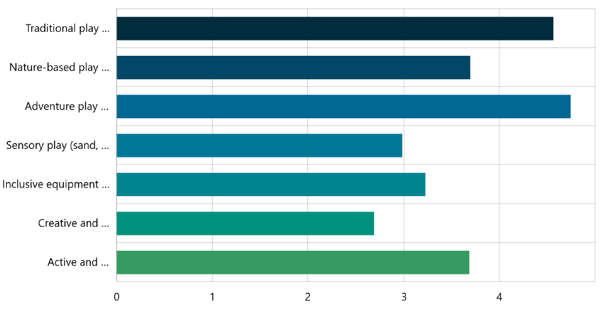
Responses also indicate a range of play equipment and features would be desirable.
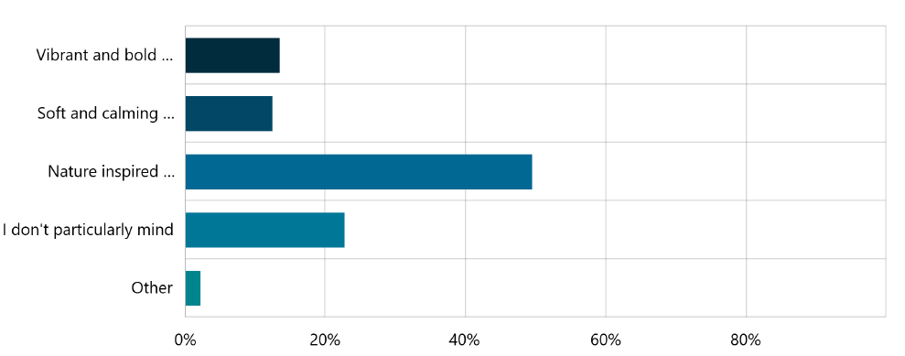
Finally, there was a clear preference from respondents for the aesthetics of the play space to be sympathetic to the natural environment.

Build your play space
In addition to the survey the community was also asked to provide further input into what they would like to see in the proposed play space through the ‘Build Your Play Space’ tool. This provided the respondents the opportunity to choose key items to be included for their ideal play combination.
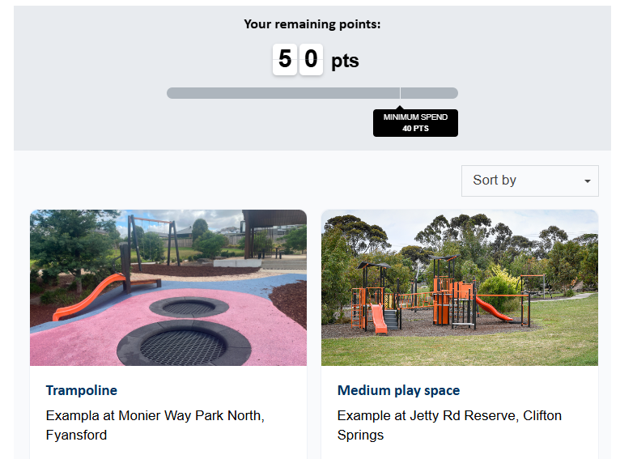

Snapshot of what we heard – Build Your play space
89 contributions were received on this tool during the engagement period.
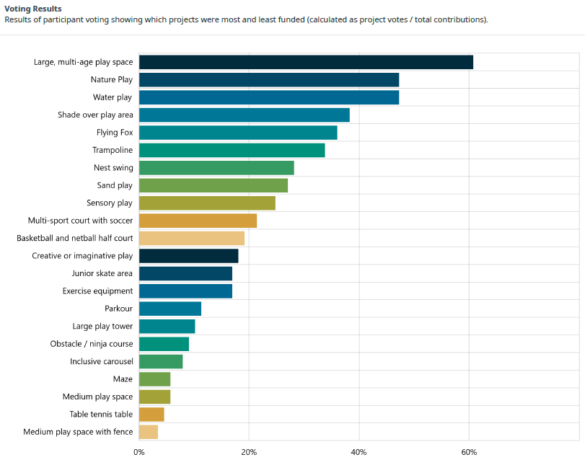

The highest voted item for inclusion was the large multi aged play space with 54 votes, followed by nature play and water play.
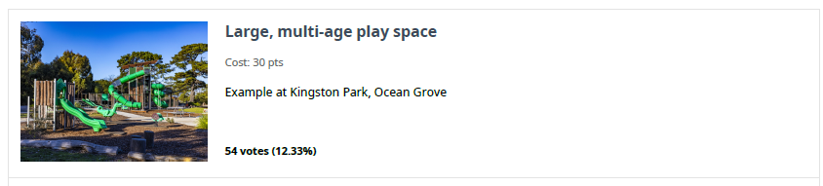

Onsite DROP-IN session
A 2 hour onsite drop-in session was held on Saturday 9 August at the reserve on the corner of Coastside Drive and Iris Loop.

The session provided an opportunity for residents and interested community members to stop by and ask the project team any questions they had about the proposal and for any children to complete the build your playground activity.

The below image is an example of the dotmocracy activity (voting using dots) was used at the popup to select playground equipment.

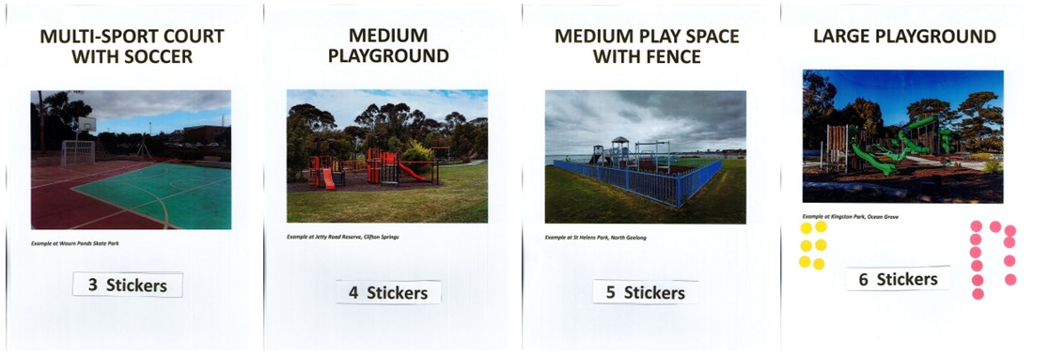
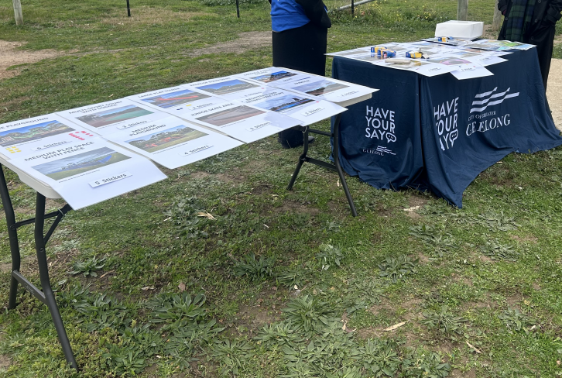
20 people attended the session with feedback received largely positive for the draft master plan with some questions and suggestions for potential improvements and additional opportunities.

Next Steps
The engagement phase is now closed, and feedback is being reviewed and analysed. This information will be used to refine and finalise the master plan.
A detailed report is being prepared to summarise the engagement process, outline the feedback received, and explain how community input has informed the final version of the plan.
The completed master plan will be presented to Council for adoption in November 2025.

