The City Of
Greater Geelong

special rates and charges

POLICY

- VERSION: | - 3
- TYPE OF POLICY: | - Council
- APPROVAL DATE: | - 9 december 2025
- REVIEW DATE: | - 9 december 2029
- RESPONSIBLE OFFICER: | - special rates and charges program manager
- AUTHORISING OFFICER: | - executive director city infrastructure

Table of Contents
Introduction 3
Definitions 4
Policy 5
1. open and transparent engagement with the community 5
2. principles 6
3. prioritisation framework 7
Implementation of this Policy 8
References 9

Introduction

purpose
A Special Rate and Charge Scheme is a funding model by which the City can recover the costs, or part thereof, from property owners where works or services provide a special benefit to those property owners.
This policy provides guidance for implementing and delivering services paid for through contributions as part of a Special Rate and Charge Scheme pursuant to Section 163 of the Local Government Act 1989 and 2020.

scope
Under the Local Government Act 1989, Councils may levy a special rate or charge to fund services or infrastructure that provide a special benefit to specific property owners. These schemes enable the City to deliver projects more efficiently, overcoming budget and timing constraints, and benefiting both individual properties and the broader community.
Special Rate and Charge Schemes are not limited to physical infrastructure—they may also support services such as marketing, promotion, and economic development.
In new developments, infrastructure costs are typically apportioned by the developer across all lots. Where infrastructure or services are introduced later, property owners may be required to contribute fairly to the cost of those benefits.
This policy outlines the decision-making process and criteria for implementing Special Rate and Charge Schemes, ensuring transparency, equity, and alignment with community benefit.

Services include but are not limited to:
• Increase in maintenance above municipal pre-determined levels of intervention
• Treatments to address nuisance amenity issues associated with City infrastructure
• Marketing and promotion
The provision of Infrastructure includes but is not limited to:
• Sealed roads
• Drainage
• Kerb and channel
• Footpaths
• Streetlighting
• Other capital infrastructure
• Design and construction of the above

Definitions
The following definitions apply to this Policy:
Term | Definition
City | The City of Greater Geelong organisation, led by the CEO.
City Officers | Includes employees, volunteers and contractors.
Council | The City of Greater Geelong Council comprised of elected councillors and led by the Mayor.
ELT | The Executive Leadership Team of the City, as constituted from time to time.
Submission Review Panel (SRP) | A panel of Councillors to consider feedback from property owners who support or oppose a proposed scheme.
Special Benefit | Benefit received by those property owners included in the scheme. Benefitting property owners pay the special benefit.
Community Benefit | The wider community that are not receiving a Special Benefit in the proposed scheme. The community benefit is paid by the City.
Total Benefit | Special Benefit plus Community Benefit.
VCAT | Victorian Civil and Administrative Tribunal.

Policy
The City aims to deliver a standard of infrastructure and services that ensures the connection, safety, wellbeing and prosperity of all members of the community. This in turn creates a healthier community by reducing isolation, encouraging physical activity and socialisation and strengthens the local economy.
The City welcomes nominations and support from the community where infrastructure and services may need improvement and could be delivered under a Special Rate and Charge Scheme funding model.
Where possible, works and services delivered under a Special Rate and Charge Scheme will comply with relevant standards and guidelines and the Local Government Act 1989 and the Local Government Act 2020.
As a result of increasing population growth in Greater Geelong, there is community expectation that infrastructure and services are provided to support the growing community.
A Special Rate and Charge Scheme may be initiated by the City via a petition or may be requested by property/business owners or residents. A Special Rate and Charge Scheme may be delivered to raise the standard of a specific service or infrastructure to provide better amenity for residents or to better respond to growth. Without Special Rate and Charge Schemes, the upgrading or construction of new infrastructure or provision of services would be significantly delayed or never delivered.
Apportioning costs enable the City to balance its financial sustainability with benefiting communities/properties. Any cost adjustments will be confirmed in accordance with the requirements of the Local Government Act 1989 at the finalisation of the Scheme.
Apportionment of costs from a Special Rate and Charge Scheme is calculated in recognition of the benefit to the property owners and the local community. The classification of the road or drain defines the ratio of Special Benefit and Community Benefit for the different asset classes.
Costs will be apportioned using information available to derive the proportion of Special Benefit gained by each individual party to the Scheme and Community Benefit.

open and transparent engagement with the community

When engaging in a Scheme, the City aims to provide an open and transparent process, on a fair, reasonable and equitable basis and encourages property owner input.

To ensure a Special Rate and Charge Scheme is implemented in accordance with the requirements of the Local Government Act 1989 and 2020, Council follows this policy, and internal procedures, for all Schemes undertaken.

Each Special Rate and Charge Scheme is unique. A community engagement plan shall be prepared to suit specific needs in accordance with Council’s Community Engagement Policy.

The City, in considering a Scheme, may adopt, abandon or modify a proposed scheme. If a Scheme is abandoned, it generally won’t be revisited within 10 years from the decision or unless it is clearly demonstrated that community support has changed. Support is demonstrated by the majority (60% or more) of survey responses received indicating their support for the upgrade under a future SRC Scheme.

principles

The following principles underpin the City’s Special Rate and Charge Scheme decision making.
As a principle the City will: | What will this look like in practice?
Consult and engage with the community and stakeholders | The City aims to connect with the community and stakeholders when planning for new, upgraded or improved infrastructure or services for the community.  The City commits to engage with the community to ensure the community has a voice.
Be driven by evidence of need and the benefit to the community | The City aims to take a purposeful and strategic approach to funding infrastructure or services that deliver meaningful community benefit and social impact.  The City aims to ensure that decisions are aligned to the agreed provision standards, robust evidence and the requirements of the community.  As a priority, the City aims to consider solutions that meet safety and mobility outcomes, the place-based needs of the community and focus on addressing social challenges, economic impacts and opportunities.
Provide access to services where it is needed, in a timely way | The City aims to ensure that service and infrastructure design, location, and support arrangements address the needs and obstacles faced by the community.  The City aims to ensure that the community has access to infrastructure, support and services where it is needed and as soon as practicable.
Align decisions with Council’s role, strategic priorities, and needs of the community | The City aims to ensure that community spend is focussed on delivering strategic objectives and priorities, while ensuring there are appropriate mechanisms to consider community led ideas and initiatives.  The City aims to play a stronger role as an advocate, leader, facilitator, planner, monitor and part funder of new and upgraded services. The City aims to continue to fulfil a variety of roles as appropriate, including the support and delivery of new and upgraded infrastructure and services.  If the City identifies the need for new or upgraded infrastructure but the contributing parties do not support the Scheme, it may still proceed if the City contributes more than one-third of the total cost. Under Section 163B of the Local Government Act 1989, the Scheme can proceed even if a majority of property owners object, provided the Council’s contribution exceeds one-third of the cost. Alternatively, the City may refer the proposal to Council’s budget process and/or explore external funding sources.  The City aims to be fair and transparent in its funding priorities, processes and decision making, ensuring funding achieves best value.
Demonstrate fairness and transparency in decision making | The City aims to provide the community with a clear understanding of Council’s role and how decisions are made to ensure that the community understands what is planned for the place that they live.

prioritisation framework 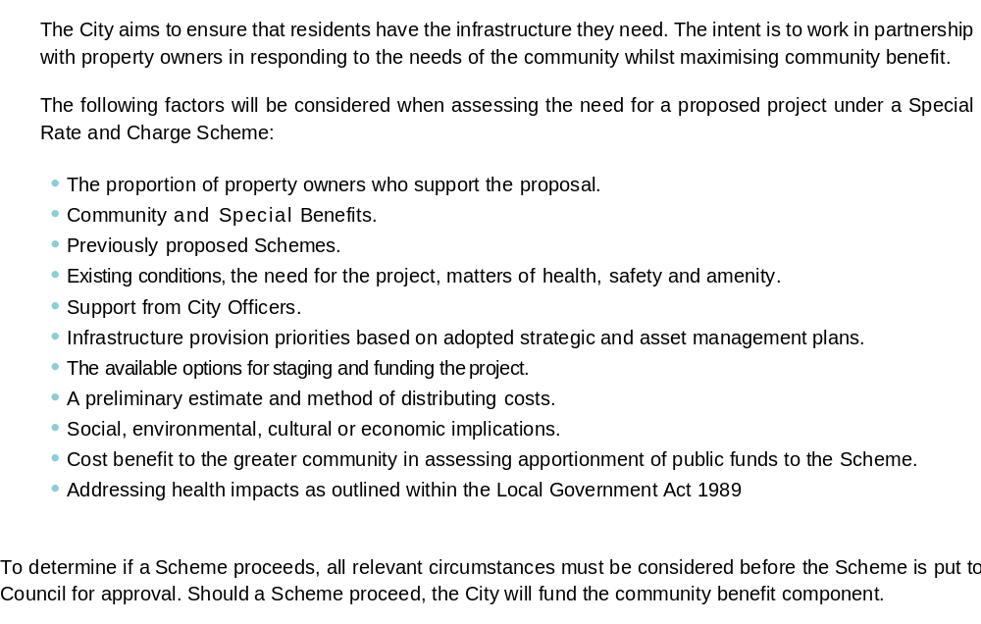

Implementation of this Policy

Monitoring and reporting
The City’s commitment to the implementation of this Policy includes:
- Providing a rolling four-year Special Rate and Charge infrastructure plan in alignment with Council’s Community Plan and the long-term financial plan; and
- Periodically review the economic development derived from commercial businesses for services provided through a Special Rate and Charge Scheme; and
- Conduct an annual review of Special Rate and Charge Scheme priorities.

Advice and assistance
The Responsible Officer for this policy manages the provision of advice to the organisation regarding this policy.
A person who is uncertain how to comply with this policy should seek advice from this person or from their Manager.

Records
The City must retain records associated with this Policy and its implementation in accordance with its Records Information Management Policy

Review
The City should review and, if necessary, amend this Policy within four years of the Approval Date.

References
Legislation
- Local Government Act 1989
- Local Government Act 2020
- Ministerial Guidelines 2004

Other Documents
- Records Information Management Policy
- Infrastructure Design Manual (IDM)
- Community Plan 2025-2029
- Special Rate and Charge Scheme Procedure 2025

